**A Study On Current Scenario Of Training And Development**

**Kata Ramadevi**

Roll No: 212122672146, Department of Management Studies

Aristotle PG College,Chilkur, Moinabad, Ranga Reddy District, Telangana.

**Mr.T.Ramesh**

Assistant Professor

Aristotle PG College, Chilkur, Moinabad, Ranga Reddy District, Telangana.

[rameshyadavthotakuri@gmail.com](mailto:rameshyadavthotakuri@gmail.com)

**Abstract:**

Training and Development can be defined as a means to an end. It helps an organization to achieve its ultimate target which is elevating the happiness quotient leading to exemplary performance by the employees hence generating quality production and a healthy organization. Healthy organizations lead to good employee retention and which indirectly builds the image of the company and helps it earn goodwill in the market. It is like a bridge that reduces the gap between competence and performance. Training and Development is the key to employee satisfaction. Managing human resources is the biggest challenge faced by an organization and training and development seems to be the best available option to deal with and tackle this problem. The research was conducted with the help of a questionnaire randomly distributed to 120 employees working at various levels in the organization. From the study conducted it was observed that the training and development system is not up to date and needs the intervention of the latest tools and technologies.

**Keywords:** Training and Development, employee retention, tools and technologies

**INTRODUCTION:**

# INTRODUCTION

The situation of the present study "Training" is a crucial a part of Human Resource Development.

The phrase "Resource" refers back to the productive power of herbal items. Human Resource is, consequently, the effective electricity in human beings. Unlike the cloth resources, human sources are the participant as also the beneficiaries of economic development system. Human Resource Development has received increasing interest in final decade from Human Resource specialists, schooling and Development specialists, Chief Executives and Line Managers. Many dimensions of human useful resource improvement had been integrated into Research, Training, Organizational Design and Change.

**TRAINING AND DEVELOPMENT**

Employee training is awesome from control improvement or government development. While the previous refers to training given to employees within the regions of operations, technical and allied place, the later refers to developing of a worker in the areas of concepts and techniques of control, management, business enterprise and allied place.

|  |  |  |
| --- | --- | --- |
| Areas | Training | Development |
| Content | Technical skills and knowledge | Managerial & behavioral skills  and knowledge |
| Purpose | Specific job- related | Conceptual and  general knowledge |
| Duration | Short term | Long term |
| For whom | Mostly technical and non - managerial  personnel | Mostly for managerial personnel. |

**Benefits of Training:**

Leads to progressed profitability and / or greater fantastic attitudes towards earnings orientations.

* + - * Improve the process understanding and talents in any respect stages of the companies.
      * Improve the moral of the personnel.
      * Helps people perceive with organizational desires.
      * Helps create a higher corporate image.
      * Faster’s authenticity, openness and consider.
      * Improves the connection among boss and subordinate.
      * Aids in organizational improvement.
      * Learns from the trainee.

**REVIEW OF LITERATURE:**

**Muhammad Zahid Iqbal et. Al in the year (2011) has done their research in the topic**

“AN EMPIRICAL ANALYSIS OFTHE RELATIONSHIP BETWEEN CHARACTERISTICS AND FORMATIVE EVALUATION OF TRAINING”

Their analysis is about the relationship between characteristics and formative evaluation of Training. This paper attempted to signify these of formative training evaluation. The authors have carried out a study at three public-sector training institutions to empirically test the predicted relationship between the training characteristics and formative training evaluation under the Kirkpatrick model(reaction and learning) . This study explains the causal linkage between components of formative training evaluation, the mediating role of reaction in the relationships between training characteristics and learning was also investigated. The principal finding revealed that a set of seven training characteristics explained 59% and 61% variance in reaction and learning respectively. All training characteristics were found to have a positive impact on reaction and learning except training contents.

**Eugen Rotarescu in the year (2010) has reviewed on the topic**

**“ALTERNATIVE SELECTION UNDER RISKCONDITIONS IN HUMAN RESOURCES TRAINING AND DEVELOPMENT THROUGH THE APPLICATION OFTHE ESTIMATED MONETARY VALUE AND DECISION TREE ANALYSIS”.**

The topic in this article is the presentation in a succinct and applicative manner of several decision making processes and the methods applied to human resources training and development in environments with risk factors. The decisions have been optimized by the human resources training and development, the decision makers have readily available with two methods of analysis they are: (1) the decision matrix and (2) the decision tree method. Both methods compute the alternatives based on the estimated monetary value (EMV). Finally the decision matrix and the decision tree analyses represent two viable, scalable and easily applicable framework analyses for selecting the optimum course of action regarding the training and development of human resources. Both analyses generate the same solution and rely on the accuracy of the expected monetary value (EMV) method calculated for each course alternative action. Of these two methods, the selected decision method depends on the circumstances, the complexity of the situation and preference of the decision makers.

**RESEARCH GAP:**

# Training and development activities in which employees had participated bring new potentials of employees in performing task and resulted in employee effectiveness. Individual employee development plans, where you are training to fill a skill or knowledge gap, address a performance issue, or prepare the employee to take on greater managerial and/or leadership responsibilities.

**OBJECTIVES:**

* To evaluate the training and development programs
* To know the improvement of skill, knowledge of an employee through training program
* To know whether training is useful for enhancing productivity and performance
* To know whether the organizations is maintaining the health and safety standards

**RESEARCH METHODOLOGY:**

**Need For The Study**

Training is the most important technique of human resource development. As stated earlier, no organization can get a candidate who exactly matches with the job and the organizational requirements. Hence, training is the most important to develop the employee and make him suitable to the job.

Job and organizational requirements are not static; they are changed from time to time in view of the technological advancement. Trained employees would be valuable asset to an organization.

Training is important, as it constitutes significant part of management.

The Human Resource Department is involved in activities that lead to the Efficient & Effective Management of Human Resources.

**Scope Of The Study:**

The study covers various aspects like employee details, work nature, job specification and knowledge and personality development of employees of the organization. It also covers job nature of technical, behavioral, awareness and various aspects of training programs conducted by the personnel department. The study has a scope of learning about the various programs organized by the personnel department till date and the programs which they are going to organize and also the analytical based programs which we will be suggested based upon the survey.

**Methodology**

The present study will get the data from two types of Methodologies.

* PRIMARYDATA
* SECONDARYDATA

For this project,

**primary data** was collected from the employees of the organization. The basic approach for the collection of primary data is by conducting a survey with the help of a questionnaire.

Towards the accomplishment of the said objectives, information would be obtained from primary as well as secondary data sources; Primary data will be generated by way of meeting different executives concerned with training and development programs. Also, a survey on training program is conducted by means of a questionnaire to derive the training programs effectiveness. Efforts will be directed in obtaining the view of employees/ executives who got trained in the in-house/outside training programs.

**Secondary data** is such data, which is already published, collected for some purpose other than the one confronting the researcher at a given point of time.

Information pertaining to training and development programs organized over a period will be obtained by way of referring to record of the statistical departments, personal department, and training and development departments. In-house magazines, journals, newspapers, any other published materials will be referring to in collection of necessary data.

**Limitations of the study**

* The findings of the present study cannot be generalized as they are based purely limiting to the one unit of this singular organization without giving any comparisons to the practices in similar industry. Being a company spread all over India, for all practical reasons and limitations.
* This study is more of professional oriented. Hence it cannot be constructed to denote and / or purported to standardize as a model for this project.
* Some information was unavailable due to confidentiality maintained by the company.

**DATA ANALYSIS & INTERPRETATION:**

**Training is must for enhancing productivity and performance.**

|  |  |  |
| --- | --- | --- |
| **Particulars** | **No. of Respondents** | **% of Respondents** |
| **Strongly agree** | 55 | 45.833 |
| **Agree** | 39 | 32.5 |
| **Neutral** | 24 | 20 |
| **Disagree** | 1 | 0.833 |
| **Strongly disagree** | 1 | 0.833 |
| **Total** | 120 | 100 |

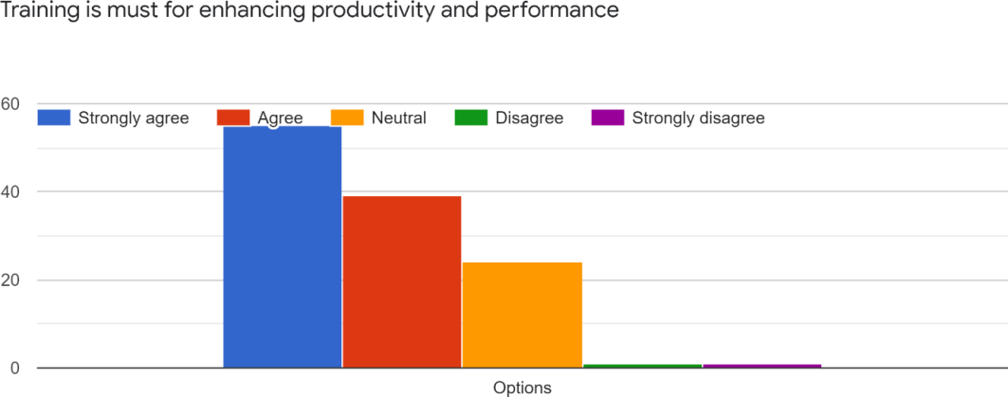**INTERPRETATION:**

It is observed that 45.8% of respondents strongly agreed that training is must for enhancing productivity and performance, 32.5% of respondents agreed that training is must for enhancing productivity and performance, 20% of respondents stood on neutral, 0.8% of respondents stood disagree, 0.8% of respondents disagree and strongly disagreed that training is must for enhancing productivity and performance.

## Your organization considers training as a part of organizational strategy. Do you agree with this statement

|  |  |  |
| --- | --- | --- |
| **Particulars** | **No. of Respondents** | **% of Respondents** |
| **Strongly agree** | 29 | 24.166 |
| **Agree** | 53 | 44.166 |
| **Neutral** | 34 | 28.333 |
| **Disagree** | 3 | 2.5 |
| **Strongly disagree** | 1 | 0.833 |
| **Total** | 120 | 100 |

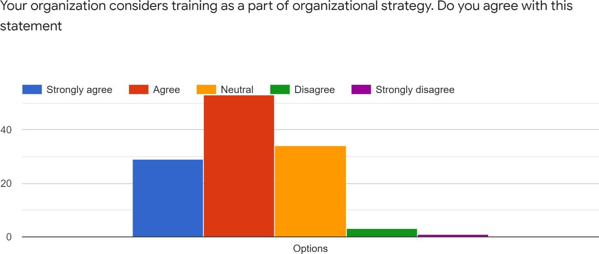

**INTERPRETATION:**

It is observed that 44.1% of respondents agreed on that their organization considers training as a part of organizational strategy, 28.3% of respondents stood on neutral, 24.1% of respondents agreed on their organization considers training as a part of organizational strategy, 2.5% of respondents disagree and 0.8% of respondents strongly disagreed that their organization considers training as a part of organizational strategy.

## Do you agree with training method focus on developing teamwork and leadership skills

|  |  |  |
| --- | --- | --- |
| **Particulars** | **No. of Respondents** | **% of Respondents** |
| **Strongly agree** | 35 | 29.166 |
| **Agree** | 37 | 30.833 |
| **Neutral** | 41 | 34.166 |
| **Disagree** | 6 | 5 |
| **Strongly disagree** | 1 | 0.833 |
| **Total** | 120 | 100 |

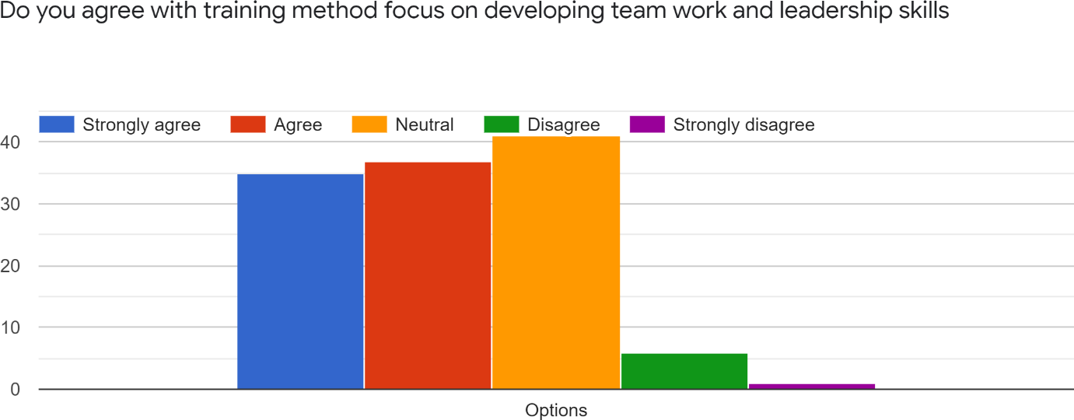

**INTERPRETATION:**

It is observed that 30.8% of respondents agreed that the training method focus on developing team work and leadership skills, 34.1% of respondents stood on neutral, 29.1% of respondents strongly agreed that the training method focus on developing team work and leadership skills, 5% of respondents disagreed that the training method focus on developing team work and leadership skills, 0.8% of respondents strongly disagreed that the training method focus on developing team work and leadership skills.

## CONCLUSION

Training is the organized process by which people learn knowledge and a skill or attitude for a purpose. The objective of the organization education and training policy is to enable all its employees to make their maximum contribution towards achieving business objectives.

Measuring training effectiveness or evaluation of training is the means used to

determine the worth or value of training. A comprehensive and effective evaluation plan is a critical component of any successful training program. It should be well structured to generate information on the reactions on the amount of learning that has taken place on the trainee’s behavior and its contribution to the job/organization.

## REFERENCES

**1.**Mamoria.C.B. and Mamoria.S., ‘Personnel Management’, Himalaya Pub-lishing Company, 1997

2.Lan Beardwell, Len Holden, ‘Human Resource Management’, Pitman pub- lishing, 1994

3.Uma Sekaran, ‘Research Methods for Business’, John Wiley and Sons Inc., New York, 2000.

4.K. ASWATHAPPA, Human Resource and Personnel Management, Tata Mc Graw Hill, 2003.