Analysis & Design of Pre-Engineered & Conventional Industrial Building
Omkareshwar Prabhakar Tekale¹ and Dr. Swati Ambadkar²
¹PG student, Department of Civil Engineering, G.H. Raisoni University ,School of Engineering and Technology, Amravati.
²Assistant Professor, Department of Civil Engineering, G.H. Raisoni University ,School of Engineering and Technology, Amravati.
ABSTARCT:
This study presents a comparative analysis of Conventional Steel Building (CSB) and Pre-Engineered Building (PEB) models using STAAD-PRO software. The analysis focuses on assessing the structural behavior and performance of both building systems under various loading conditions. The findings reveal that PEB models demonstrate a reduction in displacement compared to CSB models, indicating greater stiffness and resistance to deformation. However, the PEB model with a 7m bay spacing exhibits maximum reactions and beam forces, highlighting potential challenges associated with specific configurations. These observations underscore the importance of considering structural characteristics and loading conditions in the design and evaluation of PEBs and CSBs. Overall, this study contributes to a better understanding of the comparative performance of PEB and CSB structures, facilitating informed decision-making in building design and construction projects.
Keywords: Pre-Engineered Buildings, traditional steel structures, structural engineering, literature review and historical evolution

1. Introduction
The construction industry continually seeks innovative solutions to meet the growing demand for efficient, cost-effective, and resilient building structures. In this context, the comparison between Pre-Engineered Buildings (PEBs) and Conventional Steel Buildings (CSBs) has emerged as a crucial area of investigation. PEBs are characterized by their prefabricated components and streamlined construction process, while CSBs follow traditional construction methods involving on-site fabrication and assembly of steel components.
The comparison between PEBs and CSBs encompasses various aspects, including structural performance, construction time, cost efficiency, and sustainability. This comparison is particularly relevant in the industrial sector, where the need for large, column-free spaces often drives the choice of building systems. Additionally, with seismic events being a significant concern in many regions, evaluating the seismic performance of PEBs and CSBs becomes paramount.
Several studies have been conducted to assess the performance and suitability of PEBs and CSBs in different contexts. These studies consider factors such as structural design, material properties, loading conditions, and compliance with relevant building codes and standards. By analyzing these factors, researchers aim to provide insights into the strengths and limitations of each building system, aiding decision-making processes for architects, engineers, and project stakeholders.

2. REVIEW OF LITERATURE:
In the studies conducted by AUTHORS the focus lies on the analysis and design of industrial structures, particularly Pre-Engineered Buildings (PEB) and Conventional Steel Buildings (CSB), in accordance with Indian standards.
Gilbile et al. [1] analyzed PEB and CSB frames, considering different widths and conducting a parametric study to evaluate performance based on weight, cost, and time comparisons. Similarly, Zende et al. [2] considered various loads such as dead, live, wind, seismic, and snow loads, adhering to IS codes, to compare PEB and CSB in terms of shear force, support reaction, weight correlation, and cost evaluation.
Sharma et al. [3] emphasized the importance of long-span, column-free structures in industrial settings and compared static and dynamic analyses of PEB and conventional steel frames using Staad Pro software. They concluded that PEB structures offer reduced cost due to lighter weight.
In Wakchaure et al.'s study [4], PEB and conventional steel frames were compared, with a focus on dynamic forces such as wind and seismic loads. Manual wind analysis per IS 875 (Part III) – 1987 and seismic analysis per IS 1893 (2002) were conducted.
Finally, Bhadoria et al. [5] utilized Bentley STAAD PRO software to analyze and design structures, concluding that PEBs are more sustainable and cost-effective compared to conventional steel buildings. They advocate for the implementation of PEBs due to their lower construction and maintenance costs.
Overall, these studies underscore the importance of comparative analysis between PEBs and conventional steel buildings, highlighting the advantages of PEBs in terms of cost-effectiveness, sustainability, and structural performance.

3. METHODOLOGY
The following models are prepared in STAAD-PRO software
- 6m-1in10-conv
- 5m-1in10
- 6m-1in10
- 7m-1in10
- 5m-1in15
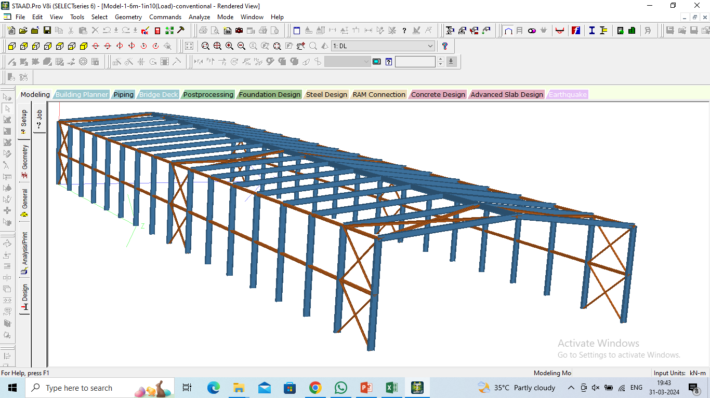
Fig.1: Conventional Industrial building

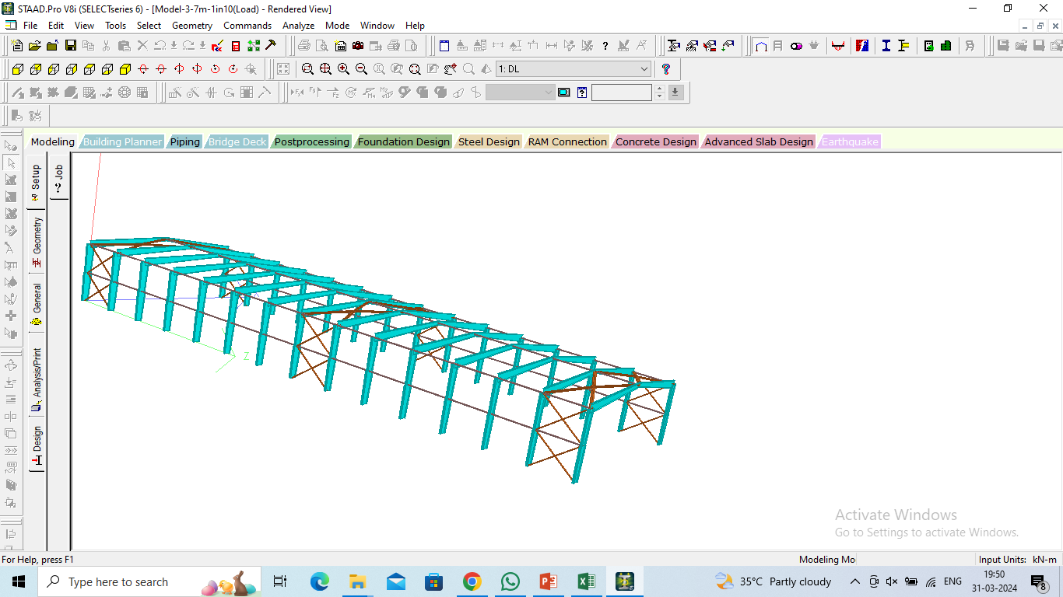
Fig.2: PEB Industrial building

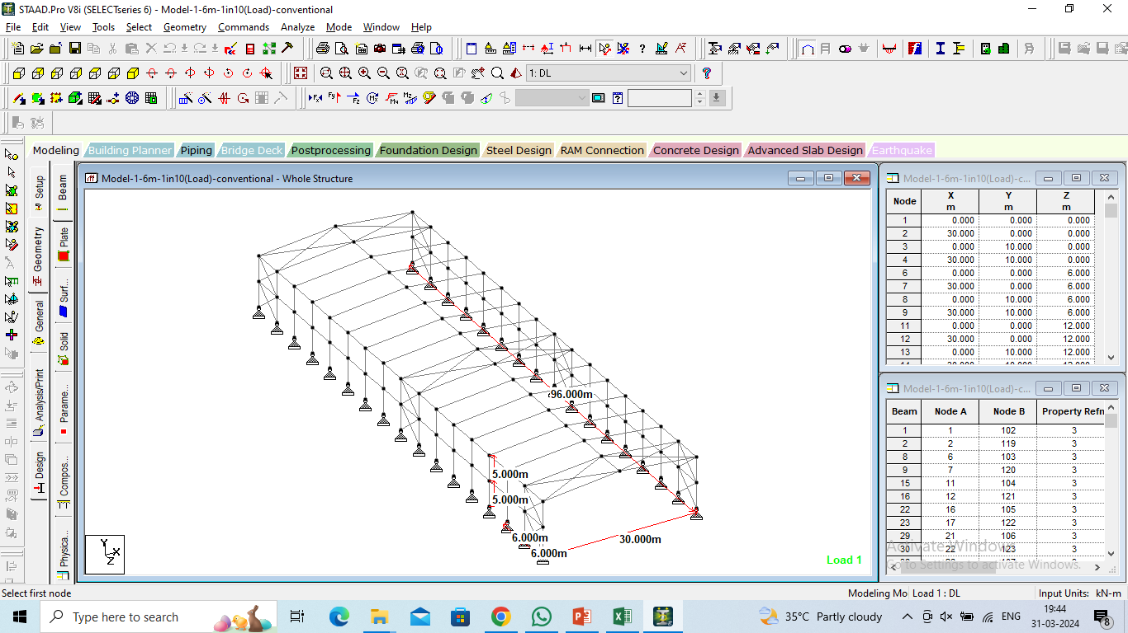
Fig.3: Geometry of the model

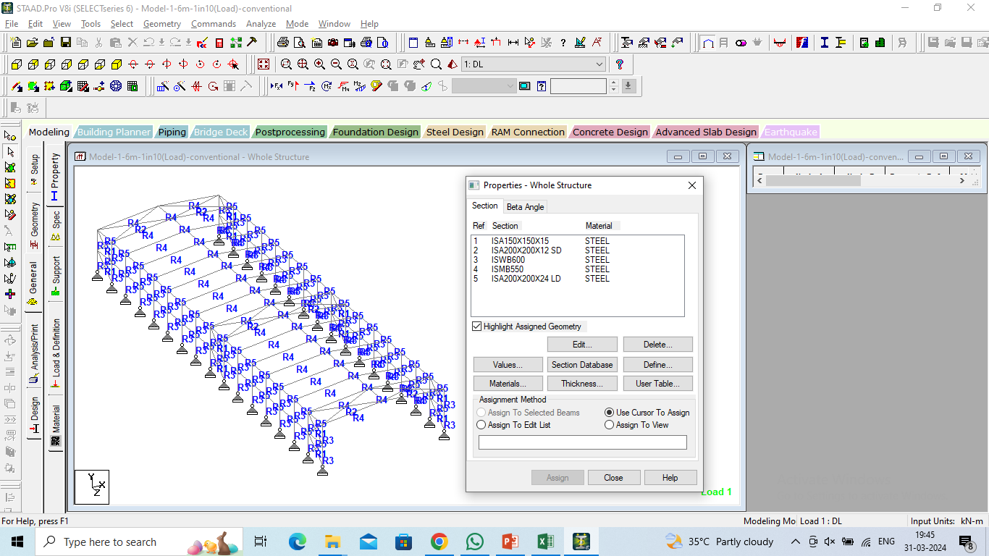
Fig.4: Properties assigned to the model

4. RESULTS
The following results are obtained
Fig.5: Displacement of all the models

Fig.6: Displacement of 6m (1 in 10)-conventional model

Fig.7: Reactions of all the models

Fig.8: Beam Forces of all the models

5. CONCLUSIONS
In the analysis conducted using STAAD-PRO software, both Conventional Steel Building (CSB) and Pre-Engineered Building (PEB) models were evaluated to assess their structural behavior and performance. The following observations were made based on the analysis:
1. Displacement Reduction in PEB Models:
- The analysis revealed a decrease in displacement for the PEB models compared to the CSB models. This reduction in displacement suggests that the PEB structures exhibit greater stiffness or resistance to deformation under applied loads. Such behavior is often attributed to the inherent design characteristics of PEBs, which typically feature optimized structural configurations and efficient use of materials.
2. Maximum Reactions in PEB Model with 7m Bay Spacing:
- Among the PEB models analyzed, the PEB model with a 7m bay spacing exhibited maximum reactions. Reactions refer to the forces exerted on the supports or foundations of the structure in response to applied loads. The higher reactions observed in the PEB model with a 7m bay spacing may be attributed to various factors such as the structural configuration, loading conditions, and material properties specific to this particular model.
3. Maximum Beam Forces in PEB Model with 7m Bay Spacing:
- Additionally, the analysis identified maximum beam forces in the PEB model with a 7m bay spacing. Beam forces represent the internal forces experienced by structural members, such as beams, due to applied loads. The higher beam forces observed in the PEB model with a 7m bay spacing indicate that this particular configuration experiences greater stress and demands on its structural elements compared to other models analyzed.
Overall, these findings suggest that while PEB structures may offer advantages such as reduced displacement, they may also exhibit higher reactions and beam forces under certain configurations and loading conditions. Understanding these characteristics is essential for optimizing the design and performance of PEBs, allowing engineers to make informed decisions regarding their suitability for specific applications and environments.
6. REFERENCES
- Gilbile, M. J., & Mane, S. S. (2020). A Review on Comparative Study on the Structural Analysis and Design of Pre-Engineered Building [PEB] with Conventional Steel Building [CSB]. International Journal of Engineering Research & Technology (IJERT) ISSN, 2278-0181.
- Zende, A. A., Kulkarni, A. V., & Hutagi, A. (2013). Comparative study of analysis and design of pre-engineered-buildings and conventional frames. IOSR Journal of Mechanical and Civil Engineering (2013), 2278-1684.
- Sharma, L., Taak, N., & Mishra, P. K. (2021). A comparative study between the pre-engineered structures and conventional structures using STAADPRO. Materials Today: Proceedings, 45, 3469-3475.
- Wakchaure, S., & Dubey, N. C. (2016). Design and comparative study of pre-engineered building. Int. J. Eng. Dev. Res, 4, 2108-2113.
- Bhadoria, S. S., & Pathak, Y. (2017). Comparative study of Pre-Engineered building and conventional steel structures. International Research Journal of Engineering and Technology (IRJET) ISSN, 2395-0056.
- Pattanshetti, S., & Kulkarni, S. M. (2017). Comparative study on the economy between pre-engineered and conventional steel buildings. International Research Journal of Engineering and Technology (IRJET), 4(7), 2708-2711.
- Sai, V. V., Poluraju, P., & Rao, B. V. (2021, November). Structural Performance of Pre Engineered Building: A Comparative Study. In IOP Conference Series: Materials Science and Engineering (Vol. 1197, No. 1, p. 012086). IOP Publishing.
- Gilbile, M. J., & Mane, S. S. (2020). A Review on Comparative Study on the Structural Analysis and Design of Pre-Engineered Building [PEB] with Conventional Steel [CSB] Building.
- Naidu, G. D. R., Rao, K. S. V., Sri, V. D., Navakanth, M., & Rao, R. (2014). Comparative study of analysis and design of pre-engineered buildings and conventional frames. Int. J. Eng. Res. Dev, 10, 33-41.
- Jibhkate, M. H., & Budhlani, D. L. COMPARATIVE ANALYSIS OF PRE-ENGINEERED BUILDING AND CONVENTIONAL STEEL BUILDING BY STAAD PRO. International Research Journal of Modernization in Engineering Technology and Science, vol, 3, 698-707.
- Siddarth Manoj, D., Mol, J., & Eswaramoorthi, P. A COMPARATIVE STUDY OF PRE-ENGINEERED BUILDING, AND CONVENTIONAL STEEL STRUCTURE.
- Radake, N. D., & Prasad, R. V. R. K. A Comparative Study between the Pre-Engineered Building and Conventional Steel Building’.
- Patil, M. R., Patil, M. K., & Khadake, N. V. COMPARATIVE STUDY OF STRUCTURAL DESIGN OF PRE-ENGINEERED BUILDING WITH DESIGN OF CONVENTIONAL STEEL STRUTURE.
- Jacob, B., & Althaf, M. (2020, November). Design comparison of conventional steel structure with pre-engineered structure. In IOP Conference Series: Materials Science and Engineering (Vol. 989, No. 1, p. 012008). IOP Publishing.
- Sharma, H. (2017). A Comparative Study on Analysis & Design of Pre-Engineered & Conventional Industrial Building. International Journal for Innovative Research in Science & Technology, 3(10), 91-99.

