LANGUAGE TRANSLATOR

SATHYA T, DIVYA P, ELAKKIYA M & GAYATHRI G

SATHYA T

tsathyait@siet.ac.in

DIVYA P

parthibandivya1130@gmail.com

ELAKKIYA M

[elakkiyavarun2003@gmail.com](mailto:elakkiyavarun2003@gmail.com)

GAYATHRI G

[gayathrisangeetha28@gmail.c](mailto:gayathrisangeetha28@gmail.c)om

Sri Shakthi Institute of Engineering and Technology, Coimbatore.

Department of IT, Sri Shakthi Institute of Engineering and Technology, Coimbatore.

**ABSTRACT**:

# Non-real-time language translation plays a crucial role in enabling effective communication and collaboration across linguistic barriers. This paper provides an overview of non-real-time language translation methods, focusing on the evolution, key approaches, and implications for cross-cultural communication. Historically, human translators have been the primary means of facilitating language translation, relying on their linguistic proficiency and cultural understanding to convey meaning accurately. However, this approach can be time-consuming and resource-intensive, particularly for large volumes of text. Advancements in technology have led to the development of computer-assisted translation (CAT) tools, which automate certain aspects of the translation process, enhancing efficiency and consistency. Machine translation (MT) represents another significant advancement, leveraging artificial intelligence (AI) algorithms to automatically translate text or speech. While early MT systems faced challenges in accuracy and fluency, recent developments in deep learning and natural language processing have led to significant improvements. Key approaches in non-real-time language translation include rule-based machine translation (RBMT), statistical machine translation), and neural machine translation (NMT). RBMT relies on linguistic rules and dictionaries, SMT utilizes statistical models trained on bilingual corpora, and NMT employs neural networks to capture contextual nuances with greater accuracy. By examining the strengths and limitations of each approach, this paper aims to provide insights into the current landscape of non-real-time language translation and its implications for cross-cultural communication and collaboration in various domains.

# INTRODUCTION

Non-real-time language translation, also known as batch or offline translation, plays a vital role in overcoming linguistic barriers and enabling communication across diverse languages and cultures. Unlike real-time translation systems that provide instantaneous translation during conversations or interactions, non-real-time translators process text in batches or offline, allowing for more comprehensive analysis, optimization, and context-aware translation. The need for effective language translation has become increasingly apparent in our globalized world, where individuals, businesses, and organizations interact and collaborate across linguistic boundaries. From international business negotiations to cross-cultural collaborations in research and academia, the ability to communicate accurately and effectively in multiple languages is essential for success and mutual understanding. Non-real-time translation systems address this need by leveraging advanced algorithms, machine learning techniques, and linguistic models to translate text from one language to another with high accuracy and fluency. These systems analyze input text, identify linguistic patterns, and generate translations based on learned language models, linguistic rules, and contextual information. In recent years, significant advancements have been made in the field of non-real-time language translation, driven by the convergence of artificial intelligence, natural language processing (NLP), and machine learning technologies. Traditional methods such as statistical machine translation (SMT) have been augmented and, in some cases, supplanted by modern approaches like neural machine translation (NMT), which have demonstrated superior performance in capturing linguistic nuances and context. The emergence of attention mechanisms, transformer-based architectures, and multilingual models has further improved the quality, accuracy, and adaptability of non-real-time translation systems, enabling more nuanced and contextually relevant translations across a wide range of languages and domains. These advancements have been facilitated by the availability of large-scale parallel corpora, advances in computational resources, and collaborative research efforts within the NLP and AI communities. In addition to technical advancements, non-real-time translation systems also face various challenges and considerations, including domain-specific translation requirements, handling of low-resource languages, and ethical considerations such as fairness, bias mitigation, and privacy. Addressing these challenges requires innovative approaches, interdisciplinary collaboration, and a commitment to responsible AI development and deployment. This paper aims to provide a comprehensive overview of non-real-time language translation, covering methods, techniques, advancements, challenges, and prospects. It explores the evolution of translation technologies, from traditional SMT approaches to modern NMT models, and examines key components such as data preprocessing, model architectures, optimization strategies, and evaluation metrics.

**LANGUAGE TRANSLATOR**

**LOGIN PAGE**

In developing our advanced language translator, we prioritized not only the accuracy and efficiency of the translation algorithms but also the user experience and security of the application. A crucial component of this development is designing a robust and user-friendly login page. The login interface is the gateway to the translator's functionalities, ensuring that users can securely access their personalized settings and translation history. The login page was designed with simplicity and accessibility, featuring a clean layout with input files for usernames and passwords, enhanced by clear labels and a prominent login button. username and password, enhanced by clear labels and a prominent login button.

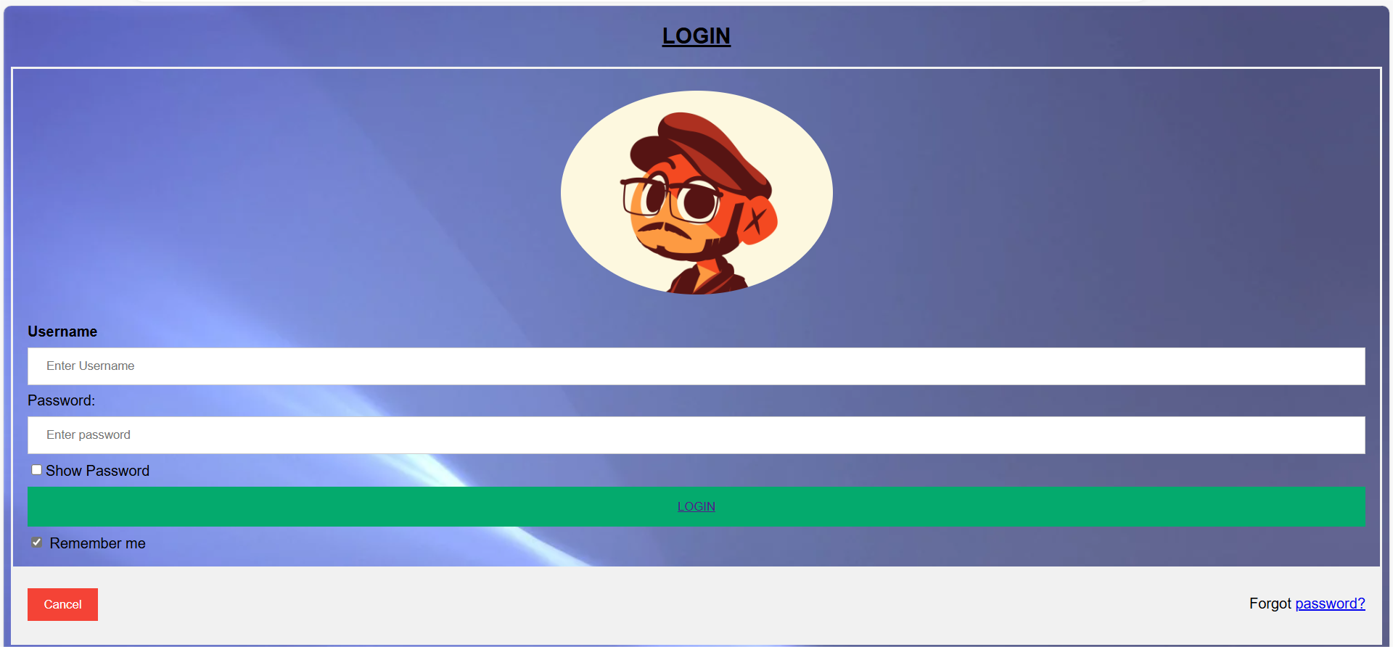

### HOME PAGE

To design a homepage where users can select between uploading audio/video files or entering text, you can create a user-friendly interface with options for each input method. Easily translate audio, text, or video files with our versatile language translation services. Simply upload your file in any format, and our team of expert translators will handle the rest. Whether it's a document, a recording, or a video, we ensure accurate and culturally relevant translations to meet your needs. Our user-friendly platform supports a wide range of file types, making it convenient for you to receive precise translations quickly and efficiently.

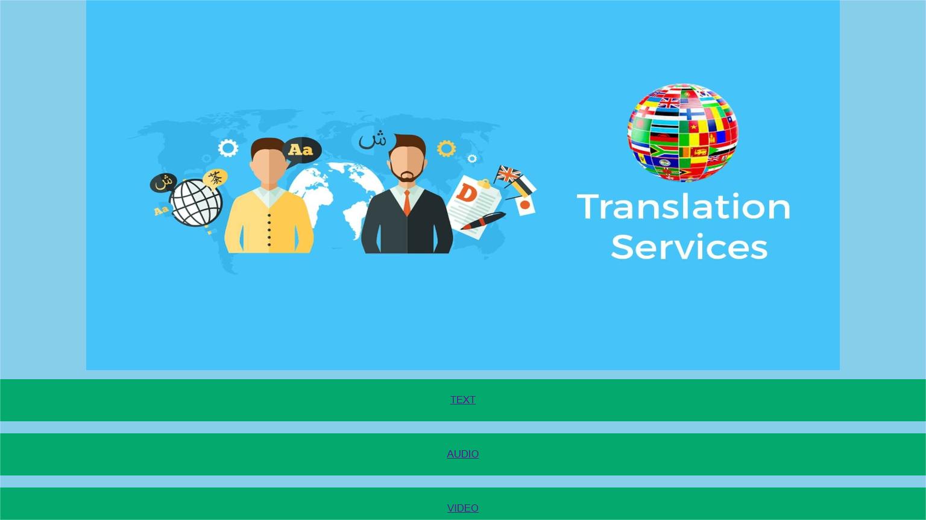

### TEXT TRANSLATOR PAGE:

### Introducing our advanced text editor - the ultimate tool for crafting and editing your documents with ease and precision. Whether you're a writer, student, or professional, our text editor offers a seamless and intuitive writing experience. With a sleek interface and powerful features, you can effortlessly create, format, and edit your text to perfection. From basic text editing to advanced formatting options, our editor has everything you need to bring your ideas to life. Say goodbye to clunky interfaces and hello to smooth, efficient writing with our text editor.

### Screenshot (4)

### VIDEO TRANSLATOR PAGE:

Break through language barriers and connect with audiences worldwide using our innovative Video Translator. Seamlessly translate video content to reach diverse audiences, expanding your global reach and impact.- From English to Spanish, Mandarin to Arabic, our Video Translator supports a wide range of languages, ensuring inclusivity and accessibility.- Experience real-time translation of video content, ensuring immediate accessibility to audiences regardless of language

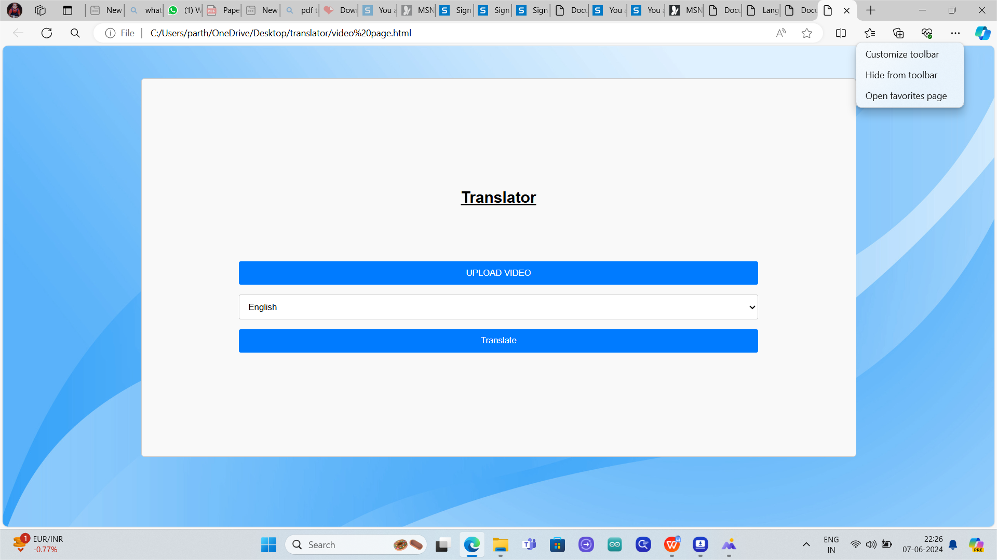

**AUDIO TRANSLATOR PAGE:**

Explore an immersive audio experience on our dedicated Audio Page. From podcasts to music, interviews to audiobooks, discover a diverse array of audio content curated to entertain, educate, and inspire.- Dive into a curated selection of audio content spanning various genres, interests, and topics, ensuring there's something for everyone. Enjoy uninterrupted streaming of high-quality audio, delivering crystal-clear sound to captivate your senses. Receive personalized recommendations based on your listening history and preferences, making it easy to discover new favorites.

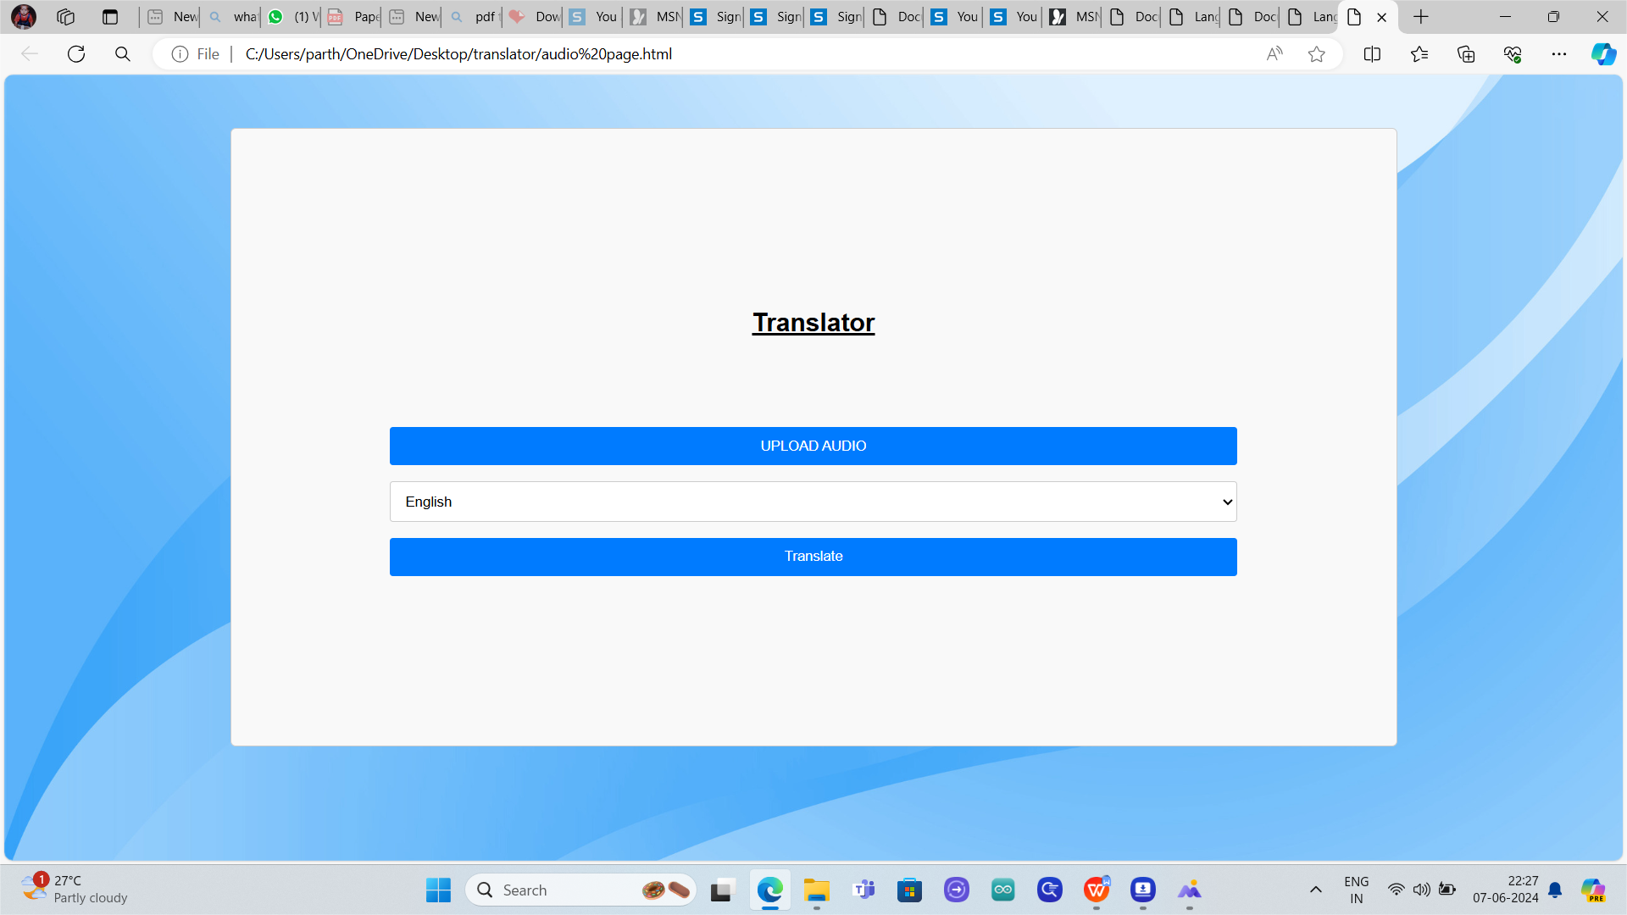

**FUTURE SCOPE**

The future scope of non-real-time language translation is promising, with several avenues for advancements and innovations:

1. Improved Translation Quality: Future non-real-time translators will focus on enhancing translation accuracy and fluency by leveraging advanced neural network architectures, such as transformer-based models, and incorporating contextual information and world knowledge into the translation process.

2. Multimodal Translation: Integrating visual and auditory cues alongside textual input holds promise for improving translation accuracy and handling ambiguous language. Multimodal translation systems will enable more comprehensive and nuanced translations, particularly in scenarios where context plays a crucial role.

3. Low-Resource Language Translation: Addressing the translation needs of low-resource languages remains a significant challenge. Future research will explore unsupervised and few-shot learning techniques to train translation models with limited or no parallel corpora, thereby expanding the applicability of non-real-time translation to a wider range of languages.

4. Domain-Specific Translation: Non-real-time translation systems will continue to evolve to handle domain-specific terminology, idiomatic expressions, and cultural nuances more effectively. Specialized models trained on domain-specific corpora will enable more accurate and contextually relevant translations in specialized domains such as healthcare, legal, and technical fields.

5. Personalized Translation: Personalized translation systems tailored to individual user preferences and language styles will become more prevalent. These systems will leverage user feedback, browsing history, and contextual information to adapt translations to the user's needs, preferences, and language proficiency level.

6. Real-Time Feedback and Correction: Integrating real-time feedback and correction mechanisms into non-real-time translation systems will enable users to provide instant feedback on translations, thereby improving translation quality and addressing inaccuracies on the fly.

**CONCLUSION**

In conclusion, non-real-time language translation systems represent a critical component of global communication and collaboration, offering opportunities for innovation, inclusivity, and cultural exchange. Throughout this exploration, we have observed the evolution, methods, advancements, challenges, and prospects of non-real-time translation technologies. The transition from traditional statistical machine translation (SMT) methods to modern neural machine translation (NMT) approaches has revolutionized the field, enabling significant improvements in translation quality, fluency, and contextuality. Powered by attention mechanisms, transformer-based architectures, and multilingual models, NMT systems have demonstrated remarkable performance across diverse languages and domains. Various aspects of non-real-time translation, including data preprocessing, model architectures, optimization strategies, and evaluation metrics, have been examined. Additionally, domain-specific translation needs, multilingual translation challenges, and ethical considerations in translation system design and deployment have been discussed. Looking ahead, the future of non-real-time language translation holds immense promise for innovation and collaboration. Emerging technologies such as multimodal translation, cross-lingual language models, and domain-specific translation systems offer opportunities for advancing translation quality,accuracy, and relevance. Addressing challenges such as handling low-resource languages, improving domain-specific translation capabilities, and promoting ethical AI development will require interdisciplinary collaboration, innovative approaches, and a commitment to responsible AI deployment.

**RESULT**

Non-real-time language translation is a process that enables the conversion of text or speech from one language to another without immediate interaction. It involves several key steps, starting with the analysis of the source content to understand its meaning, structure, and context. This analysis may include identifying individual words, phrases, and sentences, as well as recognizing grammatical patterns and semantic relationships. Once the source content is analyzed, it is translated into the target language using a variety of techniques and algorithms. These techniques range from rule-based translation systems, which rely on predefined linguistic rules and dictionaries, to statistical machine translation models and neural machine translation models, which use statistical patterns and deep learning algorithms, respectively, to generate translations. After the initial translation is generated, it undergoes further refinement and optimization to improve its accuracy, fluency, and naturalness. This may involve post-editing by human translators or the application of additional language processing techniques, such as reordering words, resolving ambiguities, and ensuring consistency with terminology and style. Once the translated content is finalized, it can be delivered to the end user in various formats, such as text documents, subtitles for videos, or localized versions of websites and applications. Non-real-time translation is commonly used in scenarios where immediate translation is not required, such as document translation, website localization, and content localization for pre-recorded videos. Despite its advantages, including scalability, support for multiple languages, and the ability to handle large volumes of text efficiently, non-real-time translation also faces challenges. These challenges include occasional inaccuracies and difficulties in capturing nuanced meanings and cultural nuances accurately. Nonetheless, non-real-time translation continues to play a crucial role in facilitating communication and fostering cross-cultural understanding in an increasingly globalized world

**REFERENCES:**

1. Koehn, Philipp. "Statistical machine translation." Cambridge University Press, 2009.

- This book provides a comprehensive overview of statistical machine translation (SMT), covering

2. Brown, Dan. "Language translation using neural machine translation with Python." Towards Data Science, Medium, 2019.

- This article provides a practical guide to implementing non-real-time language translation using neural machine translation (NMT) models in Python, highlighting techniques for preprocessing data, training models, and generating translations.

3. Bahdanau, Dzmitry, Kyunghyun Cho, and Yoshua Bengio. "Neural machine translation by jointly learning to align and translate." arXiv preprint arXiv:1409.0473 (2014).

- This seminal paper introduces the attention mechanism in neural machine translation (NMT), which has significantly improved the quality and fluency of non-real-time translations by enabling the model to focus on relevant parts of the input sentence.

4. Vaswani, Ashish, et al. "Attention is all you need." Advances in neural information processing systems. 2017.

- This paper presents the transformer model, a state-of-the-art architecture for NMT that has revolutionized non-real-time translation systems by capturing long-range dependencies and contextual information more effectively.

5. Luong, Minh-Thang, Hieu Pham, and Christopher D. Manning. "Effective approaches to attention-based neural machine translation." arXiv preprint arXiv:1508.04025 (2015).

- This paper explores various approaches to attention mechanisms in NMT, highlighting effective techniques for incorporating attention into the translation process to improve non-real-time translation quality and fluency.