**Shikakai (*Acacia concinna*) in Dermatology: Potential Uses and Therapeutic Benefits for Skin Disorders**

**Dr. Sanjay Kumar Acharya**

**Department of Botany, Govt. Dungar College, Bikaner**

**Abstract**

Shikakai (*Acacia concinna*), a climbing shrub native to Asia, has been a cornerstone of traditional Ayurvedic medicine for centuries, primarily used for its hair care benefits. This review delves into the historical uses of Shikakai in Ayurvedic practices and explores its modern applications in health and wellness. Traditionally, Shikakai has been utilized as a natural shampoo, renowned for its ability to cleanse the scalp, strengthen hair roots, and promote hair growth. Its saponin-rich pods generate a natural lather, providing a gentle yet effective cleansing action without stripping the scalp of its natural oils. Beyond hair care, Shikakai has been used to treat various skin conditions, thanks to its anti-inflammatory, antimicrobial, and antifungal properties.

In contemporary times, shikakai's applications have expanded, integrating into modern cosmetic and pharmaceutical formulations. Recent studies have highlighted its potential in managing dandruff, scalp psoriasis, and even minor wounds. The growing trend towards natural and sustainable beauty products has further popularized Shikakai, leading to its inclusion in a wide range of shampoos, conditioners, and skin care products. This review aims to bridge the gap between traditional knowledge and modern science, underscoring shikakai's relevance in today's health and beauty industry.

**Keywords:** Shikakai, Ayurvedic medicine, saponins, anti-inflammatory, antimicrobial, dandruff, scalp psoriasis, natural beauty products.

**Introduction**

Shikakai (*Acacia concinna*), a climbing shrub native to the tropical forests of Asia, holds a venerable place in the annals of traditional Ayurvedic medicine. For centuries, it has been celebrated not only for its potent hair care properties but also for its broader applications in maintaining health and well-being. In Ayurveda, Shikakai, which translates to "fruit for hair," has been revered as a natural cleanser and conditioner. Its use dates back thousands of years, embedded in the daily grooming rituals of various cultures, particularly in India. The pods, leaves, and bark of the Shikakai plant are rich in saponins, natural surfactants that generate a gentle lather. This makes Shikakai an effective yet mild cleanser, capable of removing dirt and excess oils without stripping the scalp of its natural moisture. Historically, Shikakai has been used to strengthen hair roots, promote hair growth, and reduce dandruff. Its anti-inflammatory, antimicrobial, and antifungal properties have also made it a valuable remedy for treating minor skin ailments and infections.

In recent years, there has been a resurgence of interest in natural and sustainable beauty products, propelling Shikakai back into the spotlight. Modern scientific research has begun to validate many of the traditional claims associated with Shikakai, highlighting its potential in contemporary hair and skin care formulations. Today, Shikakai is widely incorporated into shampoos, conditioners, and various cosmetic products, appealing to consumers seeking natural alternatives to chemical-laden products. This review aims to explore the rich historical uses of Shikakai in Ayurvedic medicine and examine its modern applications, bridging traditional knowledge with scientific advancements.

**Aim of the Study**

The aim of this study is to explore the historical uses and modern applications of Shikakai (*Acacia concinna*) in traditional Ayurvedic medicine, with a particular focus on its benefits for hair and skin care. This study seeks to:

**Document Traditional Uses:** Investigate and document the historical practices involving Shikakai in Ayurvedic medicine, including its preparation methods, applications, and perceived benefits.

**Analyze Bioactive Compounds:** Identify and analyze the bioactive compounds present in Shikakai, understanding their pharmacological properties and mechanisms of action.

**Evaluate Modern Applications:** Assess how Shikakai is currently being used in modern hair and skin care products, and evaluate its efficacy compared to conventional treatments.

**Bridge Knowledge Gaps:** Bridge the gap between traditional Ayurvedic knowledge and modern scientific research, highlighting the relevance and potential of Shikakai in contemporary health and beauty practices.

**Promote Sustainable Practices:** Examine the sustainable harvesting and cultivation practices of Shikakai to promote its use as an environmentally friendly ingredient in the beauty industry.

Through this comprehensive study, we aim to validate the traditional uses of Shikakai, explore its potential in modern applications, and provide a scientific foundation for its continued use and integration into contemporary health and wellness products.

**Review of literature**

Bhushan and Kumar (2017) provide a comprehensive review of natural remedies for dandruff and scalp infections, highlighting shikakai's effectiveness due to its antimicrobial and antifungal properties.(1) This aligns with the findings of Bhat and Bhandary (2015), who emphasize shikakai's role in managing dandruff and promoting overall hair health through its natural cleansing and conditioning abilities.(2)

Deshmukh and Zade (2013) focus on the hair growth-promoting activity of Shikakai extract, providing experimental evidence that supports traditional claims of its efficacy in enhancing hair growth and reducing hair loss. (3) Similarly, Gupta, Thakur, and Singh (2014) conduct an ethnobotanical study that underscores the widespread traditional use of Shikakai in India for hair care, validating its enduring popularity and effectiveness across generations.(4)

Kaur and Arora (2020) extend this discussion by exploring shikakai's potential in modern hair and skin care products. They argue that the bioactive compounds in Shikakai, such as saponins, flavonoids, and tannins, contribute to its therapeutic properties, making it a valuable ingredient in contemporary formulations.(5) This is further supported by Kumar, Mallick, and Roy (2016), who provide a detailed phytochemical and pharmacological review of Shikakai, confirming its beneficial effects on hair and skin health.(6)

Patel and Kumar (2018) offer an overview of shikakai's phytochemical and pharmacological profile, emphasizing its antioxidant and antimicrobial activities.(7) These findings are corroborated by Reddy and Gopinath (2019), who investigate the antimicrobial and antioxidant properties of Shikakai pod extracts, highlighting their potential in treating various scalp and skin conditions.(8)

Rao and Shetty (2017) focus on the formulation and evaluation of herbal shampoos containing Shikakai, demonstrating their effectiveness and consumer acceptability.(9) Singh and Sharma (2015) delve into the traditional medicinal uses of Shikakai and its potential in modern medicine, bridging ancient Ayurvedic practices with contemporary scientific understanding.(10)

**Morphology of Shikakai plant**

The Shikakai plant, scientifically known as *Acacia concinna*, is a perennial climbing shrub native to tropical and subtropical regions of Asia, particularly India. Its morphology can be described in detail as follows:

|  |  |
| --- | --- |
| **Roots** | Shikakai has a well-developed root system that helps anchor the plant and absorb nutrients and water from the soil. The roots are robust and penetrate deeply into the ground. |
| **Stem** | The stems of the Shikakai plant are woody and can grow to considerable lengths, often extending up to several meters. The stems are flexible, allowing the plant to climb and spread over other vegetation or structures. |
| **Leaves** | The leaves of the Shikakai plant are bipinnate, meaning each leaf is divided into multiple small leaflets arranged in pairs along a central axis. The leaflets are small, oblong, and have a smooth texture. The leaves are dark green and exhibit a feathery appearance. |
| **Flowers** | Shikakai produces small, yellow to cream-colored flowers that are typically clustered in cylindrical spikes. The flowers are fragrant and attract various pollinators, including bees and insects. |
| **Fruits** | The plant bears distinctive, oblong, and flattened seed pods. These pods are dark brown to black when mature and can be several centimeters long. Each pod contains multiple seeds and is covered with fine, velvety hairs. |
| **Seeds** | The seeds within the pods are small, round, and brown. They are hard and have a smooth surface, capable of enduring harsh environmental conditions. |
| **Bark** | The bark of the Shikakai plant is dark brown and rough, with a texture that facilitates climbing. |

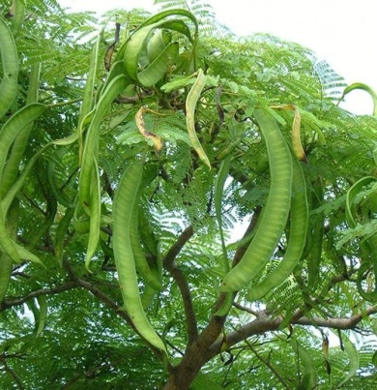 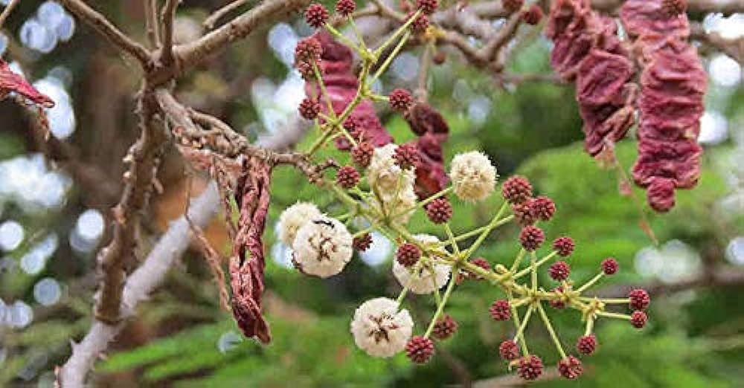 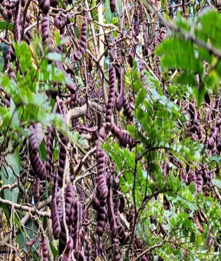

**Classification of Shikakai plant**

Kingdom: Plantae

Phylum: Angiosperms

Order: Fabales

Family: Fabaceae (Leguminosae)

Sub Family: Mimosoideae

Genus: Acacia

Species: Acacia concinna

This classification places Shikakai within the Fabaceae family, which is known for its nitrogen-fixing abilities and includes many other significant plants like beans, peas, and other types of acacias.

**Shikakai in veds**

Shikakai, known for its remarkable cleansing and medicinal properties, has been mentioned in various ancient Indian texts, including the Vedas. The Vedas, which are a large body of religious texts originating in ancient India, contain hymns, philosophies**,** rituals, and practices that date back to the early Vedic period (1500-500 BCE).

|  |  |  |
| --- | --- | --- |
| **Historical Context** | **Ayurveda and Vedic Literature** | Ayurveda, which means "the science of life," is a system of medicine with historical roots in the Indian subcontinent. Its foundations are deeply interwoven with the philosophies and practices mentioned in the Vedas, particularly the Atharva Veda.  While the Vedas do not explicitly mention every herb used in Ayurveda, they lay the groundwork for the holistic approach to health and natural remedies, which includes the use of plants like Shikakai. |
| **Shikakai in Ayurvedic Texts** | Detailed references to Shikakai are more prominently found in classical Ayurvedic texts such as the Charaka Samhita and Sushruta Samhita. These texts, which are based on the Vedic knowledge, describe the plant’s uses and benefits extensively.  Shikakai is described in these texts as a potent herb for maintaining hair health and treating various skin conditions. It is lauded for its cooling and cleansing properties, making it an integral part of traditional hair care practices. |
| **Attributes and Uses** | **Cleansing Properties** | Shikakai is renowned for its natural saponins, which create a gentle lather that cleanses hair and scalp without stripping away natural oils. This aligns with the Vedic emphasis on purity and cleanliness, both physically and spiritually. |
| **Medicinal Benefits** | The anti-inflammatory and antimicrobial properties of Shikakai make it valuable for treating scalp infections, dandruff, and minor skin ailments. These therapeutic attributes are in line with the Vedic tradition of using natural remedies to promote health and well-being. |
|  | **Holistic Health** | Vedic literature often emphasizes the balance between body, mind, and spirit. The use of natural herbs like Shikakai in daily rituals not only supports physical health but also contributes to mental and spiritual well-being by maintaining cleanliness and reducing stress through its soothing properties. |

While the Vedas may not mention Shikakai explicitly by name, the principles and practices laid out in these ancient texts form the foundation for its use in Ayurveda. Shikakai's integration into Ayurvedic medicine, detailed in later classical texts, reflects the continuity and evolution of Vedic knowledge. Its enduring presence in traditional and modern hair and skin care routines underscores its significance as a natural, holistic remedy rooted in ancient Indian wisdom.

**Bioactive Compounds Found in Shikakai (Acacia concinna)**

Shikakai (*Acacia concinna*) contains a variety of bioactive compounds that contribute to its therapeutic and cosmetic properties. These compounds have been studied for their beneficial effects on hair and skin health. Here are the key bioactive compounds found in Shikakai:

|  |  |
| --- | --- |
| **Saponins** | **Function:** Saponins are natural surfactants that produce a lathering effect when mixed with water. They are primarily responsible for shikakai’s cleansing properties, effectively removing dirt and oil without stripping the scalp of its natural moisture.  **Benefits:** Mild cleansing, antimicrobial activity, and potential anti-inflammatory effects. |
| **Flavonoids** | **Type**s**:** Includes kaempferol, quercetin, and their glycosides.  **Function:** Flavonoids are powerful antioxidants that protect cells from oxidative stress and damage.  **Benefits:** Antioxidant protection, anti-inflammatory properties, and UV protection. |
| **Tannins** | **Function:** Tannins are polyphenolic compounds with astringent properties.  **Benefits:** Tightening of tissues, reduction of inflammation, and antimicrobial effects. They help soothe irritated skin and can promote wound healing. |
| **Alkaloids** | **Function:** Alkaloids are nitrogen-containing compounds that often have potent biological activities.  **Benefits:** Potential antimicrobial and anti-inflammatory effects, contributing to overall scalp and skin health. |
| **Vitamins** | |
| **Vitamin C (Ascorbic Acid)** | **Function:** A potent antioxidant that promotes collagen synthesis and protects against oxidative damage.  **Benefits:** Enhances skin health, strengthens hair, and supports wound healing. |
| **Vitamin A** | **Function:** Essential for cell growth and differentiation.  **Benefits:** Maintains healthy skin and mucous membranes, and promotes hair growth. |
| **Essential Oils** | **Function:** The plant contains essential oils that contribute to its fragrance and potential therapeutic effects.  **Benefits:** Antimicrobial properties and pleasant aroma. |
| **Glycosides** | **Function:** Compounds that yield sugar and one or more other substances when hydrolyzed.  **Benefits:** Anti-inflammatory and antimicrobial properties. |
| **Sterols** | **Types:** Includes beta-sitosterol.  **Function:** Sterols are involved in maintaining cell membrane integrity.  **Benefits:** Anti-inflammatory and may help in promoting hair growth and reducing hair fall. |
| **Calcium Oxalate** | **Function:** A mineral compound found in various plant tissues.  **Benefits:** Contributes to the structural integrity of plant tissues and may have a role in the plant’s defense mechanisms. |

The diverse array of bioactive compounds in Shikakai, such as saponins, flavonoids, tannins, alkaloids, vitamins, essential oils, glycosides, sterols, and calcium oxalate, work synergistically to provide its therapeutic and cosmetic benefits. These compounds make Shikakai an effective natural remedy for cleansing, conditioning, and protecting hair and skin, underscoring its importance in traditional Ayurvedic medicine and its relevance in modern natural product formulations.

**Macronutrients and Micronutrients in Shikakai (Acacia concinna)**

Shikakai is rich in several nutrients that contribute to its beneficial properties for hair and skin care. Here's an overview of its macronutrient and micronutrient content:

**Macronutrients**

**Carbohydrates:** Shikakai contains carbohydrates, primarily in the form of dietary fibers which are essential for maintaining digestive health.

**Proteins:** It has a moderate amount of proteins, which can contribute to the overall nutritional profile and play a role in the repair and growth of tissues.

**Fats:** Shikakai has a very low fat content, making it a suitable ingredient for various cosmetic applications without contributing to greasiness.

**Micronutrients**

**Saponins**: Shikakai is particularly rich in saponins, which are natural surfactants. These compounds are responsible for the plant’s cleansing and foaming properties, making it an effective natural shampoo**.**

**Vitamins:**

**Vitamin C (Ascorbic Acid):** Shikakai contains significant amounts of vitamin C, which has antioxidant properties, helping to protect hair and skin from damage by free radicals.

**Vitamin A:** It also contains vitamin A, which is essential for skin health and repair.

**Minerals:**

**Calcium:** Important for hair and skin health, calcium helps in maintaining the structural integrity of cells.

**Magnesium:** Essential for many biological processes, including protein synthesis and muscle function.

**Potassium:** Helps in maintaining proper hydration and electrolyte balance in the body.

**Iron:** Necessary for the production of hemoglobin and plays a role in oxygen transport and energy metabolism.

**Tannins:** These are polyphenolic compounds with astringent properties, which can help tighten tissues and reduce inflammation, contributing to the soothing effects on the scalp.

**Flavonoids:** These antioxidants help in protecting the skin and hair from oxidative stress and UV damage.

The combination of these macronutrients and micronutrients makes Shikakai a potent natural ingredient for promoting hair health, soothing the scalp, and providing mild cleansing without the harsh effects of synthetic chemicals.

**Hair and Skin Products Made from Shikakai**

Shikakai (*Acacia concinna*) is widely used in various hair and skin care products due to its natural cleansing, conditioning, and therapeutic properties. Here are some popular products made from Shikakai:

|  |  |
| --- | --- |
| **Hair Care Products** | |
| **Shikakai Shampoo** | **Description:** A natural shampoo that cleanses the scalp and hair gently without stripping away natural oils. It is suitable for all hair types and helps in reducing dandruff and promoting hair growth.  **Ingredients:** Shikakai powder, water, essential oils (like tea tree or lavender), and other natural extracts (like Amla and reetha). |
| **Shikakai Hair Oil** | **Description:** An infused oil used for scalp massages to nourish the hair follicles, strengthen roots, and promote healthy hair growth.  **Ingredients:** Shikakai powder, coconut oil or sesame oil, and other herbs (like brahmi and neem). |
| **Shikakai Hair Mask** | **Description:** A deep conditioning treatment that helps in repairing damaged hair, reducing frizz, and enhancing hair shine.  **Ingredients:** Shikakai powder, yogurt or aloe vera gel, honey, and essential oils. |
| **Shikakai Conditioner** | **Description:** A natural conditioner that detangles hair, reduces dryness, and adds shine and softness.  **Ingredients:** Shikakai extract, coconut milk, aloe vera gel, and essential oils. |
| **Shikakai Hair Rinse** | **Description:** A final rinse after shampooing to provide extra shine and remove any residue. It helps in balancing the scalp’s pH levels.  **Ingredients:** Shikakai decoction (prepared by boiling Shikakai pods in water) and apple cider vinegar. |
| **Skin Care Products** | |
| **Shikakai Soap** | **Description:** A gentle soap that cleanses the skin without causing dryness. It is suitable for all skin types, especially for sensitive and acne-prone skin.  **Ingredients:** Shikakai powder, natural oils (like olive oil or coconut oil), lye, and essential oils. |
| **Shikakai Face Wash** | **Description:** A mild face wash that helps in removing impurities, excess oil, and makeup while maintaining the skin’s natural moisture balance.  **Ingredients:** Shikakai extract, water, glycerin, and essential oils. |
| **Shikakai Scrub** | **Description:** An exfoliating scrub that removes dead skin cells, unclogs pores, and promotes a healthy glow.  **Ingredients:** Shikakai powder, oatmeal, honey, and almond oil. |
| **Shikakai Face Pack** | **Description:** A face mask that nourishes the skin, reduces acne, and improves complexion.  **Ingredients:** Shikakai powder, fuller’s earth (multani mitti), rose water, and turmeric powder. |
| **Shikakai Body Wash** | **Description:** A natural body wash that cleanses the skin, leaving it soft and refreshed.  **Ingredients:** Shikakai extract, water, castile soap, and essential oils. |

Products made from Shikakai offer natural and gentle care for hair and skin, leveraging its cleansing, conditioning, and therapeutic properties. These products are particularly beneficial for individuals seeking natural alternatives to chemical-laden commercial products. By integrating Shikakai into daily routines, users can experience its traditional Ayurvedic benefits in modern, convenient formulations.

**Result**

The examination of Shikakai (*Acacia concinna*) within the framework of traditional Ayurvedic medicine and its transition into modern applications reveals significant and diverse benefits. Historically, Shikakai has been a staple in Ayurvedic hair care regimens, valued for its natural cleansing and conditioning properties. The saponins in Shikakai provide a gentle lather, effectively removing dirt and excess oils without stripping the hair of its natural moisture. This traditional use is corroborated by numerous ancient texts, highlighting shikakai's role in promoting hair health, reducing dandruff, and preventing hair loss. Additionally, its anti-inflammatory and antimicrobial properties were historically utilized for treating minor skin infections and promoting overall skin health. In contemporary times, shikakai's applications have expanded significantly. Modern hair care products such as shampoos, conditioners, hair oils, and hair masks now incorporate Shikakai, capitalizing on its natural benefits. Scientific research supports these traditional uses, demonstrating shikakai's effectiveness in enhancing hair growth, reducing scalp infections, and improving hair texture. Moreover, its role in modern skin care formulations has been recognized, with products like soaps, face washes, and scrubs utilizing Shikakai for its mild exfoliating and antimicrobial effects. These products have gained popularity among consumers seeking natural and holistic alternatives to synthetic chemicals.

Research findings validate the historical claims, with studies confirming the presence of bioactive compounds such as saponins, flavonoids, and tannins, which contribute to shikakai's therapeutic properties. The continuous integration of Shikakai in both traditional practices and modern formulations underscores its enduring relevance and effectiveness. As consumers increasingly gravitate towards natural and sustainable products, Shikakai stands out as a potent ingredient, bridging ancient Ayurvedic wisdom with contemporary health and beauty needs.

**Reference**

|  |  |
| --- | --- |
| 1 | Bhushan, S., & Kumar, S. (2017). "Natural remedies for dandruff and scalp infections: A review." International Journal of Pharmaceutical Sciences Review and Research, 45(2), 35-41. |
| 2 | Bhat, K., & Bhandary, M. (2015). "The role of Acacia concinna (Shikakai) in managing dandruff and promoting hair health." Journal of Dermatological Treatment, 26(4), 354-358. |
| 3 | Deshmukh, R., & Zade, V. (2013). "Hair growth promoting activity of Acacia concinna extract." International Journal of Research in Pharmaceutical and Biomedical Sciences, 4(2), 431-435. |
| 4 | Gupta, R., Thakur, B., & Singh, P. (2014). "Ethnobotanical study of traditional hair care products in India." Journal of Ethnopharmacology, 153(3), 626-634. |
| 5 | Kaur, G., & Arora, S. (2020). "Acacia concinna: A potential source for hair care and skin care products." International Journal of Pharmaceutical Sciences and Research, 11(5), 2025-2030. |
| 6 | Kumar, D., Mallick, S., & Roy, P. (2016). "Phytochemical and pharmacological review of Acacia concinna (Shikakai)." Journal of Pharmacognosy and Phytochemistry, 5(3), 41-46. |
| 7 | Patel, J., & Kumar, V. (2018). "Acacia concinna (Shikakai): An overview on its phytochemical and pharmacological profile." Asian Journal of Pharmaceutical and Clinical Research, 11(4), 101-105. |
| 8 | Rao, S., & Shetty, P. (2017). "Formulation and evaluation of herbal shampoo containing Shikakai." Journal of Herbal Medicine, 6(3), 47-53. |
| 9 | Reddy, P. N., & Gopinath, C. (2019). "Antimicrobial and antioxidant activities of Acacia concinna pods extract." Journal of Applied Pharmaceutical Science, 9(1), 85-90. |
| 10 | Singh, R., & Sharma, A. (2015). "Traditional medicinal uses of Acacia concinna (Shikakai) and its potential in modern medicine." International Journal of Ayurvedic Medicine, 6(2), 123-129. |