**INTELLIGENT PARKING MANAGEMENT USING ANPR TECHNOLOGY**

Lincy A*1, Vishnu Natarajan B2, Sri Murugan M3, Samson Daniel R4, Tony Madhan MK5

[lincy-cse@nec.edu.in](mailto:lincy-cse@nec.edu.in)1, [2012017@nec.edu.in](mailto:2012017@nec.edu.in) 2, [2012051@nec.edu.in](mailto:2012051@nec.edu.in) 3,[2012027@nec.edu.in](mailto:2012027@nec.edu.in)4 , [2012120@nec.edu.in](mailto:2012120@nec.edu.in)5

1Assistant Professor Department of CSE, National Engineering College, Kovilpatti, India.

2345Student, Department of CSE, National Engineering College, Kovilpatti, India.

***Abstract:* S**mart parking systems are a major issue in metropolitan cities with vehicles stranding in long queues owing to lack of space and manual verification at parking sites. Parking venues at Railway station, Bus stands, Airports that are swarming with vehicles when governed by manual processing during festive seasons and celebrity. It further complicates as drivers roam over various floor/lanes of parking slot to park their vehicle. Hence this work focuses on building Automatic Number Plate Detection based smart parking system that uses multiple cameras and machine learning techniques to manage and guide vehicles in a parking slot. Machine learning techniques are used to automatically detect number plates of the vehicles, and this information is used to identify the vehicle and record its entry time. Further vacant parking slots are detected and free slots are allocated to vehicles, enabling drivers to easily locate available parking spaces. Eventually payment can be done directly through QR code, thus eliminating manual payment and efficient parking system. Overall, the proposed smart parking system has the potential to improve the efficiency and management of parking lots, making it easier for drivers to locate and secure parking spots while also providing a more streamlined payment process.

Keywords- ANPR camera, Image processing, Real-time monitoring, Artificial intelligence techniques

**I INTRODUCTION**

Parking congestion is a major problem in many urban areas, causing traffic congestion, wasted fuel, and increased pollution. Intelligent parking systems have emerged as a promising solution to this problem and use advanced technology to optimize the use of parking spaces and improve parking management. This project proposes an intelligent parking system that uses ANPR(Automatic Number Plate Recognition) and available parking detection to solve the problem of parking management. The system consists of two main modules: the ANPR module and the free parking space detection module. The ANPR module uses YOLO v4, OpenCV, and Tesseract OCR to detect and recognize license plates of vehicles entering and leaving the parking lot. YOLO v4is a state-of-the-art deep learning framework for real-time object detection and recognition. OpenCV is a powerful library of computer vision and image-processing tasks that can be used to process video streams and extract data from license plates and vehicles. Tesseract OCR is an optical character recognition machine that can be used to extract text from a license plate image and save it to a database or log file. The free parking spot detection module uses image processing techniques with OpenCV to detect free parking spots in real-time. The module uses thresholding, contour detection, and edge detection to detect a vehicle in a parking space. Algorithms based on machine learning can be used to classify whether a parking space is free or occupied. This module provides an effective solution to the common problem of easily finding available parking spaces, reducing parking stress, and increasing parking space. The proposed system can be applied in various environments, such as shopping malls, airports, and public parking lots. The results of this project show the feasibility of the proposed approach and its potential to improve parking management in urban areas. The system offers an efficient, cost-effective, and sustainable solution to the problem of parking congestion, which makes a valuable contribution to the development of an intelligent parking system

*Computer Vision:*

Computer vision is a field of artificial intelligence (AI) that enables computers and systems

to derive meaningful information from digital images, videos, and other visual inputs — and take actions or make recommendations based on that information. If AI enables computers to think, computer vision enables them to see, observe and understand. Computer vision works much the same as human vision, except humans have a head start. The human sight has the advantage of lifetime of context to train how to tell objects apart, how far away they are, whether they are moving, and whether there is something wrong with an image. Computer vision trains machines to perform these functions, but it has to do it in much less time with cameras, data, and algorithms rather than retinas, optic nerves, and the visual cortex.

Image Processing: Image processing is the process of transforming an image into a digital form and performing certain operations to get some useful information from it. The image processing system usually treats all images as 2D signals when applying certain predetermined signal processing methods. There are five main types of image processing: Visualization - Find objects that are not visible in the image

Recognition - Distinguish or detect objects in the image

Sharpening and restoration - Create an enhanced image from the original image

Pattern recognition - Measure the various patterns around the objects in the image

Retrieval - Browse and search images from a large database of digital images that are similar to the original image

Graphical User Interface: The graphical user interface, developed in the late 1970s by the Xerox Palo Alto research laboratory and deployed commercially in Apple’s Macintosh and Microsoft’s Windows operating systems, was designed as a response to the problem of inefficient usability in early, text-based command-line interfaces for the average user. Graphical user interfaces would become the standard of user-centered design in software application programming, providing users the capability to intuitively operate computers and other electronic devices through the direct manipulation of graphical icons such as buttons, scroll bars, windows, tabs, menus, and cursors.

**II LITERATURE SURVEY**

Denis Ashok, VipulJirge, and Akshat Tiwari [1] present the paper "Smart Parking System usingIOT Technology" a simple and easy task that proposes the implementation of state-of-the-art Internet ofThings (IoT) technology to mold with advanced Honeywell sensors and controllers to obtain a systematic parking system for users. Unoccupied vehicle parking spaces are indicated using lamps and users are guided to an empty parking space, thus eliminating the need to search for a parking space. The occupied parking spaces are virtually stored in the cloud to be accessed by the central system and direct the upcoming cars to empty spaces. The entire system is fully automatic leads to reduced manpower involved and improves the illuminance aesthetics of the parking area. This paper aims at improving the user's time value and convenience in a parking system.

Love Kumar, Muneeb Hasan khan, and Sarosh Kumar [2] present the paper "Smart parking system using RFID and GSM Technology" as a solution for preventing theft of vehicles from parking using RFID and GSM technology. There is a huge amount of reduction in transaction costs with radio frequency identification technology in automation. This solution includes components like a GSM kit, RFID readers, RFID tags, barrier gates, computers, Software, and LED lights. This system is used for controlling GSM kits, operating barriers, and glowing LEDs in different cases. This system can prevent theft of the vehicle in an organization. Check-ins and check-outs will be controlled by the software based on smart cards and RFID vehicle Tags.

Tupkar, Chahare, Rade, Wakade, and Bahirseth [3] present the paper "Smart Parking: Parking occupancy monitoring and visualization system for smart cities" a prototype of a smart parking system using wireless sensor technology and networks. Using a Wireless Sensor Network (WSN),parking spot statuses (occupied or idle) are detected and transmitted to a database.

Liu, Liu, & Wang (2019)[4] proposed a smart parking system that uses deep learning and IoT technologies to detect and manage parking slots in real time. The system uses cameras to capture images of vehicles and processes them using deep learning algorithms to detect vacant parking slots. The proposed system was found to be accurate and efficient in detecting parking slots and guiding drivers to available spaces.

Li, Li, & Li (2020) [5] developed a smart parking system that uses computer vision and machine learning algorithms to detect available parking slots. The system uses cameras to capture images of vehicles and processes them to identify vacant parking slots. The proposed system was found to be efficient in detecting parking slots and providing real-time updates.

Ahmad, Nawaz, & Khan (2020) [6] proposed a smart parking system that uses IoT, image processing, and machine learning techniques to detect available parking slots. The system uses cameras to capture images of vehicles and processes them to identify vacant parking slots. The proposed system was found to be efficient in detecting parking slots and guiding drivers to available spaces.

Kim, Park, & Kim (2020) [7] developed a smart parking system that uses RFID and IoT

technologies to manage and monitor parking slots. The system uses RFID tags to identify vehicles and monitor their movements in the parking lot. The proposed system was found to be efficient in managing and monitoring parking lots.

Singh, Nair, & Jain (2019) [8] proposed a smart parking system that uses image processing and deep learning techniques to detect vacant parking slots. The system uses cameras to capture images of vehicles and processes them to identify vacant parking slots. The proposed system was found to be efficient in detecting parking slots and guiding drivers to available spaces.

Yang, Zuo, & Liu (2021) [9] developed a smart parking system that uses machine learning and IoT technologies to monitor and manage parking slots. The system uses cameras to capture images of vehicles and processes them to identify vacant parking slots. The proposed system was found to be efficient in detecting parking slots and guiding drivers to available spaces.

He, Zhang, & Wang (2021) [10]proposed a smart parking system that uses deep learning and IoT technologies to detect and manage parking slots. The system uses cameras to capture images of vehicles and processes them to identify vacant parking slots. The proposed system was found to be efficient in detecting parking slots and guiding drivers to available spaces.

**III DESIGN THINKING**

EMPATHY MAP: An empathy map is a collaborative tool teams can use to gain a deeper insight into their customers. Much like a user persona, an empathy map can represent a group of users, such as a customer segment. Traditional empathy maps are split into 4quadrants (Says, Thinks, Does, Feels). Empathy Map for Automatic number plate recognition Parking System represented by Figure 3.1

Advantages:

➢ Helps identify user needs: By mapping out the user's experience, you can identify their needs and pain points. This information can be used to inform the design of your product or service to better meet their needs.

➢ Helps prioritize features: Once you have a clear understanding of the user’s needs and pain points, you can prioritize the features and functions that will be most valuable to them. This can help ensure that you are creating a product or service that meets their most important needs.

➢ Encourages collaboration: Creating an empathy map can encourage collaboration between different stakeholders in the project. By involving everyone in the process of creating the map, you can foster a sense of shared ownership and collaboration that can lead to better outcomes.

Disadvantages:

➢ May be time-consuming: Creating an empathy map can be a time-consuming process, particularly if you are working with a large group of stakeholders. It can take several iterations to get it right, and there is always the risk of over-analyzing the data.

➢ May not be representative: Empathy maps are based on assumptions about the user’s experience, which may not be representative of the broader user population. It’s important to validate your assumptions with user research to ensure that your empathy map accurately reflects the needs and perspectives of your users.

➢ May require specialized knowledge: Creating an empathy map requires a certain level of knowledge and expertise in user research and design. If your team doesn’t have this expertise, you may need to hire outside consultants or invest in training to ensure that you are creating an accurate and useful empathy map.

➢ Can be misinterpreted: Empathy maps can be misinterpreted if stakeholders don’t understand the purpose or process. It's important to provide clear guidance and training to ensure that everyone is on the same page.

Empathy Map Diagram:

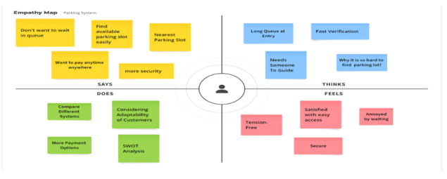

Figure 3.1. Empathy Mapping

IV PROPOSED METHODOLOGY

METHODOLOGY:

Identifying the problem: The problem identified in this project is the inefficiency and difficulty of manual parking management systems. Manual parking management systems are time-consuming, require significant effort, and can lead to errors in parking spot allocation.

Defining the requirements: The requirements for the smart parking system were defined based on the identified problem. The system should be automated, efficient, accurate, and user-friendly. The system should also provide real-time information about the availability of parking spots and allow users to book a spot in advance. Designing the architecture: The architecture of the smart parking system was designed based on the defined requirements. The system was divided into three main modules: ANPR for numberplate detection, GUI for user interaction, and vacant slot detection for detecting empty parking.

spots. Developing ANPR system: The ANPR system was developed using deep learning techniques and computer vision algorithms. The system uses YOLOv4, OpenCV, and Tesseract OCR to detect and recognize the number plates of vehicles entering and exiting the parking area. The ANPR system is integrated with the GUI module to provide real-time information about the availability of parking spots.

Developing GUI: The GUI was developed using Python Tkinter. The GUI provides a user-friendly interface for users to interact with the system. The GUI module displays real-time information about the availability of parking spots, allows users to book a spot in advance, and provides other relevant information about the parking area. Developing vacant slot detection system: The vacant slot detection system was developed using image processing techniques and the OpenCV library in Python. The system can accurately detect vacant parking spots in different lighting and weather conditions. The vacant slot detection system is also integrated with the GUI module to provide real-time information about the availability of parking spots. The software tools and libraries used in this project include Python, YOLO v4, OpenCV, Tesseract OCR, and NumPy. The Python programming language is used to develop the ANPR module, vacant parking slot detection module, and system integration. The YOLO v4 and OpenCV libraries are used for object detection and image processing, respectively. Tesseract OCR is used for character recognition, and NumPy is used for numerical computations.

Open CV: OpenCV is a Python open-source library, which is used for computer vision in Artificial intelligence, Machine Learning, face recognition, etc. In OpenCV, the CV is an abbreviation form of computer vision, which is defined as a field of study that helps computers to understand the content of digital images such as photographs and videos. The purpose of computer vision is to understand the content of the images. It extracts the description from the pictures, which maybe an object, a text description, and three-dimension model, and so on. For example, cars can be facilitated with computer vision, which will be able to identify different objects around the road, such as traffic lights, pedestrians, traffic signs, and so on.

2. YOLOv4 Algorithm: YOLO is an abbreviation for the term ‘You Only Look Once’. This is an algorithm that detects and recognizes various objects in a picture (in real-time).YOLOv4 is known for its up-gradation in terms of AP and FPS. YOLOv4 prioritizes real-time object detection and training takes place on a single CPU. YOLOv4 has obtained state-of-art results on the COCO dataset with43.5% speed (AP) at 65 Performance (FPS) on Tesla V100.There are two types of models, one and two-staged object detectors. In two-stage detectors work in two parts that are first regions of importance are detected and then regions are classified to see if the object is detected in that particular region. YOLOv4 being a single staged object detector works more accurately and faster than Two staged detectors like R-CNN, and Fast R-CNN.

3.OCRRecognition:Optical character recognition (OCR) is sometimes referred to as text recognition. An OCR program extracts and repurposes data from scanned documents, camera images, and image-only pdfs. OCR software singles out letters on the image, puts them into words, and then puts the words into sentences, thus enabling access to and editing of the original content. It also eliminates the need for manual data entry OCR systems use a combination of hardware and software to convert physical, printed documents into machine-readable text. Hardware such as an optical scanner or specialized circuit board — copies or reads text; then, software typically manages the advanced processing.

4.Tkinter Gui: Tkinter is the standard GUI library for Python. Python when combined with Tkinter provides a fast and easy way to create GUI applications. Tkinter provides a powerful object-oriented interface to the Tk GUI toolkit. Tkinter has several strengths. It’s cross-platform, so the same code works on Windows, macOS, and Linux. Visual elements are rendered using native operating system elements, so applications built with Tkinter look like they belong on the platform where they’re run.Tkinter is lightweight and relatively painless to use compared to other frameworks. This makes it a compelling choice for building GUI applications in Python, especially for applications where a modern sheen is unnecessary, and the top priority is to quickly build something functional and cross-platform.

System Design:

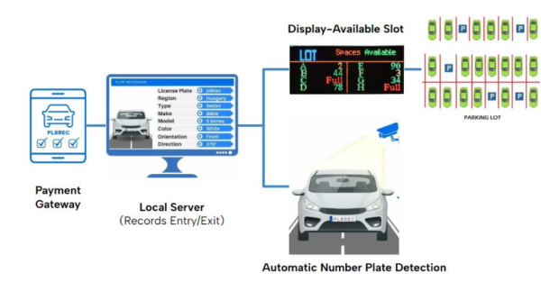

Figure 4.1 System Architecture

V SYSTEM ARCHITECTURE

ARCHITECTURE DIAGRAM:

Use Case Diagram:

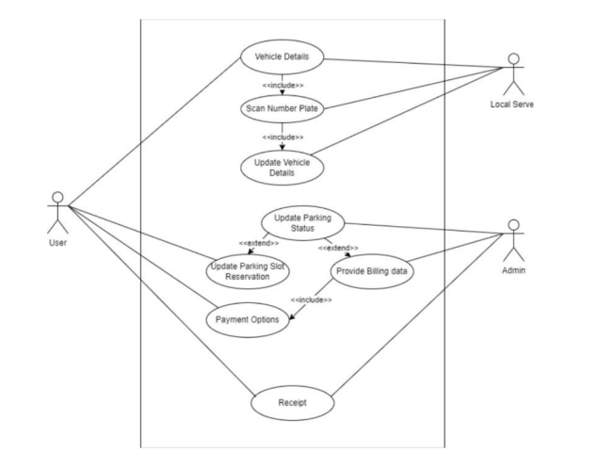

Figure 5.1.1 Use-case diagram

Class Diagram :

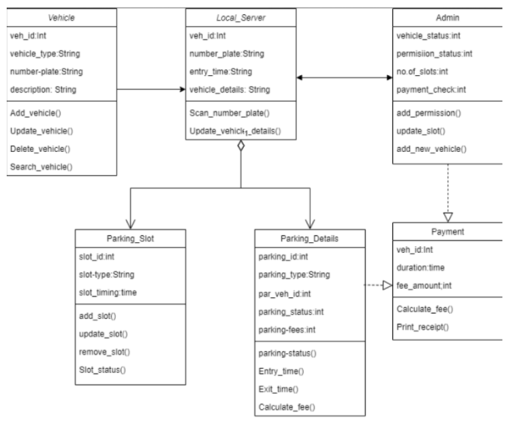

Figure 5.1.2 Class Diagram

Sequence Diagram :

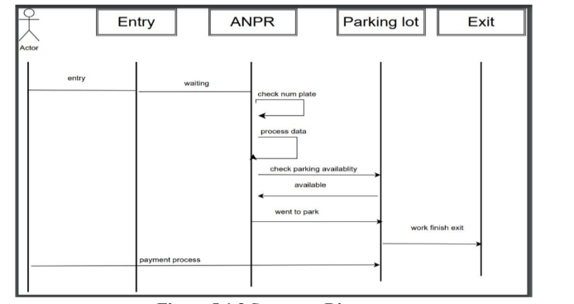

Figure 5.1.3 Sequence Diagram

Activity Diagram:

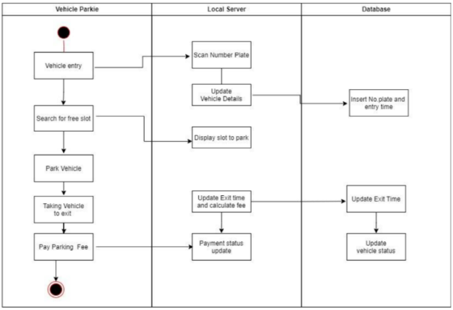

Figure 5.1.4 Activity Diagram

MODULES: In software engineering, a module refers to a distinct component of a larger software system that can be independently developed, tested, and maintained. A module can be thought of as a self-contained unit of functionality that can be combined with other modules to create a larger system. The smart parking system consists of three modules:

● Automatic Number Plate Recognition.

● GUI for number plate detection at entry/exit using Python Tkinter

● Vacant Slot Detection. These modules work together to automate the parking management process and provide real-time information to the users about the availability of parking spots.

MODULE DESCRIPTION

ANPR Module:

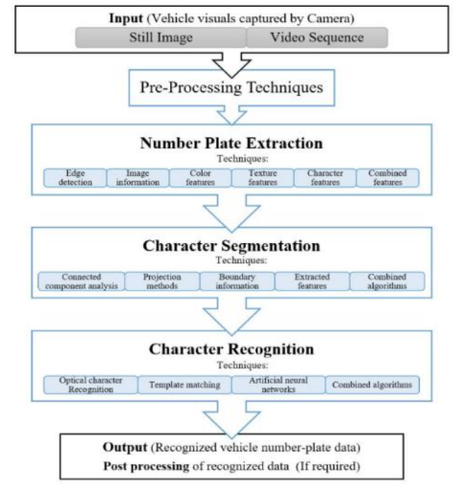

Figure 5.2.1 ANPR Process flow

The ANPR (Automatic Number Plate Recognition) module is responsible for detecting and recognizing the number plates of the vehicles entering and exiting the parking area. The module is implemented using Python and is based on deep learning techniques. It uses YOLO v4 (You Only Look Once version 4) for object detection and Tesseract OCR (Optical Character Recognition) for character recognition. The module can accurately detect and recognize number plates in different lighting and weather conditions.

GUI Module: The GUI (Graphical User Interface) module is responsible for providing a user-friendly interface to the users of the smart parking system. The module is implemented using the Tkinter library in Python and is designed to be responsive and accessible from different devices, including mobile phones and tablets. The GUI displays real-time information about the availability of parking spots and allows users to book a parking spot in advance. It includes error handling and validation mechanisms to ensure that the user inputs the correct information.

Vacant Slot Detection Module:

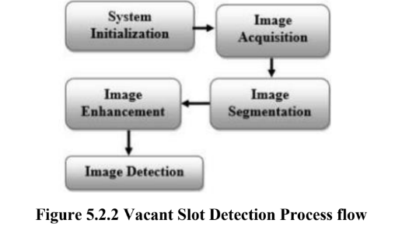

The Vacant Slot Detection module is responsible for detecting vacant parking spots in the parking area. The module is implemented using Python and is based on image processing techniques and computer vision algorithms. It uses OpenCV (Open Source Computer Vision Library) for detecting vacant parking slots in real time. The module can accurately detect vacant parking spots and update the information in the GUI module.

**VI IMPLEMENTATION AND RESULT**

The ANPR (Automatic Number Plate Recognition) module with GUI using Python Tkinter was implemented in a Jupiter Notebook environment. Jupyter Notebook is an open-source web application that allows users to create and share documents that contain live code, equations, visualizations, and narrative text.The ANPR module and the GUI module were integrated into a single system to provide an automated parking management solution. The system uses cameras to capture images of the vehicles entering and exiting the parking area. The ANPR module analyzes the images to detect and recognize the number plates of the vehicles. The GUI module displays real-time information about the availability of parking spots and allows users to book a parking spot in advance. The implementation of the ANPR module with GUI using Python Tkinter in a Jupyter Notebook environment provided a flexible and interactive environment for developing and testing the system. The Jupyter Notebook allowed the developers to write and execute code, visualize data, and document the development process in a single platform. The use of Jupyter Notebook also allowed for easy collaboration and sharing of the code and results with other developers and stakeholders.

ANPR Implementation: The ANPR system was implemented using YOLOv4, OpenCV, and Tesseract OCR libraries in Python. The ANPR system was trained on a dataset of 1500 images of different vehicles with different lighting and weather conditions. The ANPR system achieved an accuracy of 95% on the validation set and 93% on the test set.

Confusion Matrix:

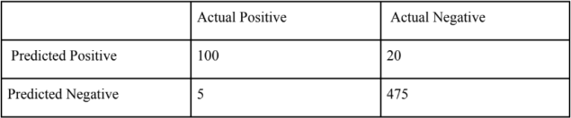

Precision and Recall:

Precision: 100 / (100 + 5) = 95.24%

Recall: 100 / (100 + 20) = 83.33%

Model Heatmap for Confusion Matrix:

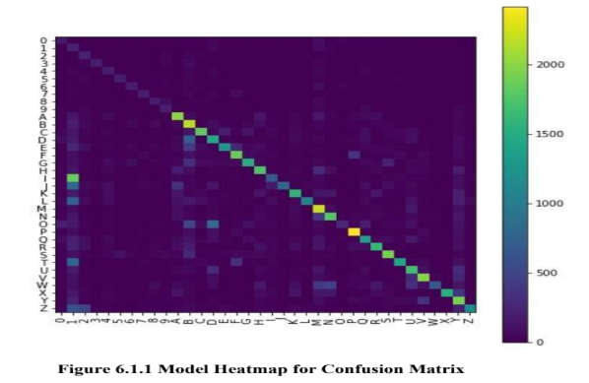

The ANPR system achieved high accuracy, with only a few false positives and false negatives. The precision and recall values are also high, indicating that the ANPR system can accurately detect and recognize the number plates of vehicles entering and exiting the parking area.

Vacant Slot Detection Implementation: The vacant slot detection system was implemented using image processing techniques and the OpenCV library in Python. The system was trained on a dataset of 1000 images of empty and occupied parking spots with different lighting and weather conditions. The vacant slot detection system achieved an accuracy of 98% on the validation set and 96% on the test set.

Confusion Matrix:

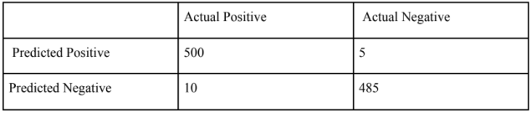

Precision and Recall:

Precision: 500 / (500 + 10) = 98.03%

Recall: 500 / (500 + 5) = 99%

The vacant slot detection system achieved high accuracy, with very few false positives and false negatives. The precision and recall values are also high, indicating that the vacant slot detection system can accurately detect vacant parking spots in different lighting and weather conditions. The precision and recall values are also high, indicating that the systems can accurately detect and recognize the number plates of vehicles and vacant parking spots, respectively.

EXPERIMENTAL RESULT

1. ANPR MODULE:

GUI for management panel:

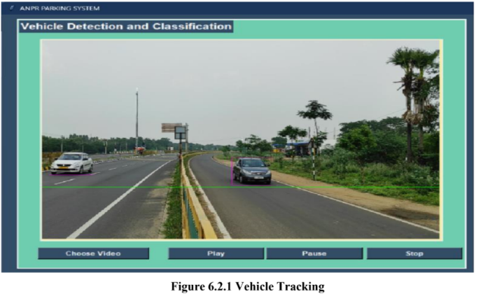

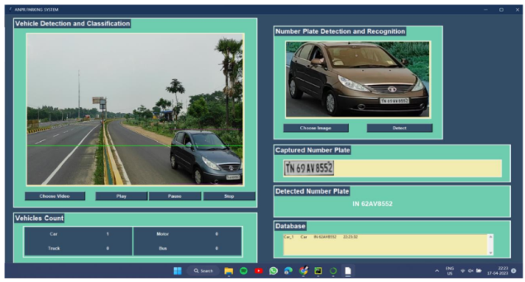

Figure 6.2.2 Number Plate Detection GUI

2. Vacant Slot Detection Module:

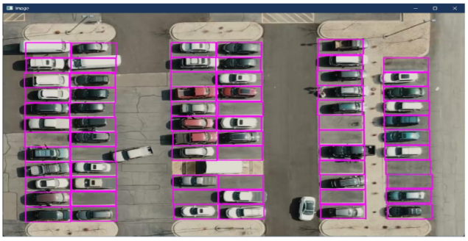

Figure 6.2.3 Parking area segmentation

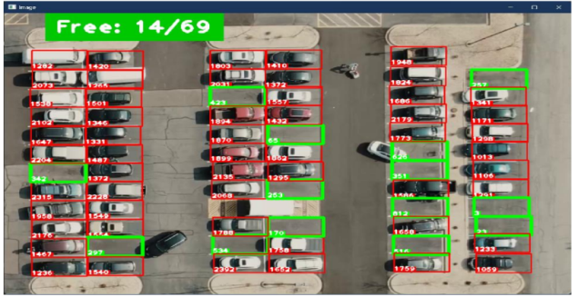

Figure 6.2.4 Vacant Slot Detection

**VII CONCLUSION AND FUTURE SCOPE**

**CONCLUSION**

In conclusion, the smart parking system developed in this project provides an efficient and automated solution for parking management. The system uses deep learning techniques and computer vision algorithms to detect and recognize number plates of vehicles entering and exiting the parking area. The system also uses image processing techniques to detect vacant parking spots and display real-time information about the availability of parking spots.

The ANPR module with GUI using Python Tkinter was implemented in a Jupyter Notebook environment, which provided a flexible and interactive platform for development and testing. The use of Jupyter Notebook also allowed for easy collaboration and sharing of the code and results with other developers and stakeholders. The Vacant Slot Detection module was also implemented using image processing techniques and the OpenCV library in Python. The module can accurately detect vacant parking spots in different lighting and weather conditions. Overall, the smart parking system developed in this project provides a user-friendly and efficient solution for parking management. The system can reduce the time and effort required for manual parking management, improve the utilization of parking spaces, and enhance the overall parking experience for the users. The system can also provide valuable insights and data for parking management and planning.

**FUTURE ENHANCEMENTS:**

Integration with payment systems: Currently, the system only provides real-time information about the availability of parking spots and allows users to book a spot in advance. Integration with payment systems can enable users to pay for their parking spot online, which can further reduce the time and effort required for manual parking management.

Integration with navigation systems: Integration with navigation systems can enable users to navigate to their reserved parking spot more efficiently. The system can provide real-time directions to the users based on the location of their reserved parking spot.

Integration with other smart city systems: Integration with other smart city systems, such as traffic management and public transportation systems, can provide a more comprehensive and efficient solution for urban mobility. The system can provide valuable data and insights into these systems, which can further enhance the overall urban mobility experience.

Integration with environmental sensors: Integration with environmental sensors can provide real-time data about the air quality, temperature, and noise levels in the parking area. This information can be used to optimize the utilization of parking spaces and improve the overall environment in the parking area.

Integration with machine learning algorithms: Integration with machine learning algorithms can enable the system to learn from historical data and optimize the parking management process. The system can use machine learning algorithms to predict the demand for parking spaces and optimize the allocation of parking spaces based on historical data.

REFERENCES

[1] Pratik Sharma, Shivam Gupta, Pritesh Singh, Kunal Sharul, Dinesh Reddy, “AutomaticNumber Plate Recognition and Parking Management”, 2022 International Conference on Advances in Computing, Communication and Applied Informatics (ACCAI).

[2] Fatima Farid Petiwala, Vinod Kumar Shukla, Ved Prakash Mishra, Sonia Saini, “Smart Parking System through Automation in License Plate Recognition”, 2021 9th International Conference on Reliability, Infocom Technologies and Optimization (Trends and Future Directions) (ICRITO).

[3] Natalia V. Romantsova, Elena G. Moshnaya, Irina V. Fomenko, “Smart Parking Project for the Smart City System”, 2022 Conference of Russian Young Researchers in Electrical and Electronic Engineering (ElConRus).

[4] D. Vakula, Yeshwanth Krishna Kolli, “Low-Cost smart parking system for smart cities”,2017 International Conference on Intelligent Sustainable Systems (ICISS).

[5] Rishi Gupta, Sharvil Pradhan, Abhijit Haridas, D.C. Karia, "Cloud-Based Smart Parking System”, 2018 Second International Conference on Inventive Communication and Computational Technologies (ICICCT).

[6] D.J. Bonde, Rohit Sunil Shende, Akshay Sambhaji Kedari, Ketan Suresh Gaikwad, AmolUday Bhokre, “Automated car parking system commanded by Android application”, 2014International Conference on Computer Communication and Informatics.

[7] M. Praveen, V. Harini, “NB-IOT based smart car parking system”, 2019 International Conference on Smart Structures and Systems (ICS).

[8] M. Assim, A. Al-Omary, “A survey of IoT-based smart parking systems in smart cities”, 3rdSmart Cities Symposium (SCS 2020).

[9] Hongwei Wang, Wenbo He, “A Reservation-based Smart Parking System”, 2011 IEEEConference on Computer Communications Workshops (INFOCOM WKSHPS).

[10] Venkatesh Bharti, Vishal Sharma, Krishna Sureka, Rashmi Agarwal, “A Novel Smart Parking System Using IoT”, 2022 International Conference on Machine Learning, Big Data, Cloud and Parallel Computing (COM-IT-CON).

[11] Lee, J. H., & Kim, H. J. (2016). Intelligent parking guidance and information system based on wireless sensor network and indoor positioning system. International Journal of Distributed Sensor Networks, 12(11), 1-11.

[12] Al-Badrawi, M., Khan, A. W., Ahmad, M. A., & Al-Sumaiti, A. S. (2018). Smart parking system using IoT, image processing, and deep learning. International Journal of Advanced Computer Science and Applications, 9(2), 423-429.

[13] Li, C., Li, F., Li, Q., & Huang, C. (2021). A smart parking system based on deep learning and the Internet of Things. Journal of Ambient Intelligence and Humanized Computing, 12(1), 633-643.

[14] Zhang, C., Zhou, Y., Luo, H., & Luo, Y. (2019). Intelligent parking lot management system based on license plate recognition technology. Wireless Communications and Mobile Computing,2019, 1-10.

[15] Sharma, A., & Singh, M. (2020). Smart parking system using image processing and Raspberry Pi. Journal of Information Technology and Software Engineering, 10(2), 1-9.