Chatbot To Determine Individual’s Prakriti

1. Mrs. Nethra H L,[2]Shivani Achanta[3]Shivaprasad Shetty,[4]Shreyas A, [5]Sinchana M 2,3,4,5 UG Students, Department of Computer Science and Engineering 1Assistant. Professor, Department of Computer Science and Engineering

1,2,3,4Dayananda Sagar Academy of Technology and Management, Bangalore, Karnataka India

***Abstract****-* AyurBot is a web-based platform developed on the MERN stack, offering personalized Prakriti assessment and Ayurvedic healthcare information. It addresses the limitations of traditional Prakriti assessment methods by providing a standardized and efficient approach. Through a user-friendly interface, individuals can independently assess their Prakriti, access educational resources, and schedule consultations with Ayurvedic practitioners. The integration of Botpress for chatbot functionality and Python- based Prakriti prediction algorithms enhances automation and accuracy. AyurBot aims to enhance accessibility to Ayurvedic healthcare, empower individuals in their wellness journey, and streamline the Prakriti assessment process for improved efficiency and patient outcomes.

***Index Terms****—*AyurBot, Prakriti assessment, Chatbot, Consultations, Educational resources, MERN stack, Machine Learning .

* 1. INTRODUCTION

Ayurveda, an ancient holistic healing system originating in India, is founded on the belief that health is a balance between mind, body, and spirit. Central to Ayurvedic philosophy is the concept of Tridosha, which identifies three fundamental energies or humors: Vata, Pitta, and Kapha. These energies govern various physiological and psychological functions within the body and are influenced by factors such as diet, lifestyle, environment, and genetics. Each individual possesses a unique combination of these doshas, known as their Prakriti, which determines their inherent constitution and predisposition to certain health conditions.

AyurBot represents a groundbreaking fusion of traditional Ayurvedic wisdom and modern technological innovation. By harnessing the power of the MERN stack, AyurBot provides a seamless and user-friendly platform for individuals to explore their Prakriti, connect with Ayurvedic practitioners and provides access to educational resources with respect to Prakriti. At the core of AyurBot's functionality lies its advanced predictive modeling capabilities, prominently facilitated by Support Vector Machines (SVM). SVM is a robust machine learning algorithm renowned for its effectiveness in classification tasks, making it particularly well-suited for Prakriti prediction. Through meticulous analysis of patterns and relationships in user data, SVM accurately classifies individuals into specific Prakriti types in alignment with Ayurvedic principles. With AyurBot, users gain invaluable insights into their unique constitution, enabling them to make informed lifestyle choices tailored to their individual needs, ultimately guiding them towards optimal health and well-being. AyurBot thus stands as a pioneering solution, bridging the gap between ancient wisdom and modern technology to empower individuals on their journey to holistic wellness.

# METHOD

In this section, we delve into the practical aspects of translating conceptual ideas into tangible solutions. By elucidating our methodology, we aim to provide transparency and clarity regarding the steps taken to develop, refine, and deploy our system.

## Prakriti prediction:

Within Ayurbot, the Prakriti prediction module plays a pivotal role in providing users with their Prakriti based on their unique constitution. This section outlines the methodology employed by Ayurbot to accurately predict an individual's Prakriti type.

1. *User Interaction with Chatbot Interface*: The process begins when a user interacts with the chatbot interface within Ayurbot. This interface, powered by Botpress, presents conversational prompts to the user, facilitating the collection of relevant data for Prakriti assessment.
2. *Data Collection and Storage*: As the user responds to the chatbot prompts, the collected data is sent via a webhook to MongoDB, a NoSQL database. MongoDB efficiently stores the user's responses, ensuring seamless data management and retrieval.
3. *Prakriti Prediction Algorithm*: A Python script file, integrated into Ayurbot's backend system, retrieves the user data stored in MongoDB. This script file is equipped with algorithms designed to predict the user's Prakriti based on established Ayurvedic principles and guidelines.
4. *Execution of Prediction Algorithms*: Upon retrieving the user data, the Python script executes the prediction algorithms, which analyze the collected information to determine the user's Prakriti type. These algorithms consider various factors such as physical attributes, behavioral tendencies, and lifestyle preferences associated with each Prakriti.
5. *Writing Predicted Prakriti to MongoDB*: Once the prediction process is complete, the Python script writes the predicted Prakriti type back to MongoDB. This ensures that the user's Prakriti assessment is seamlessly integrated

into *Ayurbot's* database, allowing for easy access and retrieval of the predicted Prakriti for future reference.

## Telemedicine Consultation Integration:

Ayurbot revolutionizes healthcare accessibility through its innovative telemedicine services, offering users convenient access to Ayurvedic doctors. The features that are provided are:

* 1. *Appointment Booking*:
     + Users can easily schedule telemedicine appointments with Ayurvedic practitioners, streamlining the booking process for enhanced convenience.
  2. *Doctor Selection:*
     + Ayurbot empowers users to select doctors based on their qualifications or specialties, ensuring personalized healthcare experiences tailored to individual needs.
  3. *Doctor Dashboard:*
     + Practitioners benefit from a dedicated dashboard within Ayurbot, providing comprehensive appointment lists and patient details for efficient management of telemedicine consultations.

## Website development with MERN Stack:

The website development with MERN Stack integrates a comprehensive educational resource section aimed at providing users with extensive information on Prakriti and strategies for achieving a balanced lifestyle. MongoDB serves as the backbone, storing educational content, user profiles, and other website data in a flexible and scalable NoSQL database. Express.js plays a pivotal role in building robust and efficient backend APIs, handling requests related to educational resource retrieval, user authentication, and content management. On the frontend, React.js empowers dynamic and interactive user interfaces within the educational resource section,

facilitating seamless browsing and access to information on Prakriti and balanced lifestyles. *Node.js* drives the server-side logic, ensuring smooth communication between the frontend and backend components of the website. Through its Educational Resource Section, the website offers a comprehensive collection of guides curated to educate users on Ayurvedic principles and methods for maintaining a balanced lifestyle.

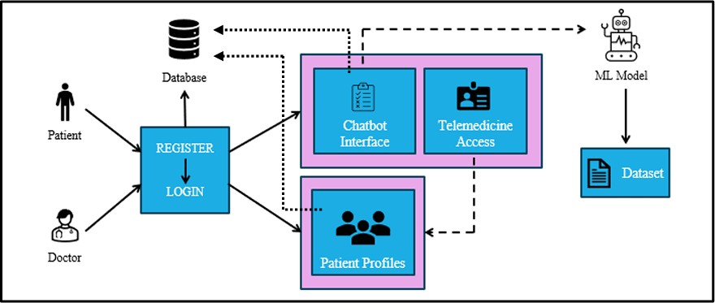

Fig. 1: System Architecture.

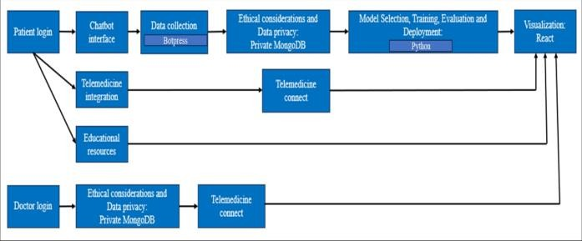

Fig. 2: Dataflow Diagram

# EXPERIMENTS AND RESULTS

1. *Data Collection*: Data collection for Prakriti prediction involved gathering patient data from Sri Sri Ayurvedic College. This dataset contained information on various aspects of individuals' constitutions, including physiological attributes, lifestyle habits, and dosha imbalances. The data collection process ensured that a diverse range of individuals' characteristics were captured, providing a comprehensive dataset for analysis.
2. *Preprocessing*: After data collection, the dataset underwent preprocessing to ensure its quality and suitability for analysis. This involved transforming categorical variables into a numerical format using techniques like OneHotEncoding. Data preprocessing aimed to prepare the dataset for feature extraction and model training, ensuring that the analysis produced accurate and reliable results.
3. *Feature Extraction*: In the context of Prakriti prediction, feature extraction involved identifying and selecting relevant attributes from the dataset that could serve as predictors for determining individuals' Prakriti classifications. The selected features formed the basis for training the machine learning model to accurately classify individuals into different Prakriti types.
4. *Analysis Procedure*: The analysis procedure comprised several steps, including data splitting, model training, and evaluation. The dataset was divided into training and testing sets to facilitate model training and validation. A machine learning algorithm, such as a Support Vector Machine (SVM), was trained on the training data using the selected features to learn patterns and relationships within the dataset. The trained model was then evaluated using the testing data to assess its performance and determine its predictive accuracy.
5. *Result Display*: Once the machine learning model made predictions on the testing data, the results were displayed to the users on the AyurBot platform. Users received insights into their Prakriti classifications.
6. *Model Analysis*: Model analysis involved evaluating the performance of the trained machine learning model and comparing it with alternative models. The results of the model analysis informed the selection of the most suitable machine learning algorithm for Prakriti

prediction, ensuring accurate and reliable results for users of the AyurBot platform.

|  |  |
| --- | --- |
| *Classifier* | *Accuracy%* |
| *Decision Tree* | *40.6* |
| *K-Nearest Neighbour (k=9)* | *62.5* |
| *SVM* | *70.4* |
| *Naïve Bayes* | *56.3* |

Table. 1 Accuracy Comparison of Various Prediction Algorithms

# WEBSITE OVERVIEW

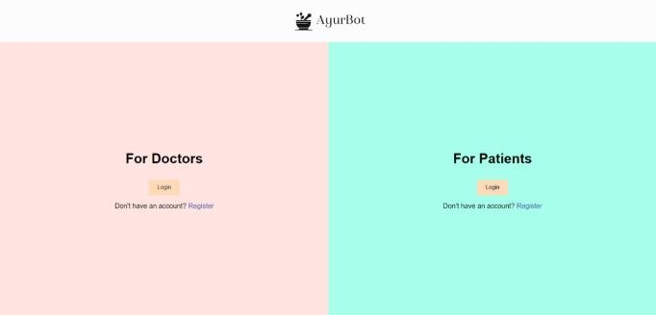

Fig. 3: Main login page

## B. User Dashboard:

The user dashboard provides easy access to AyurBot's features. Users can navigate to the chatbot for prakriti assessment, schedule telemedicine consultations with Ayurvedic practitioners, and explore educational resources on Ayurveda.

This section provides a visual introduction to the AyurBot website. Through screenshots and brief descriptions, readers will gain insight into the platform's user interface and functionalities. These visuals complement the preceding discussions, offering a practical demonstration of AyurBot's integration of Ayurvedic principles with modern technology.

## C. Chatbot:

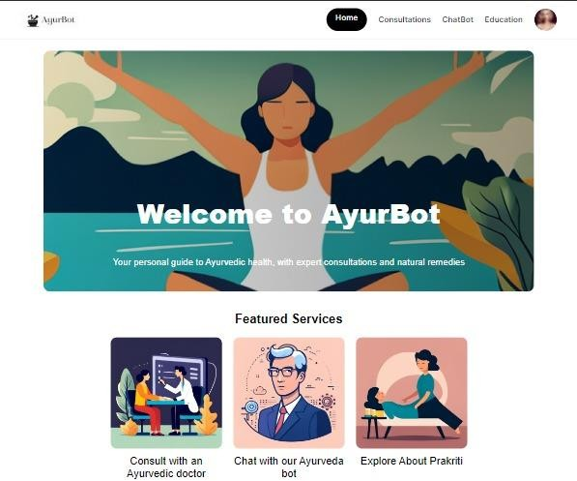Fig. 4: User dashboard

## A. Login page:

For the doctor and patient login, credentials typically include a Registered email address along with a secure password.

The chatbot will prompt users to answer a series of questions related to their physical and mental characteristics, lifestyle, and dietary preferences. Based on their responses, the chatbot will determine their Prakriti (constitution type) according to Ayurvedic principles.

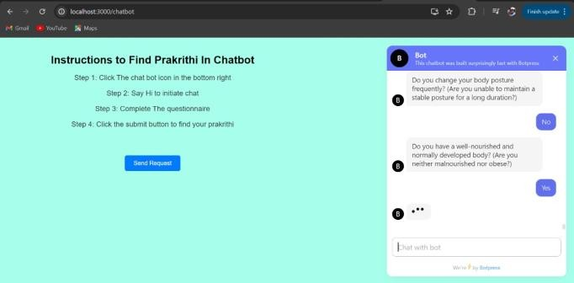

Fig. 5: Chatbot

## Educational Resources:

These resources aim to provide comprehensive knowledge and guidance for individuals seeking to incorporate Ayurvedic principles into their daily lives for improved well- being.

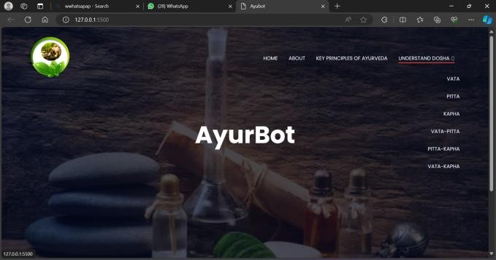

Fig. 6: Educational Resources

## Consultation :

The consultation form enables patients to schedule appointments by selecting preferred date and time slots, along with the option to choose their desired healthcare provider, streamlining the booking process for efficient and tailored medical care.

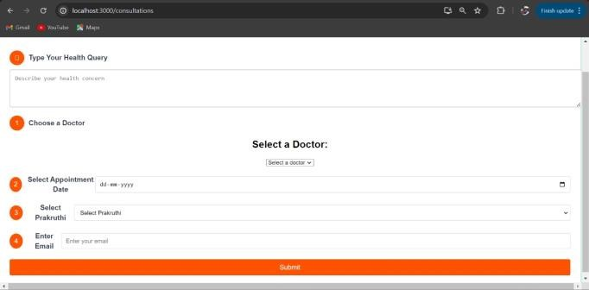

Fig. 7: Consultation

## User Profile:

The patient profile includes essential information such as the individual's name, email address, and Prakriti (constitution type).

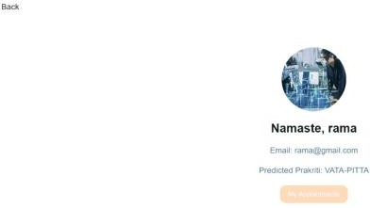

Fig. 8: User Profile

## Appointment List:

The appointment list provides a comprehensive overview of scheduled appointments to the doctor, including date, time, patient name, and patient Prakriti , facilitating efficient patient management and coordination of healthcare services.

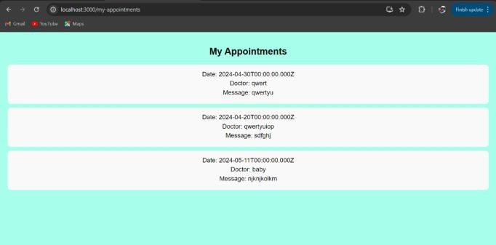

Fig. 9: Appointment List

# CONCLUSION AND CHALLENGES

In conclusion, AyurBot represents a significant advancement in the field of Ayurvedic healthcare, offering users a convenient and accessible platform for Prakriti assessment. By leveraging modern technologies such as machine learning and web development frameworks, AyurBot bridges the gap between ancient Ayurvedic wisdom and contemporary healthcare practices. The integration of telemedicine services, educational resources, and predictive modeling capabilities enhances user experience

and empowers individuals to take proactive steps towards improving their health and well-being.

Despite the project's success in predicting the prakriti, several challenges were encountered along the way. These challenges include:

* + 1. *Reliance on User-Provided Data:*

AyurBot's effectiveness for Prakriti prediction depends on the completeness and accuracy of the user-provided data, which may introduce biases or inaccuracies.

* + 1. *Variability in Machine Learning Model Performance:* The accuracy of machine learning models, such as Support Vector Machines (SVM), used for Prakriti prediction may vary depending on the diversity and representativeness of the dataset used for training.
    2. *Adoption and Acceptance Hurdles:*

The adoption and acceptance of AyurBot within the healthcare community may be influenced by cultural beliefs, regulatory constraints, and technological literacy, posing challenges to its widespread implementation and utilization.

* + 1. *Technological and Infrastructure Limitations:* AyurBot's functionality and accessibility may be limited by technological infrastructure constraints, particularly in regions with limited internet connectivity or digital literacy.

# REFERENCES

1. R. H. Raval et al., "Determinants of Prakriti, the human constitution types of Indian traditional medicine and its correlation with contemporary science," J Ayurveda Integr Med., vol. 5, no. 3, pp. 167-175, Jul. 2014.
2. Q. N. Nguyen, A. Sidorova, R. Torres, "User interactions with chatbot interfaces vs. Menu based interfaces: An empirical study," Computers in Human Behavior, vol. 128, pp. 107093, 2022.
3. H. Mondal, C. Baidya, S. Mondal, S. Mondal, "Validity and reliability of adapted Bengali

version of the self-assessment questionnaire to assess Prakriti." Int. J. Ayurvedic Med., vol. 13, no. 4, pp. 1017-1022, 2022.

1. M. T. Edwards and D. L. Streiner, "Development of a reliable Dosha self-assessment questionnaire," in EXPLORE, vol. 18, no. 5, pp. 573-578, 2022, doi: 10.1016/j.explore.2021.09.003.
2. S. Majumder et al., "On Intelligent Prakriti Assessment in Ayurveda: a Comparative Study," pp. 9827–9844, Jan. 2023. [6] S. Rastogi, "Development and validation of a Prototype Prakriti Analysis Tool (PPAT): Inferences from a pilot study," Ayu, vol. 33, no. 2, pp. 209-218, Apr. 2012. doi: 10.4103/0974 8520.105240. PMID: 23559792; PMCID: PMC3611641.