**Assessment of Structural Response and Energy Distribution in Steel and Concrete Pipes Buried in Different Ground Media Exposed to Surface Blast**

Akinola Johnson OLAREWAJU and Joseph Oladapo OLAOYE

Civil Engineering Department, Federal Polytechnic Ilaro,Ogun State.

Contact Email: akinolajolarewaju@gmail.com

**Abstract**

*This research employs the finite element method to model surface blast loads and predict the response of empty underground pipes. The study examines various responses, including external work, energy, and viscous dissipation within subterranean pipelines. Blast loads of different magnitudes, ranging from 10 kg TNT to 250 kg TNT, are investigated. The Unified Facilities Criteria (2008) guidelines for surface blasts with commonly used explosives are utilized, considering different stand-off distances. The study assumes soil and pipe materials to be elastic, homogeneous, and isotropic, drawing on geotechnical and material properties from existing research and pipe manufacturers. Underground pipe responses to surface blasts are analyzed using the time integration technique in ABAQUS/Explicit, a finite element numerical code. The study observes the external work, energies, and viscous dissipation in underground steel and concrete pipes buried at various embedment ratios in loose sand, dense sand, and undrained clay. The findings suggest that employing loose backfill material around underground pipes may reduce the impact of blast loads on them.*

**Key Words:** *Blast, Pipes, Concrete, Steel, Soil, Explicit, Numerical, Analysis*

**Introduction / Background Study**

The destructive potential of blast events is well-documented, with tremors capable of causing extensive damage to substructures across wide areas (Talmadge and Yuasa, 2011). According to Marusek (2008), the severity of destruction caused by explosions varies significantly. Blast waves with an overpressure of 21 kPa have been reported to be lethal to individuals caught in the open, while typical residential structures may collapse under an excess pressure of 35 kPa. Moreover, blast waves exceeding 83kilopascals can reduce large office buildings to rubble, and at 138 kPa, reinforced concrete structures can be completely leveled (Marusek, 2008). An example illustrating the devastating impact of such events is the Ibadan explosion of January 16, 2024, as reported by Punch on February 7, 2024. Given the profound consequences of blast-induced earth tremors, blast events can be likened to artificial earthquakes. This study focuses on evaluating the responses of simulated underground empty pipes to surface blast loads using the finite element numerical code, ABAQUS. The material properties considered, including those of the ground medium, intervening medium, and pipes, are constrained to linear, elastic, homogeneous, and isotropic materials.

The blast effects resulting from an explosion manifest as shock waves comprised of high-intensity pressure waves that emanate outward from the explosive's surface into the surrounding atmosphere. As these waves propagate, they undergo a process of decay in strength, elongation in duration, and reduction in velocity. This evolution occurs due to both spherical divergence and the completion of the chemical reaction, with some residual afterburning attributed to the mixing of hot explosion products with the surrounding air. As the shock wave expands through the air, it encounters structures in its path, subjecting them to the impinging shock pressures. The magnitude and distribution of blast loads exerted on structures by these pressures are contingent upon various factors, including the properties of the explosive (such as type, energy output, and weight), the detonation's proximity to the structure, and the reinforcement of pressure through its interaction with the ground, barriers, or the structure itself (Taylor, 1950; Longinow and Remennikov, 2003; 2009; Unified Facilities Criteria, 2008). The Unified Facilities Criteria (2008) classifies blast loads on structures into two main categories: unconfined explosions, including air and Free air burst, and surface explosions, and confined explosions, which encompass partially and completely Vented, Wilkinson and Anderson (2003), numerous warheads and munitions employ a mix of blast and fragmentation to target damage. These weapons' casings may naturally fragment or lack pre-formed fragments. During fragmentation, a significant portion of the explosive energy is absorbed, reducing the energy available for blast generation. Consequently, a cased weapon typically generates a weaker blast compared to an uncased one with an equivalent mass of high explosive (Unified Facilities Criteria, 2008). Among the six blast loading categories outlined, air burst explosions are infrequent, with free air bursts being the least common. Although these blast loading categories can be individually classified, there are no clear-cut boundaries between them. Most explosive facilities experience overlapping blast environments, requiring judgment in applying recommendations to determine blast parameters consistent with various blast-loading categories (Unified Facilities Criteria, 2008).

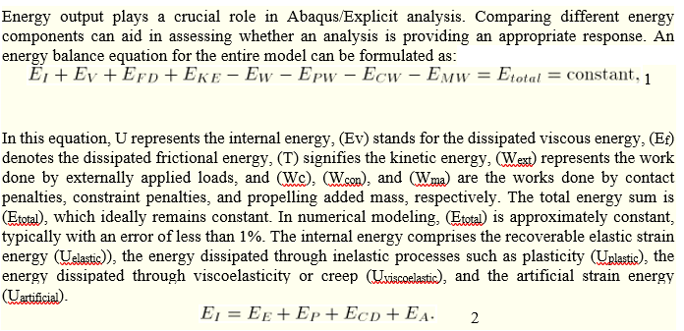

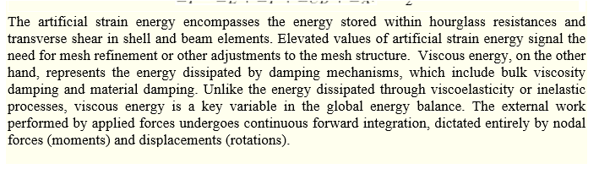

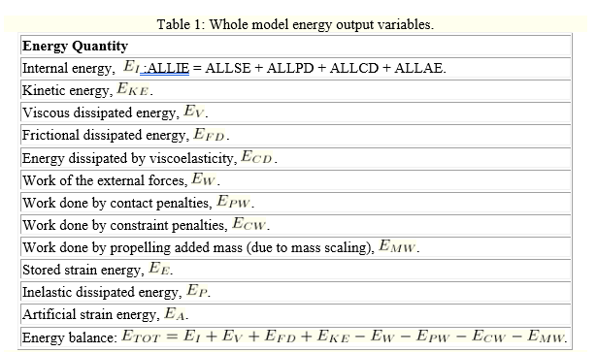

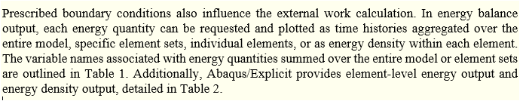

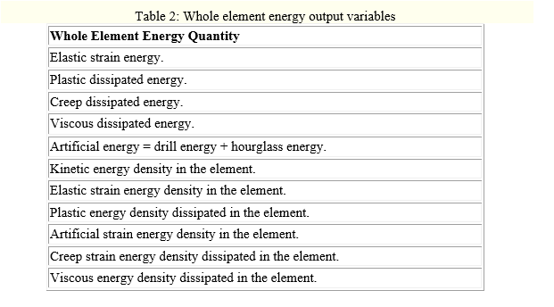

**Methodology**

For this study, an infinite soil medium consisting of loose sand, dense sand, and undrained clay, each measuring 100 meters in length, 100 meters in width, and 100 meters in depth, was modeled. Additionally, underground steel and concrete pipes, also measuring 100 meters in length, with thicknesses of 10 mm and 20 mm respectively, and having an external diameter of 1 meter, were simulated. These pipes were surrounded by an intervening medium with an internal diameter of 1 meter and a thickness of 0.15 meters. The diagram depicting the underground pipe's response to surface blast is presented in Figure 1. A comprehensive analysis was conducted using ABAQUS/Explicit. The soil and pipe properties utilized are detailed in Table 3, drawing from various sources (Craig, 1994; Coduto, 2001; Das, 1994; FLAC, 2000; Kameswara, 1998; Gravessmith, 1985; Shacklock, 1974).

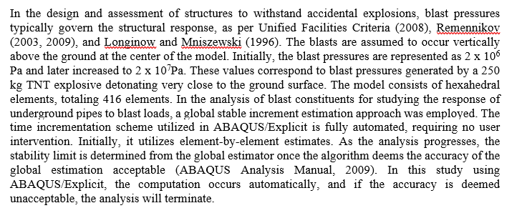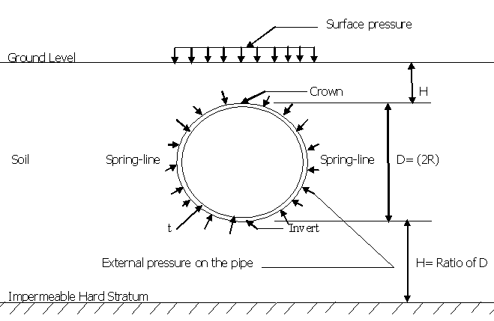

**Figure 1: Cross-section of underground pipe under surface blast**

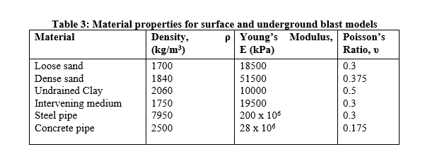

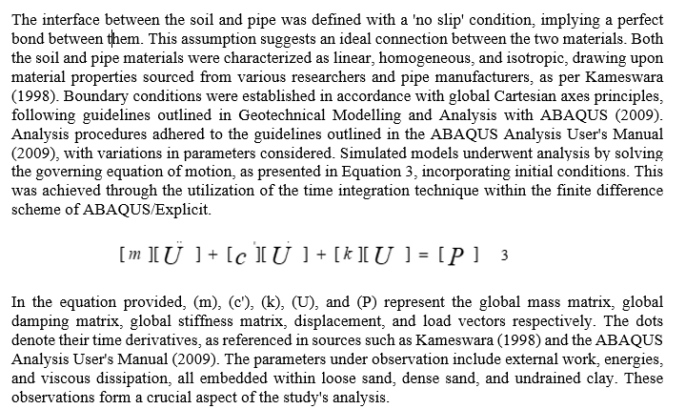

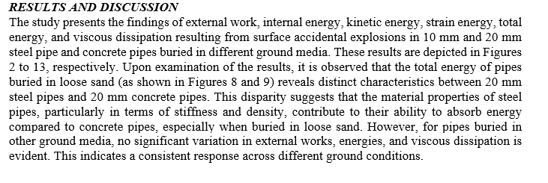

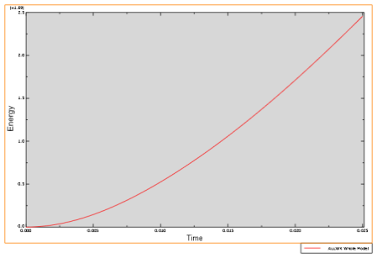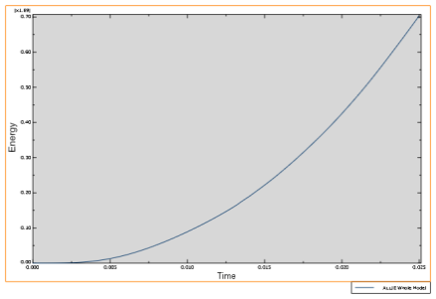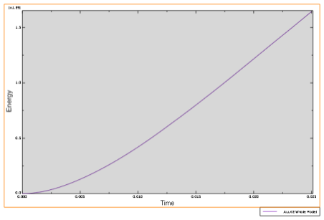

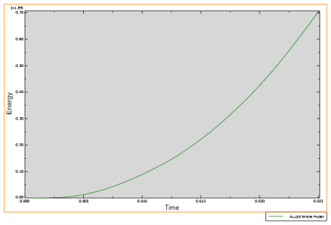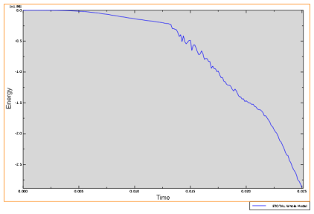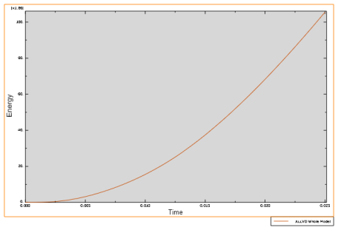

Figure 2 illustrates the various energy components generated in a 10 mm steel pipe buried in loose sand as a result of a surface accidental explosion. These components include external work, internal energy, kinetic energy, strain energy, total energy, and viscous dissipation. This visualization provides insights into how different types of energy are distributed and interact within the pipe structure under these specific conditions.

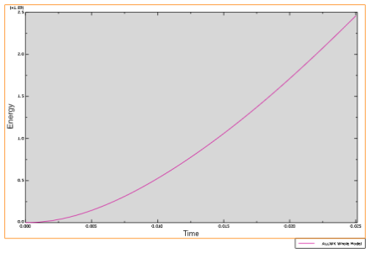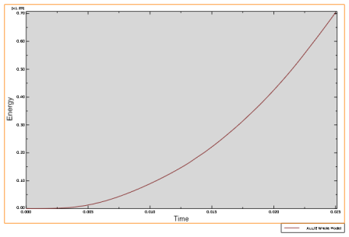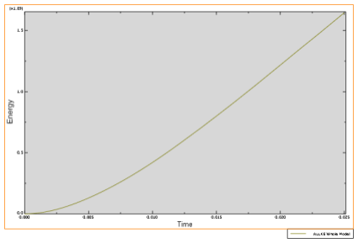

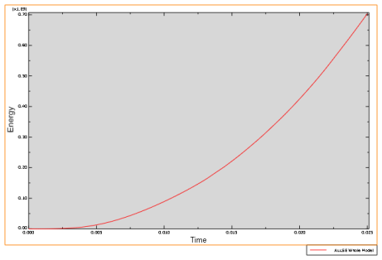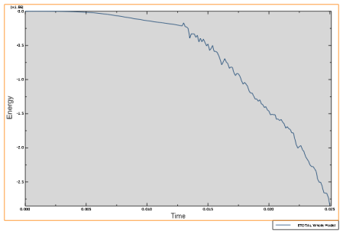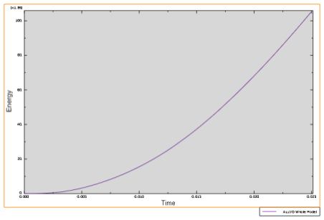

Figure 3 depicts the distribution of external work, internal energy, kinetic energy, strain energy, total energy, and viscous dissipation resulting from a surface accidental explosion in a 10 mm concrete pipe buried in loose sand. This visualization offers insights into the energy dynamics within the concrete pipe under these specific conditions, facilitating a comprehensive understanding of its response to the explosion.

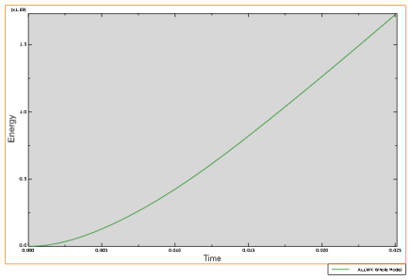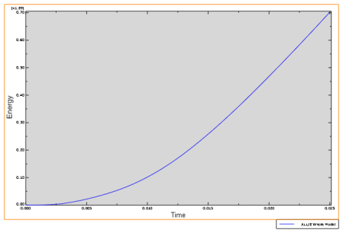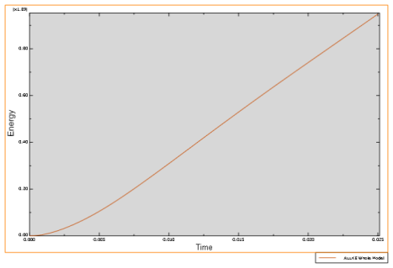

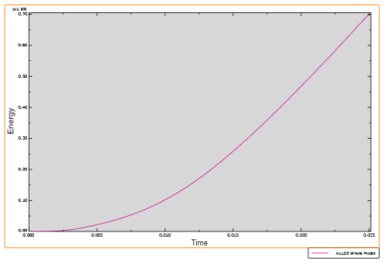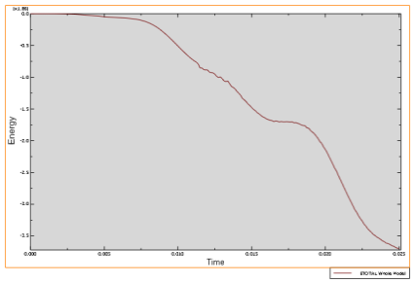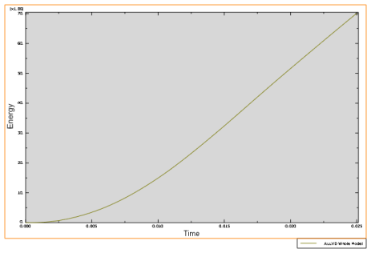

In Figure 4, it was observed that the distribution of external work, internal energy, kinetic energy, strain energy, total energy, and viscous dissipation resulting from a surface accidental explosion in a 10 mm steel pipe buried in dense sand. This visualization provides a detailed overview of how these energy components interact within the steel pipe under the specific conditions of dense sand burial, offering valuable insights for analysis and interpretation.

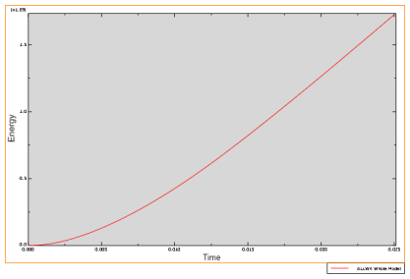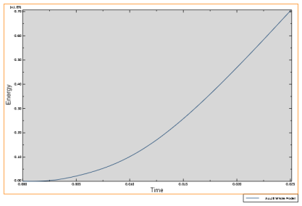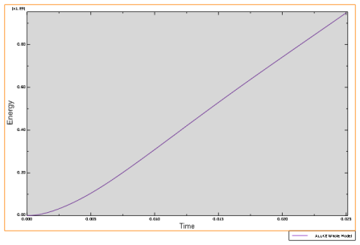

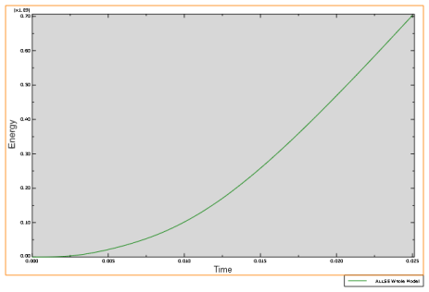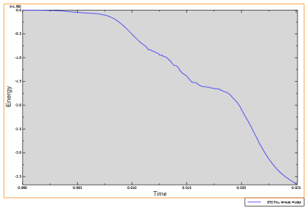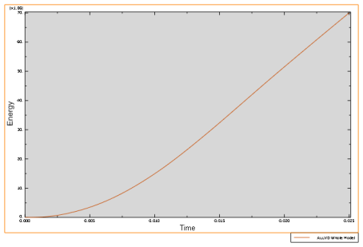

In Figure 5, the distribution of external work, internal energy, kinetic energy, strain energy, total energy, and viscous dissipation is presented for a 10 mm concrete pipe buried in dense sand following a surface accidental explosion. This visualization offers a comprehensive depiction of how these energy components are distributed within the concrete pipe under the specific conditions of dense sand burial, providing valuable insights for understanding its response to the explosion.

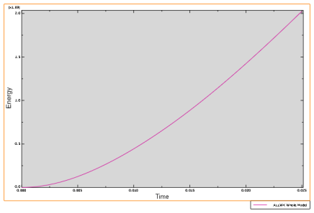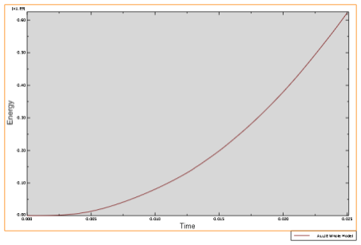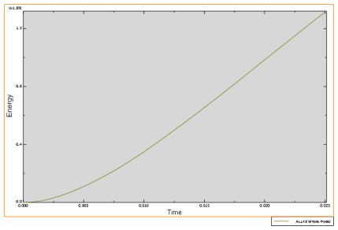

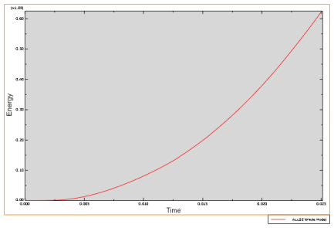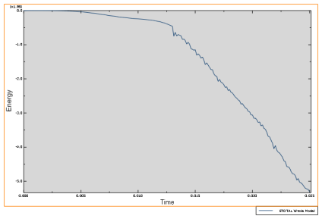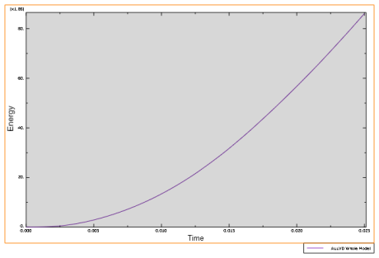

Figure 6 illustrates the distribution of external work, internal energy, kinetic energy, strain energy, total energy, and viscous dissipation resulting from a surface accidental explosion in a 10 mm steel pipe buried in undrained clay. This visualization provides a comprehensive understanding of how these energy components interact within the steel pipe under the specific conditions of undrained clay burial, offering valuable insights for analysis and interpretation.

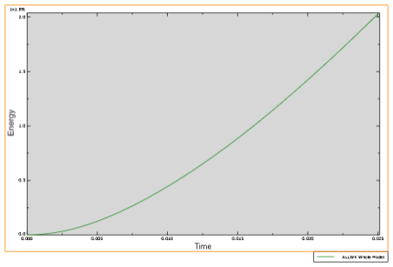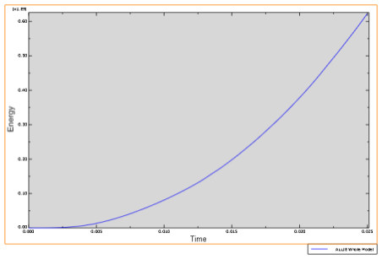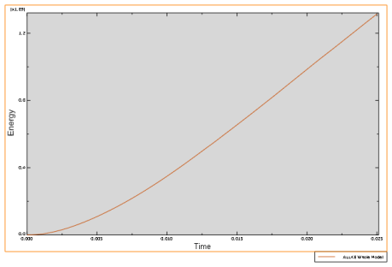

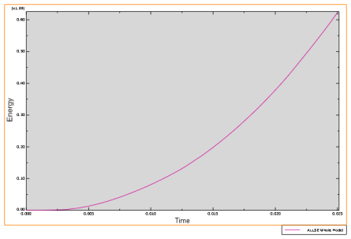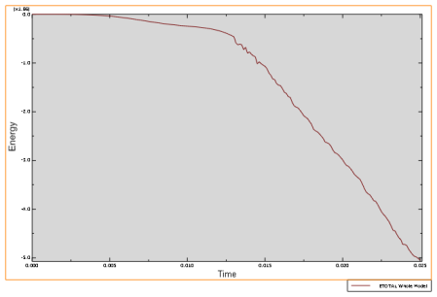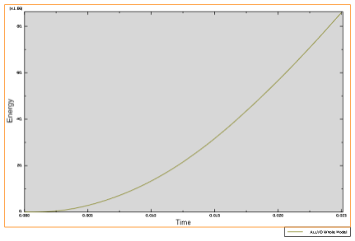

In Figure 7, the distribution of external work, internal energy, kinetic energy, strain energy, total energy, and viscous dissipation is presented for a 10 mm concrete pipe buried in undrained clay following a surface accidental explosion. This visualization provides a comprehensive depiction of how these energy components are distributed within the concrete pipe under the specific conditions of undrained clay burial, offering valuable insights for understanding its response to the explosion.

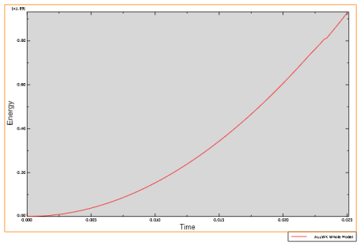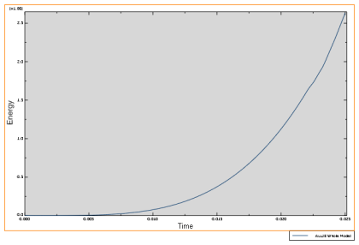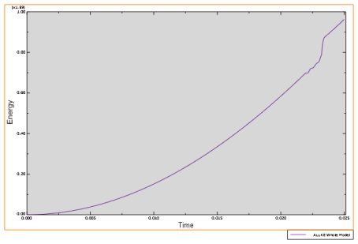

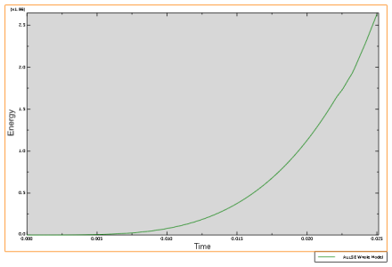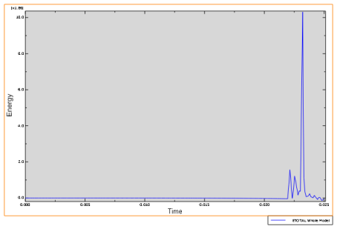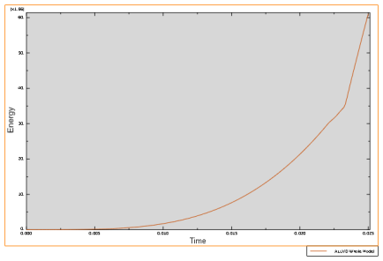

Figure 8 displays the distribution of external work, internal energy, kinetic energy, strain energy, total energy, and viscous dissipation resulting from a surface accidental explosion in a 20 mm steel pipe buried in loose sand. This visualization provides a detailed overview of how these energy components interact within the steel pipe under the specific conditions of loose sand burial, offering valuable insights for analysis and interpretation.

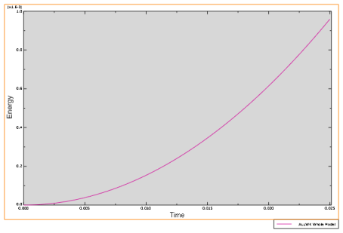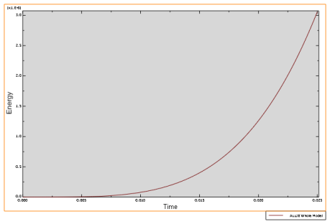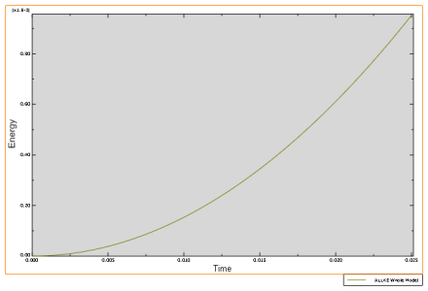

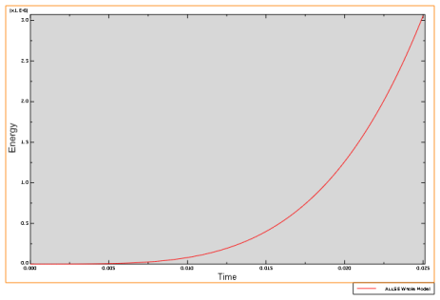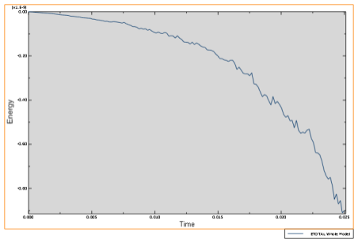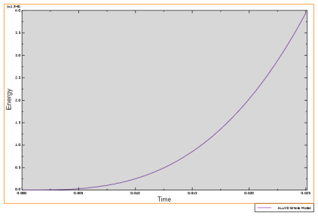

Figure 9 showcases the distribution of external work, internal energy, kinetic energy, strain energy, total energy, and viscous dissipation resulting from a surface accidental explosion in a 20 mm concrete pipe buried in loose sand. This visualization provides a comprehensive depiction of how these energy components are distributed within the concrete pipe under the specific conditions of loose sand burial, offering valuable insights for understanding its response to the explosion.

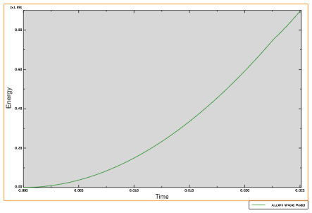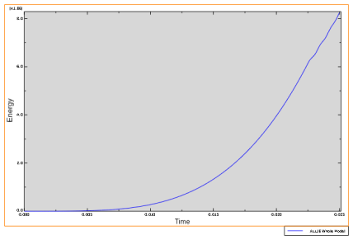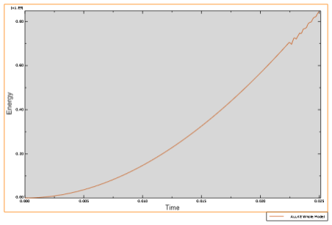

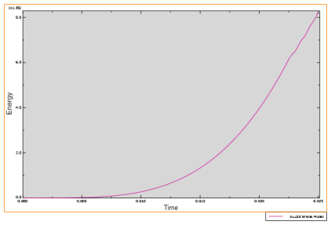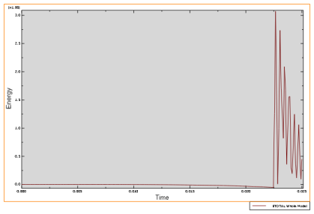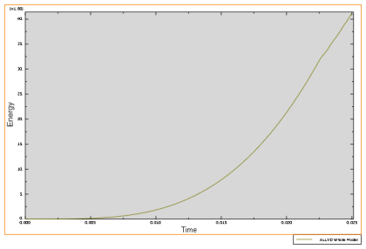

Figure 10 presents the distribution of external work, internal energy, kinetic energy, strain energy, total energy, and viscous dissipation resulting from a surface accidental explosion in a 20 mm steel pipe buried in dense sand. This visualization offers a detailed insight into how these energy components interact within the steel pipe under the specific conditions of dense sand burial, providing valuable information for analysis and interpretation.

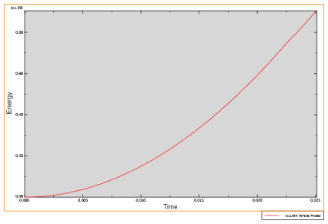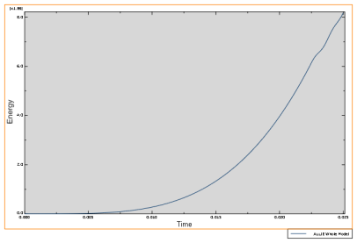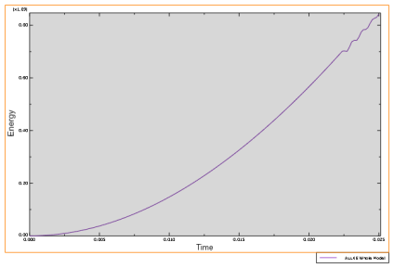

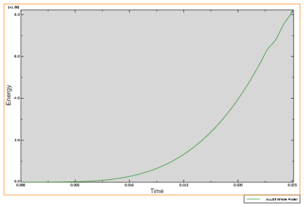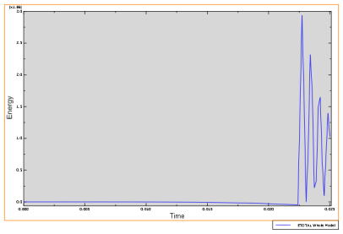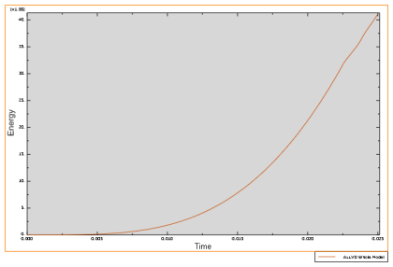

In Figure 11, the distribution of external work, internal energy, kinetic energy, strain energy, total energy, and viscous dissipation resulting from a surface accidental explosion in a 20 mm concrete pipe buried in dense sand is presented. This visualization offers a comprehensive depiction of how these energy components are distributed within the concrete pipe under the specific conditions of dense sand burial, providing valuable insights for understanding its response to the explosion.

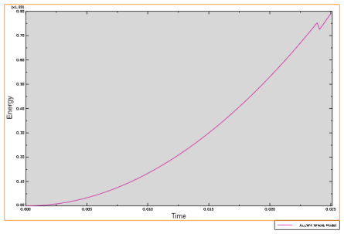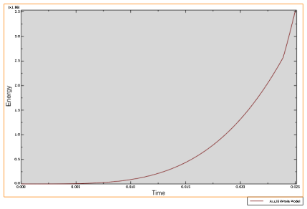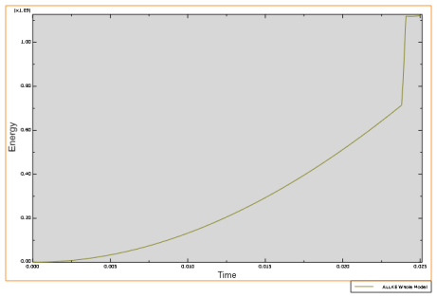

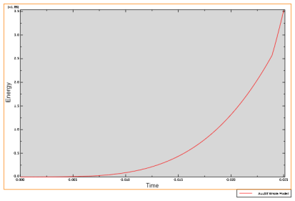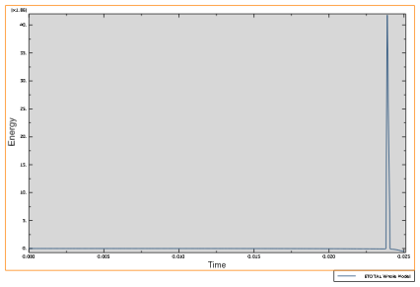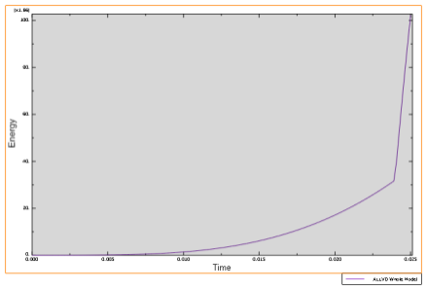

Figure 12 illustrates the distribution of external work, internal energy, kinetic energy, strain energy, total energy, and viscous dissipation resulting from a surface accidental explosion in a 20 mm steel pipe buried in undrained clay. This visualization provides a comprehensive understanding of how these energy components interact within the steel pipe under the specific conditions of undrained clay burial, offering valuable insights for analysis and interpretation.

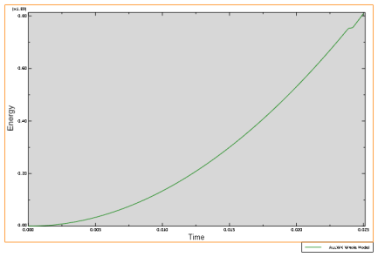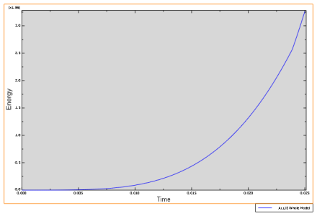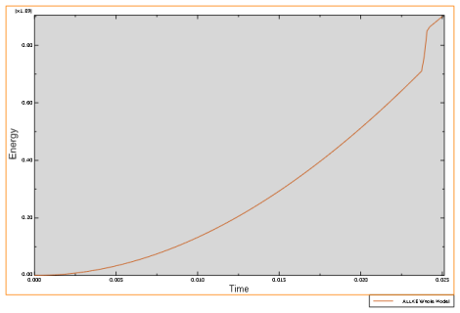

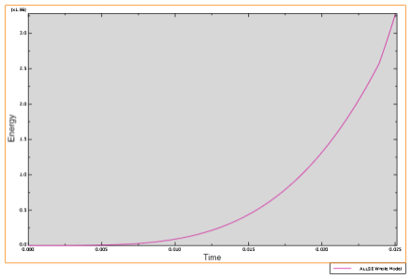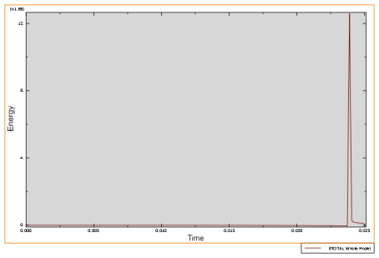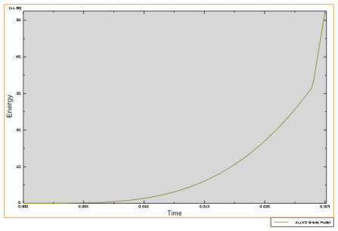

In Figure 13, we observe the distribution of external work, internal energy, kinetic energy, strain energy, total energy, and viscous dispersion resulting from a surface accidental explosion in a 20 mm concrete pipe buried in undrained clay. This visualization offers valuable insights into how these energy components are distributed within the concrete pipe under the specific conditions of undrained clay burial, facilitating a comprehensive understanding of its response to the explosion.

**CONCLUSION**

This study comprehensively investigated the distribution of external work, internal energy, kinetic energy, strain energy, total energy, and viscous dispersion generated in 20 mm concrete pipes buried in various ground media following surface accidental explosions. Our findings reveal intriguing insights into the response of these pipes under different burial conditions. Notably, pipes buried in loose sand exhibited the least response, attributed to the arching effects observed in this ground medium. This suggests that loose materials could serve as effective mitigating materials against the detrimental effects of surface blast on underground pipes.

These findings underscore the importance of considering the specific ground conditions when assessing the vulnerability of underground infrastructure to accidental explosions. Furthermore, they provide valuable guidance for the development of strategies aimed at enhancing the resilience of such infrastructure in the face of unforeseen events. Future research endeavors could delve deeper into exploring the effectiveness of various mitigation measures and their applicability in real-world scenarios.

**References**

ABAQUS Inc. 2009. ABAQUS*/Explicit: Advanced Topics*, Dassault Systemes Simulia,

Providence, Rhode Island, USA,

<http://www.simulia.com/products/products_legal.html>.

ABAQUS Inc. 2009. ABAQUS *Analysis User’s Manuals - Documentation*, Dassault

SystemesSimulia, Providence, Rhode Island, USA,

<http://www.simulia.com/products/products_legal.html>.

ABAQUS Inc. 2009. ABAQUS *User’s Manuals - Documentation*, DassaultSystemes

Simulia, Providence, Rhode Island, USA,

<http://www.simulia.com/products/products_legal.html>.

ABAQUS Inc. 2009.*Geotechnical Modeling and Analysis with* ABAQUS, Dassault

SystemesSimulia, Providence, Rhode Island, USA,

<http://www.simulia.com/products/products_legal.html>.

Adel-Aziz I. K. 1987. *Groundwater Engineering,* International Edition. McGraw

Hill Book Company, Singapore, 12-50.

Andrew, G. 1997. *Dam Design*, University of Durham, <http://www.dur.co>,

15/052004.

Arthur, H. G. 1974. *Design of Small Dams (Earthfill Dams)* (2nd edition), A Water

Resources Technical Publication, U.S Department of the Interior, Oxford and Ibh Publishing Company, New Delhi, **231**, 100-350.

Benham, P. P. and Crawford, R. J. 1987.*Mechanics of Engineering Materials* (1st

edition), Longman Scientific and Technical, New York, 45-90.

Boh, J. W., Louca, L. A. and Choo, Y. S. 2007.*Finite Element Analysis of Blast*

*Resistance Structures in the Oil and Gas Industry*, Singapore and UK,

ABAQUS User’s Conference, 1-15.

Bolt, B. A. 1976. Nuclear Explosions and Earthquakes: The Parted Veil, W. H.

Freeman, San Francisco, **309**, 113-132.

Bostrom, B., and Skomdal, E. 2004.*Reservoir Geomechanics with ABAQUS*,

ABAQUS User’s Conference, Norway, 117-131.

Bowles, J. E. 1981. *Engineering Properties of Soils and their Measurement*

(2nd edition), McGraw-Hill Intl., London, 79-92.

Bowles, Joseph E. 1997. *Foundation Analysis and Design* (5th edition),

International Edition, McGraw-Hill Company Inc., Singapore, 151.

Brian, P. B., Senthil, S. V., Jeffery, S. K. 2004. *Utilizing ABAQUS to analyze*

*the active vibration suppression of structural systems*, ABAQUS User’s Conference, 81-94.

Brian Vickers, 1980. *Soil Mechanics*: Laboratory Work in Civil Engineering, Granada

Publishing, London, 11-38.

BS 1377, 1990. Methods of Test for Soils for Civil Engineering Purposes, British

Institution, London.

BS 1881; Part 1-4, 1970.Part 6, 1971. Methods of Testing Concrete for Strength,

British Standard Institution, London.

Chen, W. F. 1995. *The Civil Engineering Handbook,* CRC Press, London. 1386, 20-

154.

Chi-Yuen W., Alex, W., Douglas, S. D. and Michael, M. 2006. Liquefaction Limit

during Earthquakes and Underground Explosions: Implications on Ground-Motion Attenuation – Short Note, Bulletin of the Seismological Society of America, **1** (96): 355-363.

Coduto, D. P. 2001. *Foundation Design: Principles and Practices* (2nd edition),

Prentice-Hall, Inc., New Jersey, 883-884.

Converse, F. J. 1953.*Compaction of sand at resonant frequency*, Symposium on

Dynamic Testing of Soils, ASTM Special Technical Publication No. **156**,

124-137.

Craig, R. F. 1994. *Soil Mechanics* (5th edition), Chapman and Hall, Great Britain,

248-292, 403-420.

Das, B. M. 1994. *Principles of Geotechnical Engineering* (3rd edition), PWS

Publishing, Co., Boston, Massachusetts, 671-672.

Duncan, J. M. 2001. *CEE 5564: Seepage and Earth Structure*, Course Notes, Spring

2001, Virginia Tech, Blacksburg, Virginia.

FLAC User’s Manual, 2000. *Version 4.0.* Itasca Consulting Group, Inc., Minneapolis,

Minnesota.

Ganesan, T. P. 2000. *Model of Structures* (1st edition), University Press Ltd., India, 20-55.

George, P. K., George, D. B. and Charis, J. G. 2007.*Analytical calculation of blast*

*induced strains to buried pipelines*. International Journal of Impact

Engineering, **34**, 1683-1704.

Gravessmith, T. R. 1985. *Strength of Materials: Civil Engineering Reference Book*

(3rd edition), Butterworth-Condon, 11-14.

Greg, B. C. 2008. *Modeling Blast Loading on Reinforced Concrete Structures with*

*Zapotec*, ABAQUS User’s Conference, 1-12.

Grim, R. E. 1953.*Clay Mineralogy*, McGraw-Hill, New York, 50-53.

Gupta, R. N., Mukherjee, K. P., and Singh, B. 1987.*Design of Underground*

*Artificial Dams for Mine Water Storage*. International Journal of Mine Water, **6** (2): 1-14.

Inanov, P. L. 1967. Comparison of noncohesive soils by explosions.Izdatel’sstvo

Literatury Po Stroietl’stvu, Leningrad, U.S.S.R., translated by the Indian National Scientific Documentation Centre, New Delhi, India, Published for the U.S. Department on Interior, Bureau of Reclamation and National Science Foundation, Washington, D.C., 211.

Johnson, D. 1986. *Advanced Structural Mechanics, An Introduction to Continuum*

*Mechanics and Structural Dynamics*, Collins, London, 16-45, 118-125, 136

-151.

Kameswara Rao, N. S. V. 1998. *Vibration Analysis and Foundation Dynamics* (1st

edition), Wheeler Publishing Co. Ltd., New Delhi, India, 190-197, 522-571.

Kameswara Rao, N. S. V. 2000. *Dynamic Soil Tests and Applications* (1st edition),

Wheeler Publishing Co. Ltd., New Delhi, India, 6-30, 84-134, 164-177.

Kameswara Rao, N. S. V. 2011. *Foundation Design: Theory and Practice* (1st

edition), John Wiley and Sons (Asia) Pte Ltd., Singapore, 203.

Lamb, H. 1904. *On the propagation of tremors over the surface of an elastic solid*,

Philosophical Transactions of the Royal Society, **203,** 1-42.

Liu Huabei, 2009. *Dynamic Analysis of Subways Structures under Blast Loading*,

University Transportation Research Center, New York, USA, 1-24.

Longinow, A. and Mniszewski, R. K. 1996. Protecting buildings against vehicle bomb

attacks, Practice Periodical on Structural Design and Construction, ASCE, New York, 51-54.

Marusek A. James, 2008. *Personal Shelters*, ABAQUS User’s Conference, US

Department of the Navy, 1-12.

Newcomb, W. K. 1951. *Principles of Foundation Design for Engines and*

*Compressors*, Trans of the ASME, **73,** 307-318.

Newmark, N. M. and Haltiwanger, J. D. 1962. *Air Force Design Manual, Principles*

*and Practices for Design of Hardened Structures*, Technical

Documentary Report Number AFSWC-TDR-62-138.

Newmark, N. M. and Hansen, R. J. 1961.*Design of blast resistant structures*, Shock

and Vibration Handbook, Vol. 3, Eds. Harris and Crede., McGraw-Hill,

New York, USA, 1-75.

Ola, S. A. 1983. *Tropical Soils of Nigeria in Engineering: Geotechnical Properties of*

*Some Nigeria Lateritic Soils,* Practice A. A., Balkema/Rotterdam, Netherland, 71-82.

Peck, R. B., Hanson, W. E. and Thornburn, T. H. 1974.*Foundation Engineering* (1st

edition), Wiley, New York, 514.

Peter, L. B. and David, R. 1987.*Introduction to Soil Mechanics*, McGraw-Hill

London, 1-75.

Puppala, A. J. and Chittoori, B. C. S. 2010.*Modified Stabilization Design*

*Incorporating Clay Mineralogy of Soil,* Indian Geotechnical Conference, GEOtrendz, Macmillan Publisher India Ltd., **III**, 73-80.

Raju, V. R. 2010. *Ground Improvement – Application and Quality Control,* Indian

Geotechnical Conference, GEOtrendz, Macmillan Publisher India Ltd., **III**, 121-131.

Ramakrishan, K. 1979. *Finite element analysis of pipes buried in linearly and non*

*linear elastic media.*M.Tech Thesis, Civil Engineering Department, Indian Institute of Technology, Kanpur, India.

Remennikov, A. M. 2003. *A Review of Methods for Predicting Bomb Blast Effects on*

*Buildings*. International Journal of Battlefield Technology,6 (3), 5-10.

Remennikov, A. M. 2009. The state of the art of explosive loads characterization,

Report, University of Wollongong, 1-25.

Robert, W. D. 2002.*Geotechnical Earthquake Engineering Handbook*, McGraw

Hill, New York, 5-120.

Ronanki, S. S. 1997. *Response Analysis of Buried Circular Pipes under 3*

*Dimensional Seismic Loading*.M.Tech Thesis, Civil Engineering Department,

Indian Institute of Technology, Kanpur, India.

Shacklock, B. W. 1974. *Concrete Constituent and Mix Proportions* (1st edition),

Cement and Concrete Association, 15-35.

Taylor, G. I. 1950. *The formation of a blast wave by a very intense explosion.II.*

*The atomic explosion of 1945*, Proc. Roy. Soc. London, **A201**, 159.

Taylor, W. H. 1977. *Concrete Technology and Practice* (4th edition), McGraw-Hill

Book Company, Australia, 35-55.

Tay Soon Chuan, 1994. Design Guidelines for Water Supply Systems, Standards

and Practice Committee, Technical Manual, Malaysian Water Association (MWA), 45-150.

Terzaghi, K. 1978. *Soil Mechanics,* Macdonald and Evans, London, 1-50.

Terzaghi, K., Peck, R. B. and Nesri, G. 1996. *Soil Mechanics in Engineering Practice*

(3rd edition), John Wiley and Sons, New York, 549.

Terzaghi, K. 1943. *Theoretical Soil Mechanics,* John Wiley and Sons, New York, 34

-40.

Thomas, H. H. 1976. *The Engineering of Large Dams: Part 1 and 2,* John Wiley

and Sons, 45-235.

Unified Facilities Criteria, 2008.*Structures to Resist the Effects of Accidental*

*Explosions*, UFC 3-340-02, Department of Defense, US Army Corps of Engineers, Naval Facilities Engineering Command, Air Force Civil Engineer Support Agency, United States of America.

Wagner, A. A. 1957. *Unified Soil Classification System*, Proceedings of the Fourth

International Conference on Soil Mechanics and Foundation Engineering SMFE, London, **1**.

Wilkinson, C. R. and Anderson, J. G. 2003. An Introduction to Detonation and Blast

for the Non-Specialist (Unclassified). Weapon Systems Division, Weapon Systems Sciences Laboratory, DSTO-TN-0526, Australian Government Department of Defence, November, 1-8.