**CLASS CONNECT**

Dr.S. Prakash & A. Imthiyaz Husain & R. Barath & R.G Deepak

Dr.S. Prakash

[hodit@srishakthi.ac.in.com](mailto:hodit@srishakthi.ac.in.com)

A. Imthiyaz Husain

[imthiyazhusain02.09.2005@gmail.com](mailto:imthiyazhusain02.09.2005@gmail.com)

R. Barath

[barathramesh26@gmail.com](mailto:barathramesh26@gmail.com)

R.G Deepak

[rgdeepak91@gmail.com](mailto:rgdeepak91@gmail.com)

Sri Shakthi Institute of Engineering and Technology, Coimbatore.

Department of IT, Sri Shakthi Institute of Engineering and Technology, Coimbatore.

**Abstract:**

CLASS CONNECT is a comprehensive mobile and web application designed to streamline and enhance the academic and administrative processes at SIET. It offers a range of features including student profile management, attendance tracking, grade entry and review, and semester result publication. The app aims to facilitate efficient communication and data management between students, teachers, and administrators, ensuring transparency and accessibility. By integrating robust security measures, CLASS CONNECT ensures the privacy and security of sensitive information, ultimately fostering a more efficient. The student management feature allows for the creation and maintenance of detailed student profiles, encompassing personal and academic information. This module also supports the management of student enrollments and academic history, making it easy for administrators to keep track of each student’s journey. In addition, the attendance management system enables teachers to mark daily attendance quickly and accurately, generate detailed attendance reports, and send notifications for absenteeism, ensuring better tracking and accountability. For academic performance management, CLASS CONNECT offers a robust grade entry system where teachers can input and update grades for various assessments. This feature includes a centralized gradebook for each class and subject, facilitating easy access and management. Students can review their grades through the app, receive feedback on their performance, and track their progress over time with historical data and performance trends.

**Keywords:**

CLASS CONNECT, Dashboard, Attendance, Absentees, Students List, Notice and Queries,

Gmail Notifications, Conclusion.

**Introduction:**

In today’s fast-paced educational environment, efficient management of student data, attendance, grades, and academic results is crucial for both educators and students. To address these needs, we have developed the "CLASS CONNECT" a comprehensive mobile and web application designed specifically for the students, teachers, and administrators of SIET.

The " CLASS CONNECT " aims to streamline various academic and administrative processes, enhancing productivity and ensuring seamless communication among all stakeholders. The application integrates multiple features, including student profile management, attendance tracking, grade entry and review, and semester result publication, into a single, user-friendly platform. This integration not only simplifies routine tasks but also provides real-time access to essential information, promoting transparency and accountability.

By leveraging modern technology, " CLASS CONNECT " offers a robust solution that caters to the dynamic needs of the academic community at SIET. The app is designed to be intuitive and accessible, ensuring that users of all technical proficiencies can navigate and utilize its features effectively. Importantly, the app is fully responsive, providing an optimal user experience on both mobile devices and PCs. This ensures that users can access the platform conveniently, whether they are on the go or at their desks.

With strong security measures in place, the app prioritizes the privacy and protection of sensitive student information. Through the development of " CLASS CONNECT " we aim to foster a more efficient, transparent, and engaging educational environment, ultimately enhancing the overall academic experience for students and supporting teachers and administrators in their essential roles.

**Dashboard:**

The dashboard of the " CLASS CONNECT " app serves as the central hub, offering a comprehensive overview of key information and quick access to various features. It displays the total number of students categorized by gender, lists the top five students with the highest attendance percentages, and shows the number of students with the lowest attendance. Additionally, it features a digital notice board for important announcements and a section for students to submit queries directly to the Head of Department (HOD). The navigation bar provides quick links to the students list, individual student details, academic marks, and the main dashboard. Moreover, it includes a feature to display the number of students currently on duty, ensuring accurate tracking of attendance and student participation in official activities. This user-friendly interface facilitates better decision-making, communication, and overall management within the institution.

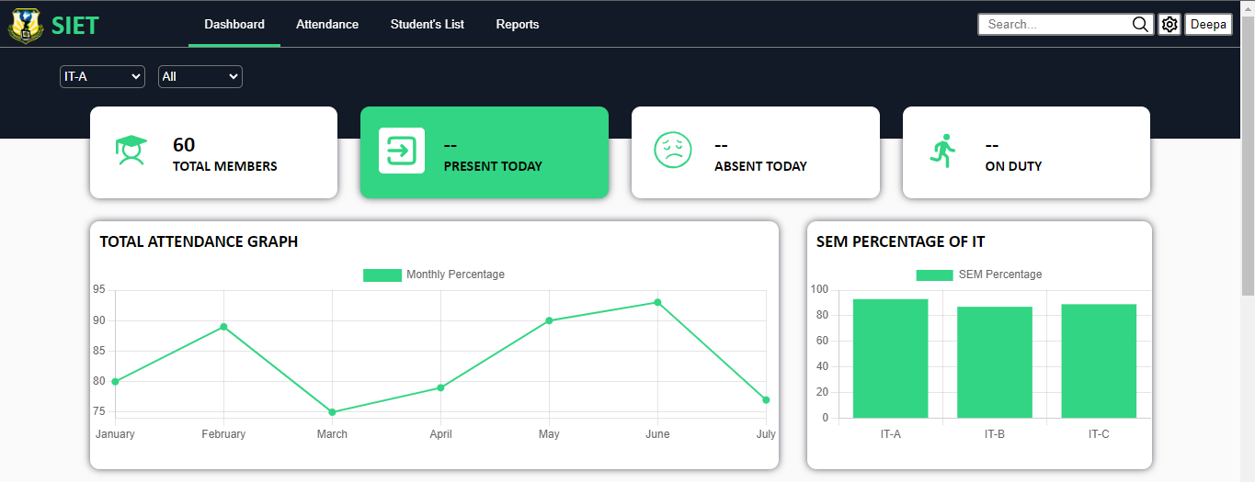

**Attendance:**

The attendance management feature in the " CLASS CONNECT " app is designed for simplicity and efficiency, initially displaying the total number of students as present by default. Class advisors can mark absences by clicking the "Present" button next to a student's name, which changes the status to "Absent." After marking the absentees, the advisor submits the record, updating the attendance summary to reflect the actual number of students present and absent for that session. This streamlined process ensures accurate attendance tracking and easy updates.

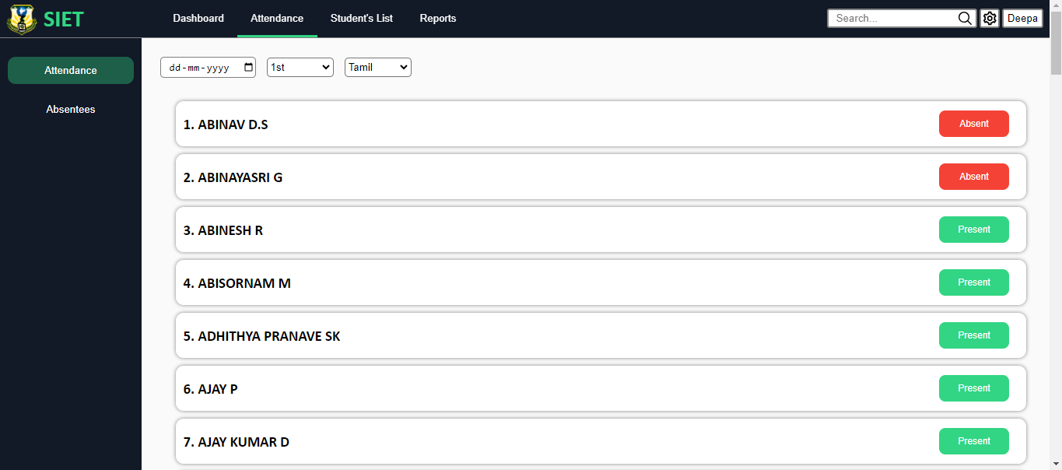

**Absentees:**

The attendance management feature in the " CLASS CONNECT " app allows class advisors to efficiently track and record student attendance. Advisors can mark absentees by clicking the "Absentees" button next to each student's name and then finalize the attendance by clicking the "Submit" button at the bottom of the page. This submission displays the total number of students present and absent. On the Absentees page, a "Send" button is available, which, when clicked, sends an automated Gmail notification to the parents of absent students, informing them of the absence and displaying the advisor's contact number. This feature ensures prompt communication with parents and provides a clear summary of attendance data.

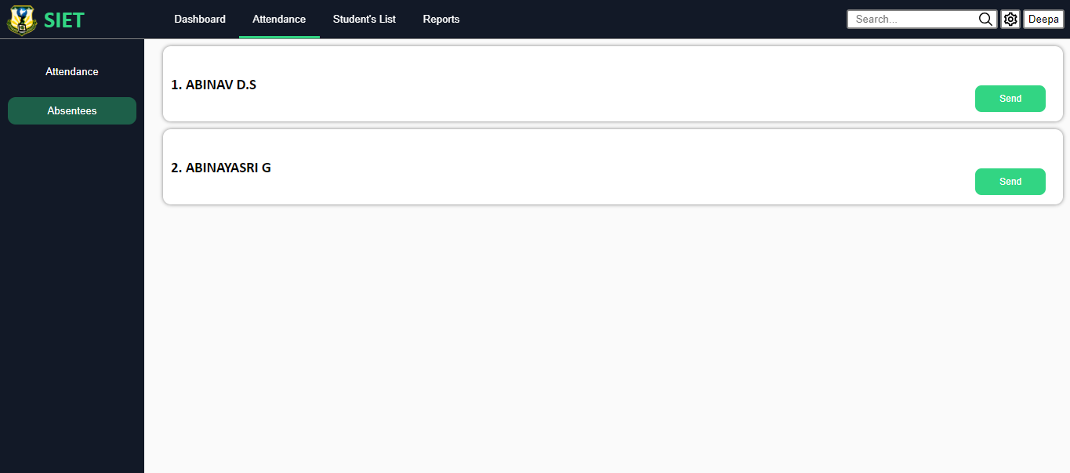

**Students list:**

The student list feature in the " CLASS CONNECT " app provides a comprehensive overview of all enrolled students. It displays the total number of students and presents each student's name in a list format. Next to each name, there is a dropdown button that, when clicked, reveals detailed information about the student, such as their personal details, academic records, attendance history, and contact information. This functionality allows for easy access to individual student profiles, enabling educators and administrators to quickly find and review specific student information.

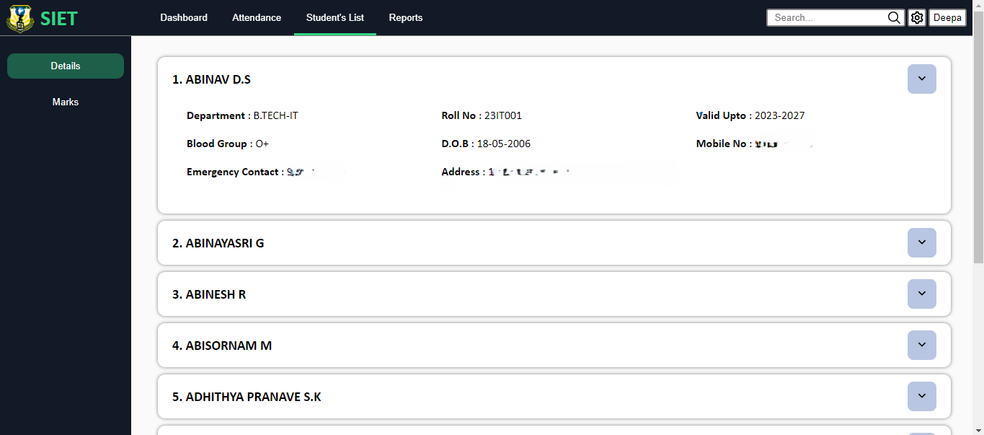

**Notice and queries:**

The notices and queries feature in the " CLASS CONNECT " app includes a box located at the bottom of the dashboard, where important notices from advisors or the HOD are displayed. These notices can include updates, announcements, or reminders and are easily accessible to students directly from the dashboard. This ensures that all important information is prominently displayed and readily available, keeping students informed of any significant developments or instructions from their advisors or the HOD.

**Gmail notification:**

The Gmail notification feature in the " CLASS CONNECT " app ensures prompt communication with parents regarding their child's attendance. When a student is marked absent, the class advisor can click the "Send Mail" button, which triggers an automated email to the parents informing them that their ward is absent for the day. This email also includes the contact number of the class advisor, enabling parents to reach out directly for further information or clarification. This feature helps maintain transparency and keeps parents informed about their child's attendance in real time.

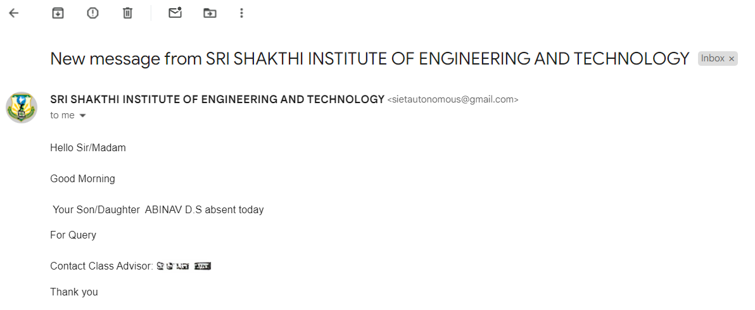

**Conclusion:**

The " CLASS CONNECT " is a transformative mobile and web application designed to streamline and enhance the academic and administrative operations at SIET. This comprehensive app integrates a range of functionalities aimed at improving efficiency, communication, and data management within the educational institution. Its key features focus on real-time attendance tracking, academic records management, personalized student details, and an intuitive dashboard, making it an essential tool for modern educational management.

One of the standout features of the " CLASS CONNECT " is its real-time attendance management system. This feature allows educators to track student attendance seamlessly and ensures that parents are immediately informed if their child is absent. When a student misses a class, the class advisor can send an immediate Gmail notification to the parents, alerting them to the absence. This prompt communication helps parents stay informed about their child's attendance and encourages students to maintain consistent attendance records. It also aids in early intervention if a student's absenteeism becomes a concern, allowing for timely discussions and support.

Moreover, the app is fully responsive, functioning seamlessly on both mobile devices and PCs. This cross-platform compatibility ensures that users can access the app conveniently, whether they are on-the-go or at their desks. The adaptive layouts adjust to different screen sizes and resolutions, providing an optimal user experience regardless of the device used.

In conclusion, the " CLASS CONNECT " is a versatile and secure solution that significantly enhances the academic and administrative processes at SIET. By leveraging real-time management, robust security measures, user-friendly UI/UX design, and cross-platform responsiveness, the app provides a seamless and efficient experience for all users. Its comprehensive features, from attendance management to academic records and personalized student details, coupled with an intuitive dashboard, make it an indispensable tool for fostering a more organized, transparent, and engaging educational environment. The "CLASS CONNECT" " is poised to benefit students, parents, educators, and administrators alike, creating a more efficient and supportive academic community at SIET.

**Reference:**

This book offers practical advice on web usability and user-centered design, crucial for creating an intuitive user interface for your app.

"The Design of Everyday Things" by Don Norman

A foundational text on design principles that emphasizes the importance of user-friendly design.

"UX for Beginners: A Crash Course in 100 Short Lessons" by Joel Marsh

Provides a beginner-friendly introduction to UX design, with practical tips and examples that can be directly applied to app development.

Security:

"Web Application Security: Exploits and Countermeasures for Modern Web Applications" by Andrew Hoffman

This book covers various security threats to web applications and offers strategies to protect against them.

"Security Engineering: A Guide to Building Dependable Distributed Systems" by Ross Anderson

An in-depth resource on security engineering, including best practices for ensuring the security and privacy of user data.

Educational Technology and Administration:

"The Handbook of Educational Technology" by J. Michael Spector, M. David Merrill, Jan Elen, and M. J. Bishop.

Provides comprehensive coverage of the use of technology in education, including best practices for implementing and managing educational technology.

"Educational Administration: Theory, Research, and Practice" by Wayne K. Hoy and Cecil G. Miskel