**An Examination and Design of the G +13 Multi-Story Residential building RC shear walls**

**GANESH KV 1 , Mr.R.RajKumar2**

1M.Tech (Structural Engineering), Department of Civil Engineering, VISWAM Engineering College, Madanapalle, India.

2 Associate Professor in Department of Civil Engineering, VISWAM Engineering College, Madanapalle, India.

**ABSTRACT**

STAAD Pro is used to analyze building frames in the computer-aided "ANALYSIS AND DESIGN of RC Shear Walls G + 13 Multi-Storied Residential Building." The conventional method of analysis is time-consuming due to the numerous complications and laborious calculations involved. Investigation can be made rapidly by utilizing programming's. The most popular design software is STAAD Pro. This software is utilized by numerous design firms for project design. As a result, the building's STAAD Pro analysis is the primary focus of this project. Significant improvement in tremor safe plan has been seen in late past. The Indian seismic code as a result is: 1893 has likewise been reconsidered in year 2002, following a hole of 18 years. This Task presents the seismic burden and wind load assessment for Private structure according to IS: 1893-2002 and IS: 875 - Recommendations in Part 3 of 2015 For RC WALL outlined Private structure of G +13 are thought of and examined according to IS456-2000. The seismic powers, processed by IS: When compared to wind forces, they are found to be significantly higher between 1893 and 2002. For breaking down a Private structure one needs to consider every one of the potential loadings and see that the construction is protected against all conceivable stacking conditions. The dead burden &live loads are applied and the plan for radiates, segments, balance and RC wall is acquired STAAD Master with its new highlights outperformed its ancestors and compotators with its information imparting abilities to other significant programming like AutoCAD, and MS Succeed. We conclude that STAAD Pro is a very effective tool that saves a lot of time and is extremely accurate when designing. As a result, the STAAD pro package can be used to design a building with multiple floors.

**Keywords:** Shear Wall, STAAD pro, Live Loads, Wind Load

**1. INTRODUCTION**

**1.1 General**

Using tables and charts, a typical multi-story housing structure was designed. A residential building typically cannot be divided into multiple plane frames due to its typical layout. In situations like these, the only option is to analyze the structure using the approximation method, which takes into account the free bodies of the individual parts. The reader now knows how to design members from the ground up, so design tables, charts, and other tools were used to figure out the details of the design, which saved a lot of time and effort. For the benefit of users, the design aids utilized in this project have been provided in Appendices. The unified construction technology concept is adapted in this proposal. This suggests that the section and the remainder of the structure are projected in a solitary pour. To build a monolithic structure, we clearly need stronger formwork, so conventional formwork is insufficient. Thus, we require an aluminum formwork known as mivan covering.

Multi storied buildings are two types based on the material used for construction of structural elements.

1. R.C.C.framed structures
2. Steel framed structures

R.C.C.framed structures are preferable than steel framed structures because of the advantages.

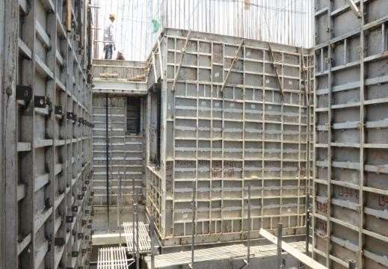

**Fig 1.1 CONSTRUCTION USING MIVAN TECHNOLOGY**

1.2 OBJECTIVES

* + - Utilizing STAAD Pro, analyze and design the R.C.C. framed structure for static loads.
    - Conduct substitute frame analysis for the typical beam's static loads.
    - To verify the STAAD Pro model, compare the accuracy of the STAAD Pro analysis with substitute frame analysis.
    - ComparetheaccuracyoftheSTAADProdesignwithmanualdesignforverification of the STAAD Master model. Estimate the building's material quantities and the project's total construction costs..

**Table1.1: DIMENSIONS OF THE ROOMS**

|  |  |  |  |
| --- | --- | --- | --- |
|  | **Block3** | **Block2** | **Block1** |
| **Living room** | 5.1x3.20 | 6.5x4.7 | 5.5x3.3 |
| **Bedroom1** | 4.1x3.2 | 4.5x3.7 | 3.9x3.3 |
| **Bedroom2** | 4.4x3.2 | 3.7x3.2 | 4.0x3.2 |
| **sBedroom3** | - | 4.5x4.2 | - |
| **Dining/kitchen** | 4.1x3.2 | 4.2x2.7 | 5.6x3.2 |
| **Bathroom1** | 1.8x1.4 | 2.4x1.2 | 2.1x1.5 |
| **Bathroom2** | 2.3x1.2 | 2.5x1.2 | 2.3x1.5 |
| **Shaft1** | 1.2x0.7 | 3.1x1.5 | 1.5x0.7 |
| **Shaft2** | 3.2x0.9 | - | - |
| **Utility** | 3.2x1.0 | 2.0x1.2 | 3.2x1.2 |
| **Balcony** | - | 2.0x1.2 | 3.3x1.2 |

**2. LITERATURE REVIEW**

The G+4 multistory building's static analysis was presented by Adapa (2017). He deals with the displacement and static forces at member joints. In a nutshell, he said that calibrated loadings are done with the Staad-pro software and compared to manual analysis, which he thought was adequate. Additionally, he stated that Time History Analysis, a dynamic analysis calibrated with reference to the Response spectrum, should be used to obtain a comprehensive response of a structure under various loads in addition to static analysis.

Giresh et al. ( 2017) A G + 7 residential building's seismic analysis and design were demonstrated using STAAD Pro. To compute the reaction of a construction exposed to seismic feeling, tremor, or Seismic investigation is utilized. For the purpose of the structure's seismic investigation, he gathered all necessary seismic data. The seismic reaction of the designs was assessed as far as part powers, join uprooting, support response, and story float in this review.

**3. METHODOLOGY**

* 1. **DESIGNPROCEDURE:**

G+13 on a floor residential building's architectural plan and frame plans are created, as depicted in the figure below, and the structure is then modeled in STAAD Pro. The building's entire inspection was completed in a single step with the IS code condition in mind.

Each underlying part of the total design — piece, bars, sections, and footings — has been isolated separated.

At first, the piece was characterized into two gatherings as per boundaries, Lx and so on Ly proportions, edge conditions, ranges, and common examination. These sections' heaps — both their live and dead loads — are communicated to the supporting construction in the two bearings of X and Y.

In view of the heaps going through the chunk, its own extra weight (expected segment), and all wall pressures coming in that capacity, an underlying format of a standard shaft was created. The column part is designed to hold the weights. The maximum positive and negative shear stresses for the supporting structure and column have been established.

* + - * Modeling of building by using STAAD PRO.
      * Drawing by using AUTOCAD.
      * Analysis of bending moment and shear force.
      * Design of SLABS, BEAMS,COLUMNS,STAIRCASE and WATERTANK by using IS 456-2000codebook.
      * ARCHITECTURE design by using REVITARCHITECTURE

**4. ANALYSIS & DESIGN**

In STAAD pro, dead load is performed by itself by assigning the member's properties.

Weight=volume x density Slab weight = 0.15x25= 3.75 kN/m2

Self-weight of Floor finishing=0.01x25=0.25 kN/m2

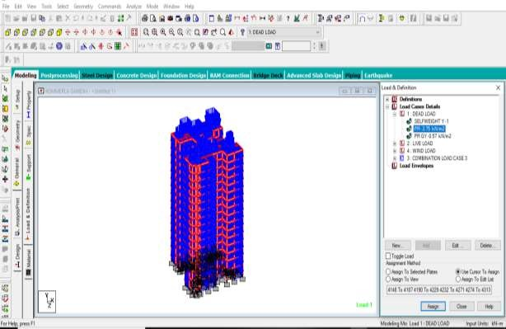 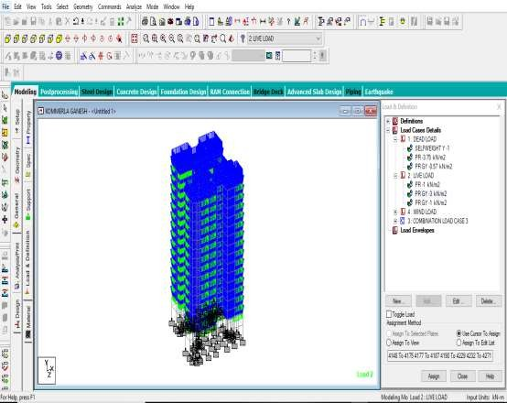

**Fig 4.1 DEAD LOAD & LIVE LOAD**

* 1. **WIND LOAD**

**Design Wind Pressure:**

It can be mathematically expressed as follows

Vz = Vb x k1x k2 x k3 x k4 {Pg.no5clauseno6.3ofIS875-2015} pz=0.6Vz2 {Pg.no9clauseno7.2ofIS875-2015}

pd=Kd x Kax Kcx pz {ssssPg.no9clauseno 7.2of IS 875-2015}

0.7 pz {Pg.no9clauseno7.2ofIS875-2015} Design Wind Pressure is Maximum of (pd, 0.7pz)

Where

Vb = design wind speed at height Z in m/s {Pg.no51AnnexureAofIS875Part3- 2015}

k1 =risk coefficient

k2=terrain roughness and height factor k3 = topography factor

k4=Importance factor for cyclonic region.

Basic wind speed in Bangalore 33 m/s

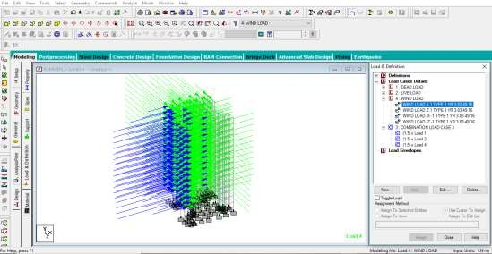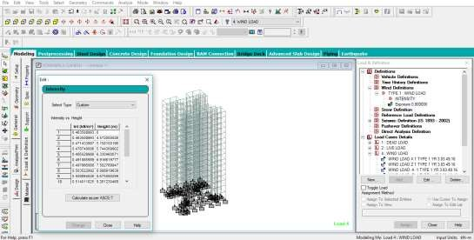

**Fig 4.2 WIND LOAD DISTRIBUTION WIND INTENSITY**

**4.2 RC WALL LOAD**

The stress placed on the RC Walls is used to compute the floor load. By building a load case for an RC WALL load, the floor load is assigned. Following the assignment of a structure's RC WALL load, the structure appears as indicated below.

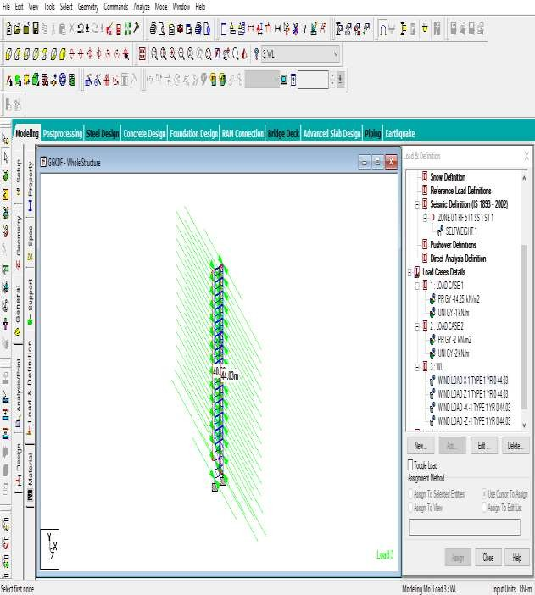

**Fig 4.3 WALL LOAD DISTRIBUTION**

After analysis of results the post processing data are arrived.

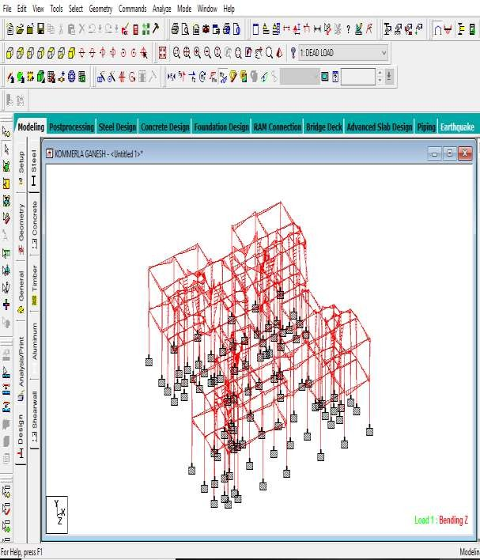

**Fig 4.4 SHEAR FORCE DIAGRAM & BENDING MOMENT**

**4.3 DESIGN OF BEAM**

**Table 4.1: BEAM REINFORCEMENT DETAILS**

|  |  |  |  |  |
| --- | --- | --- | --- | --- |
| FLOOR | BEAM  NO | BEAM  SIZE | REINFORCEMENT | |
| G.F | 1 to 71 | 450x600 | 16mmdia@4no’s (main)  16mmdia@4no’s (main) | 8mmdia@100mmc\c(shear) 8mmdia@100mm c\c(shear) |
| 1st FLOOR | 72 to 145 | 450x600 | 16mm dia @4 no’s (main) 16mmdia@4no’s(main) | 8mmdia@100mmc\c(shear) 8mmdia@100mm c\c(shear) |

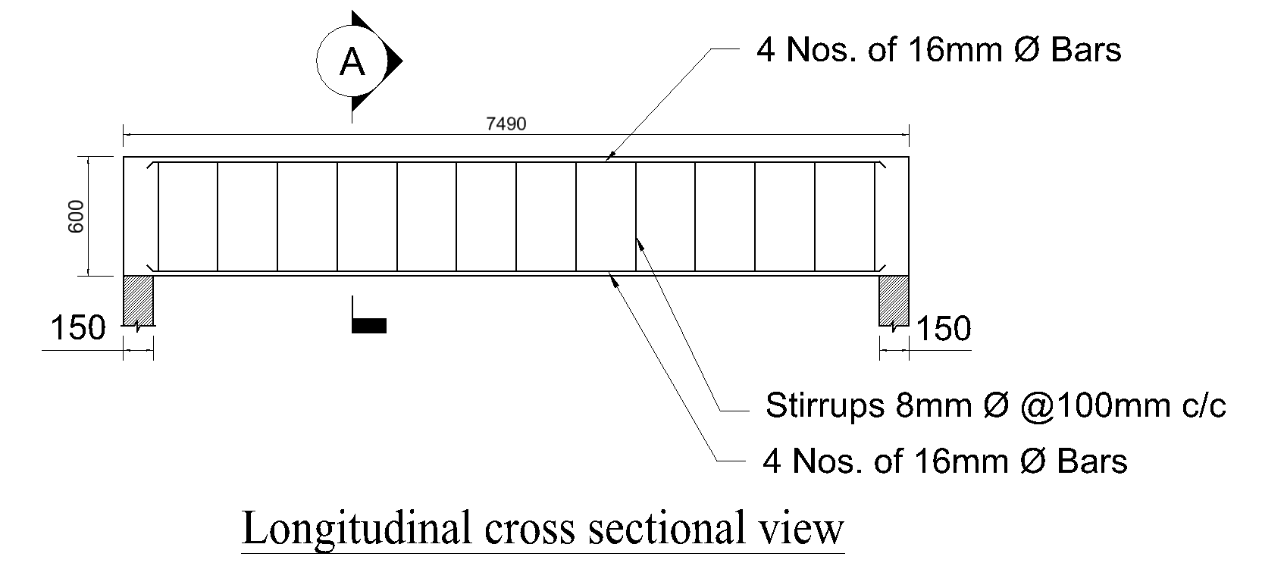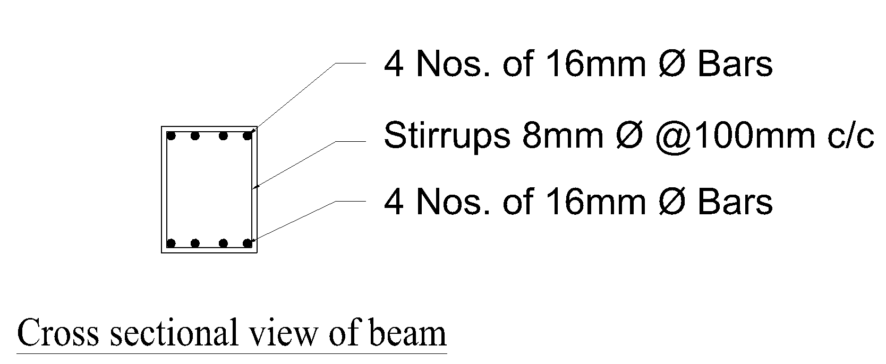

**Fig 4.5 REINFORCEMENT DETAILS OF BEAM**

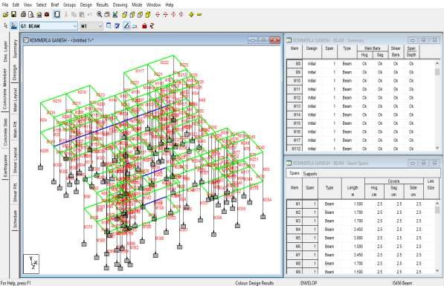

**Fig 4.6 : BEAM DESIGN IN STAAD**

**4.4 DESIGN OF COLUMN**

**Table 4.2**

|  |  |  |  |  |
| --- | --- | --- | --- | --- |
| **S NO** | **COLUMN SIZE** | **NAMEOF COLUMN** | **REINFORCEMENT DETAILS** | **COLUMN LAYOUT** |
| **1** | **450X750** | **C1** | **16T16@255ccandT8@255cc** |  |
| **2** | **300X850** | **C2** | **12T16@255ccandT8@255cc** |  |
| **3** | **300X1150** | **C3** | **20T16@255ccandT8@255cc** |  |
| **4** | **300X1050** | **C4** | **24T16@255ccandT8@255cc** |  |

**4.5 DESIGN OF SLAB**

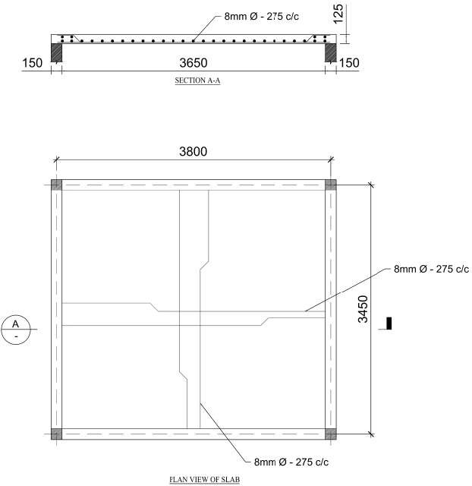

**Fig 4.7 REINFORCEMENT DETAILS OFTWO-WAYSLAB**

**4.6 DESIGN OF FOOTING**

**Table: FOOTINGS CHEDULE**

|  |  |  |  |  |  |
| --- | --- | --- | --- | --- | --- |
| **FOOTING SCHEDULE** | | | | | |
| **FOOTING**  **NUMBER** | **FOOTINGSIZE** | | | **REINFORCEMENT** | |
|  | **LENGHT** | **BREADTH** | **DEAPTH** | **SHORTBARS** | **LONGBARS** |
| **F1** | **2750** | **1900** | **500** | **T12@125 C/C** | **T12@125 C/C** |
| **F2** | **2450** | **1900** | **500** | **T10@100 C/C** | **T10@100 C/C** |
| **F3** | **1900** | **1750** | **500** | **T10@100 C/C** | **T10@100 C/C** |
| **F4** | **1750** | **1600** | **450** | **T10@100 C/C** | **T10@100 C/C** |
| **F5** | **1650** | **1500** | **450** | **T10@100 C/C** | **T10@100 C/C** |
| **F6** | **2350** | **1800** | **500** | **T10@100 C/C** | **T10@100 C/C** |
| **F7** | **2550** | **1900** | **500** | **T10@100 C/C** | **T10@100 C/C** |

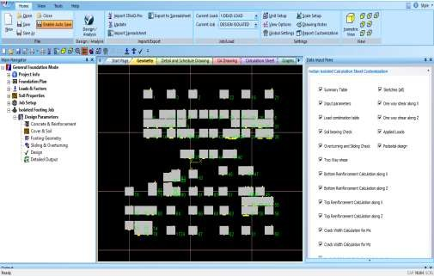

**Fig 4.8 FOOTING LAYOUT**

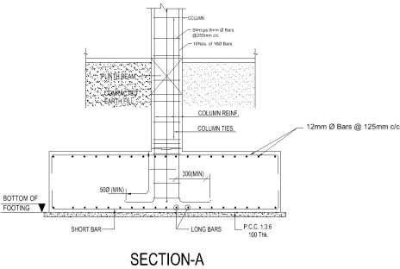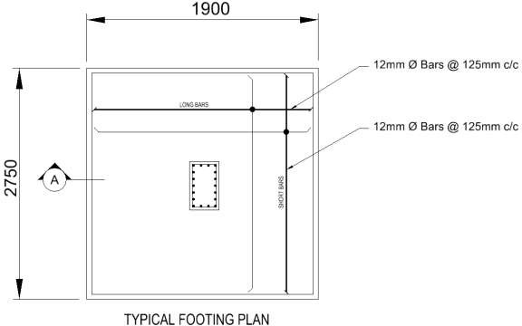

**Fig 4.9 REINFORCEMENT DETAIL OF FOOTING**

**4.7 DESIGN OF RC SHEAR WALL**

Built to serve as a tensile member, the wall is made of reinforced concrete. For heavy loads supported by a concrete foundation without a beam or where the brick wall’s thickness is restricted, strengthened concrete walls are employed.

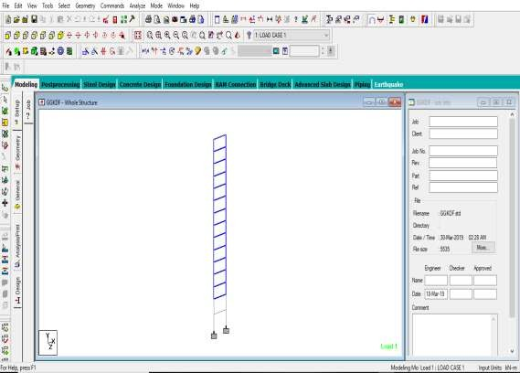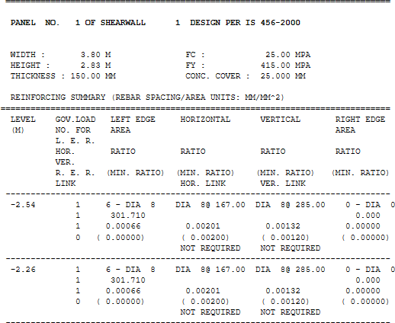

**Fig 4.10 SHEAR WALL STAADPRO RESULTS**

**4.8 ARCHITECTURE DESIGN**

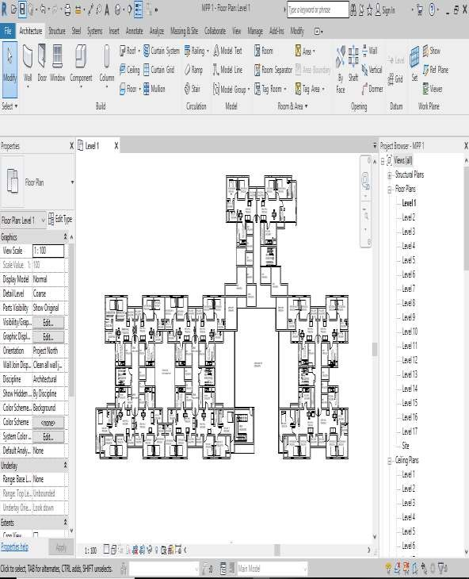

**Fig 4.11 BUILDING DRAWING BY REVIT**

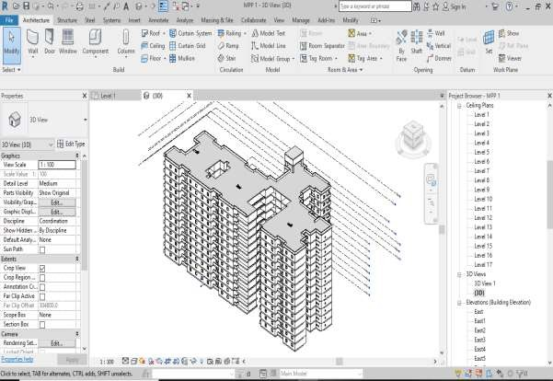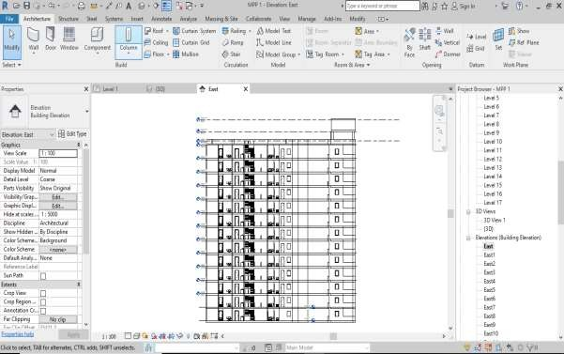

**Fig 4.12 3D PLAN DESIGNED ELEVATION IN REVIT**

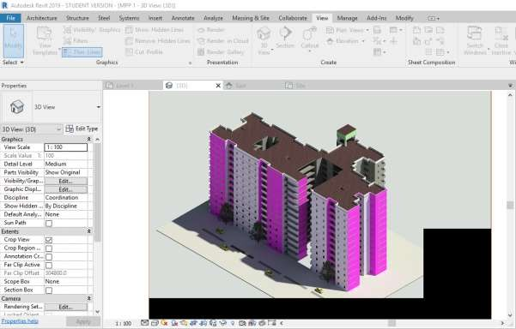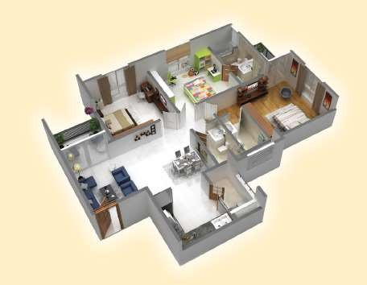

**Fig 4.13 INTERIOR DESIGN OF 3BHK BY USING REVIT**

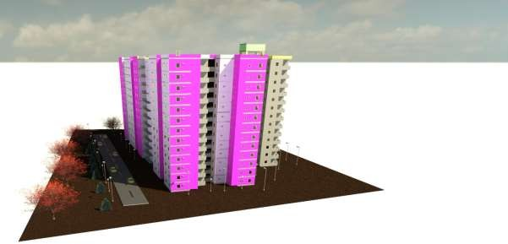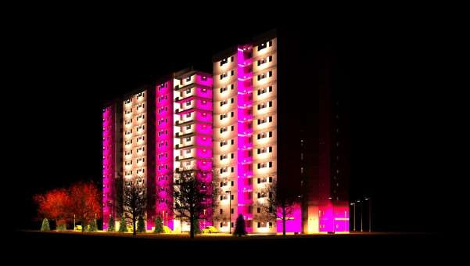

**Fig 4.14 RENDERING VIEW 2 IN REVIT**

The total estimation of the building is 21,08,44,76.

**5. CONCLUSION**

1. The primary focus of this project is research and design of a house complex with RC walls and all possible loading scenarios using STAAD. Pro Meeting design challenges are conceptually described.

2. Additionally, under the given stacking conditions, we might take a gander at how various individuals redirect..

3. Besides, amendment is all around as straightforward as changing the qualities at the area of the shortcoming, and the outcomes are shown in the result.

4. Extremely less space is expected for the capacity of the information.

5. STAAD Star V8i refined programming that gives us with a quick, proficient, easy to understand, and precise stage for primary examination and plan.

6. REVIT offers a residential building's efficient and well-designed architectural and engineering blueprint. It provides a general synopsis of the material take-off, schedule, and quantity of the building model project. Using a 3D-realistic viewpoint, the installed components and family of the building model can be shown.

**REFERENCE**

1] Adapa, Narendra kuamar. (2017) ‘The Static Analysis & Design of Residential Building Using Staad-pro V8i’, International Journal of Advance Technology and Innovative research, Vol. 09, pp. 0529-0536

2] Babu Giresh B, “Seismic Analysis and Design of G+7 Residential Building using Staad-pro”, International Journal of Advance Research, Ideas and Innovation in Technology, Vol 3, Issue 3, pp 924-930, 2017

3].IS: 875 (Part 1) – 1987 for Dead Loads, Indian Standard Code Of Practice for Design Loads (Other Than Earthquake) For Buildings and Structures, Bureau of Indian Standards, Manak Bhavan, 9 Bahadur Shah ZafarMarg, New Delhi 1100 02.

4].IS: 875 (Part 2) – 1987 for Imposed Loads, Indian Standard Code Of Practice for Design Loads (Other Than Earthquake) For Buildings and Structures, Bureau of Indian Standards, Manak Bhavan, 9 Bahadur Shah ZafarMarg, New Delhi 110002.

5].IS: 875 (Part 3) – 1987 for Wind Loads, Indian Standard Code Of Practice for Design Loads (Other Than Earthquake) For Buildings And Structures, Bureau of Indian Standards, Manak Bhavan, 9 Bahadur Shah ZafarMarg, New Delhi 110002.

6]. IS 1893 (Part 1)-2002, Indian Standard Criteria for Earthquake Resistant Design of Structures, (Part 1-General Provisions and Buildings), Bureau of Indian Standards, ManakBhavan,9 BahadurShah ZafarMarg,New Delhi110002.[6].IS456-2000,Indian standard code of practice for plain and reinforced concrete standards, New Delhi, 1980.

7]. IS 456-2000, Indian standard code of practice for plain and reinforced concrete standards, New Delhi, 1980.

8]. SP: 34-1987, Hand Book of Concrete Reinforcement and Detailing, Bureau of Indian standards, New Delhi, 1987.