Indian Number Plate Detection with neural network

|  |
| --- |
| Sugam Singh#, Hemang Shrivastava*, Neeraj Chandnani**  #M.Tech. Scholar, Institute of Advance Computing (Specialization), SAGE University, Indore, Email: [sugam.singh.sbg@gmail.com](mailto:sugam.singh.sbg@gmail.com)  *Head of Department, Institute of Advance Computing (Specialization), SAGE University, Indore, Email: [drhemang.shrivastava@sageuniversity.in](mailto:drhemang.shrivastava@sageuniversity.in)  **Institute of Advance Computing (Specialization), SAGE University, Indore, Email: [chandnani.neeraj@gmail.com](mailto:chandnani.neeraj@gmail.com)  Corresponding Author: Neeraj Chandnani (Email: [chandnani.neeraj@gmail.com](mailto:chandnani.neeraj@gmail.com)) |

Abstract—Designing Automatic Number Plate Recognition (ANPR) systems for Indian vehicle number plates presents a substantial challenge due to the wide array of variations in size, font, script, and shape. A key necessity in overcoming this challenge is access to a comprehensive dataset that encompasses the unique characteristics of the Indian context. However, such datasets are currently scarce, hindering progress in developing ANPR solutions that are both accessible to the public and easily replicable. Unlike China and the United States, which have invested in creating comprehensive ANPR datasets such as the Chinese Citys Parking Dataset (CCPD) and the Application-oriented License Plates (AOLP) dataset, India lacks an equivalent dataset.

In this study, we introduce a comprehensive dataset of 1.5k images specifically curated to cover a wide range of Indian number plates. This dataset serves as a valuable resource for ANPR research, particularly in the Indian context. To enhance the usability of this dataset, we propose a scalable and reproducible methodology for augmenting its contents. Using this expanded dataset, we explore an End-to-End (E2E) ANPR architecture tailored for the Indian scenario. While the E2E architecture was originally introduced for Chinese vehicle number plate recognition using the CCPD dataset, adapting it to our Indian dataset has provided significant insights, which are thoroughly discussed in this paper. This adaptation helps us tackle the unique challenges posed by Indian number plates and lays the groundwork for improved ANPR solutions in India.

Our analysis highlights the challenges encountered when directly applying the E2E model from the CCPD dataset to the Indian dataset. The substantial diversity in Indian number plates, along with differences in their distribution compared to the CCPD dataset, requires careful alignment between the characteristics of the Indian and Chinese datasets. Through this alignment process, we observed a significant 42.86% improvement in license plate detection performance.

Furthermore, we compare the performance of our E2E model with the YOLOv5 pre-trained model on the COCO dataset. Surprisingly, through the fine-tuning process using a collection of Indian vehicle images, we found that developing an ANPR solution for Indian conditions based on the COCO dataset proves to be more efficient than relying solely on the CCPD dataset, even when employing an equal number of Indian vehicle images for fine-tuning the detection module.

In conclusion, this paper presents a valuable dataset tailored for ANPR research in the Indian context. Additionally, we provide insights gained through the customization of an E2E ANPR architecture. These findings underscore the necessity of tailored datasets and the importance of selecting appropriate pre-training datasets to achieve accurate and efficient ANPR solutions in India.

***Keywords—ANPR (Automatic Number Plate Recognition System), CCPD (Chinese City Parking Dataset), Object detection, Pre-detection, Object Recognition, Convolutional neural network, LP (License Plate)***

# 1. Introduction

ANPR systems typically consist of multiple stages, including detection, recognition, and optionally, segmentation. However, the inherent disconnect between the detection and recognition modules poses limitations. This paper explores the advantages of an end-to-end model, specifically the RPnet model, for number plate recognition. Compared to a multistage approach, an end-to-end model offers several benefits, including the ability to simultaneously train both modules, parameter sharing between stages, and improved speed and accuracy.

Methods:

The proposed work leverages the large-scale and widely used Chinese City Parking Datasets (CCPD) and adapts it to Indian state due to the limited availability of Indian datasets. This paper provides a detailed description of the CCPD datasets and its relevance to the Indian context. Subsequently, the end to end (E2E) model, encompassing the recognition and detection modules, is presented. Evaluation metrics for assessing the model’s performance are discussed, followed by a comprehensive explanation of the experimental setup and results.

Results and Discussion:

The scarcity of the Indian datasets and the diverse range of Indian vehicles images pose challenges when applying the E2E model baseds on the CCPD datasets for Indian work. The experiments demonstrate the limitations of the CCPD dataset in accurately recognizing Indian number plates, highlighting the need for a dedicated Indian dataset to address the unique characteristics and variations of Indian plates.

Conclusion:

This paper give significance of ANPR systems and role of deep learning techniques in vehicle plate identification. The advantages of end-to-end models, such as simultaneous training of detection and recognition modules and parameter sharing, are highlighted. However, the limited availability of annotated Indian datasets and the diversity of Indian vehicles images render the E2E model baseds on the CCPD datasets is not fit for Indian usage. Future work should focus on creating a dedicated Indian dataset to improve ANPR systems’ effectiveness in Indian conditions.vehicle images make the E2E model that is based on CCPD dataset impractical for Indian usage.

## A. Chinese Datasets

The RPnet models [8] is built upon the CCPD datasets, which is recognized as the most comprehensive dataset available for license-plates. This dataset boasts over 250,000 distinct car images, each meticulously annotated to account for a wide range of conditions such as weather variations, illumination changes, rotation angles, image quality, and camera-to-car distance [1].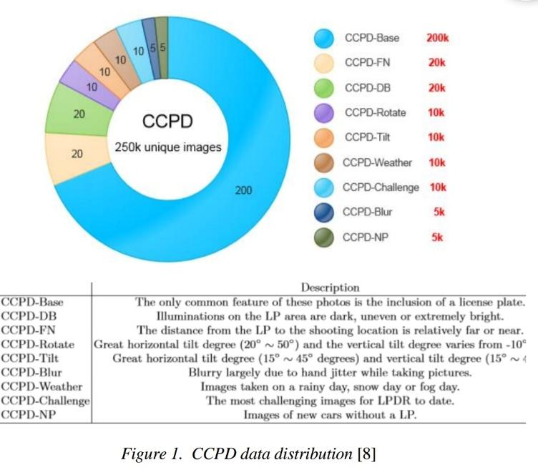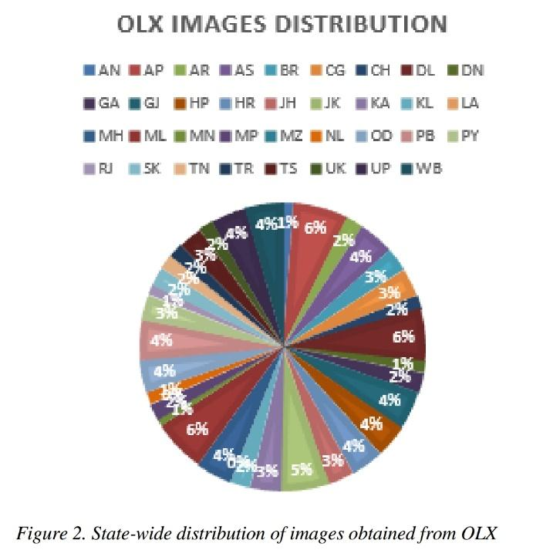

To ensure thorough coverage, the cars in the CCPD dataset are classified into nine distinct classes: ccpd_np, ccpd_blur, ccpd_challenge, ccpd_db, ccpd_fn, ccpd_rotate, ccpd_weather, ccpd_tilt and ccpd_base. Each category captures specific aspects, including different weather conditions, varying illumination levels, rotation angles, image quality variations, and camera distances [1].

The annotations provided in the CCPD dataset furnish extensive information crucial for training license plate recognition models. These annotations encompass multiple key factors, including the ratio of license plate’s bounding boxs to the entire images, the degree of horizontal tilt and vertical tilt of the license plate within the image, the coordinates of the license plate’s top-left and bottom-right corners, the coordinate of all four vertice of the license plates, the alphanumeric characters comprising the license plate number, and indicators of the image’s brightnes and blurrines [1].

In summary, the CCPD dataset’s annotations offer an abundance of valuable information necessary for training accurate license plate recognition models, enabling researchers and practitioners to develop robust solutions for license plate recognition tasks.

B. Indian Datasets

In order to address the lack of an annotated public datasets for Indian vehicle image, we employed various methods to generate our own dataset. Firstly, we utilized web scraping techniques to extract images from online platforms such as OLX. Additionally, we captured vehicles image from highway under different conditions. Through these efforts, we successfully created a dataset comprising approximately 1500 Indian image, which is publicly available for everyone [3].

Scraping of Web proved a particularly valuable approach for obtaining state wise image from OLX website. The proportion of images collected for each state specific to the number of car sellers in that particular state, as illustrated in Figure 2. This method enabled us to gather a diverse range of images representative of different regions within India.

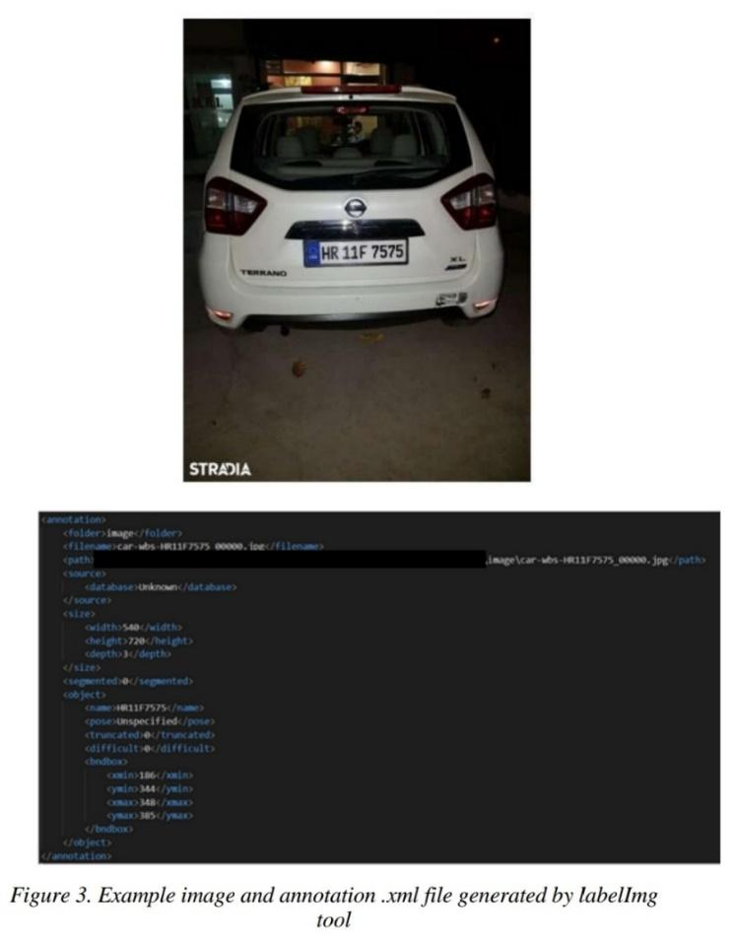

Our dataset serves as a valuable resource, especially given the scarcity of existing Indian vehicle image datasets, such as ImageNet. Furthermore, the dataset has the potential to be expanded by incorporating additional samples based on the specific requirements of end-users.

# 2. Algorithm

RPnet is composed of two modules, namely detection Module (wR2) and recognition module (fh02) as shown in Figure 4

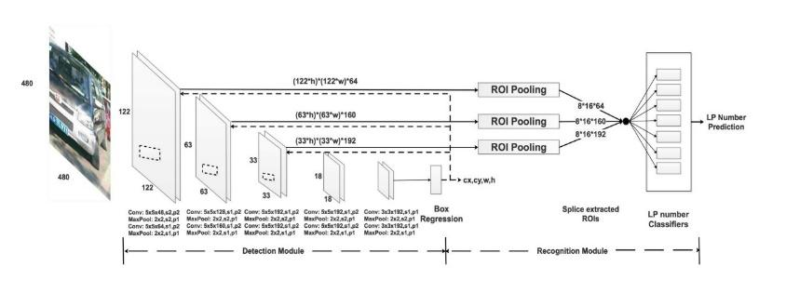

*Figure 4.* RPNet architecture – An end-to-end model for license plateDetection and recognition [8]

A. Detection Modules (wR2)

The detection module (wR2) is a powerful deep convolutional neural network consisting of ten meticulously designed convolutional layers. Its purpose is to extract feature maps of different levels from the input license plate image, employing advanced techniques that enable comprehensive analysis and representation of the license plate's distinctive characteristics.

Figure 5. Parameters to calculate the prediction of the detection module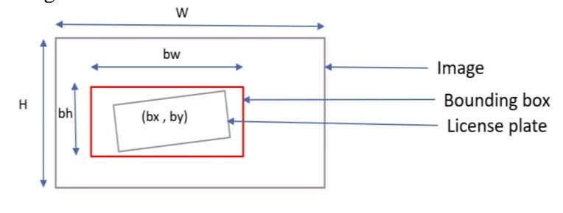

Prior to train the RPnet in an end to end fashion, the module must generate the sensible prediction of the bounding boxses: (Cx, Cy, w, h), is: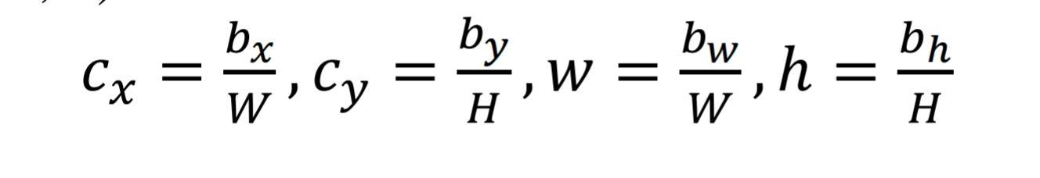

In this representation, (bx, by) corresponds to the x and y coordinates of bounding box's center, while (bw, bh) denote the dimensions of the bounding box, encompassing its width and height, respectively. In this context, 'W' and 'H' denote the dimensions of the entire image, where 'W' represents the width and 'H' represents the height. It is important to note that this detection module is applicable to both the Chinese and Indian contexts, providing bounding boxs predictions in form a list (Cx, Cy, w, h).

B. Recognition Modules (fh02)

The recognition modules Is a crucial in our work by utilizing region of interest (ROI) pooling layer, which take out detailed featured map from a input image. These feature map serve as a foundation for our approach to predicting the license plate (LP) number. In the specific case of Chinese license plates, our methodology employs seven classifiers, each dedicated to predicting one of the 7 character on a license plates.

However, when considering the Indian version of datasets , we have made significant modifications to our approach. To accurately handle the complexity of Indian license plates, we have implemented nine classifiers, each responsible for predicting one of the ten characters found on the license plate.

In the Indian scenario, the first classifier assumes the vital task of predicting the state and union territory codes, which is composed of 2 character. The remaining 8 character on the license plate are alphanumeric, encompassing the 24 English characters (minus ‘I’ and ‘O’) and 10 decimal digits (0 to 9).

This recognition module serves as an integral component of a unified network known as RPnet, which we designed to handle both LP recognition and detection. Trained end to end using the comprehensive CCPD dataset, RPnet possesses the ability to simultaneously accomplish LP in single forward pass. This integration of detection and recognition ensures a streamlined and efficient process for license plate analysis.

# 3. Evaluation Metrics

The training process entails selecting appropriate loss functions to optimize detection and recognition performances. Additionally, it involves pre train the detection modules prior to train RPnet in an end to end fashion. The enternal loss is determined using a loss of smooth L1, while the loss of classification is calculated using cross entropy. According to the writer [8], optimizing both losses simultaneously can lead to improved detection and recognition performance.

1. Detection centainty metric

One of a metrics used to measure the detection accuracy of the bounding boxs is a “Intersection over Union” (IoU) criterion. For a bounding box to be considered correct, its IoU with a ground truth bounding boxs needs to exceed 70% (IoU > 0.7). Notably, after employing a wR2 module [8], the detection accuracy has been reported to reach an impressive 99.3% for “ccpd_base” image, which are devoid of weather-related challenges. However, in the case of ccpd_weather images that are exposed to various weather conditions, the detection accuracy drops to a relatively lower but still reasonable value of 84.1%. These findings highlight the efficacy of the wR2 module in significantly improving the detection accuracy across a range of image types.

1. Recognition accuracy metric

The recognition accuracy metric for LPLP recognition is determined based on two conditions. Firstly, the Intersection over Union (IoU) must be greater than 0.6, indicating a significant underlying between the predicted license plates (LP) region and a ground truth region. Secondly, all individual characters within a LP numbers must be truthfully identified. A claimed recognition accuracy varies depending on the dataset used. For the ccpd_base dataset, the recognition accuracy is reported more then 98.5%, indicating that the system correctly identifies the LP and its characters in the majority of cases. However, for the more challenging ccpd_challenge dataset, the recognition accuracy drops to 85.1%, suggesting that the system struggles to accurately recognize LPs in difficult scenarios. Notably, the recognition rate for both datasets is impressively fast, operating at a rate of 61 frames per second (FPS) according to reference [8].

# 4. Software And Hardware Requirements

By the paper [8], the wR2 models and RPnet models underwent training on a powerful GPU server. The server boasted 8 CPUs, specifically the Intel Xeon CPU E5-2682 v4 at 2.50GHz, accompanied by a generous 60GB RAM. To further enhance the computational capabilities, the server featured a single Nvidia GPU, specifically the Tesla P100 PCIe 16GB.

During the evaluation phase, all works were performed on Leptop equipped with eight 3.40 GHz Intel Core i5-6700 CPUs, along with 16GB RAM. These laptop were also equipped with a Nvidia 1050ti GPU, which contributed to the overall performance. It is worth noting that, for the specific work being described.

In terms of software, the implementation relied on Python 3.7.7, a versatile programming language widely used in the field of machine learning. To facilitate deep learning tasks, the researchers utilized PyTorch 1.9.0, a popular framework that provides support for GPU acceleration through Cuda 10.2. These software tools played a vital role in enabling efficient model training and evaluation processes.

# 5. Experiment

The objective of experimentation was to reproduce the accuracy reported in the literature [8] and attempt to customize the model and the dataset for Indian vehicles.

A. Testing images by running the demo code

To begin our experiment, we executed the demo code given by the creator of CCPD, which included a set of sample test data. This data was specifically selected by the CCPD authors to showcase the performance of their license plate recognition system. We utilized the pre-trained weights [1], which were already trained on a large dataset to enhance the recognition capabilities of the system.

Upon testing sample images, we observed that a license plate recognition functionality successfully operated on 80% of the test images. This means that out of the total test image set, the system accurately detected and recognized the license plates in 80% of the cases. It is worth noting that this impressive success rate demonstrates the effectiveness and reliability of the CCPD system in identifying license plates in real-world scenarios.

By employing the pre-trained weights and the provided test data, we gained valuable insights into the performance of 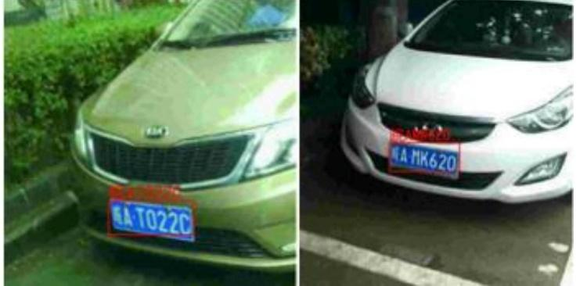

*Figure 6.*  Rigth and wrong prediction on the demo image

model developed by CCPD. The high accuracy achieved in the majority of the test images highlights the robustness and potential of the system, making it a promising solution for various applications requiring license plate identification.

## B. The pretrained model testing on Indian images

The pre trained of RPnet model underwent rigorous testing using a diverse set of Indian images to evaluate its performance. To ensure an unbiased assessment, near 10% of the image were randomly selected as testing data. The test results revealed a concerning issue regarding the bounding box predictions made by the model. In fact, upon examination of all the test images, it was found that the bounding box predictions were consistently incorrect. An illustrative example showcasing one such erroneous bounding box prediction can be seen in Figure 7. This 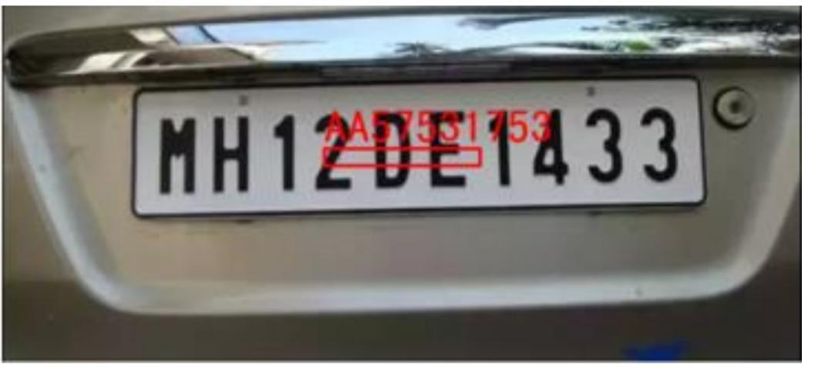

*Figure 7.* Wrong bounding boxs prediction in Indian number plate image

discovery raised important concerns about the model’s accuracy and highlighted the need for further investigation and improvement.

## C. Test images inference over CCPD

To assess a accuracy claimed in a paper, we conducted a comprehensive evaluation by subjecting the model to all the test images available in the CCPD. The result revealed that the accuracy varied across different subsets of the dataset. For the ccpd_base subset, the accuracy was measured at 41.57%, while for ccpd_weather images, it yielded 38.58% accuracy. Notably, the ccpd_challenge subset demonstrated a lower accuracy of 29.17%. These contrasting outcomes could potentially be attributed to a crucial factor: the model provided in GitHub repositorys might differ from the one employed to obtain the reported result in a papers.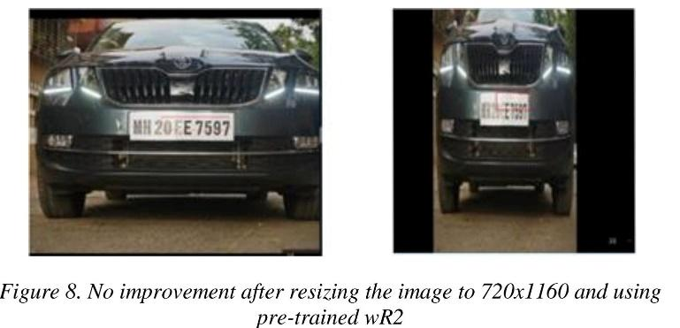

In this paper, the detection module of the model underwent training using a collection of randomly selected 200,000 CCPD images [1]. This training process resulted in a noteworthy enhancement in accuracy for ccpd_weather images, exhibiting a 20% improvement. However, the effect on Indian images was found to be insignificant, as detailed in Table 1. These additional insights shed light on the experimental setup and offer a more nuanced understanding of the model’s performance across different image subsets.TABLE I.

TABLE 1. Similarities of my Model and Pre-trained model.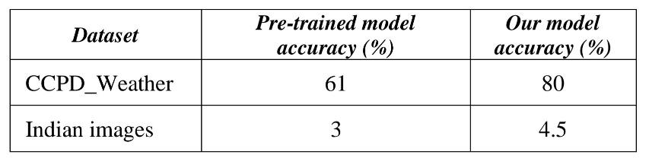

## D. Calibrateing RPNet on Indian Datasets

After observing that there were no discernible enhancements in the working of the detection model on Indian images, we decided to carry out a fine-tuning process on RPnet. To do this, we utilized a subset comprising 25% of Indian images, focusing specifically on those where the pre-trained detection model had shown promising results. Unfortunately, despite our efforts, the experiment did not yield any noticeable improvements in the efficiency of the detection model. However, this outcome served as a strong motivator for us to explore alternative approaches. Consequently, we embarked on a path to align the characteristic of the Indian datasets with the Chinese City Parking Datasets (CCPD) through the application of image pre-processing techniques.

## E. Altering the images in Datasets to 720x1160 pixels

After carefully examining the original implementation [1], we discovered crucial details regarding the network’s input shape. It became apparent that the initial dimensions were set at 720x1160 pixels. However, during the image processing stage, the images underwent a resizing operation, resulting in a final size of 480x480 pixels. It worth noting about the bounding boxs was normalized based on the primary image’s proportions, despite utilizing the resized images.

Taking this observation into account, we made an informed decision to modify our data preprocessing pipeline. We opted to directly resize the images to the original dimensions of 720x1160 pixels, adjusting the annotations accordingly. Unfortunately, this adjustment did not give any major improvement in the accuracy of a bounding box predictions when utilizing the pre-trained wR2 weights.

Upon closer analysis, we discovered that the resizing operation caused a distortion of the input features. This distortion is clearly illustrated in Figure 8, where the effects of this process on the input-features are evident. Despite our initial hopes, the use of the resized images did not result in the desired enhancement of the bounding box prediction accuracy.

## F. Letterboxing images

When the process of letterboxing is applied to the images, they undergo resizing while maintaining their original aspect ratio. The remaining portions of the images are then padded in order to make a last image size of a 720x1160 pixels. This letterboxing technique effectively eliminates the previously reported image distortions, which is seen in the Figure 9. Notably, this approach result in a significant 3.5% enhancement over the utilization of pretrained weight with the originally, unmodified images.

G. . Calibrateing wR2 with image have IoU>0.5

During the process of fine-tuning wR2, a computer vision model, it was found that by including 20% of the images that exhibited an Intersection over Union (IoU) value greater than 0.5 after undergoing letterboxing, significant improvements in IoU accuracy were achieved. Specifically, the initial IoU accuracy of 6.40% was notably enhanced, resulting in a final IoU accuracy of 7.55%. This enhancement demonstrates the effectiveness of incorporating a subset of images with higher IoU values and the impact of letterboxing on refining the model’s performance.

## H. CCPD and Indian Datasets,Data Analysis

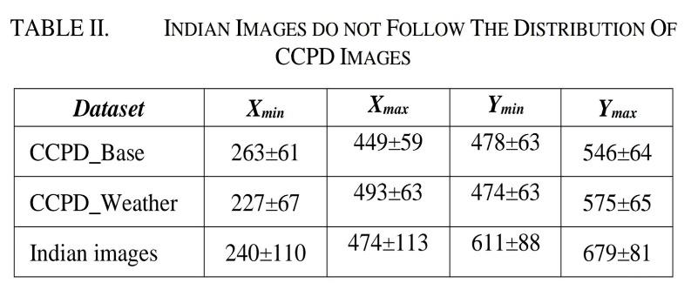

We were motivated to conduct a comprehensive data analysis of both CCPD image datasest and Indian image datasest due to the poor concept observed in Indian image. Our objective was to gain deeper insights into the discrepancies between the two datasets. Upon examination, we discovered that training image and testing image in the CCPD dataset exhibited a same distribution pattern. In contrast, a Indian dataset displayed notable differences. These dissimilarities were further substantiated by comparing the variances of the bounding box coordinates between the two datasets. Our findings, as illustrated in Table II, clearly indicate that the CCPD images exhibited significantly lower variances in bounding box coordinates compared to the Indian dataset.

I. After shifting the image checking IoU

The Indian image underwent a series of preprocessing steps in order to align them with the CCPD distribution. First, each image was shifted to the appropriate bounding box location, determined by the (xmin, ymin) coordinates. This adjustment ensured that the objects of interest within the images were properly aligned with the standardized dataset. Additionally, the images were subjected to a stretching process to further normalize their appearance.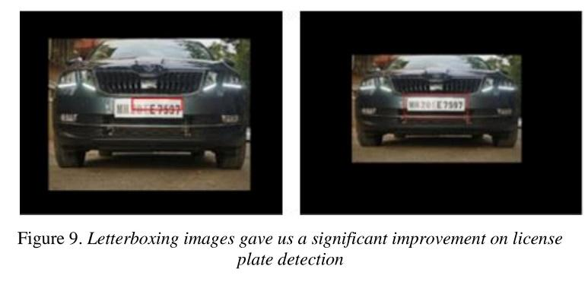

Upon implementing these preprocessing steps, a notable improvement was observed in the Intersection over Union (IoU) metric, which Calculates the degree of intersection between the predicted and actual values of bounding boxes. This positive effect is clearly depicted in Figure 10 and Figure 11, where the IoU scores exhibited a significant increase.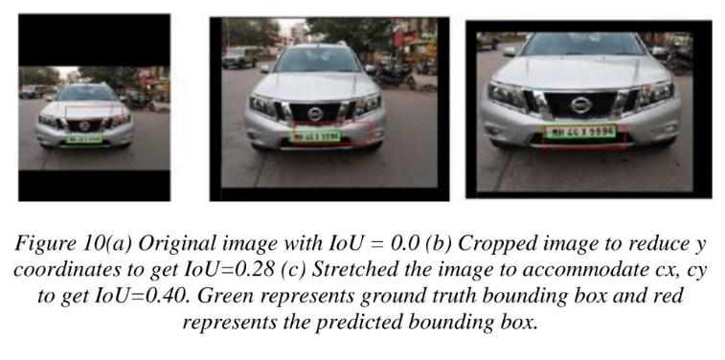

To streamline the entire process, an automated system was developed. This system was designed to handle a given set of images, automatically performing the necessary translation, and generating new annotations for the shifted images. The resulting annotations were then stored in the widely-used Pascal VOC format, ensuring compatibility with other tools

and frameworks commonly used in computer vision tasks.

## J. After adding classifiers and training RPNet

After Calibrateing the wR2 model, we observed a significant improvement in Intersection over Union (IoU) scores. Encouraged by these results, we decided to utilize this enhanced model to train RPnet, focusing on a specific subset of images. We selected 75% of the images that achieved an IoU greater than 0.5 and had license plates consisting of exactly 10 digit characters.

In the scenario of Indian license plate, the structure typically involves a combination of alphabets and numbers, where the initial two alphabets on the license plate correspond to the state code. Consequently, we developed a total of nine classifiers, with the initial classifier being dedicated to identifying the state code. 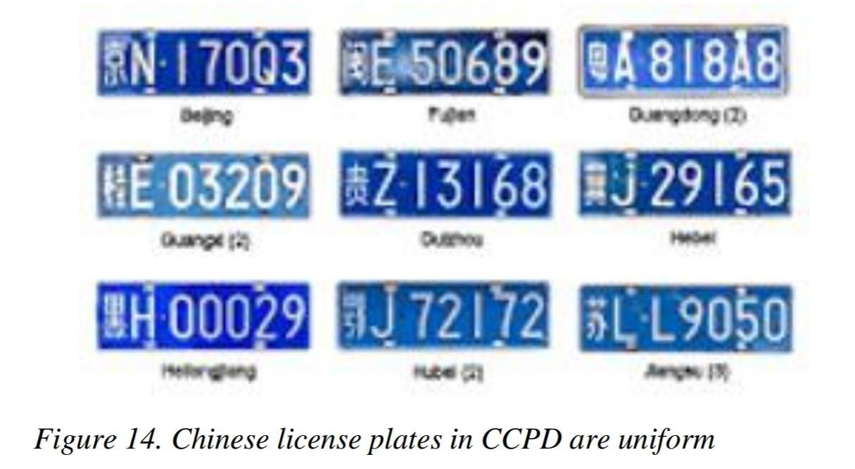

During the training process, we observed a notable decrease in the overall loss metric, which reached a reduction of 68.54%. This outcome highlighted the effectiveness of our approach, indicating that our model was able to make more accurate predictions and improve performance compared to previous iterations.

## K. Leveraging the power of YOLOv5 for Accurate License Plate Detection

In our research, we encountered a limitation with RPnet, a neural network model, as it struggled to effectively recognize and analyze images specific to the Indian context. To address this issue, we embarked on a solution involving the fine-tuning of Yolov5s, an advanced object detection model pretrained on the COCO dataset [9], specifically for the task of detecting number plates. Through this process, we aimed to enhance the performance of Yolov5s on Indian images.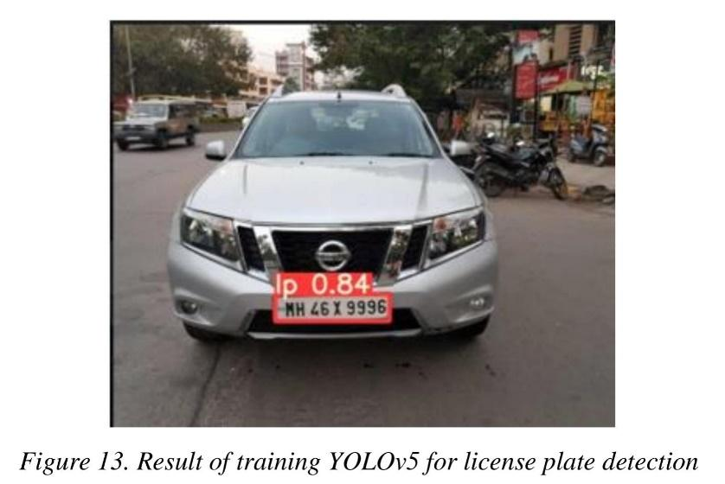

After extensive efforts, we achieved remarkable results, with the fine-tuned Yolov5s exhibiting a remarkable number plate detection accuracy of 99.52% when evaluated on Indian images. This significant improvement in accuracy is a testament to the effectiveness of our approach. To provide visual evidence of our findings, we have included an illustrative example in Figure 13, which showcases the successful identification of a number plate using our fine-tuned Yolov5s model.

This experiment shed light on the importance of utilizing a comprehensive dataset like COCO for training models in the context of Indian images. The wide diversity and unique characteristics found in Indian imagery necessitate the availability of a rich and expansive dataset during the training process to ensure accurate and reliable performance.

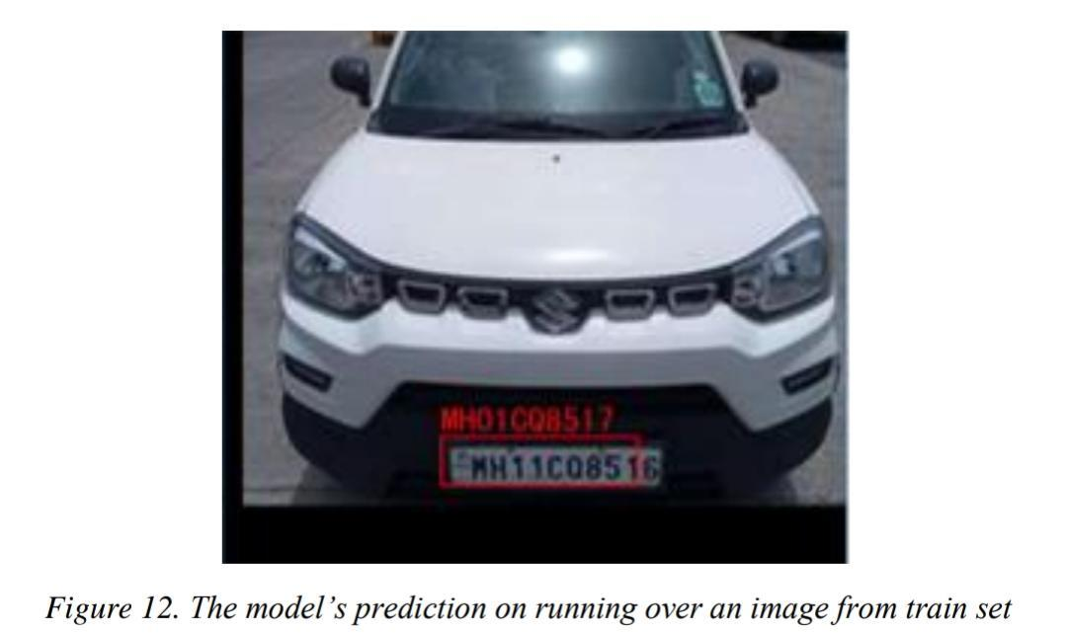

# 6. DISCUSSIONS

In our endeavor to comprehend the factors behind the incompatibility of the CCPD-trained RPnet model for the Indian context, we conducted an in-depth investigation. In the course of Experiment H, which involved meticulous data analysis, we made several enlightening observations. One notable finding was that the CCPD dataset exhibited a remarkable degree of uniformity regarding the license plates it contained. Specifically, all 250,000 license plate images featured a consistent, the background color is a pristine shade of blue, perfectly complemented by flawlessly rendered white text in an identical font. This uniformity in color, text style, and font choice across the entire dataset provided valuable insights into the distinct nature of the CCPD dataset, further highlighting the challenges it poses when directly applied to the Indian context.

One major issue arises from the diverse array of vehicles that populate the typical Indian road. A multitude of transportation options can be found, ranging from cars,scooters, and motorcycles , buses,tractors, trucks, and auto . What further complicates matters is the fact that the majority of these vehicles possess license plates with varying formats and styles. For instance, multiline number plates are prevalent among 95% of two-wheelers and auto rickshaws, while single line plates are utilized by around 90% of cars [14].

Another problem stems from the wide assortment of "Various font styles and uniquely crafted license plates" employed throughout country. Furthermore, license plate vary in their shapes and sizes, with rectangular plates constituting only a portion of the whole. Trapezoidal and irregular shapes are also prevalent. In addition to the license number, various additional characters or shapes, such as hyphens, periods, or large spaces, can be found on the number plate. The character set on Indian license plates extends beyond the conventional alpha-numeric datasets, encompassing “Letters originating from the local culture and heritage” as well. These situation arises due to the ongoing implementation of a the standardized format of vehicle number plates in India. Consequently, The significant diversity in license plate designs poses a formidable challenge since there is presently no dataset available that adequately captures this extensive range of variations.

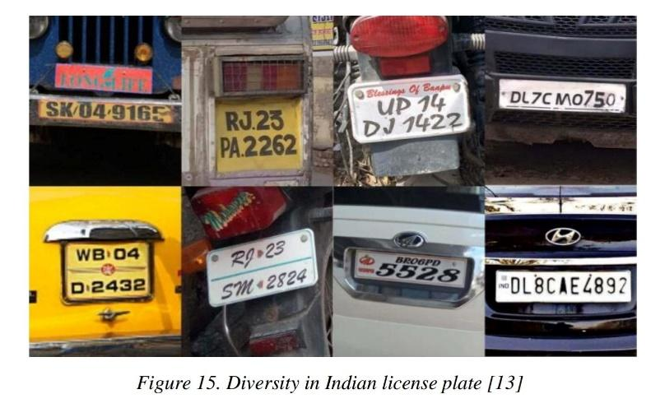

In our project, we encountered a persistent issue of having a limited dataset. Specifically, we were faced with a lack of a large dataset to work with. The dataset we utilized, known as CCPD, consisted of 250,000 images. To train the RPnet model, we employed 100,000 images from the dataset and reserved the remaining images for testing purposes.

In contrast, our project focused on a significantly smaller set of 1,500 images. These images exhibited a diverse distribution, posing a challenge for our analysis. It became evident, however, that the license plate detection performance improved when we applied a preprocessing step to the Indian dataset, mirroring the methods used for a Chinese datasets. This pre-processing involved implementing letterbox and translating the image to simulate the characteristics of the Chinese images.

This observation highlighted a notable distinction between the Chinese and Indian datasets. Specifically, the Chinese dataset demonstrated less diversity in terms of license plates size within the image and a series of coordinate points with a defined range of a bounding boxs for a predicted license plates. Consequently, the RPnet model, which was successful with the Chinese dataset, did not yield satisfactory results when applied to the Indian vehicle images. This finding further emphasized the importance of dataset similarity in achieving accurate license plate detection.

# 7. CONCLUSION

Due to the scarcity of available data in the Indian dataset, we undertook the task of creating our own dataset consisting of approximately 1.5k images. These images were meticulously annotated following the Pascal VOC standard, ensuring accurate labeling for training purposes. In order to validate the accuracy claimed in a previous study [8], we conducted tests using the ccpd_weather test images. The results indicated that our model achieved an accuracy of 80%, slightly lower than the 84% as asserted by the original papers.

To enhance a stereotype capability of the module in Indian image, we implemented specific preprocessing techniques. This led to a substantial improvement, as the IoU (Intersection over Union) score increased from 0.01 to 0.325. However, despite our efforts, the recognition module did not exhibit the same level of generalization on the test image of Indian datasets. The observed difference can be attributed to the utilization of the CCPD model as a baseline in this study, had been trained on a dataset consisting of 100K images, while the Indian dataset was relatively limited in size.

To address this limitation, we explored an alternative approach using Yolov5s. Remarkably, this alternative method achieved an impressive accuracy of 99.5% for the detection task. The utilization of Yolov5s proved to be an effective solution in compensating for the limited number of Indian images and surpassing the performance of the original model.

# REFERENCES

1. Codebase and CCPD database for RPNet. [Online] [https://github.com/detectRecog/CCPD.](https://github.com/detectRecog/CCPD)
2. Application-oriented license plate recognition. Hsu, GeeSern, Chen, Jiun-Chang and Chung, Yu-Zu. s.l. : IEEE transactions on vehicular technology, 2012. [3] Indian Vehicle Dataset. Amazon drive link. [Online] https://www.amazon.com/clouddrive/share/rrCCyD1yoEt6 WqHRcprU0C1FzMFJo26xajwC9nZEEgl.

1. Automated License Plate Recognition: A Survey on Methods and Techniques. J., Shashirangana, et al. IEEE Access, Vol. 9, pp. 11203-11225.
2. Lubna, Mufti, Naveed and Shah, Syed Afaq Ali. Automatic Number Plate Recognition:A Detailed Survey of Relevant Algorithms. s.l. : Sensors, 2021.
3. Real-time Bhutanese license plate localization using

YOLO. Yonten, Jamtsho, Panomkhawn, Riyamongkol and Rattapoom, Waranusast. 2, s.l. : ICT Express, Vol. 6.

1. NTUT ML license plate recognition. GitHub Link. [Online] https://github.com/hsuRush/DeepANPR.
2. Towards End-to-End License Plate Detection and Recognition: A Large Dataset and Baseline. Xu, Zhenbo, et al. s.l. : Springer, 2018. ECCV.
3. Everingham, Mark and Winn, John. The PASCAL Visual Object Classes Challenge 2012 (VOC2012) Development Kit. [Online] May 2012. https://pjreddie.com/media/files/VOC2012_doc.pdf.
4. LabelImg tool GitHub Link. [Online] https://github.com/tzutalin/labelImg.
5. Yolov5 GitHub Link. [Online] https://github.com/ultralytics/yolov5.
6. Automatic License Plate Recognition for Indian Roads Using Faster-RCNN. P., Ravirathinam and A., Patawari. 2019. 11th International Conference on Advanced Computing (ICoAC).
7. ANPR for India. [Online] https://platerecognizer.com/anpr-for-india/.
8. SLPNet: Towards End-to-End Car License Plate Detection and Recognition Using Lightweight CNN. Zhang, W., Mao, Y. and Han, Y. s.l. : Pattern Recognition and Computer Vision, 2020.