FACE RECOGNITION

Mr. B. Varun Kumar

Abinav DS

[abinavds18@gmail.com](mailto:abinavds18@gmail.com)

Abinesh R [abinesh26060@gmail.com](mailto:abinesh26060@gmail.com)

Akash D [akashdhandapani39@gmail.c](mailto:akashdhandapani39@gmail.c) om

Sri Shakthi Institute of Engineering and Technology, Coimbatore.

Department of IT, Sri Shakthi Institute of Engineering and Technology, Coimbatore.

## Abstract:

Face recognition technology has become an essential component of modern security and authentication systems due to its non-intrusive nature and high accuracy. This paper provides an overview of the latest advancements in face recognition techniques, focusing on the evolution from traditional methods, such as Principal Component Analysis (PCA) and Linear Discriminant Analysis (LDA), to contemporary deep learning approaches, notably Convolutional Neural Networks (CNNs) and their variants. We explore the implementation of these methods in various applications, including security surveillance, access control, and personal device authentication. The paper also addresses the challenges associated with face recognition, such as variations in lighting, pose, and occlusions, and examines solutions like data augmentation and adversarial training. Additionally, we discuss privacy concerns and ethical considerations arising from the widespread deployment of face recognition systems. Our analysis underscores the potential of integrating face

recognition with other biometric modalities to enhance accuracy and robustness, paving the way for more secure and reliable identity verification systems.

## Keywords:

There are no specific keywords for face recognition in the context of Lightroom Classic. However, face recognition is a feature in Lightroom Classic that allows you to identify and tag people in your photos. The feature is also known as "People" or "Face Detection".

If you're looking for keywords related to face recognition in a more general sense, here are some examples:

* Face detection
* Face recognition
* Facial recognition
* Person detection
* People tagging
* Face identification

## Introduction:

Face recognition is a biometric technology that uses algorithms to identify or verify a person's identity from a digital image or video frame by analysing their facial features. It has become increasingly accurate and widely used in various applications such as personal security, law enforcement, digital onboarding in finance, and commercial identification

Face recognition technology is a sophisticated method of verifying or ascertaining an individual's identity using an algorithm that processes digital images or video frames. It matches the distinguishing features of a face in an image against a database of faces to confirm an individual's identity

Face recognition algorithms have evolved from using geometric features to more advanced techniques like convolutional neural networks (CNNs) and

deep learning. These methods analyse the face holistically, considering shapes, contours, and shading, rather than just specific geometries.

While face recognition is less accurate than fingerprint or iris recognition, it is often preferred due to its contactless nature. However, factors such as illumination, expression, pose, and image quality can still affect the performance of facial recognition systems.

**FACIAL LAND MARK DETECTION**

Facial landmark detection is the process of identifying key points or landmarks on a human face in an image or video. It is a crucial step in many computer vision applications, such as facial recognition, facial expression analysis, and augmented reality.

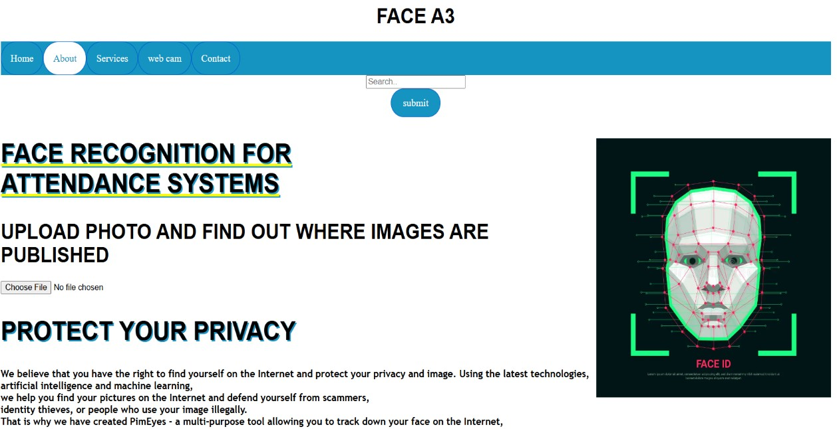

**PREVENTS SECURITY ISSUE**

The system checks the user's identity by comparing the recognized face to the stored facial data. This ensures that only authorized individuals can access the system.

If the user is recognized, they are redirected to a page where they can select the class they are attending. The attendance for the selected class is then updated in the database.



**SERVICES OF FACE RECOGNITION**

* + Face Detection: Identifying and locating human faces within images or videos.
  + Face Verification: Confirming that a face matches a specific identity through "one-to-one" matching.
  + Face Identification: Matching a face to a set of identities in a database through "one-to-many" matching.
  + Facial Analysis: Extracting attributes like head pose, age, emotion, facial hair, and glasses from faces



Face analysis is a technology that uses artificial intelligence and machine learning to analyse human faces and provide detailed information about the individual. This includes features such as age, gender, and emotions. Face analysis can be used in various applications, including beauty and skincare analysis, facial recognition, and customer experience enhancement.

**FACE ANALYSIS**

+

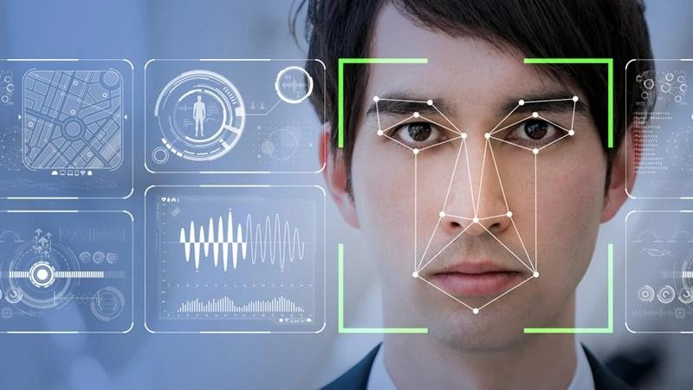

**Proposed Method:**

Face recognition technology has witnessed significant advancements in recent years, driven by breakthroughs in deep learning and computer vision. Here's a proposed method for face recognition using state-of-the-art models:

# Face Detection

Use a face detection algorithm, such as the Dlib library, to detect faces in an image or video stream. This step is crucial in identifying the region of interest (ROI) for face recognition.

# Facial Landmark Detection

Use a facial landmark detection algorithm, such as the Dlib library, to detect key facial features, such as the eyes, nose, and mouth. This step helps in aligning the face and extracting relevant features.

# Face Alignment

Use the facial landmarks to align the face, which involves rotating and scaling the face to a standard position. This step ensures that the face is in a consistent orientation, making it easier to extract features.

# Feature Extraction

Use a deep learning-based model, such a Convolutional Neural Network (CNN), to extract features from the aligned face. This step involves extracting a compact representation of the face that can be used for recognition.

# Face Recognition

Use a face recognition algorithm, such as face recognition model, to compare the extracted features with a database of known faces. This step involves computing the similarity between the input face and the faces in the database.

# Identity Verification

Verify the identity of the individual based on the similarity score obtained in the previous step. This step involves determining whether the input face matches a known face in the database.

# Conclusion:

Face recognition technology has made significant strides in recent years, becoming a crucial tool in various applications such as security, authentication, and personalized user experiences. The advancements in deep learning and neural network architectures have enhanced the accuracy and efficiency of face recognition systems.

# REFERNCES

* + "Face Recognition: A Survey" by W. Zhao, R. Chellappa, P. J. Phillips, and A. Rosenfeld (2003) - A comprehensive survey of face recognition techniques.
  + "Deep Face Recognition" by M. Yang, and L. Wolf (2014) - A paper on deep learning-based face recognition.

Libraries and Frameworks:

* + OpenCV - A computer vision library with face recognition capabilities.
  + Face Recognition - A Python library for face recognition.
  + D lib - A C++ library with face recognition capabilities.
  + TensorFlow - A deep learning framework with face recognition examples.
  + PyTorch - A deep learning framework with face recognition examples.