E-COMMERCE SHOPPING WEBSITE

M.Kirubadevi & M.Abisornam & S.Arunthathi

M. Kirubadevi [mkirubadeviit@siet.ac.in](mailto:mkirubadeviit@siet.ac.in)

M.Abisornam [abisornam16@gmail.com](mailto:abisornam16@gmail.com)

S.Arunthathi [anuarunthathi127@gmail.com](mailto:anuarunthathi127@gmail.com)

Sri Shakthi Institute of Engineering and Technology, Coimbatore.

Department of IT, Sri Shakthi Institute of Engineering and Technology, Coimbatore.

# Abstract:

"E-Commerce Website” creates a dynamic platform for buying and selling goods and services. Nowadays, E-Commerce websites face a lot of cyberattacks. These cyberattacks can be prevented by using encrypted data for storing personal user information. Continuous advancements in technology are necessary for overcoming challenges in digital marketplaces. The main goal of this website is maintaining customer satisfaction. It enhances the convenience of customers by shopping from their own place. A key to long term success in this platform is by focusing on customer-centric approaches. It reduces likelihood of human error. It can help customers with choosing products according to their preferences. Furthermore, it can also operate all 24 hours a day. People from rural areas can purchase products without having any difficulty in moving from one place to another. Many retail sellers can take part and sell their goods easily.

# Keywords:

. Website development platforms and frameworks ,email marketing tools, analytics and reporting, user experience and interface design, payment gateways.

# Introduction:

E-commerce website enables customers the best comfortable shopping experience at any time without the need of any physical locations. It provides a good platform for businesses and consumers in buying and selling . Continuous mobile experiences are now emerging, where the main portion of online shopping occurs through responsive websites and applications. E-commerce websites must be continuously updated to meet daily challenges of the global market. Using E-Commerce websites, individuals can easily opt for their start-up businesses. This offers more opportunities for entrepreneurs. E-commerce platforms enhance customer services like reviews. Physical stores have more costs like rent, cost for labour, etc. They also show wide range of variety in products in a digital catalogue, which is not possible in real-time stores. They are reasonably low-maintenance websites. Customers can use their own devices to access these online stores. In physical stores customers might have difficulty locating a particular product. Since E-Commerce websites are available to all, people from remote areas can also access it. It creates new opportunities for brands to engage with consumers. User-generated content such as product reviews, ratings, and feedback play an important role in influencing purchasing decisions in e-commerce. Positive reviews and social proof can build trust and trustworthiness for brands and products. E-commerce provides businesses the flexibility to adapt quickly with changing market conditions and extend their operations as per their needs.

## E-COMMERCE SHOPPING WEBSITE

**HOME PAGE**

This homepage shows a visually appealing design with a model layout, making it easy for users to navigate to their desired pages. The search bar allows users to easily search for specific products within our E-commerce websites. The high-quality images added enhances the shopping experience.

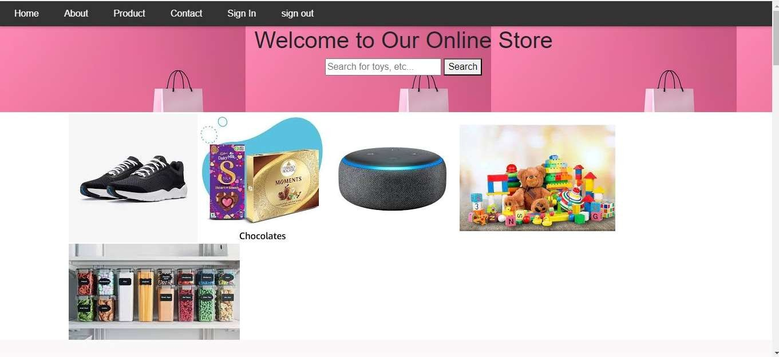

## ABOUT US

About us page helps in establishing trust and reliability with customers. It allows our visitors to connect with us in a deep level. It also creates a sense of positive impression and authenticity. It creates trust among users.



## PRODUCTS :

Products page showcases all the products with high quality pictures and costs of all products and it ensures clarity and transparency for customers. The add to cart and buy now buttons helps users to decide whether to buy the product now or buy it later.

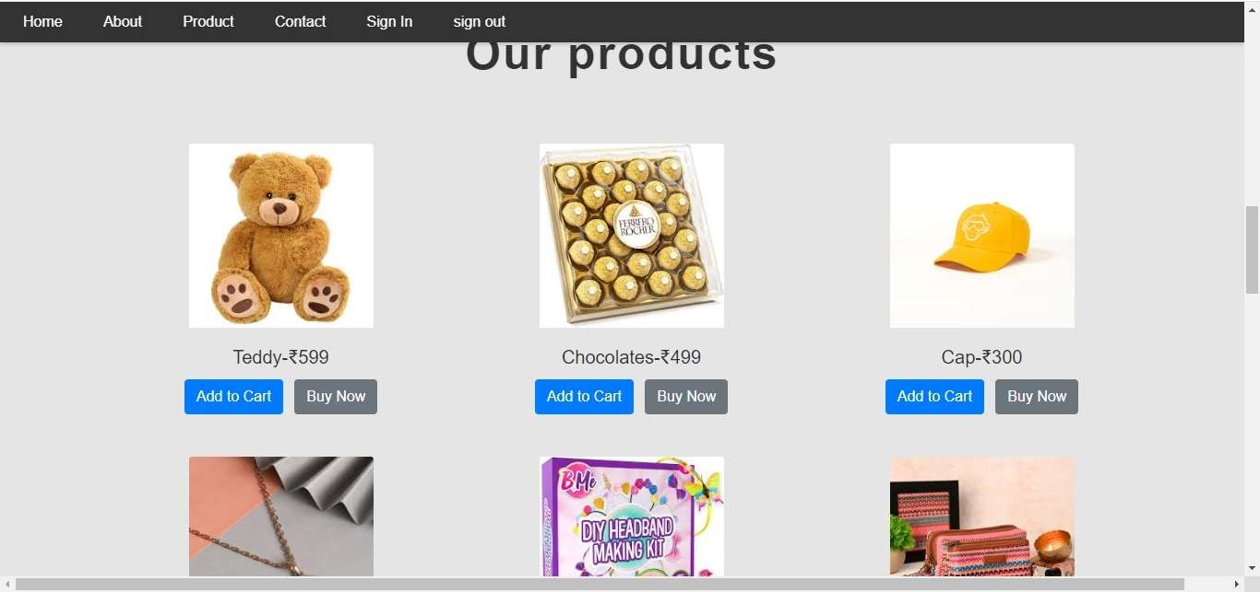

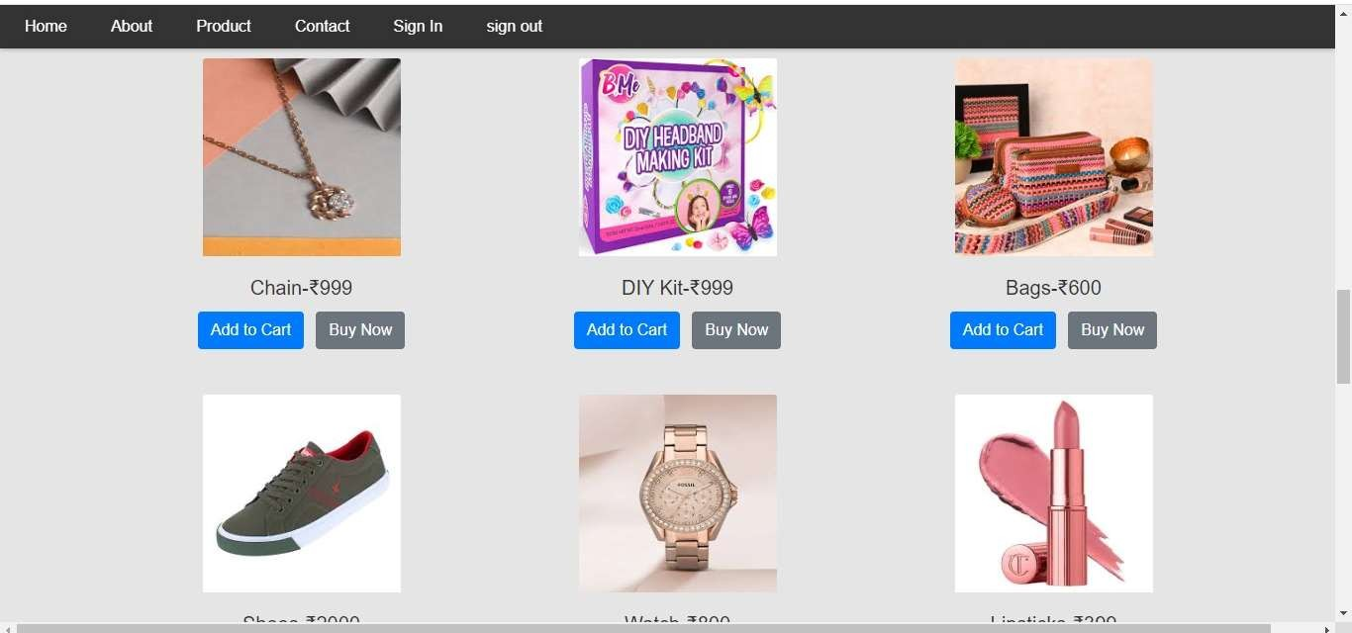

## CONTACT

Contact us page serves as a bridge between our business and our customers. It provides means for communication, feedback and queries , if any. It enhances customer experience. This user-friendly form helps users to contact us in case of any queries. Reviews are much important in developing E-Commerce websites. It not only facilitates communication but also enhances customer satisfaction.

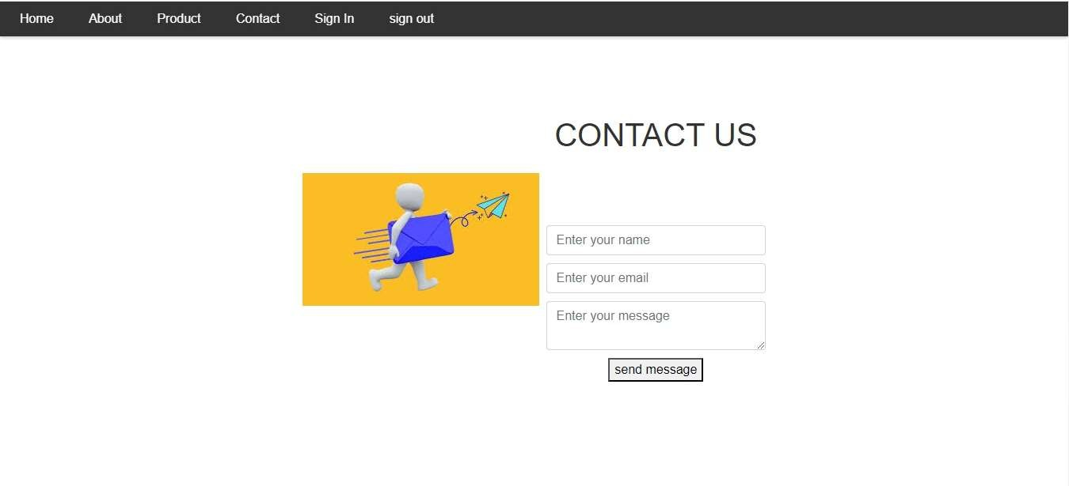

## SIGN IN PAGE

Sign in page serves as a gateway for registered users to access their accounts by logging in.This design is simple and user-friendly which helps in quick logins.

## ENCRYPTED PASSWORDS :

The passwords are encrypted so that even the owner cannot get access to it. The passwords that are saved in database are encrypted using salting method.

## PURPOSE

Salting is adding random set of characters to each user’s password before encrypting it. The user’s saved data is stored in the form of tokens. In case if the user has already registered in database , then it identifies their tokens and helps in logging in successfully.

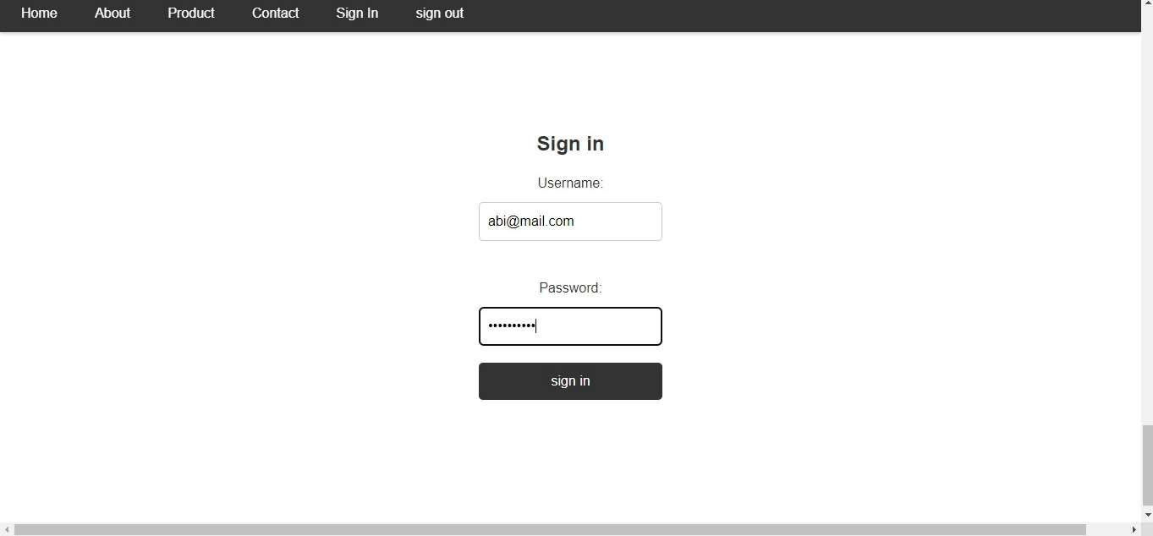



## LOGOUT PAGE

It is the action of ending the current session and logging out the user out of their account. If the user clicks logout , the username of the user is removed .But if the user clicks logout without logging in , then it will show error message.



# References:

1. "E-commerce and its Socio-Economic Impacts in India" by Sanchita Paul and Debabrata Talukdar (2004)
2. "Challenges and Opportunities of E-commerce Adoption in India" by Anupam Krishna and Nripendra P. Rana (2014)
3. "Consumer Behavior in Indian E-commerce" by Tanvi Gupta and Rohit Trivedi (2015)
4. **“**E-commerce Adoption in Indian Small and Medium Enterprises: Some Exploratory Evidence" by

K. R. Jayasimha and B. Karthikeyan (2013)

1. "Digital Divide: E-commerce Opportunities in India" by Abhinav Pandey and Dharmendra S. Sengar (2011)
2. "Critical Success Factors for E-commerce Adoption in Indian SMEs: A Review and Meta-analysis" by Sandeep K. Kautish and Yogesh K. Dwivedi (2014)