**A Study On The Effectiveness Of Job Satisfaction On Employee Performance In The It Sector**

**Peddagolla Akhila**

Roll No: 212122672077, Department of Management Studies

Aristotle PG College,Chilkur, Moinabad, Ranga Reddy District, Telangana.

**Ms.C.Jyothika Sony**

Assistant Professor

Aristotle PG College, Chilkur, Moinabad, Ranga Reddy District, Telangana.

[jyothika.chh@gmail.com](mailto:jyothika.chh@gmail.com)

**Abstract:**

Job satisfaction refers to one's feelings towards one's job. If the employees expectations are fulfilled (or) the employees get higher than what he / she feels satisfied. If the job satisfaction increases organization commitment will increased. This results in the higher productivity. The main objectives of this project are to assess the job satisfaction: to identify the effectiveness of job satisfaction and to find out the several factors like personal and organizational factors influencing job satisfaction: to identify the effectiveness of job satisfaction and to find out the several factors like personal and organizational factors influencing job satisfaction of employees. In this study, 125 no's of respondents have been taken as sample. Percentage analysis, weighted average, chi-square have been incorporated for research analysis. The study helped in revealing the level of satisfaction of employees with reference to the various factors provided in the organization. This study clearly shows that employees under organization are more or less satisfied with the job. The organization should consider on the salary, relationship of employees and supervisors, grievance handling and give more opportunity for the new employees.

**Keywords:** Job satisfaction, organizational factors, chi-square, weighted average

**INTRODUCTION:**

## JOB SATISFACTION

Workplace satisfaction is a popular topic in the fields of organizational behavior and human resource management. In addition, it is a reflection of an employee's devotion to the business. In other words, job satisfaction is a person's sentiments or state of mind about their employment. It's a measure of how happy a person is with his or her employment.

When a person feels satisfied at work, it works as a motivator to work. In other words, it isn't self-satisfaction or self-happiness, but rather fulfilment at work.

## VARIOUS DEFINITIONS OF JOB SATISFACTION:

As described by Bullock (1952), job satisfaction is an attitude that emerges from balancing and summing up numerous distinct likes and dislikes associated with the job.

Job satisfaction is described by Smith (1955) as the employee's evaluation of how effectively his job as a whole meets his different requirements.

It's a pleasure or a good emotional state that arises from a person's evaluation of their job or employment experience, according to Locke (1969).

"Job satisfaction is the workers' reaction to the role they play in their employment," Vroom says.

It is possible to define job satisfaction based on these definitions by adding up all the negative and positive aspects of an individual's salary, physical and emotional working conditions, level of power and autonomy he/she has, success she/he has achieved and the rewards received as a result of this success, and social state in relation to his/her job.

## THEORIES OF JOB SATISFACTION:

There are some theories to describe the job satisfaction.

* + **Fulfillment theory:** According to this idea, contentment is measured in terms of reward. What a person obtains or how well his wants are met. The researchers also hypothesized that work satisfaction and actual fulfilment of predicted requirements are directly related. As a result, job satisfaction is not only a function of what a

person gets, but also what he believes should get at there would be substantial variation in the accruals and expectations of individuals. Because of this, work happiness is not only a consequence of how much a person gets from his or her employment.

* + **Discrepancy theory:** People who support this idea believe that contentment is determined by both what a person really receives and what he believes he should receive. When real satisfaction is less than projected satisfaction, discontent occurs as a consequence. It's a result of the perceived link between what one wants from a job and what one believes it offers.
  + **Equity theory:** Perceived equity, according to its proponents, determines a person's level of pleasure. There's a perceived ratio between what a person gets from his profession and what he puts into it, which is called input-output balance. That both under and over rewards may lead to discontent, while under awards can lead to sentiments of unjust treatment, and over rewards can lead to guilt and discomfort.
  + **Two factor theory:** According to Herzberg, Mnusener, Peterson & Corpwell, some variables satisfy and dissatisfy people. There are a number of factors that are satisfied by the existence of them but their absence does not result in work satisfaction.

**REVIEW OF LITERATURE:**

**ARTICLE: 1**

**Title:** Employees' Job Satisfaction And Their Work Performance As Elements Influencing Work Safety

**Author: Szymon T. Dziuba1,** **Manuela Ingaldi2, Marina Zhuravskaya**

**Source:** **CzOTO 2020, volume 2, issue 1, pp. 18-25**

Job satisfaction has a big impact on how an employee performs his job. Both elements have an impact on job safety and employee perception of it. A satisfied employee devotes himself to work, performs orders better, cares for others and for him. He feels safe in the enterprise. The aim of the paper was to assess employees' job satisfaction and their work performance with use of simply survey. In order to achieve this aim, a survey was conducted among employees of a chosen metallurgical enterprise who were asked to assess level of their job satisfaction. The employees defined their job satisfaction by referring to 20 statements describing this satisfaction and evaluating three factors that were used to compute the satisfaction index. The survey allowed for indication the general level of employee satisfaction. Keywords: job satisfaction, work performance, work safety.

**ARTICLE: 2**

**Title:** A Study on Employee Satisfaction And Organizational Commitment

**Author:** Maruti Sriram and Remya Lathabhavan

**Source:** **Mukt Shabd Journal**

Employee satisfaction is a factor in motivation, retention and goal achievement in the place of work and commitment is a factor that includes no excess work load, treating employee with respect, provide recognition & rewards, fringe benefits and positive management. The purpose of this topic is to study the employee satisfaction and organizational commitment and to examine the satisfaction level of staff and its impact on Commitment. This is descriptive and empirical in nature and purposive sampling technique is used. The study is based on primary data, which has been collected through structural questionnaire , filled by member stake 50 respondents of has been selected on random sampling basis percentage method is used for data analysis. According to findings of this data the employee satisfaction effects commitment of management and staff. Factors affecting employee satisfaction and commitment are rewards, stress, leave, benefits and compensation given to the staff by the management which are important to improve the motivation level and employee satisfaction.

**ARTICLE: 3**

**Tile:** A Study on Factors Affecting Employee Job Satisfaction

**Author:** Gnaneshwar Koorella1 & Dr.R.Perumal2

**Source:** **IJRAR- International Journal of Research and Analytical Reviews**

Employee satisfaction and Loyalty represents one of the most key challenges faced by the managers today when it comes to managing their employees. Employees are the most valuable resource for all organizations; the longer an employee works for a company the more valuable it becomes. Many researchers have been conducted in various sectors to demonstrate the impact of Job satisfaction on employee loyalty. Employee satisfaction is all about employees being satisfied in the organization with a strong belief that working with that particular organization is their best option. The aim of the study was to find the impact of job satisfaction of an employee. This study also finds out various factors underlying employee satisfaction. To achieve the aim of the study questionnaire survey was used. The results show that there is direct impact of all the factors in the organization. Job satisfaction is related to different Socioeconomic and personal factors, such as: Age, Sex, Incentives, Working Environment, Education, duration of work etc. The present paper will highlight different factors affecting job satisfaction in pharmaceutical company in Hyderabad, India.

**RESEARCH GAP:**

The results show that there is direct impact of all the factors in the organization. Job satisfaction is related to different Socioeconomic and personal factors, such as: Age, Sex, Incentives, Working Environment, Education, duration of work etc. The present paper will highlight different factors affecting job satisfaction in Wipro company in Hyderabad, India.

**OBJECTIVES:**

* To determine the level of influence of compensation on employee job satisfaction.
* To identify the factors that motivate the employees in satisfaction of the job.
* To study the employee's perception towards any organization concerning job satisfaction.
* To study how the job satisfaction effectiveness on employee performance.
* To analyze the relationship between the Employee Satisfaction and job performance.

**RESEARCH METHODOLOGY:**

**Need For The Study**

Job satisfaction is critical to the success of an organization. Without employee happiness with their jobs, no one would perform effectively, and it will be very difficult to achieve organizational goals and objectives without employee satisfaction.

Job satisfaction helps employees perform at their best, which is why this study is being conducted to assess employee satisfaction with their jobs in the IT sector.

**Scope Of The Study:**

* Job satisfaction is an important output that employees work for organization.
* It comprises of extrinsic and intrinsic factors and helps maintain able and willing work forces.
* It is an interesting and significant area for conducting research.
* The study made on the topic of Job Satisfaction will reveal the factor of feelings of employees.
* This report is useful to the management of the company to know the satisfaction levels of employees and they can take measures to increase productivity.

**Methodology**

**DATA COLLECTION:**

When we talk about data, we are talking about information or facts. It's common for researchers to think of data as just a number. Descriptive facts, numerical data and quantitative data are also included in this section of the book Research requires the collection of data. Quality of data obtained determines how much research will be conducted.

Collection of data is done by 2 methods.

1. Primary data collection.
2. Secondary data collection.

### Primary data collection:

As a result of a field survey, we acquire primary data. Those data are collected with a certain set of goals in mind, such as determining the present state of a variable. Primary data is collected via questionnaires.

### Secondary data collection:

From the Research articles, I gathered secondary data for my study.

**Sample size:** It refers to the number of objects chosen from the universe to form a sample.

### Sample size: 120

**Statistical Tools:** The various technique applied in the case of analysis are listed and are as follows:

* + Graphical.
  + Mean.
  + Standard Deviation.

**Hypotheses**

Null Hypothesis H0: The initial hypothesis is that job satisfaction is positively related to organizational commitment, which is negatively related to turnover intention.

Alternate Hypothesis H1: The greater the employees' job satisfaction, the greater their organizational commitment or vice versa..

**LIMITATIONS OF THE STUDY**

* In addition, the project has an extremely limited time frame.
* Data has been collected during normal working hours.
* As a result of confidentiality, the respondents did not disclose the exact response.
* There were some biased opinions.
* In most cases, it was impossible to obtain data from employees due to their varying shift patterns.

**DATA ANALYSIS & INTERPRETATION:**

**1.The organization provides all necessary facilities for work**

|  |  |  |
| --- | --- | --- |
| **Scaling** | **No. Of**  **Respondents** | **percentage** |
| Quite true | 6 | 5% |
| True | 61 | 50.3% |
| No idea | 19 | 15.83% |
| False | 13 | 10.83% |
| Quite false | 21 | 17.5% |
| Total | 120 | 100 |

**INTERPRETATION:** From the above Interpretation, it is showing that most of the respondents said true that the organization provides all necessary facilities for work by 50.30%.

### 2.The physical environment is good.

|  |  |  |
| --- | --- | --- |
| **Scaling** | **No. Of**  **Respondents** | **Percentage** |
| Quite true | 5 | 4.16% |
| True | 64 | 53.33% |
| No idea | 14 | 11.66% |
| False | 24 | 20% |
| Quite false | 13 | 10.83% |
| Total | 120 | 100 |

**INTERPRETATION:** From the above Interpretation, it is showing that most of the respondents said true that the physical environment is good by 53.33%.

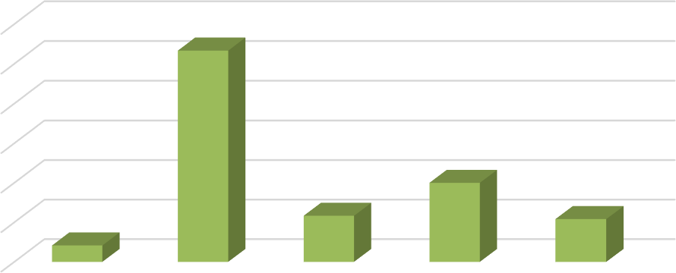

**The physical environment is good.**

60.00%

53.33%

50.00%

40.00%

30.00%

20%

20.00%

11.66%

10.83%

10.00%

4.16%

0.00%

QUITE TRUE

TRUE

NO IDEA

FALSE

QUITE FALSE

**3.The necessary safety and health measures at work place are good.**

|  |  |  |
| --- | --- | --- |
| **Scaling** | **No. Of**  **Respondents** | **Percentage** |
| Quite true | 13 | 10.83% |
| True | 60 | 50% |
| No idea | 19 | 15.83% |
| False | 14 | 11.66% |
| Quite false | 14 | 11.66% |
| Total | 120 | 100 |

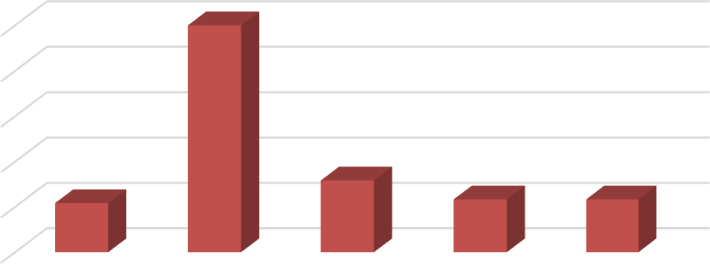

**The necessary safety and health measures at work place are**

**good.**

50%

50.00%

40.00%

30.00%

20.00%

15.83%

10.83%

11.66%

11.66%

10.00%

0.00%

QUITE TRUE

TRUE

NO IDEA

FALSE

QUITE FALSE

**INTERPRETATION:** From the above Interpretation, it is showing that most of the respondents said true that necessary safety and health measures at work place are good by 50%.

**4.The subordinates achieve targets with least supervision**

|  |  |  |
| --- | --- | --- |
| **scaling** | **no. of**  **respondents** | **percentage** |
| quite true | 10 | 8.33% |
| true | 40 | 33.33% |
| no idea | 36 | 30% |
| false | 25 | 20.83% |
| quite false | 9 | 7.5% |
| total | 120 | 100 |

**INTERPRETATION**: From the above Interpretation, it is showing that most of the respondents said true that the subordinates achieve targets with least supervision by 33.33%.

**5.Wages are adequate**

|  |  |  |
| --- | --- | --- |
| **Scaling** | **No. Of**  **Respondents** | **Percentage** |
| Quite true | 15 | 12.5% |
| True | 49 | 40.83% |
| No idea | 25 | 20.83% |
| False | 21 | 17.5% |
| Quite false | 10 | 8.33% |
| Total | 120 | 100 |

**INTERPRETATION:** From the above Interpretation, it is showing that most of the respondents said true that the wages are adequate by 40.83%.

**CONCLUSION**

* Employees believe that their degree of motivation influences their performance, thus the firm should encourage employees to be enthusiastic about their work.
* In the employee PF Scheme, the firm might give extra withdrawal options.
* The firm should place a greater emphasis on offering additional perks that make working here simpler or more beneficial.
* In order for employees to execute their jobs properly, I believe the firm should provide them with additional tools and technology.
* If the firm offers employees with raises, they will be happier with their salary.
* Employees will be happier with their jobs and perform better if the firm recognizes and solves their problems.

**REFERENCES**

* Academy of Management Journal, Volume 60, Issue 3, June 2016; Academy of Management
* Human Relations, Volume 69, Issue 8, August 2016; Sage
* Human Resource Management, Volume 55, Issue 6, November 2016; Wiley Periodicals, Inc.