**SOIL BASED CROP ANALYSIS**

Mr .B.Varun Kumar

varunkumarb@siet.ac.in

P.Krishna Bharathi

Krishnabharathip23it@srishakthi.ac.in

S. Balaji

Balajis23it@srishakthi.ac.in

S.K Adhithya Pranave

adhithyapranavesk23it@srishakthi.ac.in

Sri Shakthi Institute of Engineering and Technology, Coimbatore.

Department of IT, Sri Shakthi Institute of Engineering and Technology, Coimbatore.

**Abstract:**

The analysis of soil-based crop production is pivotal in optimizing agricultural outputs and ensuring sustainable farming practices. This study examines the relationship between soil characteristics and crop yield, focusing on parameters such as soil texture, structure, pH, nutrient content, moisture levels, and microbial activity. By employing a combination of field sampling, laboratory analysis, and advanced geospatial techniques evaluate the influence of these soil properties on the growth and productivity of various crops. Our research highlights the critical role of soil health in determining crop performance. We found that nutrient-rich soils with balanced pH and adequate organic matter significantly enhance crop yields, while poor soil conditions, such as high salinity or compaction, impede plant growth. The study also explores the effectiveness of soil amendments and management practices, such as crop rotation, cover cropping, and the application of fertilizers and organic matter, in improving soil fertility and structure.

**Introduction:**

Agriculture is the cornerstone of human civilization, providing the essential resources needed to sustain the global population. As the world faces the dual challenges of a growing population and the impacts of climate change, the need for sustainable and efficient agricultural practices has never been more critical. This project aims to explore and implement innovative strategies for enhancing agricultural productivity while ensuring environmental sustainability.

Advancements in agricultural technology and science provide new opportunities to understand and improve soil conditions. Techniques such as precision agriculture, which utilizes soil sensors, remote sensing, and geospatial analysis, allow for real-time monitoring and management of soil health. These technologies enable farmers to make informed decisions, optimize resource use, and enhance crop production efficiency .This project will involve a comprehensive study of various soil types and their impact on crop growth, employing both traditional field sampling and modern analytical methods. By examining the effectiveness of different soil management practices, such as crop rotation , cover cropping, and organic amendments, we aim to identify best practices for maintaining soil fertility and promoting sustainable agriculture.

In summary, the primary objective of this agricultural project is to bridge the gap between soil science and practical farming, fostering an environment where scientific insights into tangible improvements in agricultural productivity and sustainability. Through this project, we seek to contribute to the global effort of feeding a growing population while preserving the natural resources essential for future generations.

## Home Page:

The "Home" page serves as the landing area, welcoming users with an overview of the site's features, quick links to different sections, and general information on the importance of soil health and crop selection

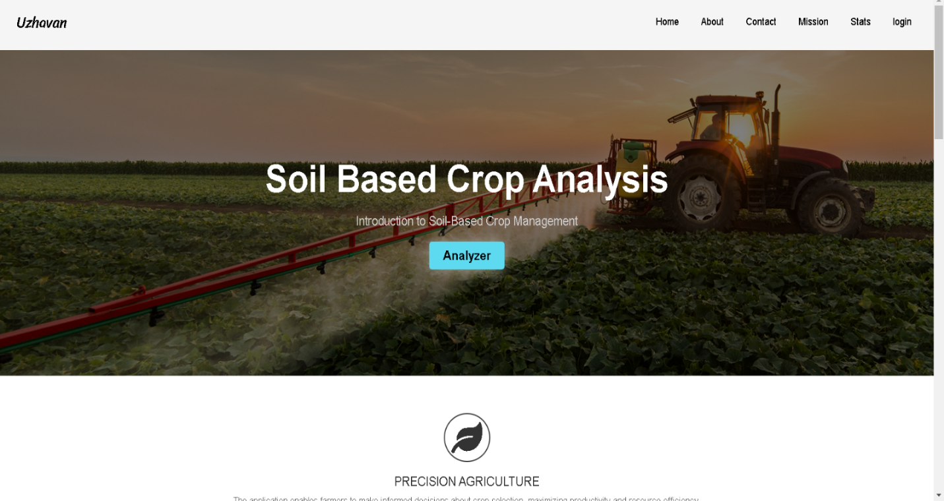

## ANALYZER

The "Analyzer" page is an interactive tool where users can input specific soil characteristics or district information to receive tailored recommendations on suitable crops, enhancing decision-making for farmers and agricultural planners. Together, these pages create a holistic resource aimed at improving agricultural outcomes through informed choices . it is that Recommends the soil types of the Entered Districts in Tamilnadu and it also Recommends the suitable crops for the soil type it provides.

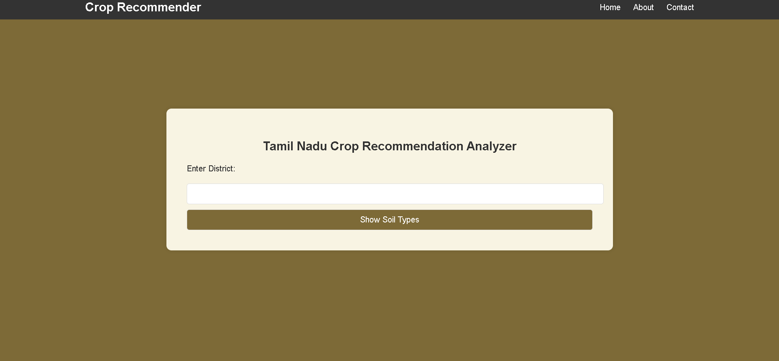

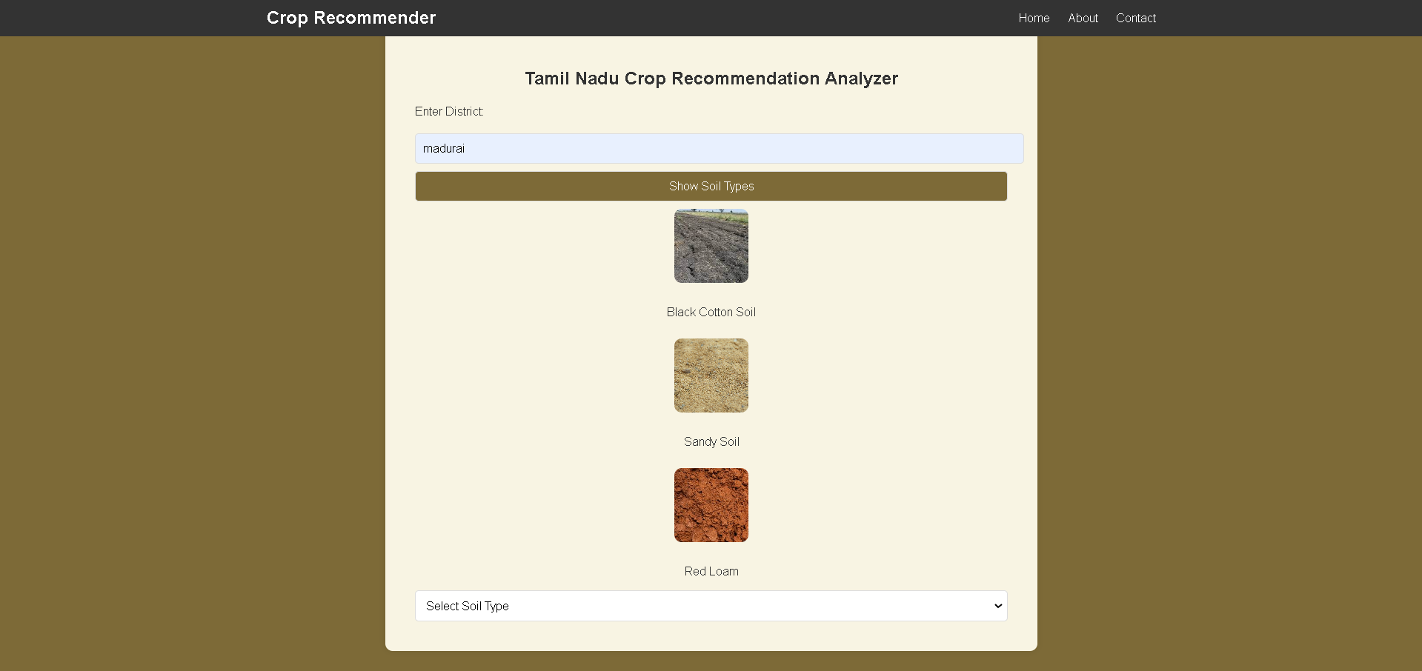

# **ABOUT PAGE :**

## 

## The "About" page offers insights into the purpose and mission of the website, detailing its commitment to guiding agricultural practices in Tamil Nadu by providing data on soil types and suitable crops. It gives an details about the soil types that are present in Tamil Nadu .

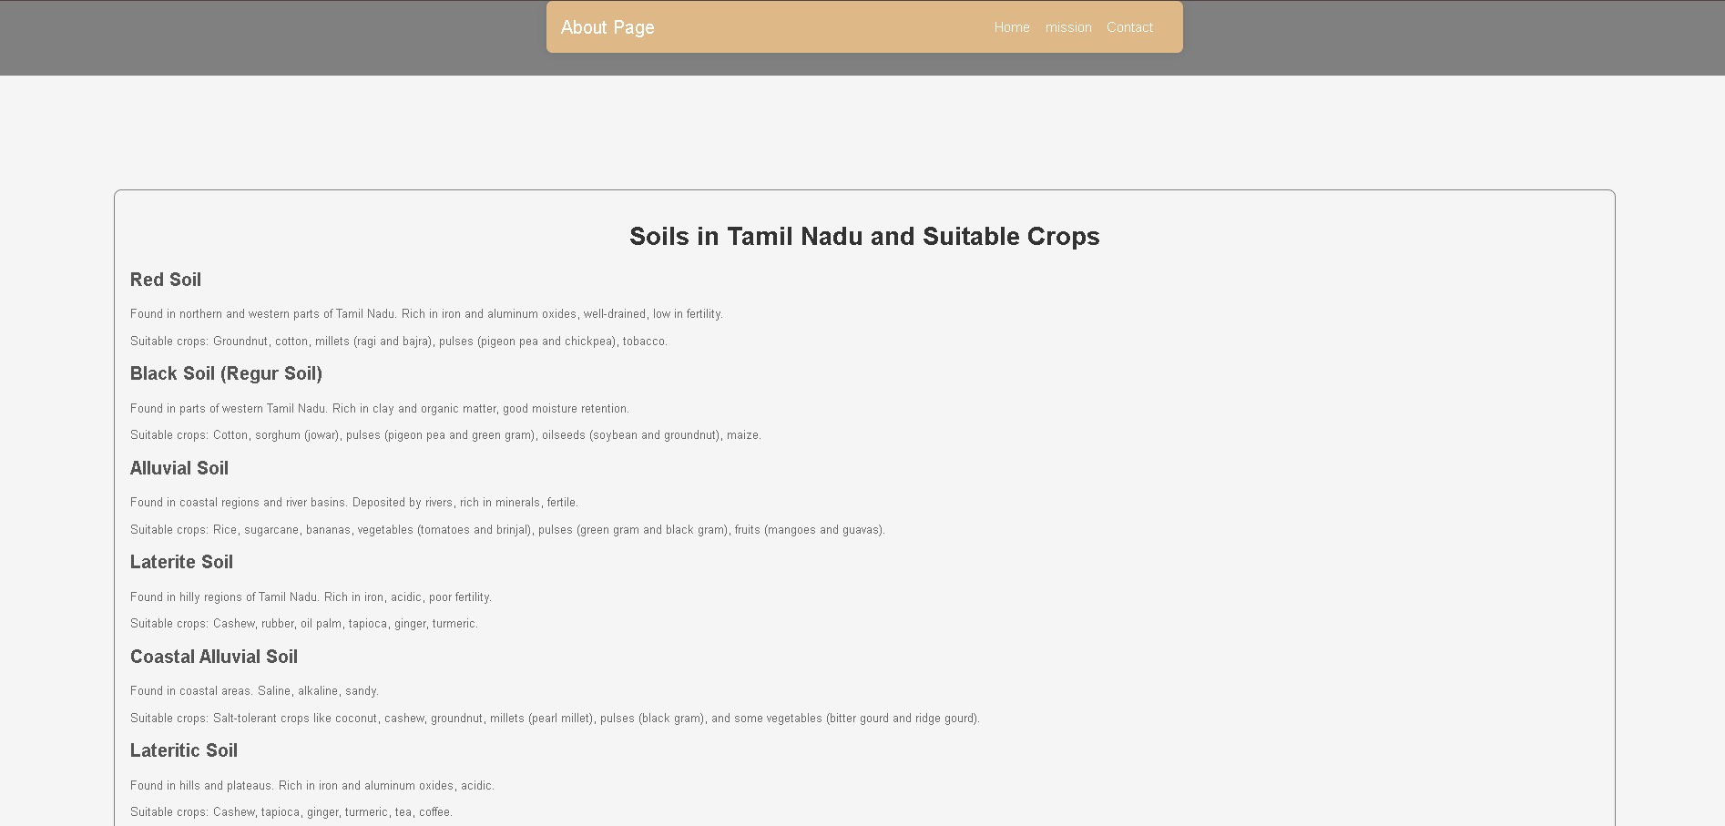

**STATS ABOUT TAMIL NADU**

This webpage provides a detailed overview of soil types and suitable crops for various districts in Tamil Nadu, India. The content is organized into a table that lists each district along with its prevalent soil types and the crops that are best suited for those soils. For instance, Ariyalur district features Sandy Loam, Clayey Loam, and Black Soil, making it ideal for cultivating rice, pulses, millets, oilseeds, and vegetables. Similarly, Chennai's soil types—Sandy Loam, Clayey Loam, and Red Loam—support crops like rice, pulses, millets, vegetables, and fruits.

**MISSION**

The primary objective of this presentation is to provide an in-depth overview of common soil types and their respective properties within the framework of soil-based crop management. Additionally, the presentation aims to recommend suitable crops for each soil type, based on their adaptability and growth requirements. By exploring this framework, farmers and agricultural stakeholders will gain valuable insights into soil-based crop management practices, enabling them to optimize agricultural productivity and sustainability.

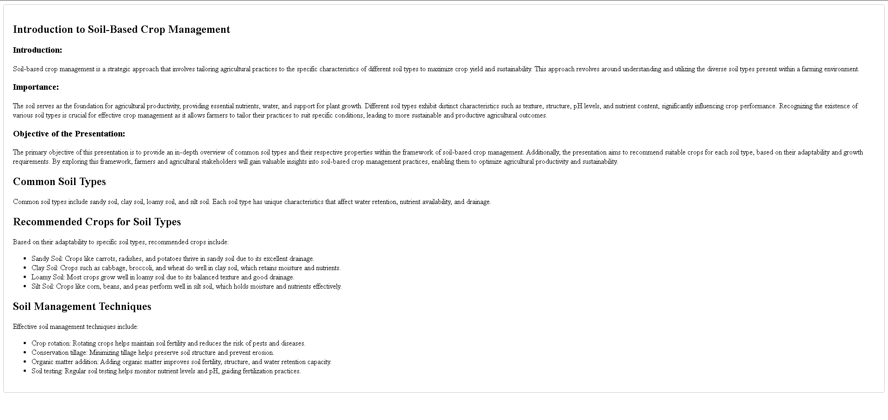

**LOGIN PAGE**

This is the login page where we can Store the Data of the Customer’s   
User Name and Password , where we used an xammp server and php for the connectivity of backend



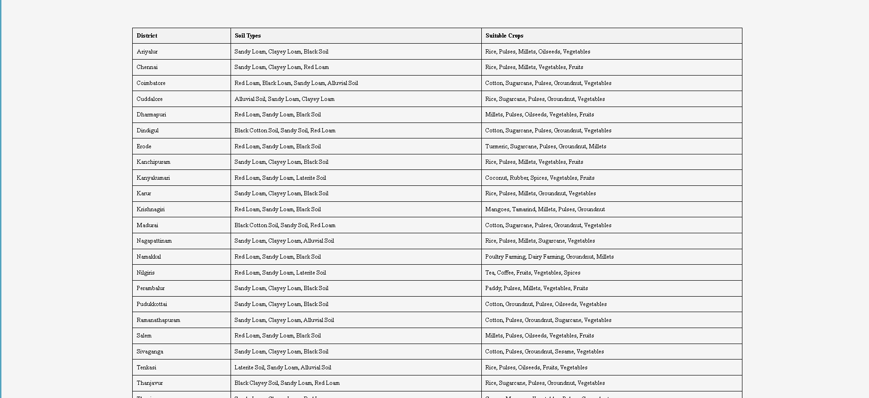

## Recommended Method for General Soil Analysis::

1. **Sample Collection**:

* + Collect soil samples from different depths and locations within the study area to ensure representativeness.

1. **Physical Analysis**:
   * Perform soil texture analysis using the hydrometer or sieve method.
   * Measure bulk density and moisture content.
2. **Chemical Analysis**:
   * Determine soil pH.
   * Analyze organic matter content using the Walkley-Black method or LOI.
   * Conduct nutrient analysis for major and minor nutrients using appropriate spectroscopic technique
3. **Biological Analysis** (if needed):
   * Assess microbial biomass and activity using fumigation-extraction and respiration methods.
   * Perform enzyme activity assays.
4. **Contaminant Analysis** (if relevant):
   * Test for heavy metals using AAS or ICP-MS.
   * Screen for pesticide residues using GC-MS or LC-MS.

**Recommended Workflow:**

1. **Sample Collection**:
   * Collect samples from various depths and locations for representativeness.
2. **Physical Analysis**:
   * Perform soil texture analysis, measure bulk density, and moisture content.
3. **Chemical Analysis**:
   * Determine soil pH, organic matter content, and nutrient levels.

**Results and Discussions:**

The future of soil-based crop analysis lies in the integration of cutting-edge technologies, enhanced biological understanding, continuous monitoring systems, and supportive policies. By advancing these areas, we can achieve more precise, efficient, and sustainable agricultural practices. These improvements will not only increase crop yields and soil fertility but also contribute to environmental sustainability and climate resilience. Investing in research, technology, and education is crucial for the continued advancement of soil-based crop analysis and the long-term health of our agricultural systems

This methodical approach to soil-based crop analysis ensures a comprehensive  
 understanding of soil conditions and facilitates informed decision-making for optimizing crop production. It combines field sampling, laboratory analysis, data interpretation, practical recommendations, and continuous monitoring to improve soil health and crop yields

**Conclusion**

The proposed method for soil-based crop analysis is designed to provide a detailed and actionable understanding of soil health and its impact on crop productivity. This method encompasses a series of systematic steps, from field selection and soil sampling to laboratory analysis, data interpretation, and the implementation of tailored recommendations. By following this approach, farmers and agronomists can make informed decisions that enhance crop yield, improve soil fertility, and promote sustainable agricultural practices.

**FUTURE SCOPES:**

1. **Integration of Advanced Technologies**

* **Remote Sensing and GIS**: Utilizing satellite imagery and GIS can help in the creation of detailed soil maps, identifying variability within fields and guiding precise interventions. These technologies can also monitor changes over time, providing a dynamic view of soil health.
* **Precision Agriculture**: Implementing precision agriculture technologies such as drones, automated machinery, and variable rate technology can optimize the application of inputs like fertilizers and water, reducing waste and improving efficiency.

2. **Automation and Data Analytics**

* **Automation**: Innovations in robotics and AI can automate soil sampling and analysis, making the process faster, more accurate, and less labor-intensive.
* **Big Data and AI**: Advanced data analytics and machine learning algorithms can analyze large datasets from soil tests, climate conditions, and crop performance, uncovering patterns and providing predictive insights that can inform future farming practices.

3. **Enhanced Biological Analysis**

* **Microbial Diversity and Function**: Understanding the role of soil microbiomes through advanced techniques like metagenomics can provide deeper insights into soil health and fertility. Research can focus on how microbial communities influence nutrient cycling and plant health.
* **Biological Indicators**: Developing new biological indicators and standardizing their use can provide a more comprehensive picture of soil health, beyond traditional chemical and physical analyses.

4. **Soil Health Monitoring Systems**

* **IoT and Real-Time Monitoring**: Integrating IoT sensors into soil health monitoring can provide real-time data on soil moisture, temperature, nutrient levels, and other critical parameters. This real-time data can be used to make immediate adjustments to farming practices.
* **Mobile Applications**: User-friendly mobile applications can allow farmers to access and interpret soil data easily, receive tailored recommendations, and track the effectiveness of implemented practices over time.

5. **Sustainable Practices and Climate Change Adaptation**

* **Agroecological Practices**: Promoting agroecological practices such as crop diversification, reduced tillage, and organic farming can enhance soil structure, increase biodiversity, and improve resilience to pests and diseases.
* **Climate-Smart Agriculture**: Developing and implementing climate-smart agricultural practices can help farmers adapt to and mitigate the effects of climate change. This includes selecting drought-resistant crops, optimizing water use, and improving soil carbon sequestration.

6. **Policy and Education**

* **Supportive Policies**: Advocating for policies that support soil health initiatives, such as funding for soil testing, incentives for sustainable farming practices, and regulations to prevent soil degradation, can enhance overall soil management efforts.
* **Farmer Training and Outreach**: Expanding educational programs for farmers on soil health management and the benefits of sustainable practices can empower them to implement the findings of soil analyses effectively. This includes hands-on training sessions, workshops, and access to advisory services.

### Summary

The future of soil-based crop analysis lies in the integration of cutting-edge technologies, enhanced biological understanding, continuous monitoring systems, and supportive policies. By advancing these areas, we can achieve more precise, efficient, and sustainable agricultural practices. These improvements will not only increase crop yields and soil fertility but also contribute to environmental sustainability and climate resilience. Investing in research, technology, and education is crucial for the continued advancement of soil-based crop analysis and the long-term health of our agricultural systems.

# Reference

• "The Nature and Properties of Soils" by Nyle C. Brady and Ray R. Weil

* **Description**: This comprehensive textbook covers all aspects of soil science, including soil formation, classification, physical properties, chemical properties, and biological properties. It also addresses soil fertility, soil management, and the impact of soils on plant growth.
* **Edition**: 15th Edition (2016)
* **Publisher**: Pearson
* **ISBN**: 978-0133254488

• **"Soil Fertility and Fertilizers: An Introduction to Nutrient Management" by John L. Havlin, Samuel L. Tisdale, Werner L. Nelson, and James D. Beaton**

* **Description**: This book provides a detailed understanding of soil fertility, plant nutrition, and the use of fertilizers. It covers nutrient cycles, soil pH, organic matter, and practical aspects of managing soil fertility for different crops.
* **Edition**: 8th Edition (2013)
* **Publisher**: Pearson
* **ISBN**: 978-0135033739

• **"Soil Microbiology, Ecology, and Biochemistry" by Eldor A. Paul**

* **Description**: This book explores the biological and biochemical processes in soil, including the role of microorganisms in nutrient cycling, soil organic matter dynamics, and soil health. It provides insights into the ecological aspects of soil biology and its impact on crop productivity.
* **Edition**: 4th Edition (2014)
* **Publisher**: Academic Press
* **ISBN**: 978-0124159556

• **"Handbook of Soil Science" edited by Malcolm E. Sumner**

* **Description**: This handbook offers a detailed and comprehensive overview of soil science, including soil chemistry, physics, biology, and fertility. It serves as a valuable reference for soil analysis methods and soil management practices.
* **Edition**: 2nd Edition (2011)
* **Publisher**: CRC Press
* **ISBN**: 978-1439829952

• **"Principles of Soil and Plant Water Relations" by M.B. Kirkham**

* **Description**: This book focuses on the principles governing soil and plant water relations, essential for understanding water management in agriculture. It covers soil water retention, movement, and availability to plants.
* **Edition**: 2nd Edition (2014)
* **Publisher**: Academic Press
* **ISBN**: 978-0124200227