**CAPITAL STRUCTURE ITS IMPACT ON PROFITABILITY WITH SUKHJIT STARCH MILLS LTD**

**P PRIYANKA**

Roll No: 212122672139, Department of Management Studies

Aristotle PG College, Chilkur, Moinabad, Ranga Reddy District, Telangana.

**Dr. U Kanaka Rao**

Associate Professor

Aristotle PG College, Chilkur, Moinabad, Ranga Reddy District, Telangana.

[dr.ukrao2015@gmail.com](mailto:dr.ukrao2015@gmail.com)

**Abstract:**

Hence capital structure implies the composition of funds raised from various sources broadly classi­fied as debt and equity. It may be defined as the proportion of debt and equity in the total capital that will remain invested in a business over a long period of time. Capital structure is concerned with the quantitative aspect. A decision about the proportion among these types of securities refers to the capital structure decision of an enterprise.

Theoretically, the financial manager should plan an optimum capital structure for his company. The optimum capital structure is obtained when the market value per share is maximum. In practice, the determination of an optimum capital structure is a formidable task, and one has to go beyond the theory. There is significant variation among industries and among individual companies within an industry in terms of capital structure. Since a number of factors influence the capital structure decision of a company, the judgment of the person making the capital structure decision plays a crucial part.

**Keywords:** Capital Structure, Profitability.

**INTRODUCTION:**

# The financing decisions occupy a pivotal role in the overall finance function in a corporate firm which mainly concerns itself with an efficient utilization of the funds provided by the owners or obtained from external sources together with those retained or ploughed back out of surplus or undistributed profits. These decisions are mainly in the nature of planning capital structure, working capital and mechanism through which funds can be raised from the capital market whenever required.

# The financing decisions explains how to plan an appropriate mix with least count, how to raise long term funds, and how to mobilize the funds for working capital within a short span of time. Such a financing policy provides an appropriate backdrop for formulating effective policies for investment of funds as well as management of earnings. It contributes to magnifying the earnings on equity as profitability (expressed as return on equity), to a large extent, is dependent on the degree of leverage in the capital structure.

# Besides, the valuation of the structure of physical assets depends fundamentally on the financing mix. This makes it necessary for the management of a firm to pursue a well thought out of financing policy, which ought to be framed initially, incorporating, among other things, the proportion of the debt and equity, types of debts and own funds to be used and volume of the funds to be raised from each source or combination of sources, to enable the firm to have a proper capitalization. In the absence of this, the firm may face the problem of either over capitalization or under capitalization impeding its smooth financial functioning.

# It is obvious that functioning decisions are extremely important for corporate firms. Such decisions, in management parlance, are termed as capital structure decisions. The term capital structure is used to describe the combination of various source of financial employed to raise funds. It implies, in other words, that when a firm chooses to use a group of sources in certain proportions the resulting pattern is referred to as capital structure of the firm.

# The sources of finance could be divided in terms of ownership of funds and duration of funds. The former comprises owned and borrowed funds while the latter includes long, medium and short term funds. Of the two, the duration-based classification is useful for preparing a plan to meet long term as well as short term capital requirements while ownership-based classification is useful for selection of specified sources, determining debt-equity ratio and analyzing impact of capital structure decisions on the earnings on equity.

**REVIEW OF LITERATURE:**

**ARTICLE: 1**

**Tile: Empirical Capital Structure: A Review**

**Author:** **Sheridan Titman**

**Source:** **ISBN: 978-1-60198-203-2,**

**Abstract**

This survey provides a synthesis of the empirical capital structure literature. Our synthesis is divided into three parts. The first part examines the evidence that relates to the cross-sectional determinants of capital structure. This literature identifies and discusses the characteristics of firms that tend to be associated with different debt ratios. In the second part, we review the literature that examines changes in capital structure. The papers in this literature explore factors that move firms away from their target capital structures as well as the extent to which future financing choices move firms back toward their targets. Finally, we complete our review with a set of studies that explore the consequences of leverage, rather than its determinants. These studies are concerned with feedback from financing to real decisions. For example, we explore how a firm's financing choices influences its incentive to invest in its workers, price its products, form relationships with suppliers, or compete aggressively with competitors.

**ARTICLE: 2**

**Tile: Capital Structure Analysis**

**Source: The Journal of Business Management**

**Author:** **Pieter van Beurden**

The firm's capital structure - how it funds operations by raising capital from a variety of sources – has attracted considerable attention from both academics and practitioners. The empirical capital structure literature explores both the cross-sectional determinants of capital structure as well as time-series changes. Empirical Capital Structure reviews both aspects of this literature. Empirical Capital Structure is organized around a simple framework that contains three key ingredients: the costs and benefits that determine a firm's capital structure; the existence of shocks that cause firms to deviate, at least temporarily, from their targets; the presence of factors that may prevent firms from constantly maintaining debt ratios that match their targets. Empirical Capital Structure is organized as follows. Section II discusses specification and econometric issues that will be important for many of the tests considered. Section III reviews cross-sectional capital structure determinants. Section IV explores factors that pull firms away from their leverage targets. Section V discusses reasons why firms might not immediately reverse the effect of these leverage shocks, apparently allowing deviations from their targets to persist for extended periods of time. Section VI explores a group of studies that look at how leverage feeds back into a firm's real business decisions. Finally, Section VII concludes and provides suggestions for new research.

**ARTICLE: 3**

**Tile: The effect of market conditions on capital structure adjustment**

**Author** **Murray Z. Frank**

**Source: Finance Research Letters**

**Abstract**

The empirical implications of the trade-off theory, the market timing theory, and Welch's theory [Journal of Political Economy (in press)] of capital structure are examined using aggregate US data for 1952 to 2000. There is a long-run leverage ratio to which the system reverts. Deviations from that ratio help to predict debt adjustments, but not equity adjustments. A high market-to-book ratio is associated with subsequent debt reduction, but there is no effect in the equity market.

**RESEARCH GAP:**

# The study is helpful to companies, market researchers, academicians and investors by knowing the influence of capital structure on the profitability of the firm.

**OBJECTIVES:**

# The basic objective of studying the capital structure of the company is to know the financial position of the company.

# To know the debt-equity position of the company.

# To study the operating leverage and financial leverage so as to know the fixed cost of Sukjit Stratch Mills ltd.

# To know the stock reserve for sales of the business.

# To study the balance of cash and credit in the organization.

# To find out the impact of capital structure on profitability.

**RESEARCH METHODOLOGY:**

**Scope Of The Study**

# The study cover a period of four years from 2019-2023.

# • The data used in the study is secondary in nature.

# • The financial data of SME’s taken into consideration for analysis.

# Variables taken for the study are as follows:

# • Net profit

# • Return on capital employed

# • Return on equity

# • Debt-equity ratio

# • Debt to total funds ratio

# **Need For The Study:**

The value of the firm depends upon its expected earnings stream and the rate used to discount this stream. The rate used to discount earnings stream it’s the firm’s required rate of return or the cost of capital. Thus, the capital structure decision can affect the value of the firm either by changing the expected earnings of the firm, but it can affect the reside earnings of the shareholders. The effect of leverage on the cost of capital is not very clear. Conflicting opinions have been expressed on this issue. In fact, this issue is one of the most continuous areas in the theory of finance, and perhaps more theoretical and empirical work has been done on this subject than any other.

**Data Collection:**

# Research Methodology used to find out the relation between the variables

# Research tools used in this project are:-

# Descriptive Statistics

# Correlation

# Hypothesis testing

# Regression

**Tools Used for Data Collection**

###### **Ratio analysis**

The relationship between the figures expressed mathematically is called as “RATIO”. It is a numerical relationship between two numbers, which are related in some manner. Ratio analysis is a technique of analysis and interpretation of figures for helping in decision making.

It also helps the analyst to make qualitative judgment about firm’s financial performance.

**DATA ANALYSIS & INTERPRETATION:**

# **1.1: Calculation of net profit:**

# **PBT** :Profit before tax (PBT) is a profitability measure that looks at a company's profits before the company has to pay corporate income tax by deducting all penses from revenue including interest expenses and operating expenses except for income tax.

# **Interest:** Interest is payment from a [borrower](https://en.wikipedia.org/wiki/Debtor) or deposit-taking financial institution to a [lender](https://en.wikipedia.org/wiki/Lender) or depositor of an amount above repayment of the [principal sum](https://en.wikipedia.org/wiki/Principal_sum) (*i.e.* the amount borrowed). It is distinct from a [fee](https://en.wikipedia.org/wiki/Fee) which the borrower may pay the lender or some third party.

# **Net profit**: **Net profit** represents the number of [sales](http://www.investinganswers.com/node/5682) dollars remaining after all [operating expenses](http://www.investinganswers.com/node/2792), interest, [taxes](http://www.investinganswers.com/node/4567) and preferred [stock dividends](http://www.investinganswers.com/node/5151) (but not common stock dividends) have been deducted from a company's total [revenue](http://www.investinganswers.com/node/5108).

# **Working notes:**

# Net profit = Profit before tax + Interest

# Net profit for the year 2019-2020: -2023354 + 2870585 = 852231

# 2020-2021: -4279451+ 4640607 = 361376

# 2021-2022: -4653888 + 5066590 = 414702

# 2022-2023: -73758 + 3846717 = 3772959

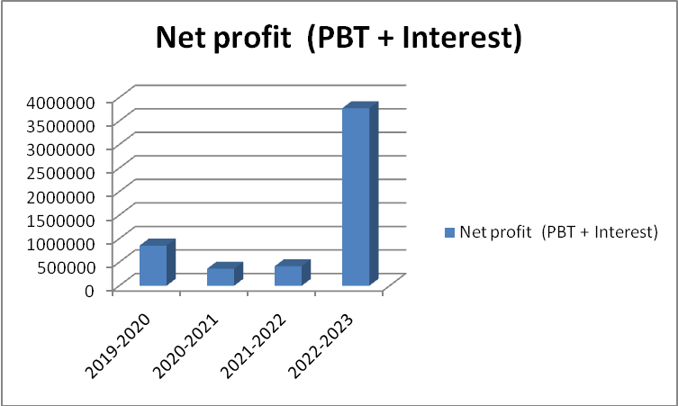

|  |  |  |  |
| --- | --- | --- | --- |
| **Year** | **PBT** | **Interest** | **Net profit** **(PBT + Interest)** |
| 2019-2020 | (2023354) | 2870585 | 852231 |
| 2020-2021 | (4279451) | 4640607 | 361376 |
| 2021-2022 | (4653888) | 5066590 | 414702 |
| 2022-2023 | (73758) | 3846717 | 3772959 |

**Interpretation:**

* From the above data, we can notice that, there has been a fluctuation in the past four financial years in net profit of the company.
* From 2019-2020 to 2020-2021, the net profit has fallen from 852231 to 361376 and in the next year it has slightly increased to 414702.
* In the year 2022-2023, the net profit has greatly increased from 414702 to 3772959.
* Increase in the net profit of the company is a healthy sign.
* It shows the company’s ability to pay off its debts and operating costs in time.
* It also indicates that the company is operating efficiently.

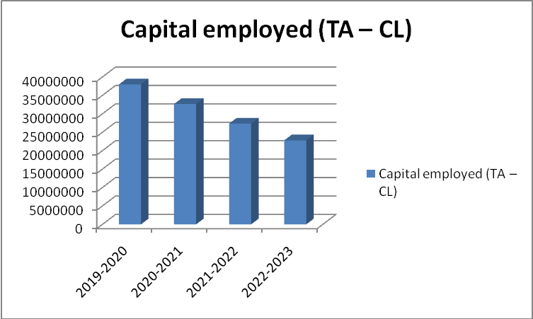

|  |  |  |  |
| --- | --- | --- | --- |
| **Year** | **PBT** | **Interest** | **Net profit** **(PBT + Interest)** |
| 2019-2020 | (2023354) | 2870585 | 852231 |
| 2020-2021 | (4279451) | 4640607 | 361376 |
| 2021-2022 | (4653888) | 5066590 | 414702 |
| 2022-2023 | (73758) | 3846717 | 3772959 |

**Interpretation:**

# From the above data, we can notice that the capital employed has been a gradual decrease in the past four financial years.

# From 2019-2020 to 2020-2021 the capital employed has reduced from 37988326 to 32664960 and it has again decreased from 32664960 to 27353555.

# In the next year, it has again fallen to 22809351. Decrease in capital employed indicates the unavailability of cash in hand of a company. It shows the utilisation of fixed assets and working capital.

**CONCLUSION:**

# **Suggestions from table 1:**

# Company should try to increase the return on capital employed in order to make use of the capital efficiently.

# **Suggestions from table 2:**

# We suggest that company should increase the ratio of return on equity for better investment.

# **Suggestions from table 3:**

# We suggest the company to use its debt more efficiently in financing the assets.

# **Suggestions from table 4:**

# We suggest that should ideally use the company’s assets in order to attain better optimum position.

**REFERENCES:**

[www.kesoram.com](http://www.kesoram.com)

[www.indiancements.com](http://www.indiancements.com)

[www.fixedassectsmanagement.com](http://www.fixedassectsmanagement.com)

[www.googlefinance.com](http://www.googlefinance.com)