**Analysis and Design of Pre Engineered Building**

**Using STAAD.Pro V8i**

Prof.P.V.Nimbalkar 1,Dhande Snehal 2,Lawande Shubham 3,Malve Shubham 4, Landge Sailee 5

DVVPCOE Ahmednagar.

**ABSTRACT:** In recent years, the introduction of Pre Engineered Building (PEB) concept in the design of structures has helped in optimizing design. Steel is one of the best material for design due to its inherent properties like ductility and flexibility. It is very flexible under extreme loads rather than crumbling and crushing. Steel mostly used in construction of industrial buildings. . Pre-engineered buildings are cost effective, time consuming as compared to other conventional buildings. Generally pre-engineered buildings are faster than conventional buildings, 25% less time consuming & 30% lighter than conventional buildings. The plan & load on the building are calculated at the beginning & the members are manufactured in factory & they are just assembled on actual site at time of construction. The pre-engineered steel building system construction has great advantages to the single storey buildings, practical and efficient alternative to conventional buildings, the system representing one central model within multiple disciplines. Pre-engineered building creates and maintains in real time multidimensional, data rich views through a project support is currently being implemented by software for design and engineering.

**Keywords:** Pre Engineered Building, Ductility, Flexibility, Conventional buildings.

**1.INTRODUCTION**

Steel industry is growing rapidly in almost all the parts of the world. The use of steel structures is not only economical but also eco friendly at the time when there is a threat of global warming. Here, “economical” word is stated considering time and cost. Time being the most important aspect, steel structures (Pre-fabricated) is built in very short period and one such example is Pre Engineered Buildings (PEB). Pre-engineered buildings are nothing but steel buildings in which excess steel is avoided by tapering the sections as per the bending moment’s requirement. One may think about its possibility, but it’s a fact many people are not aware about Pre Engineered Buildings. If we go for regular steel structures, time frame will be more, and also cost will be more, and both together i.e. time and cost, makes it uneconomical. Thus in pre-engineered buildings, the total design is done in the factory, and as per the design, members are pre-fabricated and then transported to the site where they are erected in a time less than 6 to 8 weeks.

The structural performance of these buildings is well understood and, for the most part, adequate code provisions are currently in place to ensure satisfactory behaviour in high winds. Steel structures also have much better strength-to-weight ratios than RCC and they also can be easily dismantled. Pre Engineered Buildings have bolted connections and hence can also be reused after dismantling. Thus, pre-engineered buildings can be shifted and/or expanded as per the requirements in future. In this paper we will discuss the various advantages of pre-engineered buildings and also, with the help of three examples, a comparison will be made between pre-engineered buildings and conventional steel structures.

**1.2 Component of an Industrial Building:**

The elements of industrial buildings are listed below:

1) Purlins

2) Sag rods

3) Principal rafters

4) Roof truss

5) Gantry girders

6) Bracket

7) Column and column base

8) Girt rods

The previous elements are briefly explained below:

**1.2.1 Purlins:**

Purlins are beams which are provided over trusses to roof coverings. Purlin spans between top chords of two adjacent roof trusses.

**1.2.2 Sag Rod:**

These are round sections rods and are fastened to the web or purlin. The roof covering in industrial buildings are not rigid and do not provide proper support. A sag rod is designed as a tension member to resist the tangential component of the resultant of the roof load and purlin dead load.

**1.2.3 Principal Rafter:**

The top chord member of a roof truss is called as principal rafter. They mainly carry compression but they may be subjected to bending if purlins are not provided at panel points.

**1.2.4 Roof Trusses:**

Roof trusses are elements of the structure. The members are subjected to direct stresses. Truss members are subjected to direct tension and direct compression.

**1.2.5 Gantry Girder:**

Gantry girders are designed as laterally unsupported beams. Overhead travelling cranes are used in industrial buildings to lift and transport heavy jobs, machines, and so on, from one place to another.

**1.2.6 Brackets:**

Brackets types of connections are made whenever two members to be secured together do not intersect.

**1.2.7 Column and Column Base:**

A column is a structural member which is straight to two equal and opposite compressive forces applied at the ends.

**1.2.8 Girt:**

These are beams subjected to unsymmetrical bending. These supports vertical dead load from the sliding and horizontal wind loads.

**2.LITERATURE REVIEW**

**Sharan. K.et.al.2023,** PEB pre-engineered building are easy to construct, time saving in construction, easy to design as per country standards, cost efficiency. By increasing the area of Industrial building material and cost of the building is minimized in case of PEB while in case of Convention building the material and cost is not optimized if we increase the area of building. The PEB concepts that help in reducing the cost and time of construction. This technology helps in construction of sustainable structures with an increased durability when compared to standard steel structures which involves more time and cost. PEB stands top position when compared to all other technologies. The use of high grade steel is economical and weight of the structure is reduced almost 50% .

**Pratiksha Deepak Pawaskar.et.al.2023,** The alternative material is proposed without compromising the height of the frame. That is pre engineered building materials are used to optimize the steel consumption building frames. The steel consumption in intermediate frames for the conventional Pratt truss type industrial frame is 77% higher than that of pre engineered building and 75% higher than lattice girder frame. The main focus of this investigation is to conduct a detailed study and examine the behaviour of PEB. The calculation of DL,LL, and WL will be carried out according to Indian standards 875 and steel frames with IS 800-2007(Limit state method).Serviceability and displacement of members are checked with IS codes(should fall under the IS limit). The steel frame will be subjected to various load combinations. Also manual designs of purlins are calculated and compared with the software results.

**T. Bharat Bhushan Gupta.et.al.2022**, The load and load combinations are probably studied. The study also tells that steel is a versatile material. Wide choice for construction purpose and environmentally it is good. Pre-engineered structures are simply steel structures with surplus steel avoided by tapering the sections to the required bending moment. It's possible, although few people are aware of pre-engineered buildings, despite the possibilities. Then, in accordance with the design, members are pre-fabricated and transported to the site, where they are quickly put into place within 6 to 8 weeks.

**Sudhir Paswan et.al.2022,** The earthquake's demand, the building's structure has changed significantly. Because the moment of inertia and cross-sections play a significant role in strongly laden buildings, the required design requirements cannot be reached by employing the ISMB steel parts that are now available. Although reinforced concrete sections may support enormous loads, it is not ideal to employ concreting procedures when the assembly is facing a maximum height of around 50 to 60 metres. As a result, it is simple to create a permanent structure utilising a built structure. But as with everything new, technology also brings with it a fresh set of issues. STAAD Pro makes seismic analysis relatively simple to perform. The multi-story Industrial Building has been chosen, thoroughly examined, and thoughtfully designed. Floor plus Floor is chosen. Analysis and design shall be carried out in accordance with standard standards to the greatest extent possible. STAAD PRO.V8i software will be used to do structural analysis. 4. The building will be entirely hand designed. Consolidation specifics will be completed in AutoCAD 2013. The software's utilization results in prompt savings. Instead of the craft, the pricing is needed to be on the safe side.

**Shaik Kalesha et.al.2020,** The main objective is to understand the concepts of PEB and to minimize the usage of cost and time. While compared to other technologies in construction Pre Engineered Building is more sustainable and stands top position when compared with other technologies. The implementation of the Pre Engineered Building (PEB) is a modern-day concept in which utilizing the steel structure and optimizing the design by ensuring economical integrity.

**Apruv Rajendra Thorat et.al.2017,** The incorporating bracing in Pre Engineered Buildings significantly reduces structural displacements in both the X and Y directions during dynamic loading, which can contribute to enhanced stability and safety of these structures. The Dynamic load action on Pre Engineered Building is observed. Displacement along X-direction of Pre Engineered building with bracings is observed 34% less than the Pre Engineered Building without bracings along longitudinal direction. Displacement along Y-direction is observed 13% less than the Pre Engineered Building without bracings but it is permissible in both cases hence no extra bracings required for specified ground motion. Displacement along Z-direction is observed 23% less than the Pre Engineered Building.

**M D Gawade et.al.2017,** The use of tapered members for columns and rafters is one of the basic properties of PEB. Use of web-tapered members increases the efficiency of the PEB from previous research work it is clear that the Weight of PEB is very less as compared to CSB where both has same load bearing capacity. Use of tapered members for columns and rafters is one of the basic properties of PEB. Use of web-tapered members increases the efficiency of the PEB. Rather there are limitations for design of tapered members by Indian code the use of these members is made in the industry which has its design based on the American design.

**3.MATERIALS AND METHODOLOGY**

**3.1. General**

The scientific-sounding term pre-engineered buildings came into being in the 1960s.The buildings were pre-engineered because, like their ancestors, they relied upon standard engineering designs for a limited number of off-the-shelf configurations. The first rigid-frame buildings introduced in the late 1940s could span only 40 ft. In a few years, 50, 60, and 70ft buildings became possible. By the late 1950s, rigid frames with 100-ft spans were made; ribbed metal panels became available, allowing the buildings to look different from the old tired corrugated appearance. Third, collared panels were introduced by Strand-Steel Corp. in the early 1960s, permitting some design individuality. At about the same time, continuous span cold-formed Z purlins were invented. All these factors combined to produce a new metal-building boom in the late 1950s and early 1960s. Even though the term pre-engineered buildings are still widely used, and will be often found even in this book, the industry now prefers to call its product metal building systems.

**3.2. Materials**

**3.2.1 Steel Section**

Steel sections refer to standardized shapes or profiles of structural steel that are commonly used in construction. These sections are manufactured according to established standards and specifications to ensure uniformity and compatibility in building design and construction.

I-Beams (Universal Beams): I-beams are one of the most widely used steel sections in construction. They have a distinctive "I" shape with wide flanges (the top and bottom horizontal sections) and a narrow web (the vertical section).

H-Beams (Universal Columns): H-beams are similar to I-beams but have thicker flanges and a thicker web. They are commonly used as columns or vertical supports in building structures. Hbeams provide excellent load-bearing capacity and are suitable for heavy-duty applications.

Channels: Channels have a C-shaped cross-section with two parallel flanges connected by a web. They are used as beams, purlins, or support members in building frames and other structural applications.

Angles: Angles have an L-shaped cross-section with two legs that form a 90-degree angle. They are often used as braces, lintels, or framing elements in building construction. Angles provide structural stability and support and are available in equal and unequal leg lengths.

Tee Sections: Tee sections have a T-shaped cross-section with a vertical stem (the web) and horizontal flanges at the top and bottom. They are used as beams, columns, or support members in building frames and other structural applications.

**3.2.2 Steel Bar:** Steel bars are also known as reinforcement bars or rebars, are widely used in construction to provide additional strength and reinforcement to concrete structures. Steel bars are primarily used to reinforce concrete structures such as foundations, columns, beams, slabs, and walls. They help improve the structural integrity, durability, and resistance to cracking and deformation under various loads. Common grades include Fe 415, Fe 500, Fe 550, and Fe 600, where the number indicates the minimum yield strength in MPa.

**3.2.3** **Metal Sheets:** Metal sheets are used for roofing, siding, wall cladding, and structural components in commercial, industrial, and residential buildings. Metal sheets are fabricated into components and parts for machinery, equipment, appliances, and vehicles in manufacturing industries such as automotive, aerospace, and electronics.

**3.3 Methodology**

Pre-Engineered Buildings by STAAD Pro Overview The power tool for Computerized Structural engineering STAAD Pro is the most popular structural engineering software product for 3D model generation, analysis and multilateral design. It has an intuitive, user-friendly, visualization tools, powerful analysis and design facilities and seamless integration to several other modelling and design software products The software is fully compatible with all Windows operating systems. For static or dynamic analysis of PreEngineered Buildings, STAAD Pro has been the choice of design professionals around the world for their specific analysis needs. Research Engineers International introduces the next generation of RET's flagship product, Staad pro, the most popular structural engineering software product for 3D model generation, analysis, and multi-material design. It has an intuitive, user-friendly, visualization tools, powerful analysis and design facilities and seamless integration to several PreEngineered Buildings modelling and design. Staad pro is one of the best software for Pre-Engineered Buildings for Structural Analysis and Design Software Supporting Indian and major international codes. Mainly used by Civil, Structural Engineers and other Engineers. The choice of Structural Engineers worldwide. Staad pro is guaranteed to meet all the structural engineering needs. Staad pro features state of the art user interface, visualization tools, powerful analysis and design engineers with advanced finite element and dynamic analysis capabilities. From model generation, analysis and design to visualization and result verification Staad pro is the professional first choice. Staad pro was developed by practicing engineers around the globe. It has evolved over 20 years and meets the requirements of ISO 9001 certification and has building codes for most of the countries, the general-purpose software for integrated structural analysis and design shape of Pre-Engineered Buildings.

**3.3.1 The Advantages of Pre-engineered steel structures:**

Following are some of the advantages of Pre-engineered building structure.

**A)Construction Time:** Buildings are generally constructed in just 6 to 8 weeks after approval of drawings. PEB will reduce total construction time of the project by at least 40%. This allows faster occupancy and earlier cost.

**B) Flexibility of Expansion:** These can be easily expanded in length by adding additional bays. Also expansion in width and height is possible by pre designing for future expansion. Metal buildings are relatively easy to expand by lengthening, which involves disassembling bolted connections in the end wall, removing the wall, and installing an additional clear spanning frame in its place.

**C)Large Clear Spans:** Buildings can be supplied to around 90m clear spans. This is one of the most important advantages of PEB giving column free space.

**D)Quality Control:** Buildings are manufactured completely in the factory under controlled condition, and hence the quality can be assured.

**E) Low Maintenance:** PEB Buildings have high quality paint systems for cladding and steel to suit ambient conditions at the site, which in turn gives long durability and low maintenance costs.

**F) Cost efficiency:** In addition, each structural member is designed for near-total efficiency, minimizing waste of material. Less labour and less material translate into lower cost. The estimates of this cost efficiency vary, but it is commonly assumed that pre-engineered buildings are 10 to 20 percent less expensive than conventional ones.

**G) Energy Efficient Roofing:** Buildings are supplied with polyurethane insulted panels or fibre glass blankets insulation to achieve required “U” values (overall heat transfer coefficient).

**H) Erection:** Steel members are brought to site in CKD conditions, thereby avoiding cutting and welding at site. As PEB sections are lighter in weight, the small members can be very easily assembled, bolted and raised with the help of cranes. This allows very fast construction and reduced wastage and labour requirement.

**Section Plan:**

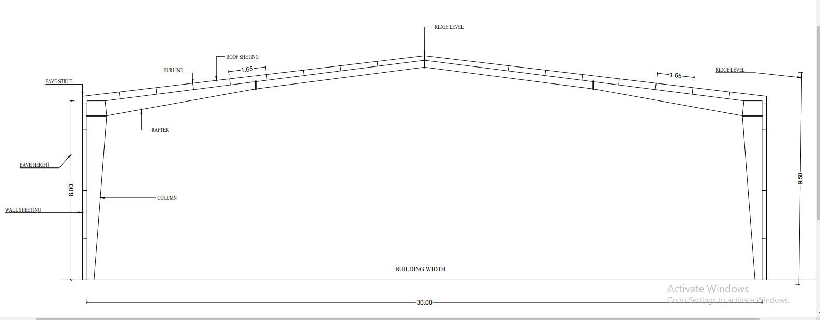

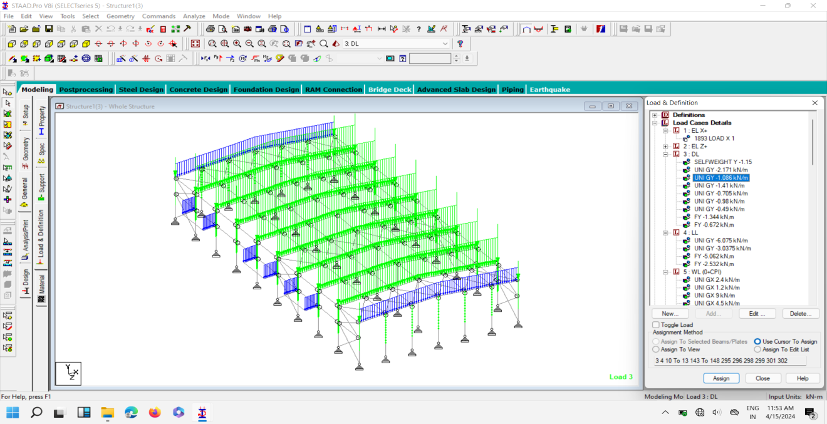

**Fig :Dead Load**

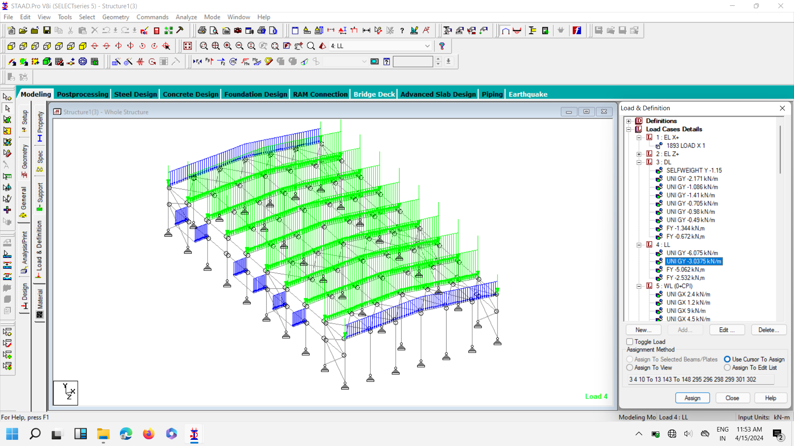**Fig :Live Load**

**Fig: WIND LOAD**

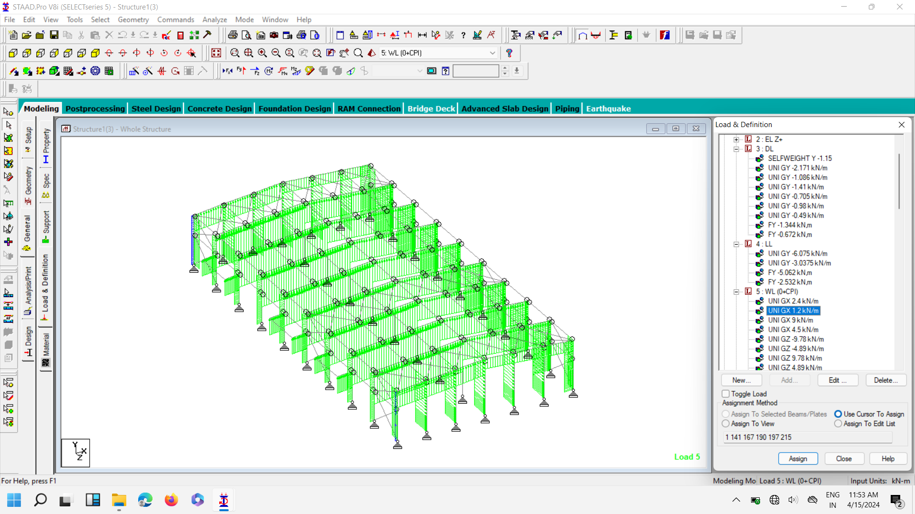

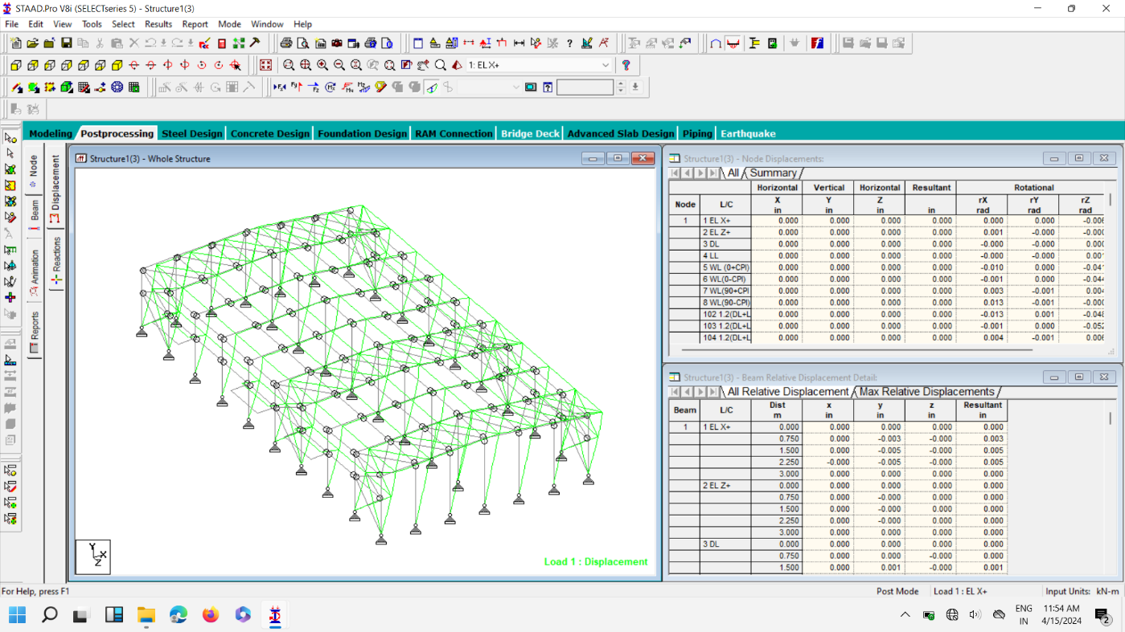



**Fig : DEFLECTION**

**4. CONCLUSION**

At the end of project thorough understanding of pre-engineered building systems is essential for ensuring the structure. By comprehensively analyzing structural elements, connections, and construction techniques, engineers can guarantee that beams, columns, and roof trusses meet stringent safety and performance standards. This analysis involves assessing factors such as load distribution, material strength, and environmental conditions to ensure the resilience and durability of the structure. Conducting structural analysis using modern computational tools and simulation software offers numerous advantages in evaluating the behaviour of Pre-Engineered Building (PEB) systems under various loading conditions. Computational tools and simulation software utilize advanced algorithms and models to accurately predict the behavior of PEB systems. Engineers can simulate real-world scenarios with high precision, allowing for more reliable analysis results. Traditional methods of structural analysis often involve manual calculations and simplifications, which can be time-consuming and prone to errors. Computational tools streamline the analysis process, saving time and effort while ensuring thorough evaluations of PEB systems.

**REFERENCES**

1) B K Raghu Prasad, Sunil Kumar, Amaranth K (2014), "Optimization of Pre Engineered Buildings".

2) D V Swathi. I.M.E, Dept. Of Civil, Pydah College of Engg. (2014), "DSSesign and analysis of pre-engineered steel frame".

3) Sai Kiran Gone, Kailash Rao, Pradeep Kumar Ramancharla (2014), "Comparison of Design Procedures for Pre Engineering Buildings (PEB)”.

4) Sagar Wankhade, Prof. Dr. P. S. Pajgade (2014), “Review Paper on Comparison of Conventional Steel Building & Pre-Engineering Building".

5) Aijaz Ahmad Zende, Prof. A. V. Kulkarni, Aslam (2013), “HutagiComparative Study of Analysis and Design of Pre-Engineered-Buildings and Conventional Frames".

6) Dr. N. Subramanian (2008), “Pre-engineered Buildings Selection of Framing System, Roofing and Wall Materials", TheMasterbuilder, p. 48-6.

7) Darshan, K.; Sujay, D.; Pavan, G. A Comparative study on the Performance of PEB with CSB considering various parameters. Int. Res. J. Eng. Technol. 2017, 4, 1082–1088.

8) John A. Rolphes (2006), “Industrial Building Design - Seismic Issues", the Iron and Steel Technology, pp. 282-298.

9) Dr. N. Subramanian (2008), “Pre-engineered Buildings Selection of Framing System, Roofing and Wall Materials", The Master builder, p. 48-6.

10) SapnaKulshrestha (2012), “Designing of Pre-engineered Structures”, TheBuildotechInida

11) Structural and crane load design criteria for steel building systems, “The National Building Code of Canada, 2005. Buildings and Conventional Frames", IOSR

12) A.S. Kumar, et al., Design and Analysis of Pre Engineered Industrial Buildings (PEB), Int. J. Appl. Sci., Eng. Manag. ISSN, 2320–3439.

13) IS: 800 - 2007 :- General Construction In Steel - Code of Practice.

14) IS: 875 (Part 1) - 1987:- Code of Practice for Design Loads (Other Than

Earthquake) for Buildings and Structures- Dead Loads.

15) IS: 875 (Part 2) - 1987:- Code of Practice for Design Loads (Other Than Earthquake)

for Buildings and Structures- Live Loads.

16) IS: 875 (Part 3) - 1987:- Code of Practice for Design Loads (Other Than Earthquake)

for Buildings and Structures- Wind Loads.

17) 2IS 1893: 2002 Criteria For Earthquake Resistant Design of Structures.

18) IS: 800 – 2007 Indian Standard General Construction In Steel – Code of Practice

19)Limit state design in structural steel by M.R. SHIYEKAR.