**ERP-IMPLEMENTATION WITH REFERENCE TO TATA CONSULTANCY SERVICES**

**KONERU SAI PRASAD**

Roll No: 212122672020, Department of Management Studies

Aristotle PG College, Chilkur, Moinabad, Ranga Reddy District, Telangana.

**Dr. U Kanaka Rao**

Associate Professor

Aristotle PG College, Chilkur, Moinabad, Ranga Reddy District, Telangana.

[dr.ukrao2015@gmail.com](mailto:dr.ukrao2015@gmail.com)

**Abstract:**

Enterprise resource planning (ERP) integrates internal and external management information across an entire organization, embracing finance/accounting, manufacturing, sales and service, customer relationship management, etc. ERP systems automate this activity with an integrated software application. Its purpose is to facilitate the flow of information between all business functions inside the boundaries of the organization and manage the connections to outside stakeholders. ERP systems can run on a variety of hardware and network configurations, typically employing a database as a repository for information. ERP enables companies to optimize their business processes and analysis capabilities for improved speed and efficiency. It delivers a single database that contains all data for the software modules, which would include: ERP systems collect all information in one location to better coordinate and manage resources and activities needed for a particular business process. Enterprise Resource Planning can be used as a powerful tool assisting in better decisions and helping the team work together. This is just another step in building a foundation to optimize operations and supply chain.

**Keywords:** Job Satisfaction, Communication Professinals

**INTRODUCTION:**

The initials ERP originated as an extension of MRP (material requirements planning; later manufacturing resource planning) and CIM (Computer Integrated Manufacturing). It was introduced by research and analysis firm Gartner in 1990. ERP systems now attempt to cover all core functions of an enterprise, regardless of the organization's business or charter. These systems can now be found in non-manufacturing businesses, non-profit organizations and governments.

To be considered an ERP system, a software package must provide the function of at least two systems. For example, a software package that provides both payroll and accounting functions could technically be considered an ERP software package Examples of modules in an ERP which formerly would have been stand-alone applications include: Product lifecycle management, Supply chain management (e.g. Purchasing, Manufacturing and Distribution),Warehouse Management, Customer Relationship Management (CRM),Sales Order Processing, Online Sales, Financials, Human Resources ,and Decision Support System.

Some organizations — typically those with sufficient in-house IT skills to integrate multiple software products — choose to implement only portions of an ERP system and develop an external interface to other ERP or stand-alone systems for their other application needs.

For example, one may choose to use human resource management system from one vendor, and perform the integration between the systems themselves.

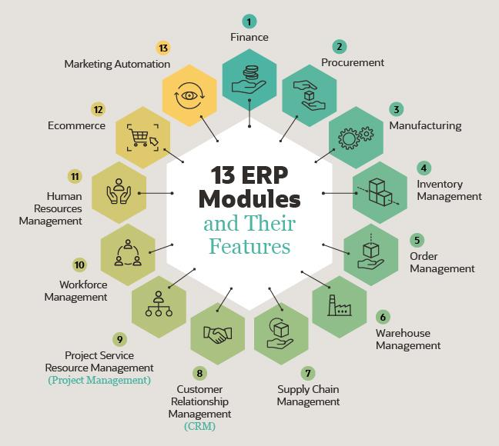

**REVIEW OF LITERATURE:**

**ARTICLE: 1**

**Title:** Enterprise Resource Planning (ERP): a review of the literature

**Author:** Young B. Moon

**Source:** Int. J. Management and Enterprise Development, Vol. 4, No. 3, 2007

Abstract: This article is a review of work published in various journals on the topics of Enterprise Resource Planning (ERP) between January 2000 and May 2006. A total of 313 articles from 79 journals are reviewed. The article intends to serve three goals. First, it will be useful to researchers who are interested in understanding what kinds of questions have been addressed in the area of ERP. Second, the article will be a useful resource for searching for research topics. Third, it will serve as a comprehensive bibliography of the articles published during the period. The literature is analysed under six major themes and nine sub-themes.

**ARTICLE: 2**

The set of papers published in various journals between 2000 and 2006 (as of 31 May 2006) is vast, comprising 313 articles. As a consequence, it is difficult to provide detail review of all the articles. Instead, an aggregate summary for each theme is described. Direct references are deliberately avoided, but a complete list of references for each theme is provided. The reviewed articles are organised into themes and some collective properties of the articles are described for each theme.

**ARTICLE: 3**

Two review articles have been written on ERP prior to this article. The one by Esteves and Pastor (2001) is an annotated bibliography of the main journal and conference articles in Information Systems (IS) during the period 1997–2000. They include a brief summary sentence for each article along with a complete list of references. The total numbers of articles surveyed are 189. However, the numbers of journal articles among these is only 21, perhaps reflecting the infancy of the field during that period. The other review article on ERP is by Botta-Genoulaz et al. (2005). They analysed the ERP literature during the period 2003–2004. Similar to this article, they also developed six categories and classified the articles under each category. The six categories that they adopted are: 1 implementation of ERP 2 optimisation of ERP 3 management through ERP 4 the ERP software 5 ERP for supply chain management 6 case studies.

**RESEARCH GAP:**

For this study, the research was organized along key ownership experience criteria that allowed the research to capture quantitative and qualitative information across the major components of enterprise applications. The list of criteria was thoroughly defined to take into account the experience of not only the technical staff, but also end-users who must accomplish specific business tasks with the application.

**OBJECTIVES:**

* Enhancing the customer relationship management is a main feature coming under the objectives of ERP.
* Error controlling is another objective behind ERP implementation in an organization.
* It helps in better planning and coordination of business resources so as to achieve maximum profit.
* Reducing inventory cost is another core objective of ERP.
* Return on investment, best known as ROI is another core objective of ERP.

**RESEARCH METHODOLOGY:**

**The software versions that were compared included:**

* Microsoft Great Plains version 7.5 and previews of Microsoft Great Plains version 8.0
* Oracle E-Business Suite 11.5.9
* PeopleSoft Enterprise 8.8 and 8.9 and Enterprise One 8.11
* SAP: my SAP Business Suite R/3 4.6 and SAP R/3 Enterprise4.7
* Siebel 7.5 and Siebel 7.7 The research also included functional areas such as Financial and Human Capital Management Systems (FMS & HCM), Supply Chain Management (SCM),Customer Relationship Management (CRM); and application lifecycle phases such as installation, implementation, configuration, usage, maintenance, support, and upgrades. We have broken the entire process down into five steps:
* Reviewed vendors' web sites and their positioning documents, as well as their online and hard copy documentation.
* Utilized analyst reports, press articles, and technical reviews that are available to the general public.

•Validated, using the defined criteria, the information collected insteps 1 and 2 through in-depth interviews with the consulting panel of experts. For the interview process, preference was givento respondents with multi-year experience and experience with the latest version of the application to ensure that the entire application lifecycle was properly covered.

•Compared and analyzed findings from this primary and secondary research to generate a rating for each vendor on specific criteria. In this comparison and analysis, the respondent’s experience with multiple vendors was leveraged Aswell.

•Aggregated comparisons and ratings along three major phases of the enterprise application ownership lifecycle.

**DATA ANALYSIS & INTERPRETATION:**

**Which Industry Are You Into**

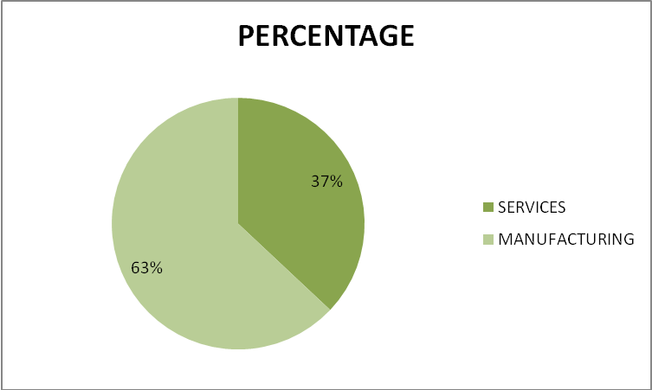

|  |  |
| --- | --- |
| **INDUSTRY** | **PERCENTAGE** |
| SERVICES | 37% |
| MANUFACTURING | 63% |

**INTERPRETATION:**

Among the respondents,37% are into service industry and 63% are into manufacturing.

**Which Industry Are You Into**

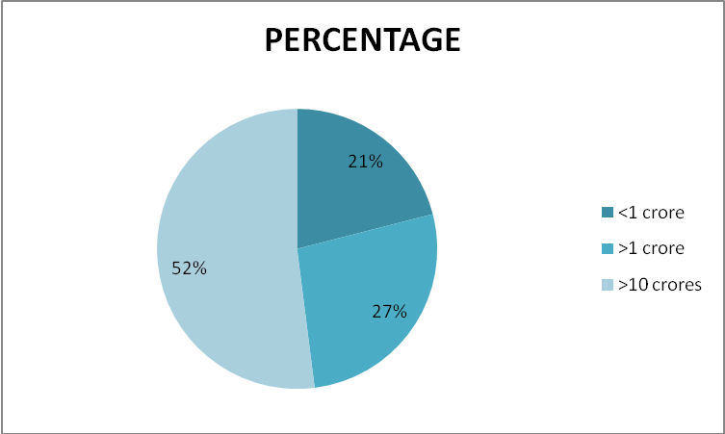

|  |  |
| --- | --- |
| **INDUSTRY** | **PERCENTAGE** |
| <1 crore | 21% |
| >1 crore | 27% |
| >10 crores | 52% |

**INTERPRETATION:**

21%, 27%, 52% of the respondents have their turnover<1crore,>1crore,>10crores respectively.

**Which Industry Are You Into**

|  |  |
| --- | --- |
| **INDUSTRY** | **PERCENTAGE** |
| <50 | 7% |
| >50 <100 | 33% |
| >100 | 60% |

**INTERPRETATION:**

There are 13% of the companies whose total no. of employees are <50,7% whose total no. of employees are >50 & <100 and 80% of the companies whose total no. of employees are >100 among the respondents.

**Are You Using An Erp Currently**

|  |  |
| --- | --- |
| **INDUSTRY** | **PERCENTAGE** |
| YES | 33% |
| NO | 67% |

**INTERPRETATION:**

: Among the respondents 33% are using ERP currently and 67% are not using an ERP.

**Tools Of An Erp Being Used**

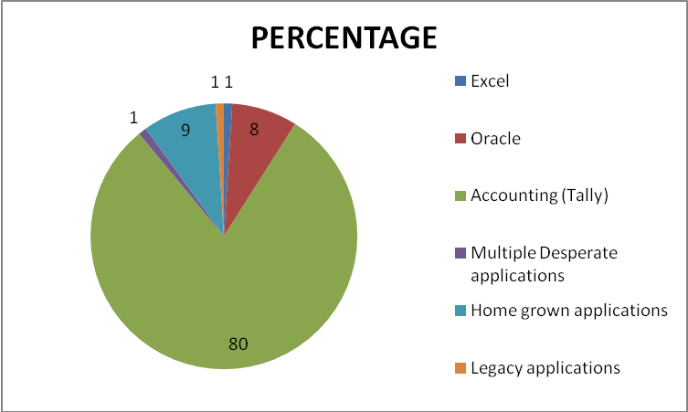

|  |  |
| --- | --- |
| **TOOLS TO BE USED** | **PERCENTAGE** |
| Excel | 1 |
| Oracle | 8 |
| Accounting (Tally) | 80 |
| Multiple Desperate applications | 1 |
| Home grown applications | 9 |
| Legacy applications | 1 |

**INTERPRETATION:**

: Among the respondents who are not using an ERP,8% are using Oracle a tool of ERP and 80% are using Tally and others are using miscellaneous percentage.

**CONCLUSIONS:<**

* Among the respondents who are using an ERP,50% say that they are using it to standardize the business practices and 45% say it is to improve the processes,3% say to optimize the current capacity and resources and 2% say Modernizing technical infrastructure and applications.
* 100% of the respondents say that explosive growth is the compelling reason for them to buy an ERP.
* 40% among the respondents said that they have reduced the administrative cost after the implementation of an ERP while 60% said it is the inventory cost that they have reduced after the implementation of an ERP.

**REFERENCES:**

* + - [www.google.com](http://www.google.com)
    - [www.wikipedia.com](http://www.wikipedia.com)
    - [www.indian](http://WWW.INDIAN) industry.com