**Role of Security Analysis & Portfolio Management**

**Gattupally Dinesh**

Roll No: 212122672012, Department of Management Studies

Aristotle PG College, Chilkur, Moinabad, Ranga Reddy District, Telangana.

**Dr. U Kanaka Rao**

Associate Professor

Aristotle PG College, Chilkur, Moinabad, Ranga Reddy District, Telangana.

[dr.ukrao2015@gmail.com](mailto:dr.ukrao2015@gmail.com)

**Abstract:**

Security Analysis examines the industries and securities of individual companies primarily to develop value and return expectations for securities and thus to distinguish overprices securities from underpriced ones, with the evolution of portfolio theory and new methods of addressing investment management issues, the job of financial analysts has become more demanding.

Portfolio Management IS a process encompassing many activities aimed at optimizing investment of funds, each phase is an integral part of the whole process and the success of portfolio management depends upon the efficiency in carrying out each phase.

**Keywords:** Security Analysis, Portfolio Management, Models.

**INTRODUCTION:**

The process of investment management begins with an evaluation of the available investment opportunities. The financial analyst must have a clear picture of the current investment. He should be able to design a framework for evaluation of risk return profile of various securities.

Today money flows effortlessly into those avenues which offer higher returns. These developments have transformed the task of security analyses calling for application of scientific tools and techniques.

Portfolio management involves investing through a rational decision making process in which the investors attempt to select portfolios of securities that meet predetermined levels of returns based on their capacity to bear risk.

**INVESTMENT:**

Investment is a financial activity that involves risk. It is the commitment of funds for a return expected to be realized in the future. Investment can be made in financial assets or physical assets. In either case there is possibility that the actual return may vary from the expected return that possibility is risk involved in it.

Investment is generally distinguished from speculation in terms of 3 factors namely **risk, capital gain and time period.** Gambling is the extreme form of speculation. Investors may be individual or institutions.

There is large no. of investment avenues for savers in India. Corporate securities, deposits in the banks and non-banking companies, mutual funds schemes, provident fund schemes, life insurance policies, government securities are some of the important avenues.

**Investment avenues:**

There are a large number of investment avenues for savers in India. Some of them are marketable and liquid, while others are non-marketable. Some of them are highly risky while some others are almost risk less. Investment avenues can be broadly categorized under the following head.

1. Corporate securities
2. Equity shares.
3. Preference shares.
4. Debentures/Bonds.
5. Derivatives.
6. Others.

**REVIEW OF LITERATURE:**

**ARTICLE: 1**

**TITLE:** A Study on the Factors Influencing Investors Decision in Investing in Equity Shares in Jaipur and Moradabad with Special Reference to Gender

**Author:** Jeet Singh, Preeti Yadav

**Source : Amity Journal of Finance**

The present study tries to find out the factors that have major influence on the share investment decisions of a sample of 100 investors in Moradabad city of Uttar Pradesh. Revolution in the finance industry is brought about through the advent and evolution of behavioral finance. Investors hardly act rationally in taking decisions while investing. Investors simply react on the available information possessed by them and react accordingly. Lots of consideration is required to be dealt with before investing in the equity market. Ratio analysis is required to be considered. Technical and financial analysis of the company along with the fundamental analysis of the economy is to be taken into account while investing in the capital market. The present paper tries to find out the perception of male and female investors regarding various considerations to be kept in mind while investing in the equity market. The paper tries to cram the attitude of male and female investors towards variety of investment alternatives. The researchers have selected 60 male investors and 40 female investors from Jaipur and Moradabad cities. The study uses independent t-test, mean scores to test the hypothesis. The paper concludes that investors should as far as possible try to make fundamental, technical and financial analysis before investing in the shares. **ARTICLE: 2**

**TITLE:** Factors Effecting Investment Decision Making Behavior: The Mediating Role of Information Searches

**Author:** Samina Gill1, Muhammad Kashif Khurshid2, Shahid Mahmood3, Arfan Ali\***Source:** **European Online Journal of Natural and Social Sciences 2018;**

This study investigates the factors affecting the investment decision making behavior through the mediation role of information searches. Two factors i.e. overconfidence bias and economic expectations are used as independent variables while investment decision making behavior is taken as dependent variable. Information search is used as mediating variable. For this purpose, a survey questionnaire was used to test the hypotheses. The population in this survey was investors of Lahore Stock Exchange of Pakistan and Faisalabad Trading Floor. Total 270 questionnaires were distributed; only 245 of them were received back 11 were not included in the analyses as they were incomplete. Hence, 229 questionnaires were used in the analyses. Simple and multiple regression analysis were used as statistical tool. The results showed positive and significant relationship between economic expectations and investment decision making behavior but when information search was included as mediator the relationship became insignificant and negative; which suggests full mediation in case of economic expectations. Overconfidence bias was also found to have positive and significant relationship with investment decision making behavior which remained significant when information search was added as mediator; suggesting a partial mediation in case of overconfidence.

**ARTICLE: 3**

**TITLE:** A Study on Problems and Prospects of Online Stock Trading in Solan Town of Himachal Pradesh Author**:** Siska Atmaningrum1, Dwi Sunu Kanto1, Zainul Kisman1

**Source:** **Journal of Economics and Business**

Investment is an economic activity that can be a way for a person to expand or maintain his wealth. However, in investing, the public must be more careful in making decisions so that they are not trapped by fake investments. In investing, there are several factors that influence the decision to invest, namely Financial Knowledge, Income, Self-Control, Financial Behavior, and Financial Attitude towards Investment Decisions. This study aims to examine the influence of the variables of Financial Knowledge, Income, and Self-Control on Investing Decisions mediated by Financial Behavior and Financial Attitudes. This study uses Financial Knowledge, Income, and SelfControl as independent variables, then Investment Decisions as the dependent variable, then Financial Behavior, and Financial Attitudes as intervening variables. The results of this study indicate that financial knowledge has an effect on financial behavior.

**RESEARCH GAP:**

# This study investigates the factors affecting the investment decision making behavior through the mediation role of information searches. Two factors i.e. overconfidence bias and economic expectations are used as independent variables while investment decision making behavior is taken as dependent variable.

**OBJECTIVES:**

* To analyze the securities
* To study the investment pattern and its related risk and returns.
* To understand, analyze and select the best portfolio.
* To help the investor to chose wisely between the alternative investment.
* To strike the balance between costs of funds, risk and returns

**RESEARCH METHODOLOGY:**

**Need For The Study**

Today the stock market is more volatile the for example the sensex index which had touched the peak of 20,000, now it is around 9000.the study of security analysis and portfolio management is helpful to understand the risk involved in investing in the stock market and it helps the investor to invest in the diversified portfolio to reduce the risk.

The investor should think before he invests in some company the analysis of that security is must be done before investment. The investor should also know about the different investment avenues, but some times the investor may loose his money in stock market because of uncertain events like Satyam(corporate governance failure)

**Scope Of The Study:**

To study the investment pattern and its related risk and returns. To help the investor to chose wisely between the alternative investment. For Different companies, financial data has been collected from the year 2022-2023(Jan)

**Methodology**

**Sources of data collection**:

the methodology adopted or employed in this study was mostly on secondary data collection i.e..,

* Companies annual reports
* Information from internet
* Publications
* Information provided by inter connected stock exchange.

**Period of study:**

For different companies, financial data has been collected from the year 2018-2023(jan)

**Sample size :** 5 companies chosen for analysis

**Selection of companies:** companies which selected for analysis are

* Infosys ,Ranbaxy, Jindal steel, Acc, Bhel

**DATA ANALYSIS & INTERPRETATION:**

**EARNINGS PER SHARE**

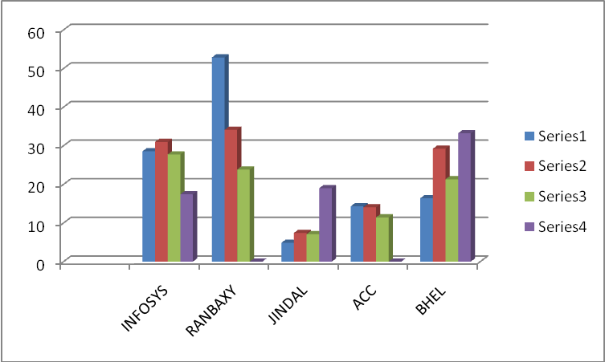

|  |  |  |  |  |
| --- | --- | --- | --- | --- |
| **YEAR** | **2020** | **2021** | **2022** | **2023** |
| Infosys | 28.55 | 30.98 | 27.74 | 17.43 |
| Ranbaxy | 52.86 | 34.12 | 23.83 | - |
| Jindal | 4.87 | 7.44 | 7.10 | 19.02 |
| Acc | 14.35 | 14.07 | 11.45 | - |
| Bhel | 16.40 | 29.23 | 21.32 | 33.23 |

**Interpretation**: According to Above Table and Graphs shows that EPS of the Infosys, Ranbaxy, Acc, has downfall trend while Jindal has upward trend.

**P/E RATIO**

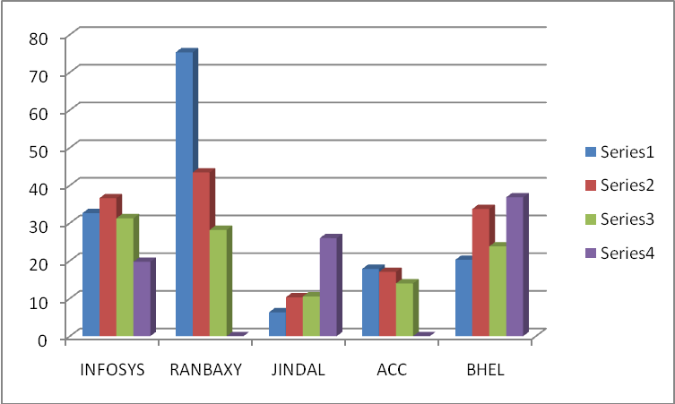

|  |  |  |  |  |
| --- | --- | --- | --- | --- |
| **YEAR** | **2020** | **2021** | **2022** | **2023** |
| Infosys | 32.66 | 36.62 | 31.28 | 19.73 |
| Ranbaxy | 75.33 | 43.44 | 28.19 | - |
| Jindal | 6.33 | 10.32 | 10.55 | 26.02 |
| Acc | 17.85 | 17.07 | 14.00 | - |
| Bhel | 20.27 | 33.75 | 23.83 | 36.84 |

**Interpretation**: According to Above Table and Graphs shows that p/e ratio of Infosys good in early stages but gradually decreases but the p/e ratio of Bhel is increasing.

**DIVIDEND YEILD RATIO**

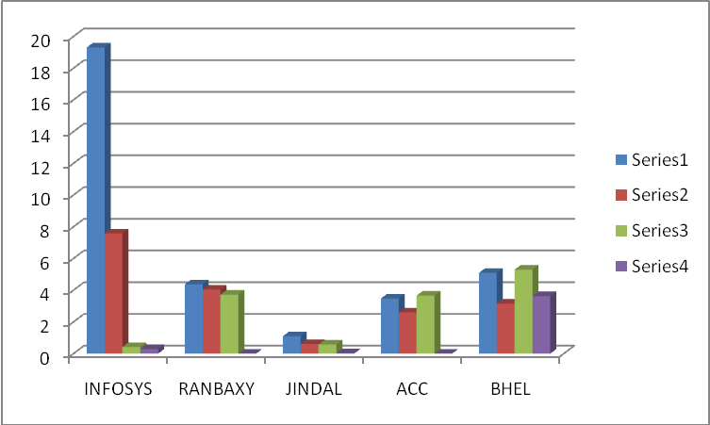

|  |  |  |  |  |
| --- | --- | --- | --- | --- |
| **YEAR** | **2020** | **2021** | **2022** | **2023** |
| Infosys | 19.31 | 7.58 | 0.42 | 0.29 |
| Ranbaxy | 4.37 | 4.04 | 3.72 | - |
| Jindal | 1.10 | 0.61 | 0.58 | 0.03 |
| Acc | 3.48 | 2.60 | 3.66 | - |
| Bhel | 5.10 | 3.16 | 5.30 | 3.63 |

**Interpretation**: According to Above Table and Graphs shows To express the relationship between the MPS & the DPS The dividend yield ratio of Infosys is more fluctuating and while bhel is on study dividend yield radio.

**CALCULATION OF AVERAGE RETURN OF COMPANIES**

**INFOSYS**

|  |  |  |  |  |  |
| --- | --- | --- | --- | --- | --- |
| **Year** | **Dividend (d)** | **Opening share price(p0)** | **Closing share price(p1)** | **D+(p1-p0)** | **D+(p1-p0)/p0*100** |
| 2018-2019 | 129.5 | 3566.15 | 4960 | 1523.35 | 42.72 |
| 2019-2020 | 11.5 | 4960.8 | 5111 | 161.7 | 3.26 |
| 2020-2021 | 45 | 3050.12 | 2981.4 | -23.72 | -0.78 |
| 2021-2022 | 11.5 | 2980.12 | 3142.15 | 173.53 | 5.82 |
| 2022-2023 | 33.25 | 1951.1 | 1439.9 | -477.95 | -24.50 |
| **Total return** | | | | | 26.53 |

**Average Return = 26.53/5 = 5.30**

**RANBAXY**

|  |  |  |  |  |  |
| --- | --- | --- | --- | --- | --- |
| **Year** | **Dividend (d)** | **Opening share price(p0)** | **Closing share price(p1)** | **D+(p1-p0)** | **D+(p1-p0)/p0*100** |
| 2018-2019 | 8.5 | 634.75 | 939.75 | 313.5 | 49.38 |
| 2019-2020 | 8.5 | 989.4 | 1008.8 | 27.9 | 2.82 |
| 2020-2021 | 8.5 | 1015 | 830.8 | -175.7 | -17.31 |
| 2021-2022 | 8.5 | 440.35 | 490.6 | 58.75 | 13.34 |
| 2022-2023 | 8.5 | 341.6 | 438.45 | 105.35 | 30.84 |
| **Total return** | | | | | 79.07 |

**Average Return = 79.07/5 = 15.81**

**JINDAL STEEL**

|  |  |  |  |  |  |
| --- | --- | --- | --- | --- | --- |
| **Year** | **Dividend (d)** | **Opening share price(p0)** | **Closing share price(p1)** | **D+(p1-p0)** | **D+(p1-p0)/p0*100** |
| 2018-2019 | 2 | 148.40 | 508.00 | 361.60 | 243.67 |
| 2019-2020 | 3 | 521.50 | 1041.60 | 523.10 | 100.31 |
| 2020-2021 | 3 | 1099.45 | 1095.80 | -0.65 | -0.06 |
| 2021-2022 | 3.6 | 1095.85 | 2377.45 | 1285.20 | 117.28 |
| 2022-2023 | 4 | 2245.10 | 2070.00 | -171.10 | -7.62 |
| **Total return** | | | | | 453.57 |

**Average Return = 453.57/5 = 90.74**

**ACC**

|  |  |  |  |  |  |
| --- | --- | --- | --- | --- | --- |
| **Year** | **Dividend (d)** | **Opening share price(p0)** | **Closing share price(p1)** | **D+(p1-p0)** | **D+(p1-p0)/p0*100** |
| 2018-2019 | 4 | 157.10 | 254.65 | 101.55 | 64.64 |
| 2019-2020 | 7 | 261.65 | 360.55 | 105.90 | 40.47 |
| 2020-2021 | 10.66 | 363.95 | 782.2 | 428.91 | 117.85 |
| 2021-2022 | 15 | 796.5 | 735.25 | -46.25 | -5.81 |
| 2022-2023 | 20 | 704.45 | 826.15 | 141.70 | 20.11 |
| **Total return** | | | | | 26.53 |

**Average Return = 237.27/5 = 47.45**

**BHEL**

|  |  |  |  |  |  |
| --- | --- | --- | --- | --- | --- |
| **Year** | **Dividend (d)** | **Opening share price(p0)** | **Closing share price(p1)** | **D+(p1-p0)** | **D+(p1-p0)/p0*100** |
| 2018-2019 | 6 | 203.80 | 604.35 | 406.55 | 199.48 |
| 2019-2020 | 8 | 637.05 | 766.4 | 137.35 | 21.56 |
| 2020-2021 | 14.5 | 801.65 | 2241.95 | 1454.80 | 181.48 |
| 2021-2022 | 24.5 | 2297.75 | 2261.35 | -11.90 | -0.52 |
| 2022-2023 | 15.2 | 2154.15 | 2061.35 | -77.60 | -3.60 |
| **Total return** | | | | | 398.4 |

**Average Return = 398.4/5 = 79.68**

**CONCLUSIONS:**

Public companies issue shares, which allow investors to buy a part of a particular company share ownership entitles you to part of the company Profits of dividends are paid. Shares may be classified in a range from conservative to speculative. Blue chip is often used to describe the highest quality and shares, as they are shares in companies with a proven track record, producing profits in good times and bad. They usually set the level of the market. All shares are affected by share market fluctuation. Individual share process also vary based on supply and demand from sellers and buyers. Information about shares listed on the stock exchange is printed largely daily in news papers. You can buy and sell shares listed on the stock exchange through a stockbroker. When you buy a parcel of shares, you receive a CHESS statement of holdings form the company, showing the number of shares you own and the date you bought them.

**REFERENCES:**

* [www.investsmartindia.com](http://www.investsmartindia.com)
* [www.nseindia.com](http://www.nseindia.com)
* [www.bseindia.com](http://www.bseindia.com)
* [www.iseindia.com](http://www.iseindia.com)