**Role of Decision Support System**

**Gavara Naga Lakshmi Priyanka**

Roll No: 212122672011, Department of Management Studies

Aristotle PG College, Chilkur, Moinabad, Ranga Reddy District, Telangana.

**Dr. U Kanaka Rao**

Associate Professor

Aristotle PG College, Chilkur, Moinabad, Ranga Reddy District, Telangana.

[dr.ukrao2015@gmail.com](mailto:dr.ukrao2015@gmail.com)

.s

**Abstract:**

*Classification is a classical trouble in machine getting to know and statistics mining. Given a set of training statistics tuples, every having a category label and being represented via a characteristic vector, the project is to algorithmically build a model that predicts the magnificence label of unseen check tulle primarily based on the tulle's function vector. One of the most famous class fashions is the choice tree version. Decision timber are popular due to the fact they're sensible and clean to recognize. Rules also can be extracted from decision timber easily. Many algorithms, such as ID3 and C4.Five have been devised for decision tree construction. These algorithms are broadly followed and utilized in a huge variety of applications inclusive of image popularity, clinical analysis, and credit score of loan candidates, medical checks, fraud detection, and target advertising..*

**Keywords:** Decision Support System, Models, Proposed Tools.

**INTRODUCTION:**

A decision support system (DSS) is a computerized program used to support determinations, judgments, and courses of action in an organization or a business. A DSS sifts through and analyzes massive amounts of data, compiling comprehensive information that can be used to solve problems and in decision-making.

Traditional selection tree classifiers paintings with facts whose values are recognized and particular. We increase such classifiers to deal with data with unsure facts. Value uncertainty arises in many programs at some point of the records collection technique. Example sources of uncertainty include measurement/quantization errors, data staleness, and more than one repeated measurements. With uncertainty, the value of a information object is often represented not with the aid of one single value, but through multiple values forming a probability distribution. Rather than abstracting uncertain records through statistical derivatives (which includes imply and median), we discover that the accuracy of a choice tree classifier can be a lot advanced if the “complete information” of a records item (thinking of the chance density feature (PDF) is applied. We make bigger classical decision tree constructing algorithms to deal with information tuples with unsure values. Extensive experiments were conducted that show that the resulting classifiers are more accurate than those the use of fee averages.

Since processing PDF’s is computationally more luxurious than processing unmarried values(e.G., averages), choice tree production on uncertain statistics is greater CPU traumatic than that for certain records. To address this hassle, we recommend a series of pruning strategies that could substantially enhance creation efficiency.

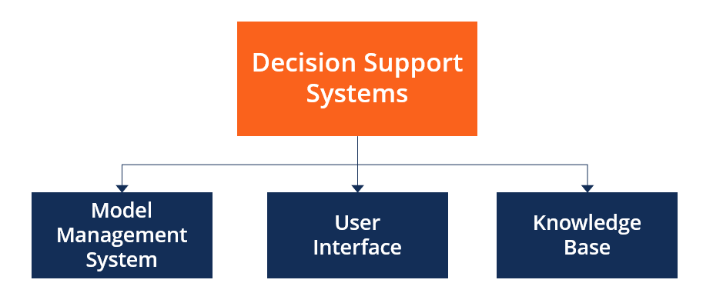

**REVIEW OF LITERATURE:**

* **Author:** Ziwei Wang : The common thread of articles published in Decision Support Systems is their relevance to theoretical and technical issues in the support of enhanced decision making. The areas addressed may include foundations, functionality, interfaces, implementation, impacts, and evaluation of decision support systems (DSSs). Manuscripts may draw from diverse methods and methodologies, including those from decision theory, economics, econometrics, statistics, computer supported cooperative work, data base management, linguistics, management science, mathematical modeling, operations management, cognitive science, psychology, user interface management, and others. However, a manuscript focused on direct contributions to any of these related areas should be submitted to an outlet appropriate to the specific area.
* **Author:** 1a.haritha, 2k. Divya: Decision support system (DSS) refers to any tool or task which has the potential to support decision-making activities. Decision making is one of the major and difficult tasks which ultimately results in the success or failure of a system in general and an application in particular. In Internet of Things (IoT), DSS has an immense potential to influence the outcome of various applications. The data streams originating from embedded sensors in various IoT applications, e.g., smart farming, industrial automation, healthcare, etc, need to be assessed in view of the sensitive information present in the data.
* **Author:** David Arnott: This paper reports the preliminary results of a project that is investigating the theoretic foundations of decision support systems (DSS). The project is principally motivated by a concern for the direction and relevance of DSS research. The main areas of research focus are the decision and judgement theoretic base of the discipline, the research strategies used in published articles, and the professional relevance of DSS research. The project will analyse DSS articles published in 17 selected journals from 1990 to 2002. This preliminary report is based on the analysis of 358 papers. The findings indicate that DSS research is dominated by positivist research (in particular laboratory experiments and surveys), is heavily influenced by the work of Herbert Simon, and has a healthy balance of theory and application, but, it is poorly grounded in judgement and decision-making research, and falls down in the identification of the nature of clients and users.
* **Evaluation and realisation of IS/IT benefits: an empirical study of current practice (2015):** This paper presents the main findings of a 1994 survey of UK industry practices in the evaluation and realisation of IS/IT benefits (‘benefits management ‘). The survey addresses the issues which affect the ability of organizations to realise the full benefits of IS/IT investments, i.e. not only the pre-investment appraisal and post-investment evaluation processes, but also how organizations do or do not ensure that benefits claimed are actively managed through to realisation. To do this a new benefits management process model was used to structure a questionnaire to elicit details of how effective organizations are in addressing benefits management throughout the investment lifecycle. Sixty organizations responded to the survey, thus providing a wealth of data for analysis. This paper presents some of the key results of that analysis. From the survey, it is clear that many organizations believe that current methods are far from satisfactory in ensuring that the benefits are properly identified and realised. Very few have a comprehensive process for managing the delivery of benefits from IS/IT. This paper offers new insight into the reasons for the current unsatisfactory situation and points the way to how the situation could be significantly improved.
* **IT outsourcing has grown considerably in the private sector (2013)**: with IT software and service suppliers reporting increased revenues. Similarly in the public sector, the introduction of market testing and compulsory competitive tendering (CCT) will inevitably lead to the contracting-out of significant levels of IT work. This may lead to the demise of some public sector IT departments where external bids are favoured over those offered by the in-house team. This paper is divided into two sections. First, it considers some of the relevant literature on IT outsourcing in both private and public sector British and American organizations. It draws together important themes which explain the attraction of IT outsourcing to senior executives. Second, it introduces the results from a questionnaire survey of nearly 200 UK private and public sector organizations on IT outsourcing. In particular it looks at the proportion of organizations that claims to use outsourcing, how contracts are negotiated and the type of IT solutions preferred by IT managers. The central argument is that IT outsourcing poses significant challenges to both private and public sector organizations and is not simply a quick-fix panacea. Moreover, public sector IT managers would do well to analyse some of the less favourable reports from private sector outsourcing as they gear themselves up for CCT in the months ahead.

**RESEARCH GAP:**

This preliminary report is based on the analysis of 358 papers. The findings indicate that DSS research is dominated by positivist research (in particular laboratory experiments and surveys), is heavily influenced by the work of Herbert Simon, and has a healthy balance of theory and application, but, it is poorly grounded in judgement and decision-making research, and falls down in the identification of the nature of clients and users..

**OBJECTIVES:**

* common is taken from a big range of nuclei from an picture,
* The radius of an (irregularly-fashioned) nucleus is acquired by means of averaging the length of the radial line segments defined by way of the centroid of the nucleus and a massive variety of sample points at the nucleus’ perimeter
* A nucleus’ perimeter was mentioned by a user over a fuzzy 2D image.

**RESEARCH METHODOLOGY:**

**Need For The Study**

To devise an algorithm for constructing selection trees from unsure statistics the use of the Distribution-based approach; To look into whether or not the Distribution-based method could result in a higher classification accuracy compared with the Averaging method; and

To set up a theoretical basis on which pruning techniques are derived that can notably enhance the computational performance of the Distribution-based algorithms.

**Scope Of The Study:**

“How many hours of TV do you watch each week?” A traditional respondent might not reply with an exact specific solution. Rather, a variety (e.G., “6–8 hours”) is typically replied, probably due to the fact the respondent isn't so certain about the solution himself. In this example, the survey cans restriction a solution to fall into a few pre-set categories (inclusive of “2–four hours”, “four–7 hours”, and many others.). However, this limit unnecessarily limits the respondents’ choices and adds noise to the information. Also, for retaining privacy, on occasion point statistics values are converted to levels on motive before publication

**METHODOLOGY**

**PHASE DESCRIPTION:**

|  |  |  |
| --- | --- | --- |
| **Phase** | **Task** | **Description** |
| Phase 1 | Analysis | Analyze the information related to the proposed study. |
| Phase 2 | Literature survey | Collect raw data and elaborate on literature surveys. |
| Phase 3 | Design | Assign the module and design the process flow control. |
| Phase 4 | Implementation | Implement the code for all the modules and integrate all the modules. |
| Phase 5 | Testing | Test the code and overall process weather the process works properly. |
| Phase 6 | Documentation | Prepare the document for this project with conclusion and future enhancement. |

**INPUT & OUTPOUT REPRESENTETION**

Input layout is part of typical system design. The predominant goal throughout the enter design is as given beneath:

• To create a cost-powerful approach of input.

• To gain the highest likely level of correctness.

• To make sure that the contribution is acceptable and unspoken by using the consumer.

**INPUT STAGES:**

The important input ranges may be listed as under:

• Data recording

• Data transcription

• Data conversion

• Data verification

• Data manage

• Data transmission

• Data validation

• Data correction

**DATA ANALYSIS & INTERPRETATION:**

**MODULES**

1. Administrator
2. Catalog Management
3. Customer
4. Payment Gateway
5. Tree generation and Prediction
6. Reports

**MODULES DESCRIPTION:**

1. **Administrator:**

This module has complete control over all the activities that can be store administrator will add new products to the site. Here the products will be grouped into various categories. Administrator will enter all the information about product including its brand, price, discount, manufacture date and its category. The admin can update already added products.

1. **Catalog Management:**

In this module products are grouped into various categories. Products from a particular category will be displayed when the user clicks a particular category. Here this categorization is made at the time of product entry by admin. He will insert a product into its category. The result of this search is the list of products from a selected category.

1. **Customer:**

A Customer can browse through the shops and choose products to place in a virtual shopping cart. The shopping cart details can be viewed and items can be removed from the cart. To proceed with the purchase, the customer is prompted to login. Also, the customer can modify personal profile information (such as phone number and shipping address) stored by the application. The customer can also view the status of any previous orders, and cancel any order that has not been shipped yet.

1. **Payment Gateway:**

This is the cart module where it contains all the products which the user has shopped. As the customer browse through the products he can add products to the cart. The cart contains product information and its billing information along with discount. And these details will be present to the user for check out. The cart contents will be saved into the database once the user checks out.

1. **Tree generation and Prediction:**

This module is for prediction of all missing items in a shopping cart.

1. **Reports**

When a visitor decides to checkout, the order information including the buyer's name, address ,sure home delivery, getting customer's delivery-time feedback, updating order's status and answering client's queries online and billing information is recorded in the system from that generate Report.

**System Requirements**

**Software Requirements**

Web-Server : Tomcat 6.0

Server-side Technologies : Java, Java Server Pages, Servlets

Client-side Technologies : HTML, CSS, Java Scripts,

Operating System : Windows

**Hardware Requirements**

Processor : P4 or higher

RAM : 512 MB

Hard disk : 20 GB

**Feasibility Study**

The next step in analysis is to verify the feasibility of the proposed system. “All projects are feasible given unlimited resources and infinite time“. But in reality both resources and time are scarce. Project should confirm to time bounce and should be optimal in their consumption of resources. This place a constant is approval of any project.

Feasibility has applied to pertain to the following areas:

* Technical feasibility
* Operational feasibility
* Economical feasibility

**Technical Feasibility:**

To determine whether the proposed system is technically feasible, we should take into consideration the technical issues involved behind the system.

This paper uses the web technologies, which is rampantly employed these days worldwide. The world without the web is incomprehensible today. That goes to proposed system is technically feasible.

**Operational Feasibility:**

To determine the operational feasibility of the system we should take into consideration the awareness level of the users. This system is operational feasible since the users are familiar with the technologies and hence there is no need to gear up the personnel to use system. Also the system is very friendly and to use.

**Economic Feasibility:**

To decide whether a project is economically feasible, we have to consider various factors as:

* + - * Cost benefit analysis
      * Long-term returns
      * Maintenance costs

It requires average computing capabilities and access to internet, which are very basic requirements hence it doesn’t incur additional economic overheads, which renders the system economically feasible.

**System Design**

System design is transition from a user oriented document to programmers or data base personnel. The design is a solution, how to approach to the creation of a new system. This is composed of several steps. It provides the understanding and procedural details necessary for implementing the system recommended in the feasibility study.

Designing goes through logical and physical stages of development, logical design reviews the present physical system, prepare input and output specification, details of implementation plan and prepare a logical design walkthrough.

The database tables are designed by analyzing functions involved in the system and format of the fields is also designed. The fields in the database tables should define their role in the system. The unnecessary fields should be avoided because it affects the storage areas of the system. Then in the input and output screen design, the design should be made user friendly. The menu should be precise and compact.

**Software Design:**

In designing the software following principles are followed:

**Modularity and partitioning**:

Software is designed such that, each system should consists of hierarchy of modules and serve to partition into separate function.

**Coupling:**

Modules should have little dependence on other modules of a system.

**Cohesion:**

Modules should carry out in a single processing function.

**Shared use:**

Avoid duplication by allowing a single module is called by other that needs the function it provides.

**Data Flow Diagrams:**

A Data Flow Diagram (DFD) is also known as a Process Model. Process Modeling is an analysis technique used to capture the flow of inputs through a system (or group of processes) to their resulting output. The model is fairly simple in that there are only four types of symbols Process, dataflow, external entity, and data store. Process Modeling is used to visually represent what a system is doing. It is much easier to look at a picture and understand the essence than to read through verbiage describing the activities. System Analyst after talking with various users will create DFD diagrams and then show them to users to verify that their understanding is correct. The process models can be created to represent an existing system as well as a proposed system.

**DATA FLOW DIAGRAMS**

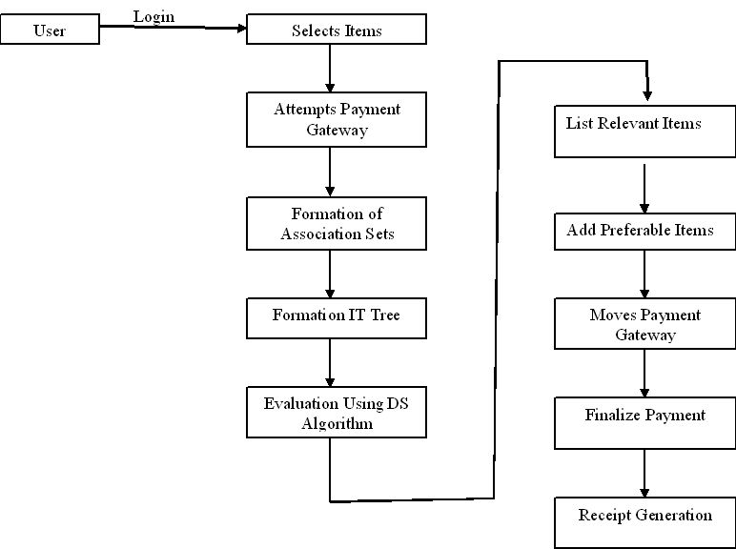

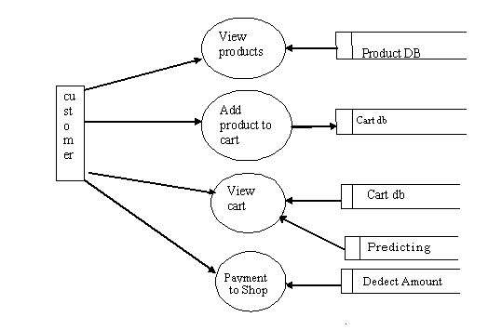

**USE CASE DIAGRAM:**

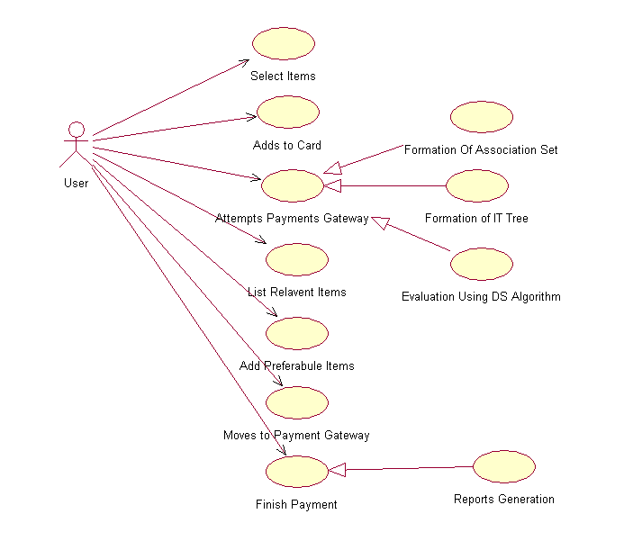

**Sequence Diagram**

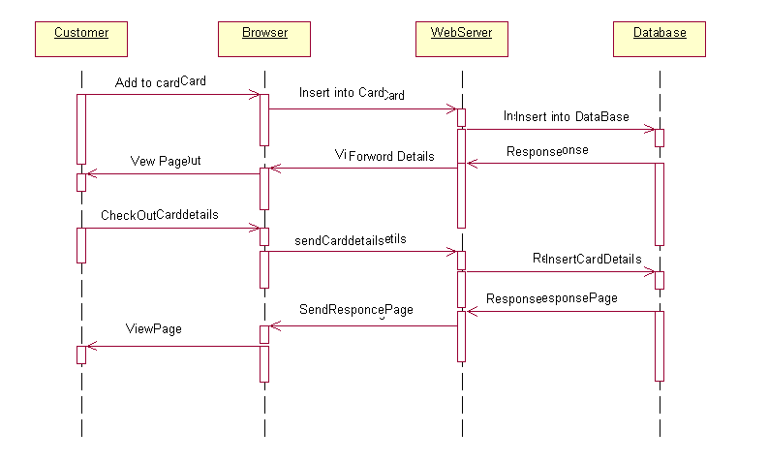

**Collaboration Diagram**



**Activity Diagram**



**Deployment Diagram of Client/server**

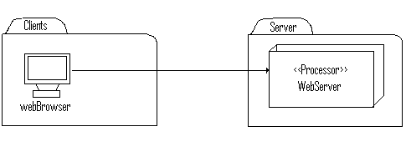

**Static Deployment view of services Involved**

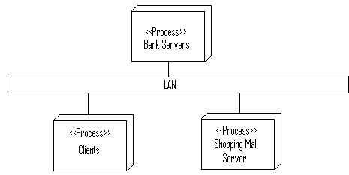

**Component Diagram**

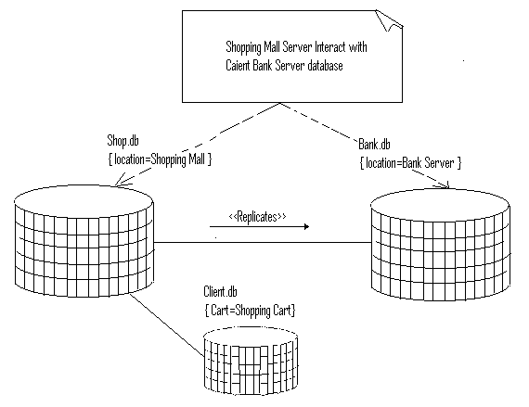



**CONCLUSION**

As prediction accuracy is by some distance the maximum critical measure of a classifier, we studied the prediction accuracy of DTU classifier first. The below figure suggests the end result for numerical datasets and Figure 2 shows the result for specific datasets. In both experiments, we use ten-fold move validation. Data is cut up into 10 about identical partitions; each one is used in turn for testing even as the remainder is used for education, that is, nine/10 of facts is used for schooling and 1/10 for check. The complete technique is repeated 10 times, and the overall accuracy fee is counted because the common of accuracy quotes on every partition. When DTU is carried out on certain statistics, it works as a traditional C4.Five classifier. For numerical records, the uncertainty varies among zero to 30%. As shown in Figure 1, while the volume of uncertainty increases, the classifier accuracy declines slowly. For maximum datasets, the performance decrement is within five%, even if records uncertainty reaches 30%. The worst performance decrement is for the glass identity dataset, the classifier has over ninety five% accuracy on certain facts, reduces to round ninety two% whilst the uncertainty is 10%, to eighty one% when the uncertainty is 20%, and to 78% while the uncertainty reaches 30%. The effects for express datasets are comparable, as proven in Figure. Overall talking, the accuracy of DTU classifier remains quite stable. The overall lower in classifier accuracy is inside 10% even if the uncertainty reaches 40%. Both experiments show DTU is quite sturdy towards statistics uncertainty.

**REFERENCES:**

* JAVA Technologies
* JAVA Complete Reference
* Java Script Programming by Yehuda Shiran
* Mastering JAVA Security
* JAVA2 Networking by Pistoria
* JAVA Security by Scotl oaks
* Head First EJB Sierra Bates
* J2EE Professional by Shadab siddiqui
* JAVA server pages by Larne Pekowsley
* JAVA Server pages by Nick Todd
* HTML
* HTML Black Book by Holzner