**Reviewon Brain Tumor**

Name:- Kangune Rajnandini Somnath

Guidance by: - Gaikwad Saurabh.D

Principal: - Dr.Salve Megha.T

College: - Shivajirao Pawar College of pharmacy Pachegaon

**Abstract**

The successful early diagnosis of brain tumors plays a major role in improving the treatment outcomes and thus improving patient survival.Computer-aided brain tumor diagnosis from MRI images consists of tumor detection, segmentation, and classification processes.Recently, interest has developed in using deep learning techniques for diagnosing brain tumors with better accuracy and robustness. This study presents a comprehensive review of traditional machine learning techniques and evolving deep learning techniques for brain tumor diagnosis

In the field of medicine, a brain tumor is one of the most difficult disorders to treat. During the early stages of tumors growth, an efficient and productive test is particularly a top priority for the radiologist. The gold standard and hence the norm for identifying the degree of a brain tumors is histological grading, which is backed by a stereotactic biopsy test. The biopsy procedure entails the neurosurgeon drilling a tiny hole in the skull to extract tissue. The biopsy test has a number of risks, including infection from tumors and brain hemorrhage, seizures, terrible migraine, stroke, coma, and may be death. However, the most serious problem with stereotactic biopsy is that it is not 100% accurate, that can out turn into substantial diagnosis mistake and subsequent incorrect clinical treatment of the disease. As a result, to reduce the rate of human fatality, reliable and automated categorization methods are required.

Brain tumor is an abnormal growth of mass of cells in (or) around the brain. Brain tumors can be malignant (cancerous) or being non-cancerous. It is the most common malignant primary intracranial tumors of central nervous system. Brain tumor can affect brain function if they grow large enough to press on surrounding nerves, blood vessels and tissues. Only one third of tumors formed in the brain are formed as cancerous cells. Brain tumors release molecular information to the circulation. Liquid biopsies collect and analyze tumor component in the body fluid and there is an increasing interest in investigation of liquid biopsies as substitute from tumor markers.

**INTRODUCTION**

Brain tumors are a diverse group of neoplasms arising from different cells within the central nervous system (CNS) or from systemic cancers that have metastasized to the CNS.A brain tumor Is a growth of cells in the brain or near it. Brain tumors can happen in the brain tissue. Nearby locations include nerves, the pituitary gland, the pineal gland, and the membranes that cover the surface of the brain Brain tumors can begin in the brain. These are called primary brain tumors. Sometimes, cancer spreads to the brain from other parts of the body. These tumors are secondary brain tumors, also called metastatic brain tumors. Brain tumor treatment options depend on the type of brain tumor you have, as well as its size and location. Common treatments include surgery and radiation therapy. There are many types of brain tumors. The type of brain tumor is based on the kind of cells that make up the tumor. Special lab tests on the tumor cells can give information about the cells. Your health care team uses this information to figure out the type of brain tumor.

Some types of brain tumors usually aren’t cancerous. These are called noncancerous brain tumors or benign brain tumors. Some types of brain tumors usually are cancerous. These types are called brain cancers or malignant brain tumors. Some brain tumor types can be benign or malignant.Brain tumors can produce symptoms and signs by local brain invasion, compression of adjacent structures, and increased intracranial pressure (ICP). In addition to the histology of the tumor, the clinical manifestations are determined by the function of the involved areas of the brain. The proper evaluation of the patient with a suspected brain tumor requires a detailed history, comprehensive neurologic examination, and appropriate diagnostic neuroimaging studies.

An overview of the clinical manifestations and diagnosis of primary and secondary brain tumors in adults will be reviewed here. The evaluation of brain masses in patients with human immunodeficiency virus (HIV) is presented separately.

The brain is one of the major organs of human body. It controls most of the nervous system and it is responsible for managing most of the functions of our body. The brain weighs about 3 pounds and it contains soft tissues, fat, protein, carbohydrate, water and salts. The soft tissues (i.e. gray matter and white matter) contain neurons, blood vessels and other cells. The gray matter is the outer part of the brain having darker colors and the white matter is the inner part with lighter colors. This sequence is opposite for other major organ of the nervous system, the spinal cord. A tumor, “an abnormal mass of tissue” may occur due to the deviation of regular cell life cycle or growth or both, may occur in the brain. Although the normal life cycle of a cell is that they grow, then are divided to two cells and eventually die, this cycle may be disrupted and some cells are divided into multiple cells uncontrollably and if they do not die, they create a mass which is the tumor. Tumors can be benign (i.e. non-cancerous) or malignant (i.e. cancerous). Benign tumors do not invade other nearby tissues nor do they spread to other organs or parts of the body. Malignant tumors may, however, spread to other organs and invade nearby tissues. Cancer is the disease caused by such malignant tumors. Brain tumors are tumors that starts in the brain or in the spinal cord.

They are called primary brain tumors if the origin of the tumor is brain or spinal cord. But if the tumor originated in another part or organ and then spread to the brain then they are called secondary brain tumors or brain metastases.

A brain tumor diagnosis includes different types of physical exams, blood tests, urine tests, medical images, biopsies and spinal taps. Medical images are very popular non-invasive diagnosis tools that may include computed tomography (CT), positron emission tomography (PET) and magnetic resonance imaging (MRI) scans. The CT scan images are generated by combining X-rays taken from different angles to create a 3D view of an organ and it can also detect fluids (e.g., bleeding, blood vessels etc.) and bone structures, whereas PET scans take pictures of organs and tissues with the help of various mostly injected substances. MRI uses magnetic fields to generate details images of organs, tissues and they can also provide information about brain functionalities, chemical composition, blood flow etc.Although each type of imaging has its’ own benefits, MRI images are generally preferred for brain tumor imaging as they are less risky and produce clearer images. The different tissues of the brain are shown with various contrasts in different modalities of MRIs according to the imaging parameters like echo time, repetition time, flip angel etc.Medical professionals can asses the brain tumor, tumor location, tumor size, tumor area and other tumor properties from MRI images. Researchers have, however, been trying to automate those tasks due to the high cost of having this done by the medical professionals. Initially various conventional methods like thresholding/filtering, morphology-based models, geometry-based models, contouring, region-based models etc. were used for brain tumor detection and segmentation for automated brain tumor image analysis Once machine learning (ML) models became popular and showed higher efficiency in classification and image analysis tasks, researchers started to focus more on ML-based tumor detection and segmentation models using supervised, unsupervised and hybrid modelsMedical image analysis aims at detecting abnormalities from images and then extracting the abnormal region from the images. The first task in brain tumor analysis from brain medical images is therefore called ‘brain tumor detection’. The task is to detect if brain tumor is present in a brain medical image or notShows the architecture of the proposed system. The proposed model provides a web application that can be used to upload patient data by the user or it can directly access patient data from the connected hospital or medical databases. After the data collection process, the data Is pre-processed and sent to the brain tumor analysis for brain tumor detection and segmentation. Then the generated outputs are pre-processed and the user has the option to provide feedbacks on the results as required.

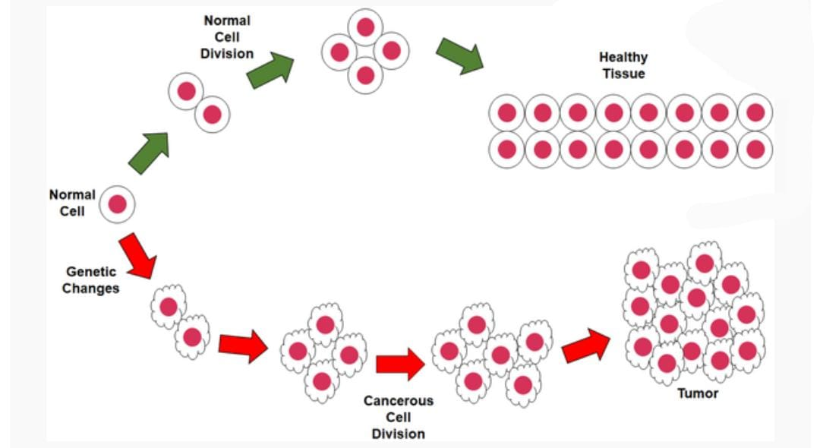

**Fig: Sample image of brain tumor**

**History: -**

In 1879, using Lister’s principles of antisepsis, the first recorded brain tumor surgery was performed by Sir William MacEwen. The tumor was a meningioma and the patient survived for 8 more years before succumbing to Bright disease, an unrelated ailment.

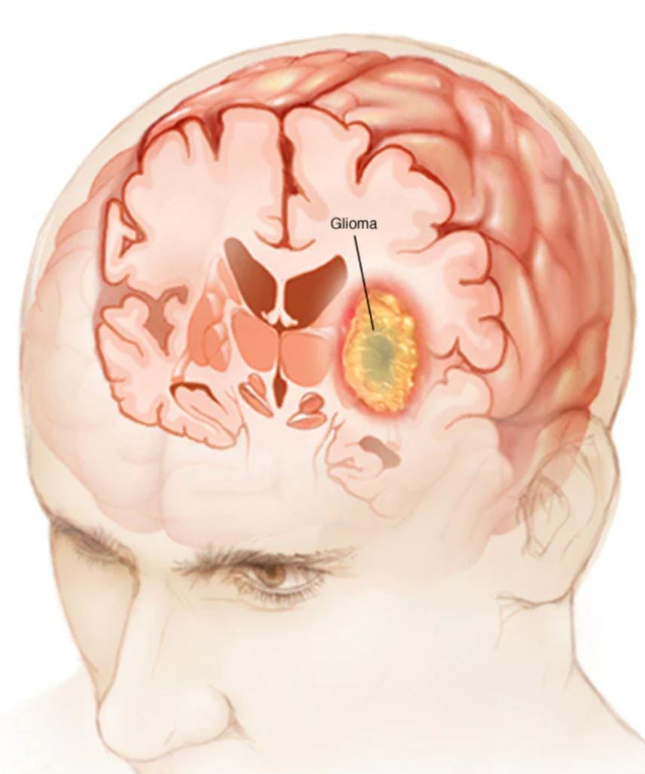

National Brain Tumor Foundation

The National Brain Tumor Foundation (NBTF) was founded in 1981 when Walter Newman and David and Nora Plant, feeling helpless following the loss of their sons to brain tumors, asked themselves the same question: “What can we do to help fight back against brain tumors? “The Newman’s and Plants started fundraising to help support Dr. Charles Wilson’s research lab at UCSF. Even after NBTF expanded its research grants program beyond funding solely Dr. Wilson’s lab, the organization continued to support studies at UCSF that have helped advance brain tumor research in a number of critical ways. The Foundation’s mission was to provide comprehensive resources and support services for the brain tumor community. Throughout its nearly 30 years, the group established a number of pivotal programs for the community including the first national conference for people with the disease, a national volunteer support network, and the only searchable database of brain tumor treatment centers in the United States.

**Types**

There are many types of brain tumors. The type of brain tumor is based on the kind of cells that make up the tumor

**Types of brain tumors include:**

**Gliomas and related brain tumors: -** Gliomas are growths of cells that look like glial cells. The glial cells surround and support nerve cells in the brain tissue. Glioma is a growth of cells that starts in the brain or spinal cord. The cells in a glioma look similar to healthy brain cells called glial cells. Glial cells surround nerve cells and help them function. As a glioma grows it forms a mass of cells called a tumor. The tumor can grow to press on brain or spinal cord tissue and cause symptoms. Symptoms depend on which part of the brain or spinal cord is affected. There are many types of gliomas. Some grow slowly and aren’t considered to be cancers. Others are considered cancerous. Another word for cancerous is malignant. Malignant gliomas grow quickly and can invade healthy brain tissue. Some types of gliomata happen mostly in adults. Others happen mostly in kids.Glioma treatment options include surgery, radiation therapy, chemotherapy and others.

**Types**

Astrocytoma

Ependymoma

Glioblastoma

Oligodendroglioma

**Symptoms**

Common signs and symptoms of gliomas include:

* Headache, particularly one that hurts the most in the morning.
* Nausea and vomiting.
* Confusion or a decline in brain function, such as problems with thinking and understanding information.
* Memory loss.
* Personality changes or irritability.
* Vision problems, such as blurred vision, double vision or loss of peripheral vision.
* Speech difficulties.
* Seizures, especially in someone who hasn’t had seizures before.
* Causes

Doctors aren’t sure what causes glioma. It starts when cells in the brain or spinal cord develop changes in their DNA. A cell’s DNA contains the instructions that tell a cell what to do. The DNA changes tell the cells to make more cells quickly. The cells continue living when healthy cells would die. This causes too many cells that don’t work right. The cells form a mass called a tumor. The tumor can grow to press on nearby nerves and parts of the brain or spinal cord. This leads to glioma symptoms and can cause complications.In glioma, the tumor cells look similar to healthy brain cells called glial cells. The glial cells surround and support nerve cells in the brain and spinal cord.

**Risk factors**

Things that can increase the risk of glioma include:

Getting older: -

Being exposed to radiation.

Having a family history of glioma

**Choroid plexus tumors: -** Choroid plexus tumors start in cells that make the fluid that surrounds the brain and spinal cord. This fluid is called cerebrospinal fluid.

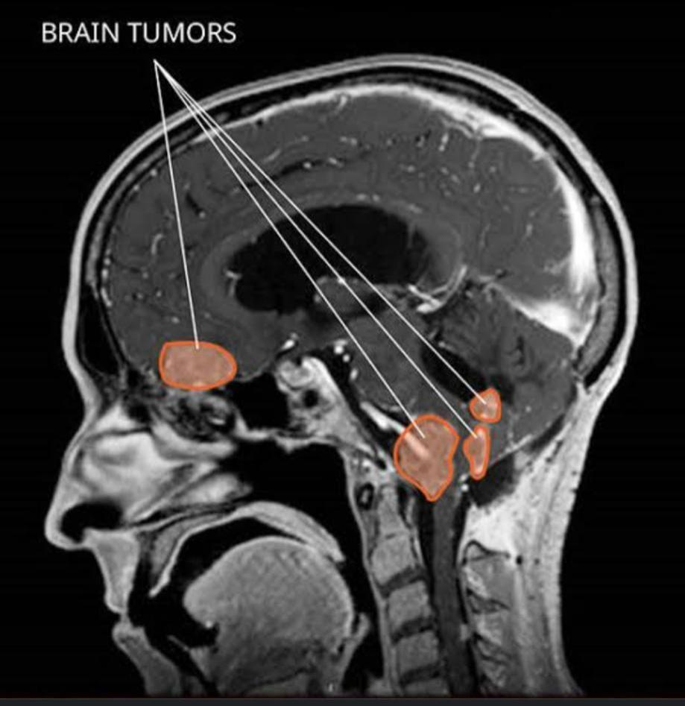

Choroid plexus carcinoma is a rare type of brain cancer that happens mainly in children.

**Diagnosis**

Choroid plexus carcinoma happens the most in children under 2 years old. Tests and procedures used to diagnose choroid plexus carcinoma include:

1) Neurological exam

2) Brain imaging tests.

3) Genetic tests

Treatment

Treatment of a choroid plexus carcinoma is often surgery followed by chemotherapy, radiation therapy or both.

**Surgery** The goal of surgery is to remove all of the cancer, when possible.

**Chemotherapy: -**Chemotherapy uses medicines to kill cancer cells

**Radiation therapy: -** Radiation therapy uses powerful energy beams to kill tumor cells. The energy can come from X-rays, protons and other sources

**Clinical trials: -** Clinical trials are studies of new treatments. These studies provide a chance to try the latest treatments. The risk of side effects might not be known. Each trial has strict requirements that each person must meet in order to be in the trial. Ask your health care provider if you might be able to be in a clinical trial.

1. **Embryonal tumors: -** Embryonal tumors begin in cells that are left over from fetal development. The cells, called embryonal cells, stay in the brain after birth.

Embryonal tumors are a type of brain cancer, also called malignant brain tumor. This means the cells that make up the tumor can grow to invade the brain and cause damage to healthy brain tissue. They also can spread through the fluid that surrounds the brain and spinal cord, called cerebrospinal fluid

1. **Germ cell tumors: -** Germ cell tumors start in reproductive cells, called germ cells, that go on to become the sperm and egg cells. Germ cells are mostly in the ovaries and testicles

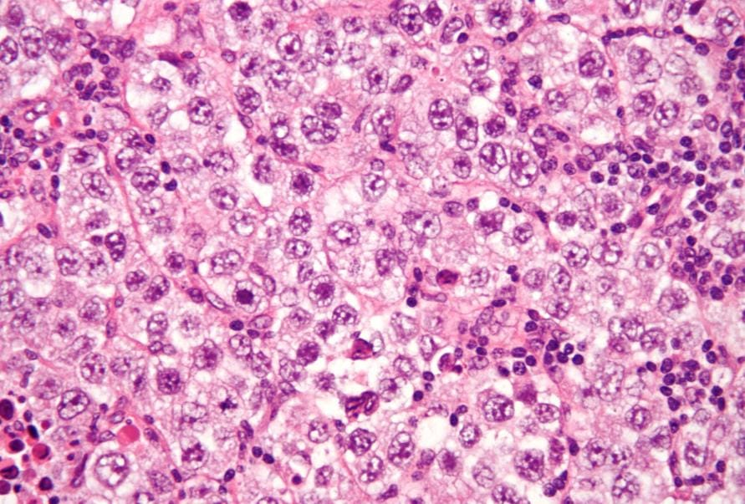

1. **Pineal tumors: -**

Pineal tumors start in and around the brain’s pineal gland. The pineal gland is located in the center of the brain. It makes a hormone called melatonin that helps with sleep.

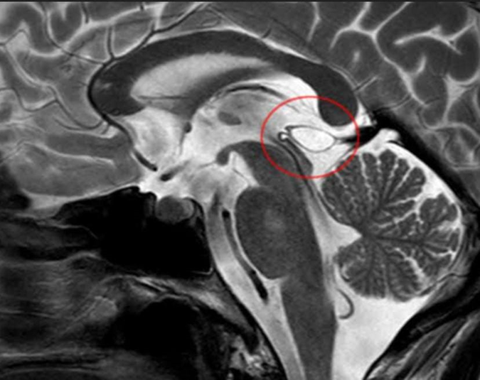

1. **Nerve tumors: -**

Nerve tumors are growths that happen in and around nerves. The most common type that happens in the head is acoustic neuroma, also called schwannoma. This benign tumor is located on the main nerve that connects the inner ear to the brain.

1. **Meningiomas: -** Meningiomas are brain tumors that start in the membranes around the brain and spinal cord.

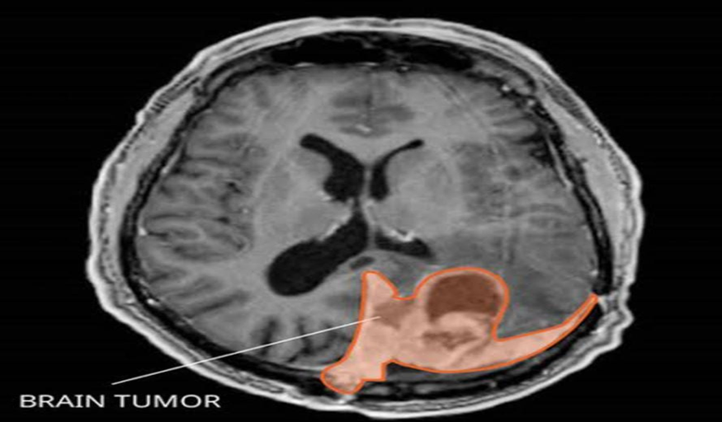

1. **Pituitary tumors: -**

Brain tumors can begin in and around the pituitary gland.

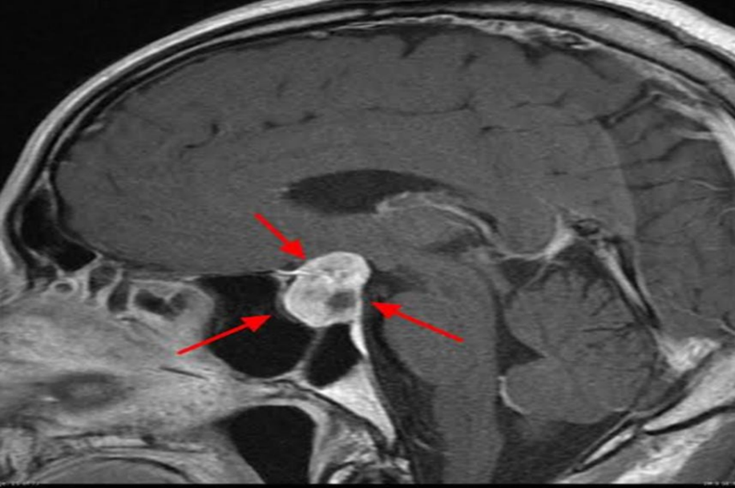

1. **Other brain tumors: -** Many other types of rare tumors can happen in and around the brain. Tumors can start in the muscles, blood vessels and connective tissue around the brain. Tumors can form in the bones of the skull.

**Brain tumor headaches**

Headaches are the most common symptom of brain tumors. Headaches happen in about half of people with brain tumors. Headaches can happen if a growing brain tumor presses on healthy cells around it.

**Brain tumor symptoms by location**

The main part of the brain is called the cerebrum. Brain tumors in different parts of the cerebrum might cause different symptoms.

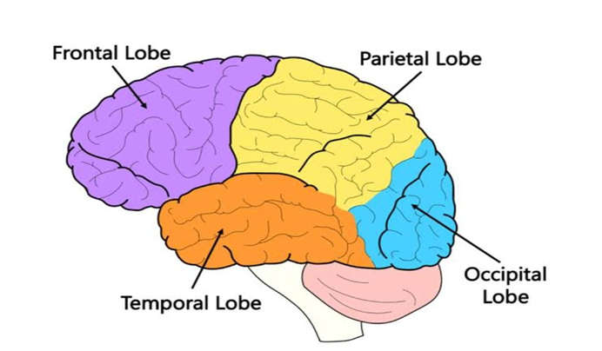

**Brain tumors in the front of the brain.**

They control thinking and movement.

**Brain tumors in the middle of the brain**

They help process information about touch, taste, smell, vision and hearing.

**Brain tumors in the back of the brain.**

They control vision.

**Brain tumors in the lower part of the brain**

They process memories and senses.

**Symptoms: -**

* General signs and symptoms caused by brain tumors may include:
* Headache or pressure in the head that is worse in the morning.
* Headaches that happen more often and seem more severe.
* Headaches that are sometimes described as tension headaches or migraines.
* Nausea or vomiting.
* Eye problems, such as blurry vision, seeing double or losing sight on the sides of your vision.
* Losing feeling
* Trouble with balance.
* Speech problems.
* Feeling very tired.
* Confusion in everyday matters.
* Memory problems.
* Having trouble following simple commands.
* Behavior changes.
* Seizures, especially if there is no history of seizures.
* Hearing problems.
* Dizziness
* Feeling very hungry and gaining weight.

**Diagnosis**

If your health care provider thinks you might have a brain tumor, you’ll need a number of tests and procedures to be sure. These might include:

**A neurological exam: -**A neurological exam tests different parts of your brain to see how they’re working. This exam may include checking your vision, hearing, balance, coordination, strength and reflexes.

**Head CT scan: -** A computed tomography scan, also called a CT scan, uses X-rays to make pictures. It’s widely available, and results come back quickly. So CT might be the first imaging test that’s done if you have headaches or other symptoms that have many possible causes

**Brain MRI: -**

MRI is often used to detect brain tumors because it shows the brain more clearly than do other imaging tests.

**PET scan of the brain: -**A positron emission tomography scan, also called a PET scan, can detect some brain tumors. A PET scan uses a radioactive tracer that’s injected into a vein. The tracer travels through the blood and attaches to brain tumor cells. The tracer makes the tumor cells stand out on the pictures taken by the PET machine. Cells that are dividing and multiplying quickly will take up more of the tracer.

A PET scan may be most helpful for detecting brain tumors that are growing quickly.

**Collecting a sample of tissue: -** A brain biopsy is a procedure to remove a sample of brain tumor tissue for testing in a lab. Often a surgeon gets the sample during surgery to remove the brain tumor.

If surgery isn’t possible, a sample might be removed with a needle. Removing a sample of brain tumor tissue with a needle is done with a procedure called stereotactic needle biopsy.

**Testing the tissue sample in the lab: -**The biopsy sample is sent to a lab for testing. Tests can see whether the cells are cancerous or not cancerous. The way the cells look under a microscope can tell your health care team how quickly the cells are growing. This is called the brain tumor’s grade. Other tests can find out what DNA changes are present in the cells. This helps your health care team create your treatment plan.

**Treatment: -**

Treatment for a brain tumor depends on whether the tumor is a brain cancer or if it’s not cancerous, also called a benign brain tumor. Treatment options also depend on the type, size, grade and location of the brain tumor. Options might include surgery, radiation therapy, radiosurgery, chemotherapy and targeted therapy. When considering your treatment options, your health care team also considers your overall health and your preferences.

**Surgery: -**

The goal of surgery for a brain tumor is to remove all of the tumor cells. The tumor can’t always be removed completely. When it’s possible, the surgeon works to remove as much of the brain tumor as can be done safely. Brain tumor removal surgery can be used to treat brain cancers and benign brain tumors.

**Removing part of the skull to get to the brain tumor.** Brain surgery that involves removing part of the skull is called craniotomy. It’s the way most brain tumor removal operations are done. Craniotomy is used for treating cancerous brain tumors and benign brain tumors.

When the tumor removal surgery is finished, the part of the skull bone is put back in place.

**Using a long, thin tube to get to the brain tumor.** Endoscopic brain surgery involves putting a long, thin tube into the brain. The tube is called an endoscope. The tube has a series of lenses or a tiny camera that transmits pictures to the surgeon.

Endoscopic brain surgery is often used to treat pituitary tumors. These tumors grow just behind the nasal cavity. The long, thin tube is put through the nose and sinuses and into the brain.

**Radiation therapy: -**

Radiation therapy for brain tumors uses powerful energy beams to kill tumor cells.

The radiation can be placed inside the body. This is called brachytherapy.

Radiation therapy can be used to treat brain cancers and benign brain tumors.

External beam radiation can focus just on the area of your brain where the tumor is located, or it can be applied to your entire brain. Most people with a brain tumor will have radiation aimed at the area around the tumor. If there are many tumors, the entire brain might need radiation treatment. When all of the brain is treated, it’s called whole-brain radiation. Whole-brain radiation is most often used to treat cancer that spreads to the brain from another part of the body and forms multiple tumors in the brain.

Side effects of radiation therapy for brain tumors depend on the type and dose of radiation you receive. Common side effects that happen during treatment or right after it are fatigue, headaches, memory loss, scalp irritation and hair loss. Sometimes radiation therapy side effects show up many years later. These late side effects might include memory and thinking problems.

**Radiosurgery: -**

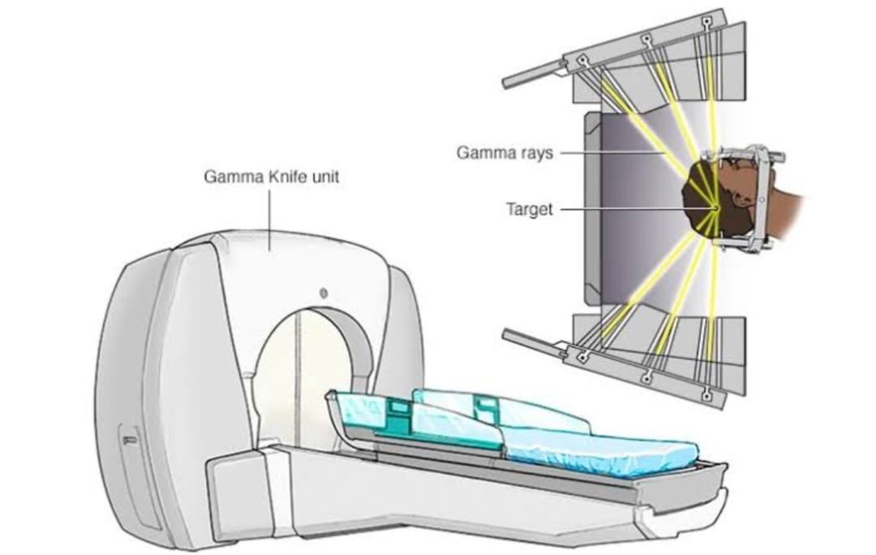

**Fig: Brain Stereotactic radiosurgery**

Stereotactic radiosurgery for brain tumors is an intense form of radiation treatment. It aims beams of radiation from many angles at the brain tumor. Each beam isn’t very powerful. But the point where the beams meet gets a very large dose of radiation that kills the tumor cells.

Radiosurgery can be used to treat brain cancers and benign brain tumors.

Some examples include:

* Linear accelerator radiosurgery: -
* Gamma Knife radiosurgery: -
* Proton radiosurgery. Proton: -

Side effects of radiosurgery include feeling very tired and skin changes on your scalp. The skin on your head may feel dry, itchy and sensitive. You might have blisters on the skin or hair loss. Sometimes the hair loss is permanent

Chemotherapy for brain tumors uses strong medicines to kill tumor cells. Chemotherapy medicines can be taken in pill form or injected into a vein. Sometimes the chemotherapy medicine is placed in the brain tissue during surgery.

Chemotherapy can be used to treat brain cancers and benign brain tumors.

Chemotherapy side effects depend on the type and dose of drugs you receive. Chemotherapy can cause

nausea, vomiting and hair loss.

**Targeted therapy: -**

Targeted therapy for brain tumors uses medicines that attack specific chemicals present within the tumor cells. By blocking these chemicals, targeted treatments can cause tumor cells to die.

**Recovering after treatment: -**

**Physical therapy** to help you regain lost motor skills or muscle strength.

**Occupational therapy** to help you get back to your typical daily activities, including work.

**Speech therapy** to help if speaking is difficult.

**Tutoring for school-age children** to help them cope with changes in their memory and thinking.

**Conclusions: -**

Brain tumor detection, segmentation, and classification are three processes that can be used to produce computer-aided methods for tumor diagnosis from MRI images. These methods offer enhanced accuracy, reduced noise, and improved speed compared to manual methods. Thus, these methods have been intensively researched with respect to the applications of traditional machine learning and deep learning approaches. This study reviewed various diagnosis techniques for brain MRI images.

**References: -**

<https://www.sciencedirect.com/science/article/abs/pii/S0730725X18304302>

<https://link.springer.com/chapter/10.1007/978-981-19-4300-3_33>

<https://iopscience.iop.org/article/10.1088/1742-6596/2115/1/012039>

https://pubmed.ncbi.nlm.nih.gov/31173851/

<https://www.mayoclinic.org/diseases-conditions/brain-tumor/symptoms-causes/syc-20350084>

<https://www.mayoclinic.org/diseases-conditions/glioma/symptoms-causes/syc-20350251>

A review on brain tumor diagnosis from MRI images: Practical implications, key achievements, and lessons learned.

https://www.researchgate.net/publication/333621096_A_review_on_brain_tumor_diagnosis_from_MRI_images_Practical_implications_key_achievements_and_lessons_learned.

<https://www.mayoclinic.org/diseases-conditions/brain-tumor/diagnosis-treatment/drc-20350088>.

https://onlinelibrary.wiley.com/doi/10.1002/ima.22211