**Performance Analysis of Graphene Nanoribbon Field Effect Transistor**

Sudha B S

Associate Professor,

# Department of Electronics and Communication Engineering, Dr. Ambedkar Institute of Technology, Bengaluru, India

Sneha S K T Shweta

# Department of Electronics and Communication Department of Electronics and Communication

# Engineering, Engineering

# Dr. Ambedkar Institute of Technology Dr. Ambedkar Institute of Technology,

# Bengaluru, India Bengaluru, India

***Abstract*—Graphene is a very promising material for future electronics because it outperforms silicon in many ways. While traditional transistors (MOSFETs) have problems with short channels, graphene offers unique properties. It's incredibly strong, conducts electricity and heat very well, and functions efficiently at room temperature. It's also incredibly thin, can carry high currents, and is almost completely transparent. Additionally, graphene exhibits a special magnetic behaviour. Made of carbon atoms arranged in a honeycomb pattern, graphene is a special form of carbon (allotrope) with some metallic characteristics (semimetal). In this project, we'll analyse and simulate how graphene nanoribbons with a specific structure (armchair chirality) can be used to create transistors. We'll use MATLAB to model and graph the electrical properties of these transistors, including how current varies with voltage at the drain and gate terminals, current density at different channel lengths, conductance, on-off current ratio, channel potential, and density of electronic states. Essentially, this project will explore and model graphene nanoribbons, including their electrical behaviour using computer simulations.**

***Keywords—Graphene Nanoribbon, MATLAB, Performance Analysis.***

# INTRODUCTION

Electronic devices are constantly evolving, and silicon has been the go-to material for keeping up with this demand. However, silicon has limitations. As we shrink transistors (MOSFETs) to make even faster devices, we run into problems like leakage and limitations due to the insulating layer used in these transistors. This has opened the door for new materials with better properties.

The number of transistors on a chip has been doubling roughly every two years (Moore's Law), but this trend is nearing its limits as transistors become incredibly tiny. When transistors get very small (sub-100 nanometers), they start to behave differently, creating challenges for engineers. Researchers are looking for new materials with different structures to overcome these limitations of silicon and boost device performance.

Carbon-based materials, like graphene, hold promise for future electronics. Graphene has many desirable qualities, such as high carrier mobility (how easily electrons move through it), high carrier concentration (the number of available electrons), and excellent heat conduction. Additionally, by patterning graphene into thin strips (nanoribbons), we can introduce a bandgap, which is necessary for transistors to function as switches.

Graphene nanoribbons (GNRs) are essentially one-dimensional highways for electrons, allowing them to travel with minimal scattering. This leads to very high currents in transistors made with these ribbons. A narrow semiconducting GNR acts as the channel in a special type of transistor called a top-gated field-effect transistor (GNRFET). This project focuses on simulating and analysing the behaviour of these GNRFETs using MATLAB software.

Graphene, a single layer of carbon atoms arranged in a honeycomb pattern, is a promising candidate for future nanoelectronics. Devices made from graphene can move electrons very quickly, switch states rapidly due to high carrier velocity, and have excellent heat dissipation due to their thinness. Another advantage is the potential to manufacture large, flat sheets of graphene that can be integrated with existing silicon chip fabrication processes, unlike carbon nanotubes (CNTs). While regular graphene conducts electricity too well (like a metal), we can create a bandgap (necessary for transistors) by patterning it into thin nanoribbons. The narrower the ribbon, the larger the bandgap.

# SIMULATION AND MODELLING

Fig.1 shows the representation of GNRFET under study. A single layer of armchair Graphene Nano-Ribbon (A-GNR) with index of N=12 is used as the channel material which is taken to be intrinsic. The Index N, defines the number of dimer carbon atom lines transverse to transport direction which is determined by the GNR width, W. The width and length of this GNR channel are assumed to be Wg=33.54nm and L=15nm,respectively.The insulating layers have 0.95nm thickness and consist of the SiO2 material with the dielectric constant of k=4.The source and drain regions are assumed to be heavily doped GNR with doping concentration value of 1*10^16.

The below mentioned flow chart in Fig.2 is designed using self-consistent solution. Here E is energy level in vector form. Which defines different energy levels. Specify Density of States and Current Density analytically. Initialize Surface Potential as zero. And solve for N and Uscf iteratively using Self-Consistent solution. If du converges to certain value as defined in flow chart, then evaluate current Id.

STEPS:

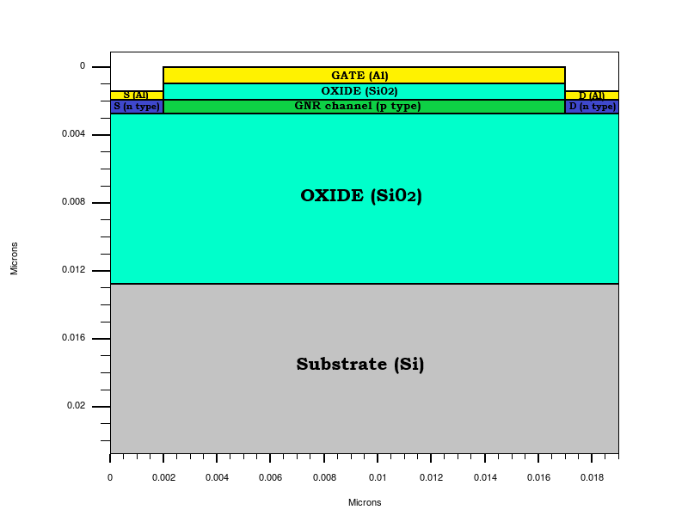(1) Specify the Semiconductor carrier and Current Density J(E) and Density of states D(E) analytically.

Fig 1: Structure of GNRFET

(2) Specify Vg, Vd, Vs and Ef.

(3) Iteratively solve for Uscf=UL+UP and N.

(4) Evaluate the current for the assumed and Vg and Vds

TERMS USED IN THE DERIVATIONS:

1. DENSITY OF STATES (DOS):

The density of states of a system is described as the number of states per an interval of energy at each energy level available to be occupied. It is mathematically represented by a [density distribution](https://en.wikipedia.org/wiki/Probability_density_function) and it is generally an average over the space and time domains of the various states occupied by the system.

$D\left(E\right)=\frac{g}{2π}×\frac{1}{E^{2}+(g/2)^{2}}$ (1)

1. FERMI FUNCTION:

If the source and drain regions are coupled to the channel (with VD held at zero), then electrons will flow in and out of the device bringing them all in equilibrium with a common electrochemical potential, µ, just as two materials in equilibrium acquire a common temperature (T). In this equilibrium state, the average (over time) number of electrons in any energy level is typically not an integer, but is given by the Fermi function:

 (2)

## (3) SELF-CONSISTENT POTENTIAL (Uscf)

Surface potential is defined as potential which is determined between source and drain that is along the channel. So it is determined using self-consistent solution. This can be determined by iteratively solving Electrostatic and Transport equations.

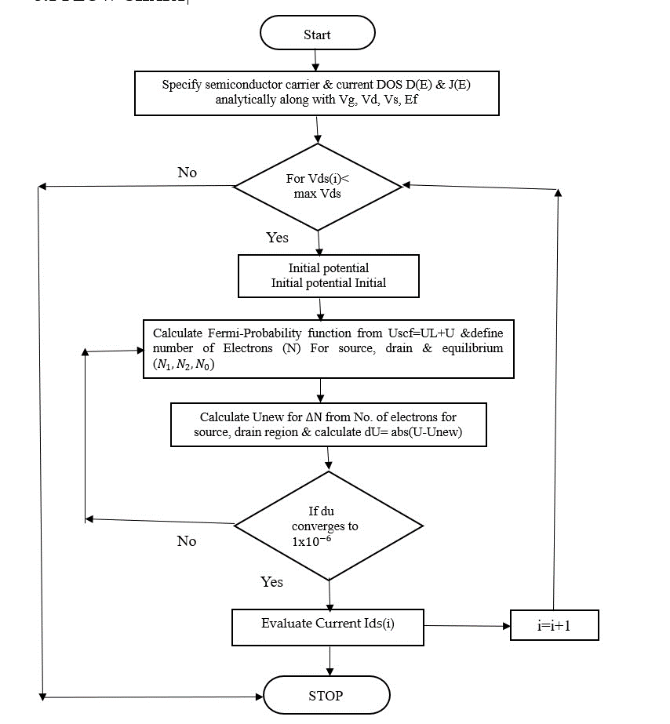Uscf = UL + U (3)

Fig 2: Flowchart of Self- Consistent Potential

## (4) ELECTRON DENSITY (N)

Electron density is the measure of the [probability](https://en.wikipedia.org/wiki/Probability) of an [electron](https://en.wikipedia.org/wiki/Electron) being present at a specific location within an orbital.

## (5) CURRENT DENSITY (J)

Current density is defined as the [electric current](https://en.wikipedia.org/wiki/Electric_current) per unit area of cross section. The current density vector is defined as a [vector](https://en.wikipedia.org/wiki/Vector_(geometric)) whose magnitude is the [electric current](https://en.wikipedia.org/wiki/Electric_current) per cross-sectional area at a given point in space, its direction being that of the motion of the charges at this point. In [SI units,](https://en.wikipedia.org/wiki/SI_unit) the electric current density is measured in [amperes](https://en.wikipedia.org/wiki/Ampere) per [square metre.](https://en.wikipedia.org/wiki/Square_metre)

|  |  |
| --- | --- |
| |  | | --- | | Fig 3: Drain current vs drain-Source voltage (GNRFET)    Fig 4: Drain current vs drain-Source voltage (MOSFET) | $J\left(E\right)=\frac{1}{2}q(\frac{2}{π}\sqrt{\frac{2(E)}{m^{*}}}$  )D(E) (4) $D\left(E\right)=\frac{g}{2π}×\frac{1}{E^{2}+(g/2)^{2}}$   (5) $J\left(E\right)=\frac{1}{2}q(\frac{2}{π}\sqrt{\frac{2(E)}{m^{*}}}$ )D(E) (6) $∆N=\left(N_{1}+N_{2}\right)-N_{0}$   (7) $N_{0}=\int_{-∞}^{+∞}{D\left(E\right)f{}_{0}\left(E\right)dE}$ (8) $N_{1}=\frac{1}{2}\int_{-∞}^{+∞}{D\left(E\right)f{}_{1}\left(E\right)dE}$ (9) $N_{2}=\frac{1}{2}\int_{-∞}^{+∞}{D\left(E\right)f{}_{2}\left(E\right)dE}$ (10)  Where, $f_{1}\left(E\right)=f(E+U_{scf}-E_{f1})$ (11) $f_{2}\left(E\right)=f\left(E+U_{scf}-E_{f2}\right)$   (12) $U_{scf}=U_{L}+U_{P}$ (13)  Where,      (14)  (15)  where,  D(E) is density of states,  ‘g’ is broadening facto  J(E) is current density, Conclusion ${ U}_{scf}$ is self consistent potential GNRFET code  1. Parameters and Performance:  -Lower threshold voltage (0.35 V)  -Higher transconductance parameter (5e-4 A/V²)  -Varying gate voltages (0.6 to 0.64 V)  -Varying drain-source (0 to 1)  -Higher current levels |

- Clear transitions between regions (cutoff, linear, saturation)

- Better for high-performance applications

MOSFET code

1. Parameters and Performance:

-Higher threshold voltage (0.6 V)

-Lower transconductance parameter (1e-3 A/V)

-Varying drain-source voltage (0.1, 0.2, 0.3 V)

-Varying gate-source voltage (0 .6 to 0.64 V)

-Lower current levels compared to GNRFET

-Smooth transitions between regions

-Suitable for general applications

The GNRFET shows higher current and clearer operational regions, making it ideal for high-performance uses. The MOSFET, with its lower current and smoother transitions, is better for standard applications. GNRFETs are more advanced and efficient in handling higher currents and faster switching.

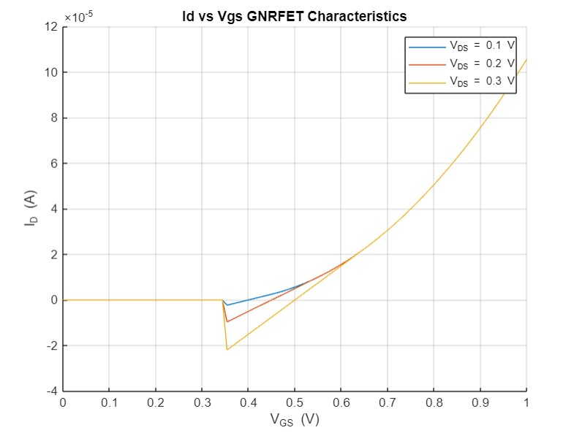

Fig 5: Drain Currents vs Gate-Source voltage (GNRFET)

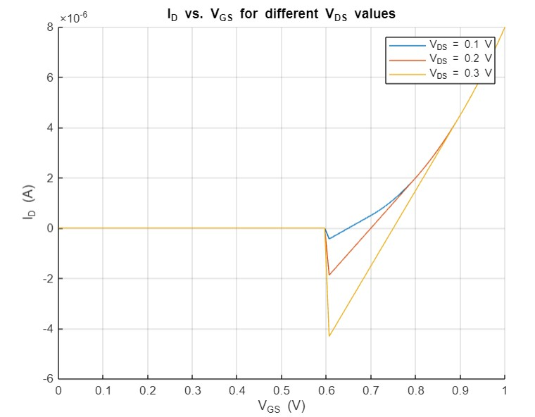

Fig 6: Drain Currents vs Gate-Source voltage (MOSFET)

Conclusion:

1. GNRFET:

* Uses a lower threshold voltage (0.1 V) and a higher transconductance parameter (5e-4 A/V²).
* Produces higher drain current compared to the MOSFET for similar conditions.
* Shows distinct regions (cutoff, linear, and saturation) more clearly.

2. MOSFET:

* Uses a higher threshold voltage (0.2 V) and a lower transconductance parameter (1e-4 A/V²).
* Generates lower drain current than the GNRFET.
* Shows the same regions but with less pronounced transitions.

GNRFETs demonstrate higher performance with more current and clearer transitions between operating regions, making them better for high-performance applications compared to conventional MOSFETs, which offer moderate current levels and smoother transitions.

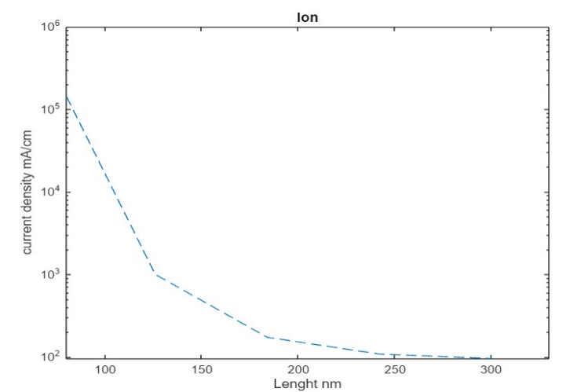

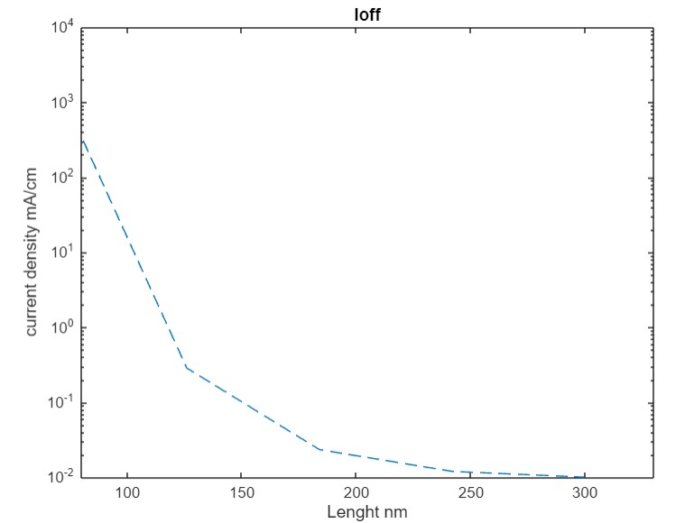Fig 7: Ion Current Density v/s Length

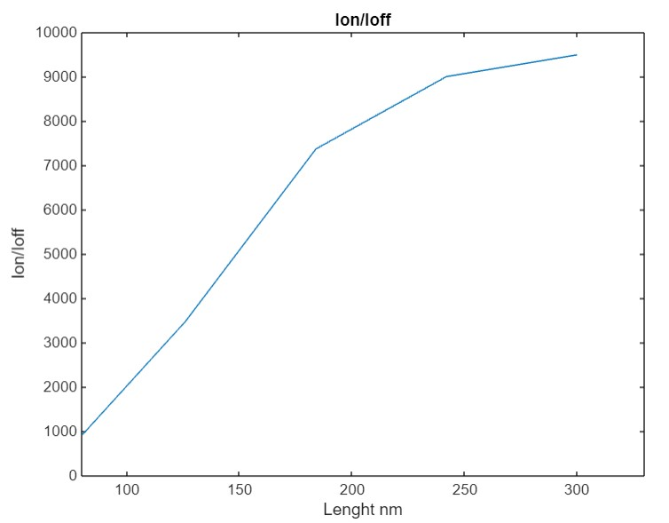Fig 8: Ioff Current Density v/s Length

Fig 9: Ion/Ioff Current Density vs Length

Conclusoin

- The plots illustrate how Ion , Ioff, and their ratio change with gate length.

- A higher Ion/Ioff ratio indicates better transistor performance, ideal for switching applications.

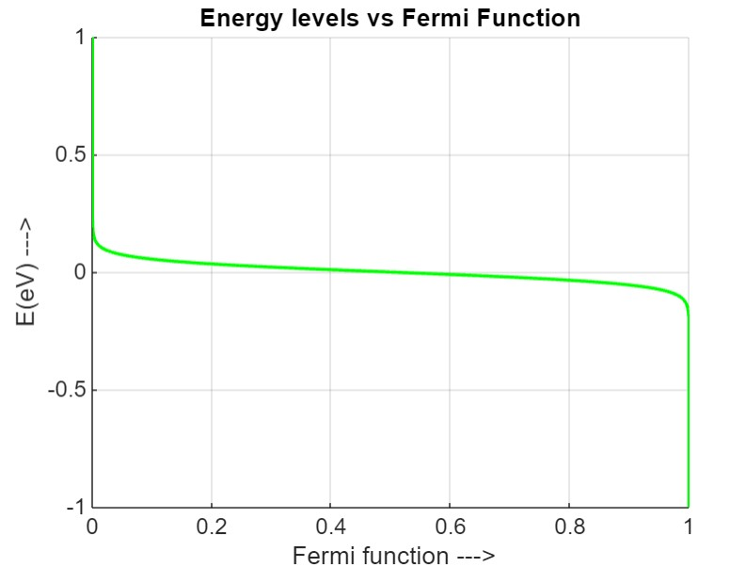

Fig 10: Energy levels vs Fermi Function

Conclusion:

Shows the Fermi function vs. Energy (E), illustrating the occupancy probability of states at different energy levels.

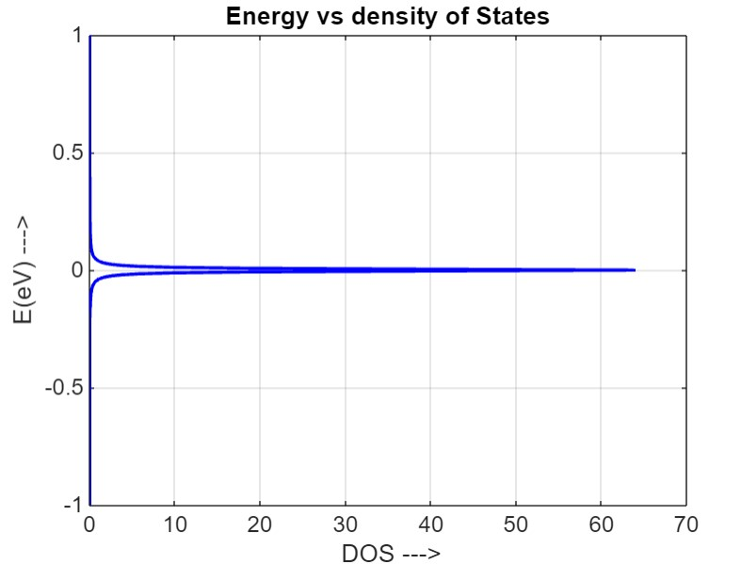

Fig 11: Energy vs Density of States

Conclusion:

Displays the DOS vs. Energy (E), indicating how states are distributed across energy levels.

IV. CONCLUSION

We developed a model for a Graphene Nanoribbon Field-Effect Transistor (GNRFET) using a self-consistent solution approach in MATLAB. We then simulated the transistor's behaviour and compared the results with real-world measurements. The simulations showed excellent agreement with the experimental data. This suggests that GNRFETs offer several advantages over traditional MOSFETs, including higher carrier mobility (easier electron movement), a high on-current to off-current ratio (better switching behaviour) and a very thin channel for potentially better performance.

ACKNOWLEDGMENT

We would like to thank our Respected guide Sudha B S, Associate Professor, for her valuable guidance and helping us in this work. We would like to show our gratitude to the Electronics and Communication Department, Dr. Ambedkar Institute of Technology, for providing us an opportunity and facilities to carry out the project.

REFERENCES

1. Huei Chaeng Chin Cheng Lim,Weng Wong,Vijay Arora, ”Enhanced Device and Circuit –Level performance Benchmarking of Graphene

Nanoribbon FET against a Nano-MOSFET with Interconnects” Hindawi Publishing Corporation,Journal of Nanomaterials,Volume 2014, Article ID 879813, 14 pages

1. <http://dx.doi.org/10.1155/2014/879813>
2. Anisur Rahman,Jing Guo,Supriyo Datta,Fellow,IEEE, and Mark S.Lundstrom,Fellow,IEEE, “Theory of Ballistic Nanotransistors”,IEEE Transactions on Elecronic Devices,Vol.50,No.9,September 2003
3. M.Akbari Eshkalak, “Graphene Nano-Ribbon Field Effect Transistor under Different Ambient Temperatures”, Iranian Journal of Electrical and Electonic Engineering,Vol.12,No.2,June 2016
4. Mohmmadi Banadaki,Yaser,”Physical Modelling of Graphene Nanoribbon Field Effect Transitor Using Non-Equilibrium Green

Function Approach for Integrated Circuit Design”(2016).LSU Doctoral Dissertations. 1052.

1. https://digitalcommons.lsu.edu/gradschool_dissertations/1052
2. Supriyo Datta,“Quantum Transport Atom to Transistor”, Cambridge

University Press, The Edinburgh Building, Cambridge , New York, ISBN 978-0-511-11322-2, 2005

1. Ying-Yu Chen , Artem Rogachev , Amit Sangai , Giuseppe Iannaccone , Gianluca Fiori and Deming Chen, “A SPICE-Compatible Model of Graphene Nano-Ribbon Field-Effect Transistors Enabling Circuit-Level

Delay and Power Analysis Under Process Variation”, IEEE TRANSACTION, Italy, ISBN 978-3-9815370, 2013.

[9] Special Issue – 2019 International Journal of Engineering Research & Technology (IJERT) ISSN: 2278-0181 NCRACES - 2019 conference proceedings “Analytical Modelling Of GNRFET”

Fig 9: Ion/Ioff Current Density vs Length

Conclusion: