**ONLINE TRADING MECHANISM IN INDIAN STOCK EXCHANGE AT KOTAK SECURITIES LTD.**

**MADISHETHI VAISHNAVI**

Roll No: 212122672022, Department of Management Studies

Aristotle PG College, Chilkur, Moinabad, Ranga Reddy District, Telangana.

**Dr. S. Deepthi**

Associate Professor

Aristotle PG College, Chilkur, Moinabad, Ranga Reddy District, Telangana.

[drsajjadeepthi@gmail.com](mailto:drsajjadeepthi@gmail.com)

**Abstract:**

*Internet is a worldwide, self-governed network connecting several other smaller networks and millions of computers and persons, to mega sources of information. This technology shrinks vast distances, accelerating the pace of business reforms and revolutionizing the way companies are managed. It allows direct, ubiquitous links to anyone anywhere and anytime to build up interactive relationships. A combination of time and space, called the Internet promises to bring unprecedented changes in our lives and business. Internet or net is an inter-connection of computer communication networks spanning the entire globe, crossing all geographical boundaries. It has re-defined the methods of communication, work study, education, business, leisure, health, trade, banking, commerce and what not it is virtually changing every thing and we are living in dot.com age. Net being an interactive two way medium, through various websites, enables participation by individuals in business to business and business to consumer commerce, visit to shopping arcades, games, etc. in cyber space even the information can be copied, downloaded and retransmitted.*

**Keywords:** Online Trading, Proposed Tools.

**INTRODUCTION:**

The use of Internet has grown 2000 percent in last decade and is currently growing at 10 percent per month. In India, growth of Internet is of recent times. It is expected to bring changes in every functional area of business activity including management and financial services. It offers stock trading at a lower cost. Internet can change the nature and capacity of stock broking business in India.

**2. E-commerce:**

Electronic commerce is associated with buying and selling over computer communication networks. It helps conduct traditional commerce through new way of transferring and processing of information. Information is electronically transferred from computer to computer in an automated way. E-commerce refers to the paperless exchange of business information using electronic data inter change, electronic technologies. It not only reduces manual processes and paper transactions but also helps organization move to a fully electronic environment and change the way they operated.

PC’s and networking attempts to introduce banks of the tools and technologies required for electronic commerce. The computers are either workstations of individual office works or serves where large databases and information reside. Network connects both categories of computers; the various operating systems are the most basis program within a computer. It manages the resources of the computer system in a fair and efficient manner.

**Now we can enter in to the concept known as online trading:**

In the past, investors had no option but to contact their broker to get real time access to market data. The net brings data to the investor on-line and net broking enables him to trade on a click of mouse. Now information has become easily accessible to both retail as well as big investor.

**REVIEW OF LITERATURE:**

**ARTICLE: 1**

**Tile: A STUDY ON EVALUATION OF ONLINE TRADING**

**Author:** **C K Gomathy**

**Source:** **International Research Journal of Engineering and Technology (IRJET)**

**Abstract**

Small businesses are vital for employment and job creation in South Africa. The implementation of sound cash management

practices is essential to ensure the profitability and sustainability of any successful business. The purpose of this paper is to

identify the cash management challenges faced by small businesses in a developing community. This research targeted small

retail businesses in the Tongaat area in KwaZulu-Natal, South Africa. The research design for this paper was descriptive,

quantitative and cross-sectional. The data instrument was a questionnaire. These findings indicate a significant relationship

between cash management knowledge and managing cash flow. The findings also indicate a correlation between profitability in

the business and implementation of cash management practices as well as a correlation between the challenges of cash

management practices and their ability to ensure profitability in their business. This paper recommends that businesses should

implement cash management procedures to eliminate cash management difficulties.

Forecasting is supposed to be one of the oldest management activities. In biblical times there were frequent allusions to clairvoyants and prophets. Nowadays it is becoming increasingly necessary for companies to make forecasts; those that do not give the prospect to their competitors a clear advantage. No forecasting is a main cause of most of today’s business failures. In the past, goods could be sold on company reputation alone and forecasting was not too important. In today’s more competitive times, sentiment does not apply, and firms that do not challenge their selves to make an accurate forecast on which to base their future production will find it increasingly difficult to survive (Lancaster G.A. & Lomas R.A., 1985).

Forecasting is important for many aspects of the modern business. Organisations make plans which become effective at some point in the future so they need information about prevailing circumstances (Waters, 2003). This information must be forecast; but unfortunately forecasting is a difficult situation and despite its importance, progress in many areas has been limited (Waters, 2003).

According to literature forecasting can be defined:

“Forecasting is predicting, projecting, or estimating some future event or condition which is outside an organization’s control and provides a basis for managerial planning” (Golden J. et.al, 1994, p.33)

“Forecasting is generally used to predict or describe what will happen (for example to sales demand, cash flow, or employment levels) given a set of circumstances or assumptions” (Waddell D., et.al, 1994, p.41)Small businesses are vital for employment and job creation in South Africa. The implementation of sound cash management

practices is essential to ensure the profitability and sustainability of any successful business. The purpose of this paper is to

identify the cash management challenges faced by small businesses in a developing community. This research targeted small

retail businesses in the Tongaat area in KwaZulu-Natal, South Africa. The research design for this paper was descriptive,

quantitative and cross-sectional. The data instrument was a questionnaire. These findings indicate a significant relationship

between cash management knowledge and managing cash flow. The findings also indicate a correlation between profitability in

the business and implementation of cash management practices as well as a correlation between the challenges of cash

management practices and their ability to ensure profitability in their business. This paper recommends that businesses should

implement cash management procedures to eliminate cash management difficulties.

A study on evaluation of online trading facilities with reference to financial services of various sectors .The main objective of the research was to evaluate the online trading facilities of which was carried out a period of specified deals.This paper study conducted is descriptive in nature and the sample size used for this study is 200. The method used for this study is Primary and secondary data collection method. For colleting the data structured questionnaire was used in this study. Percentage analysis and graphical representation were used for analyzing and interpretation. This paper mainly focuses on customer feedback and suggestions that would be useful to to take necessary actions to solve them in a better manner. The findings revealed that most of the respondents are satisfied with the online trading facilities provided by the organization. The work would surely help to forecasts the customer needs and help the company to take the necessary steps

**ARTICLE: 2**

**Tile: A STUDY ON EVALUATION OF ONLINE TRADING**

**Source: International Journal for Quality Research**

**Author:** **Dr.T.S. Gomathy**

**Abstract:**

A study on evaluation of online trading facilities with reference to financial services of various sectors .The main objective of the research was to evaluate the online trading facilities of which was carried out a period of specified deals.This paper study conducted is descriptive in nature and the sample size used for this study is 200. The method used for this study is Primary and secondary data collection method. For colleting the data structured questionnaire was used in this study. Percentage analysis and graphical representation were used for analyzing and interpretation. This paper mainly focuses on customer feedback and suggestions that would be useful to to take necessary actions to solve them in a better manner. The findings revealed that most of the respondents are satisfied with the online trading facilities provided by the organization. The work would surely help to forecasts the customer needs and help the company to take the necessary steps.

**ARTICLE: 3**

**Tile: INVESTOR ATTITUDE TOWARDS ONLINE TRADING AND OFFLINE TRADING**

**Author: CH. DeepthiSource: Journal of Emerging Technologies and Innovative Research**

**Abstract**

Online trading has emerged as one of the greatest and easiest ways to invest in shares by the investors. This study sheds light on how this online trade markets work and how they are satisfying their investors. It aims at studying the investor’s perception of online trading in share market and helps to find out accessing the present level of service provided by identifying the areas which require attention for improving its services. Data collected shows that the investors have referred others to online share market. The share brokers may improve services of proper response from the dealer, putting the orders without delay. Online trade markets can issue the cheque to customer earlier it would increase the customer confidence. New account processing time can be completed within 3-4 days. Each new method of trade offers an opportunity for economic agents to compare its cost and benefits relative to the status quo, such evaluation motivates sorting across market segments and reshapes the whole market place. The internet provides an excellent example as it introduces substantial search cost saving over brick and mortar retail stores but imposes new obstacle for seller to convey quality using sports card trading as a case study, we provide experiential evidence on

(1) The sorting of product quality between the online and offline segments

(2) The changes for retail outlet after the internet came into place, and

(3) How supporting industries such as professional grading and card manufacturing adapted to take advantage of the new market.

**SEARCH GAP:**

The study examined the relationship between the growth and online trading facility of stock market through the correlation technique and significant difference across demographical profile of the respondents which includes age, gender, occupation and annual income.

**OBJECTIVES:**

* + The know more about online trading trends in India.
  + To study about the backup measures with respect to primary communications liabilities, in order to achieve network availability & connectivity back-up options.
  + Knowing about the latest & future development in the stock exchange trading system.
  + Clearly defining each & every term of the stock exchange trading products.
  + To know the on-line screen based trading system adopted by Kotak Securities limited.

**S**

**RESEARCH METHODOLOGY:**

**Need For The Study**

In outcry the broker has to buy or sell securities for which he has received the orders .for this, the broker or his authorized representatives goes to the stock exchange. Basically the broker shouts while buying or selling the securities. The floor of the stock exchange is divided in to a number of market also ‘post pit’ or wing based on particular securities dealt there In the post pit or wing, the broker using ‘open outcry’ method makes an offer or bid price. For making the necessary bargain, he codes his purchase or sales price, also known as offer or bid price. The dealer, to whom the price is quoted, quotes his own price quotation of the dealer suits the broker, he may lose the bargain. If he is not satisfied with the quote price he may turn to some other dealer .On the close of the bargain, the dealer sell as well as the broker makes a brief notes of the particulars of the deal. Such notes are made on some pad and on it the number of shares, the price agreed upon, the name of the party, what membership number etc., are noted.

The disadvantages of outcry system are it lack transparency, the scope of manipulation, Inaudibility and also speculation and malpractice is more, in order to overcome the above problems, online trading came in to existence. Hence the need to study the advantages of online trading system and its importance in making the market operations and smooth while retaining the flexibility of conventional trading practices.

**Scope Of The Study:**

SEBI in September 1996 has issued guidelines to the stock exchanges to go for online trading procedure by the end of the year 1996. Following its directions ASIT C. MEHTA has installed the online trading system. The major need for this study is to know the effectiveness of the online system in comparison with the outcry or mock trading to study its advantages and recommend for beneficial and effective use of the system.

**Data Collection**

**RESEARCH:**

Research is process in which the researcher wishes to find out the end result for a given problem and thus the solution helps in the future course of action. Redman and Mary defines research as a “systematized effort to gain new knowledge”.

**RESEARCH DESIGN:**

A research design is the arrangement of conditions for collection and analysis of data in a manner that aims to combine relevance to the research purpose with company in procedure. In fact, the research design is the conceptual structure with which research is conducted; it constitutes the blue print for the collection, measurement and analysis of data.

**RESEARCH DESIGN USED IN THE STUDY**

**Descriptive Research:**

Investigations whose purpose is to provide precise descriptions of variables and their relationships; surveys are frequently used as designs for descriptive research.

**SOURCES OF DATA:**

There are two sources of data

* Primary data
* Secondary data

**Primary Data:**

This method includes the data collected from the personal discussions with the authorized dealers and members of the company.

**Secondary Data:**

The Secondary data is collected through annual reports and statements available with company records, journals and websites .

**Sample Size**: In the data can be used and divided into 5 weeks.

* **5 weeks** PRICES OF ICICI BANK.
* **5 weeks** PRICES OF RELIANCE COMMUNICATION.

**•STATISTICAL TOOLS:**

* MS-excel and pie and bar diagrams are used to analyze the data.
* Break Even Point is also used to analyze the data

**DATA ANALYSIS & INTERPRETATION:**

The objective of this analysis is to look into the profit/loss position through online trading. This analysis is based on date taken of Reliance Communication and ICICI bank scrip. This analysis considered the January contract of Reliance Communication and ICICI Bank. The lot size of Reliance Communication is 350 and ICICI bank is 175, the time period in which this analysis done is from the period is 27th December, 2012 to 31st January, 2022.

In the data can be divided into 5 weeks.

* **5 weeks** PRICES OF ICICI BANK.
* **5 weeks** PRICES OF RELIANCE COMMUNICATION.

**FIRST WEEK.**

|  |  |  |  |  |
| --- | --- | --- | --- | --- |
| **DATE** | **OPEN** | **HIGH** | **LOW** | **CLOSE** |
| 27-12-2022 | 1165 | 1210.05 | 1163 | 1205.5 |
| 28-12-2022 | 1202 | 1235 | 1200 | 1227 |
| 31-12-2022 | 1240 | 1288 | 1237 | 1282 |
| 01-01-2023 | 1302.5 | 1352.05 | 1301 | 1347 |
| 02-01-2023 | 1339.05 | 1322.5 | 1248 | 1248 |

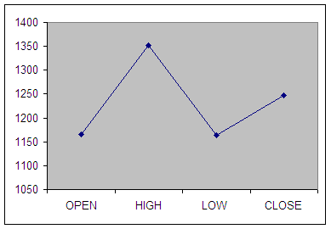

**Interpretation of first week graph:**

Open = 1165

High = 1352.05

Low = 1163

Close = 1248

**CALCULATION OF B.E.P. :**

B.E.P = High Value + Low Value / 2

= 1352.05+1163/2

= 1257.52

**SECOND WEEK:**

|  |  |  |  |  |
| --- | --- | --- | --- | --- |
| **DATE** | **OPEN** | **HIGH** | **LOW** | **CLOSE** |
| 03-01-2023 | 1238.5 | 1285 | 1233 | 1238.5 |
| 04-01-2023 | 1240 | 1302.2 | 1238 | 1287.55 |
| 07-01-2023 | 1322.05 | 1394.25 | 1322.05 | 1394.25 |
| 08-01-2023 | 1392.5 | 1710 | 1384.05 | 1384 |
| 09-01-2023 | 1388.5 | 1398 | 1360 | 1362.7 |

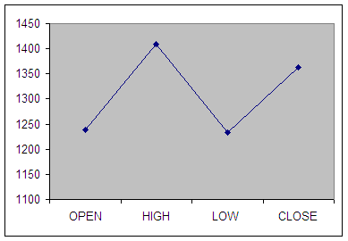

**Interpretation of Second week graph:**

Open = 1238.5

High = 1710

Low = 1233

Close = 1362.7

**CALCULATION OF B.E.P. :**

B.E.P = High Value + Low Value / 2

= 1710 + 1233 / 2

= 1321.50

**THIRD WEEK:**

|  |  |  |  |  |
| --- | --- | --- | --- | --- |
| **DATE** | **OPEN** | **HIGH** | **LOW** | **CLOSE** |
| 10-01-2023 | 1370.65 | 1720 | 1370 | 1707 |
| 11-01-2023 | 1712 | 1752 | 1396 | 1735 |
| 17-01-2023 | 1748 | 1755 | 1729 | 1739 |
| 15-01-2023 | 1742 | 1774 | 1735 | 1741 |
| 16-01-2023 | 1768 | 1769 | 1759 | 1760 |

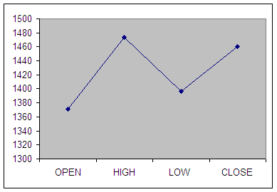

**Interpretation of Third week graph:**

Open = 1370.65

High = 1774

Low = 1396

Close = 1760

**CALCULATION OF B.E.P. :**

B.E.P = High Value + Low Value / 2

= 1774 + 1396 / 2

= 1735

**FOURTH WEEK*:***

|  |  |  |  |  |
| --- | --- | --- | --- | --- |
| **DATE** | **OPEN** | **HIGH** | **LOW** | **CLOSE** |
| 17-01-2023 | 1732 | 1746 | 1730 | 1727 |
| 18-01-2023 | 1722.5 | 1729 | 1389 | 1392.2 |
| 21-01-2023 | 1368 | 1369 | 1341 | 1340.7 |
| 22-01-2023 | 1335.01 | 1362 | 1322.05 | 1360 |
| 23-01-2023 | 1347 | 1706 | 1347 | 1387 |

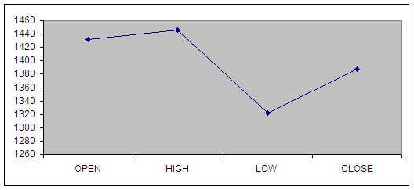

Interpretation of Fourth week graph:

Open = 1732

High = 1746

Low = 1322.05

Close = 1387

**CALCULATION OF B.E.P. :**

B.E.P = High Value + Low Value / 2

= 1746 + 1322.05/ 2

= 1384.02

**FIFTH WEEK:**

|  |  |  |  |  |
| --- | --- | --- | --- | --- |
| **DATE** | **OPEN** | **HIGH** | **LOW** | **CLOSE** |
| 24-01-2023 | 1380 | 1705 | 1372.5 | 1388 |
| 25-01-2023 | 1385 | 1720 | 1382.1 | 1705 |
| 28-01-2023 | 1388 | 1392 | 1246 | 1250 |
| 29-01-2023 | 1239.85 | 1286 | 1201.10 | 1277.30 |
| 30-01-2023 | 1299 | 1299.90 | 1191.10 | 1223.85 |
| 31-01-2023 | 1244 | 1224 | 1167 | 1187.40 |

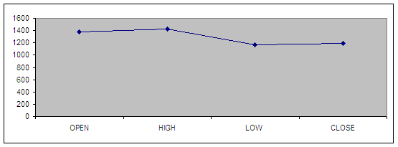

**Interpretation of Fifth week graph:**

Open = 1380

High = 1720

Low = 1167

Close = 1187.40

**CALCULATION OF B.E.P. *:***

B.E.P = High Value + Low Value / 2

= 1720 + 1167/ 2

= 1293.5

**PRICES OF RELIANCE COMMUNICATION**

**FIRST WEEK:**

|  |  |  |  |  |
| --- | --- | --- | --- | --- |
| **DATE** | **OPEN** | **HIGH** | **LOW** | **CLOSE** |
| 27-12-2022 | 792 | 796.1 | 775.3 | 778.5 |
| 28-12-2022 | 782.1 | 799 | 791.1 | 795 |
| 31-12-2022 | 782.1 | 784 | 771 | 775.6 |
| 01-01-2023 | 770 | 790.2 | 781.25 | 783 |
| 02-01-2023 | 778.06 | 781.45 | 753 | 760 |

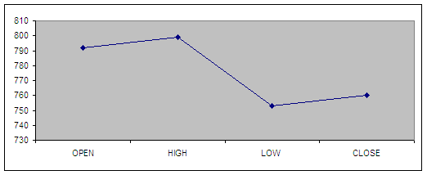

**Interpretation of first week graph:**

Open = 792

High = 799

Low = 753

Close = 760

**Calculation of Break Even Point(BEP):**

BEP = High Value + Low Value/2

= 799 + 753 / 2

= 776

**ECOND WEEK:**

|  |  |  |  |  |
| --- | --- | --- | --- | --- |
| **DATE** | **OPEN** | **HIGH** | **LOW** | **CLOSE** |
| 03-01-2023 | 765 | 772.6 | 740.7 | 749.5 |
| 04-01-2023 | 742 | 776.4 | 742 | 768.45 |
| 07-01-2023 | 795 | 810 | 790 | 810 |
| 08-01-2023 | 818 | 823 | 809 | 812 |
| 09-01-2023 | 820 | 849 | 826 | 835 |

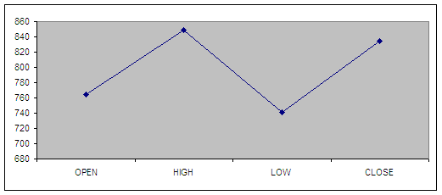

**Interpretation of second week graph:**

Open = 765

High = 849

Low = 740.7

Close = 835

**Calculation of Break Even Point (BEP):**

BEP = High Value + Low Value/2

= 849 + 740.7 / 2

= 794.85

**CONCLUSION**

In the present scenario to compete with the Broker’s would require sound infrastructure and trading as per international standards.

The concept of business has changed today, this is a service oriented industry hence the survival would require them to provide the best possible service to the clients.

The benefits of depository system are significant. Introduction of depositories will improve the market efficiency, through adopting criteria for describing scrip depositors eligible. If the company is not able to meet the criteria , the company gels to be shifted to paper based market. This leads to falloff image of the company. Hence, the company will try their best to reach the eligible criteria to move into system.

Secondly, the paper management will substantially reduce. This helps in savings in time for allotment/transfer of scripts. This improves internal systems effectively.

Thirdly, the intensity of trading in the script is likely to increase substantially. The experiences of the developed countries, these who are introduced the depository system, shows that there will be around 5 to 6 times increase in the turnover. This happens due to investors indulging more and more in buying and selling even for marginal trading profits.

Fourthly, the cost of bad deliveries, forged share certificates and unproductive back office activity will vanish for corporate.

Last but not least, the depository system will bring in a sea change in corporate democracy, particularly in corporate management price discovery in market place and proxy exercise etc.

**REFERENCES:**

• www.smcglobalsecurities.com

• www.bseindia.com

• www.sebi.com

• www.moneycontrol.com

• www.economictimes.com

• www.nseindia.com