**Inventory Management -With Reference to Whirlpool India Limited**

**Ayeela Mounika**

Roll No: 212122672180, Department of Management Studies

Aristotle PG College, Chilkur, Moinabad, Ranga Reddy District, Telangana.

**Dr. L Srinivas Reddy**

Professor & Principal

Aristotle PG College, Chilkur, Moinabad, Ranga Reddy District, Telangana.

[srinivsreddylokasani@gmail.com](mailto:srinivsreddylokasani@gmail.com)

**Abstract:**

*Inventory control is vitally important to almost every type of business, whether product or service oriented. Inventory control touches almost every facets if operations. A proper balance must be struck to maintain proper inventory with the minimum financial impact on the customer. Inventory control is the activities that maintain stock keeping items at desired levels. In manufacturing since the focus is on physical product, inventory control focus on material control. “Inventory” means physical stock of goods, which is kept in hands for smooth and efficient running of future affairs of an organization at the minimum cost of funds blocked in inventories. The fundamental reason for carrying inventory is that it is physically impossible and economically impractical for each stock item to arrive exactly where it is needed, exactly when it is needed. Inventory management is the integrated functioning of an organization dealing with supply of materials and allied activities in order to achieve the maximum co-ordination and optimum expenditure on materials. Inventory control is the most important function of inventory management and it forms the nerve center in any inventory management organization. An Inventory Management System is an essential element in an organization. It is comprised of a series of processes, which provide an assessment of the organization’s inventory.*

**Keywords:** Inventory Management, Materials.

**INTRODUCTION:**

Inventory Management systems are the rule for such enterprises, but smaller businesses and vendors use them, too. The systems ensure customers always have enough of what they want and balance that goal against a retailer’s financial need to maintain as little stock as possible. Mismanaged inventory means disappointed customers, too much cash tied up in warehouses and slower sales. Factors such as quicker production cycles, a proliferation of products, multi-national production contracts and the nature of the big-box store make them a necessity.

Modern inventory management systems must have the ability to track sales and available inventory, communicate with suppliers in near real-time and receive and incorporate other data, such as seasonal demand. They also must be flexible, allowing for a merchant’s intuition. And, they must tell a store owner when it’s time to reorder and how much to purchase.

To achieve this, inventory management systems pull together several technologies into one cohesive approach. Read on to learn about the history of inventory management systems and how modern systems work. The couplet beautifully sums up the predicament of all those who are connected with the stock (inventory). What is this inventory? What are its functions? What can be done to minimize this inventory? These and other relevant issue has been discussed in this chapter.

In a complex industry like “Ramco Cements Limited”.+ It studied clearly of how the thing are being preformed and what is the real impact of these on industry and how effectively the inventory is utilized is interested to be known by researcher because of this great significance in the research.

Inventory management consists of maintaining for a given financial investment an adequate of something in order to meet and accepted pattern of demand. Inventory considers control over costs of inventory on one hand an handle the size of inventory on other hand. Controlling investments in inventories constitute crucial part in current assets.

company's inventory is one of its most valuable assets. In retail, manufacturing, food services, and other inventory-intensive sectors, a company's inputs and finished products are the core of its business. A shortage of inventory when and where it's needed can be extremely detrimental.

At the same time, inventory can be thought of as a liability (if not in an accounting sense). A large inventory carries the risk of spoilage, theft, damage, or shifts in demand. Inventory must be insured, and if it is not sold in time it may have to be disposed of at clearance prices—or simply destroyed.

For these reasons, inventory management is important for businesses of any size. Knowing when to restock inventory, what amounts to purchase or produce, what price to pay—as well as when to sell and at what price—can easily become complex decisions. Small businesses will often keep track of stock manually and determine the reorder points and quantities using spreadsheet (Excel) formulas. Larger businesses will use specialized enterprise resource planning (ERP) software. The largest corporations use highly customized software as a service (SaaS) applications.

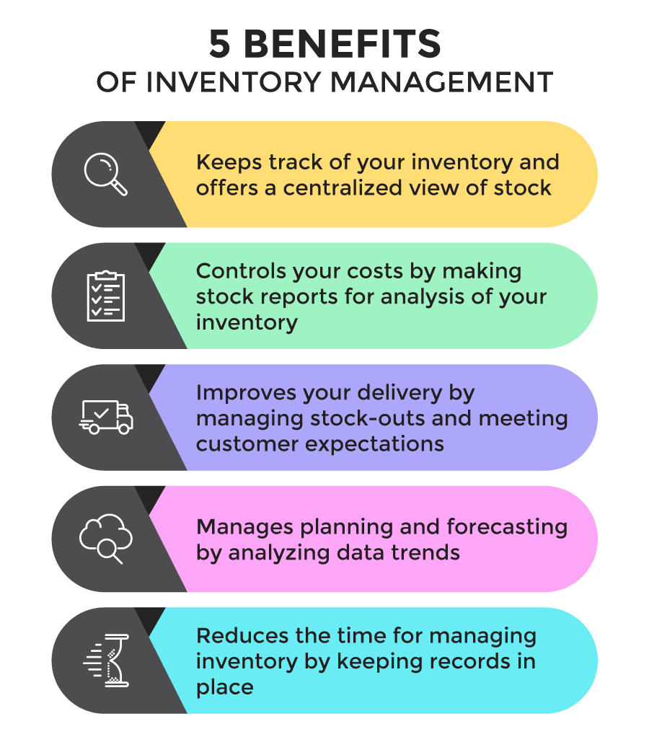

**REVIEW OF LITERATURE:**

* **Author:** **Ayad K. Ali Source:** **Archives of Pharmacy Practice Vol. 2, Issue 4, 2011**
* **Abstract** Small businesses are vital for employment and job creation in South Africa. The implementation of sound cash management
* practices is essential to ensure the profitability and sustainability of any successful business. The purpose of this paper is to
* identify the cash management challenges faced by small businesses in a developing community. This research targeted small
* retail businesses in the Tongaat area in KwaZulu-Natal, South Africa. The research design for this paper was descriptive,
* quantitative and cross-sectional. The data instrument was a questionnaire. These findings indicate a significant relationship
* between cash management knowledge and managing cash flow. The findings also indicate a correlation between profitability in
* the business and implementation of cash management practices as well as a correlation between the challenges of cash
* management practices and their ability to ensure profitability in their business. This paper recommends that businesses should
* implement cash management procedures to eliminate cash management difficulties.
* Forecasting is supposed to be one of the oldest management activities. In biblical times there were frequent allusions to clairvoyants and prophets. Nowadays it is becoming increasingly necessary for companies to make forecasts; those that do not give the prospect to their competitors a clear advantage. No forecasting is a main cause of most of today’s business failures. In the past, goods could be sold on company reputation alone and forecasting was not too important. In today’s more competitive times, sentiment does not apply, and firms that do not challenge their selves to make an accurate forecast on which to base their future production will find it increasingly difficult to survive (Lancaster G.A. & Lomas R.A., 1985).
* Forecasting is important for many aspects of the modern business. Organisations make plans which become effective at some point in the future so they need information about prevailing circumstances (Waters, 2003). This information must be forecast; but unfortunately forecasting is a difficult situation and despite its importance, progress in many areas has been limited (Waters, 2003).
* According to literature forecasting can be defined:
* “Forecasting is predicting, projecting, or estimating some future event or condition which is outside an organization’s control and provides a basis for managerial planning” (Golden J. et.al, 1994, p.33)
* “Forecasting is generally used to predict or describe what will happen (for example to sales demand, cash flow, or employment levels) given a set of circumstances or assumptions” (Waddell D., et.al, 1994, p.41)Small businesses are vital for employment and job creation in South Africa. The implementation of sound cash management
* practices is essential to ensure the profitability and sustainability of any successful business. The purpose of this paper is to
* identify the cash management challenges faced by small businesses in a developing community. This research targeted small
* retail businesses in the Tongaat area in KwaZulu-Natal, South Africa. The research design for this paper was descriptive,
* quantitative and cross-sectional. The data instrument was a questionnaire. These findings indicate a significant relationship
* between cash management knowledge and managing cash flow. The findings also indicate a correlation between profitability in
* the business and implementation of cash management practices as well as a correlation between the challenges of cash
* management practices and their ability to ensure profitability in their business. This paper recommends that businesses should
* implement cash management procedures to eliminate cash management difficulties.
* In pharmacy operations, inventory is referred to as the stock of pharmaceutical products retained to meet future demand. Inventory represents the largest asset in pharmacy practice, and its value continues to rise because of the growth in variety and cost of pharmaceutical products. From both financial and operational perspectives, efficient inventory management plays a great role in pharmacy practice. Inventory management aims at reducing procurement and carrying costs, while maintaining an effective stock of products to satisfy customer and prescriber demands. The author reviews methods of inventory management in pharmacy practice, and highlights approaches by which the process of inventory management is evaluated. Factors affecting inventory management, including the role of information technology, are summarized. The author outlines, with recommendations, the impact of inventory mismanagement on patient safety.
* **Source: RESEARCH REVIEW International Journal of Multidisciplinary**
* **Author:** **Dr. Pushpender Kumar and 2Anupreet Kaur Mokha** Inventories are raw materials, work-in-process goods and completely finished goods that are considered to be the portion of business’s assets that are ready or will be ready for sale. Formulating a suitable inventory model is one of the major concerns for an industry. The earliest scientific inventory management researches date back to the second decade of the past century, but the interest in this scientific area is still great. Again considering the reliability of any process is an important feature in the research activities. Values of some factors are very hard to define or almost unreal. In such cases, fuzzy models of inventory management take an important place. This paper analyses possible parameters of existing models of inventory control. An attempt is made to provide an up-to-date review of existing literature, concentrating on descriptions of the characteristics and types of inventory control models that have been developed.
* **Author: Henrik Andersson Source: Computers & Operations Research**
* **Abstract** This paper describes industrial aspects of combined inventory management and routing in maritime and road-based transportation, and gives a classification and comprehensive literature review of the current state of the research.
* The literature is contrasted with aspects of industrial applications from a constructive, but critical, viewpoint. Based on the status and trends within the field, future research is suggested with regard to both further development of the research area and industrial needs. By highlighting the industrial aspects, practitioners will hopefully see the benefit of using advanced decision support systems in complex situations related to combined inventory management and routing in their business. In addition, a classification and presentation of the research should help and motivate researchers to further focus on inventory management and routing challenges.

**RESEARCH GAP:**

Gap between the time of placing order and the receipt of the delivery. This time gap can be due to delay in transportation, loading and many other factors, which are beyond control.

**OBJECTIVES:**

* To analyze the efficiency of Inventory Management of Whirlpool of India Ltd.
* To identify optimum level of inventory this minimizes the cost.
* To identify the safety stock level for various components.
* To classify the various components based on its value and movements.
* To identify inventory requirement of the company for the next year.

**RESEARCH METHODOLOGY:**

**Need For the Study**

Every organization needs inventory for smooth running of its activities. It serves as a link between production and distribution processes. The investment in inventories constitutes the most significant part of current assets/working capital in most of the undertakings. Thus, it is very essential to have proper control and management of inventories. The purpose of inventory management is to ensure availability of materials in sufficient quantity as and when required and also to minimize investment in inventories. So, in order to understand the nature of inventory management of the organization, I took this Inventory Management as a topic for my project, to give findings and suggestions by adopting and analyzing different inventory control techniques.

**Scope of the Study:**

The scope of study is limited to collecting the financial data published in the annual reports of the company with reference to the objectives stated above. The main scope of the study is an analysis of the data with a view to suggest favorable solutions to the various problems related to Inventory Control Management.

**Methodology**

# **Research:**

Research is a process in which the researcher wishes to find out the end result for a given problem and thus the solution helps in future course of action. The research has been defined as “A careful investigation or enquiry especially through search for new facts in branch of knowledge”

# RESEARCH DESIGN:

The research design used in this project is Analytical in nature the procedure using, which researcher has to use facts or information already available, and analyze these to make a critical evaluation of the performance.

# **Data Collection**:

## **Primary Sources:**

Data are collected through personal interviews and discussion with Finance- Executive.

Data are collected through personal interviews and discussion with Material Planning- Deputy Manager.

### **Secondary Sources:**

The data are collected from the annual reports maintained by the company for the past six years viz., 2018-2023.Data are collected from the company’s website.

Books and journals pertaining to the topic.

#### Tools used in the analysis:

* Economic Order Quantity.
* Safety Stock.
* ABC Analysis.
* FSN Analysis.
* Linear Regression method.
* Inventory turnover ratios.

**Period Of Study**

The period of the study at Whirlpool of India Limited, Hyderabad is for one month.

**Tools:**

Research tool is an instrument or means through which the research is carried out, for example, Surveys, Questionnaires, etc. tool used in the study.

**DATA ANALYSIS & INTERPRETATION:**

**Economic Order Quantity**

|  |  |  |  |  |  |  |  |
| --- | --- | --- | --- | --- | --- | --- | --- |
| Sl. No. | Components | **Demand**  **Per year** | **Re-Order Cost/ order** | **Carrying Cost/unit/year** | **EOQ** | **No. of units Ordered** | **No. of order**  **per year** |
| 1. | Bearing - Ball Sealed – 6006 | 3,60,000 | 12,200 | 2 | 66,272.17 | 30,000 | 5.43 |
| 2. | Bearing - Ball Sealed - 6205 - Swift | 48,000 | 6,200 | 2 | 17,251.09 | 4,000 | 2.78 |
| 3. | Drive assly - NBO - China (Agitator) - 2 pin drive | 1,44,000 | 1,700 | 36 | 3,687.82 | 12,000 | 39.05 |
| 4. | Drive assly - ECO Dlx - NBO - China (Impeller) | 96,000 | 1,700 | 36 | 3,011.09 | 8,000 | 31.88 |
| 5. | Driven Pulley - NBO - China (Same pulley) | 2,40,000 | 1,700 | 36 | 4,760.95 | 20,000 | 50.41 |
| 6. | Wash timer - Eco Dlx (Ningbo) - With buzzer (S60) | 30,000 | 1,700 | 2 | 7,141.43 | 2,500 | 4.20 |
| 7. | Wash timer - Eco Dlx (Ningbo) - Without buzzer (SI 60) | 42,000 | 1,700 | 2 | 8,449.85 | 3,500 | 4.97 |
| 8. | Heater (WW) | 21,600 | 4,700 | 2 | 10,075.71 | 1,800 | 2.14 |
| 9. | Heater (Chandini) | 9,600 | 6,200 | 2 | 7,714.92 | 800 | 1.24 |
| 10. | Pig tail connector-3.0 | 3,60,000 | 6,200 | 2 | 47,244.05 | 30,000 | 7.62 |
| 11. | Pig tail connector-3.8 | 1,80,000 | 6,200 | 2 | 33,406.59 | 15,000 | 5.39 |
| 12. | Seal drive tube - Swift | 42,000 | 6,200 | 2 | 16,136.91 | 3,500 | 2.60 |
| 13. | Seal tub support - Swift | 42,000 | 6,200 | 2 | 16,136.91 | 3,500 | 2.60 |
| 14. | WW Motor - Welling | 90,000 | 6,200 | 18 | 7,874.01 | 7,500 | 11.43 |
| 15. | Splash Motor | 42,000 | 6,200 | 18 | 5,378.97 | 3,500 | 7.81 |
| 16. | Motor - Jeamo | 3,00,000 | 65,200 | 18 | 46,619.02 | 25,000 | 6.44 |
| 17. | Clamp tub | 66,600 | 10,100 | 2 | 25,935.69 | 5,550 | 2.57 |
| 18. | Suspension Spring Assly FLT 70 (Fimstud) | 7,200 | 10,000 | 2 | 8,485.28 | 600 | 0.85 |
| 19. | Door Lock - High End | 1,800 | 15,400 | 2 | 5,264.98 | 150 | 0.34 |
| 20. | Door Lock, Low End, FLT70 | 1,800 | 15,400 | 2 | 5,264.98 | 150 | 0.34 |
| 21. | Ball Bearing-Outer, FLT70 | 3,600 | 8,400 | 2 | 5,499.09 | 300 | 0.65 |
| 22. | Ball Bearing-Inner, FLT70 | 3,600 | 8,400 | 2 | 5,499.09 | 300 | 0.65 |
| 23. | Heating Element , High/Mid End,FLT70 | 1,800 | 8,400 | 2 | 3,888.44 | 150 | 0.46 |
| 24. | Heater Low end | 1,800 | 8,400 | 2 | 3,888.44 | 150 | 0.46 |
| 25. | Pressostat, FLT70 | 3,600 | 8,400 | 2 | 5,499.09 | 300 | 0.65 |
| 26. | Timer T2-EC6018-FLT | 1,800 | 8,900 | 2 | 4,002.50 | 150 | 0.45 |
| 27. | Water Distribution Actuator, FLT70 | 1,800 | 7,900 | 2 | 3,770.94 | 150 | 0.48 |
| 28. | Nut Push In, FLT70 | 21,600 | 16,400 | 2 | 18,821.26 | 1,800 | 1.15 |
| 29. | Heater Clip,FLT70 | 3,600 | 7,750 | 2 | 5,282.05 | 300 | 0.68 |
| 30. | Bellow, FLT70 | 3,600 | 84,300 | 2 | 17,420.68 | 300 | 0.21 |
| 31. | Shock Absorber Assy, FLT70 | 7,200 | 9,800 | 2 | 8,400.00 | 600 | 0.86 |
| 32. | Universal Motor Assy, Mid&High End,FLT70 | 1,800 | 49,200 | 18 | 3,136.88 | 150 | 0.57 |
| 33. | Motor Low end | 1,800 | 57,200 | 18 | 3,382.31 | 150 | 0.53 |
| 34. | Window Glass,FLT70 | 3,600 | 23,100 | 18 | 3,039.74 | 300 | 1.18 |
| 35. | Drain Pump, FLT | 1,800 | 20,100 | 2 | 6,014.98 | 150 | 0.30 |
| 36. | On / Off Switch Low end (Push button switch) | 1,800 | 7,700 | 2 | 3,722.90 | 150 | 0.48 |
| 37. | Thermostat Variable, Low End, FLT70 | 1,800 | 8,500 | 2 | 3,911.52 | 150 | 0.46 |
| 38. | Poly V Belt,FLT70 | 1,800 | 1,700 | 2 | 1,749.29 | 150 | 1.03 |
| 39. | Tub Sealing, FLT70 | 3,600 | 1,700 | 2 | 2,473.86 | 300 | 1.46 |
| 40. | SS COIL | 2,40,000 | 52,200 | 18 | 37,309.52 | 20,000 | 6.43 |

Interpretation:

In the above table the EOQ & the no. of orders purchased per year for various components are calculated. The calculated EOQ is compared with the no. of units of each component purchased in the organization. It is found that, there is a variation in the EOQ & no. of unit purchased. It is understood that the company is not following EOQ for purchasing the materials & therefore the inventory management is not satisfactory.

**Safety stock**

|  |  |  |  |  |  |
| --- | --- | --- | --- | --- | --- |
| Sl. No. | **Components** | **Max. Lead Time** | **Normal Lead Time** | **Demand** | **Safety Stock** |
| 1. | Bearing - Ball Sealed – 6006 | 0.27 | 0.166 | 3,60,000 | 37,440 |
| 2. | Bearing - Ball Sealed - 6205 – Swift | 0.27 | 0.166 | 48,000 | 4,992 |
| 3. | Drive assly - NBO - China (Agitator) - 2 pin drive | 0.27 | 0.166 | 1,44,000 | 14,976 |
| 4. | Drive assly - ECO Dlx - NBO - China (Impeller) | 0.27 | 0.166 | 96,000 | 9,984 |
| 5. | Driven Pulley - NBO - China (Same pulley) | 0.27 | 0.166 | 2,40,000 | 24,960 |
| 6. | Wash timer - Eco Dlx (Ningbo) - With buzzer (S60) | 0.27 | 0.166 | 30,000 | 3,120 |
| 7. | Wash timer - Eco Dlx (Ningbo) - Without buzzer (SI 60) | 0.27 | 0.166 | 42,000 | 4,368 |
| 8. | Heater (WW) | 0.27 | 0.166 | 21,600 | 2,246.4 |
| 9. | Heater (Chandini) | 0.27 | 0.166 | 9,600 | 998.4 |
| 10. | Pig tail connector-3.0 | 0.27 | 0.166 | 3,60,000 | 37,440 |
| 11. | Pig tail connector-3.8 | 0.27 | 0.166 | 1,80,000 | 18,720 |
| 12. | Seal drive tube – Swift | 0.27 | 0.166 | 42,000 | 4,368 |
| 13. | Seal tub support – Swift | 0.27 | 0.166 | 42,000 | 4,368 |
| 14. | WW Motor – Welling | 0.27 | 0.166 | 90,000 | 9,360 |
| 15. | Splash Motor | 0.27 | 0.166 | 42,000 | 4,368 |
| 16. | Motor - Jeamo | 0.27 | 0.166 | 3,00,000 | 31,200 |
| 17. | Clamp tub | 0.27 | 0.166 | 66,600 | 6,926.4 |
| 18. | Suspension Spring Assly FLT 70 (Fimstud) | 0.27 | 0.166 | 7,200 | 748.8 |
| 19. | Door Lock - High End | 0.27 | 0.166 | 1,800 | 187.2 |
| 20. | Door Lock, Low End, FLT70 | 0.27 | 0.166 | 1,800 | 187.2 |
| 21. | Ball Bearing-Outer, FLT70 | 0.27 | 0.166 | 3,600 | 374.4 |
| 22. | Ball Bearing-Inner, FLT70 | 0.27 | 0.166 | 3,600 | 374.4 |
| 23. | Heating Element , High/Mid End,FLT70 | 0.27 | 0.166 | 1,800 | 187.2 |
| 24. | Heater Low end | 0.27 | 0.166 | 1,800 | 187.2 |
| 25. | Pressostat, FLT70 | 0.27 | 0.166 | 3,600 | 374.4 |
| 26. | Timer T2-EC6018-FLT | 0.27 | 0.166 | 1,800 | 187.2 |
| 27. | Water Distribution Actuator, FLT70 | 0.27 | 0.166 | 1,800 | 187.2 |
| 28. | Nut Push In, FLT70 | 0.27 | 0.166 | 21,600 | 2,246.4 |
| 29. | Heater Clip,FLT70 | 0.27 | 0.166 | 3,600 | 374.4 |
| 30. | Bellow, FLT70 | 0.27 | 0.166 | 3,600 | 374.4 |
| 31. | Shock Absorber Assy, FLT70 | 0.27 | 0.166 | 7,200 | 748.8 |
| 32. | Universal Motor Assy, Mid & High End,FLT70 | 0.27 | 0.166 | 1,800 | 187.2 |
| 33. | Motor Low end | 0.27 | 0.166 | 1,800 | 187.2 |
| 34. | Window Glass,FLT70 | 0.27 | 0.166 | 3,600 | 374.4 |
| 35. | Drain Pump, FLT | 0.27 | 0.166 | 1,800 | 187.2 |
| 36. | On / Off Switch Low end (Push button switch) | 0.27 | 0.166 | 1,800 | 187.2 |
| 37. | Thermostat Variable, Low End, FLT70 | 0.27 | 0.166 | 1,800 | 187.2 |
| 38. | Poly V Belt,FLT70 | 0.27 | 0.166 | 1,800 | 187.2 |
| 39. | Tub Sealing, FLT70 | 0.27 | 0.166 | 3,600 | 374.4 |
| 40. | SS Coil | 0.27 | 0.166 | 2,40,000 | 24,960 |

Interpretation:

In the above table, safety stock for the various components calculated are shown. Actual demand is given for each component for a period of 1 year and the lead-time is calculated at a maximum of 100 days & normal of 60 days and these were converted into per annum. So, from calculation of safety stock, we can able to determine how much the company can hold the inventory in reserve stock per annum.

**CONCLUSION OF THE STUDY:**

A better inventory management will surely be helpful in solving the problems the company is facing with respect to inventory and will pave way for reducing the huge investment or blocking of money in inventory. From the analysis we can conclude that the Company can follow the Economic Order Quantity (EOQ) for optimum purchase and it can maintain safety stock for its components in order to avoid stock-out conditions & help in continuous production flow. This would reduce the cost and enhance the profit. Also there should be tight control exercised on stock levels based on ABC analysis & maintain high percentage in fast moving items in inventories as per on FSN analysis for efficient running of the inventory. Since the inventory Turnover ratio shows the increasing trend, there will be more demand for the products in the future periods. If they could properly implement and follow the norms and techniques of inventory management, they can enhance the profit with minimum cost.

**REFERENCES:**

* [www.whirlpoolindia.com](http://www.whirlpoolindia.com)
* www.inventorymanagementreview.org/2016/06/safety_stock
* [www.inventorymanagementreview.org/inventory_basics/index](http://www.inventorymanagementreview.org/inventory_basics/index)
* [www.inventorymanagementreview.org/justintime/index](http://www.inventorymanagementreview.org/justintime/index)
* www.inventorymanagementreview.org/inventory_control/index