**Performance Evaluation of Public & Private Sector Mutual Fund Schemes-With Reference to SBI Mutual Fund**

**Mettu Hemanth Kumar**

Roll No: 212122672182, Department of Management Studies

Aristotle PG College, Chilkur, Moinabad, Ranga Reddy District, Telangana.

**Dr. L Srinivas Reddy**

Professor & Principal

Aristotle PG College, Chilkur, Moinabad, Ranga Reddy District, Telangana.

[srinivsreddylokasani@gmail.com](mailto:srinivsreddylokasani@gmail.com)

**Abstract:**

*A Mutual Fund is a trust that pools the savings of a number of investors who share a common financial goal. The money thus collected is invested by the fund manager in different types of securities depending upon the objective of the scheme. These could range from shares to debentures to money market instruments. The income earned through these investments and the capital appreciation realized by the scheme is shared by its unit holders in proportion to the number of units owned by them (pro rata). Thus a Mutual Fund is the most suitable investment for the common man as it offers an opportunity to invest in a diversified, professionally managed portfolio at a relatively low cost. Anybody with an investible surplus of as little as a few thousand rupees can invest in Mutual Funds. Each Mutual Fund scheme has a defined investment objective and strategy*

**Keywords: Performance Evaluation, Mutual Funds**

**INTRODUCTION:**

A mutual fund is the ideal investment vehicle for today’s complex and modern financial scenario. Markets for equity shares, bonds and other fixed income instruments, real estate, derivatives and other assets have become mature and information driven. Price changes in these assets are driven by global events occurring in faraway places. A typical individual is unlikely to have the knowledge, skills, inclination and time to keep track of events, understand their implications and act speedily. An individual also finds it difficult to keep track of ownership of his assets, investments, brokerage dues and bank transactions etc. A mutual fund is the answer to all these situations. It appoints professionally qualified and experienced staff that manages each of these functions on a full time basis. The large pool of money collected in the fund allows it to hire such staff at a very low cost to each investor. In effect, the mutual fund vehicle exploits economies of scale in all three areas – research, investments and transaction processing. While the concept of individuals coming together to invest money collectively is not new, the mutual fund in its present form is a 20th century phenomenon. In fact, mutual funds gained popularity only after the Second World War. Globally, there are thousands of firms offering tens of thousands of mutual funds with different investment objectives.

Typical asset management companies utilize a basic set of resources to achieve success for their investors:

**Investment Services** - These are the planned programs that seek to balance growth with risk. These programs usually combine various types of investments such as stocks, bonds, and precious metals.

**Research** - Asset management companies employ an array of researchers and consultants who concentrate on individual market sectors and try to forecast how each sector will perform in the short, mid, and long terms.

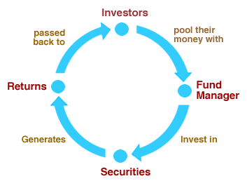

**REVIEW OF LITERATURE:**

**Author:** **Tanya Gupta and Magdalene Peter:**Dr.G. Santhiyavaili: M.Usharani, “A Study On Investment Avenues With Particular reference To Mutual Fund Many developments have been taking place in the Indian capital market with the opening of the Indian economy .The Indian financial system fosters savings among the public and channels them to their most efficient use through financial institutions or intermediaries operating in the money and capital markets segments. One such financial intermediary which has played a significant role in the development and growth of capital markets is Mutual Fund. Like most developed countries the mutual fund cult has been catching on in India. There are various reasons for this. Mutual fund makes it easy and less costly for investors to satisfy their need for capital growth and income generation. In addition to this, a mutual fund brings the benefit of diversification and money management to the individual investors, providing an opportunity for financial success that was once available only to a select few. This paper will focus on saving pattern of investors, investment avenues, awareness about various investments and preference towards mutual funds and their different types.

**Author:** **Amit Agrawal:** Lunde, Timmermann, and Blake (1999), in “The Hazards of Mutual Fund Underperformance: A Cox Regression Analysis” investigate the relationship between funds’ conditional probability of closure and their return performance. The authors explain that the process of fund attrition rates is important because: (1) survivorship bias is impacted by the funds’ lives and their relative performance; (2) duration profiles of funds is important for understanding fund managers’ incentive environments; and (3) termination processes may provide information about investor reaction to poor performance. The paper measures the importance of various factors influencing the process and rate by which funds are terminated. After examining a data set of dead and surviving funds (973 and 1402, respectively), the authors present some reasons why funds are terminated: (1) not reaching critical mass in capitalization, (2) merging a poorly performing fund with a similar, more successful fund, and (3) merging or closing a poorly performing fund to improve family group performance overall. All of these are related to fund performance, which the authors use to explain fund deaths.

**ARTICLE: 3**

**Source: European Journal of Molecular & Clinical Medicine-** **ISSN 2515-8260**

**Abstract:** Susanta Swain, Dr. Ansuman Sahoo, focused on “Investors Perception and Growth Prospects of Mutual Funds: With Special Reference to SBI Mutual Fund” Bhubaneswar, Financial markets are constantly becoming more efficient by providing more promising solutions to the investors. Being a part of financial markets although mutual funds industry is responding very fast by understanding the dynamics of investor’s perception towards rewards, still they are continuously following this race in their endeavor to differentiate their products responding to sudden changes in the economy. Thus, it is high time to understand and analyze investor’s perception and expectations, and unveil some extremely valuable information to support financial decision making of mutual funds. In few years Mutual Fund has emerged as a tool for ensuring one’s financial well being. Mutual Funds have not only contributed to the India growth story but have also helped families tap into the success of Indian Industry. As information and awareness is rising more and more people are enjoying the benefits of investing in mutual funds. The main reason the number of retail mutual fund investors remains small is that nine in ten people with incomes in India do not know that mutual funds exist. But once people are aware of mutual fund investment opportunities, the number who decide to invest in mutual funds increases to as many as one in five people.

**RESEARCH GAP:**

To plan successful strategies for increasing investment in mutual funds and they can spread more awareness about mutual funds.

**OBJECTIVES:**

* To analyze the trends in returns of selected mutual funds.
* To evaluate the performance of selected Public and Private sector Mutual Funds.
* To study the performance of the selected mutual funds and comparing public and private companies mutual funds

**RESEARCH METHODOLOGY:**

**Need For the Study**

### Mutual Funds are financial intermediaries concern with the mobilizing savings of those have surplus income and channels lavation of those avenues where there is demand of Funds. The purpose of this study of performance evaluation of mutual funds is to see that these mutual funds employ the resources in such a manner as to afford for the investors combine benefits of low risk, steady returns, high liquidity and capital appreciation through diversification and expert management.

**Scope of the Study:**

The scope of study is limited to collecting the financial data published in the annual reports of the company with reference to the objectives stated above. The main scope of the study is an analysis of the data with a view to suggest favorable solutions to the various problems related to Inventory Control Management.

**Methodology**

**Primary Data:**

It has been collected from industrial guides and other executive from different Functional areas.

**Secondary Data:**

It has been collected from the websites, Company records & Economic Times news papers.

**STATISTICAL TECHNIQUES**

The simple statistical techniques like percentages and growth rates are calculated. For the purpose of evaluation the popular methods such as Sharpe, Treynor and Jensen are applied.

**PERIOD OF STUDY**

The period of the study at SBI Mutual Fund, Hyderabad is for one month.

**Tools:**

Research tool is an instrument or means through which the research is carried out, for example, Surveys, Questionnaires, etc. tool used in the study.

**DATA ANALYSIS & INTERPRETATION:**

**Performance Measurement**

In this section, an attempt is made to measure the performance of selected mutual funds. For this purpose, the models developed by Sharpe, Trey nor and Jensen were used. Before taking up this, the details about returns of selected funds are presented. In addition, to have an idea about volatility of funds to market return, the Beta values and standard deviation values are calculated.

**Equity Fund Dividends**

|  |  |  |  |  |  |
| --- | --- | --- | --- | --- | --- |
| **Year** | **Percentage of return** | | | | |
| **SBI** | **UTI** | **HDFC** | **JM financial** | **Market Index** |
| 2021 | 9.70 | 6.65 | 13.25 | 4.18 | 9.60 |
| 2022 | 9.15 | 2.35 | 5.00 | 0.692 | 11.41 |
| 2023 | 12.93 | 10.70 | 8.70 | 11.40 | 10.10 |
| AVG | 10.40 | 6.57 | 8.98 | 5.43 | 10.37 |

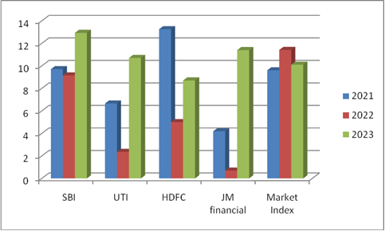

**Interpretation**

The average return of SBI is 10.40% and it is high in the year by 12.93% and lowest in the year 2022 by 9.15% it is concluded that the return is in increasing trend. The return of UTI fund shows that it has earned highest return of 10.70 % on its investments in the year 2023. It has on an average generated a return of 6.57% for the period from 2021-2023. Average return of HDFC is 8.978% and the highest in 2021 is 13.25% and lowest is in 2021 is decreased 5.00%. The return of JM financial fund shows that earned highest return of 11.40% on its investments in the year 2023 and lowest is in 2022 is decreased 0.692%. It has on AVG generated return of 5.43%for the period from 2021-2023. Market return is in 2021 9.60% and in 2022 11.47% and in 2023 is 10.105%. So, it concluded that market return also high in 2021 but it decreased in 2022 and increased in 2023. The average return of SBI is more than other mutual funds.

**Equity fund growth**

|  |  |  |  |  |  |
| --- | --- | --- | --- | --- | --- |
| Year | Percentage of return | | | | |
| SBI | UTI | SBI | JM financial | SBI |
| 2021 | 9.70 | 2021 | 9.70 | 2021 | 9.70 |
| 2022 | 10.83 | 2022 | 10.83 | 2022 | 10.83 |
| 2023 | 11.68 | 2023 | 11.68 | 2023 | 11.68 |
| AVG | 10.73 | AVG | 10.73 | AVG | 10.73 |

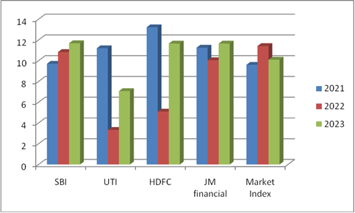

**Interpretation:**

The above table reveals that SBI made a highest return of 11.68% on its investment year 2023.and lowest is in 2021 is decreased 9.70%. However it has earned on an average 10.73% return on investment for the period 2021-20 The UTI fund made highest return of 11.20% on its investment in the year 2021 and lowest is in 2022 is decreased 3.33%.on an average the fund made a return 7.20% in period 2021-20. The return of HDFC fund also following this same trend. It has need highest return 13.22% and lowest is in 2023 is decreased 5.10%. The fund however average return of 9.99% during period. The JM financial fund made a highest return of 11.65% on its investments in the year 2022 it has also and lowest return of 10.05% in year 2023 on average return of 10.98% for the period 2021-20. Market return fund also following same trend it has made highest return of 11.41% it investment in year 2022 and lowest return of 9.60% in year 2021. The fund hewer AVG return of 10.37% during the period. The comparative analysis this for funds shows that JM finance fund made a highest average return 10.98% and on its investment for the period 2021-20, followed by SBI and UTI and HDFC fund that order.

**Balanced Fund Dividend**

|  |  |  |  |  |  |
| --- | --- | --- | --- | --- | --- |
| Years | Percentage of return | | | | |
| SBI | UTI | SBI | JM financial | SBI |
| 2021 | 6.3 | 2021 | 6.3 | 2021 | 6.3 |
| 2022 | 8.13 | 2022 | 8.13 | 2022 | 8.13 |
| 2023 | 9.45 | 2023 | 9.45 | 2023 | 9.45 |
| AVG | 7.98 | AVG | 7.98 | AVG | 7.98 |

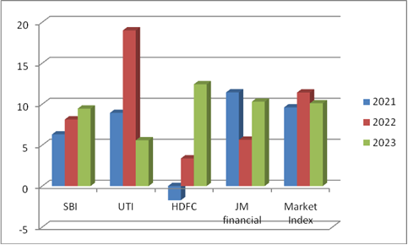

**Interpretation:**

For the above can be concluded that SBI fund made highest return of 9.45% on it investment for the year 2023 and lowest return of 6.30%, in 2021. However the fund made on an AVG 7.98% for period 2021-22. The return of UTI fund shows that it has earned a highest return of 19.00% on its investment in year 2022 and lowest return of 5.58% in 2023. It has on an AVG a return of 11.17% for period 2021-20. The return of HDFC fund is also following the same trend. It has made highest return 12.42% on its investment in the year 2023. It has also incurred a loss of 1.73% in year 2021 it has on an average generated a return of 4.69% for the period 2021-20. The return of JM finance fund shows that it has earned a highest return of 11.43% on investment in the year 2021 and lowest return of 5.65% in year 2023.The funds average return is 9.13% during the period. The return of market return fund is also following the same trend it has made highest return of 10.41% and lowest return of 9.60% in year 2021. The fund however has an average return of 10.37% during period, the average return UTI more than other mutual funds.

**CONCLUSION OF THE STUDY:**

It is hopeful that this study creates awareness that the mutual funds are worth investment practice. The various schemes of mutual funds provide the investors with a wide range of investments options according to his risk bearing capacities and interest. Besides they also give a handy return to the investors. The project analyses various schemes of Different Companies.

In India Mutual funds are playing important role. The mutual fund Companies pool the savings of small investors and invest those collected huge amount of funds in different sectors of the economy. They are performing like intermediary between small investor and the Indian capital market. In recent years many mutual fund companies are established. Through this competition is increased among the companies. To encounter the competition the different companies are introducing different types of mutual fund schemes with attractive returns and low risk. So it is an advantage to the investors,

**REFERENCES:**

* [www.whirlpoolindia.com](http://www.whirlpoolindia.com)
* www.inventorymanagementreview.org/2016/06/safety_stock
* [www.inventorymanagementreview.org/inventory_basics/index](http://www.inventorymanagementreview.org/inventory_basics/index)
* [www.inventorymanagementreview.org/justintime/index](http://www.inventorymanagementreview.org/justintime/index)
* www.inventorymanagementreview.org/inventory_control/index