**Fixed Assets Management-With Reference to**

**Bajaj Electricals Limited**

**Gudupally Manivishan Reddy**

Roll No: 212122672009, Department of Management Studies

Aristotle PG College, Chilkur, Moinabad, Ranga Reddy District, Telangana.

**Dr. L Srinivas Reddy**

Professor & Principal

Aristotle PG College, Chilkur, Moinabad, Ranga Reddy District, Telangana.

[srinivsreddylokasani@gmail.com](mailto:srinivsreddylokasani@gmail.com)

**Abstract:**

*In economic accounting, belongings are economic sources. Anything tangible or intangible this is able to being owned or controlled to supply price and this is held to have nice financial value is taken into consideration an asset. Simply said, property represent ownership of fee that can be transformed into coins (although coins itself is likewise taken into consideration an asset). The balance sheet of a firm records the economic fee of the belongings owned by way of the firm. It is money and other valuables belonging to a person or commercial enterprise. Two fundamental asset classes are tangible and intangible belongings. Tangible assets comprise diverse subclasses, together with contemporary property and glued assets. Current assets encompass inventory, even as constant assets consist of such objects as homes and system*

**Keywords:** Fixed Assets, Bajaj Electronics.

**INTRODUCTION:**

Intangible property are nonphysical sources and rights that have a value to the company because they provide the company a few forms of gain within the marketplace region. Examples goodwill, copyrights, logos, patents and financial assets, which include such items as bills receivable, bonds and shares. Fixed assets also are referred to as PPE (assets, plant, and device); these are bought for endured and lengthy-time period use in earning income in a business. This organization includes as an asset land, buildings, machinery, furniture, tools, and certain wasting resources e.G., timberland and minerals. They are written off against profits over their expected existence by means of charging depreciation charges (with exception of land property). Accumulated depreciation is proven within the face of the balance sheet or in the notes. These are also called capital assets in control accounting. A lengthy-time period tangible piece of property that a firm owns and uses within the production of its income and isn't anticipated to be fed on or converted into cash (Fixed belongings are sometimes collectively referred to as "plant".)

An asset that isn't always fed on or sold in the course of the regular course of business, together with land, buildings, device, machinery, automobiles, leasehold improvements, and different such objects. Fixed assets permit their owner to carry on its operations. In accounting, fixed does now not necessarily imply immovable; any asset anticipated to last, or be in use for, multiple yr is taken into consideration a hard and fast asset. On a stability sheet, those assets are shown at their ebook value (buy charge less depreciation). TANGIBLE FIXED ASSETS are those, which have physical life and generate goods and offerings. Included in this category are land, constructing, flowers, machinery, furniture, and so on. They are proven in the balance sheet, according with the fee idea, at their fee to the company on the time they were purchased. Their price is allotted to/charged against/spread over their useful life. The yearly price is called depreciation. As a result, the amount of such assets proven within the stability sheet each yr declines to the volume of the quantity of depreciation charged in that yr and by the quit of the useful lifestyles of the asset it equals the salvage fee, if any. Salvage fee signifies the quantity realized by using the sale of the discarded asset on the quit of its beneficial lifestyles. INTANGIBLE ASSETS do now not generate goods and services at once. In a way, they reflect the rights of the company. This category of property contains patents, copyrights, logos and goodwill. They confer sure special rights to their owner’s patents conger different rights to use an invention, copyrights relate to production and sale of literary, musical and creative works, alternate marks constitute distinctive right to use positive names, symbols, labels, designs, and so forth intangible fixed belongings also are written-off over a time period.

Intangible property lack bodily substance and get up shape a right granted via the government or another corporation. Intangibles may be received or evolved internally. Examples of rights granted via the authorities are patents, copyrights, and emblems, even as am example of a privilege granted by using another organization is a franchise. Other types of intangibles encompass business enterprise charges, leasehold improvements, and goodwill. Organization costs are the expenditures incurred in starting a brand new organization; an instance would be legal expenses. Leasehold improvements are costs made with the aid of a tenant to his or her leased assets, consisting of the fee of placing up new panelling.

**REVIEW OF LITERATURE:**

* Author: Emmanuel Ikechukwu Okoye: Source: Natural Journal of Banking and Finance

This research work is on Fixed Asset Management in Public Sector Organizations with a reflection on its Economic Impact on a Developing Country with focus on Nnamdi Azikiwe University (NAU). The problem necessitating this study is the stealing, vandalization and abandonment of fixed assets in the public sector organizations in Nigeria. The main objective of the paper, therefore, is to find the causes of these problems and ways of solving them. In carrying out this research, both primary and secondary data were used. Simple percentages and the chi-square statistical tool were used in analyzing the data. After. the research, a number of findings were made. which included the fact that Nigerians have poor maintenance culture among others. Consequent upon the findings, we concluded that there is need to inculcate discipline, care and trustworthiness in the lives of staff, in the light of the above conclusion, some recommendations were made which included that staff should be adequately motivated (financially and otherwise) to enable the staff, not only care for these properties, but to look beyond looting them. The researchers believe that if all these are put in placed Fixed Asset Management would yield its maximum economic benefit to any developing country.

* Author: 1a.haritha, 2k. Divya: Source: JES Journal of Engineering Sciences:Fixed asset, also known as a non-current asset or as property, plant, and equipment (PP&E), is a term used in accounting for assets and property which cannot easily be converted into cash. This can be compared with current assets such as cash or bank accounts, which are described as liquid assets. In most cases, only tangible assets are referred to as fixed. Moreover, a fixed/non-current asset can also be defined as an asset not directly sold to a firm's consumers/end-users. As an example, a baking firm's current assets would be its inventory (in this case, flour, yeast, etc.), the value of sales owed to the firm via credit (,i.e. debtors or accounts receivable), cash held in the bank, etc. Its non-current assets would be the oven used to bake bread, motor vehicles used to transport deliveries, cash registers used to handle cash payments, etc. Each aforementioned non-current asset is not sold directly to consumers.
* 2 I shireesha, 3dr. vara Lakshmi thavva: Source: International Journal of Scientific Development and Research (IJSDR) [www.ijsdr.org](http://www.ijsdr.org) Every company owns a fixed asset that is used in its business operations. To maintain a complete, accurate, and up-to-date fixed asset can be a challenge if tracking the asset without an automated process. PT. Invest Systems, an IT based Automation Company owns fixed assets such as furniture, vehicles, office equipment, etc. which the data are stored in an excel spreadsheet. The increasing number of fixed assets lays difficulties for the staff to be able to accurately track and manage the assets. This paper intends to develop a fixed asset management system to computerize the manual form of PT. Invest Systems fixed assets. “Avoca Systems” will help the company manage their assets, maintain a more detailed asset records, automate depreciation, as well as maintain the conditions of the assets through daily maintenance. Furthermore, this system can help notify the staff members to manage the assets that they are responsible for through Telegram Bot via Telegram Messenger as an interface and determine the performance capabilities of it.

**RESEARCH GAP:**

Many studies are considered in this analysis regarding Fixed Assests management of any manufacturing or Service Company. Only few studies are identifying the How much amount spend for fixed assets in the form of Capital and Revenue Expenditure of the company for the period of the study.

**OBJECTIVES:**

* To evaluate the fixed assets turnover of Bajaj Electricals Limited by the use of ratio evaluation.
* The study is carried out to realize the amount of capital expenditure made through the employer all through the 2019 to 2023 duration.
* The have a look at is carried out to evaluate fixed assets performance of Bajaj Electricals Limited, above-mentioned duration.

**RESEARCH METHODOLOGY:**

**Need For the Study**

As constant assets play an important position in enterprise’s targets. These fixed aren't convertible or not liquid able over a time frame. The owner’s funds and long-term liabilities are invested in fixed property. Since, fixed property play dominant function in the commercial enterprise and the company has utilization of fixed belongings. So, ratio contributes in analyzing and comparing the overall performance of the enterprise. If companies fixed property are idle and now not utilized properly it influences the long-time period sustainability of the firm, which may affect liquidity and solvency and profitability positions of the business enterprise. The idle of constant belongings ends in a fantastic loss in financial price and intangible fee partner of it. So, this may result in evaluation of fixed belongings performance. **Scope of the Study:**

The venture is covered on fixed belongings of Bajaj Electricals Ltd. Drawn from annual reviews of the corporation. The problem matter is restrained to fixed belongings, its analysis and its overall performance but not to every other region of accounting corporate, advertising and financial matters. Importance: Fixed property are the assets which cannot be liquidated into cash inside one year. The massive quantities of finances of the organization are invested in those assets. Every yr organization invests a further fund in those assets without delay or in directly. **Primary Data:**

Primary data is basically the live data which I collected on field while doing cold calls with the Distributor and shopkeeper, customers, I shown them list of Question for which I had required their responses. In some cases I got no response from their side and then on the basis of my previous experiences I filled those fields.

Source: Main source for the primary data for the project was questionnaires which I got filled by the customers or sometimes filled me on the basis of discussion with the customers.

**Secondary Data:**

* 1 Internet,
* 2 Books
* 3 Journals,
* 4 Newspaper,
* 5 Annual reports,
* 6 Database available in the library,
* 7 Catalogues and presentations.

**Statistical Tools**

Time series and trend analysis of ratio indicates the direction of changes. This kind of analysis is particularly applicable to the profit and loss account. It is advisable that trends of sales and net income may be studied in the light of two factors.

**DATA ANALYSIS & INTERPRETATION:**

In financial analysis the direction of change over a period of years is of initial importance. Time series and trend analysis of ratio indicates the direction of charges. This kind of analysis is particularly applicable to the profit and loss account. It is advisable that trends of sales and net income may be studied in the light of two factors. The general price level that might be found in practice is that a number of firms would be shown at persistent growth over period of years but to get a true trend of growth, the sales figure should be adjusted index of general prices.

**Fixed Assets Turn Over Ratio:**

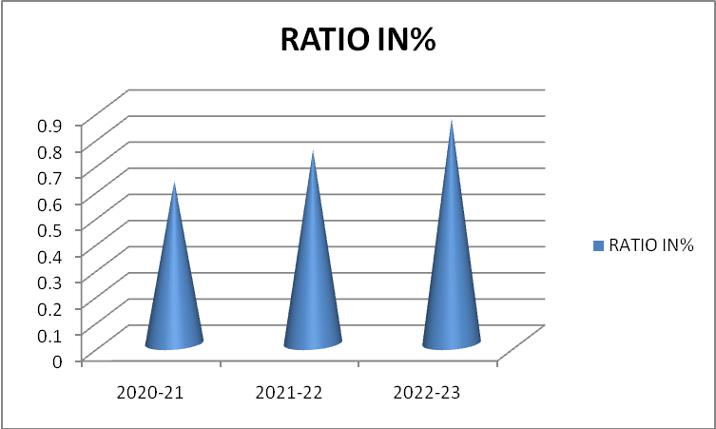

|  |  |  |  |
| --- | --- | --- | --- |
| Year | Net fixed assets | Sales | Ratio in% |
| 2020-21 | 11029800 | 6924990 | 0.62 |
| 2021-22 | 15560300 | 10158700 | 0.74 |
| 2022-23 | 18291100 | 17826800 | 0.86 |

**Interpretation:**

The above desk and graph show that the fixed property turnover ratio is pleasant. But in lower facet and there is considerable increase in ratio yr by way of yr I.E. 2020, 2021, 2022 and 2023.

**Fixed Assets Ratio:**

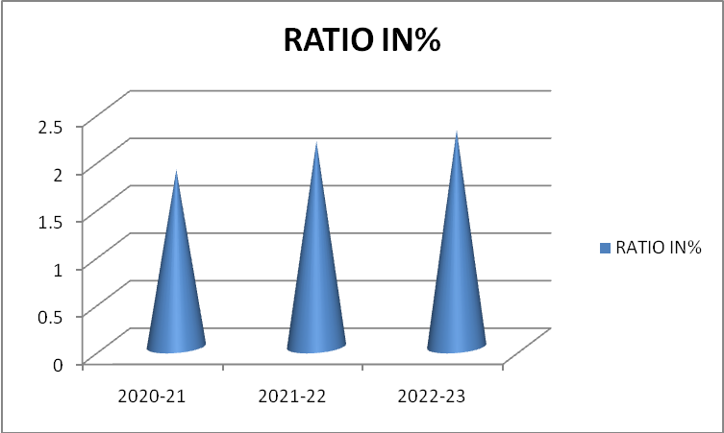

|  |  |  |  |
| --- | --- | --- | --- |
| Year | Net fixed assets | Sales | Ratio in% |
| 2020-21 | 1102800 | 5915900 | 1.86 |
| 2021-22 | 15560300 | 6529500 | 2.16 |
| 2022-23 | 18291100 | 8121500 | 2.28 |

**Interpretation:**

The above table and graph indicate that a continuous increase in fixed assets and capital hired. This suggests the first-class position of the organization. Fixed belongings ratio should never be extra than 1, a ratio of one. Sixty-seven is considered.

|  |  |  |  |
| --- | --- | --- | --- |
| **Year** | **Sales** | **Investment** | **Ratio in %** |
| 2020-21 | 6924990 | 763300 | 12.60 |
| 2021-22 | 10158900 | 763300 | 15.65 |
| 2022-23 | 17826800 | 2170420 | 7.35 |

**Investment Turns Over Ratio:**

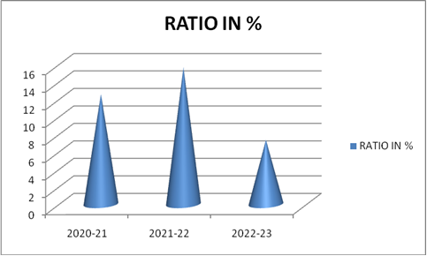

**Interpretation:**

The above table and graph show that increase in investment. Sales also in increasing manner. That indicates a good sign.

**Fixed Assets Ratio:**



|  |  |  |  |
| --- | --- | --- | --- |
| Year | Net fixed assets | Sales | Ratio in% |
| 2020-21 | 11029800 | 100 | 1.86 |
| 2021-22 | 15560300 | 122.94 | 2.16 |
| 2022-23 | 182911900 | 154.88 | 2.28 |

**Interpretation:**

The above desk and graph indicate that the investments in fixed assets are increasing. So that may be a good signal for the corporation. When as compared to 2020-21 it is been always multiplied in the ratio100 percentage to 34.88 percentage.

**CONCLUSION OF THE STUDY:**

The progress of Bajaj Electricals Limited indicates that there's an boom in running progress. That is 24.95% from general internet block in 2019-20. Then it step by step accelerated in 2019-20 it become 53%. When the w/p changed into increased robotically the net block turned into went down. That could be.33% to 46.47%. In overall funding turnover ratio we are able to discover that Sales had an amazing growth, funding is developing in a regular way first two years the employer increase in investment is same. But in 2021-2023 it in growing way. So we finish that the employer is in exact role.

**REFERENCES:**

* www.hdfcbank.com
* www.scribed.com

[www.googlesearch.com](http://www.googlesearch.com)