**Systematic Review of Budget and budgetary control -with reference to ICICI Bank**

**Pasupula Srujana**

Roll No: 212122672171, Department of Management Studies

Aristotle PG College, Chilkur, Moinabad, Ranga Reddy District, Telangana.

**Dr. L Srinivas Reddy**

Professor & Principal

Aristotle PG College, Chilkur, Moinabad, Ranga Reddy District, Telangana.

[srinivsreddylokasani@gmail.com](mailto:srinivsreddylokasani@gmail.com)

**Abstract:**

*A budget is a quantitative expression of a plan of action relating to the forthcoming budget period. It represents a written operational plan of management for the budget period.” A plan expressed in money. It is prepared and approved prior to the budget period and may show income, expenditure, and the capital to be employed, may be drawn up showing incremental effects on former budgeted or actual figures, or be compiled by zero based budgeting”. Budget and Budgetary control. The terms budget and budgetary control are often used interchangeable to refer to a system of managerial control. Budgetary control implies the use of a comprehensive system of budgeting to aid management in carrying out its functions like planning, co-ordination and control.*

**Keywords:** Budgetary Control, Ratio Analysis,

**INTRODUCTION:**

The Chartered Institute of Management Accountants (CIMA) London defines budgetary control as establishment budget relating to the responsibility of executives to the requirement policy and the continuous comparison of actuals with budgeted results either to secure individuals action the objective of policy or to provide a basic for its revision.

A budget is the monetary and quantitative expressions of business plans and policies to be pursued in the future period of time the term budgeting is used for preparing budgets and other procedures for planning co-ordination and control of business enterprise. Budgetary control is the process of determining various budgeted figures for the enterprises for the future period and then comparing the budgeted figures with the actual performance for calculating variations, if any first of all budgets are prepared and then actual results are recorded. A budget, therefore, be taken as a document which is closely related to both the managerial as well as accounting functions of an organization.

Budget is essential in every walk of our life – national, domestic and Business. A budget is prepared to have effective utilization of funds and for the realization of objective as efficiently as possible. Budgeting is a powerful tool to the management for performing its functions i.e., formulation plans, coordination activities and controlling operations etc., efficiently.

For efficient and effective management planning and control are tow highly essential functions. Budget and budgetary control provide a set of basic techniques for planning and control. A budget fixes a target in terms of rupees or quantities against which the actual performance is measured. A budget is closely related to both the management function as well as the accounting function of an organization. As the size of the organization increases, the need for budgeting is correspondingly more because a budget is an effective tool of planning and control. Budget is helpful in coordinating the various activities (such as production, sales, purchase etc) of the organization with result that all the activities precede according to the objective. Budgets are means of communication.

**REVIEW OF LITERATURE:**

* **R. SHAHANA PARVEEN:** Every organization needs Budget for smooth running of its activities. It serves as a link between inflow and outflow process of funds. The budget and budgetary control constitutes the most significant part for making profit by reducing expenditures. The purpose of budget and budgetary control is to compare actual with budgets and find the differences to have proper control over every activity. The data used for the study is secondary data .The secondary data was collected through the journals, magazines, websites, company annual reports and other relevant records. The data was evaluated with the help of budgets like cash budget, sales budget, selling overhead budget and comparing budget with actual. The analytical research design has been used for the study. So, in order to understand the nature of budget and budgetary control of the organization, in this project analyzing different budgets techniques for maximize
* What assessment criteria are most widely used by equity investors during their funding decisions? In the context of the so-called picking winner’s problem, which aspect do they consider most? Is it the jockey (entrepreneurial team), the horse (product/service), the race-track (market) or the odds (financials) to make the difference? Despite the investment evaluation funnel being very selective, about 35% of the venture-backed firms actually fail and, considering a conservative estimate, an additional 20% doesn’t provide the expected return on investment. The data therefore indicate that the investment process has large room for improvement. This paper is a systematic literature review of the research about the assessment criteria used by equity investors (venture capital and angel investors) during their investment decision making process. The research is designed around three research questions.

**RESEARCH GAP:**

This study Budgeting and budgetary control entails the establishment of goals by the management of an organization and designing a process which serves as a framework within which an organization effectively articulates overall planned activities

**OBJECTIVES:**

* To present the conceptual frame work of budget and budgetary control
* To analyze the budgetary system in practice in ICICI with particular reference to their objectives and phases of organizational and re-appropriation.
* To analyse the budgeted estimates and accruals of the revenue expenditure and revenue receipts.

**RESEARCH METHODOLOGY:**

**Need For the Study**

The day-to–day’s cut throat competition in the world of business, trade and commerce is leading to many complexities which when is not predicted properly according to the fast growing changes that are taking place in the market situations may result in adverse progress and sometimes may leads to exit from the industry or domestic markets.

To avoid these kinds of threats endangering the survival prospects, there is a compulsion today to have a proper plan of action in predicting the prices, costs, funding the proposals, controlling the same and implementing the framed budgets and utilize the scarce resources avoiding maximum extent of wastages.

**Scope of the Study:**

The scope of the study limited to collecting the data published in the reports of the company and opinions of the employees of the organization with reference to the objective stated above and theoretical framework of the data. With a view to suggest solutions to various problems relating to budget and budgetary control.

Research is the systematic investigation of fact that seeks to establish relationship between two types. The source which is not readily available & which is collected by questionnaires, personal interview

**Primary data:** The source which is not readily available & which is collected by questionnaires, personal interview**.**

Officers of accounts sections.

* Executives and staff of financial and accounts department.
* Meeting with concerned people.
* Personal observation.

**Secondary data:** Secondary data which is readily available and collected from reports, journals, books and periodicals

The main source for the project is purely secondary which is collected from

* Annual reports of ICICI. Financial management text books.
* Printed Materials.
* Journals and magazines
* News papers

**Statistical Tools**

The primary data has been collected by using of Questionnaire and Interview Schedule specifically developed for the purpose. Tools used for Data Analysis: Simple statistical and mathematical tools like percentages mean and ranking methods are used for analysis of data.

**DATA ANALYSIS & INTERPRETATION:**

**Calculation Of Revenue Receipts Budget**

|  |  |  |  |  |
| --- | --- | --- | --- | --- |
| **S.No** | **Description** | **Budgeted** | **Actuals** | **Variance** |
| **1.**  **2.**  **3.** | Sales and other receipts  Other Income  Increase in Inventory | 60,66,25,179  35,96,102  (-) 1,59,33,057 | 55,14,77,436  32,69,184  (-) 1,44,84,597 | 5,51,47,743  3,26,918  (-) 14,48,460 |
|  | **Total** | 59,42,88,224 | 54,02,62,023 | 5,40,26,201 |

In this year it can be seen that every item actuals are bellow the budget estimate which reprehensions a positives indications of savings, the actuals are beyond budget estimates due to revision in pay scales. Which can be ignored, because in total budget estimates are more then the actual. In revenue receipts, the actuals are below the budgeted. Except in increase in inventory value is negative. The budget estimates with a good variation percentage.

**Calculation Of Revenue Receipts Budget**

|  |  |  |  |  |
| --- | --- | --- | --- | --- |
| **S.No** | **Description** | **Budgeted** | **Actuals** | **Variance** |
| **1.**  **2.**  **3.** | Sales and other receipts  Other Income  Increase in Inventory | 40,68,80,342  28,00,738  (-) 7,807 | 36,98,91,220  25,46,126  (-) 7,098 | 3,69,89,122  2,54,612  (-) 709 |
|  | **Total** | 40,96,73,273 | 37,24,30,248 | 3,72,43,025 |

In this year, the budgeted are above the actuals. Material consumed is high value the budget estimates among all items and in total that shows a good budgeting effort makes the actuals. x`In revenue receipts, the budgeted are above the actuals, but with a minimum percentage of variation as compared with previous year.

**Calculation Of Revenue Receipts Budget**

|  |  |  |  |  |
| --- | --- | --- | --- | --- |
| **S.No** | **Description** | **Budgeted** | **Actuals** | **Variance** |
| **1.**  **2.**  **3.** | Sales and other receipts  Other Income  Increase in Inventory | 49,73,20,694  31,48,358  (-) 36,71,613 | 45,21,09,721  28,62,144  (-) 33,37,830 | 4,52,10,973  2,86,214  (-) 3,33,783 |
|  | **Total** | 40,96,73,273 | 37,24,30,248 | 3,72,43,025 |

This year budgets and actuals estimates are below compared to the 2019-2020 except in employee remuneration and benefits.

In revenue receipts, the budgeted are above the actuals. Increase in inventors value in negative the budget estimates with a good percentage of variation.

**Material Consumed**

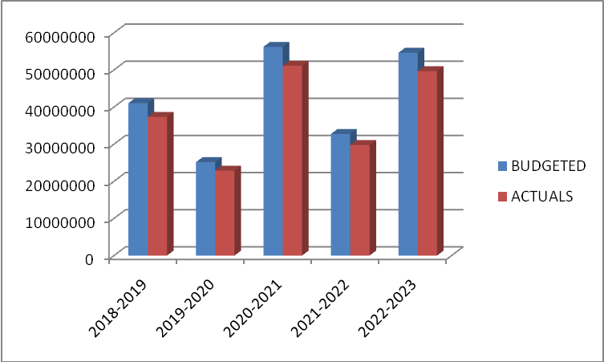

|  |  |  |
| --- | --- | --- |
| **YEAR** | **BUDGETED** | **ACTUALS** |
| **2018-2019** | 410622773 | 373293430 |
| **2019-2020** | 251639707 | 228763370 |
| **2020-2021** | 562168072 | 511061883 |
| **2021-2022** | 327669430 | 297881300 |
| **2022-2023** | 546262961 | 496602692 |

**Interpretation:**

It is observed from the above graph the materiel consumption is fluctuating from 2018-2023. So the company needs effective budget technique to get targeted actual.

**Material Consumed**

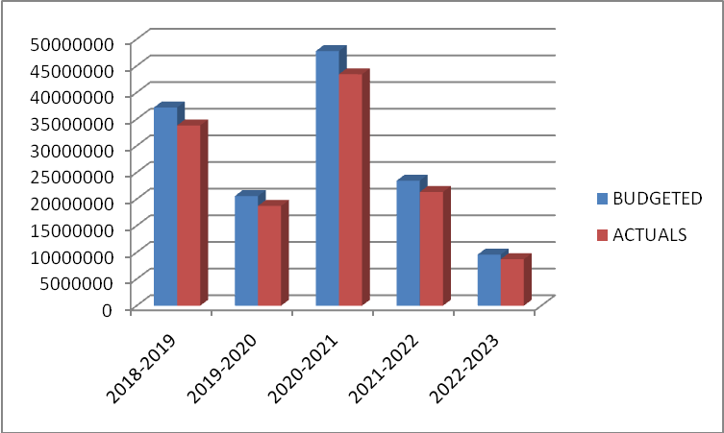

|  |  |  |
| --- | --- | --- |
| **YEAR** | **BUDGETED** | **ACTUALS** |
| **2018-2019** | 37207068 | 33824607 |
| **2019-2020** | 20589206 | 18717509 |
| **2020-2021** | 47776051 | 43432773 |
| **2021-2022** | 23474752 | 21340684 |
| **2022-2023** | 9594838 | 8722580 |

**Interpretation:**

It is observed from the above graph the materiel consumption is fluctuating from 2018-2023. So the company needs effective budget technique to get targeted actual.

**Consumable Stores**



|  |  |  |
| --- | --- | --- |
| **YEAR** | **BUDGETED** | **ACTUALS** |
| **2018-2019** | 37207068 | 33824607 |
| **2019-2020** | 20589206 | 18717509 |
| **2020-2021** | 47776051 | 43432773 |
| **2021-2022** | 23474752 | 21340684 |
| **2022-2023** | 9594838 | 8722580 |

**Interpretation:**

It is observed from the above graph the consumable stores are fluctuating from 2018-2023. The value is decreased from 3, 38, 24,607 in 2018 to 87, and 22,580 in 2022 so the company needs effective budget techniques to get targeted actual

**Employee Remuneration & Benefits**

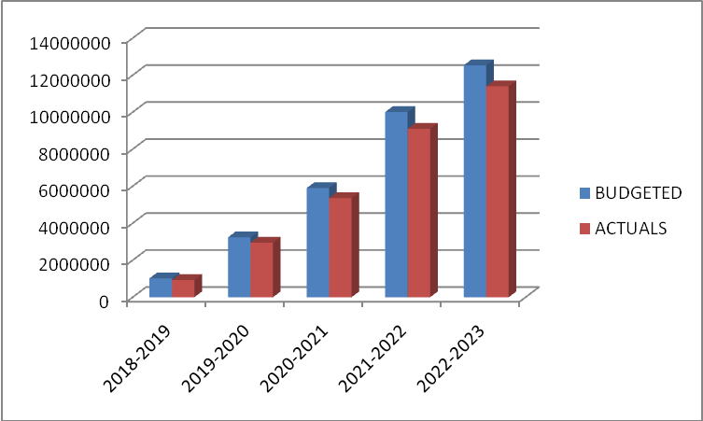

|  |  |  |
| --- | --- | --- |
| **YEAR** | **BUDGETED** | **ACTUALS** |
| **2018-2019** | 1022353 | 929412 |
| **2019-2020** | 3240003 | 2945458 |
| **2020-2021** | 5897375 | 5361250 |
| **2021-2022** | 10008138 | 9098308 |
| **2022-2023** | 12535153 | 11395594 |

**Interpretation:**

It is observed from the above graph the employee remuneration and benefits are fluctuating from 2018 to 2023. There is an increase in the values from 9, 29,412 in 2020 to 1, 13, and 95,594 in 2023. So the company should follow the same technique and also improve to get targeted actual.

**CONCLUSION OF THE STUDY:**

All the production units in ICICI. Will run perpetually throughout the year, there will be minimum variations in the revenue expenditure budget estimates and actual. As the expenditure will be incurred more or less to the estimations made by the organization. In concern with overhead expenses, it will also be with minimum variations between budget estimates and actual. The production process will be consistent. Any change in the items of expenditure, will lead to the review in the budget estimates by the accounts and finance department.

**REFERENCES:**

* [www.icici.com](http://www.icici.com)
* www.yahoofinance.com
* [www.google.com](http://www.google.com)