**Fixed Assets Performance with Reference to Ultra Tech Cement.**

**N Vaishnavi**

Roll No: 212122672002, Department of Management Studies

Aristotle PG College, Chilkur, Moinabad, Ranga Reddy District, Telangana.

**Dr. L Srinivas Reddy**

Professor & Principal

Aristotle PG College, Chilkur, Moinabad, Ranga Reddy District, Telangana.

[srinivsreddylokasani@gmail.com](mailto:srinivsreddylokasani@gmail.com)

**Abstract:**

*Valuation of fixed assets is important to have fair measure of profit or loss and financial position of the concern. Fixed assets are meant for use for many years. The value of these assets decreases with their use or with time or many other reasons. A portion of fixed assets are reduced by usage are converted into cash through charging depreciation. For correct measurement of income, proper measurement of depreciation is essential, as depreciation constitutes a Part of total cost of production. Financial transactions are recorded in the books, keeping in view the going concern aspect of the business unit. In going concern aspect it is assumed that the business unit has reasonable expectation of continuing the business for a profit for an indefinite period of time. This assumption provides much of the justification for recording fixed assets at original cost and depreciating them in a systematic manner without reference to their current realizable value.*

**Keywords:** Fixed Assets Management, Cement Company.

**INTRODUCTION:**

AS-10 on Accounting for Fixed Assets has been made mandatory with effect from 01.04.1991. According to the AS-10, “Fixed Asset is an asset held with the intention of being used on continuous basis for the purpose of producing or providing goods or services and is not held for resale in the normal course of action”. Gross book value of fixed asset is its historical cost or other amount substituted for historical costs in the books of accounts or financial statements. When the amount of depreciation is deducted from gross book value then it is Net Book Value.

**Cost of Fixed Assets** should consist of purchase price including import duties etc., and attributable cost of bringing the asset to its working condition for its intended use. Financing costs relating to borrowed funds attributable to construction or acquisition of fixed assets for the period up to the acquisition or completion. Expenditure incurred in start-up and commissioning of the project including test runs.

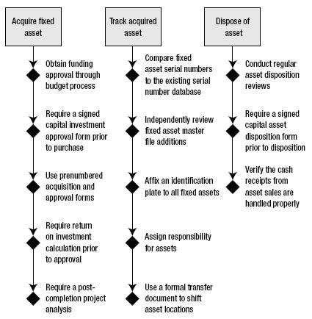

Fixed asset, also known as a non-current asset or as property, plant, and equipment (PP&E), is a term used in [accounting](http://en.wikipedia.org/wiki/Accounting) for [assets](http://en.wikipedia.org/wiki/Asset) and [property](http://en.wikipedia.org/wiki/Property) which cannot easily be converted into [cash](http://en.wikipedia.org/wiki/Cash). This can be compared with [current assets](http://en.wikipedia.org/wiki/Current_asset) such as cash or bank accounts, which are described as [liquid assets](http://en.wikipedia.org/wiki/Liquid_asset). In most cases, only tangible assets are referred to as fixed. Moreover, a fixed/non-current asset can also be defined as an asset not directly sold to a firm's consumers/end-users. As an example, a baking firm's current assets would be its inventory (in this case, flour, yeast, etc.), the value of sales owed to the firm via credit (i.e. debtors or accounts receivable), cash held in the bank, etc. Its non-current assets would be the oven used to bake bread, motor vehicles used to transport deliveries, cash registers used to handle cash payments, etc. Each aforementioned non-current asset is not sold directly to consumers.

**REVIEW OF LITERATURE:**

* **Emmanuel Ikechukwu Okoye (2018):** This research work is on Fixed Asset Management in Public Sector Organizations with a reflection on its Economic Impact on a Developing Country with focus on Nnamdi Azikiwe University (NAU). The problem necessitating this study is the stealing, vandalization and abandonment of fixed assets in the public sector organizations in Nigeria. T
* **Ramana (20218):**  The objective of the paper is chi-square statistical tool were used in analyzing the data. After. the research, a number of findings were made. which included the fact that Nigerians have poor maintenance culture among others. Consequent upon the findings, we concluded that there is need to inculcate discipline, care and trustworthiness in the lives of staff, in the light of the above conclusion, somerecommendations were made which included that staff should be adequately motivated (financially and otherwise) to enable the staff, not only care for these properties, but to look beyond looting them. The researchers believe that if all these are put in placed Fixed Asset Management would yield its maximum economic benefit to any developing country.
* **Haritha and Divya (20218):**  Fixed asset, also known as a non-current asset or as property, plant, and equipment (PP&E), is a term used in accounting for assets and property which cannot easily be converted into cash. This can be compared with current assets such as cash or bank accounts, which are described as liquid assets. In most cases, only tangible assets are referred to as fixed. Moreover, a fixed/non-current asset can also be defined as an asset not directly sold to a firm's consumers/end-users.
* **Rambabu (2017):** As an example, a baking firm's current assets would be its inventory (in this case, flour, yeast, etc.), the value of sales owed to the firm via credit (,i.e. debtors or accounts receivable), cash held in the bank, etc. Its non-current assets would be the oven used to bake bread, motor vehicles used to transport deliveries, cash registers used to handle cash payments, etc. Each aforementioned non-current asset is not sold directly to consumers.
* **Balavan hula sairam, I shireesha, Dr. Vara Lakshmi thavva (2017):** Every company owns a fixed asset that is used in its business operations. To maintain a complete, accurate, and up-to-date fixed asset can be a challenge if tracking the asset without an automated process. PT. Invest Systems, an IT based Automation Company owns fixed assets such as furniture, vehicles, office equipment, etc. which the data are stored in an excel spreadsheet. The increasing number of fixed assets lays difficulties for the staff to be able to accurately track and manage the assets. This paper intends to develop a fixed asset management system to computerize the manual form of PT. Invest Systems fixed assets. “Avoca Systems” will help the company manage their assets, maintain a more detailed asset records, automate depreciation, as well as maintain the conditions of the assets through daily maintenance. Furthermore, this system can help notify the staff members to manage the assets that they are responsible for through Telegram Bot via Telegram Messenger as an interface and determine the performance capabilities of it.
* **S.B. Gupta (2016):** A bank is an institution that accepts deposits of money from the public withdrawals by cheque and used for lending. Thus, there are two essential functions which make a financial institution a bank: The literature review included asset management concepts, current asset management practices and philosophies of other state departments of transportation (DOTs) and the FHWA, and research efforts focused on right-of-way acquisition. The purpose of this review was to ensure that TxDOT and the research team will benefit from state-of-the-art concepts and practices for asset management. ASSET MANAGEMENT CONCEPTS 1 Asset management is an emerging effort to integrate finance, planning, engineering, personnel, and information management to assist agencies in managing assets cost-effectively (AASHTO 1997). In its broadest sense, asset management is defined as “a systematic process of maintaining, upgrading, and operating assets, combining engineering principles with sound business practice and economic rationale, and providing tools to facilitate a more organized and flexible approach to making the decisions necessary to achieve the public’s expectations” (OECD 2001). The main objective of asset management is to improve decision-making processes for allocating funds among an agency’s assets so that the best return on investment is obtained. To achieve this objective, asset management embraces all of the processes, tools, and data required to manage assets effectively (Nemmers 2004).
* **Pradeep Kumar Das (2016):**, “ Financing Pattern and Utilisation of Fixed Assets -A Study”, this study deals with analysis on the financing pattern and utilisation of fixed assets of Tata Steel Limited., the selected company have been studied with the help of several statistical measures during the period from 2019-12 to 2023-16. The study reveals the sufficiency of owners fund to finance fixed assets requirements and that the company had also enough long term funds to finance the entire fixed assets as well as part of current assets. The pace of expansion in gross block on sales was not impressive in the years of study. Apart from this, slow increase in the indices of depreciation points out that overall provision for depreciation was moderate in the company under reference

**RESEARCH GAP:**

Many studies are considered in this analysis regarding Fixed Assests management of any manufacturing or Service Company. Only few studies are identifying the How much amount spend for fixed assets in the form of Capital and Revenue Expenditure of the company for the period of the study. The data used for the analysis and interpretation is from annual reports of the company i.e., secondary forms of data. Ratio analysis is used for calculation purpose. The project is presented using tables, graphs and with their interpretations. No survey is undertaken or observation study is conducted by evaluating fixed assets performance of the company. **OBJECTIVES:**

* The study is conducted to know the amount of capital expenditure incurred by the company UltraTech Cement Limited during study period 2018-23.
* The study is conducted to evaluate fixed assets performance of UltraTech Cement Limited.
* To analyse the fixed assets turnover of UltraTech Cement Limited.
* The study is conducted to know the amount of finance made by long-term liabilities and owners funds towards fixed assets.

**RESEARCH METHODOLOGY:**

**Need For the Study**

As fixed assets play an important role in company’s objectives. These fixed are not convertible or not liquid able over a period of time. The owner’s funds and long-term liabilities are invested in fixed assets. Since, fixed assets play dominant role in the business and the firm has utilization of fixed assets. So, ratio contributes in analyzing and evaluating the performance of the business.

**Scope Of the Study:**

Fixed assets are the assets which cannot be liquidated into cash within one year. The huge amounts of funds of the company are invested in these assets. Every year company invests an additional fund in these assets directly or indirectly. The survival and other objectives of the company depend on operating performance of management i.e. effective utilization of these assets. Firm has evaluated the performance, of fixed assets with proportion of capital employed on net assets turnover and other parameters which are helpful for evaluating the performance of fixed assets. Many studies are considered in this analysis regarding Fixed Assests management of any manufacturing or Service Company. Only few studies are identifying the How much amount spend for fixed assets in the form of Capital and Revenue Expenditure of the company for the period of the study.

#### **Data Collection Methods:**

The study is based on both primary and secondary data and examines the total costs vs. operating costs. The results are drawn mainly from the primary and secondary data collected.

#### **Primary Data:**

Primary data was collected in the form of questionnaire collected from the companies. Questionnaire consists of both open ended and close-ended questions.

#### **Secondary Data:**

Secondary was collected from the various sources such as

* Publications of the company
* Business magazines
* Journal, text books

**Period of Study:**

Made a study for the period of 5 years .2017-2018 to 2022-23.

**Tools used for research:**

* Ratio analysis
* Graphs

**DATA ANALYSIS & INTERPRETATION:**

**Componential Analysis:**

The componential analysis of the fixed assets of kesoram includes net blocks, capital (work in progress) and construction stores and advances. The data relating to different components of fixed assets of the UltraTech Cement Limited for 5 years commencing from 2018-2019 to 2022-2023 are set out in the following table analysis:

**Componential analysis:**

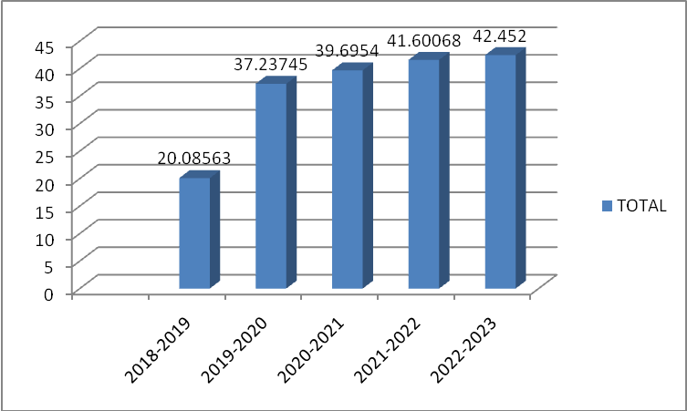

|  |  |  |  |
| --- | --- | --- | --- |
| **Year** | **Netblock**  **(FA)** | **Capital**  **(W/P)** | **Total** |
| 2018-2019 | 2500.46 | 124.49 | 20.08563 |
| 2019-2020 | 4635.69 | 124.49 | 37.23745 |
| 2020-2021 | 4941.68 | 124.49 | 39.6954 |
| 2021-2022 | 11400.25 | 274.04 | 41.60068 |
| 2022-2023 | 11634.82 | 274.07 | 42.452 |

**Interpretation:**

By observing the above table, it reveals that the investment in the net block is in increasing trend. It was 20.08 over the total fixed assets during the year 2018 and it has decreased to 42.45 during the year 2022-2023.

**Trend analysis:**

In financial analysis the direction of change over a period of years is of initial importance. Time series and trend analysis of ratio indicates the direction of changes. This kind of analysis is particularly applicable to the profit and loss account. It is advisable that trends of sales and net income may be studied in the light of two factors. The general price level that might be found in practice is that a number of firms would be shown at persistent growth over period of years but to get a true trend of growth, the sales figure should be adjusted by a suitable index of general prices.

**Growth In Total Investment**

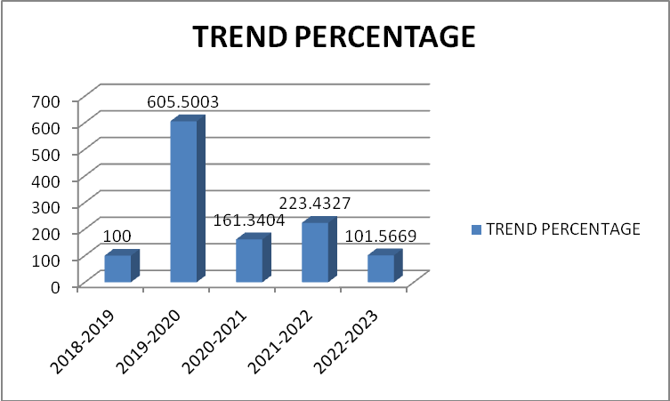

|  |  |  |
| --- | --- | --- |
| **Year** | **Netblock**  **(FA)** | **Capital**  **(W/P)** |
| 2018-2019 | 170.90 | 100 |
| 2019-2020 | 1034.80 | 605.5003 |
| 2020-2021 | 1669.55 | 161.3404 |
| 2021-2022 | 3730.32 | 223.4327 |
| 2022-2023 | 3788.77 | 101.5669 |

**Interpretation:**

From the analysis of above table, it can be observed that Total Investment of UltraTech Cement Limited had change and the growth rate is increased and in the year 2020 it is the decreasing stage and in the year 2022 it is increased due to increase in the current block. It is constant from 2018-2019 to 2022-2023.

**Ratio Analysis**:

Ratio analysis is a powerful tool of financial analysis. A ratio is defined as the indicated Quotient of two mathematical expressions and Ratios look at the relationship between individual values and relate them to how a company has performed in the past, and might perform in the future.

**Fixed Assets as A Percentage to Current Liabilities**

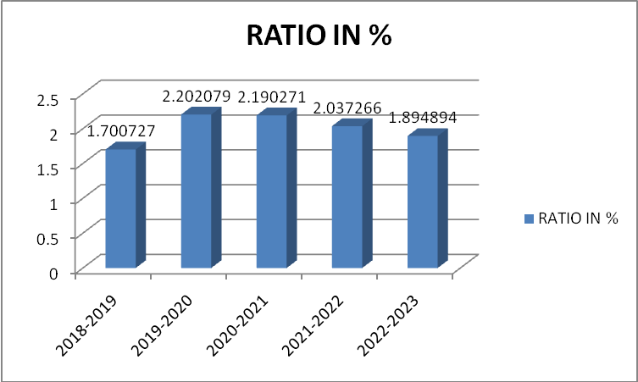

|  |  |  |  |
| --- | --- | --- | --- |
| **Year** | **Net fixed assets** | **Current liabilities** | **Ratio in %** |
| 2018-2019 | 3120.00 | 1834.51 | 1.700727 |
| 2019-2020 | 4365.38 | 1982.39 | 2.202079 |
| 2020-2021 | 4716.99 | 2153.61 | 2.190271 |
| 2021-2022 | 10890.33 | 5345.56 | 2.037266 |
| 2022-2023 | 12166.13 | 6420.48 | 1.894894 |

**Interpretation:**

The above table shows the relationship between fixed and current Liabilities. The above table shows growth in fixed assets this shows the satisfactory position of fixed assets in the company. Even the current liabilities are increasing. The highest percentage recorded was in the year 2019-2020 i.e., 2.20 and the lowest was in the year 2018-2019 i.e., 1.71.

**CONCLUSION OF THE STUDY:**

The management of UltraTech Cement Limited is quite comfortable with a mix of debt and equity. The overall assessment of financial statement signifies efficient utilization of the investments, loans and advances. The profitability of the company appears to be impressive, as judged by increase in reserves and surplus. The management discussions and analysis by Director’s report and opinions expressed by Auditor’s report through fixed asset management statements is true and fair view in accordance with the provisions of the companies Acts, and accounting standards. The overall fixed asset management of the company appears to be more than satisfactory. 5. Globalization of economies and the requirement of shares from investors in capital market, diverse and demanding audience to the company, need a clear and in-depth in information about the company’s financial position in Annual report. Instead of disclosing the combined flows of debtors and loans advances as decrease/(increase) in trade and other receivables, their separate disclosure will be more meaningful.

**REFERENCES:**

* Anthony R N and J S Reece - Management Accounting Principles, Treponemal, Bombay.
* I M Pandey - Essentials of Financial Management, Vikas Publishing House Pvt Ltd, New Delhi, 1995.
* Jain, P K , Josette Peyrard and Surendra S Yadav - International Financial Management, Macmillan India Ltd, New Delhi, 1998.
* Khan, M Y and P K Jain - Financial Management, Tata McGraw-Hill Publishing Co., New Delhi, 2007.
* Prasanna Chandra - financial Management, Tata McGraw-Hill Publishing Co., New Delhi, 2007.
* Ramesh S and A Gupta - Venture Capital and the Indian Financial Sector, Oxford university press, New Delhi, 1995.