**Role Of Internet Mailing System**

**Gavara Venkata Ramana**

Roll No: 212122672001, Department of Management Studies

Aristotle PG College, Chilkur, Moinabad, Ranga Reddy District, Telangana.

**Dr. L Srinivas Reddy**

Professor & Principal

Aristotle PG College, Chilkur, Moinabad, Ranga Reddy District, Telangana.

[srinivsreddylokasani@gmail.com](mailto:srinivsreddylokasani@gmail.com)

**Abstract:**

*This service allows an Internet user to send a message in formatted manner (mail) to the other Internet user in any part of world. Message in mail not only contain text, but it also contains images, audio and videos data. The person who is sending mail is called sender and person who receives mail is called recipient. During the procurement stage supply chain management professionals find it easy to quickly access information regarding the availability of raw material and products and the price of items. However, the supply chain management professionals should make the information available on the internet in order to be accessible. Security also should be a concern and the data should be visible only to the supply chain partners through the internet. The more information supply chain management professionals have from procurement sources the more efficiently and economically they can manage it.*

**Keywords:** Internet, Mailing Process, Models, Proposed Tools.

**INTRODUCTION:**

**Proposed system:**

Intranet Mailing System allows communication among all the employees of the same organization. The application permits employees to exchange mails and information. The mails received can be categorized and stored in different folders. This allows to manage the mails properly.

**Modules:**

* Administrative module
* Mailing module
* Folders module
* Address module.

**Administrative Module:**

This module is for an administrator of an organization. By using this module administrator can get all reports like number of users registered for this portal and can also delete any of these users.

**Mailing module:**

This module is about user of this portal. By using this module users can send mails to other colleagues, receive mails from others. The following functionalities are supported: Inbox, Compose and Change Password.

**Folders Module:**

This module is about folders and provides the functionalities to add, delete, view the folders.

**Address module:**

User can store mailing addresses of colleagues and the following functionalities are supported: Adding address, viewing all addresses and Deleting address.

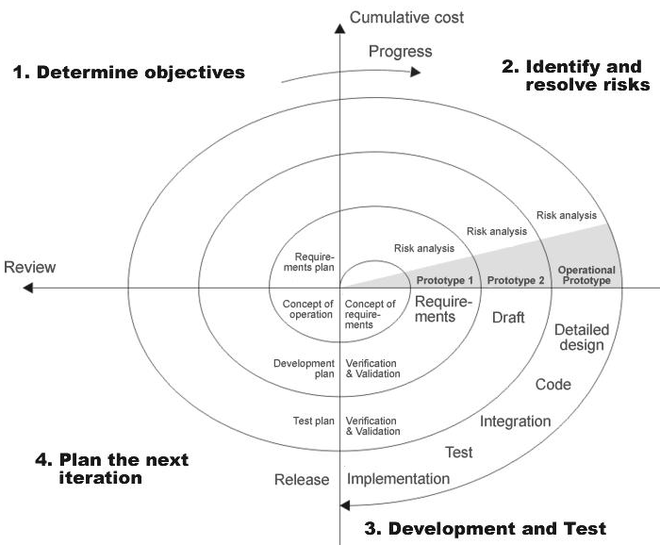

The requirements gathering process takes as its input the goals identified in the high-level requirements section of the project plan. Each goal will be refined into a set of one or more requirements. These requirements define the major functions of the intended application, define

operational data areas and reference data areas, and define the initial data entities. Major functions include critical processes to be managed, as well as mission critical inputs, outputs and reports. A user class hierarchy is developed and associated with these major functions, data areas, and data entities. Each of these definitions is termed a Requirement. Requirements are identified by unique requirement identifiers and, at minimum, contain a requirement title and

textual description. These requirements are fully described in the primary deliverables for this stage: the Requirements Document and the Requirements Traceability Matrix (RTM). The requirements document contains complete descriptions of each requirement, including diagrams and references to external documents as necessary. Note that detailed listings of database tables and fields are not included in the requirements document. The title of each requirement is also placed into the first version of the RTM, along with the title of each goal from the project plan. In the requirements stage, the RTM consists of a list of high-level requirements, or goals, by title, with a listing of associated requirements for each goal, listed by requirement title. In this hierarchical listing, the RTM shows that each requirement developed during this stage is formally linked to a specific product goal. In this format, each requirement can be traced to a specific product goal, hence the term requirements traceability.

**REVIEW OF LITERATURE:**

* **International Journal of Engineering Research: (2015):** In today’s world communication has become so easy due to the integration of communication technologies with the Internet. However, the visually challenged people find it very difficult to utilize this technology because using them requires vis-ual perception. Even though advancements have been implemented to help them use the computers efficiently, no naïve user who is visually challenged can use this technology as efficiently as a normal naïve user can do. This project aims at developing an email system that will help even a naïve visually impaired person to use services for communication without previous training. The system will not let the user make use of keyboard. Also, this sys-tem can be used by any normal person like the one who is not able to read. The system is completely based on interactive voice re-sponse which will make it user-friendly and efficient to use.
* **Tirthankar Dasgupta, Aakash Anuj, Manjira Sinha, Ritwika Ghose** **(2015):** Anupam Basu created an emailing sys-tem that is designed to be used by a visually challenged person as well as by sighted user. Using this system, we can read mail or compose mail. The compose module system will provide user with two options that are 1) Type mail 2) Record a voice message. For recording message user need to press mouse left button anywhere on screen and to stop recording he needs to release the button. Once the recording is over the system will ask for recipient mail id. At the end user either press the "send mail" or middle click on the mouse to send the mail. To access the GUI different mouse-click operations have to perform for example Left, double to compose mail, left, triple to cancel the mail etc. The system allows the person to record the voice and instead of converting speech to text the system directly sense the recorded voice message to the recipient's mail address as an attachment. Drawback of this system is user needs to re-member which mouse click does what action.
* **Yogita H. Ghadage, Sushama D. Shelke (2014):** created a speech to text for multilingual languages representing the following: This project presents a multilingual speech to text conversion system. The system operation is divided into 2 phases- training and testing. In the training phase, the speech utterances of each sentence are recorded. The speech signal is pre-processed and segmented into words. For each word, acoustic features are extracted using MFCC method. Such features for each word forming feature vector is stored for refer-ence. In the testing phase, the speech utterance to be tested is pre-processed, segmented into words and features are extracted for each word. These features are compared with the reference feature vector stored during the training phase. This is done by using a combination of SVM and Minimum Distance Classi-fier. The word having a minimum difference is given as a rec-cognized word.
* **A critical review of research on electronic mail (2014):** This paper reviews the literature on email (including computer conferencing) and discusses the most important current issues in the field. Though it will be of interest to researchers working specifically in the email field, it is intended mainly as a summary for IS researchers in other areas. Email research is part of a wider field, computer-mediated communication (CMC), which includes some areas not covered here, such as the Internet, video conferencing and EDI. Most research on email has concerned itself with the issues of media choice and media effects. Despite a great deal of published work though, the field still has an unsatisfactory, piecemeal feel to it. Much of the work that has been published is unsatisfactory in being based upon unrealistic, laboratory-like simulations, and a positivist epistemology. Most of the work concerns the use of email and the effects of using email on individuals and groups; little has been done on the effects at an organizational level. The paper concludes with some suggestions for future avenues of research.
* **Evaluation and realisation of IS/IT benefits: an empirical study of current practice (2015):** This paper presents the main findings of a 1994 survey of UK industry practices in the evaluation and realisation of IS/IT benefits (‘benefits management ‘). The survey addresses the issues which affect the ability of organizations to realise the full benefits of IS/IT investments, i.e. not only the pre-investment appraisal and post-investment evaluation processes, but also how organizations do or do not ensure that benefits claimed are actively managed through to realisation. To do this a new benefits management process model was used to structure a questionnaire to elicit details of how effective organizations are in addressing benefits management throughout the investment lifecycle. Sixty organizations responded to the survey, thus providing a wealth of data for analysis. This paper presents some of the key results of that analysis. From the survey, it is clear that many organizations believe that current methods are far from satisfactory in ensuring that the benefits are properly identified and realised. Very few have a comprehensive process for managing the delivery of benefits from IS/IT. This paper offers new insight into the reasons for the current unsatisfactory situation and points the way to how the situation could be significantly improved.
* **IT outsourcing has grown considerably in the private sector (2013)**: with IT software and service suppliers reporting increased revenues. Similarly in the public sector, the introduction of market testing and compulsory competitive tendering (CCT) will inevitably lead to the contracting-out of significant levels of IT work. This may lead to the demise of some public sector IT departments where external bids are favoured over those offered by the in-house team. This paper is divided into two sections. First, it considers some of the relevant literature on IT outsourcing in both private and public sector British and American organizations. It draws together important themes which explain the attraction of IT outsourcing to senior executives. Second, it introduces the results from a questionnaire survey of nearly 200 UK private and public sector organizations on IT outsourcing. In particular it looks at the proportion of organizations that claims to use outsourcing, how contracts are negotiated and the type of IT solutions preferred by IT managers. The central argument is that IT outsourcing poses significant challenges to both private and public sector organizations and is not simply a quick-fix panacea. Moreover, public sector IT managers would do well to analyse some of the less favourable reports from private sector outsourcing as they gear themselves up for CCT in the months ahead.

**RESEARCH GAP:**

Many studies are considered in this analysis regarding Fixed Assests management of any manufacturing or Service Company. Only few studies are identifying the How much amount spend for fixed assets in the form of Capital and Revenue Expenditure of the company for the period of the study. This document play a vital role in the development of life cycle (SDLC) as it describes the complete requirement of the system. It means for use by developers and will be the basic during testing phase. Any changes made to the requirements in the future will have to go through formal change approval process.

**OBJECTIVES:**

* To study the application is to enable communication among the employees of an organization.
* To study the employees to send and receive mails and exchange necessary information as quickly as possible.

**HYPOTHESES OF THE STUDY:**

**H0:** There is no Influence of application is to enable communication among the employees of

an organization.

**H1:** There is Influence of application is to enable communication among the employees of an

organization.

**RESEARCH METHODOLOGY:**

**Need For The Study**

Intranet Mailing System allows communication among all the employees of the same organization. The application permits employees to exchange mails and transmit documents and information. The mails and documents received can be categorized and stored in different folders. This allows to manage the mails properly.

**Scope Of The Study:**

The ‘administrative user interface’ concentrates on the consistent information that is practically, part of the organizational activities and which needs proper authentication for the data collection. These interfaces help the administrators with all the transactional states like Data insertion, Data deletion and Date updating along with the extensive data search capabilities. The ‘operational or generic user interface’ helps the end users of the system in transactions through the existing data and required services. The operational user interface also helps the ordinary users in managing their own information in a customized manner as per the included flexibilities.

**DATA ANALYSIS & INTERPRETATION:**

**Compilation of code:**

When you compile the code, the Java compiler creates machine code (called byte code) for a hypothetical machine called Java Virtual Machine (JVM). The JVM is supposed t executed the byte code. The JVM is created for the overcoming the issue of probability. The code is written and compiled for one machine and interpreted on all machines. This machine is called Java Virtual Machine.

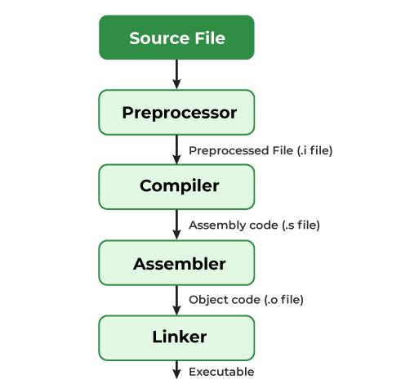

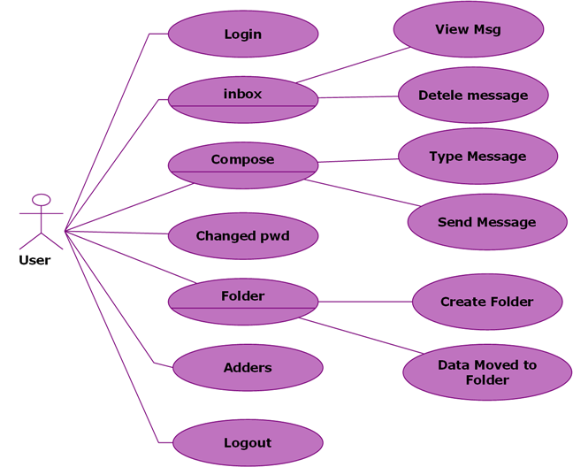

**Systems design**

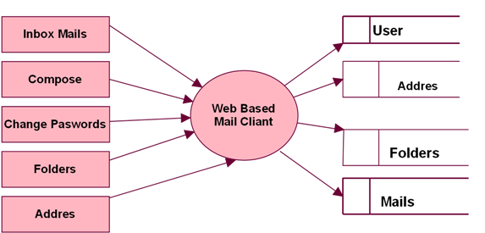

**Normalization**

A Database is a collection of interrelated data stored with a minimum of redundancy to serve many applications. The database design is used to group data into a number of tables and minimizes the artificiality embedded in using separate files. The tables are organized to:

* Reduced duplication of data.
* Simplify functions like adding, deleting, modifying data etc..,
* Retrieving data
* Clarity and ease of use
* More information at low cost

# **Normalization**

Normalization is built around the concept of normal forms. A relation is said to be in a particular normal form if it satisfies a certain specified set of constraints on the kind of functional dependencies that could be associated with the relation. The normal forms are used to ensure that various types of anomalies and inconsistencies are not introduced into the database.

**First Normal Form:**

A relation R is in first normal form if and only if all underlying domains contained atomic values only.

**Second Normal Form:**

A relation R is said to be in second normal form if and only if it is in first normal form and every non-key attribute is fully dependent on the primary key.

**Third Normal Form:**

A relation R is said to be in third normal form if and only if it is in second normal form and every non key attribute is non transitively depend on the primary key.

**CONCLUSION OF THE STUDY:**

Testing is a process, which reveals errors in the program. It is the major quality measure employed during software development. During software development. During testing, the program is executed with a set of test cases and the output of the program for the test cases is evaluated to determine if the program is performing as it is expected to perform. Basic authentication uses the Web Browser to display a username/password dialog box. This username and password is authenticated against the realm.

**Black Box Testing:**

In this strategy some test cases are generated as input conditions that fully execute all functional requirements for the program. This testing has been uses to find errors in the following categories:

* Incorrect or missing functions
* Interface errors
* Errors in data structure or external database access
* Performance errors
* Initialization and termination errors.

In this the test cases are generated on the logic of each module by drawing flow graphs of that module and logical decisions are tested on all the cases. It has been uses to generate the test cases in the following cases:

**REFERENCES:**

* JAVA Technologies
* JAVA Complete Reference
* Java Script Programming by Yehuda Shiran
* Mastering JAVA Security
* JAVA2 Networking by Pistoria
* JAVA Security by Scotl oaks
* Head First EJB Sierra Bates
* J2EE Professional by Shadab siddiqui
* JAVA server pages by Larne Pekowsley
* JAVA Server pages by Nick Todd
* HTML
* HTML Black Book by Holzner