**Market Research on Retail Industry-** **Heritage Foods India Limited- A Study.**

**Javoji Shiva Krishna**

Roll No: 212122672004, Department of Management Studies

Aristotle PG College, Chilkur, Moinabad, Ranga Reddy District, Telangana.

**Dr. L Srinivas Reddy**

Professor & Principal

Aristotle PG College, Chilkur, Moinabad, Ranga Reddy District, Telangana.

[srinivsreddylokasani@gmail.com](mailto:srinivsreddylokasani@gmail.com)

**Abstract:**

*The concepts of exchange and relationships lead to the concept of a market. A market is the set of actual and potential buyers of a product. These buyers share a particular need or want that can be satisfied through exchange relationships. Marketing means managing markets to bring about profitable customer relationships. However, creating these relationships takes work. Sellers must search for buyers, identify must first create a need-satisfying marketing offer (product). It must decide how much it will charge for the offer (price) and how it will make the offer available target consumers (place). Finally, it must communicate with the target customers about the offer and persuade them of its merits (promotion).*

**Keywords:** Market Research, Heritage Foods.

**INTRODUCTION:**

Marketing is the business function that identifies customer needs and wants. Creating customer value and satisfaction are the heart of modern marketing thinking and practice. Marketing is the delivery of customer satisfaction at a profit.

Many people think of marketing only as selling & advertising. But selling & advertising are only the tip of marketing. Marketing means managing markets to bring about exchanges and relationships for the purpose of creating value and satisfying needs & wants.

Today, marketing must be understood not in the old sense of making a sale – ‗‘telling and selling‘‘ – but in the new sense of satisfying customer needs. If the marketer does a good job of understanding consumer needs; develops products that provide superior value; and prices, distributes, and promotes them effectively, these products will sell very easily. Thus, selling and advertising are only part of a larger ‗‘marketing mix‘‘ – a set of marketing tools that work together to satisfy customer needs and build customer relationships.

Broadly Defined, Marketing Is A Social And Managerial Process By Which Individuals And Groups Obtain What They Need And Want Through Creating And Exchanging Value With Others. In A Narrower Business Context, Marketing Involves Building Profitable, Value – Laden Exchange Relationships with Customers. Hence, We Define Marketing as the Process By Which Companies Create Value For Customers And Build Strong Relationships In Order To Capture Value From Customers In Return.

**Marketing Research**

According to *American Marketing Association*, ―Marketing Research is the function that links the consumer, customer and public to the marketer through information-information used to identify and define marketing opportunities and problems, generate, refine and evaluate marketing actions; monitor marketing performance; and improve understanding of marketing as a process.‖

Marketing Research is systematic problem analysis, model building and fact finding for the purpose of important decision making and control in the marketing of goods and services.

Marketing Research is a well-planned, systematic process which implies that it needs planning at all the stages. It uses scientific method. It is an objective process as it attempts to provide accurate authentic information. Marketing Research is sometimes defined as the application of scientific method in the solution of marketing problems.

Marketing Research plays a very significant role in identifying the needs of customers and meeting them in best possible way. The main task of Marketing Research is systematic gathering and analysis of information.

#### **Marketing Management:**

The analysis, planning, implementation and control of programs design to create, build and maintain beneficial exchanges with target buyers for the purpose of achieving organizational objectives.

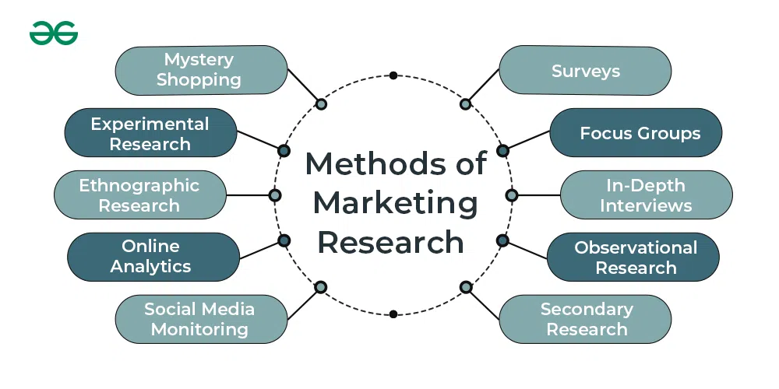

**REVIEW OF LITERATURE:**

* **Supriya Udaykumar Mogale: International Journal of Trend in Scientific Research and Development (IJTSRD)** Retailing in India has several outstanding achievements as well as impressive growth during last few decades. Indian retail market is one of the top five retail markets in the world by economic value and also it is considered as one of the fastest growing retail markets in the world. Retailing in India is the most important pillar of its economy and accounts of about 10% of its GDP. Indian retail industry is classified into organized and unorganized sectors. There is a rapid development of retailing which leads to shifting of customers from unorganized to organized sectors and it is mainly because of changing behavior and preferences of consumers. This changing behavior of consumers is due to increased income and changed life styles. Now the customer is very much aware about the product and services. He is becoming very specific and conscious about getting services by the retailers. His expectations are increasing day-by-day. Customers want everything under one roof i.e. shopping, food and entertainment and hence retailing in India is developing very fast. This is paper fully based on secondary data. This paper provides information about role of organized and unorganized sectors in India. It also includes various formats of retailing, current scenario, growth and challenges of retail industry and the future prospects of retailing in India.
* **Baba Ajay Singh Khalsa College:** The retail stores are not a new entity, they have been in this world from the early 50's and in India they have been showing their presence in various forms like departmental stores, super markets, Discount Stores, Hyper- mart, Shopping Malls etc.India has become the sought after destination for global brands and retailers owing to escalating consumerism, unprecedented awareness and youth centric customer base. The apparel retail sector in India has really emerged as a successful venture owing to its more than 35% share in the overall retail sector in India. The study Recent Trends and Developments in Apparel Retailing in India is mainly dealing with apparel retailing covering some of the popular malls in India.
* **A RESEARCH PAPER ON STUDY OF RETAIL STORE MANAGEMENT:** Retail operations emerged as a substantial Area of research in Recent years. Retailing is a significant economical sector in which changes in markets. Companies processes and products occur rapidly. The retail industry is a thought leader in the development and design of advance operations concepts and processes. Firms like Amazon, Zara, Tesco or Wal-Mart are on the forefront of operational Innovations adopted in many other industries. It also supports to improve the quality of decisions in retail and consumer goods Industry. Each of the selected paper deal with planning problems in retail operations at the interfaces with customer management.
* **Thompson & Chen (1998):** Retail store image has been shown to play an important role in store patronage, and it is widely accepted that psychological factors have a significant role in storeimage formation. Past research has often involved the measurement of tangible attributes, or links between store images and consumers’ self -images. This study was undertaken to move tothe next stage by exploring the link between perceived store image and the personal values which underlie behavioral choices. Fashion retailing was selected as an appropriate research domain because of the well-established associations between clothing choice, personality, self concept, and personal values. Means-end theory and laddering methodology were employed in interviews with 30 female respondents. The hedonic values of “enjoyment and happiness” and “quality of life” were found to be the terminal values most sought by consumers in association with store image. These were linked through the consequence “nice feeling” to the tangible attributes of “price”, “quality” and “reputation”. The study illustrates an application of means -end methodology in a retail environment, and the results provide a platform for fashion store image and positioning strategies. Suggestions for further research are made.
* **Erdem & Oumlil & Tuncalp (1999):** Retailing business is greatly affected by the patronage behavioral orientations of shoppers. Understanding these orientations can assist retailers indeveloping appropriate marketing strategies toward meeting the needs and wants of consumers.One important factor explaining consumer behavioral orientations is their values. Another important factor affecting consumer behavioral orientations is the store image, an image shaped by store attributes. This study examines the linkage between consumer values and the importance of some salient store attributes. Marketing management implications are also discussed.
* **Steve & Carralero (2000),** Argues that for many retailers, competitive advantage in the nonmarket has been based upon the development of strong store and corporate images as retailers strive to develop themselves as brands in their own right. The construction of store image, comprising both tangible and intangible dimensions, compounds problems of moving into international markets as consumers in the host environment are less familiar with the intangible dimensions of image, which have been built up over time with exposure to the retail company. Retail companies therefore need to fully understand the importance of image in competitive positioning and the components of store image before attempting to replicate this image and positioning overseas.
* **Uusitalo (2001),** Grocery retailers are operating in a slow-growth market. The pursuit of market share is one of the main concerns for retail managers. The retail structure is becoming increasingly standardized and homogenous because of concentration of the ownership of stores. Cultural differences remain, however, between different European countries. Cultural factors influence the success of a positioning strategy. This study examined how consumers perceive grocery retail formats and brands in Finland. Data from personal interviews were used in highlighting the consumer perspective. Consumers perceive meaningful differences in various store formats, meanwhile store brands are seen as quite similar. Consumers rely on functional attributes of stores when discussing grocery stores.
* **8.Paulins & Geistfeld (2003),** Consumer perceptions of retail store attributes for a set of particular stores were examined to determine their effect on store preference. Respondent’s rated13 stores. Four variables were found to affect store preference using forward stepwise logistic regression: type of clothing desired in stock, outside store appearance, shopping hours, and advertising. Significance of the effect of store attributes on store preference varied by store type.In addition, associations between customer perception of store attributes, education and age were observed. Implications for researchers and practitioners are discussed.
* **Gehrt & Yan (2004)**
* Most research related to consumer choice of retailers emphasizes retailer attributes and/or consumer characteristics. Since many retail formats, including online retailing,have emerged in recent years, knowledge of how consumers select retail formats must beupdated. A source of influence that has been examined to a very limited extent for store retailers but not for emerging retail formats is situational influence. From a modern interactionism perspective, this study investigates the influence of situational as well as consumer and retailer factors on preference for online, catalog, and store formats.
* **Miranda & Kónya (2005),** To identify the factors that influence shoppers' satisfaction with their “primary” grocery store, and those that encourage them to continue patronising it despite being presented with a significant inducement to shop elsewhere. A structured questionnaire containing31 variables relating to shopping behaviour and satisfaction was administered to 934 shoppers leaving a number of grocery stores in an Australian city during a two-week period. Results were used to construct two mathematical models predicting customer satisfaction and store loyalty, from which two research hypotheses were derived. The results of model estimation show that factors with a significant influence on store satisfaction have little in common with others that impel shoppers to remain loyal to one store.

**RESEARCH GAP:**

Marketing is the key to moving a client into the retail deals process. While the retail deals process deals with guests who are ready to buy, marketing is everything you do to allure your client base and keep them engaged until they reach that stage.

**Research Design:**

A research design is considered as the frame work or plan for a study that guides and helps the collection and analysis of the data.

Sound research is the basis of success of any formal research. It is said to be the blue print of the study conducted.

**OBJECTIVES:**

* + - To know the customer perception on **Heritage Foods (India) limited** retail products.
    - To know the customer satisfaction on **Heritage Foods (India) limited** retail products.
    - To identify the factors influencing the buying behavior of the customer
    - To know the brand image among the customers.
    - To know the brand awareness among the customers.

**RESEARCH METHODOLOGY:**

**Need For The Study**

Intranet Mailing System allows communication among all the employees of the same organization. The application permits employees to exchange mails and transmit documents and information. The mails and documents received can be categorized and stored in different folders. This allows to manage the mails properly.

**Scope of the Study:**

The study has a wider scope covering the Marketing Research of the people who are using Heritage products and it also emphasizes on the parameters like customer awareness, customer perception branding value and image. It also throws a light on the customer awareness of the retail industry with attention to HERITAGE. The project covers the entire branding features on their impact on customer

**DATA ANALYSIS & INTERPRETATION:**

**Awareness Of The People About Heritage**

|  |  |
| --- | --- |
| **Brand** | **No of Respondents** |
| Heritage | 21 |
| Big Bazaar | 39 |
| More | 18 |
| Reliance Fresh | 12 |
| Metro | 10 |
| Total | 100 |

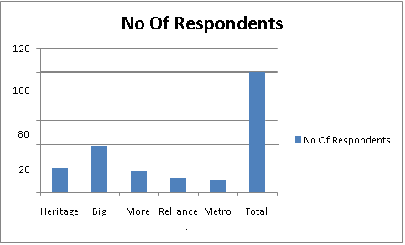

**Interpretation:**

From the table and graph shows 39% of the respondents are think Big Bazaar brand first in the industry 21% of the respondents are think HERITAGE brand first in the industry 18% of the respondents are think more brand first in the industry 18% of the respondents are think Reliance Fresh brand first in the industry 10% of the respondents are think Metro brand first in the industry

**Which Retails Do You Know**

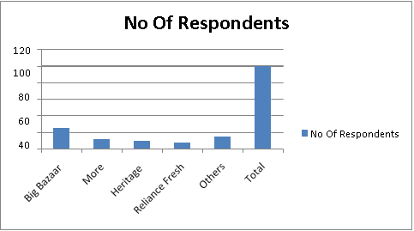

|  |  |
| --- | --- |
| **Options** | **No Of Respondents** |
| Big bazaar | 25 |
| More | 12 |
| HERITAGE | 10 |
| Reliance Fresh | 08 |
| Others | 15 |
| Total | 100 |

**Interpretation:**

From the table and graph shows ,5% of the people owned Big bazaar, 15% of the people owned Other, 12% of the people owned More, 10% of the people owned HERITAGE, 08% of the people owned Reliance Fresh.

**CONCLUSION OF THE STUDY:**

The research has brought to light various facts about customer perception on branding. The questionnaire that was contact customers to obtain their feedback had helped to understand customer needs and wants and their feedback is providing to maintain better customer relationship. • There is a need to improve service to customers for this purpose there is a need to open New service stations in twin cities. And provide best service. The Company should develop the promotional Strategies like Advertisement to capture more market.The company needs to develop the branding strategies in a publicity point of view, because public relations are more important than advertisement’s

**REFERENCES:**

* I M Pandey - Essentials of Financial Management, Vikas Publishing House Pvt Ltd, New Delhi, 1995.
* Jain, P K , Josette Peyrard and Surendra S Yadav - International Financial Management, Macmillan India Ltd, New Delhi, 1998.
* Khan, M Y and P K Jain - Financial Management, Tata McGraw-Hill Publishing Co., New Delhi, 2007.
* Prasanna Chandra - financial Management, Tata McGraw-Hill Publishing Co., New Delhi, 2007.
* Ramesh S and A Gupta - Venture Capital and the Indian Financial Sector, Oxford university press, New Delhi, 1995.
* Anthony R N and J S Reece - Management Accounting Principles, Treponemal, Bombay.