**Harnessing the Power of AIML in Agriculture – A Case Study of Cropin`s State-of-Art AIML Agri Tech Solutions**

Shrinidhi.N 1

*PhD Scholar,*

*Department of Engineering & Technology*

*Srinivas University,*

Mangaluru – 575001,

India,

ORCID: 0009-0000-7076-2658

[nidhin831@gmail.com](mailto:nidhin831@gmail.com)

*P. Sridhara Acharya 2*

*Associate Professor*

*Institute of Computer Science&Information Science,*

*Srinivas University*

*Mangaluru – 575001*

*India,*

*ORCID: 0000-0002-9996-0014*

[sridharaacharya@gmail.com](mailto:sridharaacharya@gmail.com)

***Abstract*—The core of the Indian economy and the factor that most affects the nation's socioeconomic progress is agriculture. India's agriculture industry is broad and diverse, with many different players involved. India boasts one of the world's biggest and most institutionally intricate agricultural research systems. After the green revolution, India's agricultural output increased dramatically. This was made possible by the use of fertilizers, high yielding varieties of seeds, increased irrigation capacity, innovative farming methods, and energy availability. The millions of small and marginal farmers who gave their physical and emotional labour to make this accomplishment possible deserve great recognition. The study of computer systems that are capable of carrying out tasks that have traditionally needed human intelligence is known as artificial intelligence (AI). It entails building intelligent machines that are able to reason, pick up new skills, solve issues, and make choices. One of the greatest methods to address the food scarcity and meet the needs of a growing population has long been thought to be through the application of AI in agriculture. An overview of AI's use in agronomic fields and its advancements in lab research with specific to Indian Agri Tech company, ‘Cropin’ is discussed in this paper.**

***Keywords***—***:* *Agriculture, Artificial Intelligence (AI), Agri Tech, Machine Learning, Cropin***

# Introduction

There will likely be 10 billion people on the earth by 2050, which will place enormous pressure on the agricultural sector to increase productivity and crop yields. There are two approaches that may be taken to deal with the approaching food shortages: either adopting large-scale farming and using more land, or adopting innovative techniques and taking advantage of technological advancements to increase productivity on existing farmland. The need for food is expanding many times faster than the population growth of India and other countries. A meta-analysis of projected global population and food demand indicates that between 2010 and 2050, there will be increases in food consumption of +0% to +20% and +35% to +56%, respectively. Keeping up with the world's population growth would need a large increase in agricultural productivity, yet doing so has risks because of weed and insect infestations, climate change, and other problems [1]. It also faces several challenges and uncertainties as a result of changes in market demand and production losses. Making educated decisions still requires greater technological integration, even with advances in the ability to predict calamities and climatic changes. Indian agriculture is primarily driven by local demand, and this trend may continue to pick up speed in the near future. The main cause of the agricultural diversity in cropping pattern is the commercialization of the farm market that followed economic reform. Increased domestic demand was mostly impacted by faster income growth, which in turn prompted a broad process of demand diversification.

# Agricultural Sector – Future Demands of India

Significant progress has been made in India's agricultural sector over the past 50 years, largely due to technological advancements, investments in irrigation and infrastructure and strategic policy frameworks. However, the nation's food needs will only rise due to the country's changing economic and environmental landscapes, as well as the country's population, which is predicted to reach over 1.6 billion by 2047. Therefore, in order to understand and project India's future agricultural needs, the Working Group on Crop Husbandry, Agriculture Inputs, Demand & Supply, led by Dr. Pratap Singh Birthal, Director of the National Institute of Agricultural Economics and Policy Research, New Delhi, and established by the National Institution for Transforming India (NITI) Aayog, has conducted a thorough analysis [2].

In order for India to catch up to wealthy countries by 2047, the country's economy must grow at a rate of roughly 8% each year. In addition to changing customer preferences and driving up demand for a wider variety of food products, this rapid expansion will severely strain the nation's meagre water and land resources. Changes in age, literacy, and labor force involvement are expected to trigger dietary trends, which will affect the dynamics of supply and demand for food commodities in the feed, fuel, pharmaceutical, and human consumption sectors.

The Working Group's recommendations place a strong emphasis on the necessity of strategic planning to mitigate the detrimental effects of diseases, pest infestations, and climate change on crop yields while balancing competing demands on agricultural resources. In order to achieve food security and sustainable growth, the evaluation emphasizes to immediately adopt policies and strategies that are responsive to the changing supply and demand landscape of the agricultural sector. The report of the Working Group makes a strong argument for India's ability to deal with the problems caused by a growing population, shifting dietary requirements, and limited natural resources. On the path to become a developed nation by 2047, the country needs to reform agricultural practices and regulations in addition to experiencing significant economic growth. Achieving this objective will depend critically on ensuring sustainable food production and distribution in the face of impending resource constraints and environmental issues [3].

# Future Demand Predictions of India

With its economy expanding at the current pace of 6.34% per year, India's food demand is projected to rise by roughly 2.44% per year until 2047–2048. If the economy expands more quickly, this gain could reach 3.07% yearly. Based on the baseline agricultural scenario (BAU), the country's food grain needs are projected to reach 402 million tons by 2047–2048. With stronger economic growth, this demand may rise to 415–437 million tons.

In particular, it is anticipated that the India would require more maize, pulses, and nutri-cereals than it does traditional mainstays like wheat and rice. Depending on the rates of economic growth, there could be a 49–57 million tons demand for pulses. Under the typical growth scenario, demand for vegetables is expected to reach 365 million tons, and demand for fruits to reach 233 million tons. If income growth is higher, these estimates might rise to 385–417 million tons for vegetables and 252-283 million tons for fruits.

The need for sugar and its products is expected to reach 44–45 million tons, while edible oils would require 31–33 million tons by 2047–2048. In a normal economic situation, milk demand is projected to be about 480 million tons; with stronger economic growth, this may potentially rise to 527–606 million tons. In a normal situation, demands for fish, meat, and eggs are expected to be 16, 21, and 37 million tons, respectively. In a greater growth scenario, these demands could rise even more.

Better crop yields will be required to drive large gains in food production because it is projected that the land used for crops will only grow by 0.45% year. It is anticipated that grain supply would surpass demand by 2047–2048, primarily for wheat and rice. But if yields and the cultivation area don't increase, nutri-cereal production might not be able to keep up with the growing demand. Another issue is the insufficient supply of edible oil to fulfil the existing demand, which could continue until there are significant increases in oilseed yield and the use of secondary sources [2]. Animal-based commodities like milk, eggs, and fish are produced in sufficient quantities to meet current demand, but they may face difficulties if economic growth results in higher consumption rates. In contrast, the supply of sugar exceeds demand.

# Normative Food Demand of India in Future

Population growth is expected to raise normative food demand, which is defined as the minimum amount of food required based on age, gender, and activity level. Although food is currently produced to meet these fundamental demands, actual consumption is insufficient and deficient in nutrients and balance. The difference between actual and normative food intake was 31% in 2011–12, but it narrowed to 22% in 2019–20. Actual and normative demands are predicted to converge by 2030–31, and by 2047–48, actual demand is forecast to surpass normative requirement by 20%. While the availability of fruits, vegetables, and pulses is predicted to reach or exceed the normative demand by 2047–2048, it may still be insufficient by 2030–2031 [3].

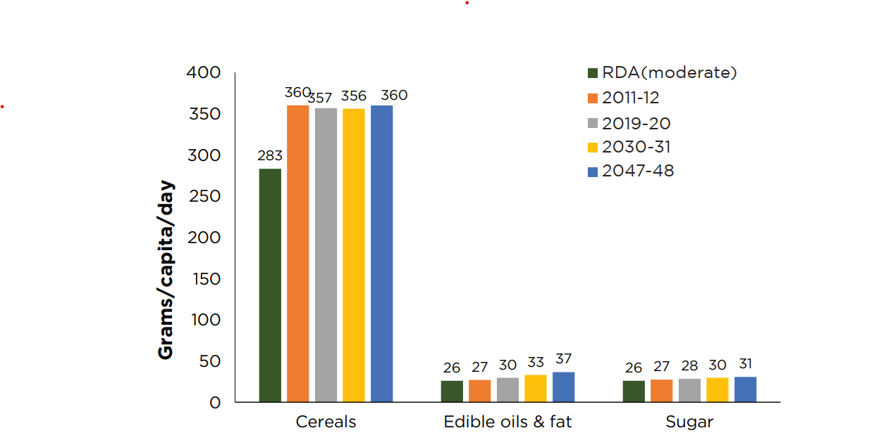

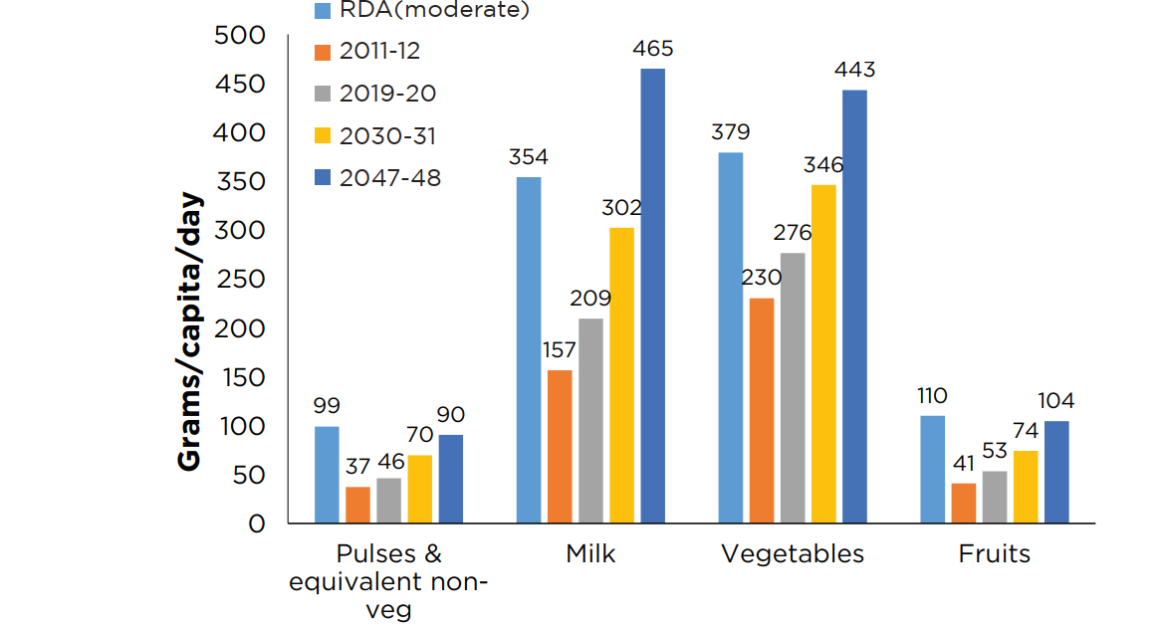

Fig 1. Comparison of projected per capita food consumption and normative requirement (moderate activity) at disaggregate level (Source: <https://www.niti.gov.in/> as on 01/06/2024)

At the commodity level, per capita consumption of sugar, edible oils, and cereals is predicted to exceed normative requirements in 2030–31; however, per capita consumption of fruits, vegetables, and pulses (and comparable non-vegetables) is expected to stay lower (Fig 1). However, by 2047–2048, it is expected that all food items will be consumed at or above their normative requirements.

# What is AI?

The field of computer science known as artificial intelligence (AI) studies the intelligence of machines. An intelligent agent is a system that makes decisions to increase its chances of success. Reasoning, knowledge, planning, learning, communication, perception, and the capacity to move and manipulate objects are among the fundamental ideas of artificial intelligence [4].

# Machine Learning

Machine Learning is an example of an artificial intelligence application where computers are naturally trained to learn from experience rather than having specific jobs explicitly coded into them. A subfield of machine learning known as "Deep Learning" does predictive analysis using artificial neural networks. Algorithms for machine learning include reinforcement learning, supervised learning, and unsupervised learning. The algorithm in unsupervised learning does not act on categorized data on its own without supervision. Using a set of input objects and the desired output, the training data in supervised learning is used to infer a function. Machines employ reinforcement learning to determine the best option that should be considered by taking appropriate activities to improve the reward [5].

# AI's advantages for agriculture

The terms artificial intelligence (AI) and agriculture may have appeared like an odd mix until recently. Agriculture has been the backbone of human society for millennia, providing both sustenance and promoting economic growth. AI is relatively a new field which is gaining momentum across all fields. All industries, are introducing novel concepts, and agriculture is no exception. Farming techniques have undergone a revolution due to the swift progress in agricultural technology in recent times [6]. The sustainability of our food system is being threatened by global issues like population increase, climate change, and resource scarcity, thus these technologies are becoming more and more important. Many issues are fixed and the drawbacks of conventional farming are diminished with the usage of AI. Fig 2. depicts the various applications of AI in agriculture.

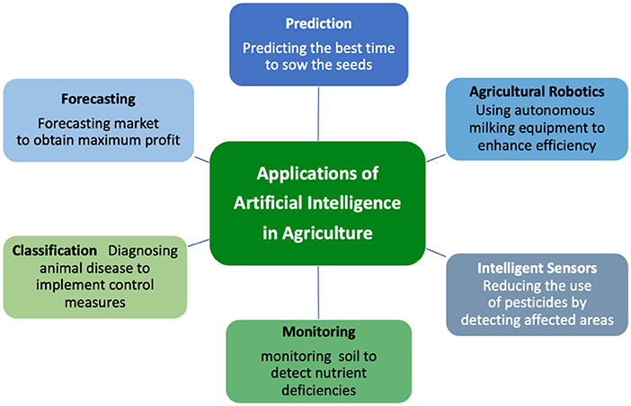

**Fig 2. Applications of Artificial Intelligence in Agriculture** (Source: https://www.frontiersin.org/)

# Decisions Based on Data

In the current world, data is everything. Companies in the agriculture sector use data to gain comprehensive insights into all facets of farming. From monitoring the entire product supply chain to understanding each acre of a field and delving deeply into the yield-generating process, data is crucial. AI-powered predictive analytics is already finding its way into the agricultural industry.AI allows farmers to collect and analyze more data faster [7]. In addition, artificial intelligence (AI) can estimate prices, analyze market demand, and determine the ideal times to sow and harvest. In agriculture, artificial intelligence can support soil health investigations to gather data, track meteorological conditions, and suggest fertilizer and pesticide applications. By using farm management software, farmers may increase production and profitability by making smarter decisions at every stage of crop development.

# Savings on Costs

Increasing farm yields is a constant goal for farmers. When paired with AI, precision farming can help farmers grow more crops using less resources. Artificial intelligence (AI) in farming combines variable rate technologies, effective data management strategies, and the finest soil management practices to maximize yields while minimizing costs. With the use of real-time agricultural insights obtained by using intelligence (AI), farmers may identify which areas need irrigation, fertilizer, or pesticide treatment. Vertical agriculture is one example of an innovative farming technique that can boost food output while using less resources. resulting in significant cost savings, improved harvest quality, decreased usage of pesticides, and increased earnings.

# Enhancing Irrigation Systems

AI systems make autonomous crop management possible. In real-time, computers can determine how much water to provide crops based on weather and soil moisture levels when paired with Internet of Things (IoT) sensors [8]. Water conservation and sustainable farming practices are the two main goals of an autonomous crop irrigation system. By automatically altering temperature, humidity, and light levels based on real-time data, artificial intelligence (AI) in smart greenhouses maximizes plant development. Artificial Intelligence is essential for identifying irrigation system leaks. Algorithms can detect trends and abnormalities in data that point to possible leaks. It is possible to train machine learning (ML) models to identify particular leak signs, including variations in water pressure or flow. Early detection is made possible by real-time monitoring and analysis, which helps to avoid both possible crop damage and water waste. In order to detect regions with high water usage, AI also integrates weather data with crop water requirements. Artificial intelligence (AI) improves water efficiency, assisting farmers in resource conservation by automating leak detection and sending out alarms.

# Crop and Soil Monitoring

The health and growth of crops can be significantly impacted by the incorrect combination of nutrients in the soil. With AI, farmers can readily identify these nutrients and determine how they affect crop productivity, allowing for required adjustments to be made [9]. While the accuracy of human observation is restricted, computer vision models can monitor soil conditions and collect precise data that is required to fight crop diseases. After that, crop health and yield predictions are made using this data. Through sensors that identify their growing conditions, plants activate AI algorithms that then automatically modify their surroundings.

# Plant Disease Detection using AI

In addition to measuring crop growth and soil quality, computer vision can identify pests and illnesses [10]. This operates by scanning photos for mold, rot, insects, or other hazards to crop health utilizing artificial intelligence (AI) in agricultural applications. When used along with alarm systems, this enables farmers to take prompt action to eradicate pests or isolate crops to stop the spread of illness. AI is accurate in identifying other insects, such as flies, bees, moths, etc.

# Pesticide Application using AI

Farmers are fully aware by now that there is opportunity to optimize the use of pesticides. Unfortunately, there are significant limitations to both automated and manual application processes. While manually applying pesticides can be labour-intensive and time-consuming, it allows for more precision when focusing on particular areas. Although automated pesticide spraying is faster and requires less labour, it frequently lacks accuracy, which can contaminate the environment. Drones driven by AI combine the finest features of each strategy without any of its disadvantages. Drones that utilize computer vision can calculate how much insecticide should be sprayed on each region. Even though this technology is still in its infancy, it is advancing quickly in precision.

# Crop Yield Prediction

Yield mapping analyses big datasets instantly using machine learning methods. Better planning is made possible for farmers as a result of their increased understanding of the patterns and traits of their crops. Farmers may forecast soil yields for certain crops by combining methods such as 3D mapping with information from sensors and drones. Multiple drone flights provide data collection, allowing for ever-more-accurate analysis through the use of algorithms [11]. With the aid of these techniques, farmers are able to accurately forecast future yields for certain crops, assisting them in seeding locations and timing as well as resource allocation for optimal return on investment [12].

# AgriTech Companies in India

With the rise in tech penetration in one of the world's largest agricultural sectors, Indian agritech companies are sitting on multibillion-dollar potential. In fact, an analysis estimates that by 2025, India's agritech entrepreneurs may potentially become a $24 billion industry. Additionally, investors from India and other countries are aware of this potential, as these businesses have raised more than $2.4 billion since 2014, according to Inc42's data [13]. A ‘fourth agricultural revolution’ that might completely alter the world food chain is about to begin in India. Agritech entrepreneurs have disrupted established practices with their creative solutions and Indian agriculture has seen a dramatic transformation in recent years. Currently, a number of agritech businesses in India are using technology to improve the sustainability and efficiency of farming. These businesses provide innovative goods and services, including drones, precision farming, farm management software, crop monitoring systems, and e-commerce platforms, to assist farmers better manage their crops, maximize yields, decrease waste, and increase profitability [14]. The top 8 Indian agritech firms that are advancing innovation and revolutionizing farming in the nation are listed below.

1. *AgroStar*

AgroStar was founded in 2013 by Shardul and Sitanshu Sheth and provides farmers with interactive voice response (IVR)-based agricultural solutions through an app. Farmers may interact with other farmers, read and watch agronomy information, share photographs of crop problems to obtain help, and utilize voice search to identify agriproducts and transact on the site through the startup's mobile application. The platform is multilingual and content-led.   
Across Gujarat, Rajasthan, Maharashtra, Madhya Pradesh, and Uttar Pradesh, it serves more than 5 million farmers and bills itself as India's largest digital farmer network and agri-inputs platform.

1. *DeHaat:*

An Indian agritech business called DeHaat runs an online marketplace where farmers may purchase agricultural products. DeHaat is a digital platform that provides a variety of services, such as access to high-quality agri-inputs, advisory services, market connections, and financial products, with the goal of empowering farmers. It was founded in 2012 by Shashank and Manish Kumar. It links farmers with a buyer's, crop advisors', and supplier's network. In addition to offering access to agricultural supplies including seeds, fertilizer, and pesticides, it offers customized crop consultancy services. In addition, the platform provides insurance policies, financing, and market linking services specifically designed for farmers. With a mission to increase agriculture's productivity, sustainability, and profitability through technology and data-driven solutions, DeHaat serves millions of farmers in several Indian states.

1. *CropIn*

Krishna Kumar and Kunal Prasad launched CropIn in 2010, and the company is based in Bangalore, India. To develop solutions for successful and sustainable farming, the company has partnered with a range of players in the agriculture value chain, including governments, food companies, agribusinesses, and farmers. Ankur Capital, Invested Development, Chiratae Ventures, and other investors have contributed money to CropIn. An agritech company called CropIn offers farmers a digital platform for managing their farms so they can maximize crop yield and make informed decisions based on data. The platform provides actionable insights for enhancing yields and agricultural operations through the use of AI, ML, and data analytics.

Crop monitoring, weather forecasting, pest and disease management, farm analytics, and traceability solutions are all available on the CropIn platform. Farmers have access to data-driven crop advisories, real-time weather and pest alerts, and remote crop monitoring. In order to verify that food safety regulations are being followed, the platform also makes it possible to track and trace produce.

1. *Ninjacart*

Thirukumaran Nagarajan, Kartheeswaran K.K., Ashutosh Vikram, Sharath Loganathan, and Vasudevan Chinnathambi developed Ninjacart in 2015. Since then, Bangalore, Chennai, Hyderabad, Delhi, Mumbai, Pune, and other Indian cities have seen the expansion of Ninjacart's activities. The goal of Indian agritech firm Ninjacart is to address supply chain inefficiencies in the agriculture industry. They have created a technologically advanced network that links farmers and retailers directly, cutting out middlemen and guaranteeing that fresh product is sold at affordable costs.

1. *FarmTheory*

Farmtheory is an innovative agri-waste management firm founded in 2019 by Arpit and Sakshi Agarwal. Its mission is to reduce waste at its source, enabling farmers to increase their income, reduce food loss, and fight climate change. Farmtheory has served more than 1,500 eateries and over 3,000 partner farmers to date, all while focusing on increasing farm yields and providing superior foods to commercial kitchens. In the future, the company wants to serve more farming communities across the country by expanding both its partner network and geographical reach, thereby sharing the advantages of its innovative approach.

1. *Fasal*

Shailendra Tiwari and Ananda Verma founded Fasal in 2018; it functions as a precision horticultural platform. It makes it easier to optimize resources (pesticides, water, etc.) and increases agricultural productivity while guaranteeing the purchase of traceable, premium produce. To deliver intelligence at the farm, crop, and crop stage levels, the agritech startup orchestrates an end-to-end optimized value chain using AI, crop sciences, and IoT.

# Overview of CropIn

Cropin is a global intelligence supplier on agriculture ecosystems. Cropin provides a wide range of Agri Tech enabled solutions. Cropin builds a smart, networked data platform by utilizing cutting-edge technologies including artificial intelligence, machine learning, and remote sensing. With Cropin, businesses can digitize their processes from farm to fork and use near real-time farm data and actionable insights to inform strategic decision-making. In addition to improving the lives of almost 7 million farmers and digitizing over 16 million acres of farmland, Cropin has teamed with more than 250 organizations worldwide to develop intelligence for more than 500 crops and 10,000 crop varieties in more than 103 countries.

# CropIn`s History

Fig 3, shows the timeline of Cropin`s history and key milestones of the company [15].

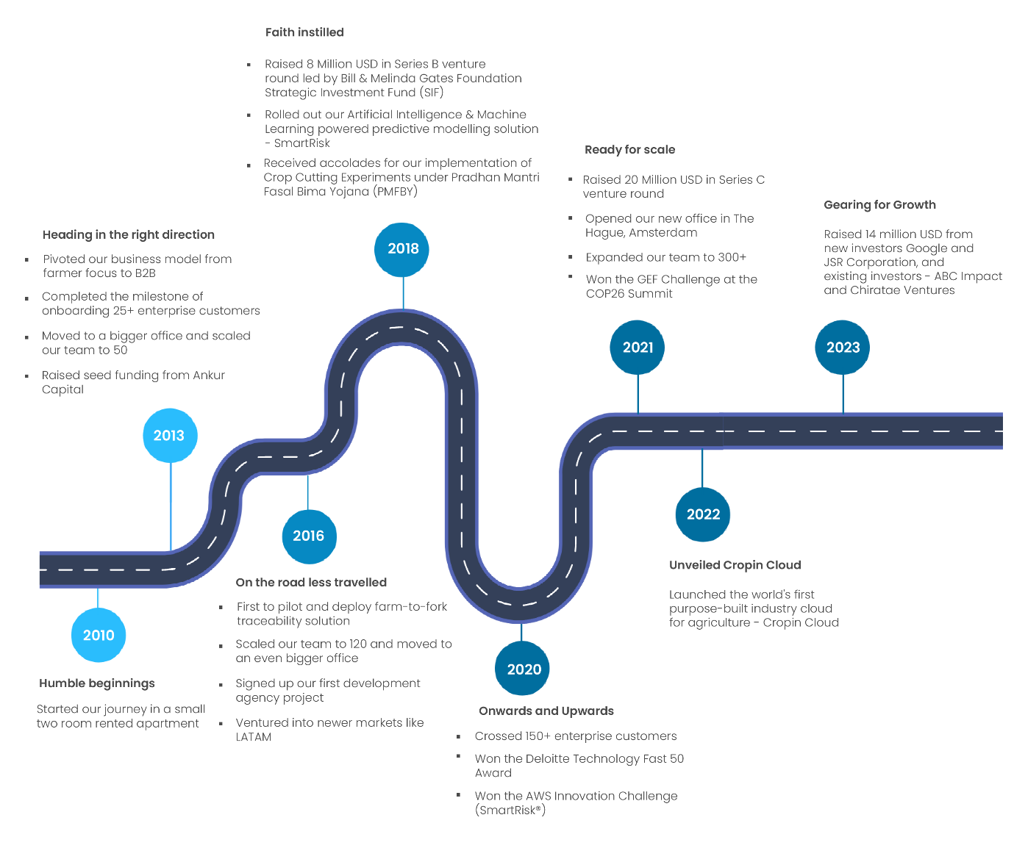

Fig 3. Cropin`s history. (Source: [www.cropin.com](http://www.cropin.com))

# Cropin`s Agritech Solutions

This section discusses the agritech solutions provided by Cropin.

1. *Cropin Cloud – Cropin Grow (Smart Farm)*

It is farm digitization and business intelligence solution. An extensive platform for highly customizable agricultural management that promotes sustainability, predictability, and efficiency. An entire suite of farm ERP and CRM. This digital cultivation procedure can reduce errors and save time. Make data-driven decisions to increase the profitability and production of farm. Integrate additional programs and data sources to increase productivity and improve decision-making.

1. *Cropin Cloud – Cropin Connect (Acre Square)*

It is an easy-to-use and deploy farmer engagement solution.

Key Features of Cropin Connect -

* Enhanced remote farm monitoring and plotting capabilities
* Streamlined task details, operational dashboards, and remote progress tracking
* Personalized forms for data collection and streamlined farmer engagement
* Intelligent farming agri-input and market services advisory to farmers
* Enhanced user experience with a simple interface supporting multiple languages

1. *Cropin Cloud – Cropin Trace (Root Trace)*

It is a QR code-enabled farm-to-fork traceability solution.

Key features of Cropin Trace are –

* End-to-end supply chain traceability
* Monitoring and managing downstream using the Cropin Trace (RootTrace) App
* Patent-protected QR-code labelling
* Customizable, weatherproof, and tamper-proof labels
* Scanning QR-codes only with CropIn's app to prevent counterfeiting
* Sharing advice and a package of practices to standardize cultivation practices.

1. *Cropin DataHub*

For both structured and unstructured agri-data sources, Cropin DataHub facilitates simple management and access to incoming data pipelines—both raw and processed. In order to address this, Cropin Data Hub structures agri-data using an agri-object model, allowing it to interface with all agri-data sources, including weather advisory sources, IoT devices and drones, in-field farm management apps, and mechanization data from farming equipment. It can save up to 80% of the data engineering work required by businesses and organizations that must set up similar data linkages for intelligent insights on their own. Furthermore, the Cropin Data Hub offers pre-configured advanced data frameworks designed to tackle the most common and enduringly challenging problems in agricultural remote monitoring. These remote monitoring include segmenting land usage, detecting farm plot boundaries, and cloud-free satellite imagery.It makes it possible to combine remote field, agronomy, and enterprise data with Cropin's Crop Intelligence models and datasets to uncover important business insights.

1. *Cropin Intelligence*

Crop & plot-level predictive intelligence powered by field-tested AI/ML models.

Key features of Cropin Intelligence –

* A hyper-tuned model built for different regions, crops, and varieties
* Accurate estimation of a plot's yield per hectare and the plot's expected production range
* Insights obtained across the different crop phases using meteorological data and remote sensing models
* Prompt intelligence at least 30 days prior to the anticipated harvest and as soon as the crop achieves maturity

# Cropin`s collaborative innovation with AWS

A Memorandum of Understanding (MoU) has been signed by Cropin Technology, a global leader in Agritech that enables intelligent agriculture, and Amazon Web Services (AWS) India. The purpose of the MoU is to enable Cropin to develop a solution to address the problem of global hunger and food insecurity. Through the development of core data architecture, analytics, modeling, and simulation components, this program seeks to assist Cropin in creating a single solution that can combine global farmland data with more comprehensive climatic knowledge. According to a statement issued by Cropin, the solution will help governments, organizations, and agribusinesses. This can guarantee food security for vulnerable populations by providing decision information [16].

Cropin would create workloads as part of this endeavour that might ultimately make up an AWS-powered Food Security Decision Intelligence solution. The solution would make use of AWS's state-of-the-art computing capabilities, including generative artificial intelligence (GAI), robots, Internet of Things (IoT), High-Performance Computing (HPC), modeling and simulation, and visual and spatial computing. Additionally, it would combine Cropin's deep domain expertise in data science, AI/ML, deep learning models, earth observation sciences, and agriculture to provide precise and detailed crop yield intelligence for the most important food crops globally, beginning with rice, wheat, potatoes, and maize, which together provide for more than half of the world's food needs.

The Cropin claims that by combining remote data, in-situ field photos, and satellite imaging, the AI-powered solution will enhance agricultural analytics by using scalable models. These models will be further examined by spotting trends and abnormalities in the output and quality of important crops in several worldwide locations. They will also offer both micro (plot) and macro (regional/global) insights. To power Cropin's platform, AWS will investigate supplying technical know-how on its advanced compute services (HPC, ML/Gen AI, IoT, GIS), together with industry knowledge from it`s agriculture and sustainability specialists. Cropin's open-source dashboard will incorporate the information obtained from the workloads. They can be shared with stakeholders, such as farmers, field officers, governments, development organizations, and agribusinesses, through WhatsApp or an SMS-based alerting system.

# SWOC Analysis

Individual traits, organizational effectiveness, and strategies within a particular environment are analyzed using a variety of approaches, such as SWOT, SWOC, PEST, McKinsey 7S framework, ICDT model, Portor's five force model, etc [17] [18], [19]. These models and approaches offer a quick and organized method of determining different elements and problems impacting people or organizational systems and present a chance for additional development [20], [21], [22]. The most well-known method for auditing and analyzing a company's overall strategic position in relation to its surroundings is SWOC analysis [23], [24]. Its main goal is to pinpoint the tactics that, when combined, will provide a business model, unique to the company that best matches its assets and competencies to the demands of the industry in which it works [25] [26]. The SWOC serves as the basis for assessing the potential and constraints within the organization as well as the opportunities and dangers that arise from the external environment [27], [28], [29]. It considers every aspect, both internal and external to the company, that influences success. Regularly monitoring the environment in which the business operates aids in anticipating and predicting shifting trends as well as incorporating them into the organization's decision-making process.

The words Strengths, Weaknesses, Opportunities, and Challenges are shortened to SWOC. It is generally accepted that we have some degree of influence over internal factors, which includes strengths (S) and weaknesses (W). Additionally, opportunities (O) and challenges (C) are by definition seen as outside variables over which the business has little to no control. The most well-known method for auditing and analyzing a company's entire strategic position and its surroundings is SWOC analysis.

# SWOC Analysis of Cropin

Below is the SWOC analysis of Cropin:

**Strengths**

* Highly technology driven and bridges the gap between technology and agriculture
* Use of state of art AIML technologies
* Easy to use cloud products and a leading platform in the digital transformation of agriculture.
* Predictive intelligence has already been made available for more than 200 million acres of farmland globally through Cropin Cloud's intelligence platform.
* Complete suite of predictive analytics related to agriculture
* Cropin has secured $14M (INR 113 crores) in funding from new investors Google and JSR Corporation, as well as existing investors ABC Impact and Chiratae Ventures in 2023.
* Over 7 million farmers have benefited from Cropin's digitization of 16 million acres of farmland through partnerships with more than 250 B2B clients.
* Using a crop knowledge network that encompasses over 500 crops and 10,000 crop types across 92 nations, the company has influenced the worldwide 'Ag-intelligence' movement and powers Cropin Cloud.
* User friendly support team
* Quest for innovation, passion for solving critical global agricultural challenges

**Weakness**

* Usual concerns of data security by the users
* Initial upfront cost for farmers to subscribe for services
* The digital divide, high rates of illiteracy, and language barriers among farmers
* Lack of subsidy to migrate to new technology
* Lack of presence in key global markets

**Opportunities**

* Creation of technologies for precision agriculture to maximize resource use
* Potential for worldwide growth
* Creation of Climate-Resilient Agriculture Methods
* Technology-enabled organic agricultural methods to preserve soil
* Improve the production by educating the farmers
* Boost the economy related to agriculture

**Challenges**

* Lack of technological access to smallholder farmers
* Adoption of technology is impeded by ignorance
* Inadequate policy regulation concerning AIML
* Policy or guideline changes depending on the nation

# Findings

With its highly flexible and customized applications at the base of its platform layers, Cropin Cloud aims to assist in digitizing every facet of the agriculture business. One of the apps in the suite is Cropin Grow, a farm management and digitization solution that enables effective and climate-resilient agriculture, geotagging of farms, digitalization of farmer records, monitoring of crop growth and health, and sharing of advice. In order to empower farmers with knowledge and information, Cropin Connect offers a seamless engagement and enablement system that links farmers, agribusinesses, and field officers. A straightforward farm-to-fork food traceability solution called Cropin Trace aids agribusinesses in getting rid of counterfeit goods and guaranteeing quality requirements. The foundation of Cropin's solutions is the knowledge that every crop is cultivated and cared for differently. They are able to comprehend any crop in the globe because of their globally validated crop-specific and location-neutral solutions. Regardless of the geography, their transfer learning-based crop detection models guarantee that important contextual details are generated more quickly.

# Conclusion

Through the digitization of farm operations from farm to fork, Cropin is assisting enterprises in utilizing data and insights that are usable almost instantly. This helps companies comply with (and be open about) the standards, certifications, and legal requirements that customers want to see, in addition to helping them make more effective judgments. In order to prepare reports for certification programs like FairTrade or GLOBALG.A.P., authorized users may access the geolocation of the farms. Data regarding the agricultural labor force, workplace safety and employee welfare processes can be accessed easily. This results in a significant reduction of the time and effort required to achieve compliance standards. Using Cropin's AI/ML powered solutions, governments, non-governmental organizations, farmers, and other key stakeholders may map past land usage using satellite imaging data. Cropin's AIML solutions can help expedite the adoption of Climate-Smart Agriculture (CSA), a strategy that focuses efforts to shift agri-food systems toward ecologically friendly and climate resilient methods. In conclusion, despite a changing environment and a rising number of global difficulties, Cropin is determined in its dedication to empowering farmers, advancing sustainability, and guaranteeing food security. To satisfy the increasing demands, Cropin is redefining the agri-food system through innovation, collaborations, and digitalization. They have the capability to build a connected, transparent, and sustainable future for all parties involved in the agricultural value chain by utilizing technology and knowledge-sharing.

**References**

[1] P. Yadav, “Future of Indian Agriculture: Prospects and Challenges,” in *Agricultural Situation in India*, 1st ed., The Controller of Publications, Ministry of Urban Development, 2014, pp. 5–51. [Online]. Available: https://www.researchgate.net/publication/319204294_Agricultural_Situation_in_India

[2] P. S. Birthal, “Working Group Report on Crop Husbandry, Agriculture Inpute, Demand & Supply,” NITI Aayog, Delhi, Jan. 2024. Accessed: Apr. 20, 2024. [Online]. Available: https://www.niti.gov.in/sites/default/files/2024-02/Working%20Group%20Report%20on%20Demand%20%26%20Supply%20Final_V9.pdf

[3] D. Pareek, “Unlocking the Future of Indian Agriculture: What Will 2047 Look Like?” Accessed: Apr. 30, 2024. [Online]. Available: https://www.linkedin.com/pulse/unlocking-future-indian-agriculture-what-2047-look-like-deepak-pareek-o13wf

[4] N. Saini, “RESEARCH PAPER ON ARTIFICIAL INTELLIGENCE & ITS APPLICATIONS,” *IJRT*, vol. 8, no. 4, 2023, [Online]. Available: https://www.ijrti.org/papers/IJRTI2304061.pdf

[5] K. Alamuthu and S. Kumar T, “Leveraging Machine Learning Technology in Agriculture to Accomplish Viksit Bharat Goal,” *Int. J. Educ. Sci. Res. Rev.*, vol. 11, no. 1, pp. 19–24, Jan. 2024.

[6] N. Sinha *et al.*, “Application of Artifical Intelligence (AI) in Agriculture An Indian Perspective,” *Harit Dhara*, vol. 5, no. 2, pp. 9–11, Mar. 2023.

[7] A. Pujitha, B. Anusha, and A. Prusty, “Artificial Intelligence in Agriculture: A Review,” in *Emerging Trends in Agricultural Extension Education*, 1st ed., S P Publishing, 2023, pp. 76–81.

[8] S. Kumari H and V. K T, “Revolutionizing Agriculture: A Case Study of IBM’s AI Innovations,” *Int. J. Appl. Eng. Manag. Lett.*, vol. 7, no. 4, pp. 95–114, Oct. 2023, doi: https://doi.org/10.5281/zenodo.10070895.

[9] S. Apat, J. Mishra, S. Raju, and Dr. N. Padhy, “IoT-Assisted Crop Monitoring Using Machine Learning Algorithms for Smart Farming,” in *IoT-Assisted Crop Monitoring Using Machine Learning Algorithms for Smart Farming*, 2022, pp. 1–11. doi: 10.1007/978-981-19-1412-6_1.

[10] S. Ramesh *et al.*, “Plant Disease Detection Using Machine Learning | IEEE Conference Publication | IEEE Xplore,” *IEEE Explore*, Apr. 2018, doi: 10.1109/ICDI3C.2018.00017.

[11] T. van Klompenburg, A. Kassahun, and C. Catal, “Crop yield prediction using machine learning: A systematic literature review,” *Comput. Electron. Agric.*, vol. 177, p. 105709, Oct. 2020, doi: 10.1016/j.compag.2020.105709.

[12] A. J., Wang and A. S V, “An interaction regression model for crop yield prediction | Scientific Reports,” *Sci Rep*, vol. 11, no. 17754, Aug. 2024, doi: https://doi.org/10.1038/s41598-021-97221-7.

[13] I. Datalabs, “Inc42 Datalabs,” Inc42 Media. Accessed: Apr. 30, 2024. [Online]. Available: https://inc42.com/datalabs/

[14] N. Raju, “Top 8 Agritech Companies in India Making Farming More Efficient,” CXOToday.com. Accessed: Apr. 30, 2024. [Online]. Available: https://cxotoday.com/digital-drives/top-7-agritech-companies-in-india-making-farming-more-efficient/

[15] C. Cropin, “CROPIN - EMPOWERING ECONOMIES OF THE AGRI-ECOSYSTEM.” Accessed: Apr. 30, 2024. [Online]. Available: https://www.cropin.com/about

[16] T. H. Bureau, “Cropin in pact with AWS to build a solution to address global hunger, food insecurity,” *The Hindu*, Bengaluru, Mar. 20, 2024. Accessed: Apr. 30, 2024. [Online]. Available: https://www.thehindu.com/business/cropin-in-pact-with-aws-to-build-a-solution-to-address-global-hunger-food-insecurity/article67972209.ece

[17] A. P S and P. M. S. Kumar, “Applying Swoc Analysis To An Institution Of Higher Education,” *Int. J. Manag. IT Eng. ISSN 2249-0558*, vol. 5, no. 7, pp. 231–247, Jul. 2015, doi: 10.5281/zenodo.163425.

[18] K. Salah, “A SWOT analysis of TSV: Strengths, weaknesses, opportunities, and threats,” in *2015 27th International Conference on Microelectronics (ICM)*, Dec. 2015, pp. 214–217. doi: 10.1109/ICM.2015.7438026.

[19] Ž. Dobrović and M. T. Furjan, “SWOT Analysis in the Strategic Planning Process - Meta-modelling Approach,” in *2020 IEEE 10th International Conference on Intelligent Systems (IS)*, Aug. 2020, pp. 574–579. doi: 10.1109/IS48319.2020.9199983.

[20] B. Phadermrod, R. M. Crowder, and G. B. Wills, “Developing SWOT Analysis from Customer Satisfaction Surveys,” in *2014 IEEE 11th International Conference on e-Business Engineering*, Nov. 2014, pp. 97–104. doi: 10.1109/ICEBE.2014.27.

[21] Y. Xu, “SWOT Analysis of E-commerce Websites – Based on Dangdang.com,” in *2013 International Conference on Computational and Information Sciences*, Jun. 2013, pp. 2015–2017. doi: 10.1109/ICCIS.2013.533.

[22] P. Petríček, R. Klír, and P. Kal’avský, “Swot Analysis And Its Application In Solving Research Tasks,” in *2020 New Trends in Aviation Development (NTAD)*, Sep. 2020, pp. 197–201. doi: 10.1109/NTAD51447.2020.9379082.

[23] Bharathi and P. Mahale, “A Study on Marketing Strategies, SWOC Analysis and CSR Activities of HCP Wellness Private Ltd,” *Int. J. Case Stud. Bus. IT Educ.*, vol. 7, no. 3, pp. 162–174, Jul. 2023, doi: 10.47992/IJCSBE.2581.6942.0293.

[24] R. Mahida and S. Chauhan, “A STUDY ON PRESIDENCY OF THE G20 IN INDIA: SWOC ANALYSIS,” *VIDYA - J. GUJARAT Univ.*, vol. 2, no. 2, Art. no. 2, Aug. 2023, doi: 10.47413/vidya.v2i2.188.

[25] V. S. Naik and R. Shinde, “SWOC ANALYSIS ON INDIAN HIGHER EDUCATION SYSTEM,” *Int. Res. J. Mod. Eng. Technol. Sci.*, vol. 3, no. 11, Nov. 2021, [Online]. Available: https://www.irjmets.com/uploadedfiles/paper/volume_3/issue_11_november_2021/17249/final/fin_irjmets1638863633.pdf

[26] A. Granulo and A. Tanović, “The advantage of using SWOT analysis for companies with implemented ITIL framework processes,” in *2020 43rd International Convention on Information, Communication and Electronic Technology (MIPRO)*, Sep. 2020, pp. 1656–1661. doi: 10.23919/MIPRO48935.2020.9245393.

[27] C. Namugenyi, S. L. Nimmagadda, and T. Reiners, “Design of a SWOT Analysis Model and its Evaluation in Diverse Digital Business Ecosystem Contexts,” *Procedia Comput. Sci.*, vol. 159, pp. 1145–1154, Jan. 2019, doi: 10.1016/j.procs.2019.09.283.

[28] H. Tran *et al.*, “A SWOT Analysis of Human- and Machine Learning-based Embryo Assessment,” *IEEE Access*, vol. 8, pp. 1–1, Dec. 2020, doi: 10.1109/ACCESS.2020.3045772.

[29] M. Ziyi, “SWOT Analysis of the Business Model of Short Video Platform: Take Tik Tok as an Example,” in *2020 Management Science Informatization and Economic Innovation Development Conference (MSIEID)*, Dec. 2020, pp. 38–42. doi: 10.1109/MSIEID52046.2020.00015.sss