**Study on the Impact of Artificial intelligence on Higher education**

**Aanchal Kushwaha,**

[aanchalkush80@gmail.com](mailto:aanchalkush80@gmail.com),

**Pramod Singh**

[pramodsinghbvv@gmail.com](mailto:pramodsinghbvv@gmail.com)

**Akhilesh A. Waoo**

[akhileshwaoo@gmail.com](mailto:akhileshwaoo@gmail.com)

**AKS University, Satna (M.P.)**

**Abstract**

**Artificial Intelligence is revolutionizing various industries, and higher education is no exception. This paper explores the integration of AI technology in higher education settings, focusing on its impact on learning outcomes, administration efficiency, and accessibility. Through a comprehensive review of current literature, this paper highlights the potential benefits and challenges of AI implementation in higher education and offers insights into future directions for maximizing its potential. Examining the educational impact of technology is increasingly evident in how students learn and how institutions teach and change. In a world where artificial intelligence is part of the fabric of our universities, the development of modern technology and the increasing pace of the use of new technologies in higher education are trying to determine the future of higher education**.

**Keyword**s - **Artificial intelligence, Higher education, Impact of Teaching and learning,**

**Impact of Assessment and Classification.**

1. **Introduction**

Artificial intelligence (AI) represents a dynamic realm of research dedicated to replicating human-like cognitive abilities in software or machines [1]. As defined by Russell and Norwig, AI encompasses machines emulating cognitive functions typically associated with human intelligence, such as learning and problem-solving [6]. Technological advances have dramatically changed the world of education by equipping students with new skills and creating a collaborative environment with significant implications for the future of higher education. Regardless of the owner, the university's curriculum strives to follow the latest trends in education, meet the demands of the job market, and adapt to technological advances. Therefore, higher education in Serbia is gradually developing for the benefit of students, academics, and society to create a stable environment for knowledge and development [2].

The COVID-19 pandemic has presented a multitude of hurdles for students, including diminished educational quality and struggles with virtual learning environments [10]

In 1950, Alan Turing proposed an answer to the question of when a human-designed system would be 'intelligent'. 'Turing proposed a simulation game that tested a human's ability to discern a conversation with a machine or another person; If this difference is not noticed, We may think we have an intelligent system or artificial intelligence. In 1956, John McCarthy made one of the first and most powerful definitions: "Research [in artificial intelligence] must begin from the assumption that all learning, or any intellectual activity, can be fully explained by how a machine can copy." Since 1956, we have experienced various AI concepts influenced by chemistry, biology, linguistics, mathematics, and the development of AI solutions [3].

**1.1 Artificial Intelligence**

Artificial intelligence (AI) is an important branch of computer science to develops intelligent computers that can perform tasks that normally require human intelligence. Alexa, self-driving cars, robot advisors, talking bots, and email spam filters are examples. Artificial Intelligence (AI) focuses on developing systems that mimic human intelligence, performing tasks like learning and problem-solving. It includes specialized narrow AI and theoretical general and super intelligent AI. Key technologies include machine learning, deep learning, NLP, and robotics, significantly improving efficiency across various sectors. The interdisciplinary interest of scholars from linguistics, psychology, education, and neuroscience who connect AI to nomenclature, perceptions, and knowledge in their disciplines could create a challenge when defining AI [4]. This paper focuses on the category of AI in Education and how AI is specifically used in higher educational contexts.

**1,2 AI in Education**

Research on AI is based on the assumption that any learning process or other intellectual activity can be described in such a way that a machine can imitate it. Efforts will be made to create machines that use speech, to create abstractions and concepts, to find ways to solve the problems that people face today, and to improve themselves. Baker and Smith (2019) provide a detailed definition of artificial intelligence: “Computers perform cognitive tasks normally associated with human intelligence, especially learning and problem-solving" [6].

1. **Literature of Review**

The literature review examines the effects of artificial intelligence (AI) on higher education. This shows the potential benefits of integrating AI improving the quality of education and introducing a new teaching method.

* 1. **AI impact on the learning and teaching process**

Embedding artificial intelligence in education and higher education is being maintained and tested. Artificial intelligence people believe in promoting education and innovation teaching and learning methods and more [15]. They researched the role of the intellectual mind in vision students at risk of preventive placement measures taken to improve learning processes standing [7].

* 1. **AI Impact on Assessment and Classification**

Artificial intelligence (AI) has a profound impact not only on learning and teaching but also on assessment and grading systems. For instance, AI-powered tools like Turnitin swiftly check assignments and research projects against vast databases, making it effortless to detect instances of plagiarism. Additionally, in online settings, AI automatically evaluates assignments and incorporates them into final grades without any manual intervention. Furthermore, AI facilitates the provision of constructive feedback to students, accessible anytime and anywhere with a unique password. Teachers can also utilize AI to capture and record ideas, enriching the learning experience and addressing errors effectively [11].

* 1. **Impact of AI in education**

An overview of ways artificial intelligence is being applied in education, with an emphasis on administrative tasks, instructions, and learning, only part of the answer shown research questions. Education offers the opportunity to be more flexible in different aspects of education. Artificial Intelligence section shows the impact of artificial intelligence on education. This study focused partly on the actual effects of AIs in demand for leadership, instruction, and learning and interpreted based on the findings of the article [13].

* + 1. **Education Administrative**

The application of artificial intelligence in education in different ways and the performance of different tasks has made a significant contribution to the effectiveness of management and governance in education. Allowed teachers or professors to work Effectively performing administrative duties such as evaluating students and providing feedback. AIWBEs program includes teacher training tasks with its scoring guide, making it easier for students to score.' and comment [8].

* + 1. **Instruction**

Analysis of different articles has revealed the rapid adoption and use of artificial intelligence in various methods for educational or training purposes by teachers. Utilizing artificial intelligence as a teaching tool has significantly impacted education. The enhanced functionality and performance of teachers' work have been recognized through various publications. Quality, in this context, is measured by the delivery of program-related content and the adaptation to the evolving needs and unique skills of students over time. Student performance is evaluated in terms of knowledge retention and academic achievement. Considering that productivity, quality, and efficiency are central to the definition of success, research results demonstrate that artificial intelligence contributes to achieving excellence and success in both learning and teaching endeavors [7]. Discuss in advance the sent by Pokrivcakova also shows that artificial intelligence is developing the quality of education and practice because the contemporary system is a system based on climate change technology means the material or content provided is determined issued by students in need and effective learning was achieved experiences [14].

**2.3.3 Learning**

Another domain of education under scrutiny in this study pertains to the utilization of artificial intelligence, particularly in enhancing the student experience. Russ et al. encapsulate the impact of artificial intelligence on learning, emphasizing how Intelligent Tutoring Systems (ITS) facilitate deep learning by incorporating interactive agents within the system. These agents evaluate students and assign them tasks tailored to their proficiency levels, providing detailed explanations to aid in improvement, and storing pertinent data [9].

* 1. **AI impact on the future career of guidance**

Artificial intelligence (AI) is not only revolutionizing the field of education but also extending its influence into various domains, including post-graduation scenarios. Suggests that AI's impact on the future labor market will be profound, potentially reshaping the required skill set. AI can replace routine tasks that necessitate standard functionalities, leaving more complex interventions to be managed by human professionals [12].

**3. Method**

This research paper adopts objectivism as its philosophical framework, grounding its findings in perceptions, feelings, and experiences. I have made a questionnaire in multiple-choice Google form survey regarding students and employees to collect qualitative data. Qualitative research prioritizes gathering insights from individuals' experiences, perspectives, and emotions regarding AI's role in higher education. The Google form link was distributed on WhatsApp, Instagram, group, and email among selected colleagues and alumni with backgrounds in higher education.

**3.1 Data collection**

Primary data collection for this study employed an anonymous survey conducted via the Google Form survey tool. The survey exclusively targeted students enrolled in universities.

**3.2 Data Analysis**

Data analysis primarily relied on the Google Form survey tool due to its robust reporting features. Data analysis in higher education, particularly in AI, significantly enhances learning outcomes and teaching effectiveness by leveraging a variety of data points on student performance, engagement, and resource utilization. Key areas of focus include tracking academic progress, predictive analytics, personalized learning, evaluation of teaching methods, professional development, and optimizing resource usage.

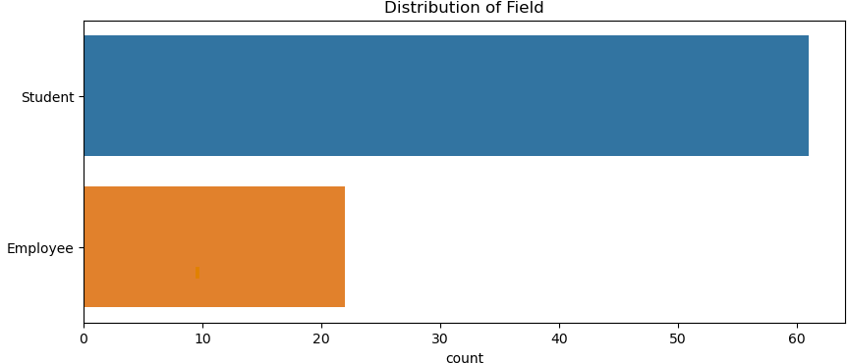

**Figure - 1 Student and Employee participants**

**4. Finding Result**

The survey findings illuminate a prevailing optimism regarding the integration of AI technology in education, underpinned by a recognition of its potential to enrich the learning journey.

**4.1 Impact of AI in Higher Education**

* **Which Areas AI can benefit students:** According to the response education content and personalized learning both are used but students mostly use them to create content**.** It enhances engagement through interactive and gamified platforms and supports diverse learning styles figure show as in (fig 2).

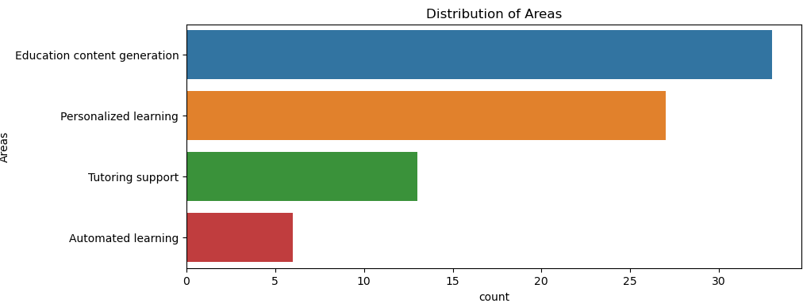

**Figure – 2 Which area benefits students**

* **comfortable with AI technology assisting teachers in grading assignments:** According to responses Yes, I would be comfortable with AI technology assisting teachers in grading assignments and exams. AI can provide consistent and unbiased evaluations, handle large volumes of grading efficiently, and offer immediate feedback to students. This allows teachers to focus more on personalized instruction and student engagement figure show as in (fig 3).

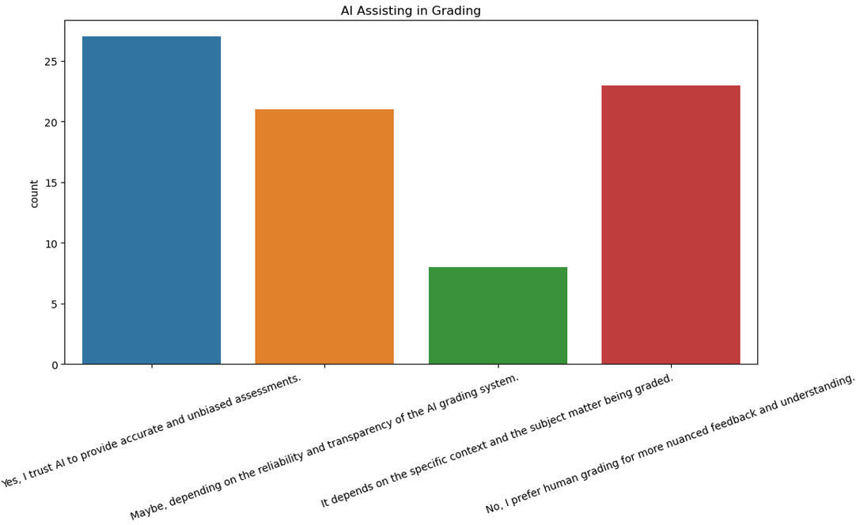

**Figure – 3 AI Assisting the teacher in grading**

* **AI technology can replace human teachers in the future:** Teachers provide emotional support, motivation, and encouragement to students, which are essential for their holistic development. AI lacks the empathy and emotional intelligence required to form meaningful connections with students. More accuracy of AI not replace human teachers in the future. According to responses, yes, but am disagree AI can not replace human teachers in the future because AI will explain only one problem at a time but human teachers will explain multiple problems at a time figure show as in (fig 5).

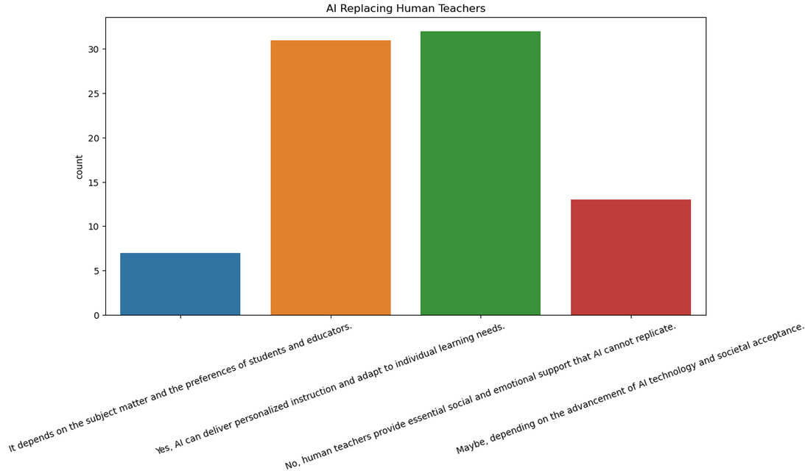

**Figure - 4 Can AI Replace human teacher**

* **Improve Education:** AI holds immense promise in revolutionizing education. It can tailor learning experiences to individual students, offering personalized support and guidance figure show as in (fig 5).

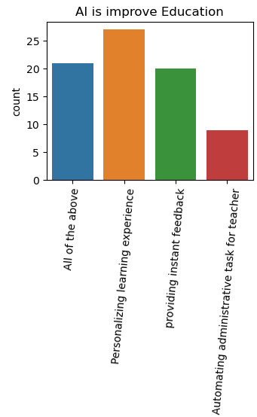

**Figure – 5 Improve Education**

* **AI benefits for students**: By offering personalized learning, tutoring, and immediate feedback on assessments. It improves accessibility, manages study schedules, aids in research, enhances language learning, and provides career guidance figure show as in (fig 6).

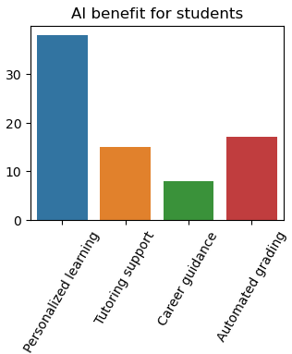

**Figure – 6 Benefits for Students**

* **Mostly used AI tool:** According to responses most students and teachers use ChatGPT.GPT used by chatbots like me can be useful tools in education. I can provide students with a learning experience through individual activities, answer questions, clarify ideas, and provide guidance on a variety of topics figure show as in (fig 7).

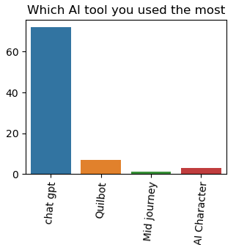

**Figure – 7 Mostly used AI tool**

**4.2 Comparison of Model 1 and Model 2**

* **Logistic Regression**

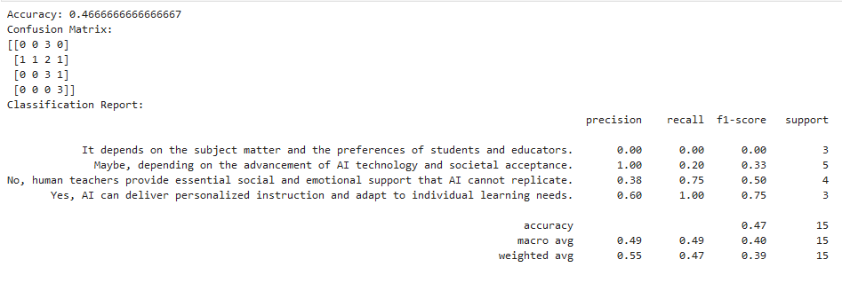

* **Random Forest**

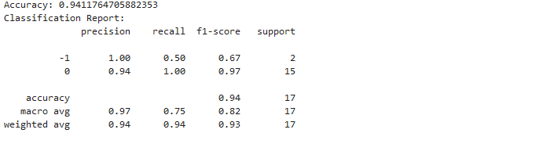

**Figure – 8 Comparison of model 1 and model 2**

* Model 2 outperforms Model 1 across all keModel 2 outperforms Model 1 across all key metrics: accuracy, precision, recall, and F1-score. This indicates that Model 2 is significantly better at correctly classifying instances and balancing the trade-off between precision and recall.
* Model 1 needs substantial improvements, especially in handling class imbalance and improving precision and recall for underperforming classes.
* If the data supports such a comparison, the focus should be on why Model 1 performs poorly and how it can be adjusted or improved, perhaps by using techniques such as class balancing, feature engineering, or selecting a more appropriate model type for the specific problem at hand.

**4.3 Discussion**

Artificial intelligence (AI) presents promising solutions to these challenges. AI-powered technologies can analyze large amounts of data about students' learning behaviors, preferences, and performance to provide personalized learning experiences. Through adaptive learning platforms, AI can dynamically adjust the difficulty and pace of content delivery to match each student's learning needs, ensuring that they remain appropriately challenged and engaged.

AI can automate routine administrative tasks, grading, and content creation, reducing the burden on educators and freeing up their time for more meaningful interactions with students. This increases efficiency and allows educators to focus on higher-order teaching activities.

Teachers in higher education generally view AI positively for its ability to automate administrative tasks, provide data-driven insights for personalized instruction, and support innovative teaching methods. Overall, teachers see AI as a beneficial tool but emphasize the importance of addressing these challenges to fully realize its potential in education.

1. **Conclusion**

In conclusion, the future of higher education lies at the intersection of human expertise and artificial intelligence. By embracing AI responsibly and leveraging its capabilities effectively, institutions can empower learners, optimize teaching practices, and foster a culture of lifelong learning in alignment with the demands of the digital age. As we navigate this evolving landscape, continued research, experimentation, and dialogue will be essential to ensure that AI remains a force for positive change in education, driving innovation, equity, and excellence.

**Reference**

1. Chassignol, M.; Khoroshavin, A.; Klimova, A.;Bilyadinova, A.(2018). Artificial intelligence trends in education: A narrative overview. In: Procedia computer science; pp.16-24
2. Kuleto ,V.; Llic, M.; Damangiu, M.; Rankovic, M.;Martins, O.M.D.; Paun, D. (2021). Exploring opportunities and challenges of artificial intelligence and machine learning in higher education institutions. In: Sustainability. https://doi.org/10.3390/su131810424
3. Popenici, St. A. D.; Kerr, S. (2017) Exploring the impact of artificial intelligence on teaching and learning in higher education. In: Springer link.
4. Compot, H.; Burke, D.(2023). Artificial Intelligence in higher education: the state of the field. In: International Journal of Education Technology in Higher Education; volume 20.
5. Baker, T., & Smith, L. (2019). Educ-AI-tion rebooted? Exploring the future of artificial intelligence in schools and colleges. Retrieved from Nesta Foundation website: <https://media.nesta.org.uk/documents/Future_of_AI_and_education_v5_WEB.pdf>
6. Priyadarshi, Neeraj., Padmanaban, Sanjeevikumar., Hiran, K. Kant., Holm-Nielson, J.Bo., & Bansal, R.C. (2021). Artificial Intelligence and Internet of Things for Renewable Energy Systems. Walter de Gruyter GmbH & Co KG.
7. Chen, L.; Chen, P.; Lin, Z.(2020) Artificial Intelligence in Education: A review. In: IEEE ACCESS.
8. Pokrivcakova, S.(2019). Preparing teachers for the application of AI-powered technologies in foreign language education. In:Sciendo; pp 135-153. <https://doi.org/10.2478/jolace-2019-0025>
9. Sharma, RC.; Kawachi, P.; Bozkurt, A.(2019). The landscape of artificial intelligence in open online and distance education: Promises and concerns. In: Asian journal Distance education; pp 1-2.
10. Sanchez, A. A. (2023). Experience and challenges of indigenous students in higher education during the pandemic. In: Handbook of research on revisioning and reconstructing higher education after global crises: pp. (288-304).
11. Mahana, M.; Johns, M.; Apte, A. (2012). Automated Essay Grading Using Machine Learning. In: Machine Learning Session Stanford University, pp. 3–7.
12. Wang, W.; Siau, K. (2017). Impact of Artificial Intelligence, Robotics, Machine

Learning, and Automation on the Medical Field, pp. 4–6.

1. Rus ,V.; S. D’Mello; Hu, X.; Graesser, A.(2013). Recent advances in conversational intelligent tutoring systems. In: AI Mag., vol. 34, no. 3, pp. 42–54.
2. Pokrivcakova, S.(2019). Preparing teachers for the application of AI-powered technologies in foreign language education, In: J. Lang. Cultural Edu., vol. 7,no. 3, pp. 135–153.
3. Slimi, Z.(2023). The impact of Artificial Intelligence on higher education: An Empirical study. In: European Journal of Educational Science. <http://dx.doi.org/10.19044/ejes.v10no1a17>