Implementation of Face Recognition in Attendance

System

Mrs. Nethra H L1, Shashank Dubey2, Shatrunjay Kumar3, Sridhar Srinath4, Sudarshan Singh5

1,2,3,4,5Department of Computer Science & Engineering, Dayananda Sagar Academy of Technology and Management (DSATM), Bengaluru

l

***Abstract--* In the realm of modern attendance management systems, the integration of facial recognition technology has revolutionized traditional methods. This abstract delves into the innovative approach of utilizing facial recognition for attendance tracking in educational settings. By harnessing the power of facial recognition algorithms, this system offers a seamless and efficient solution for recording student attendance. Through the utilization of advanced technologies, the system can accurately identify students based on their facial features. The benefits of this system include enhanced accuracy, reduced administrative burden, improved security, and real-time attendance tracking capabilities. By automating the attendance process through facial recognition, educational institutions can streamline operations, minimize errors, and provide a more secure and efficient environment for both students and staff. This abstract highlights the transformative potential of facial recognition technology in revolutionizing attendance management systems and underscores its significance in modern educational settings.**

**Keywords: Face recognition; face recognition and extraction; automatic face recognition; Haar cascade;**

**I. INTRODUCTION**

Face recognition plays a vital role in our daily lives as it helps us identify family members, friends, or acquaintances. The process of identifying human faces involves several steps. Initially, information is received through the images projected onto our retinas in the form of light. Light, being a form of electromagnetic waves, is emitted from a source, then reflected off an object, and finally projected onto the human eye. According to Robinson-Riegler and Robinson-Riegler (2008), the human visual system processes this visual information, analyzing various aspects such as shape, size, contour, and texture of the object. This analyzed information is then compared with stored representations of faces or objects in our memory to facilitate recognition.

Developing an automated system that matches the human ability to recognize faces is challenging. Human memory limitations make it difficult to remember numerous faces without errors, especially in environments like universities, where there is a diverse student population in terms of race and gender. To overcome these limitations, face recognition systems utilize computers with vast memory, high processing speed, and computational power.

The uniqueness of the human face makes face recognition an effective biometric method for individual identification. It involves comparing a real-time captured image with stored images in a database to identify an individual.

Maintaining attendance records is crucial for both teachers and students in educational institutions. Traditional methods of taking attendance, such as calling out names or roll numbers, are not only time-consuming but also require significant energy. Automatic attendance systems, such as biometric and RFID systems, offer solutions to these challenges.

This project introduces an automatic attendance marking system that seamlessly integrates with the normal teaching procedure. It can be implemented during regular classes, exam sessions, or any teaching activity where attendance is essential. This system eliminates the need for traditional student identification methods like calling out names or checking identification cards, which can disrupt the teaching process and cause stress to students, particularly during exam sessions. Additionally, students need to register in the system's database for recognition, a process that can be conveniently completed on the spot through a user-friendly interface.

**II. RELATED WORK**

In [1], the emergence of big data and the increasing commercial value of face recognition technology indicate promising prospects for its development. This method focuses on four main areas of concern: the accuracy of face recognition systems during real-time check-ins, the stability of face recognition attendance systems with real-time video processing, reducing truancy rates in face recognition attendance systems with real-time video processing, and optimizing the interface settings of face recognition attendance systems using real-time video processing.

In [2], the authors argue that signatures are not the most effective security measure and suggest integrating facial recognition technology with security systems. This study aims to enhance the proofing of face recognition systems, particularly in reducing instances of incorrect approvals and detection failures dynamically. The paper introduces a unique combination of techniques including deep recurrent learning, Successive Mean Quantization Transform (SMQT), and K-nearest neighbors (KNN), which efficiently address challenges such as noise, low light, and slight image tilting, thereby improving facial data recognition under various image conditions.

In [3], the paper presents an automated system that records students' attendance using face recognition technology. The system utilizes the Local Binary Pattern (LBP) method for face detection and recognition, aiming to streamline the attendance process and improve its accuracy.

In [4], the paper discusses the progress made in face detection and recognition for security, identification, and attendance purposes. However, challenges such as variations in human facial appearance (e.g., changes in lighting conditions, noise in face images, scale, and pose) still hinder the achievement of human-level accuracy.

In [5], this paper proposes a model for face detection and recognition using face mesh, enabling the model to operate effectively under various conditions such as varying illumination and backgrounds. The model is trained using images from the Label Wild Face (LWF) dataset and real-time captured images, employing a deep neural network architecture.

In [6], the paper addresses attendance recording issues within a company, where employees faced difficulties with the fingerprint system, resulting in delays of 3 to 5 minutes in marking their attendance, especially when fingers were wet or not properly aligned. To overcome this problem, the Viola-Jones method was employed. During the processing phase, RGB face images were converted into histogram equalized face images for subsequent recognition stages. With the implementation of facial recognition, the attendance marking process became more efficient, taking less than a minute to mark attendance.

**III. METHODOLOGY**

The conventional method used for attendance management is roll calling, where students are marked as present or absent in registers. Although still prevalent in many educational institutions, this method has significant drawbacks. For instance, students may falsely claim attendance on behalf of absent friends, and teachers verify student signatures against their names, but anonymity remains a concern since the signatory is often not verified.

To address these issues, the proposed system aims to revolutionize attendance management by incorporating facial recognition technology. It provides an automated, accurate, and efficient solution for tracking student attendance in educational institutions. The implementation of this system can be achieved using the Viola-Jones Algorithm, a Python-based machine learning algorithm used for face detection. The algorithm comprises three main components: Integral Images, AdaBoost Algorithm, and Attention Cascade.

The system captures images either from the built-in computer camera or an external camera. Real-time face detection and recognition are performed using these input images. When a recognized face corresponds to an enrolled student, attendance is automatically recorded. The system also maintains a history of attendance data for each class session.

DATA COLLECTION

The initial step involves collecting a dataset of facial images for each individual whose attendance needs to be tracked. This dataset should include a diverse range of images capturing variations in lighting conditions, facial expressions, and angles. This dataset serves as the basis for training the face recognition model.

PRE-PROCESSING

After collecting the dataset, preprocess the facial images to standardize them for improved recognition accuracy. Common preprocessing techniques include resizing the images to a consistent size, normalizing pixel values, and applying histogram equalization to enhance contrast.

FACE EXTRACTION

Utilize face recognition algorithms to extract relevant features from preprocessed facial images. These features may include key facial landmarks, texture patterns, or eigenfaces. The objective is to represent each face in a lower-dimensional feature space while retaining discriminative information essential for accurate recognition. In a face recognition attendance system, the face extraction process is crucial for precisely identifying individuals. Initially, raw input images containing various objects or backgrounds are processed to isolate and extract facial regions. Subsequently, the extracted facial images undergo preprocessing steps to standardize their size, orientation, and illumination, optimizing them for subsequent feature extraction and recognition.

TRAINING

Training a face recognition model involves several essential steps. Firstly, collect a diverse dataset of facial images representing the individuals to be recognized. Next, preprocess the images by resizing them, converting them to grayscale, and normalizing pixel values. Then, extract features from the preprocessed images, such as facial landmarks or learned deep features. Validate the trained model on a separate validation dataset and fine-tune its parameters to optimize performance. Evaluate the model's performance using metrics like accuracy, precision, and recall.

FACE DETECTION AND RECOGNITION

In an attendance system employing face detection, the process involves automatically identifying and locating faces within input images or video streams. Once detected, the system accurately delineates the boundaries of each face, considering variations in pose, scale, and orientation. This step is crucial for isolating and extracting facial features necessary for subsequent recognition tasks. Additionally, the system may incorporate techniques for filtering out false positives or dealing with occlusions to enhance detection accuracy. By efficiently identifying faces in real-time, the face detection component establishes the foundation for subsequent stages of feature extraction, recognition, and attendance logging, ensuring the system's reliability and effectiveness in seamlessly tracking attendance.

ATTENDANCE LOGGING

The flowchart (Figure 1) illustrates the steps involved in completing the task. In a face recognition attendance system, attendance logging entails recording the timestamp and the recognized identity of individuals as identified by the system. Upon successful recognition of a face, the system logs the current date and time along with the corresponding individual's identity. This information is usually stored in a database or a file, enabling efficient tracking and management of attendance records. Attendance logging is a vital component of the system, allowing for real-time monitoring of attendance, report generation, and analysis of attendance patterns over time.

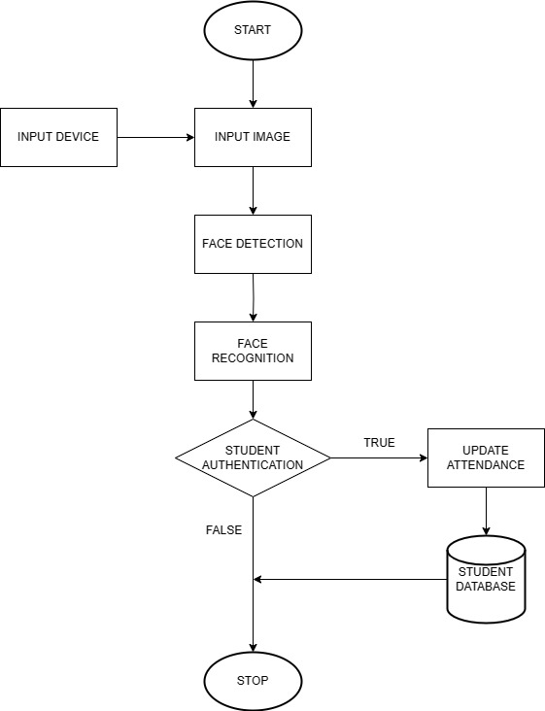

Figure 1: Flow Chart

**IV. SYSTEM ARCHITECTURE**

The face detection process comprises several key components, including the image acquisition module, face detection algorithms, feature extraction techniques, and face recognition classifiers. These components collaborate to accurately identify individuals and record their attendance in the system.

The proposed system is a Face Recognition-based Classroom Attendance System. It requires a camera installed in the classroom, positioned to capture images of all students effectively. The system architecture is depicted in the diagram below (Figure 2).

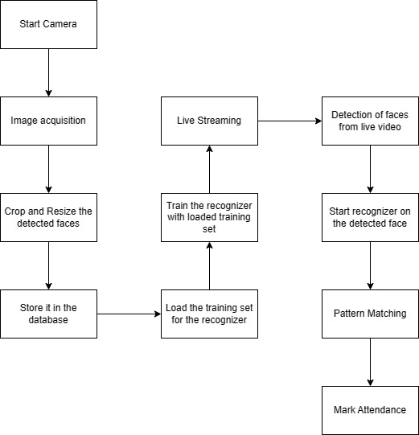

Figure 2: System Architecture

**V. IMPLEMENTATION**

The project utilized Python 3.12 as the back-end and tkinter as the front-end. Python was downloaded from the official website, https://www.python.org/downloads/. Additionally, necessary modules were installed for the project.

The application enables faculty members to take attendance by using the system through the webcam. Attendance is marked by matching the students' details previously uploaded by the faculty to the database.

Application testing is a crucial process that ensures the correctness, completeness, security, and quality of a developed user application. This process involves technical investigation intended to reveal quality-related information about the product within its intended context. It includes executing the program or application to identify errors, although testing cannot completely establish the correctness of arbitrary computer software.

It's important to differentiate software testing from Software Quality Assurance (SQA), which encompasses all business process areas, not just testing. Quality is subjective and varies for each person.

Tables 1 and 2 display the test cases conducted during this project.

|  |  |  |  |
| --- | --- | --- | --- |
| Sl. No. | Number of Persons | Position | Accuracy of Recognition (%) |
| 1 | 2 | Linear | 90 |
| 2 | 3 | Random | 60 |
| 3 | 3 | Linear | 80 |
| 4 | 5 | Random | 65 |
| 5 | 6 | Linear | 90 |
| Overall Accuracy | | | 77% |

Table 1: Recognition Accuracy Test

|  |  |  |  |  |  |
| --- | --- | --- | --- | --- | --- |
| Sl. No. | Action | Inputs | Expected Output | Actual Output | Test Result |
| 1 | Capture Images | A Person’s Face | Images are captured and Stored | Images are captured and Stored | Pass |
| 2 | Train the image Dataset | Stored images of a face | Create Histograms and store values | Histograms are created and values are stored | Pass |
| 3 | Face Recognition | A live stream of a person’s face | Name of detected person is displayed on the screen | Name of detected person is displayed on the screen | Pass |
| 4 | Update attendance for multiple people at once | Multiple faces from a live video stream | Update Attendance for all faces detected | Attendance Updates for all persons present | Pass |

Table 2: Test Cases

**VI. RESULTS**

A face recognition-based attendance system was implemented on a laptop computer and tested in a room environment. The system achieved an accuracy of approximately 77% when consistent conditions such as lighting, face distance, and facial expression were maintained during image capture.

Student feedback from a survey indicated that the system was effective, efficient, and well-accepted by students.

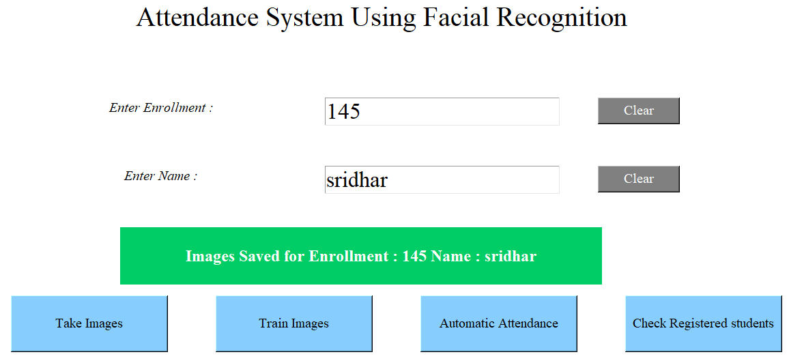

Figure 3: Main Page

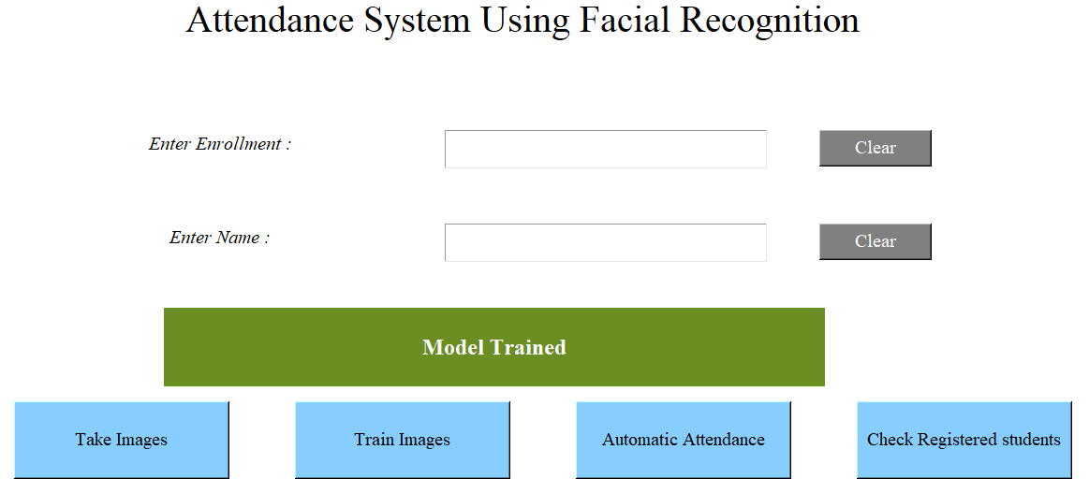

Figure 4: Model Trained

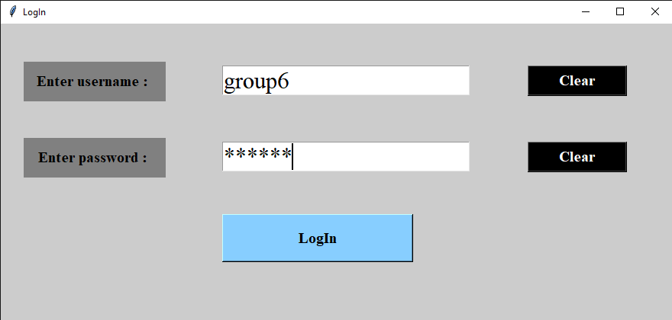

Figure 5: Login Page

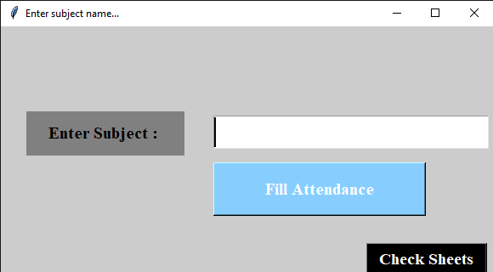

Figure 6: Attendance Subject Fill



Figure 7: Face Detection

**VII. CONCLUSION**

In conclusion, facial recognition-based attendance systems represent a significant advancement in attendance management, offering a combination of accuracy, efficiency, and convenience. By incorporating cutting-edge technologies such as machine learning algorithms and high-resolution cameras, these systems streamline the attendance tracking process in educational institutions, workplaces, and various other settings.

The integration of facial recognition technology not only enhances the accuracy of attendance recording but also reduces administrative burdens and provides real-time tracking capabilities. The system architecture, which includes components like image acquisition, face detection, feature extraction, and attendance marking, ensures a robust and reliable solution for attendance management.

As technology continues to evolve, these systems are poised to become integral tools in various industries, revolutionizing how attendance is tracked and managed. Embracing the potential of facial recognition technology in attendance systems opens up new possibilities for improving operational efficiency and enhancing the overall experience for both administrators and users alike.

**VIII. FUTURE SCOPE**

There are several potential future directions for the development and enhancement of facial recognition-based attendance systems. One possibility is to explore integrating the system with other technologies, such as access control systems or biometric authentication systems.

Additionally, further investigation into using the system in various settings, such as schools, offices, or other facilities where attendance tracking is crucial, could be beneficial.

Overall, facial recognition-based attendance systems have the potential to improve the efficiency and reliability of attendance tracking across a variety of settings. They represent valuable tools that could have a significant impact on a wide range of industries and applications.

**REFERENCES**

1. Yang, Hao, and Xiaofeng Han. "Face recognition attendance system based on real-time video processing." IEEE Access 8 (2020): 159143- 159150.
2. Mustakim, Nafis, et al. "Face recognition system based on raspberry Pi platform." 2019 1st International Conference on Advances in Science, Engineering and Robotics Technology (ICASERT). IEEE, 2019.
3. Singh, Astha. "Face Detection using Deep Recurrent Learning and SMQT Technique." 2020 International Conference on Electronics and Sustainable Communication Systems (ICESC). IEEE, 2020.
4. Elias, Shamsul J., et al. "Face recognition attendance system using Local Binary Pattern (LBP)." Bulletin of Electrical Engineering and Informatics 8.1 (2019): 239-245.
5. Shetty, Anirudha B., and Jeevan Rebeiro. "Facial recognition using Haar cascade and LBP classifiers." Global Transitions Proceedings 2.2 (2021): 330-335.
6. Damanik, Rudolfo Rizki, et al. "An application of viola jones method for face recognition for absence process efficiency." Journal of Physics: Conference Series. Vol. 1007. No. 1. IOP Publishing, 2018.
7. Bah, Serign Modou, and Fang Ming. "An improved face recognition algorithm and its application in attendance management system." Array 5 (2020): 100014.
8. Mamatkulovich, Babakulov Bekzod. "AUTOMATIC STUDENT ATTENDANCE SYSTEM USING FACE RECOGNITON." Next Scientists Conferences. 2022.
9. Teoh, K. H., et al. "Face recognition and identification using deep learning approach." Journal of Physics: Conference Series. Vol. 1755. No. 1. IOP Publishing, 2021.
10. Hangaragi, Shivalila, Tripty Singh, and N. Neelima. "Face detection and Recognition using Face Mesh and deep neural network." Procedia Computer Science 218 (2023): 741-749.