#### DESIGN AND MOULDING OF DENTAL IMPLANT BY 3D PRINTING

#### G. Suresh1, Ch. Pranay Teja2, J. Mahesh3, K. Vishnuvardhan4, S. Sriram5, B. Ajay6

1 Assistant Professor, Department of Mechanical Engineering, Ace Engineering College

2, 3,4,5 &6 Students, Department of Mechanical Engineering, Ace Engineering College

## 

## ABSTRACT

3D printing, also known as additive manufacturing, is revolutionizing biomedical equipment production by enabling the creation of complex objects layer by layer. In dentistry, this technology plays a crucial role in fabricating artificial teeth and complete dental sets. A technique like selective laser sintering, fused deposition modeling and stereo lithography are utilizes, with the integrationof "NANO PARTICLES" materials to enhance dental structure properties. This innovative approach addresses various dental issues, catering to individuals with cavities or those who have lost teeth due to aging. By employing specialized software for design and analysis, dental sets are customized to ensure longevity and effectiveness, providing viable solutions for patients in need of dental care. 3D printing offers diverse applications in dentistry, serving as a Trans formative force in biomedical component production. Its impact extends to improving accessibility to dental care, especially for individuals with specific needs or conditions. As technology continues to advance, 3D printing will likely play an increasingly significant role in revolutionizing dental treatments and enhancing patient outcomes.

## INTRODUCTION

3D printing or additive manufacturing (AM) is any of various processes for making a three- dimensional object of almost any shape from a 3D model or other electronic data source primarily through additive processes in which successive layers of material are laid down under computer control. A 3D printer is a type of industrial robot.

In recent years, the field of dentistry has witnessed a transformative shift in the way dental implants are designed and manufactured, largely attributed to the advent of three-dimensional (3D) printing technology. Traditional methods of dental implant fabrication often involved a labor-intensive process, requiring intricate molding techniques and skilled artistry. However, with the introduction of 3D printing, dentistry has entered a new era of precision, efficiency, and customization. This paper explores the intersection of design, molding, and 3D printing technology inthe realm of dental implant ology. By harnessing the capabilities of 3D printing, dentalprofessionals now have the ability to create patient-specific implants with unparalleled accuracy and biocompatibility. This advancement not only streamlines the manufacturing process but also enhances the overall quality and longevity of dental implants, ultimately improving patient outcomes and satisfaction.

The integration of 3D printing technology into dental implant ology offers several distinct advantages over traditional manufacturing methods. Firstly, it allows for the creation of highly customized implants tailored to the unique anatomical characteristics of each patient. Through advanced imaging techniques such as cone beam computed tomography (CBCT) and intraoral scanning, precise digital models ofthe patient's dentition can generate, serving as the blueprint for implant design.

Moreover, 3D printing enables the fabrication of complex geometries and intricate internal structures that were previously unattainable with conventional methods. This capability is particularly beneficial in cases where optimal Osseo integration and biomechanical stability are paramount, as it allows for the creation of implants with enhanced surface topography and structural integrity.

Furthermore, the use of biocompatible materials in conjunction with 3D printing technology ensures the production of implants that are not only functionally superior but also biologically compatible with the surrounding oral tissues. By utilizing materials such as titanium alloys and bio ceramics, dental implants can be manufacture with optimal strength, corrosion resistance.

In addition to its technical advantages, the adoption of 3D printing in dental implant ology has significant implications for the workflow and efficiency of dental practices. By eliminating the need for manual labor and outsourcing of implant components, 3D printing enables in-house production of implants, reducing turnaround times and costs associated with traditional fabrication methods. This streamlined approach not only enhances practice profitability but also empowers clinicians to exercise greater control over the entire treatment process, from design to delivery.

## HISTORY OF DENTAL MATERIALS

The history of dental materials is a fascinating journey that spans thousands of years, reflecting the evolution of human civilization and the advancement of science and technology. From ancient civilizations' rudimentary dental practices to modern-day sophisticated materials, the development of dental materials has been driven by the quest for effective treatments, improved patient outcomes, and enhanced oral health.

Ancient civilizations, such as the Egyptians, Greeks, and Romans, utilized various materials for dental treatments. Evidence suggests that as early as 7000 BC, humans used beeswax to fill cavities, providing rudimentary dental restoration. The ancient Egyptians developed dental prostheses using precious metals like gold and silver, demonstrating early attempts at tooth replacement. In ancient China, around 2000 BC, tooth decay was treated using herbal remedies and acupuncture techniques. Traditional Chinese medicine also advocated the use of materials like jade and bamboo for dental prostheses.

In the 19th century, significant developments in dental materials occurred, driven by advancements in chemistry and metallurgy. Dentists began using materials like gutta-percha, a natural latex derived from trees, for root canal fillings. In 1820, the introduction of porcelain teeth by the Crawcour brothers revolutionized denture fabrication, offering a more aesthetic and durable alternative to previous materials.

The 20th century marked a period of rapid innovation in dental materials, propelled by scientific research and technological breakthroughs. The discovery of X-rays in 1895 by Wilhelm Conrad Roentgen revolutionized diagnostic imaging in dentistry, enabling dentists to visualize internal structures and diagnose dental diseases more accurately. The development of synthetic materials

Figure 1.1 Time line of 3D printing technology

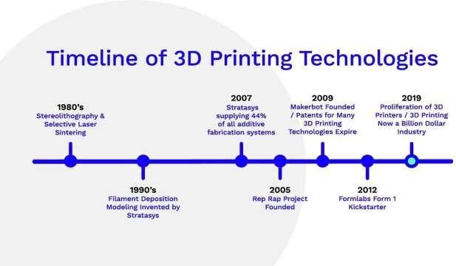**LITERATURE SURVEY**

# 

The literature survey on 3D printing in dental implant using SLA method highlights its precision, customization, and efficiency. Studies demonstrate its effectiveness in producing accurate implant components with high material integrity. SLA-based 3D printing offers promising advancements in dental implant ology, enhancing treatment outcomes and patient satisfaction.

**Rosa Pulgar et al. [1]** The study aims to assess how the thickness and printing angle impact the optical properties of 3D-printed dental restorative resins. Four resin systems were tested at different thicknesses and angles, and various optical coefficients were calculated. Results showed significant variations in scattering, absorption, transmittance, and reflectivity between different thicknesses and printing orientations. The findings emphasize the need to consider these factors to enhance the biomimetic potential of 3D-printed dental restorative resins for improved clinical performance.

**Anna Nemeth et al. [2]** the network meta-analysis aimed to assess the accuracy of 3D- printed dental models compared to digital reference models. After evaluating 16,303 articles, 11 studies were included, analyzing seven printing technologies. SLA, DLP, and PolyJet would found to be the most accurate for full- arch dental models, while FDM/FFF, CLIP, and LCD technologies were less suitable. The study suggests SLA, DLP, and PolyJet technologies are sufficiently accurate for prosthodontics purposes, highlighting variations in accuracy among different 3D printing methods.

**Aditya Acharya et al. [3]** the study aims to evaluate the knowledge and practices of dental laboratory technicians in India regarding 3D printing in dentistry.From November 2021 to January 2022, a questionnaire-based survey conducted among 220 technicians. Of the 191 responses received, 89.53% were aware of 3D printing, with 88.48% preferring it to traditional methods. The findings suggest acceptable awareness, with recommendations for educational programs to enhance expertise, especially among technicians in dental colleges.

**Anjali Jaya raj et al. [4]** 3D printing, recognized as a transformative technology in manufacturing, is widely employed in aerospace, defense, art, and medical fields, particularly dentistry. Utilizing additive manufacturing, 3D printing constructs objects layer by layer. In dentistry, it is employed for teaching, managing implant and craniofacial cases, orthogenetic treatments, and various dental restorations. Detailed 3D scans guide the printing process, employing techniques such as stereo lithography and selective laser printing. Keywords include 3D printing, copings, and various printing techniques relevant to its applications in dentistry.

**Phillip Berman et al. [5]** Mandibular reconstruction, crucial for restoring its unique shape, traditionally involves time-consuming plate contouring in the operating room. Utilizing 3D printing (3DP) technology, prefabricated models assist in accurate plate contouring and bone graft planning before surgery, enhancing precision and reducing operation time. In three clinical cases, 3DP models were founded for mandibular reconstruction, resulting in faster, cost- effective procedures with decreased exposure time to anesthesia, reduced blood loss, and shorter wound exposure time, highlighting the advantages of 3DP technology in streamlining the surgical process.

## METHODOLOGY:

Following methodology shows how design and development of 3D printer

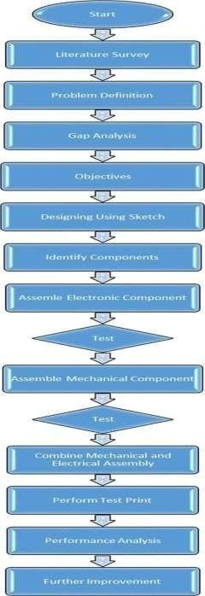

### Patient-Specific Imaging:

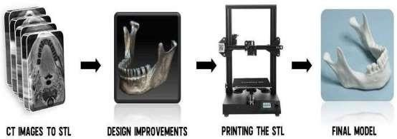

Figure 3.1 Flow Diagram of the SLA process in current research.

Utilizing advanced imaging technologies such as CT scans and intraoral scanning has revolutionized the field of dentistry, particularly in the realm of dental implant ology. These imaging modalities provide clinicians with detailed, three-dimensional representations of the patient's oral anatomy, allowing for precise treatment planning and execution. In this summary, we will explore how CT scans and intraoral scanning are utilized to capture detailed images of the patient's oral anatomy and how this imaging data is converted into a digital format compatible with SolidWorks software for further analysis and treatment planning.

Cone Beam Computed Tomography (CBCT) scans are commonly employed in dental implant ology to capture detailed images of the patient's oral structures, including the teeth, jaws, and surrounding tissues. Unlike traditional medical CT scans, which use afan-shaped X-ray beam and produce multiple slices of the body, CBCT scans utilize a cone-shaped X-ray beam and capture a single 360-degree rotation, resulting in high- resolution, three-dimensional images with minimal radiation exposure. These images provide valuable information about bone density, height, width, and morphology, as well as the location of vital structures such as nerves, sinuses, and adjacent teeth.

In addition to CBCT scans, intraoral scanning technology has emerged as a valuable tool for capturing detailed images of the patient's teeth and soft tissues. Intraoral scanners use optical sensors to capture thousands of data points per second, creating digital impressions of the patient's dentition with remarkable accuracy and precision. These digital impressions can be used to create virtual models of the patient's teeth, which can then be incorporated into the treatment planning process for dental implant placement.

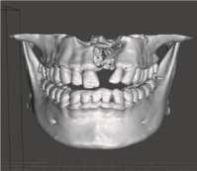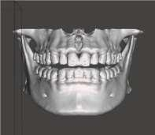

#### A B

`Figure 3.2 (a) 3D Model of CT Scan and (b) Mirrored 3D Model

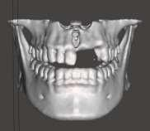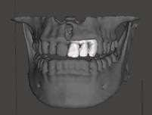

Figure 3.3 (a) Separated Teeth Model and (b) Teeth assembly in 3D model

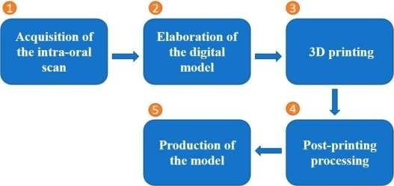

Figure 3 . 4 Five steps of clinical 3D printing workflow in dentistry.

## MATERIALS AND METHODS

### Ceramics 3D Printing Methods :

Ceramic materials are extensively used in 3D printing methods due to their excellent properties such as high strength, thermal stability, biocompatibility, and aesthetic appeal. In this article, we will explore the various ceramics used in 3D printing, the methods employed for their fabrication, and their applications across different industries.

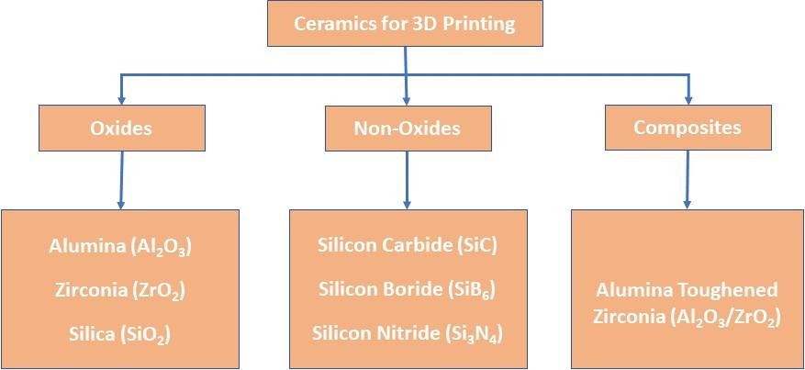

Figure 4.1 Different ceramic materials categories

### Materials and printing process

Originally, the word 'SLS refers to the polymer AM technique by selectively curing photosen- sitive polymers. Endeavours to apply this method on ceramics started about 20 years ago but the design philosophy is almost unchanged over the years: to prepare a hybrid sol of photopolymer and cer- amic particles and conduct photopolymerisation to make ceramic hybrid green bodies.

In our experiment, multiple acrylates and methacry- lates were applied as monomers, and 3 mol-% yttria- stabilised zirconia (3Y-TZP) nanoparticles, together with suitable photoinitiator, dispersant agent and other additives, are added to monomers to obtain hom- ogenous hybrid sol that can be photocured by a digital light processing 3D printer. First, acrylates and metha- crylates were mixed together and the ratio was 1:1.8, then 3Y-TZP powders were added in mixture with dis- persant agent (0.1-3 wt-% on dry weight basis of 3Y- TZP powders), and the hybrid sol was ball milling for 6 h. After that, the photoinitiator (0.1-2 wt-% on weight of basis of monomers) was added into the sus- pension, with further ball-milling process for another 2 h to attain homogenous slurry.

The 3D models of dental bridge and implant were imported into a data processing software to be sliced into a series of 2D layers as the manufacturing file for the printer. During printing, the rotating move- ment of the wiper blade provided a fresh hybrid sol layer, which would be selectively cured by the light engine. The thickness of the single layer could be adjusted from 25 to 100 µm. Once a single layer was cured, the building platform would move away from the hybrid sol surface to allow the recoating of a new layer of hybrid sol for further manufactur- ing. Under such a layer-by-layer manner, the 3D ceramic hybrid green body with defined geometry can be

manufactured. An illustration of such a ceramic stereolithography process is presented in figure 4.2

### Debinding and sintering process

With various organic additives in the hybrid sol, the debinding of hybrid green bodies usually lasts longer than traditional ceramic processing. With prolonged soaking time at different temperatures based on the amount and decomposition behaviours of correspond- ing organics, the points for holding temperature could be decided by thermal analysis. Here debinding process was performed by slowly heating up to 523°C for com- plete organics removal, and further pre-sintering at 800°C with a soaking time of 1 h. Then, the final sinter- ing process was conducted with a maximum sintering

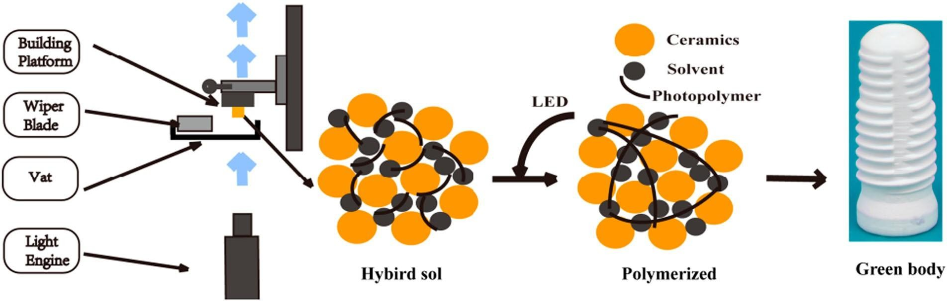Figure 4.2 A schematic illustration of the ceramic SLS process

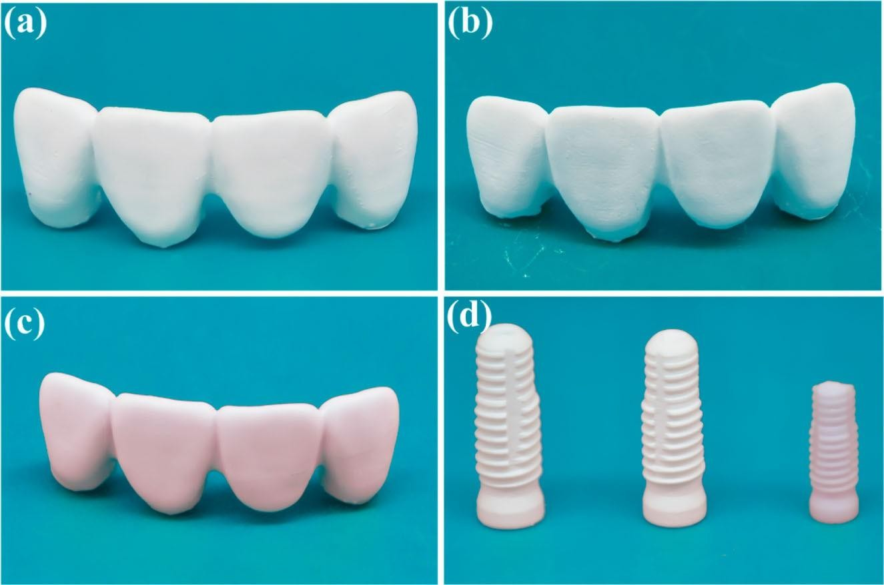

Figure 4.3 Additive manufactured Y-TZP dental bridges after (a) printing, (b) debinding and

(c) sintering. (d) Corresponding change of the size of Y-TZP dental implants after each step.

### Microstructure characterisation

The structural features, such as particle packing, grain growth and interlayer coherence evolution during the sintering process, were characterised on the debound and sintered parts using field emission scanning elec- tron microscope (TESCAN MIRA 3LMH, Czech Republic) at different magnifications. An argon ion beam cross-section polisher (IB-09020CP, JEOL, Japan) was used in the preparation of well-polished cross-section sample for SEM observation.

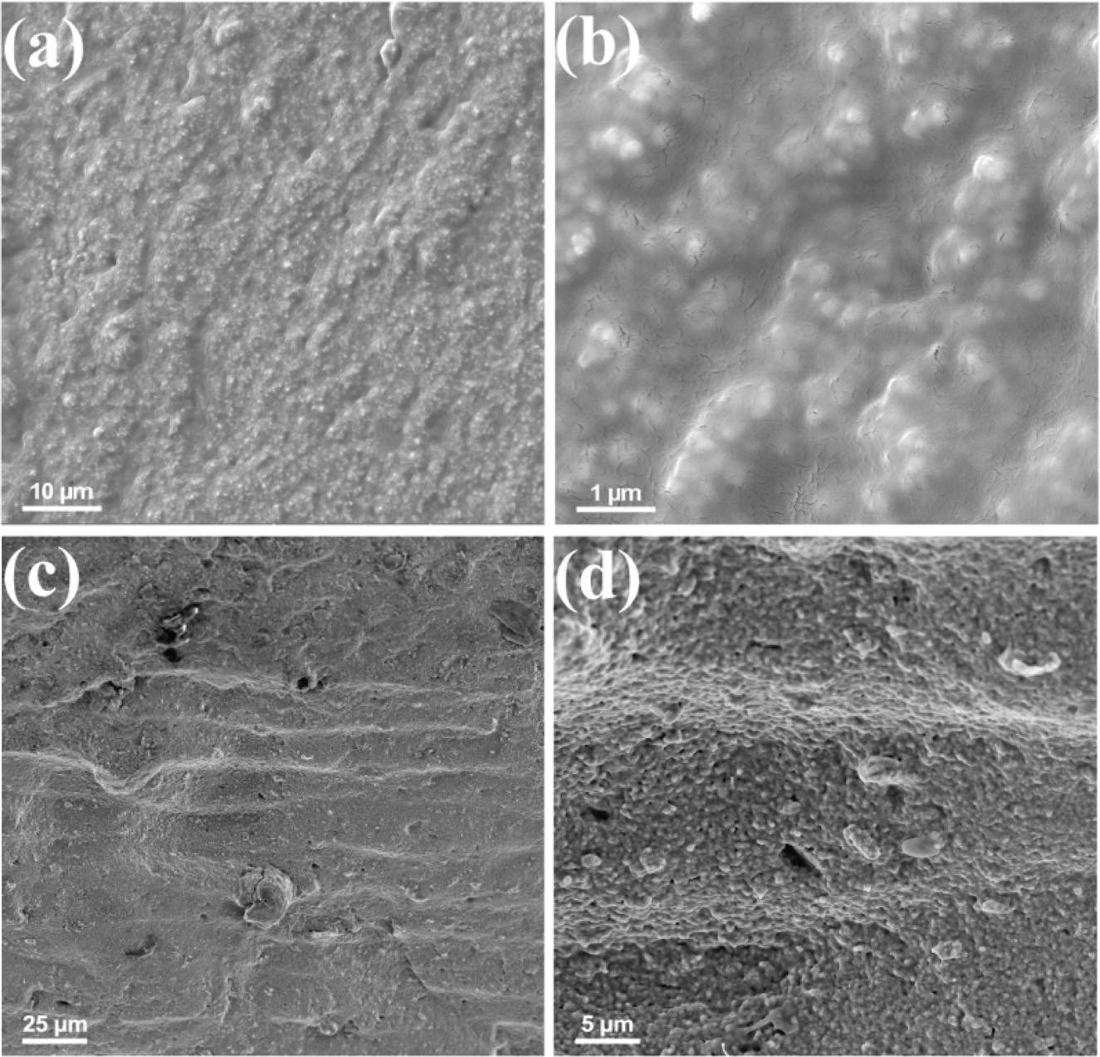

Figure 4.4 (a,b) Aggregates in the hybrid green body of Y-TZP specimen by ceramic SLS.

(c, d) The layered structure in sintered Y-TZP bridge, having a layer thickness of about 25 µm as set.

### Delamination and cracking

The occurrence of observable cracks often represents the failure of a structural material. Unfortunately, there is a big chance for such failures to form in this layer-wise fab- reaction manner. In the case shown in Figure 4.5(a,b), the cracks are observed on the outer surface of the sample, with a certain propagation orientation, but there is no crack on the inner surface. This feature could be inter- preted by stress distribution: The outer crack is subjected to tensile stress from the surface, while the internal surface is subjected to compressive stress. Thus, the crack would likely originate from the junction section of the bridge, as a possible weak point, and propagate along the direction where the surface energy decreases under the action of tensile stress (Figure 4.5(b)). Besides, the tendency of crack formation could be further enhanced by the layer-wise building manner, that is, when the gradient of stress is parallel to the xy plane, the weaker interlayer bonding strength, compared to the one within a single layer, could act as possible propa- gation route for cracks to finally become fatal.

### Microscopic defects

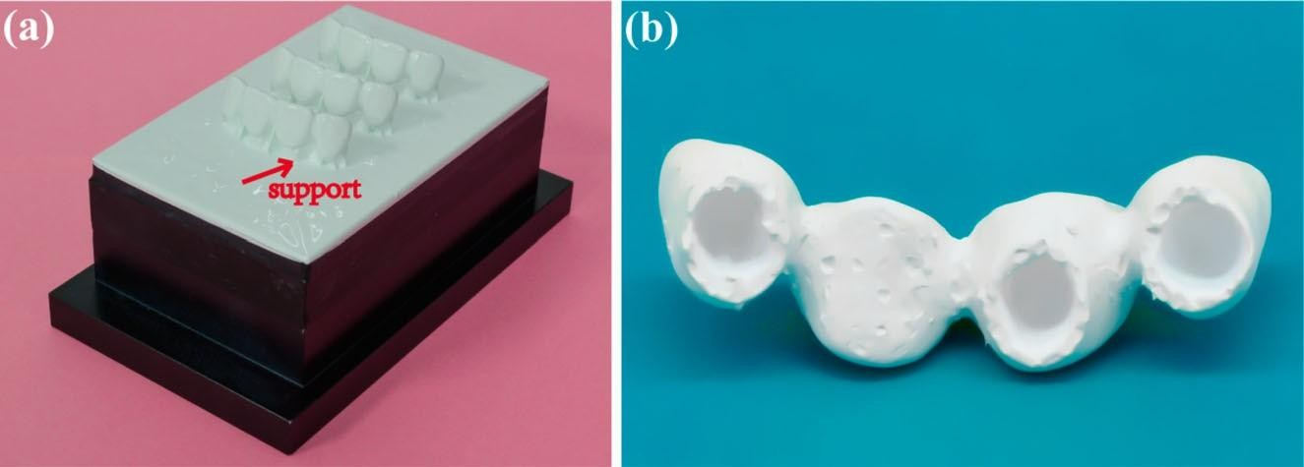

Figure 4.5 (a) The printed Y-TZP bridges with support structure on the bottom. (b) The damage on the bottom surface of the printed Y-TZP bridge after removing support structure.

Even with special care to prevent those obvious features mentioned above as macroscopic defects, one may still notice the differences in appearance compared to commonly used ceramic prosthetics. For example, the sintered 3D printed Y-TZP samples appear as opaque, and sometimes with specific colour, like purple in Figure 4.4 (c,d). Both features lie in microscopic defects, basically different structure of distributed micropores that is often unobservable by density measurement. A representative cross-section feature of a fabricated component is shown in Figure 4.7, in which we could find two kinds of pore structures: smaller ones of 200- 400 nm and larger ones with several micrometres in size. The former ones are distributed all over the whole horizon, which could be ascribed to the residual porosity due to the unfinished densification. The high organics load in hybrid green body means a low packing density for ceramic nanoparticles after debinding (about 40% of TD), which yields a much larger sintering shrinkage than traditional ceramics. On the microscale.

it means the necking and final grain growth would take higher energy with prolonged soaking time, let alone the inhomogeneity by aggregates and networks of organics mentioned above. So, we would regard these small pores as normal defects, which could possibly be eliminated by prolonged sintering, and that would lead to a better transparency. By the way, these small pores of such a high density may account for the purple appearance, as we did not find any impurities that could act as color- ant by energy dispersive spectroscopy (EDS). Tailored nanostructure is known to bring about special light absorption/reflection characteristics, and as for those randomly distributed small pores, the size of 200- 400 nm is in accord with the wavelength of violet light, thus the specifically enhanced violet light reflec- tion or interference could be suggested, leading to such a structural colouring feature

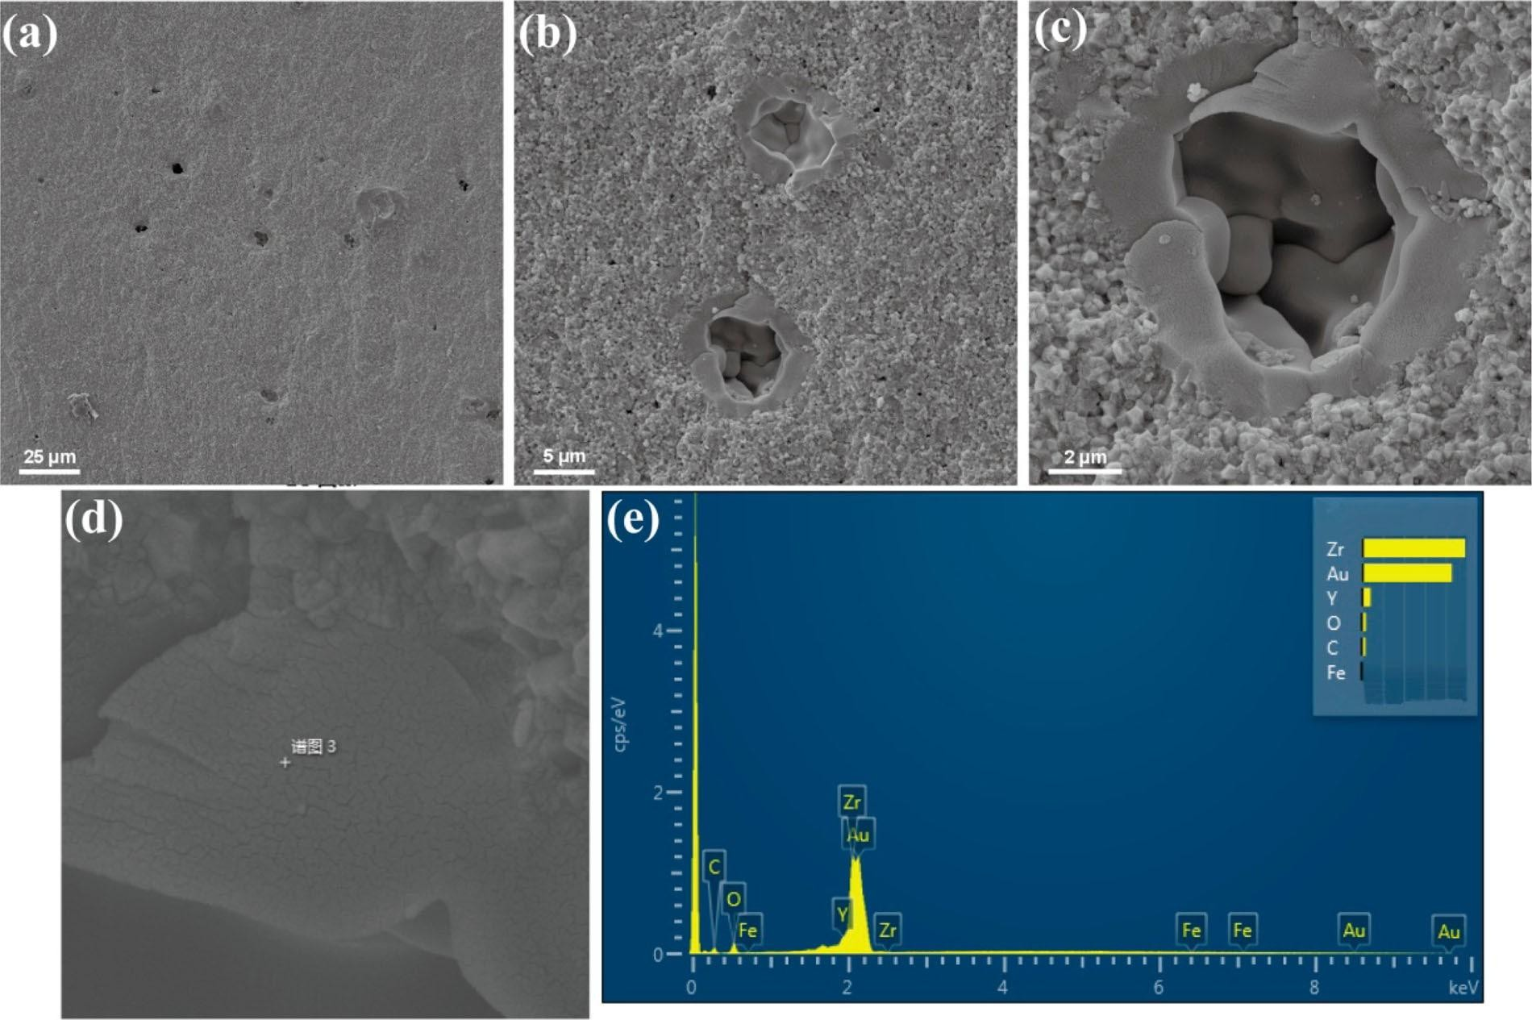

Figure 4.6. (a-d) The sintered Y-TZP products with pores and abnormally grown grains, (e) EDS of the abnormally grown grains.

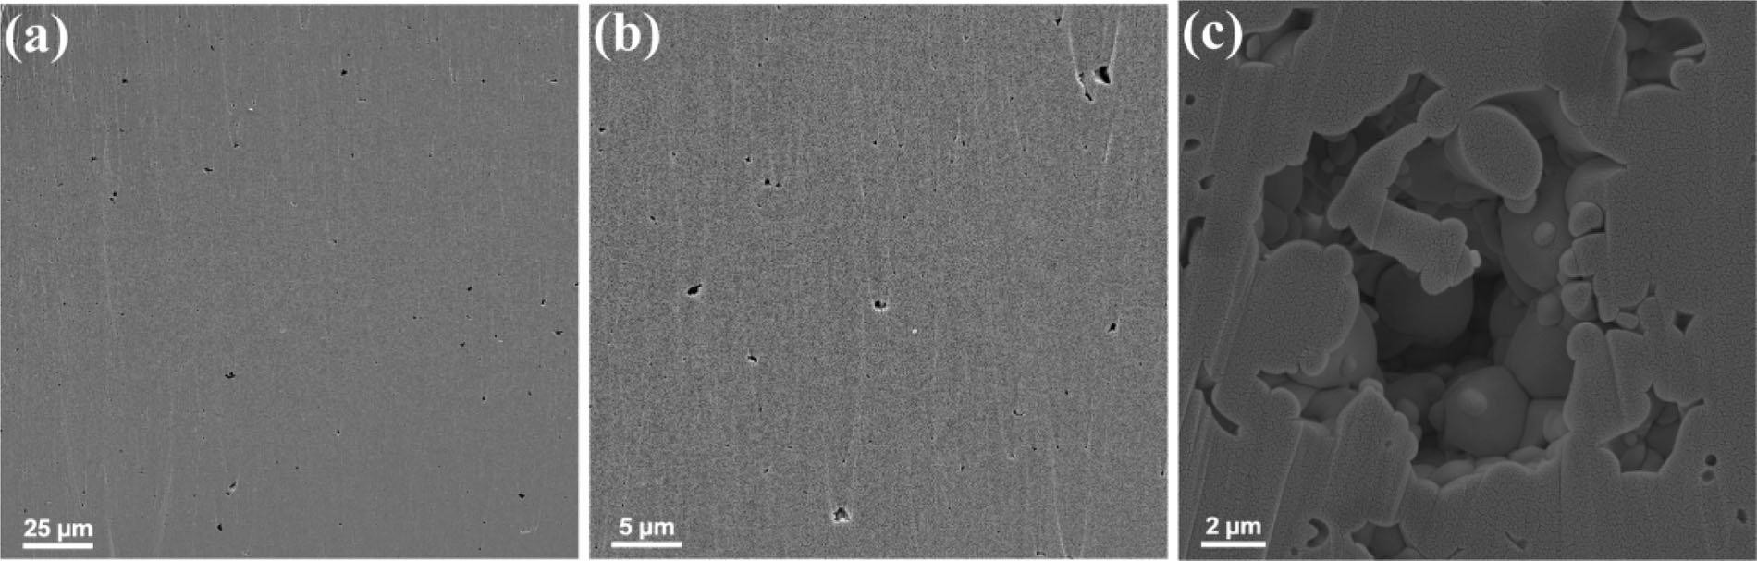

Figure 4.7 The argon ion-polished surface of sintered specimen. (a,b) The presence of abnormally larger pores in micron size under lower magnification. (c) A typical larger pore with some nanosized pore around under higher magnification.

The emergence of larger pores is more abnormal, as shown in Figure 4.6(c) and Figure4.7(c). The results of EDS did not reveal any impurities again on the pore site, so we would suppose that they were actually bubbles formed at the edge of the scraper during the rotation movement with highly viscous hybrid sol. The size of these pores is far beyond the degree that can be eliminated by normal sintering and grain growth. Some significantly larger grains observed around se pores may be interpreted as the results of free-surface accelerated abnormal grain growth leading to such pores with high coordination number.

Compared to those macroscopic defects which often cause direct failures, microscopic defects may not be obvious, but have strong influence on the mechanical performance of the components in the long term, especially for those large pores that could act as prefer- able crack initial points according to the Griffith frac- ture theory . This observation might explain why stereolithography fabricated Y-TZP specimens lack high strength. Y-TZP is well known by its high strength and toughness in ceramics. It can achieve a bending strength of 900-1400 MPa by pressureless sintering and 2400 MPa by hot isostatic pressing . In comparison, a 4-point bending strength of 650- 850 MPa was reported for the 3D printed Y-TZP speci- mens after sintering . Although this value has exceeded the minimum requirement set by the ISO standard for dentistry application the obvious low strength still indicates that the mechanical per- formance is strongly affected by the microscopic defects, which might cause failures of restorations in the oral environment particularly by countering in the cyclic loading condition.

Designing dental implants involves several critical steps to ensure proper fit, function, and biocompatibility. Here's an overview of the process:

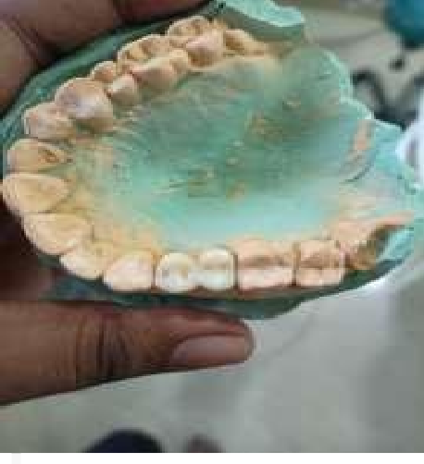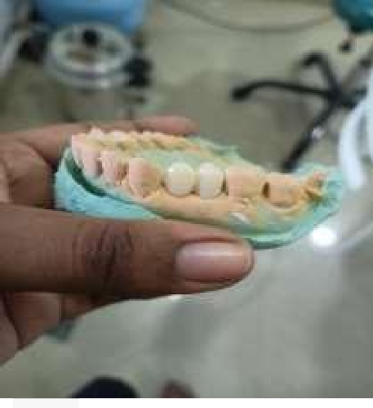

Figure 5.1 Impression of dental from patient

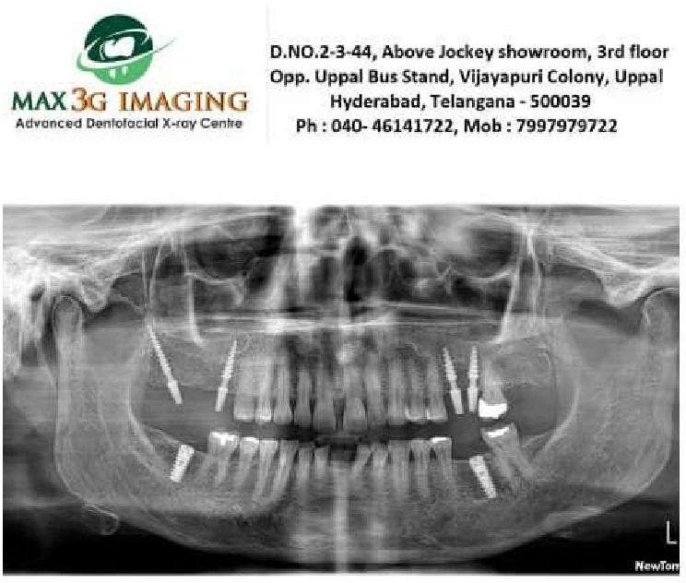

Figure 5.2 Dental customized implant x-ray after implant

Finally, SOLIDWORKS generates the necessary files for manufacturing, and the restoration is produced using the selected materials and technology. The completed restoration is then cemented into place using dental adhesive cement, ensuring complete seating and retention within the tooth structure.

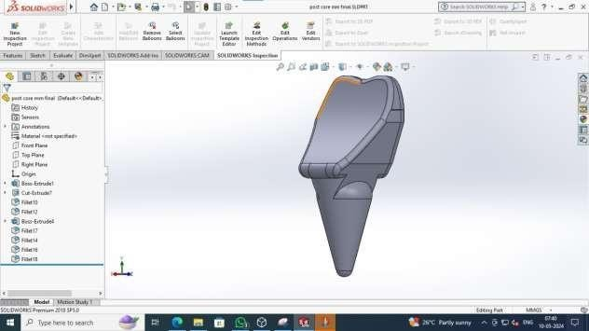

Figure 5.3 Design model of post core

Figure 5.4 Implant diameter of post core

Once the framework design is finalized, the next step is to design the pontic (artificial tooth) or pontics that will replace the missing teeth. Using SolidWorks, designers can create custom pontic shapes that blend seamlessly with the surrounding natural teeth and tissues.

SolidWorks provides tools for sculpting and shaping the pontics to achieve the desired contour, size, and alignment. Designers can also simulate the occlusal relationships and articulation of the pontics to ensure proper function and stability within the patient's bite. After designing the individual components of the bridge, the next step is to assemble them into a single cohesive unit. SolidWorks facilitates the assembly process by providing features for aligning, mating, and joining the various parts of the bridge framework and pontics.

Once the assembly is complete, designers can perform virtual tests and analyses to evaluate the structural integrity and durability of the bridge. SolidWorks offers simulation tools that allow designers to assess factors such as stress distribution, load-bearing capacity, and material properties to ensure the bridge meets the necessary performance requirements.

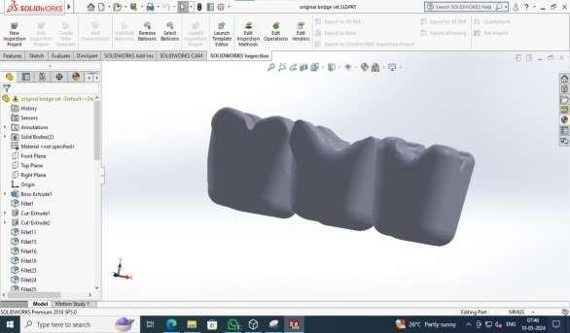

Figure 5.6 Digital model of dental bridge design

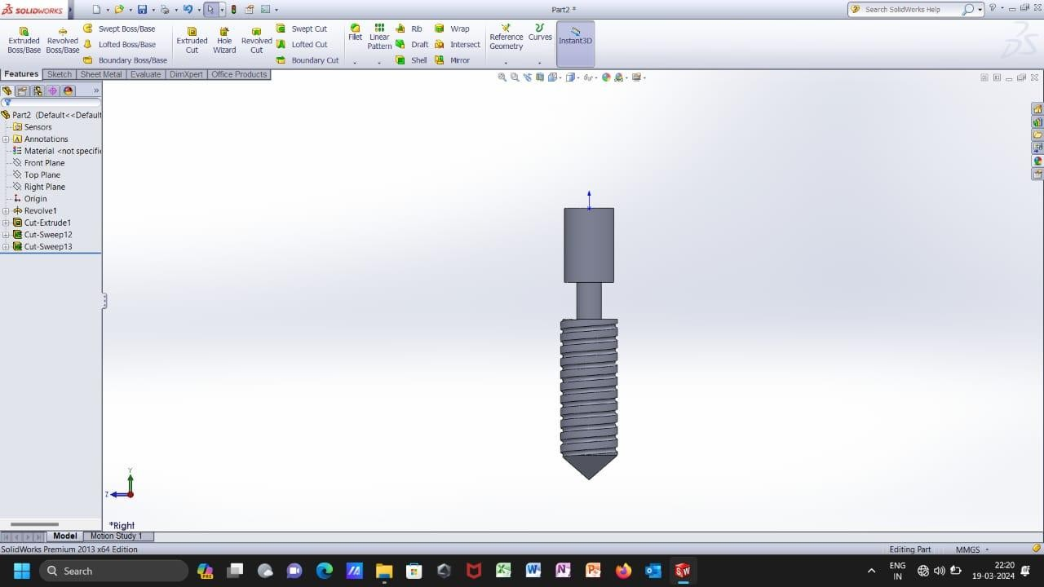Figure 5.9 Dental screw designs

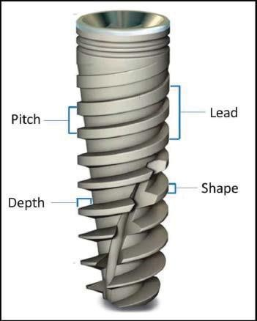

Figure 5.10 Geometric implant thread parameters

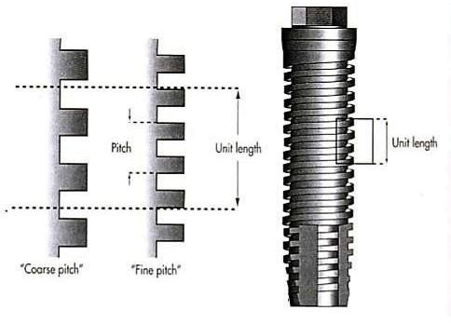

Figure 5.11 The implant on the right has smaller thread pitch and greater surface area

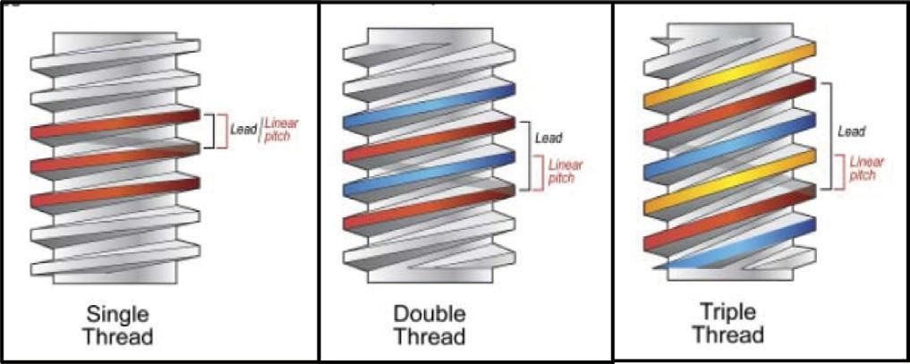

Figure 5.12 illustrates the thread configuration in relation to thread number, pitch and lead.

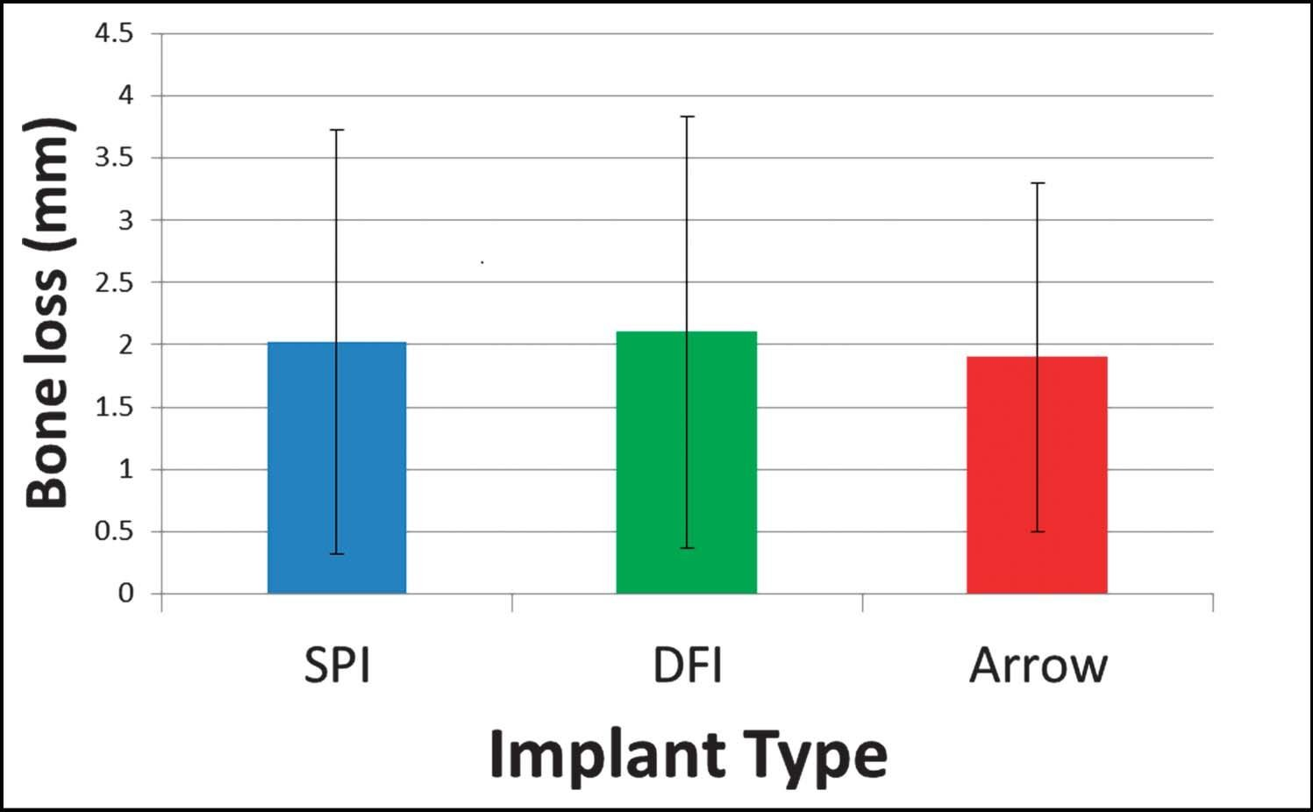

Figure 5.16 Average mesial-distal bone loss as measured from implant/abutment connection to bone level

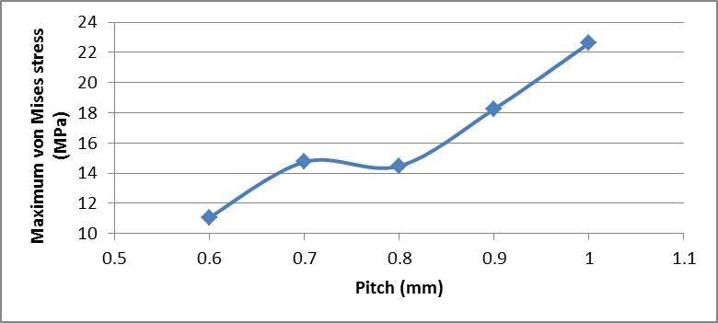

Figure 5.17 Peak von Mises stresses of the screw- Pitch variant from 0.6 to 1 mm

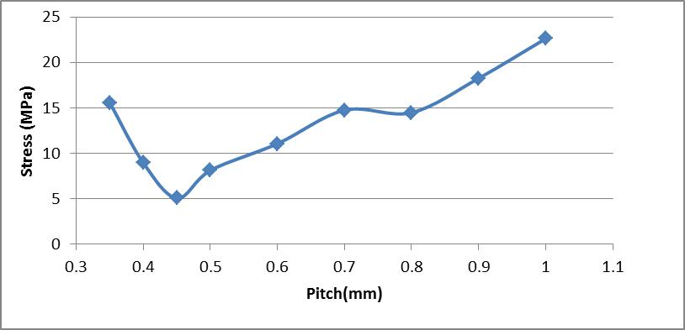

Figure 5.18 Peak von Mises stresses of the screw- pitch varia

Additionally, support structures may need to be generated automatically or manually for overhanging features or intricate geometries to prevent print failures or deformities during the printing process. Proper placement and configuration of these supports are essential to ensure successful prints with minimal post-processing requirements. Furthermore, selecting the appropriate printing speed and nozzle size can significantly impact print quality and efficiency. While higher printing speeds may reduce overall print time, they can also compromise surface finish and accuracy, especially for complex designs. Similarly, choosing the right nozzle size helps balance printing speed with detail resolution and filament flow rate. Once the slicing parameters are configured to the user's satisfaction, the slicing software generates a G-code file containing the instructions necessary to execute the print job on the Creality 3D printer. This G-code file is then transferred to the printer either via USB connection or SD card, and the printing process can commence.

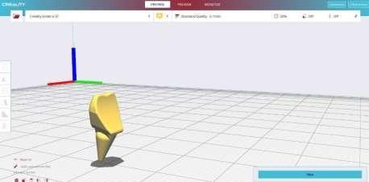

Figure 5.20 Exported sliced file in creality

The sliced data is transferred to the SLS machine, where it guides the laser sintering process. The machine builds the object layer by layer, selectively fusing the powdered material according to the instructions provided by the sliced data.

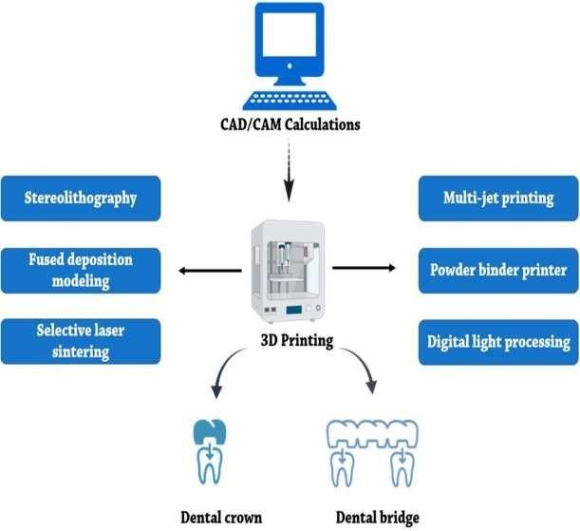

Figure 6.1 Different 3D-printing models for fabricating dental crowns and bridges.

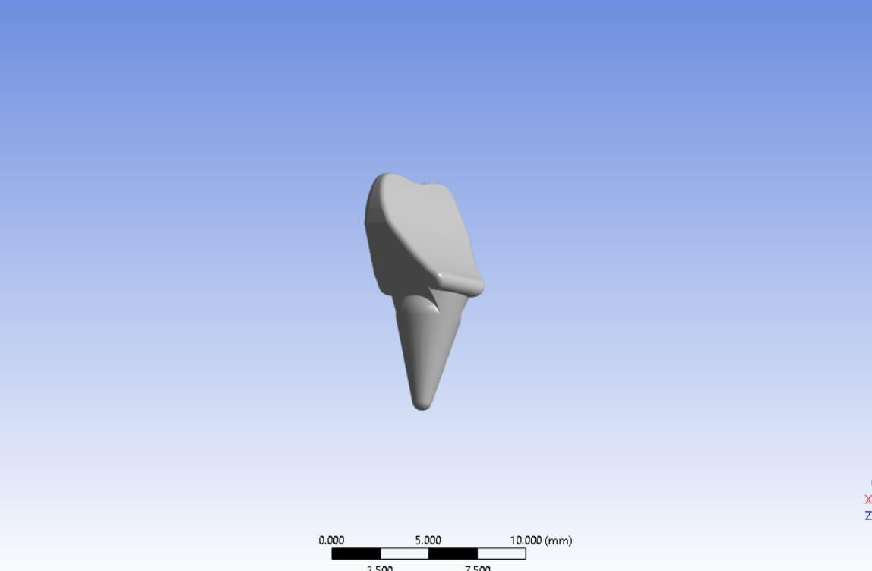3D printing has quickly accumulated broad concentration and created as a developing production method. Thus, it was broadly embraced in different fields, such as design gems, polymer printed materials, applied autonomy and mech- anization, tissue and frameworks, and gadgets items. 3D printing helped the application fields as indicated by its few qualities, for example, brief timeframe process,minimal effort, customization, and material decrease.

## RESULT

The utilization of 3D printing for designing and molding dental implants using ceramic materials yields promising results in the field of dentistry. This innovative approach offers several notable advantages over traditional manufacturing methods. Firstly, 3D printing enables the production of highly customized dental implants tailored to the individual patient's anatomy and specific treatment needs. By leveraging advanced digital design tools and precise printing techniques, dental professionals can create implants with optimal fit, functionality, and aesthetics. Moreover, ceramic materials used in 3D printing exhibit excellent biocompatibility and safety, minimizing the risk of adverse reactions or complications post-implantation. These materials are carefully selected to ensure compatibility with oral tissues, promoting osseointegration and long- term implant success. Additionally, the use of ceramic in 3D printing allows for the fabrication of implants with high precision and accuracy, resulting in superior clinical outcomes and patient satisfaction. Efficiency is another significant advantage of 3D printing in dental implant design and molding. The streamlined workflow enabled by additive manufacturing technology reduces production time and labor costs while maximizing productivity. Dental professionals can seamlessly transition from digital design to physical prototype, accelerating the treatment process and improving patient care delivery. Furthermore, the versatility of ceramic materials in 3D printing allows for the creation of complex geometries and intricate structures that are challenging to achieve with conventional manufacturing techniques. This opens up new possibilities for innovative implant designs and enhanced treatment options in restorative dentistry.

### Conclusion

In conclusion, utilizing 3D printing, particularly the Selective Laser Sintering (SLS) method, for designing and molding dental implants with ceramic materials offers significant benefits in modern dentistry. This technology allows for the creation of customized implants tailored to each patient's unique oral anatomy, improving both function and aesthetics. With high precision and accuracy, SLS printing ensures a perfect fit and long-term success of the implants. Despite some challenges, such as post-processing requirements and initial investment costs, the advantages of biocompatibility, efficiency, and customization make SLS 3D printing a valuable tool in advancing dental implant ology. Overall, this innovative approach enhances patient care by providing durable, natural-looking dental prosthetics that contribute to improved oral health and quality of life.

## REFERENCE:

1. Aditya Acharya, Raisa N. Chodankar , Raghunath Patil, Anandkumar G. Patil ―Assessment of knowledge, awareness and practices toward the use of 3D printing among dental laboratory technicians in Karnataka, India: A cross- sectional study[24 May 2023]
2. Anna Németh , Viktória Vitai , Márk László Czumbel, Bence Szabó ―Clear guidance to select the most accurate technologies for 3D printing dental models‖ [28 April 2023]
3. Cristina Espinar , Alvaro Della Bona , Maria Tejada-Casado , Rosa Pulgar―Optical behavior of 3D-printed dental restorative resins: Influence of thickness and printing angle‖ [7 August 2023].
4. Adir Cohen; Amir Laviv; Phillip Berman; Rizan Nashef; Jawad Abu-Tair ―Mandibular Reconstruction using stereolithographic 3-demensional printing modelling Technology‖.
5. Luis Fernando Velásquez-García and Yosef Kornbluth ―Biomedical Applications of Metal 3D Printing‖ [12 sep 2023].
6. Nayem Hossain,Mohammad Aminul Islam, Mohammad Asaduzzaman Chowdhury, Ashraful Alam ―Advances of nanoparticles employment in dentalimplant applications‖.[Dec 2022]
7. Silvia Vasiliu, Stefania Racovita , Ionela Aurica Gugoasa , Maria-Andreea Lungan ―The Benefits of Smart Nanoparticles in Dental Application‖[4 March2021].
8. Yifan Zhang, Karan Gulati, Ping Di ―Dental Implant Nano-EngineeringAdvances,Limitations and Futurre directions‖ [24 Sep 2021].
9. Anjali Jayaraj, Jayakrishnan, Satish SV, Krishna Prasad Shetty, K NillanShetty, Rohan Rai and Govind SL ―3D printing in dentistry: A new dimension of vision‖ [ 20 March 2019].
10. Cristian Zaharia, Alin-Gabriel Gabor, Andrei Gavrilovici, Adrian Tudor Stan, Laura Idorasi,

Cosmin Sinescu, Meda-Lavinia Negruțiu 2017;2(1):50-53

1. Khaledi AA, Farzin M, Akhlaghian M, Pardis S, Mir N. Evalu-ation of the marginal fit of metal copings fabricated by using 3 different CAD-CAM techniques: Milling, stereo lithography, and 3D wax printer. J Prosthet Dent. 2020;124(1):81-6. doi: 10.1016/j.prosdent.2019.09.002.
2. Daniel H and Buttery Lee D 2008 Tissue engineering: strategies stem cells andscaffoldsJournal of Anatomypp66–72 2019
3. Abduo, J.; Lyons, K.; Bennamoun, M. Trends in computer-aided manufacturing in prosthodontics: A review of the available streams. Int. J. Dent. 2014, 2014, 783948
4. Abdul, J., Lyons, K. and Bennamoun, M. (2014) ‗Trends in computer-aided manufacturing in prosthodontics: a review of the available streams‘, International journal of dentistry, 2014, p. 783948. doi: 10.1155/2014/783948
5. A. Barazanchi, K. C. Li, B. Al-Amleh, K. Lyons, and J. N Waddell, ―Additive technology: update on current materials and applications in dentistry,‖ Journalof Prosthodontics, vol. 26, no. 2,

pp. 156–163, 2017.

1. Md. Aminul Islam Applied Surface Science Advances 18 (2023) 100462
2. C. Ru, J. Luo, S. Xie, and Y. Sun, ―A review of non-contact micro-and nano- printing technologies,‖ Journal of Micro- mechanics and Microengineering, vol. 24, no. 5, Article ID 053001, 2014.
3. S. C. Joshi and A. A. Sheikh, ―3D printing in aerospace and its long-term sustainability,‖ Virtual and Physical Prototyping,vol. 10, no. 4, pp. 175–185, Article ID 1111519, 2015.
4. Ngo T.D., Kashani A., Imbalzano G., Nguyen K.T.Q., Hui D. Additive Manufacturing (3D

Printing): A Review of Materials, Methods, Applications and Challenges. Compos. Part B Eng. 2018;143:172–196.

1. Loomans B, Opdam N, Attin T, et al. Severe tooth wear: European consensus statement on management guidelines. J Adhes Dent. 2017;19(2):111-119.
2. Shi H., Wang T., Wang A., Liang C., Wang X., Zhang R., (2018) Thecurrent situation of ceramic 3D printing technology development and research and development trends. J. Ceramics, 16-19.
3. Yang, J.; Li, N.; Shi, J.; Tang, W.; Zhang, G.; Zhang, F. Foundation of 3D Printing and CAD File Formats Used in the Industry. InMultimaterial 3D Printing Techology; Elsevier: Amsterdam, The Netherlands, 2021; pp. 17–42. ISBN 978-0-08-102991-6.
4. M. Bengisu, Engineering ceramics, Springer Science & Business Media,2013. Journal of the European Ceramic Society 39 (2019) 661–687
5. Ebert, J.; Özkol, E.; Zeichner, A.; Uibel, K.; Weiss, Ö.; Koops, U.; Telle, R.Fischer, H. Direct inkjet printing of dental prostheses made of zirconia. J. Dent. Res. 2009, 88, 673–676. [CrossRef] [PubMed]
6. P. Everitt, I. Doggett, 2009. Advanced Ceramics in demands, CeramicIndustry Report.
7. Punj S, Singh J, Singh K. Ceramic biomaterials: properties, state of the art and future prospectives. Ceram Int 2021;47(20):28059e74.
8. Loomans B, Opdam N, Attin T, et al. Severe tooth wear: European consensus statement on management guidelines. J Adhes Dent. 2017;19(2):111-119.
9. J. Li, H. Liao and L. Hermansson, Sintering of partially-stabilized zirconia and partially- stabilized zirconia—hydroxyapatite composites by hot isostaticpressing and pressureless sintering, Biomaterials, 17 (1996), 1787-1790.
10. Lee J-Y, An J, Chua CK. Fundamentals and applications of 3D printing for novel materials. Appl Mater today. 2017; 7:120–33.
11. Gebhardt, A. Rapid Prototyping; Hanser Verlag:Munich, DE, 2003.
12. Badran N, et al. Effect of incisal porcelain veneering thickness on the fracture resistance of CAD/CAM zirconia all-ceramic anterior crowns. 2019:2019.

https://doi.org/10.1002/jbm.b.34744.