**Implementation of a Comprehensive Policy to Support Weak Students and Encourage Bright Students: Fostering Inclusivity and Excellence**

J T Patankar

Head of the Department, Instrumentation and Control Engineering

Government Polytechnic, Gandhinagar

jtpatankarblog@gmail.com

**Abstract:**

In contemporary education systems, fostering inclusivity while promoting excellence remains a paramount objective. This abstract outlines an innovative educational policy aimed at supporting weak students and encouraging bright students, ensuring equitable opportunities for all learners.

The policy framework entails multifaceted approaches tailored to the diverse needs of students across academic spectrums. For weak students, the policy emphasizes targeted intervention strategies, including personalized tutoring, remedial classes, and academic counseling, to address individual learning gaps and enhance academic performance. Additionally, a supportive infrastructure comprising mentorship programs and peer-to-peer support networks is proposed to cultivate a conducive learning environment for struggling students.

The policy advocates for the integration of project-based learning and extracurricular activities to stimulate the intellectual growth of high-achieving students.

Furthermore, the policy underscores the significance of inclusive pedagogical practices, such as differentiated instruction and universal design for learning, to accommodate diverse learning styles and abilities effectively. By fostering a culture of inclusivity and equity, the policy aims to mitigate disparities in academic achievement and promote holistic development among students.

To ensure the successful implementation of the policy, collaboration among various stakeholders, including educators, administrators, parents, and community members, is essential. Continuous monitoring and evaluation mechanisms will be established to assess the efficacy of interventions and make data-driven adjustments to optimize student outcomes.

**Introduction:**

Higher education institutions are tasked with nurturing diverse student populations, each with unique academic capabilities and learning needs. To address this challenge, the National Board of Accreditation (NBA) has mandated the formulation of a policy that supports weaker students while simultaneously encouraging and advancing brighter students. This policy aims to create an inclusive learning environment that fosters academic excellence and caters to the varying needs of the student body. This comprehensive educational policy endeavors to create a supportive and inclusive learning environment that empowers all students to reach their full potential. By prioritizing both remediation and enrichment initiatives, the policy seeks to bridge the achievement gap and cultivate a generation of resilient, innovative, and socially responsible learners.

**Objectives:**

The primary objectives of this policy are fourfold:

1. To establish a methodology for identifying weak and bright students based on academic performance criteria.

2. To plan and implement activities tailored to improving the academic performance of weak students.

3. To design and execute initiatives that promotes the advancement and enrichment of bright students.

4. To conduct impact and outcome analyses to assess the effectiveness of the implemented strategies.

**Policy Development Process:**

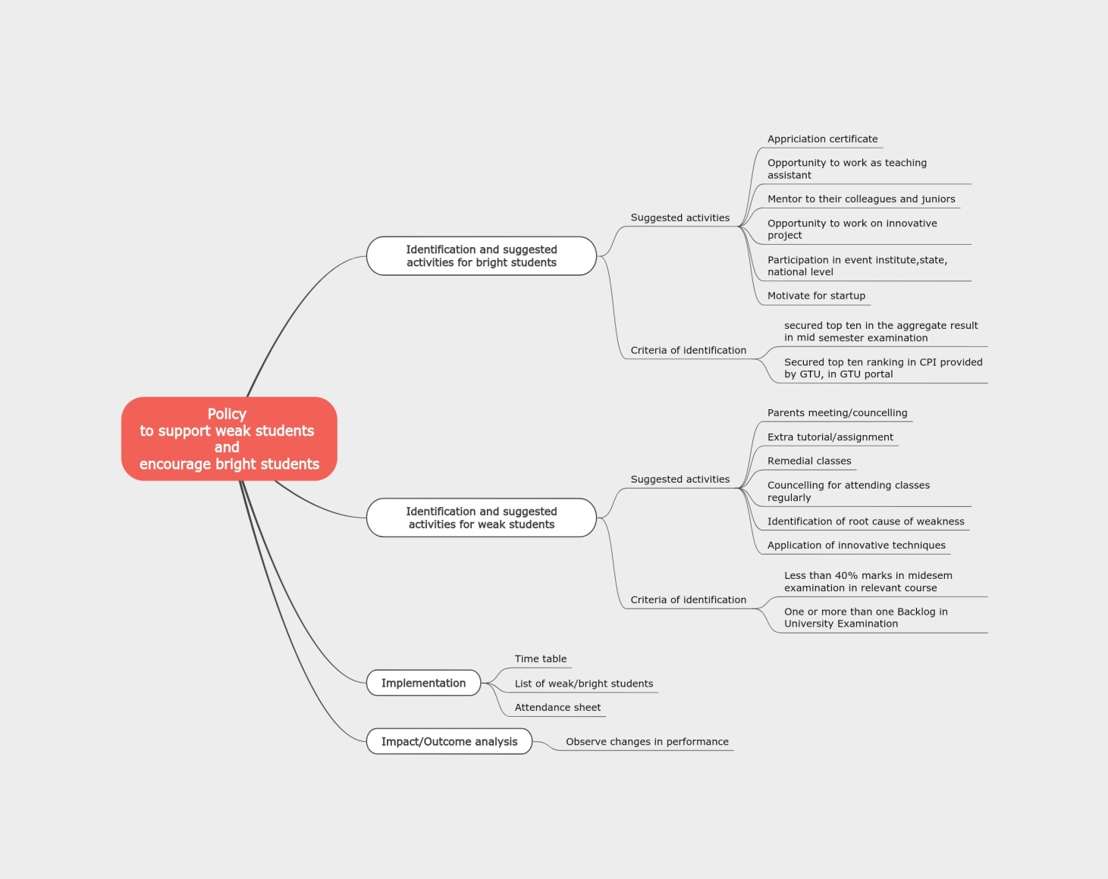

**Figure 1. Policy development process**

The formulation of this policy followed a meticulous process involving stakeholder consultations and iterative revisions. The Departmental Internal Quality Assurance Cell (IQAC) played a pivotal role in coordinating the policy development stages, which included:

1. Defining the process to prepare the policy through a meeting with IQAC members.

2. Conducting a stakeholder meeting to gather inputs from industry professionals, parents, alumni, and IQAC members on the criteria for identifying weak and bright students, suggested activities, and impact analysis mechanisms.

3. Drafting a proposed policy based on the stakeholder feedback.

4. Convening a second stakeholder meeting to validate and refine the draft policy.

5. Finalizing the policy by incorporating additional suggestions from stakeholders.

6. Obtaining stakeholder signatures, disseminating the final policy, and publishing it on the department's website.

**Policy Components:**

**Methodology to Identify Weak and Bright Students**

The policy outlines a dual-criteria approach to identify weak and bright students based on their academic performance:

1. Mid-Semester Examination performance:

- Weak students: Those scoring below 40% in the relevant course.

- Bright students: Those ranking among the top ten in the aggregate result.

2. Previous Semester's End-Semester University Examination performance:

- Weak students: Those with backlogs in one or more courses.

- Bright students: Those securing a position among the top ten in the Cumulative Performance Index (CPI) provided by the university.

**Suggested Activities to Support Weak Students and Encourage Bright Students**

The policy recommends a range of activities tailored to address the specific needs of weak and bright students:

Activities for Weak Students:

1. Arranging parent meetings and counseling sessions.

2. Providing extra tutorials and assignments.

3. Conducting extra or remedial classes.

4. Motivating and encouraging regular class attendance.

5. Mentoring and counseling to identify root causes of weaknesses and suggesting resolutions.

6. Implementing innovative teaching-learning techniques.

Activities for Bright Students:

1. Recognizing and appreciating their achievements during orientation programs and departmental events.

2. Providing opportunities to mentor weaker students or serve as teaching assistants during practical sessions and project work.

3. Encouraging participation in challenging projects, research initiatives, and technical or co-curricular events at various levels.

4. Motivating them to write student-level papers and explore entrepreneurial endeavors through startups.

**Implementation of the Policy**

The policy outlines specific steps for faculty members to implement the proposed activities effectively:

1. Identify weak and bright students based on the defined criteria and maintain a list.

2. Prepare a schedule or timetable for the planned activities and communicate it to the students.

3. Conduct the activities, maintain attendance records, capture photographs, and collect relevant supporting documents.

**Impact and Outcome Analysis**

To assess the effectiveness of the implemented strategies, the policy suggests the following measures for impact and outcome analysis:

For Weak Students:

1. Observe improvements in mid-semester examination performance by comparing results before and after remedial interventions.

2. Evaluate improvements in the next semester's End-Semester University Examination performance compared to the previous semester.

For Bright Students:

1. Monitor their contributions in mentoring weaker students and juniors.

2. Assess their involvement as teaching assistants during practical sessions.

3. Evaluate their participation in innovative projects, research initiatives, and technical or co-curricular events.

4. Track their efforts in writing student-level papers and exploring entrepreneurial ventures.

**Conclusion:**

The comprehensive policy outlined in this document represents a concerted effort to create an inclusive and supportive learning environment that addresses the diverse needs of weak and bright students. By implementing targeted activities and regularly assessing their impact, educational institutions can foster academic excellence, nurture talent, and empower students to reach their full potential. This policy serves as a guiding framework for higher education institutions committed to promoting equity, academic growth, and holistic student development.