**STATE-SPACE MODELLING AND CONTROL OF HYBRID STEPPING MOTOR FOR ROBOT GRINDING USING LQR CONTROLLER**

**Achebe, P. N., Muoghalu, C. N.**

Department of Electrical and Electronic Engineering

Chukwuemeka Odumegwu Ojukwu University

Uli, Nigeria

**ABSTRACT**

This paper presents state-space modelling and control of two-phase hybrid stepping motor (2-PHSM) for robot grinding using linear quadratic regulator (LQR). The objective of the study is to use state-space modelling approach to model 2-PHSM and subsequently designed an optimal control system rather than the commonly used transfer function model due to its limitations in modern control theory. Initially, state-space model of the 2-PHSM was obtained from transfer function using direct decomposition method and this was followed by LQR design. The Designed LQR was introduced into the control system for the 2-PHSM in robot grinding. With the system modelled and simulated in MATLAB, the results obtained by varying the Q matrix of optimal controller revealed that desired step input was achieved with negligible steady state error of 0.01 and 0.02, which agrees with 2% criterion. In both cases the system maintained good stability with 4.14% overshoot.

**Keywords:** LQR controller, State-space modelling, Optimal control, stepping motor, Robot grinding

1. **INTRODUCTION**

In the mathematical modelling of electrical systems, several methods are used to describe their dynamic characteristics. One approach that is commonly used is the transfer function. This is because the transfer function model offers simple and powerful analysis and design approaches, and is usually used in the design and analysis of feedback system involving root locus and frequency response techniques [1,2]. However, in the transfer function method, mathematical equation is used to establish a linear relationship between the input and the output of the system without providing any information regarding the components responsible for the dynamic behaviour of the system. There are some other limitations to the application of transfer function such as the fact that its use is usually applicable to wherein the initial conditions must be defined under zero initial conditions. In addition, it is only applicable to linear time-invariant (LTI) systems and confines generally to single-input single-output (SISO) systems [2]. The application of transfer function modelling multiple-input multiple-output systems makes the design and analysis process complicated [1].

With only the knowledge of the output revealed for a given input without the information regarding the internal (or state) variables of the system, a situation could arise whereby the output of a system is stable but some of the elements of the system may likely exceed their defined values [1]. This challenge is addressed in modern control theory.

Modern control systems such as optimal control methods use mathematical representation called state space modelling that provides the information regarding the internal states of the system. It is suitable for analysis of both LTI and nonlinear time-invariant or time-varying systems. It is also good method for MIMO systems.

In this paper, the advantage of state space modelling is used to represent the dynamic of stepping motor positioning system in robot grinding. Furthermore, utilizing this method of modelling, a linear quadratic regulator (LQR), which is an optimal control system, is designed in robot grinding process that uses two-phase hybrid stepper motor (2-PHSM).

1. **CONCEPT OF STATE-SPACE MODELLING**

The basic idea of state space modelling is to represent the dynamics of a system using differential equations that provide information concerning not only about the output for a given input command signal but also how the internal components of the system respond to the introduction of signal. This way a more clarity is provided and the design is equipped with the information on the overall behaviour of the system. This therefore enables the compensation to system such as controller to be properly selected and designed.

This approach has been widely used. It has been used in the state feedback control of satellite antenna and temperature control in data centre [3,4]. Linear quadratic control and integral control techniques for Single, two and three area load frequency control (ALFC) power systems have been achieved using state space modelling approach [5]. Dynamic analysis and modelling of two-mass system was performed using state model together with a modified proportional integral derivative (PID) controller in [6]. The mathematical model based on state-space modelling was used in designing an agile two-wheeled robot with machine vision [7].

State-space modelling is a time domain method that provides basis for modern control theory and system optimisation, which also functions as an effective technique for linear and nonlinear time invariant system design and analysis [1]. The block diagram description of the variables of a plant model is shown in Figure 1.

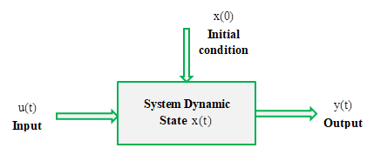

**Figure 1:** Block diagram description of state space system

The mathematical expression of a LTI system in state space form is given by:

 (1)

where: A is the state matrix, B is the input matrix, C is the output matrix, and D is the transition matrix.

1. **THE ROBOT GRINDING PROCESS AND SYSTEM DESIGN**

This section will begin with a brief description of the grinding process utilizing 2-PHSM in robotic grinding. The 2-PHSM provides the mechanical motion for the grinding process. The motor is used in milling process and provides appropriate torque together with better noise, vibration, and cost performance [8]. The schematic diagram of the robot grinding process (milling machine) is shown in Figure 2. The figure shows that the normal,  and the tangential force, are the forces for milling process [8].

The mathematical modelling of a two-phase hybrid stepper motor and the design of LQR control system are presented in subsequent subsections. For the mathematical modelling, the transfer function model of 2-PHSM is transformed to its state-space equivalent model. This approach is commonly used in control systems engineering such that state-space model can be transformed into transfer function model as well as in [9] and [10] vice versa.

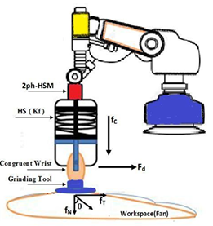

**Figure 2:** Servo system of robot grinding process [8]

## Mathematical Model of Two-Phase Hybrid Stepper Motor

The two-phase hybrid stepper motor in robotic grinding whose dynamic is represented in terms of transfer function in [8,11] is further modelled in state-space form using direct decomposition method in this subsection. The plant model in transfer function is given by [8,11]:

 (2)

Applying direct decomposition, the state variable is defined by taking the numerator of (2) as one, and this is written as:

 (3)

where the transfer function , and , U(s),  are respectively the system response, the control input and state variable respectively. Writing Eq. (3) form as:

 (4)

The state variables are now defined in state-space form as follows:Thus the resulting state-space equation is given by:

 (5)

 (6)

Expressing (6) in time domain in terms of differential equation gives:

 (7)

Equation (7) further expressed in state variable form as in (8) and this reveals the dependence of the output on the system internal variable, which are not revealed using transfer function.

 (8)

The matrix representation of the state space variables with respect to the output is given by:

 (9)

Now, considering Eq. (1), A, B, C, and D matrices are defined from the modelled state-space.

 ,



## Design of LQR System

The designed robot grinding process control using LQR controller is presented in this subsection. As a result of the stability offered by LQR technique, it has been widely used besides PID controller in several control application and is employed in modern optimal control theory [12]. The LQR is an optimal control system whose objective is to minimize the quadratic cost function defined by [13]:

 (10)

where Q and R are the state and control law matrices respectively. Usually, Q is varied while R is kept constant during design.

There are three steps to designing a LQR control system: the first is to determine the Q and R matrices, the second is to find the Ricati coefficient matrix P, and the third step is to determine the control law gain matrix K.

The Ricati coefficient matrix P is the unique symmetric matrix of the Ricatti equation given by [12,14]:

 (11)

The value of R was fixed as 1, while the Q matrix was varied and yielding corresponding values of P using MATLAB program.









The system is taken to zero state in optimal manner by the input and it is called the feedback control law of the optimal controller that minimises the cost function defined by:

 (12)

where,

 (13)

It is the gain matrix of the optimal control law and is determined using the MATLAB syntax:With respect to different values of Q matrix, different K values were computed.







The block diagram of LQR control system is shown in Figure 3.

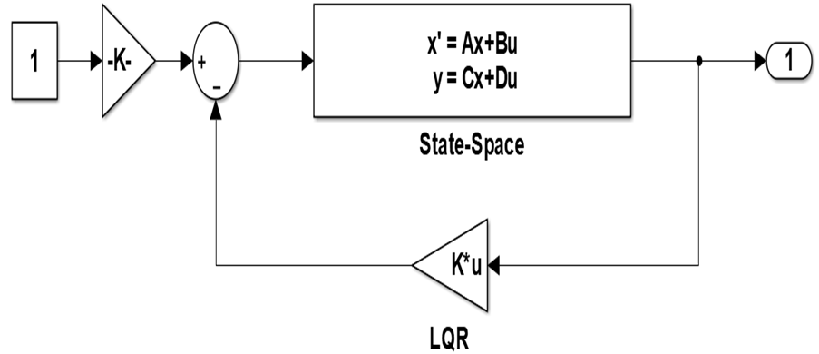

**Figure 3:** Block diagram model of LQR control system

1. **RESULTS AND DISCUSSION**

The results obtained by tuning the Q matrix for are presented in this section. With the Q matrix tuned, different optimal gain matrix were obtained resulting in different control action on the system. The system response was tagged sys1, sys2, and sys3 with respect to the each control command applied. The various graphs obtained with respect to each step response of the system for varying Q value are shown in Figures 4-6. A combination of the responses is shown in Figure 7 for comparison. Table 1 is the numerical performance analysis of the responses generated by the system for a given Q value.

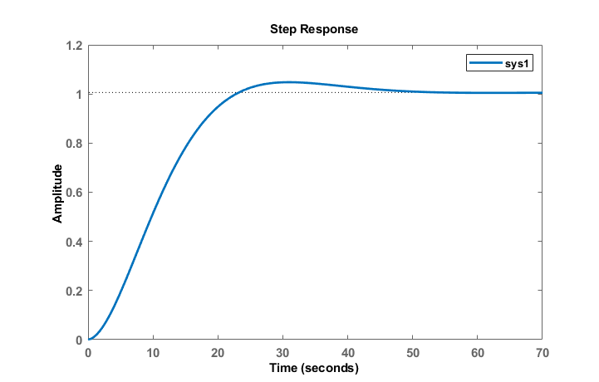

**Figure 4:** Step response for Q1 (sys1)

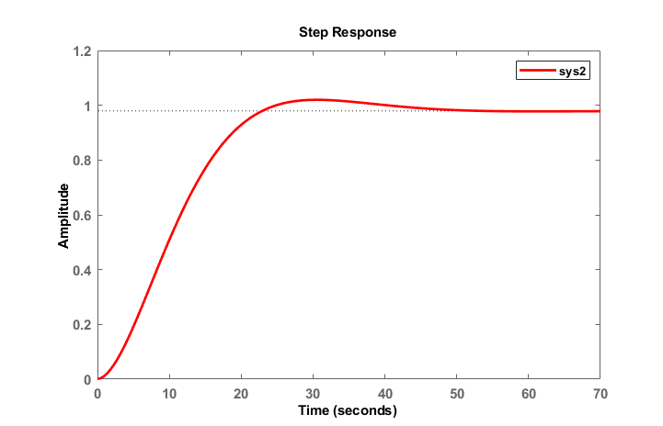

**Figure 5:** Step response for Q2 (sys2)

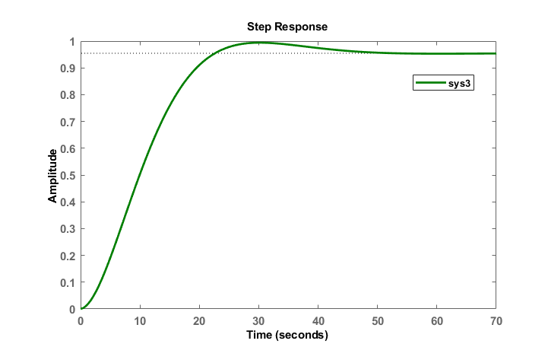

**Figure 6:** Step response for Q3 (sys3)

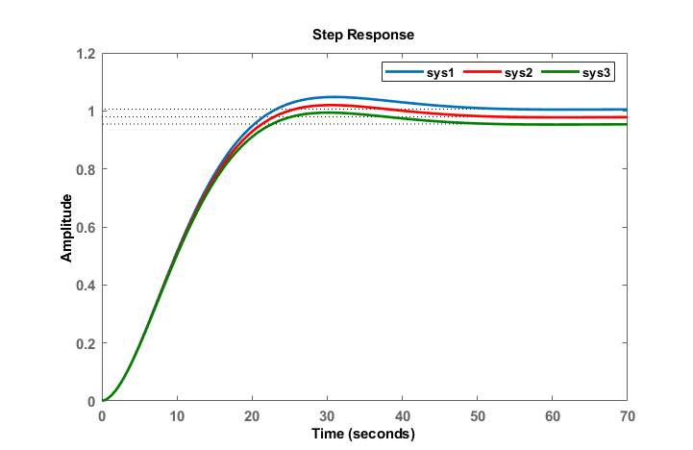

**Figure 7:** Comparison of LQR control system for varying Q matrix

**Table 1.** Numerical analysis of system response

|  |  |  |  |  |  |
| --- | --- | --- | --- | --- | --- |
| System | Rise time  (s) | Peak time  (s) | Settling time (s) | Overshoot (%) | Final value |
| Sys1 (Q1) | 15.1 | 31.1 | 41.2 | 4.14 | 1.01 |
| Sys2 (Q2) | 14.9 | 30.6 | 40.7 | 4.14 | 0.98 |
| Sys3 (Q3) | 14.7 | 30.3 | 40.2 | 4.14 | 0.96 |

The numerical analysis as shown in Table 1 revealed that the LQR was able to provide good and stable transient and steady state response performance for the grinding process. With the initial value of the Q matrix (Q1), the system (sys1) response indicated rise time of 15.1 s, peak time of 31.1 s, settling time of 41.2 s, and overshoot of 4.14% and a final value of 1.01. For Q2, the step response of the system (sys2) was slightly improved compare with sys1 in terms of rise time, peak time, and settling time. Similarly, with Q3, the third scenario showed that the response of the system (sys3) was the best in terms of rise time, peak time, and settling time. However, the peak percentage overshoot remains the same in all cases. Also, while sys1 achieved final value of 1.01 with steady state error of 0.01, sys2 yielded final value of 0.98 with steady state error of 0.02, and sys3 offered final value of 0.96 with steady state error of 0,04.

Considering the numerical analysis, the system sys1 yield the finest performance followed by sys2. The steady state error performance of sys1 and sys2 meets the 2% criterion considered during simulation. Contrary performance was provided by sys3, which yielded a final value of 0.96. This results in steady state error of 0.04 and this does not meet the 2% criterion for the simulation conducted. Thus, sys1 and sys2 are ideally suitable for robot grinding control process considering the 2% criterion.

1. **CONCLUSION**

In this paper, an optimal control system based on LQR has been designed for the control of two-phase hybrid stepping motor (2-PHSM) in robot grinding process. The dynamic of the 2-PHSM was initially established in transfer function s-domain representation. Direct decomposition technique was applied to model the system dynamic in state space form. Using the parameters of the state-space model such as the state matrix, the input matrix, and output matrix, the quantities guiding the optimal control performance of the LQR were determined. With the design of the LQR controller, the Q matrix was designed with three different values. Simulation results conducted with the designed LQR system indicated that it yielded good response performance.

**REFERENCES**

1. Ekengwu, B. O., Jonathan, A. E., & Eze, P. C. (2024). Effect of control model on internal variable dynamic characteristics of a plant: A state feedback controlled satellite antenna, International Journal of Academic Multidisciplinary Research, vol. 8, no. 3, pp. 163-169.
2. Nagrath, I. I., & Gopal, M. (2005). Control Systems Engineering, 4th ed., New Age International Publishers, New Delhi.
3. Ekengwu, B. O., Eze, P. C., Asiegbu, C. N., Olisa, C. O., & Udechukwu, C. F. (2022). Satellite dish antenna control for distribution mobile telemedicine nodes, International Journal of Informatics and Communication Technology, vol. 11, no. 3, pp. 206-217.
4. Eze, P. C., Muoghalu, C. N., Uebari, U., & Egbunugha, C. A. (2022). State variable feedback control of data centre temperature, International Journal of Advanced Networking and Applications, vol. 14, no. 01, pp. 5250-5257.
5. Shah, N. N., & Kotwal, C. D. (2012). State space modeling of single, two and three ALFC of power system using integral control and optimal LQR control method, IOSR Journal of Engineering, vol. 2, no. 3, pp. 501-510.
6. Shahgholian, G. (2017). Controller design for three-mass resonant system based on polynomial method, International Journal of Science, Technology and Society, vol. 5, no. 2, pp. 13-25.
7. Kung, F. (2017). Design of agile two-wheeled robot with machine vision, Conference paper, available at: <https://www.researchgate.net/publication/323651242>
8. Abdullah, F. N., Aziz, G. A., & Shneen, S. W., (2023). GWO-PID of two-phase hybrid stepping motor for robotic grinding force, Journal of Fuzzy Systems and Control, vol. 1, no. 3, pp. 71-79.
9. Okoye, U. P., Eze, P. C., & Oyiogu, D. C. (2021). Enhancing the performance of AVR system with prefilter aided PID controller, Access International Journal of Rsearch & Development, vol. 01, no. 01, pp. 19-32.
10. Eze, P. C., Onuora, A. E., Ekengwu, B. O., Muoghalu, C., & Aigbodioh, F. A. (2017). Design of a robust PID controller for improved transient response performance of a linearized engine idle speed model, American Journal of Engineering Research, vol. 6, no. 8, pp. 305-313.
11. Attiya, A. J., Shneen, S. W., Abbas, B. A., & Wenyu, Y. (2016). Variable speed control using fuzzy-PID controller for two-phase hybrid stepping motor robotic grinding, Indonesian Jounal of Electrical Engineering and Computer Science, vol. 3, no. pp. 102-118.
12. Frank, L., Vrabie L. D., & Symos, V. L. (2012). Optimal Control. 3rd Edition, John Wiley and Sons, New Jersey, USA.
13. Aloo, L. A., Kihato, P. K., & Kamau, S. I. (2016). DC servomotor-based antenna positioning control system design using hybrid PID-LQR controller. European International Journal of Science and Technology, 5(2), 17-31.
14. Yu, G. R. & Hwang, R. C. (2004). Optimal PID speed control of brush less DC motors using LQR approach. In Proceeding of IEEE International Conference on Man and Cybernetics, Hague, Netherlands, 473-478.