ANALYZING THE EFFICACY OF DIAGONAL BRACING SYSTEMS FOR LATERAL LOAD RESISTANCE IN MULTISTOREY BUILDING
¹Mr. Gaurav Mungalkar and ²Prof. Ishant Dahat
¹PG Scholar, Department of Civil Engineering School of Engineering and Technology, G H Raisoni University , Amravati , Maharashtra, India
²Assistant Professor, Department of Civil Engineering School of Engineering and Technology, G H Raisoni University , Amravati , Maharashtra, India
ABSTRACT:
This study examines the displacement data and structural forces of 16 models with varying diagonal bracing configurations in multi-story buildings. The analysis reveals that horizontal displacements (X and Z) significantly influence the resultant displacement, whereas vertical displacements (Y) remain relatively constant and have a minor impact. Models with higher horizontal displacements exhibit greater resultant displacements, underscoring the correlation between these parameters. Structural forces and moments vary across models, with the highest values observed in Model-15, featuring robust bracing in a five-story building, indicating enhanced stability against lateral forces. Conversely, the minimum force values are found in Model-3, characterized by less extensive bracing in a two-story building, highlighting the comparatively lower resistance to structural forces. The study underscores the critical role of diagonal bracing configurations in distributing forces effectively and mitigating displacement. Proper placement of diagonal bracing significantly enhances the structural integrity, stability, and resilience of buildings, particularly against lateral loads. These findings emphasize the importance of optimizing bracing configurations in building designs to ensure safety and performance in multi-story structures. The insights gained from this analysis are crucial for structural engineers aiming to improve building designs and enhance resistance to external forces.
Keywords- Bracings, displacement, reactions, earthquake and moment
1 INTRODUCTION
In recent years, there has been a notable shift in the complexity of residential and commercial structures compared to those built a few decades ago. Traditionally, these structures were primarily rectangular in shape, adhering to conventional lateral load paths. This simplicity facilitated straightforward structural design and analysis, ensuring that buildings could reliably withstand lateral forces such as wind and seismic loads. The rectangular geometry allowed engineers to apply well-established principles of lateral load distribution, leading to predictable and manageable stress and deformation patterns within the structure.
However, advances in technology and architectural design have ushered in an era of more complex structural forms. Modern residential and commercial buildings often feature innovative and unconventional shapes, incorporating multiple irregularities that significantly complicate their structural behavior. These irregularities can include nonparallel systems, where structural elements are not aligned in a uniform grid, creating challenges in predicting load paths and stress distributions. Diaphragm discontinuities, such as openings or changes in the diaphragm plane, disrupt the continuity of horizontal load transfer elements, further complicating the structural analysis.
2 LITERATURE REVIEW
Agarwal, P. et al observed that while damage in the irregularity after a lateral loading event has been noted for over a hundred years now, it is only in the last twenty years that research has been done to try to better understand and determine the magnitude of forces in the irregularity. Since it is difficult to determine analytically the magnitudes of the forces, as explained previously, models have been developed and tested either in wind tunnels or on shake tables to investigate the forces in irregularity structures.
Ahmad J. Durrani et al.investigated the behavior of engineered light-frame wood construction under lateral loads. Part of the investigation was to examine diaphragm action with irregularity. A uniformly distributed load was applied to the model through the use of gasbags set along the exterior floor edges. As a part of their investigation, a series of tests were executed, one of which was an ultimate load test. After the ultimate load test was performed, the irregularity of the model was examined. It was found that no visible damage had been done. They concluded that lateral loads could be successfully resisted without continuous end chord if the irregularity of the diaphragm was less than 1.0 meter.
Akshay Nagpur,et al concluded that to have a irregularity in their model less than 1.0 meter was based on a finite element analysis study on openings and offsets in buildings. Their results confirmed some of the data presented in that study. Authors from the Seismological Laboratory of the California Institute of Technology did a case study of damage to 19-story irregular steel moment frame buildings under near-source ground motion. The purpose of his study was to compare the performance of buildings that do not adhere to wind drift limits to those that do, by comparing 3 19-story irregular steel moment-frame buildings. Two of the buildings had irregularity irregularities, while the third had a plan torsional irregularity. Authors used the UBC97 and assumed that each structure was located in a Seismic Zone 4 with soil Type, also selected three different sets of three component ground motion records so as to compare results. He concluded that none of the buildings, whether they adhered to wind drift limits or not, would satisfy the life safety performance level for existing buildings as given by FEMA-356.
Amin Alavi, et al. concluded that the results from his investigation were similar to results found in structures after the 1994 Northridge earthquake. While the stress concentration in irregularity was not a part of his primary investigation, he did comment on it. Authors concluded that the specific stress concentrations were averaged out over a large area near the irregularity. The results were also inconclusive in regards to an increase in stress concentration in the irregularity since a stress concentration increase in the irregularity was only noticed in one of the two models containing irregularity. A more rigorous and detailed analysis is required to conclusively rule out the incidence of stress concentration at the irregularity.

3. METHODOLOGY
The chapter outlines a method for analyzing buildings with identified irregularities using the STAAD-PRO software. This analysis focuses on various configurations of diagonal bracing to enhance structural stability against seismic forces. The models are categorized based on the number of floors and the placement of diagonal bracing.
- EQ-2-Diagonal bracing at front: This model features two floors with diagonal braces only on the front facade to provide lateral stability.
- EQ-2-Diagonal bracing at front and side: Extending the previous model, braces are added to the front and side of a two-story building for improved resistance against lateral forces from multiple directions.
- EQ-2-Diagonal bracing at front, side, and back: This model includes diagonal bracing on the front, side, and back of a two-story building, offering comprehensive lateral support.
- EQ-2-Diagonal bracing at side: Diagonal braces are placed only on the side of the two-story building, targeting lateral stability from side forces.
- EQ-3-Diagonal bracing at front: Similar to the first model, but with three floors, this setup provides front-facing bracing for increased height.
- EQ-3-Diagonal bracing at front and side: Braces are added to the front and side of a three-story building for multidirectional stability.
- EQ-3-Diagonal bracing at front, side, and back: This model offers three-directional bracing for a three-story building, ensuring robust lateral support.
- EQ-3-Diagonal bracing at side: Diagonal braces are placed only on the side of the three-story building to counteract side forces.
- EQ-4-Diagonal bracing at front: Four floors are supported with diagonal bracing at the front, aiming for front-facing lateral stability.
- EQ-4-Diagonal bracing at front and side: This model includes front and side bracing for a four-story building to handle lateral forces from multiple directions.
- EQ-4-Diagonal bracing at front, side, and back: Providing comprehensive support, this model features diagonal bracing on the front, side, and back of a four-story building.
- EQ-4-Diagonal bracing at side: Diagonal braces are added to the side of the four-story building, focusing on side stability.
- EQ-5-Diagonal bracing at front: Diagonal braces are installed at the front of a five-story building to enhance its front-facing lateral stability.
- EQ-5-Diagonal bracing at front and side: This model incorporates diagonal bracing at both the front and side of a five-story building for improved multidirectional support.
- EQ-5-Diagonal bracing at front, side, and back: For maximum stability, this model features diagonal bracing on the front, side, and back of a five-story building.
- EQ-5-Diagonal bracing at side: Diagonal braces are placed on the side of the five-story building, targeting side lateral stability.
Each configuration aims to improve the building's resilience against seismic forces by strategically placing diagonal bracing in various locations and combinations, thus addressing the structural needs dictated by building height and expected stress points.
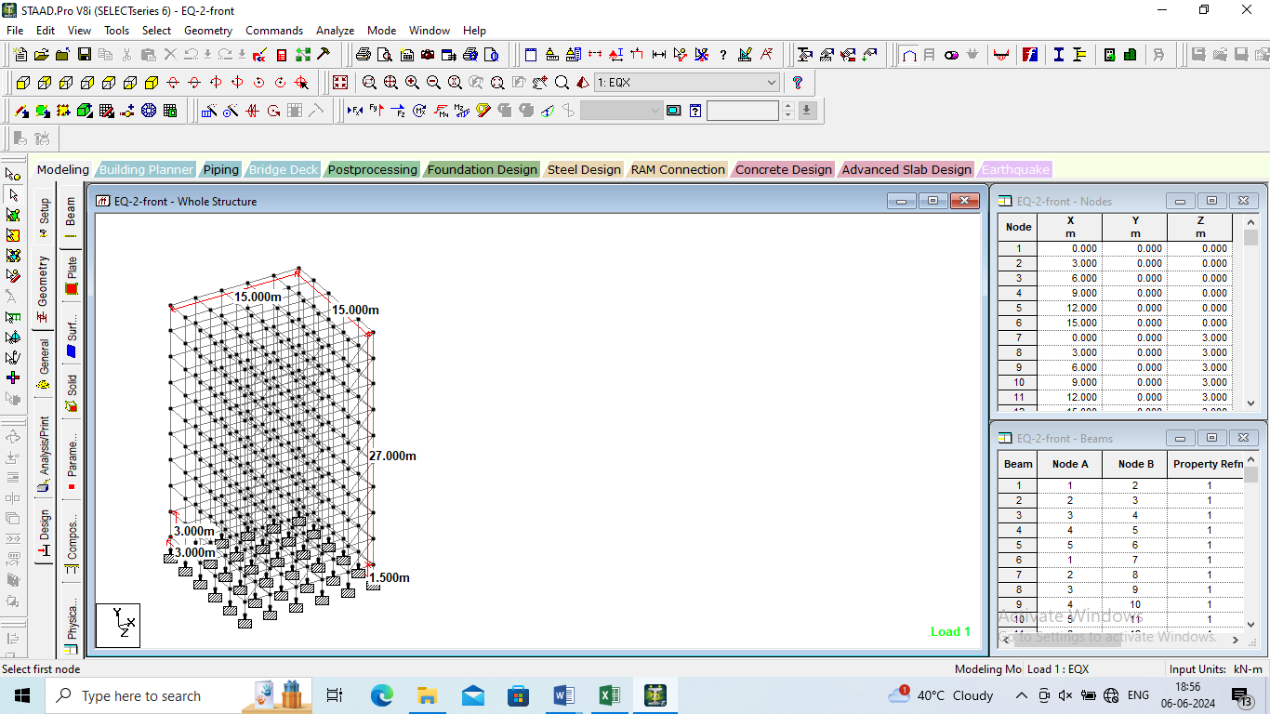
Figure 1:Geometry of the model

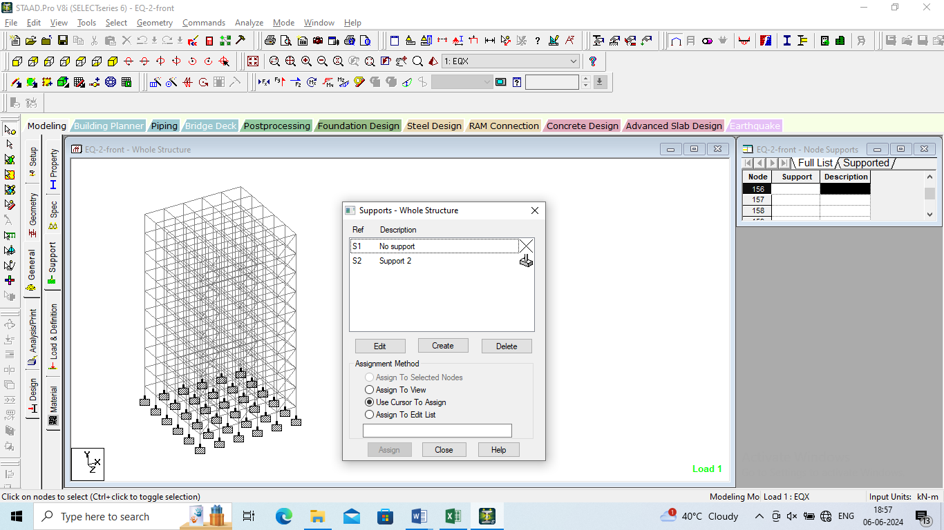
Figure 2:Supports of the model

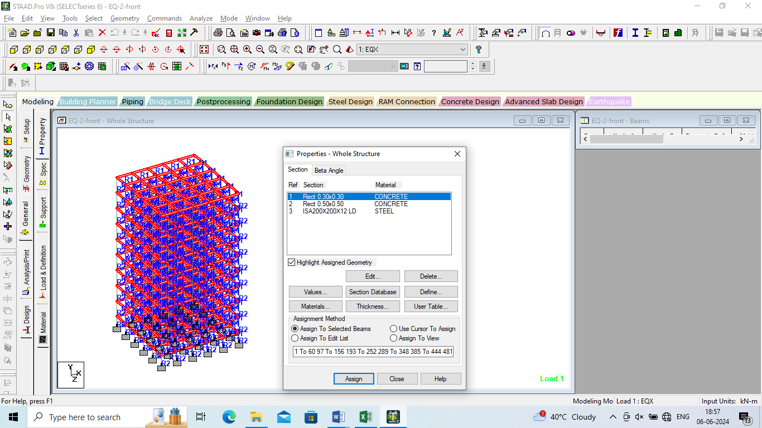
Figure 3:Properties Assigned to the model

4. RESULTS & DISCUSSIONS
The results chapter of this study presents an in-depth analysis of various structural models featuring diagonal bracing configurations. Spanning from two to five stories, each model is meticulously examined for its effectiveness in providing lateral stability against different directions of forces. By evaluating the performance of these models, valuable insights into the optimal placement and extent of diagonal bracing for enhancing structural integrity are gained, contributing significantly to the field of architectural engineering and building design.
Figure 4:Horizontal Displacement (X) for all the models
The maximum horizontal measurement, found in Model-13 (EQ-5-Diagonal bracing at front) and Model-14 (EQ-5-Diagonal bracing at front and side), suggests that these configurations offer the highest level of lateral stability among the presented models. These models are designed to withstand lateral forces effectively, making them suitable for buildings requiring robust stability in multiple directions.
Figure 5:Horizontal Displacement (Z) for all the models
Model-16 (EQ-5-Diagonal bracing at side) has the highest value of 42.213. This indicates that this model, which focuses on diagonal bracing on the side of a five-story building, provides the maximum lateral stability among all the models listed. Model-15 (EQ-5-Diagonal bracing at front, side, and back) follows closely with a value of 38.846. This model, with diagonal bracing on the front, side, and back of a five-story building, also offers very strong lateral stability.
Figure 6:Reaction Moment (Mx) for all the models
In terms of horizontal moments (Mx), Model-15 exhibits the highest recorded value at 97.151 kNm, indicating the maximum resistance against horizontal forces among all the models examined. This suggests that the configuration of diagonal bracing at the front, side, and back of the five-story building in Model-15 effectively distributes and counteracts lateral forces, resulting in superior stability.
Figure 7:Beam Forces (Fx) for all the models
The maximum and minimum values of Fx, which represent the force acting along the x-axis, provide insights into the structural behavior of the different building models under consideration. The maximum value of 1416.33 kN, observed in Model-15, indicates the highest magnitude of force experienced in any direction among all the models. This suggests that Model-15 may be subject to significant external forces or loading conditions along the x-axis, potentially due to factors such as wind or seismic activity.
Figure 8:Beam Moment (Mz) for all the models

The maximum and minimum values of Mz represent the moments about the z-axis (usually considered the vertical axis) experienced by the different building models under analysis. The maximum Mz value, 125.77 kNm, occurs in Model-15, suggesting that this particular building configuration undergoes the highest torsional force among all the models evaluated.
5. CONCLUSIONS
In the conclusion chapter, we delve into the comprehensive array of structural models aimed at enhancing lateral stability in multi-story buildings. By examining various configurations, from basic front-facing bracing to intricate designs encompassing front, side, and back bracing, we gain insight into the diverse strategies employed to mitigate lateral forces. This exploration underscores the importance of tailored approaches in ensuring the structural integrity and safety of buildings across different heights and orientations. Through this analysis, we glean valuable insights into the optimal balance between structural robustness and architectural considerations, paving the way for advancements in building design and construction practices.

REFERENCES

- Agarwal, P. and Shrikhande, M., Earthquake Resistant Design of Structures, Prentice hall of India Pvt. Ltd.,2006.
- Amin Alavi, P. Srinivasa Rao, Effect of Plan Irregular RC Buildings in High Sesimic Zones, Australian Journal of Basic and Applied Sciences, 7(13) November 2013, Pages: 1-6
- Anil K. Chopra and Chatpan Chintanapakdee “Seismic Response of Vertically Irregular Frames: Response History and Modal Pushover Analysis” Vol. 130, No. 8, August 1, 2004. ©ASCE,ISSN 0733-9445/2004/8-1177–1185
- Devesh P. Soni and Bharat B. Mistry “Qualitative Review Of Seismic Response Of Vertically Irregular Building Frames”, Vol. 43, No. 4, December 2006, pp. 121-132
- Dhiman Basu and Sudhir K. Jain “Seismic Analysis of Asymmetric Buildings with Flexible Floor Diaphragms”, Vol. 130, No. 8, August 1, 2004. ©ASCE, ISSN 0733-9445/2004/8-1169–1176
- Divyashree . M, Gopi siddappa, Seismic Behaviour Of RC Buildings With Irregularitys And Strengthening, IOSR Journal Of Mechanical And Civil Engineering., pg – 63 to 69.
- IS- 1893- Part I: 2002, Criteria for Earthquake Resistant Design of Structures,Bureau of Indian Standards, New Delhi.
- IS: 456-2000, “Code of Practice for Plain and Reinforced Concrete”, Bureau of Indian Standards, New Delhi, India.
- IS:1893-2002(Part 1) Criteria for Earthquake Resistant Design of Structures, part 1-General provisions and buildings, fifth revision, Bureau of Indian Standards, New Delhi, India
- Kazi Muhammed mustaqeem and md mansoor ahmad (2016) “impact of intermittent diaphragm and Irregularitys on seismic response of multistoried RC framed buildings” international journal of engineering research and technology. ISSN: 2278-0181, vol. 5 issue 07, July-2016

