THE CRAFT HOUSE

# Chetan Mahajan, Pooja Dharme, Pooja Gaykvad, Prof. Jinal Patel

Department of Computer Science Thakur Shivkumar Singh Memorial Engineering College,

Burhanpur, Madhya Pradesh, India

# ABSTRACT

# Online Shopping Crafts is an electronic business method that allows consumers to purchase (handmade) products or services from online sellers. Most shopping sites offer items like electronics, clothing, etc. focuses on topics, but no one focuses much on handmade products. An online craft store is an e-commerce platform where artisans and individual craftsmen can sell their products online. The network can be divided into two parts: the front end, which will be available to users, and the back end, where data will be processed and stored. A strong network will allow craftsmen to order their products in the form of a computer system connected to the Internet. Tradesmen can register as sellers by filling out the relevant form in detail. The information is entered into the database and viewed online. Artisans were deployed in a vacuum to make products available and ease the online shopping hassle.

# INTRODUCTION

Craftsmanship involves the manual processing of materials. The results can be utilitarian or graphic elements. The materials used in the product are natural, industrially processed, or possibly recycled. Product models are antique, refurbished, traditional, or modern. Crafts are deeply rooted in society and play a role in preserving and passing on traditions. Craftsmen convey in their products part of their cultural heritage in terms of ideas, styles, materials and methods, as well as personal values, life philosophies, fashion and self-image. Professionals, collectively called craftsmen, have technical knowledge of materials and work processes. They are skilled workers whose professions are based on manual skills.

Their most important tools are the power and skills of business strategies. The artifacts contain a large amount of information, pieces of unseen information on board, increasing every year. Systems and training systems are widely used to exchange information and knowledge. Theme-based crafts is a full-featured, well-designed and attractive backdrop supported by the following five selected themes: crafts, family crafts, fiber and eco-friendly crafts, fashion accessories and event-provided jewellery. depth information. about crafts, products, vendors and suppliers from the best craftsmen in that specific craft.

**MOTIVATION**

Motivations for this project are as follows:

* + - During this period of pandemic, many people have lost their livelihood. Many people have faced job recession or financial problems. This project provides them an opportunity where people can sell any product or establish their own business anywhere, anytime.
    - There are various people with skills, local shopkeepers and businessman; they don’t get to showcase their work. This website provides them a platform to buy as well as sell the artwork.
    - People have skills in their work or those who are devoted to their art but they are unable to show their work worldwide because of lack of advertisement and platform.
    - People who got an eye for appreciation of art gets to see new form of artwork worldwide and get to buy it at reasonable rates.
    - There are many individuals who want to gift customized products to family or want an artwork specially made for them. This is also possible in our project.

**OBJECTIVE OF PROJECT**

* + - Objectives of the project are:
    - Buying any product at reasonable rates.
    - To provide a right platform for peoples who have skills and uniqueness to sell their works.
    - To provide an online store to sell and buy any product anywhere, anytime.
    - A platform to get anyone’s own customized products like a specialized portrait, a wooden carving, a sketch, a painting or requesting any other product to be created as per customer’s taste.

       To provide a right platform for peoples who have skills and uniqueness in their work but they are unable to put their works in front of the world due to the lack of money for the advertisement. And on other hand it will be a platform for the buyers who are located in remote areas to buy needed products.

**APPLICATIONS**

* + - Online storage is available anytime, anywhere, from any device with internet access.
    - A home delivery agency that makes customers happy.
    - Products from all over the world are available to customers with a single click.
    - Users can buy and sell according to their needs.
    - Customers or users can request personalized products.

**FUTURE SCOPE**

* + - Many people can make a living selling their best products.
    - Stores carry out their business online via our website.
    - Educated people from remote areas and all over the world can buy and sell products.
    - Online payment gateway can be added.
    - Delivery may be managed through a third party.

**LIMITATIONS**

* + - No payment gateway, only extra charge for delivery.
    - Home delivery is not made by third parties.
    - Internet connection is required to access the store.
    - You need to register and log in.

**HOME PAGE**

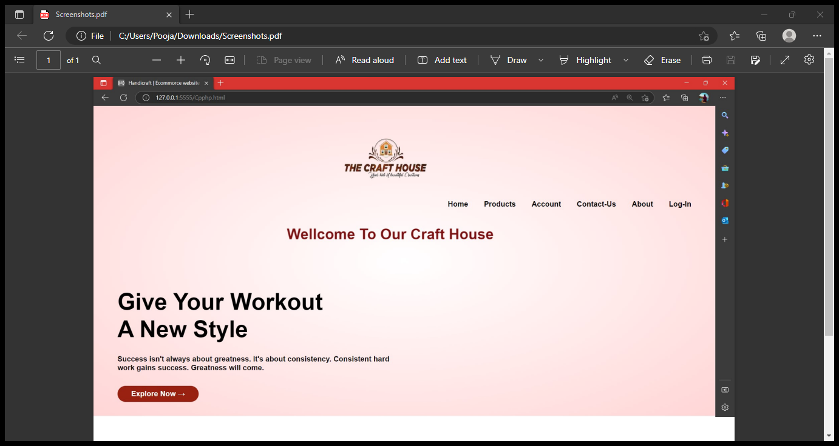

Fig 1 Home Page of The Craft House

**SUMMARY**

Motivations for this project is there are various people with skills, local shopkeepers and businessman; they don’t get to showcase their work. This website provides them a platform to buy as well as sell the artwork  The goal is to provide a right platform for peoples who have skills and uniqueness in their work but they are unable to put their works in front of the world due to the lack of money for the advertisement. An online payment gateway can be added and deliveries can be managed using a third party is the future scope of this website.

**CONCLUSION**

 Online Handicrafts store will be an ease of access for everyone, i.e. customers as well as the artisans. Due to the pandemic, it is highly risky to go out for anything but with this e-commerce website people can admire and buy the fine work of the local craftsmen sitting at home. It will help the local craftsmen reach out to a wider audience who admire the real art. It will help them reach out to those people who respect the artwork but live far away and can’t travel to shop for them.

**REFERENCES**

 [1] “A. A. Puntambekar” Software engineering and project management, 2013, Technical Publication.

[2] HTML and CSS: Design and Build Websites, November 2011 by Jon Duckett.

[3] Mastering HTML, CSS & Javascript Web Publishing Paperback –July 2016

[4] Software Engineering: A Practitioner's Approach Paperback –April 2009 by Roger Pressman (Author)

[5] Software Engineering, Tenth Edition, By Pearson Paperback –May 2017 by Ian Sommerville (Author)

[6] Beginning Software Engineering 1st Edition, Kindle Edition by Rod Stephens (Author)

[7] Introduction to Software Engineering–November 1999 by Ronald J. Leach (Author).