ASSESSING VERTICAL IRREGULARITY IN BUILDINGS ACROSS SEISMIC ZONES: A COMPARATIVE STUDY
¹Mr. Gaurav Mungalkar and ²Prof. Ishant Dahat
¹PG Scholar, Department of Civil Engineering School of Engineering and Technology, G H Raisoni University , Amravati , Maharashtra, India
²Assistant Professor, Department of Civil Engineering School of Engineering and Technology, G H Raisoni University , Amravati , Maharashtra, India
Abstract:
This study investigates the structural response of irregular buildings to seismic events of varying intensities. Fifteen models of irregular buildings are analyzed, categorized by height (21m, 30m, and 42m) and seismic loading conditions. The analysis reveals significant variations in period lengths across the different models, with shorter periods observed in shorter buildings with distributed mass, and longer periods in taller buildings with increased mass and stiffness. These findings underscore the impact of building height, mass distribution, and structural configuration on dynamic characteristics under seismic loading, providing valuable insights for the development of resilient structural designs in urban environments.
Keywords: irregular buildings, seismic events, structural response, height variation, seismic loading conditions
1.GENERAL:
During an earthquake, failure of structure starts at points of weakness. This weakness arises due to discontinuity in mass, stiffness and geometry of structure. The structures having this discontinuity are termed as Irregular structures. Vertical irregularities are one of the major reasons of failures of structures during earthquakes. Height-wise changes in stiffness and mass render the dynamic characteristics of these buildings different from the ‘regular’ building. IS 1893 definition of Vertically Irregular structures: The irregularity in the building structures may be due to irregular distributions in their mass, strength and stiffness along the height of building.
The term earthquake can be used to describe any kind of seismic event which may be either natural or initiated by humans, which generates seismic waves. Earthquakes are caused commonly by rupture of geological faults; but they can also be triggered by other events like volcanic activity, mine blasts, landslides and nuclear tests. An abrupt release of energy in the Earth's crust which creates seismic waves results in what is called an earthquake, which is also known as a tremor, a quake or a temblor). The frequency, type and magnitude of earthquakes experienced over a period of time define the seismicity (seismic activity) of that area.
2. LITERATURE SURVEY
Archana, A. R., et al (1) undertook an experimental and analytical study to understand the earthquake response of setback structures. The experimental study involved design, construction, and earthquake simulation testing of a quarter- scale model of a multistory, reinforced concrete, setback frame. The analytical studies involved design and inelastic analysis of several multistory frames having varying degrees of setbacks. Among the issues addressed were: (1) The influence of setbacks on dynamic response; (2) The adequacy of current static and dynamic design requirements for setback buildings; and (3)Design methods to improve the response of setback buildings.
Ashvin, G., et al (2) According to the numerical results, the structures designed by GB50011-2010 provides the inelastic behavior and response intended by the code and satisfies the inter-storey drift and maximum plastic rotation limits recommended by ASCE/SEI 41-06. The push-over analysis indicated the potential for a soft first story mechanism under significant lateral demands.
Ash M. (3) proposed a new method of quantifying irregularity in vertically irregular building frames, accounting for dynamic characteristics (mass and stiffness). The salient conclusions were as follows: (1)A measure of vertical irregularity, suitable for stepped buildings, called ‗regularity index‘, is proposed, accounting for the changes in mass and stiffness along the height of the building. (2) An empirical formula is proposed to calculate the fundamental time period of stepped building, as a function of regularity index.
Athanassiadou C.J, et al (4) The horizontal irregularity may be classified on the bases of Asymmetrical plan shapes, Re-Entrant corners, Diaphragm discontinuity and irregular distribution of mass, strength, stiffness along plan etc., and the vertical irregularity may be classified on the bases of Mass, Strength, Stiffness and Setback.
Bansal, H. (5) carried out Seismic analysis of a multi-story RC frame in Khartoum city was analyzed under moderate earthquake loads as an application of seismic hazardand in accordance with the seismic provisions proposed for Sudan to investigate the performance of existing buildings if exposed to seismic loads. The frame was analyzed using the response spectrum method to calculate the seismic displacements and stresses. The results obtained, clearly, show that the nodal displacements caused drifts in excess of approximately 2 to 3 times the allowable drifts. The horizontal motion has a greater effect on the axial compression loads of the exterior columns compared to the interior columns and the compressive stresses in ground floor columns were about 1.2 to 2 times the tensile stresses.
Castellazzi, G., et al (6) evaluated the earthquake response of 5-, 10-, and 20story framed structures with non-uniform mass, stiffness, and strength distributions. The response calculated from TH analysis was compared with that predicted by the ELF procedure embodied in UBC. Based on this comparison, the aim was to evaluate the current requirements under which a structure can be considered regular and the ELF provisions applicable.

3. METHODOLOGY
The following models are analyzed using STAAD-PRO software
- Model-1: Irregular building – 21 m (No-EQ)
- Model-2: Irregular building – 21 m (EQ-2)
- Model-3: Irregular building – 21 m (EQ-3)
- Model-4: Irregular building – 21 m (EQ-4)
- Model-5: Irregular building – 21 m (EQ-5)
- Model-6: Irregular building – 30 m (No-EQ)
- Model-7: Irregular building – 30 m (EQ-2)
- Model-8: Irregular building – 30 m (EQ-3)
- Model-9: Irregular building – 30 m (EQ-4)
- Model-10: Irregular building – 30 m (EQ-5)
- Model-11: Irregular building – 42 m (No-EQ)
- Model-12: Irregular building – 42 m (EQ-2)
- Model-13: Irregular building – 42 m (EQ-3)
- Model-14: Irregular building – 42 m (EQ-4)
- Model-15: Irregular building – 42 m (EQ-5)

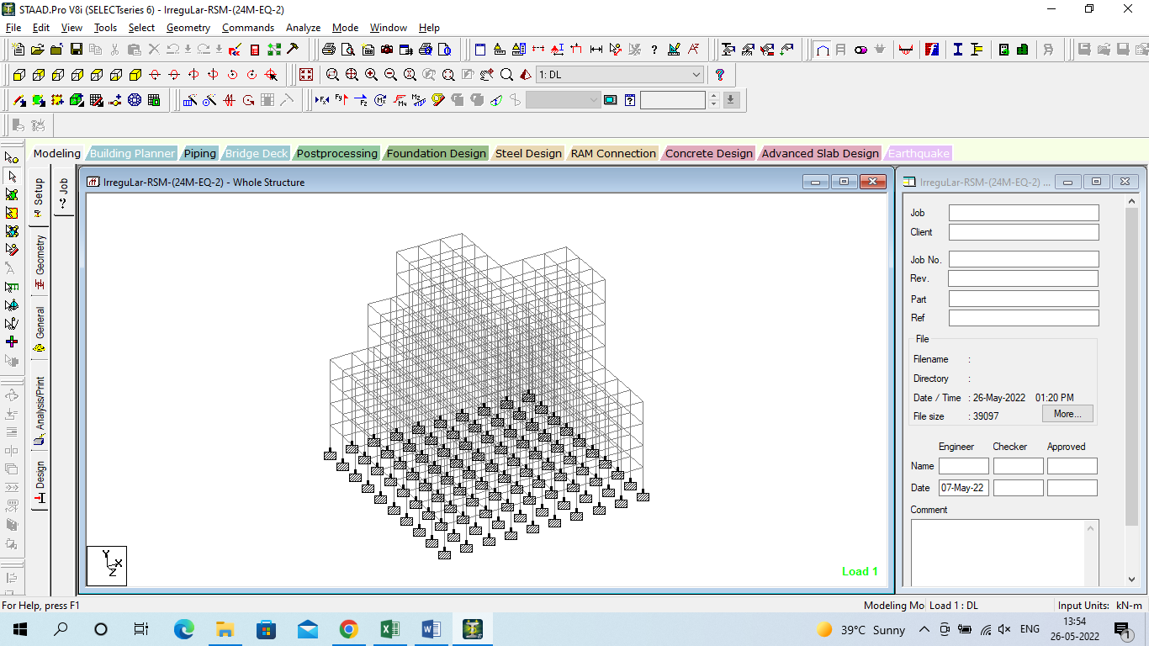
Figure 1: Geometry of the model
The above figure no. 3.1 is generated in the STAAD-PRO software, the geometry of the model is mentioned in this diagram.
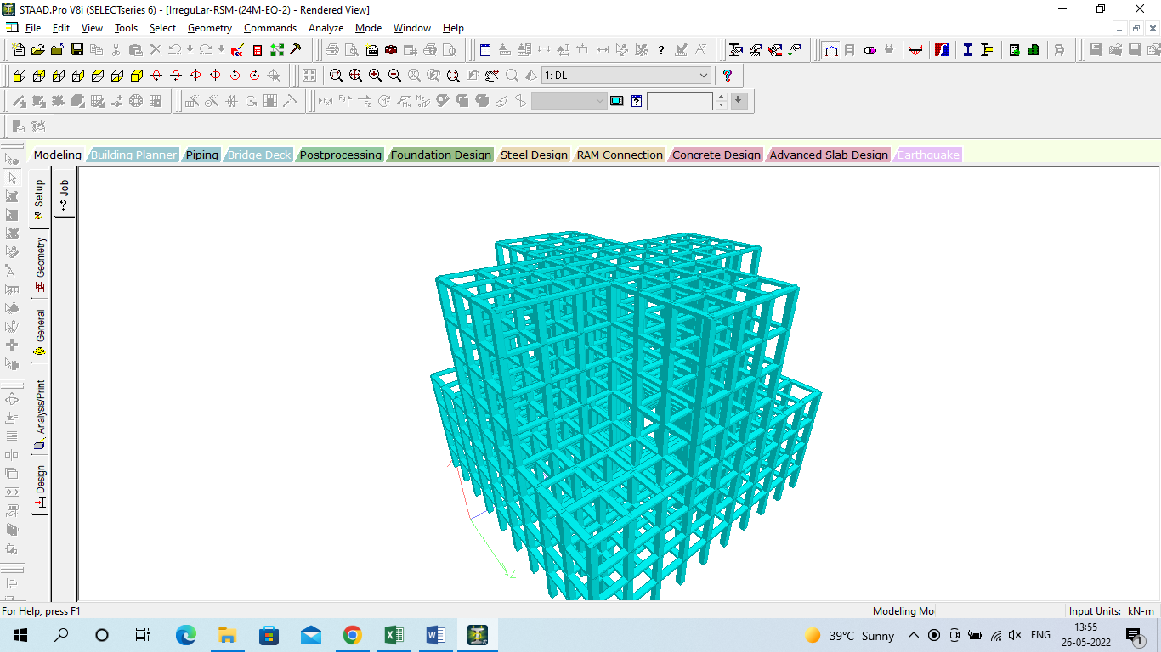
Figure 2:3D view of the model
The above figure no. 3.2 is generated in the STAAD-PRO software, the 3D view of the model is mentioned in this diagram.
4. RESULTS AND DISCUSSIONS
The present chapter deals with the results and discussion for the different models as generated in the STAAD-PRO software. The results in terms of the displacement, reactions, forces and stresses. The graphical and tabular representation has been mentioned.
Figure 3:Horizontal Displacement (X) for all the model
The horizontal displacement of a building refers to its movement in a horizontal direction, typically caused by external forces such as seismic activity. In the provided data, horizontal displacement is measured in millimeters (mm) and varies among different models of irregular buildings with different heights and seismic conditions.
Figure 4:Vertical Displacement for all the model
Vertical displacement refers to the movement of a structure in the vertical direction due to external forces acting upon it. In the context of the provided models of irregular buildings subjected to seismic activity, vertical displacement is a critical parameter to assess structural performance, especially during earthquakes where vertical movement can lead to significant structural damage or collapse. The vertical displacement values reflect the influence of building height and seismic activity on structural behavior.
Figure 5:Horizontal Reactions (Fx) for all the model
Horizontal force (Fx kN) is a critical parameter in structural engineering, as it represents the lateral load exerted on a building. Analyzing the data provided, it's evident that models with higher horizontal forces experience greater lateral loads. Take Model-15, for instance, which exhibits the highest horizontal force among all models.
Figure 6:Beam Moment (My) for all the model
The beam moment (My) for all models provides critical insights into the structural behavior, particularly regarding the bending moments experienced along the horizontal axis. Among the models, Model-10 exhibits the maximum beam moment, while the model without an earthquake zone manifests the minimum.
Figure 8:Period (sec) for all the model
The provided graph illustrates the period (in seconds) for various models of irregular buildings, ranging from Model 2 to Model 15. The shortest period is observed for models 2 to 5, while the longest period is seen for models 12 to 15. This discrepancy in period lengths can be attributed to several factors. Firstly, models 2 to 5 likely have shorter periods due to their lower height and mass distribution, resulting in quicker response to seismic forces. Conversely, models 12 to 15, being taller structures with irregular shapes, exhibit longer periods due to their increased mass and stiffness, resulting in a slower response to seismic excitation. These variations in period lengths highlight the influence of building height, mass distribution, and structural configuration on the dynamic characteristics of irregular buildings under seismic loading.
5.CONCLUSIONS
The study examines the structural response of irregular buildings subjected to seismic events of varying intensities. Fifteen distinct models of irregular buildings are considered, categorized based on their height (21m, 30m, and 42m) and seismic loading conditions (ranging from no earthquake to earthquakes of increasing magnitude). These models represent a diverse range of structural configurations commonly found in urban environments. By analyzing these models, insights into the behavior of irregular buildings under seismic loading can be gained, aiding in the development of more resilient structural designs.
Period Variation: The analysis of period lengths across different models of irregular buildings highlights significant discrepancies. Shorter periods are observed in models 2 to 5, attributed to their lower height and mass distribution, resulting in quicker responses to seismic forces. Conversely, models 12 to 15 exhibit longer periods due to their taller structures and increased mass and stiffness, leading to slower responses to seismic excitation. This underscores the influence of building height, mass distribution, and structural configuration on dynamic characteristics under seismic loading.
REFERENCES:
1. Archana, A. R., & Akbar, M. A. (2021, December). Structural irregularity quantification in buildings using vital signs. In Structures (Vol. 34, pp. 2592-2599). Elsevier.
2. Ashvin, G., Agrawal, D. G., & Pande, A. M. (2015). Effect of irregularities in buildings and their consequences. Int. J. Mod. Trends Eng. Res.(IJMTER), 2(4).
3. Ash M. , Sharma, A., K Tripathi, R., & Bhat, G. (2020). Comparative performance evaluation of RC frame structures using direct displacement-based design method and force-based design method. Asian Journal of Civil Engineering, 21(3), 381-394.
4. Athanassiadou, C. J. (2008). Seismic performance of R/C plane frames irregular in elevation. Engineering structures, 30(5), 1250-1261.
5. Bansal, H. , Dubule, S. C., & Ainchwar, D. (2018). Seismic analysis and design of vertically irregular RC building frames. International Journal of Advanced Research in Science and Engineering, 7, 290-306.
6. Castellazzi, G., Pantò, B., Occhipinti, G., Talledo, D. A., Berto, L., & Camata, G. (2022). A comparative study on a complex URM building: part II—issues on modelling and seismic analysis through continuum and discrete-macroelement models. Bulletin of Earthquake Engineering, 20(4), 2159-2185.
7. Chaudhary, K. P., & Mahajan, A. (2021, November). Response spectrum analysis of irregular shaped high rise buildings under combined effect of plan and vertical irregularity using csi etabs. In IOP Conference Series: Earth and Environmental Science (Vol. 889, No. 1, p. 012055). IOP Publishing.
8. Chintanapakdee, C., & Chopra, A. K. (2004). Seismic response of vertically irregular frames: response history and modal pushover analyses. Journal of Structural Engineering, 130(8), 1177-1185.
9. Das, P. K., Dutta, S. C., & Datta, T. K. (2021). Seismic behavior of plan and vertically irregular structures: state of art and future challenges. Natural Hazards Review, 22(2), 04020062.
10. Das, S., & Nau, J. M. (2003). Seismic design aspects of vertically irregular reinforced concrete buildings. Earthquake Spectra, 19(3), 455-477.

