The News Pulse

sreenidi

*B. Tech School of Engineering*

Malla Reddy University, India.

[2111cs020546@mallareddyuniversity.](mailto:2111cs020547@mallareddyuniversity.ac.in) [ac.in](mailto:2111cs020547@mallareddyuniversity.ac.in)

Y.GURU BHARATH

*B. Tech School of Engineering*

Malla Reddy University, India.

[2111cs020548@mallareddyuniversity.](mailto:2111cs020548@mallareddyuniversity.ac.in) [ac.in](mailto:2111cs020548@mallareddyuniversity.ac.in)

A.SRI CHARAN

*B. Tech School of Engineering*

Malla Reddy University, India.

[2111cs020549@mallareddyuniversity.](mailto:2111cs020549@mallareddyuniversity.ac.in) [ac.in](mailto:2111cs020549@mallareddyuniversity.ac.in)

S.SURYA PRAKASSH

*B. Tech School of Engineering*

Malla Reddy University, India.

[2111cs020550@mallareddyuniversity.](mailto:2111cs020550@mallareddyuniversity.ac.in) [ac.in](mailto:2111cs020550@mallareddyuniversity.ac.in)

Guide: omkar Lakshmi jagan.*Assistant Professor School of Engineering*

Computer Science – AI&ML Malla Reddy University, India.

**Abstract: Deep Learning for Enhanced Skin Disease Prediction Skin diseases affect millions globally, often requiring prompt and accurate diagnosis for optimal treatment and prevention. Traditional methods often face limitations in speed, accuracy, and accessibility. This abstract explores the potential of deep learning techniques in revolutionizing skin disease prediction, paving the way for faster, more accurate, and accessible diagnosis. The proposed methodology adopts Deep Learning techniques for identifying and classifying skin diseases caused by bacteria and fungi by making use of non-dermoscopic images**

INTRODUCTION

The human skin is the largest and outermost organ of the human body. In addition to water and proteins, the skin also contains fats and minerals. The skin primarily protects the human body from harmful substances existing outside the body and also prevents the outflow of various nutrients present inside the human body. Skin is a very sensitive part of the body. Various internal and external factors harm the functionality of the skin which leads to various skin diseases. Dermatologists often have to perform laboratory tests before concluding the type and name of the skin disease. Despite the advancements in medical equipment giving accurate results, the cost of such

Thus, there is a need for providing a quick and cost-effective solution. Such a solution can be developed by using deep learning techniques

# LITERATURE REVIEW

# Strengths:

# Highlights Challenges: It emphasizes the subjectivity and time-consuming nature of manual approaches, justifying the need for computer-aided techniques.

# Explains Machine Learning Techniques: It provides a concise overview of traditional machine learning approaches like feature extraction and classifiers (SVMs, ANNs).

# Emphasizes Deep Learning's Advantage: The text effectively highlights the benefits of deep learning in automating feature extraction and achieving superior performance.

# Supports Claims with Recent Research: It mentions promising results like high accuracy achieved by hybrid deep learning approaches and showcases the effectiveness of CNN architectures like VGG16 and VGG19.

Target Audience: Consider the intended audience (medical professionals, researchers, general public) and adjust the level of technical detail accordingly.

Expand on Deep Learning Techniques: For a more technical audience, you could delve deeper into specific deep learning architectures used for skin disease classification, such as how CNNs work (convolutional layers, pooling) or advancements like residual networks.

Mention Limitations: Briefly acknowledge limitations of deep learning models, such as potential biases in training data or the need for large datasets for optimal performance.

Future Directions: You could conclude by exploring potential future research areas in this field, such as real-world deployment challenges, explainability of deep learning models for skin disease classification, or integration with existing diagnostic workflows.

Block Diagram:

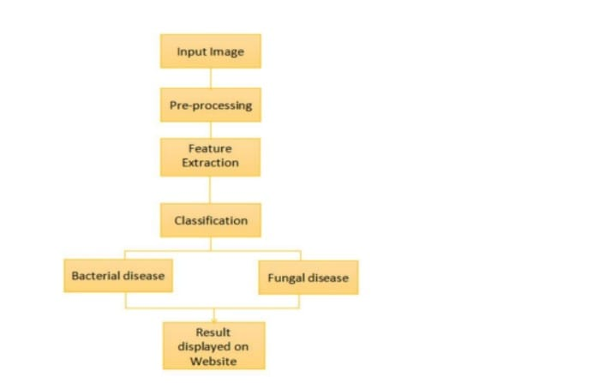

# PROBLEM STATEMENT

**Developing an accurate and cost-effective deep learning model for classifying skin diseases caused by bacteria and fungi using non-dermoscopic images. The dataset includes five classes: Cellulitis, Impetigo (bacterial skin diseases), Ringworm, Sporotrichosis (fungal skin diseases), and Healthy Skin. Leveraging transfer learning with the fine-tuned VGG16 architecture, the goal is to achieve high accuracy (87%) and an F1-score of 85%. This model will enhance dermatologists’ decision-making process, reduce diagnosis time, and minimize costs associated with skin disease diagnosis.**

**METHODOLOGY**

Objective: Classify bacterial and fungal skin diseases (Cellulitis, Impetigo, Ringworm, Sporotrichosis) and Healthy Skin using non-dermoscopic images.

Method:

Deep Learning: Leverage CNNs, specifically VGG16 architecture, for image classification.

Transfer Learning: Fine-tune pre-trained VGG16 for improved efficiency and accuracy. Web Application: Develop a user-friendly interface (Streamlit) for image upload/capture and displaying prediction

EXPERIMENTAL RESULTS

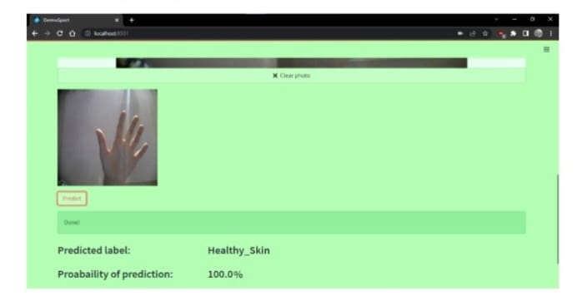

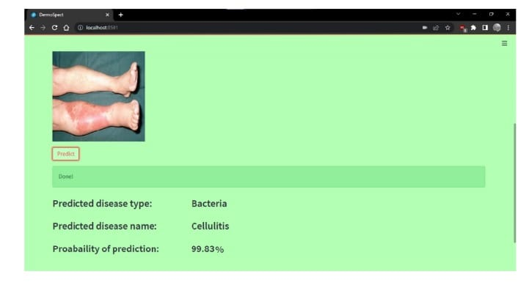

CONCLUSION

Problem: Limitations of traditional skin disease diagnosis

Proposed Solution: Deep learning for faster, more accurate, and accessible diagnosis

Focus: Identifying and classifying bacterial and fungal skin diseases using non-dermoscopic images

It also highlights the potential impact of this approach in the field of skin disease diagnosis.

Mention of further research: Briefly state that further investigation and validation are needed to confirm the effectiveness and real-world applicability of the proposed approach.

Future directions: Briefly indicate potential future research directions, such as exploring the application to a wider range of skin diseases or integrating the model into clinical workflows

Future Work

* Integrate dermoscopic image support for broader applicability.
* Implement multi-disease classification for more comprehensive diagnosis.
* Refine the model with a larger and more diverse dataset for enhanced accuracy and generalizability.
* Explore explainable AI techniques to provide insights into the model's reasoning and build trust in its predictions.

References

* Mohammed, Z. F., & Abdulla, A. A. (2021). An efficient CAD system for ALL cell identification from microscopic blood images. Multimedia Tools and Applications, 80(4), 6355-6368.
* . Li, L. F., Wang, X., Hu, W. J., Xiong, N. N., Du, Y. X., & Li, B. S. (2020). Deep Learning in Skin Disease Image Recognition: A Review. IEEE Access.
* Mahbod, A., Schaefer, G., Wang, C., Ecker, R., & Ellinge, I. (2019, May). Skin lesion classification using hybrid deep neural networks. In ICASSP 2019-2019 IEEE International Conference on Acoustics,Speech, and Signal Processing (ICASSP) (pp. 1229-1233). IEEE.
* Kumar, V. B., Kumar, S. S., & Saboo, V. (2016, September). Dermatological disease detection using image processing and machine learning. In 2016 Third International Conference on Artificial Intelligence and Pattern Recognition (AIPR) (pp. 1-6). IEEE.
* ALEnezi, N. S. A. (2019). A method of skin disease detection using image processing and machine learning. Procedia Computer Science, 163, 85-927. R. Sumithra, M. Suhilb, and D. S. Guruc, “Segmentation and classification of skin lesions for disease diagnosis,” Procedia Computer Science, vol. 45, pp. 76–85, 2015.