**INTEGRATING SECURE CUSTOMER-CENTRICITY, AND**

**ENCRYPTION FOR FUTURE-READY SQUID INSPIRED SKIN**

# SAFETY PRODUCT S.Rajkumar,Mr.R.Saravanan

*1PG Student, Computer Science And Application, SCSVMV University, Kanchipuram, India.

*2Assistant Professor, Computer Science And Application, SCSVMV University, Kanchipuram, India

## ABSTRACT

This research pioneers an innovative methodology for the bespoke manufacturing of SquidSkin safety products, meticulously tailored to the distinct requisites of diverse industries encompassin medical, military, and defense sectors. The triple DES algorithm is a three instance of DES on same plain text in blocks of 64 bits and converts them to ciphertext using keys of 168 bits. The triple DES encryption process creates ciphertext, which is an unreadable, effectively indecipherable conversion of plaintext data, the version of information that humans can read and understand. The output of the encryption process, the triple DES ciphertext, cannot be read until a secret triple DES key is used to decrypt it.The delineation of industry-specific manufacturing parameters mandates a nuanced approach to material composition and production processes, culminating in a paradigmatic advancement in safety product customization. Integral to this methodology is a rigorous analysis of industry-specific requirements, guiding the selection of optimal material compositions. This selection is underpinned by a meticulously designed material testing phase, ensuring adherence to exacting industry standards and performance benchmarks.

## I.INTRODUCTION

This research pioneers an innovative methodology for the bespoke manufacturing

of SquidSkin safety products, meticulously tailored to the distinct requisites of diverse industries encompassing medical, military, and defense sectors. The utilization of the triple DES algorithm ensures the confidentiality and security of sensitive data throughout the manufacturing process, facilitating a paradigmatic advancement in safety product customization.

# Flow Chart

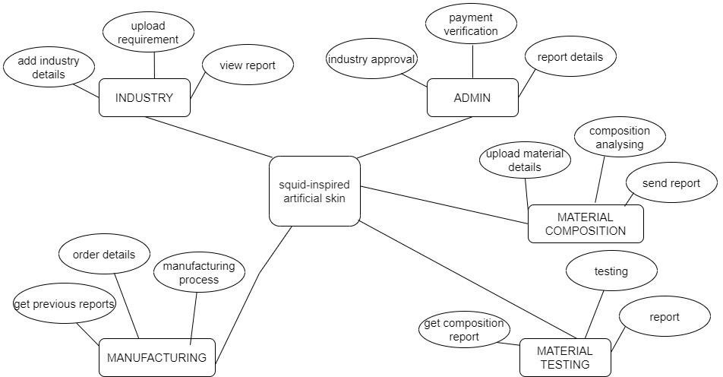

**Fig. 1: Flow Chart**

1. **System Architecture:**

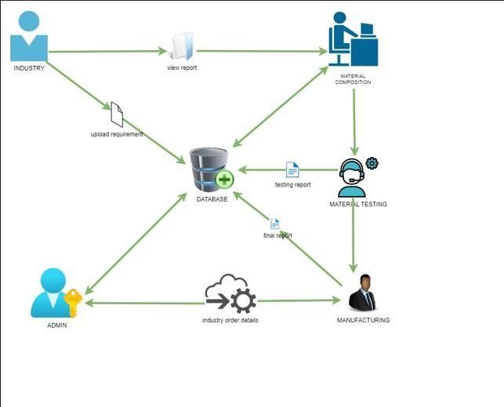

**Fig. 2: System Architecture**

.

**MODULE DESCRIPTION**

**CLIENTS:**

Following the registration process, clients' access remains pending until approval by the manager, who evaluates and verifies the submitted details. Once approved, clients are issued a unique client ID, serving as a secure identifier for authentication purposes. Upon obtaining their client ID, users can securely log in to the system, gaining access to its various functionalities. The system is organized into three primary sections: Order, Track, and Payment, each serving distinct purposes in the client interaction process.

**MANAGER:**

In the Manager module, the primary focus lies in overseeing the registration and access of both new clients and the Processing team. Access to the system is granted only upon the manager's approval, ensuring a controlled and secure environment. Once approved, clients and the Processing team can log in to the system to commence their work. The journey of a report begins with the Processing team, which initiates the submission process.

**V. SCREENSHOTS**

**Home page:**



**Fig 5.1 Home Page – Step into the reliable industry takes many forms**

**Register Page:**



**Fig 5.2 Register Page** - Welcome! Join our community by creating an account. It’s quick, easy, and unlocks a world of features tailored just for you.

**Client Order Page:**

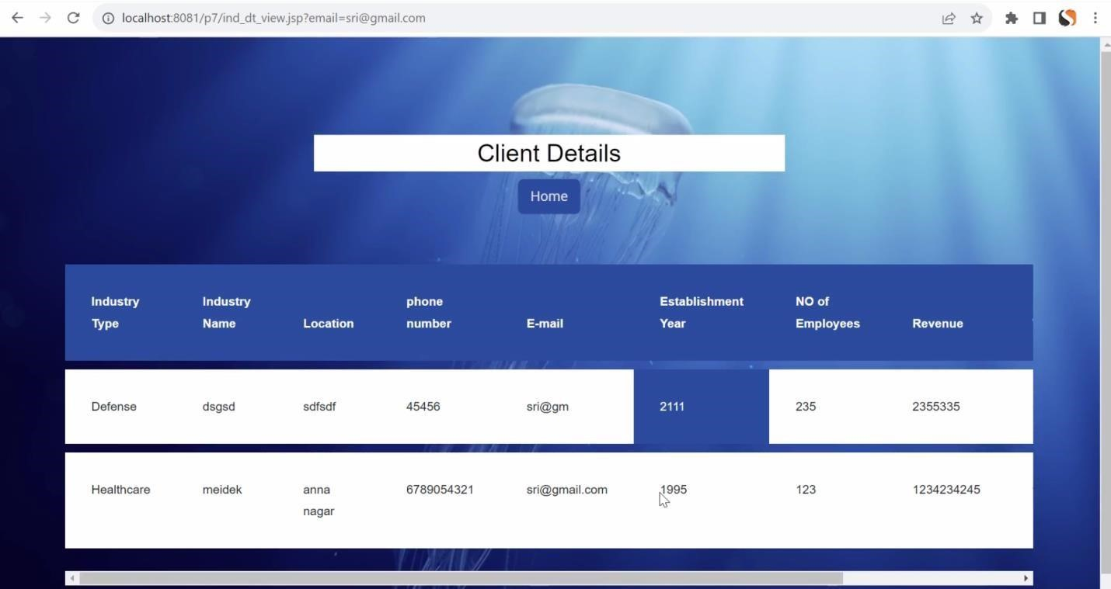

**Fig 5.3 Client Order Page** - You can order through this Client Order page

**Admin** **Page:**



**Fig 5.4 Admin Page:**An idea changes everything

**Requirement page:**

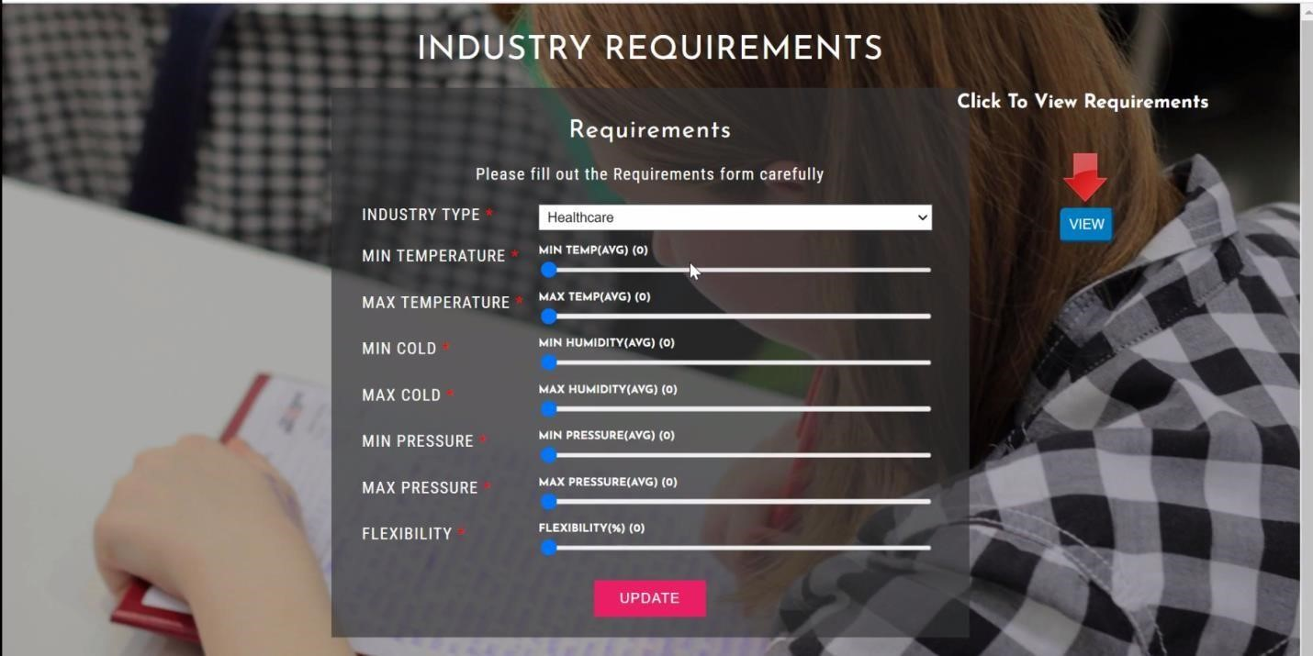

**Fig 5.5 Requirement Page -** Welcome to our Requirement Page! Here, you can easily forecast the report using this page

**Data Page:**

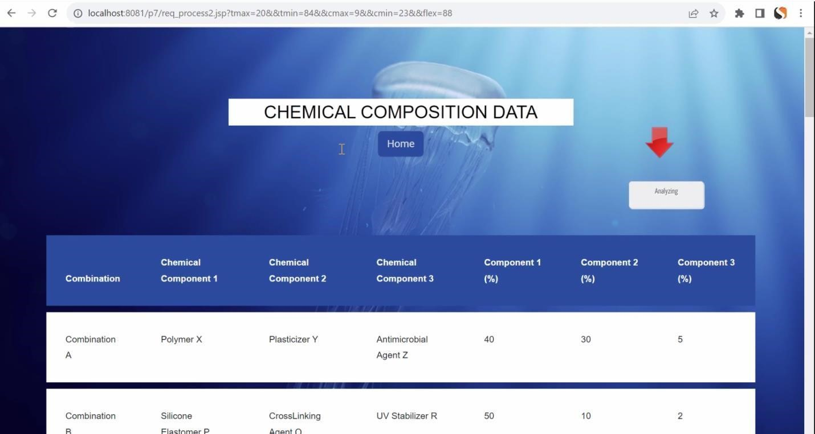

**Fig 5.6 Data Page -** Welcome to our Data Page! Here, you'll find all the details you need to understand our data structure

**VI. CONCLUSION AND FUTURE ENHANCEMENT**

**VI. CONCLUSION AND FUTURE ENHANCEMENT**

**Conclusion:**

In conclusion, the proposed SquidSkin safety product manufacturing system emerges as a revolutionary force, reshaping the landscape of personalized wearables. Its customer- centric ethos, innovative material science, and stringent security measures collectively transcend the limitations of the existing system, heralding an era where safety products are not only adaptive but also inherently secure. This bottom line underscores a commitment to excellence, where SquidSkin not only meets industry needs but anticipates and exceeds them, positioning itself as a beacon of innovation in the ever-evolving realm of safety product manufacturing. With the proposed system, the future beckons—a future+ where user-centricity, cutting-edge technology, and security converge to define the next frontier in SquidSkin safety product manufacturing..

**Future Enhancement:**

This project encompasses a comprehensive exploration of photo-mechanical nanocrystal-enhanced filtration systems, delving into their potential to revolutionize contemporary filtration methodologies. By leveraging cutting-edge advancements in nano-material science, the scope extends to the meticulous selection and characterization of membranes tailored for seamless integration with photo-mechanical nano-crystals. The project's ambit includes the systematic investigation of energy activation mechanisms, aiming to unlock the full potential of nano-crystals in dynamically responding to environmental uses.

## ACKNOWLEDGEMENTS

I express my heartfelt gratitude to Assistant prof Mr.R.Saravanan, whose unwavering dedication to my growth has been truly inspiring. His encouragement and guidance have been crucial in shaping my academic pursuits, instilling confidence, and fostering determination. I feel profoundly fortunate to have been mentored by someone who consistently prioritized my development and well-being.

## REFERENCES

1. <https://www.skillvertex.com/courses/?c=17&b=240105&lc=1>
2. https://[www.kaggle.com/datasets](http://www.kaggle.com/datasets)
3. Wang, X., Wen, J., Zhang, Y., Wang, Y. (2014). This study utilizes a support vector

machine (SVM) optimized by particle swarm optimization (PSO) for forecasting real estate prices, published in Optik-International Journal for Light and Electron Optics, volume 125, issue 3, pages 1439-1443.

1. "Real Estate Price Prediction with Regression and Classification," a final project report for CS 229 from Autumn 2016, explores methods for predicting real estate prices using both regression and classification techniques.
2. Park, B., Bae, J.K. (2015). This paper investigates housing price prediction using various machine learning algorithms, published in a journal volume 42, on pages 2928-2934.