**Research Project Report on**

**“A bibliometric analysis on venture capital exit strategies”**

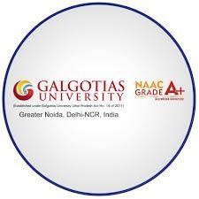

***Submitted Towards Partial Fullfillment Of***

***Master of Business Administration***

**SUBMITTED BY:**

**Bhupendra Pratap Singh   
&  
Bhanu Prakesh**

**MBA-FM (2022-2024)**

**SCHOOL OF FINANCE AND COMMERCE, GALGOTIAS UNIVERSITY GREATER NOIDA-201306**

**Student’s Declaration/ Certificate**

I “BHUPENDRA PRATAP SINGH & BHANU PRAKESH” hereby declare that the work which is being presented in this report entitled **“A bibliometric analysis on venture capital exit strategies”** is an authentic record of my own work carried out under the supervision of School of Finance and Commerce.

The matter embodied in this report has not been submitted by me for the award of any other degree.

Date: 28/04/2024

This is to certify that the work which is being presented in this report entitled **“A bibliometric analysis on venture capital exit strategies”** is an authentic record of the student carried out under my supervision. The statements made by the candidate are correct to the best of my knowledge.

Date: 28/04/2024

**Acknowledgment**

I would like to express my special thanks of gratitude to my faculty mentor School of Finance and Commerce who has supported me throughout till date and has helped me with his knowledgeable advice and insights regarding the completion of my Research project on the topic **“A bibliometric analysis on venture capital exit strategies”**. His encouragement and valuable input have been the outcome of successfully making this project.

**DATE:** 28/04/2024 **NAME OF STUDENT**

**PLACE: Aligarh Bhupendra Pratap Singh & Bhanu Prakesh**

**Table of Contents**

##### Index Page No.

**PART I**

##### Chapter I

1. Introduction 6
2. Objective of study 10

PART II

Chapter II

1. Literature Review 12

Chapter III

1. Research Methodology 16

Chapter IV

1. Data Analysis & Interpretation 19

**Chapter V**

1. Conclusion, Discussion, Limitation and Future Research Directions. 44

##### Chapter VI

1. Bibliography 48

CHAPTER I

# INTRODUCTION

###### INTRODUCTION

The affect of experience trade on beneficial development has long been the subject of talk about among scholastics (Timmons & Bygrave, 1986; Barry et al., 1990; Lerner, 1995; Gompers & Lerner, 1998; Houben & Kakes, 2002; Samila & Sorenson, 2011). This talk about still veritably later and has concentrated on modern issues( Pradhan etal., 2018; Rizvi & Arshad, 2018; Dettenhofer etal., 2019). The centrality of these bets is related to experience capital as an basic backing instrument of all investmentsbased on modern thoughts( Florida & Smith Jr, 1990; Kortum & Lerner, 1998, 2000; Dushnitsky & Lenox, 2005; Rossi & Martini, 2019; González- Uribe, 2020; Que & Zhang, 2020). In 50 times of advancement, a huge number of thinks about on enterprise capital in colorfull viewpoints have surfaced around the world and have contributed with diverse delineations and characteristics( Landström, 2007).

In common, VC investigation has developed immensely compared to other disciplines. The quotation structure recognizes the quotation position that this field has achieved, being reasonable to see the position of the most cited papers over the once 25 times. too, it appears the number of papers with lower circumstances of citations counting those that haven't entered any citations however. The composition moreover creates a diary investigation relating the commanding bones in the field. In specific, this work portrays that there are certain specialized diaries that distribute more in VC investigation with regard to other diaries, for outline, Diary of Trade Wandering, Enterprise suggestion and Hone and Little Commerce Financial matters. It too highlights other diaries for having a tall number of citations, undoubtedly if they distribute a expansive number of papers in VC investigation, comparable as the Diary of Fund, Diary of Money related Financial matters, Inquire about Arrangement, Vital Administration Diary, Institute of Administration Diary, official Science Quarterly, among others. moreover, a transient investigation is created to see which diaries have been the most persuasive bones all through time. This paper proceeds as takes after Area 2 creates the writing audit with respect to VC investigation. Segment 3 depicts the investigation framework by depicting the bibliometric ponder and its cluster investigation. Segment 4 presents the comes about of our bibliometric examination.

Bibliometrics is the field that quantitatively ponders bibliographic fabric (Broadus, 1987). Bibliometric thinks about are getting veritably prevalent in the logical writing, violently spurred by the get to bibliographic data.

Overview of Venture Capital

Adventure capital is defined as equity- linked investments in which investors support entrepreneurs by furnishing the finances and operation chops demanded to exploit request openings for long- term gains ( Kortum & Lerner, 1998). There are generally three types of adventure capital (1) angel investors, generally, fat individualities who give backing to entrepreneurs in exchange for an equity stake in the company (Prowse, 1998; Mitteness et al., 2012);( 2) strategic venture capital, also known as commercial adventure capital. This form of adventure capital allowsnon-financial pots to invest in gambles near to their core of those investments have strategic pretensions, generally to gain access to new technologies and inventions( Dushnitsky & Lenox, 2005; Wonglimpiyarat, 2016; Rossi et al., 2019a). The third type is the( 3) fiscal adventure capital; this typeof adventure capital, unlike commercial adventure capital, has further than one general mate, whose main ideal is to have a good return on investment to satisfy itsinvestors( general mates), for which they will try to achieve good exits throughan original public immolation( IPO) or combinations( Zider, 1998; Lee & Wahal, 2004). Adventure capital is also a form of private equity backing that's handed by adventure capital enterprises or finances. The ultimate acts as a middleman between the backing sources( substantially institutional investors) and entrepreneurial systems that are characterised by rapid-fire growth and high technology( Cumming & Johan, 2013). These enterprises invest in businesses of all sizes in several sectors. nonetheless, utmost of themare only involved in businesses in particular phases and specific disciplines( Elangoetal., 1995). These characteristics of adventure capital backing allow to classifya wide range of these enterprises according to their investment stage. The investment stage involves seed capital( first phase), start- up, beforehand and middle stage. likewise, adventure capital enterprises are complex agents, and their value dependson their capability to interact with others through legion functions( Ferrary & Granovetter, 2009). The main functions that have sorted in adventure capital research include backing, opting , collaborative literacy function, signaling function, and embedding function. Backing is the best known profitable function( Gompers & Lerner, 2004; Ferrary & Granovetter, 2009). Adventure capital enterprises fund entrepreneurial enterprises in exchange for returns on equity and dodge high fiscal threat, unlike banks and fiscal requests, which don't advance plutocrat to this type of investment due to a lack of means and a high position of threat exposure (Baldietal. 2015). Regarding the opting function, adventure capital enterprises try to fund the most promising systems because their gains depend on the performance of their investments( Brander etal., ; Knockaert etal., 2010). Out of further

than 500 business plans entered per time, only three or four launch- ups will be funded (Ferrary & Granovetter, 2009). As far as the collaborative literacy function is concerned, over the times, adventure capital enterprises have accumulated considerable knowledge on the creation and development of entrepreneurial businesses, assessing thousands of systems, funding them and accompanying dozens of launch- ups. They've in- depth knowledge of artificial, technological, legal, and directorial issues (Brander et al., 2002; Ferrary & Granovetter,

).They can also exploit their knowledge to borrow fiscal strategy behaviours in supporting inventions (Minola & Giorgino, 2008; Rossi etal., 2017; Rossi et al., 2019a; Rossi et al., 2020a; Ma, 2020) and canact ambidextrously in venturing investments. Adventure capital exploration has two situations of analysis micro and macro. originally, academics specialising in micro-level analysis seek to explore adventure capital perpetration strategies, entrepreneurial geste and the relationship between adventure capital enterprises, institutional investors, and entrepreneurs. At this position, exploration has concentrated on specific motifs similar as design selection. For case, Ueda ( 2004), who studied a signal model, explained the difference between banks and adventure capital enterprises in terms of design evaluation and selection, performance of entrepreneurial investee enterprises, how adventure capital enterprises apply good governance of their investment portfolio, constricting, and agency issues. Meuleman etal. ( 2017) appertained to syndication among adventure capital enterprises and alliance strategies. likewise, Hellmann (2006) illustrated the case of original public immolations (IPOs). On the other hand, exploration at the macro-level has mainly focused on the adventure capital profitable impact on the structure of the public frugality and its different variables. The ultimate have been a discussion content for several academics to determine the main rudiments affecting the public economy. Thus, Gompers and Lerner( 1998), Timmons and Bygrave (1986), and Pruthi and Wright( 2019) have argued that government programs, entrepreneurship, economicgrowth, invention, fiscal requests, internationalisation, and job creation are the main factors of any frugality. Gilson( 2002) refocused out that the venture capital assiduity in the USA has developed through request forces, unlike the rest of the world. nonetheless, they've made great sweats to wangle their adventure capital request. To this end, this study examines how countries can establish their adventure capital request by addressing three foundations the entrepreneur, the fiscal conciliator, and the capital.

#### Objective of the study:

Adventure capital exploration encompasses a wide range of academic disciplines similar as finance, operation, economics, law, and sociology (Cornelius & Persson, 2006; Cancino et al.,

). The involvement of academics from different disciplines further encourages the adventure capital content to expand and grow. This capacity for growth requires an ongoing review on the elaboration of exploration in this content. Accordingly some studies have reviewed the being literature on adventure capital and linked the major exploration aqueducts in terms of internationalisation (Wright et al., 2005; Park et al., 2015; Devign et al., 2018) and the crucial considerations applicable to the adventure backing sphere to understand this miracle Wright Robbie, 1998; Wood & Wright, 2009; Narayanan etal., 2009; Cumming & Zhang, ; Drover et al., 2017; Köhn, 2018; Harrison & Mason,2019). Current knowledge of bibliometric analyses regarding adventure capital is scarce. There have been only a many recent studies that present the elaboration of adventure capital exploration using bibliometric analysis (Cornelius & Persson, 2006; Cancinoetal., 2018; Tenca et al., 2018; Reverte & Badillo, 2019). Although former exploration has covered some perspectives of bibliometric analysis, others have entered spare attention. In the three most recent bibliometric studies, Reverte and Badillo (2019) concentrated on indispensable equity backing, where adventure capital is part of the analysis, and the field exploration is limited to the business economics sphere in the selection of the database. Tenca etal.( 2018) concentrated on business angels, which is informal adventure capital, and the field exploration is also limited to the business economics sphere. The study of Cancino et al. (2018) concentrated on the most influential journals in adventure capital exploration.

In this study, the bibliometric review aims to extend the literature by encyclopedically analysing adventure capital publications in different Web of Science( WOS) orders. Our bibliometric analysis covers papers and focuses on the quality and volume of adventure capital exploration over the last two decades using the VOSviewer software. The review aims to cover utmost of the perspectives inthe bibliometric analysis to give an overview of this exploration content and its trends. thus,co-authorship,co-citation, andco-occurrence are included in the analysis, with charts indicating their cooperation networks and influence. Available bibliometric information was used as a base for decision- timber and performance assessment of backing agencies and exploration and reclamation institutions( Butler, 2003;

Abramo etal., 2009; Schneider, 2009; Hicks etal., 2015; Moher etal., 2018). Hence, the main donation of this review is to support decision- making in a adventure capital exploration operation environment. In addition, the end is to give explanation for unborn experimenters or observers, including exploration patterns, influential authors and publications, core journals, countries, and institutions. The main influential exploration clusters and the overall development of the exploration motifs on adventure capital, as well as citations andco-citation analysis, open access vs. non-open access policy are addressed. This study also provides both theoretical and practical insights to support and companion exploration, particularly on arising fiscal requests. The paper is organized as follows first, the details of the data collection and the styles used in the analysis are presented, also the conclusions drawn from the bibliometric data and network charts are epitomized, and the main conclusions are bandied. Eventually, the limitations and counter accusations of the review are stressed.

## CHAPTER II

# LITERATURE REVIEW

#### Literature review

Venture capital (VC) plays a crucial role in supporting the growth and development of new enterprises. [Not only does it provide financial resources, but it also offers business expertise,](https://www.emerald.com/insight/content/doi/10.1108/JEFAS-01-2018-0016/full/html) [customer networks, and effective management practices1](https://www.emerald.com/insight/content/doi/10.1108/JEFAS-01-2018-0016/full/html). One critical aspect of VC investment is the exit strategy, which determines how investors realize their returns. Understanding the landscape of VC exit strategies is essential for both practitioners and researchers.

Methodology To analyze the evolution of academic research in VC exit strategies, we conducted a bibliometric analysis covering the period from 1990 to 2014. [Our study focused](https://www.emerald.com/insight/content/doi/10.1108/JEFAS-01-2018-0016/full/html) [on influential journals in VC research, using data from the Web of Science database1.](https://www.emerald.com/insight/content/doi/10.1108/JEFAS-01-2018-0016/full/html) Here are the key findings: Steady Growth in VC Research: Over the past 25 years, there has been a consistent increase in VC research output. Researchers have explored various aspects of VC, including exit strategies. Prominent Journals in VC Research: We identified 40 academic journals that regularly publish articles related to VC research. These journals serve as valuable sources for understanding VC exit strategies.

Future Research Agenda: Our work lays the groundwork for future bibliometric analyses. Researchers can explore the most productive and influential authors, universities, and countries in VC research.

In summary, VC exit strategies remain a dynamic area of study. By examining academic literature, we gain insights into the evolving landscape and can inform future research directions. [Whether you’re an investor, entrepreneur, or scholar, understanding VC exit](https://www.emerald.com/insight/content/doi/10.1108/JEFAS-01-2018-0016/full/html) [strategies is essential for making informed decisions in the world of venture capital.](https://www.emerald.com/insight/content/doi/10.1108/JEFAS-01-2018-0016/full/html)

For further reading, you can refer to the full article: [A bibliometric analysis of venture capital](https://doi.org/10.1108/JEFAS-01-2018-0016) [research](https://doi.org/10.1108/JEFAS-01-2018-0016) [published in the Journal of Economics, Finance and Administrative Science1](https://www.emerald.com/insight/content/doi/10.1108/JEFAS-01-2018-0016/full/html). Remember, successful exits are like reaching the summit of Mount Everest—strategic planning and preparation are key! Gompers and Lerner (2006) define VC as the process which starts with raising a adventure fund; proceeds with investing in, covering and adding value to enterprises; continues as the adventure commercial exits successful deals and returns capital to their investors; and renews itself with the adventure commercial caregiving fresh finances. Hence, VC exploration explores several processes, which involve the pre-investment phase of VC, the operation of VC and the exit strategies of VC. In the pre-investment phase, VC

exploration explores how changes in public request signals affected VC (Gompers etal., 2008) or the conditions to grease the creation of lesser firm value after entering VC( Dushnitsky and Lenox, 2006). Research in this stage also analyses the process of creating connections between adventure plutocrats and entrepreneurs Hochberg etal., 2010). Research in the operation stage concentrated its attention on companies when they admit VC. For illustration, experimenters have explored the links between the influence and control of VC enterprises( Bottazzi etal., 2008) and the operation chops and moxie of entrepreneurs and new gambles, similar as entrepreneurial exposure( Stam and Elfring, 2008). Eventually, exploration in the exit stage reviews how enterprises can develop either their original public immolation( IPO) or their buyout. Nahata( 2008) suggests that companies backed by further estimable VCs by IPO capitalization share are more likely to exit successfully, access public requests briskly and have advanced asset productivity at IPOs. Indeed though VC exploration has three stages of analysis, VC exploration encompasses wide range of academic areas, without a particular discipline leading scientific exploration in this field. Academics from disciplines similar as Finance, General Management, Innovation, Law, Public Policy, Sociology and Economics present a wide range of exploration adventure capital, which is veritably precious because it brings different perspectives to dissect the problem of financing new businesses. For illustration, from a Finance perspective, Berger and Udell( 1998) explain that enterprises are viewed through a fiscal growth cycle paradigm in which different capital structures are optimal at different points in the cycle. They show the sources of small business finance, and how capital structure varies with establishment size and age. From a psychology perspective, Krueger etal.( 2000) argue that promoting entrepreneurial intentions by promoting public comprehensions of feasibility and advisability isn't just desirable; but also completely doable. From a sociology perspective, Podolny( 2001) draws an logical distinction between two types of request query egocentric, which refers to a focal actor’s query regarding the stylish way to convert a set of inputs to an affair asked by a implicit exchange mate, and altercentric, which denotes the query brazened by a focal actor’s exchange mates regarding the quality of the affair that the focal actor brings to the request. From a public programs perspective, Di Gregorio and Shane( 2003) give sapience into why some universities induce further new companies to exploit their intellectual property than do others. The below exemplifications show that the analysis of VC exploration is varied and can decide from different disciplines on the one hand, it could be positive to have different perspectives to try to understand the problems on the other hand, analysis from different disciplines could be negative, especially if we want to know the specific group of authors in VC exploration who have further influence and productivity. In the realm of

adventure capital, where investors give fiscal backing to startups and small businesses with high growth eventuality, exit strategies play a vital part in determining the success of investments. These strategies encompass the styles through which investors realize their returns on investment, similar as original public immolations( IPOs), combinations and accessions( M&A), or secondary deals. Understanding the dynamics of adventure capital exit strategies is pivotal not only for investors seeking profitable exits but also for entrepreneurs aiming to attract investment and navigate the fundraising process effectively. The operation of bibliometric analysis, a quantitative system for analysing patterns in scholarly literature, offers a unique lens through which to examine trends and developments in the field of adventure capital exit strategies. By totally analysing publications,citations, and keywords related to this content, experimenters can gain precious perceptivity into the elaboration of exit strategies, the factors impacting their effectiveness, and the broader counteraccusations for the adventure capital ecosystem. multitudinous studies have delved the colorful exit strategies employed by adventure plutocrats and their impact on investment issues. For case, exploration by X etal.( time) explored the factors impacting the choice between IPOs and M&A as exit routes, pressing the significance of firm characteristics, request conditions, and nonsupervisory surroundings. Also,Y etal.( time) conducted a meta- analysis of exit strategy performance, revealing the relative success rates of different exit options across colorful diligence and stages of investment. Bibliometric analysis has surfaced as a important tool for gaining perceptivity into the geography of adventure capital exploration. By totally analysing the literature using quantitative criteria similar as citation counts, publication trends, and keywordco-occurrence networks, experimenters can identify crucial themes, influential authors, and arising areas of interest within the field. former studies, similar as Z etal.( time), have demonstrated the mileage of bibliometric analysis in mapping the intellectual structure of adventure capital exploration and relating gaps for farther disquisition. Studies employing bibliometric analysis have revealed several crucial findings regarding adventure capital exit strategies.

For illustration, analysis of citation networks has stressed seminal workshop and influential authors in the field, slipping light on the intellectual lineage of exploration in this area. Methodologically, experimenters have employed colorful ways similar asco-citation analysis, bibliographic coupling, and keyword clustering to uncover patterns and connections within the literature. By employing robust methodologies, experimenters can insure the validity and trustability of their findings, contributing to the accretive knowledge base on adventure capital exit strategies.

## CHAPTER III

RESEARCH METHODOLOGY

#### Research Methodology

Bibliometric investigate be a field that quantatively considers bibliographic fabric (Broadus, 1987) given a common neglect of a inquire about field agreeing to a wide extend of pointers. There be distinctive ways of positioning fabric in a bibliometric investigation. The foremost common ways utilize the overall number of articles or the full number of citatios. Another valuable marker be the h-index (Hirsch, 2005) that combines articles with citatios demonstrating the number of thinks about X that has gotten X or more citatios. The common suspicion be that the number of articles appears the efficiency whereas the overall cites reflects the impact of a set of articles. Not that this think about take after the strategy created by Merig´o et al. (2015) and Cancino et al. The look for articles that have centered on VC inquire about, the think about employments the watchwords “venture capital” or “business venturing” or “corporate venturing” within the title, unique and keywods of any work accessible in WoS between 1990 and 2014, to capture as numerous conceivable combioations of terms related to wander capital. This look finds 2,086 articles that has ended up 1,820 considers by as it were considering articles, surveys, letters and notes. The look was created in October 2015 and January 2016.Wander capital inquire about encompasses a wide run of scholarly disciplines such as back, administration, economics, law, and humanism. The association of scholastics from distinctive disciplines assist energizes the wander capital theme to extend and develop. This capacity for development require an progressing audit on the advancement of investigate in Îh subject. Thus a few ponders have surveyed the existing literature bn wander capital and recognized the major inquire about streams in terms of internationalization and the keycontemplations pertinent to the wander financing space to get it this marvel.

Current information of bibliometric investigations with respect to wander capital be rare. There have been as it were some later considers that display the advancement of wander capital inquire about utilizing bibliometric investigation. In spite of the fact that past investigate has secured a few viewpoints of bibliometric investigation, others have gotten insufficient consideration. Within the three most later bibliometric thinks about, Reverte and Badillo centered on elective value financing, where wander capital is portion of the examination, and the field investigate is constrained to the commerce economics domain within the selection of the database. Tenca et al. centered on commerce blessed messengers, which be casual wander capital, and the field inquire about be moreover restricted to the trade financial matters space. The studi of Cancino et al. centered on the foremost compelling diaries in wander capital

inquire about. In this consider, the bibliometric audit points to extend the writing by universally examining wander capital distributions in numerous Web of Science (WOS) categories. Our bibliometric investigation covers 1,840 papers and centers on the quality and amount of venture capital inquire about the last two decades utilizing the VOS viewer computer program. The survey points to cover most of the points of view in the bibliometric examination to grant an overlook of this investigate point and its patterns. Subsequently, co-authorship, co-citation, and co-currence are included within the examination, with maps demonstrating their participation systems and impact. Accessible bibliometric data be utilized as a premise for decision-making and execution evaluation of financing offices and inquire about and enlistment teach. Consequently, the most contribution of this audit is to support decision-making in a wander capital research administration conter.In addition, the point be to supply clarification for future analysts or evaluators, counting investigate designs, compelling creators and publications, center diaries, nations, and teach. The fundamental powerful inquire about clusters and the in general advancement of the inquire about topics on wander capital, as well as citations and co- quotation investigation, open get to vs. non open get to arrangement be tended to. Thi studi too gives both hypothetical and common sense knowledge to back and guide investigate, especially on developing budgetary markets. The paper be composed as takes after:

first, the subtle elements of the information collection and the strategies utilized within the investigation are displayed, at that point the conclusions drawn from the bibliometric information and network maps are outlined, and the most conclusions are talked about. At long last, the confinements and suggestions of the audit are highlight".

## CHAPTER IV

DATA ANALYSIS & INTERPRETATION

###### Data analysis & Interpretation:

In any experimental think about, solid information is recognized as the significant center to profitable investigate. Hence, most bibliometric ponders decidedly utilize chronicled records to gather crude information (Milojević, 2014). To this conclusion, this paper centers on the extraction of information from bibliographic records, taking advantage of common files. The Logical Quotation Record (SCI), Social Science Quotation Record (SSCI), and Expressions and Humanities Quotation File (AHCI) (Karaulova et al., 2016; Liu et al., 2017; theoretical, and/or watchwords of the distributions. Table 1 gives an outline of the information and strategies utilized in this consider. It is imperative to note that changing the date of information procurement can change the results, and this can be due to reality that the WOS is ceaselessly upgraded – too reflectively – which may result in minor changes over time (Liu et al., 2013; van Nunenet al., 2018).

In this think about a add up to of 1,840 distributions on wander capital were considered. All accessible distributions sorts (n = 11) and in numerous categories (n = 25) were included within the examination. The database contains total records and cited references for each distribution, such as creator name(s), distribution title(s), distribution type(s), creator affiliation(s), subject category(ies), distribution citation(s), distribution theoretical, distribution reference(s), and important subtle elements. Britain, Scotland, Wales, and North Ireland were assembled inside the UK gather. In spite of the fact that with the tall quality of the WOS Center Collection database, the issue of lost information exists. Table 2 appears the lost information within the WOS database. This demonstrates that the distributions with lost information in a field were disposed of in each field-related investigation (e.g., publications with lost information within the author's field were disposed of within the creator and participation examination).

Table 2 shows that 197 publications (10.71%) did not contain information within the field of theoretical, 184 distributions (10%) within the field of reference(s), 184 distributions (10%) within the field of creator affiliation(s) (incorporates nations and associations), 33 distributions (1.79%) within the field of authors, and 1 distribution (0.05%) within the field of category(ies). This information did not methodically exist in a few distributions since of their sort. Undoubtedly, a few analysts have shown that overlooking lost information within the WOS database may lead to wrong comes about (Franceschini et al., 2016; Liu et al., 2018; Zhu et al., 2019). To this conclusion, two free software programs, Microsoft Exceed expectations and VOS viewer (adaptation 1.6.11) (www.vosviewer. com), were utilized to examine and display

data to total the investigation of this ponder. Database in table limited arrange (Win) was embedded in Microsoft Exceed expectations for encourage cleaning, and to make tables and bends. VOS viewer was used to construct and show bibliometric maps (van Eck & Waltman, 2010). Based on the bibliographic information, the co-authorship and co-citation maps were made. Creators, organisations, and nations were utilized as the unit of investigation in co authorship, and cited references were utilized as the unit of investigation in co-citation.

Moreover, a map of cooccurrence terms based on text data was made.

*Research data and methods*

Publication Bibliometric analysis

|  |  |  |  |  |  |  |  |
| --- | --- | --- | --- | --- | --- | --- | --- |
| Research strategy  Type No. | | | Categories* | No. | Type |  | Software |
| WOS Core Collection | Article 1,517 | | - Management | 613 | Bibliographic data | VOSviewer | |
| - Indexes: SCIE, | Editorial material 82 | | - Business | 595 | - Co-authorship - | | Create maps |
| SSCI, AHCI | Proceedings paper | 74 | - Economics | 484 | * Authors |  | Excel |
| - Searched for topic: | Review | 56 | - Business finance | 360 | * Organisations - | | Create tables |
| “venture capital” | News item | 37 | - Operations research and | 79 | * Countries |  | and graphs |
| - Timespan: all  years | Book review | 33 | management science |  | - Co-citation |  |  |
| (2000–2018) | Meeting abstract | 13 | - Engineering industrial | 70 | * Cited   references |  |  |
| - Extraction Date: | Correction | 10 | - Environmental studies | 65 | Text data |  |  |
| 31/01/2019 | Letter | 9 | - Geography | 64 | - Co-occurrence |  |  |
| - Data last updated: | Book chapter | 5 | - Biotechnology and applied | 55 | * Terms |  |  |
| 30/ 01/2019 | Biographical item | 4 | microbiology  - Regional urban planning |  |  |  |  |
|  |  |  | 50 |  |  |  |
|  |  |  | - Other research categories** | 414 |  |  |  |

*at least one subject category; **15 categories, less than 50*

RESULTS AND DISCUSSION

Distribution Yield and Development Slant From 2000 to 2018, and over the once two decades, the number of peer- reviewed wander capital distributions has impressively expanded( Figure 1), which speaks to the advancement of wander capital interrogate about distributions. Concurring to the WOS records, an expanding drift within the number of distributions can be watched. The normal number of papers published per time within the wander capital field is97 distributions, with the most note worthy number recorded in and 2016, with 147 and154 distributions, independently. In common, the wander capital probe field has gotten more consideration in the last 10 a long time. The aggregate number of distributions in this region over the last two decades has come to a add up to of 1,840 distributions, which speaks to further than65( 1,201 distributions) distributed over the final 10 a long time( Figure 1). The paper by Cornelius and Persson( 2006) permitted to compare the advancement of the number of distributions within the wander capital field some time lately 2005 and over the final decade, which interprets into a relentlessly expanding rate of wander capital probe.

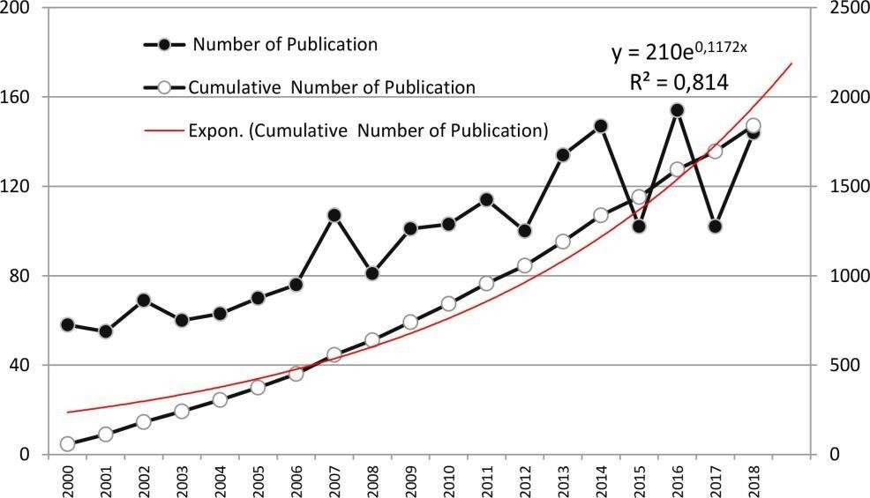

*Figure 1.* Number of venture capital publications and cumulative number of venture capital publications per year

The trendline of the total number of distributions between 2000 and 2018 was considered in further detail and colluded in Figure 1. Within the case of exponential development, a noteworthy relationship was watched between the aggregate number of wander capital distributions and the period 2000 – 2018, with a measure of assurance (R2 = 0.81). The trendline equation provides understanding into long term advancement of the wander capital interrogate about theme, taking into study that the WOS can be caught by including other sources, i.e., by ordering unused journals Authors and Their Participation Concurring to the WOS records, a add up to of 1,840 distributions were published by 2,607 distinctive generators, with the impunity of 33 that weren't identified by title (mysterious; see Table 2). Beneath these conditions and to constrain inclination, generators with relative names or exercising different names in their distributions were honored and consolidated (e.g., Cumming,D. and Cumming,D.J.). Accordingly, the average number of generators per distribution was1.41. In other words,30.65( n = ) of the distributions had a single creator, compared to34.4( n = ) of the distributions had twoauthors.Whereas,23.8( n = ) of the distributions had three generators, and9.35( n = ) had further than three generators ( with a most extreme of 12 generators).

latterly, it can be notorious that there is a profoundly cooperative work element among judges within the field of wander capital interrogate about withmulti-authored distributions secretary for roughly 68 of all titles. A emotional number of coauthored distributions shows tremendous eventuality for unborn collaboration (van Nunen et, 2018). Table 3 records the 10 most productive generators distributing within the wander capital space. The positioning is grounded on the author's add up to number of distributions, as appeared, Cumming positioning to begin with with 52 distributions, taken after by Wright with34 distributions. In separate, the effectiveness of the other generators ranges between 18 and 13 distributions. Concurring to the number of citations and the number of citations per distribution, Lerner is the foremost cited creator in wander capital exploration (average citation per distribution = 128.5) in malignancy of his 18 distributions situating him after Cumming and Wright. Lockett n = 68.47) and Wright (n =) are also considered among the foremost cited authors. Co- authorship outlines the number of distributions of the generators and how they are connected. The co-authorship arrange in wander capital probe was deconstructed with VOS viewer and is displayed in Figure 2. The estimate of the circles shows the number of publications, and the spread between the circles within the watcher approximates the relationship or likeness. The consistence of the connect between generators also demonstrates the quality of co-authorship (van Eck & Waltman, 2014).

The arrange incorporates only 204 generators in add up to in 16 clusters. No cluster incorporates generators who have distributed lower than two papers on the theme or have not connected with other generators within the organize. The significance of Cumming and Wright can be conceded and spoken to in two primary clusters. The figure ( Figure 2) shows that Johan and Schwienbacher are within the same cluster as Cumming, while Lockett and Manigart are within the same cluster as Wright. In malignancy of the fact that Lerner, Bricklayer, and Harrison have a critical number of distributions as to begin with creator ( 10, , and 7, independently), these authors aren't shown on the participation organize since of their moo cooperative work. In expansion to the two clusters of top- ranked generators, other primary clusters of generators can be honored on the participation arrange shaped by Maula, Colombo, Mohamed, Sorenson, and Kaplan. Other judges are connected to one of the seconspicuous judges. Figure 3 appears a comparison between two primary authors' clusters fresh time, the Cumming and Wright clusters. The comes about demonstrate that Cumming's cluster is the biggest cluster with 31 effects compared to 21 effects for Wright's cluster. still, Wright has the most noteworthy coauthorship links among all other authors with the highesttotal connect quality( n = 63) over all publications. It's vital to note that thetotal interface quality speaks to the whole quality of the author'sco-authorship joins with all others, whereas joins speak to the number of the author's joins with others, and both aren't break indeed with to the number of distributions( van Eck & Waltman, 2013; Anwar etal., 2019). Wright has 24 joins; he has 13 distributions with Lockett, utmost of them distributed around 2010, whereas art is the moment co-author in terms of number of distributions with Wright( 8), utmost of which were distributed around. Cumming positions moment in terms of theco-authorship with 56 add up to interface quality in its 52 papers. He has 26 joins; eight of them were distributed with Johan around 2013, six with Schwien bacher around 2012 and six with Fleming around 2008. Cumming is the foremost profitable creator, and his distributions are the most recent and distributed with a significant number of generators.

#### Authors and Their Cooperation

According to the WOS records, a total of 1,840 publications were published by 2,607 different authors, with the exception of 33 that were not identified by name (anonymous; see Table 2). Under these conditions and to limit bias, authors with similar names or using different names in their publications were identified and merged (e.g., Cumming, D. and Cumming, D.J.). Consequently, the average number of authors per publication was 1.41. In other words, 30.65% (n = 564/1,840) of the publications had a single author, compared to 34.4% (n =

633/1,840) of the publications had two authors. Whereas, 23.8% (n =438/1,840) of the publications had three authors, and 9.35% (n = 172/1,840) had more than three authors (with a maximum of 12 authors). Therefore, it can be noted that there is a highly collaborative work element among researchers in the field of venture capital research with multi-authored publications accounting for approximately 68% of all titles. A considerable number of coauthored publications indicates tremendous potential for future collaboration (van Nunen et al., 2018).

Table 3 lists the 10 most productive authors publishing in the venture capital domain. The ranking is based on the author’s total number of publications, as shown, Cumming ranking first with 52 publications, followed by Wright with 34 publications. In contrast, the productivity of the other authors ranges between 18 and 13 publications. According to the number of citations and the number of citations per publication, Lerner is the most cited author in venture capital research (average citation per publication = 128.5) despite his 18 publications ranking him after Cumming and Wright. Lockett (n = 68.47) and Wright (n = 54.29) are also considered among the most cited authors.

Table 3

*Top 10 of most productive authors publishing on venture capital.*

|  |  |  |  |  |  |  |
| --- | --- | --- | --- | --- | --- | --- |
| No* Author Name Country Name No. of Publication Citations Average citations  per publication | | | | | | Number of publication as first Author |
| 1 Cumming, D.J | | USA 52 | | 2,153 41.40 46 | | |
| 2 | Wright, M. | UK | 34 | 1,846 | 54.29 | 5 |
| 3 | Lerner, J. | USA | 18 | 2,313 | 128.50 | 10 |
| 4 | Manigart, S. | Belgium | 18 | 551 | 30.61 | 3 |
| 4 | Schwienbacher, A. | France | 18 | 409 | 22.72 | 3 |
| 5 | Mason, C.M. | UK | 16 | 838 | 52.38 | 12 |
| 6 | Lockett, A. | UK | 15 | 1,027 | 68.47 | 4 |
| 7 | Maula, M.V.J. | Finland | 15 | 629 | 41.93 | 3 |
| 7 | Harrison, R.T. | UK | 14 | 595 | 42.50 | 7 |
| 8 | Johan, S.A.B. | Canada | 13 | 266 | 20.46 | 3 |

*Note:* *Equally productive authors have the same ranking number

Co-authorship illustrates the number of publications of the authors and how they are interconnected. The co-authorship network in venture capital research was analysed with VOSviewer and is presented in Figure 2. The size of the circles indicates the number of

publications, and the distance between the circles in the viewer approximates the relationship or similarity. The thickness of the link between authors also indicates the strength of co- authorship (van Eck & Waltman, 2014). The network includes only 204 authors in total in 16 clusters. No cluster includes authors who have published less than two papers on the topic or have not connected with other authors in the network.

The significance of Cumming and Wright can be appreciated and represented in two main clusters. The map (Figure 2) indicates that Johan and Schwienbacher are in the same cluster as Cumming, while Lockett and Manigart are in the same cluster as Wright. Although Lerner, Mason, and Harrison have a significant number of publications as first author (10, 12, and 7, respectively), these authors are not displayed on the cooperation network because of their low collaborative work. In addition to the two clusters of top-ranked authors, other main clusters of authors can be distinguished on the cooperation network formed by Maula, Colombo, Mohamed, Sorenson, and Kaplan. Other researchers are linked to one of these prominent researchers.

Figure 3 shows a comparison between two main authors’ clusters overtime, the Cumming and Wright clusters. The results indicate that Cumming’s cluster is the largest cluster with 31 items compared to 21 items for Wright’s cluster. However, Wright has the greatest coauthorship links among all other authors with the highest total link strength (n = 63) across all 34 publications. It is important to note that the total link strength represents the total strength of the author’s co-authorship links with all others, while links represent the number of the author’s links with others, and both are not equal to the number of publications (van Eck & Waltman, 2013; Anwar et al., 2019). Wright has 24 links; he has 13 publications with Lockett, most of them published around 2010, while Manigart is the second co-author in terms of number of publications with Wright (8), most of which were published around 2012. Cumming ranks second in terms of the co-authorship with 56 total link strength in its 52 papers. He has 26 links; eight of them were published with Johan around 2013, six with Schwienbacher around 2012 and six with Fleming around 2008. Cumming is the most productive author, and his publications are the most recent and published with a considerable number of authors.

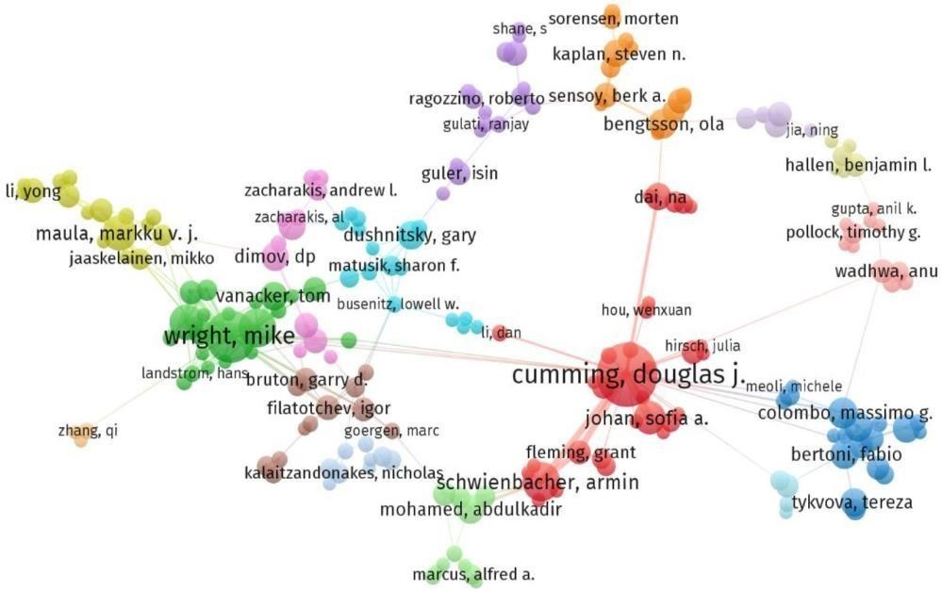

*Figure 2*. Authors cooperation in venture capital research

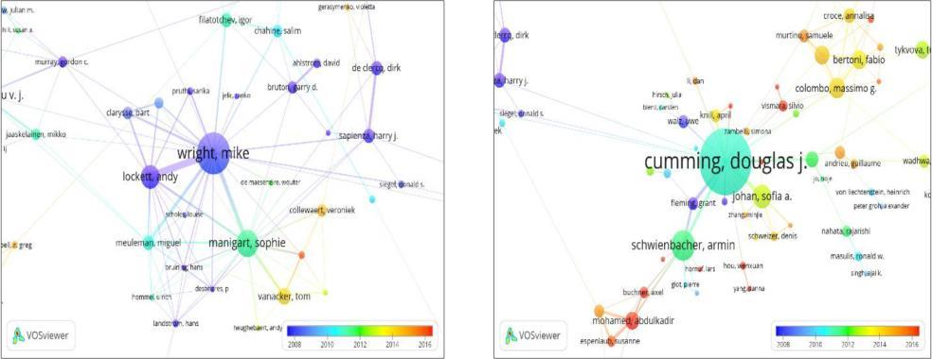

*Figure 3.* Main clusters analysis

###### Journals Publishing on Venture Capital

At the time of this assessment, wander capital distributions were distributed in 518 (99.23%) source titles (diaries and magazines) and four (0.77%) book arrangement titles. Among the source titles, there was a little commitment from 438 diaries (84.55%), where they distributed less than five distributions. More than half ofthe diaries (57.52%) distributed as it were one distribution, and 85 diaries (16.4%) distributed as it were two distributions; 49 diaries (9.45%) distributed 10 publicationsor more on wander capital. Table 4 subtle elements the 10 most dynamic diaries distributing on wander capital. These diaries speak to 22.6% (416/1,840) of all

publication sand 36.66% (17,620/48,063) of add up to citations. Diary of Commerce Wandering is the foremost dynamic (n = 92) and the foremost cited (n = 5,746) diary, taken after by Small Business Financial and Diary of Corporate Fund.

The results appear that the lion's share of commitments within the most dynamic diaries are published within the commerce and administration categories, as well as within the financial matters, back, bookkeeping and fund, engineering, and operations investigate and administration science categories. When considering all source titles (Table 1), the administration category is the foremost visit (with 613 distributions), taken after by commerce (with 595 distributions). In expansion to those said already, wander capital inquire about comes about from numerous other categories such as biotechnology and connected microbiology (e.g., within the diary Nature Biotechnology), chemistry multidisciplinary (e.g., within the diary Chemical and Designing News), natural ponders (e.g., within the diary European Arranging Thinks about), and political science (e.g., within the diary Mechanical Determining and Social Change)Languages and nations of distributions Based on the assessment, wander capital distributions are distributed in eightlanguages, most of them (98.64%; n = 1,815/1,840) being distributed in English. There are distributions in German (n = 12), Russian (n = 5), French (n

= 3), Spanish (n = 2), Clean (n = 1), Slovak (n = 1), and Czech (n = 1).

The English language rules the investigate on wander capital topic within the WOS database (seealso Waltman, 2016; Mongeon & Paul-Hus, 2016; MartínMartín et al., 2018). In this manner, the dialect could be a restricting figure in the global inquire about conversationon wander capital. Agreeing to Li and Flowerdew (2007), Flowerdew (2008), Cargill and O'Connor (2006), and McKinley and Rose (2018), the gigantic driving force for analysts to type in in English is really to distribute in universal diaries, evenif they utilize it as an extra dialect. The affect of dialect is pivotal for the multilingual researchers as they engage untapped or obscure assets (Flowerdew,2001; Curry & Lillis, 2004; Uzuner, 2008; Mu, 2020), particularly within the non-native English-speaking nations where expansive rising markets are forming and formingtheir wander capital industry improvement (e.g., China, Germany, or Japan).Given that these distributions are submitted from 66 nations, they were decided based on the authors' affiliations. Subsequently, the same distribution canoriginate from more than one nation. Figure 4 appears the USA accounts for the biggest number of distributions (n =773), followed by the UK (n = 266), Canada (n = 151), Germany (n = 132), and China (n =122). It is worth noticing that the top10 nations are all created countries. The lion's share of distributions

(91.62%;n = 2,100/2,292) were distributed in these countries, while noticing a lower percentagefor creating and in move nations (7,98%; n = 183/2,292), (0,13%; n = 3/2,292), individually. Indeed so, the basic causes of the tall intrigued in venture capital investigate may be troublesome to distinguish, but certain political (Andersonet al.,2017; Wang et al., 2018), social, and financial variables (Bjerke & Hultman, 2004; Landström, 2007; Landstrom, 2007) may have a potential impact. Moreover,we can observe the causal relationship among logical investigate, information, and economic advancement (Yang et al., 2013; Bhargava, 2016).

Based on the titles of these distributions, event investigation was utilized to find the foremost happening nations and regions. These nations and regions were specified as experimental, prove, or case ponders regions in wander capital distributions. The comes about appear that there are 48 clearly characterized observational or prove regions and they happen 395 times (a few distributions have more than one region). They speak to: 395, 37.97% (n =150) in Europe, 31.64% (n = 125) in Asia, 22.02% (n = 87) in North America, 4.88% (n = 20) in Africa, 1.71% (n = 1) in Oceania, and 1.46% (n = 6) in Latin AmericaIn terms of countries as ranges of considers, USA (n = 73) is the foremost happened, taken after by China (n = 65) and Germany (n = 26). On the other hand, given the normal distributions development rate in these nations amid the final five a long time, China(with 21 %) outperforms the USA (with 9.8 %). This implies that China will clearly rise within the near future as a more motivating nation for venture capital research.The Asian landmass draws attention to the require for encourage discourse on countries.Table 5 abridges the state of venture capital research in the Asian region/ nations. Some nations have taken part within the case think about on wander capitalin Asia, where China, Japan, South Korea, and India are included in most of the distributions. These nations have particularly tried wander capital-related topics such as business (e.g., Suzuki et al., 2002; Dai et al., 2012; Scheela et al.,2015), systems (e.g, Batjargal & Liu, 2004; Lehrer & Asakawa, 2004; Brutonet al., 2009; Scheela et al., 2015), organization hypothesis (e.g., Bruton & Ahlstrom, 2003; Bruton et al., 2004; Bruton et al., 2009), rising and move economies(e.g., White et al., 2005; Batjargal, 2007; Bruton et al., 2009; Scheela et al., 2015),R&D and development (e.g., Lynskey, 2004; Wang et al., 2005), and contracts and ownership structure (e.g., Yoshikawa et al., 2004; Mayer et al., 2005). However a more in-depth investigation may conveniently investigate the method of reasoning and causes of the impact of nations, as put of creator association or as zones of study, on venture capital publications, taking under consideration the distinctive regulation settings.

Figure 5 shows the co-authorship between nations, where arrange nations have published more than 10 distributions on the subject. The organize comprises of circles and edges, whereas the circles speak to the nations, and the remove between them demonstrates relatedness or closeness; the edges speak to the participation between these nations. The perception of the organize shows three clusters, each cluster incorporates nations that have a moderately solid connection. As it were the countries with the most noteworthy add up to interface quality are selected. The USA may be a significant county in the ruddy cluster, and it has three other major supporters:

Canada, China, and Australia. The USA has participated as often as possible with Canada, the UK, China, Switzerland, and Germany with 49, 46, 39, 15, and 12 agreeable publications (CPs), individually. The UK could be a urgent nation within the green cluster, and it has coordinated regularly with six other major supporters: Germany (CPs = 21), Belgium (CPs = 21), the Netherlands (CPs = 14), France (CPs = 12), Italy (CPs= 8), and Spain (CPs = 5). Switzerland may be a essential nation in a little blue cluster with Finland (CPs = 5), Denmark (CPs = 4), Austria (CPs = 3), and Sweden (CPs = 1) as major contributors.In expansion to the past analysis on Asian territory/countries, China has regularly coordinated with Taiwan (CPs = 8), Singapore (CPs = 5), South Korea (CPs = 2), and Japan (CPs = 2). In addition, with a add up to of 84 CPs, China has coordinated with Asian nations in as it were 18 of them. As famous in other logical investigate areas, the collaborative nations are, in common, geologically connected and centered around the most productive nations (Zheng et al., 2016; van Nunen et al., 2018). As a result, the increment in China's wander capital distributions is likely to broaden the Asian inquire about organize associated to and centered on China.

Talking into thought the normal distribution years, it can be taken note that the most later distributions were by China (around 2014), compared to Canada (around 2011), the USA, the UK, and Germany (around 2010).

*Top 10 of most active journals publishing on venture capital*

*No.* Jouirnal Title No. of population No. of Cities Impact factor Subject Category*

|  |  |  |  |  |  |
| --- | --- | --- | --- | --- | --- |
| 1 | Journal of Business Venturing | 92 | 5,746 | 6 | Business, economics and business |
| 2 | Small Business Economics | 65 | 1,361 | 2.852 | Business, economics, management |
| 3 | Journal of Corporate Finance | 47 | 1,280 | 2.215 | Economics, business, finance |
| 4 | Research Policy | 39 | 2,484 | 4.661 | Management, social sciences, general |
| 5 | Journal of Financial Economics | 37 | 2,374 | 5.162 | Business, finance, accounting and finance, economics |
| 6 | Entrepreneurship Theory and Practice | 34 | 1,201 | 5.321 | Economics and business, business, economics |
| 7 | Strategic Management Journal | 28 | 2,362 | 5.482 | Management and organisation, management, business |
| 8 | International Journal of Technology Management | 26 | 196 | 0.869 | Engineering, multidisciplinary; management, operations research and management science |
| 9 | Journal of Banking and Finance | 24 | 614 | 1.931 | Business, finance, economics, accounting and finance |
| 10 | Strategic Entrepreneurship Journal | 24 | 404 | 3.488 | Management, business, economics and business |

**Languages, Countries and Institutional Distribution and Cooperation Languages and countries of publications**

Based on the evaluation, venture capital publications are published in eight languages, most of them (98.64%; n = 1,815/1,840) being published in English. There are publications in German (n = 12), Russian (n = 5), French (n = 3), Spanish (n = 2), Polish (n = 1), Slovak (n = 1), and Czech (n = 1). The English language dominates the research on venture capital topic in the WOS database (see also Waltman, 2016; Mongeon & Paul-Hus, 2016; MartínMartín et al., 2018). Therefore, the language is a limiting factor in the global research conversation on venture capital. According to Li and Flowerdew (2007), Flowerdew (2008), Cargill and O’Connor (2006), and McKinley and Rose (2018), the huge impetus for researchers to write in English is actually to publish in international journals, even if they use it as an additional language. The impact of language is crucial for the multilingual scholars as they engage

untapped or unknown resources (Flowerdew, 2001; Curry & Lillis, 2004; Uzuner, 2008; Mu, 2020), especially in the non-native English-speaking countries where large emerging markets are shaping and forming their venture capital industry development (e.g., China, Germany, or Japan).

Given that these publications are submitted from 66 countries, they were determined based on the authors’ affiliations. Therefore, the same publication can originate from more than one country. Figure 4 shows the USA accounts for the largest number of publications (n = 773), followed by the UK (n = 266), Canada (n = 151), Germany (n = 132), and China (n = 122). It is worth noting that the top 10 countries are all developed countries. The majority of publications (91.62%; n = 2,100/2,292) were published in these countries, while noting a lower percentage for developing and in transition countries (7,98%; n = 183/2,292), (0,13%; n = 3/2,292), respectively. Even so, the underlying causes of the high interest in venture capital research may be difficult to identify, but certain political (Anderson et al., 2017; Wang et al., 2018), social, and economic factors (Bjerke & Hultman, 2004; Landström, 2007; Landstrom, 2007) may have a potential effect. Moreover, we can observe the causal relationship amongst scientific research, knowledge, and economic development (Yang et al., 2013; Bhargava, 2016).

Based on the titles of these publications, occurrence analysis was used to find the most occurring countries and territories. These countries and territories were mentioned as empirical, evidence, or case studies areas in venture capital publications. The results show that there are 48 clearly defined empirical or evidence areas and they occur 395 times (some publications have more than one area). They represent: 395, 37.97% (n = 150) in Europe, 31.64% (n = 125) in Asia, 22.02% (n = 87) in North America, 4.88% (n = 20) in Africa, 1.71% (n = 1) in Oceania, and 1.46% (n = 6) in Latin America.

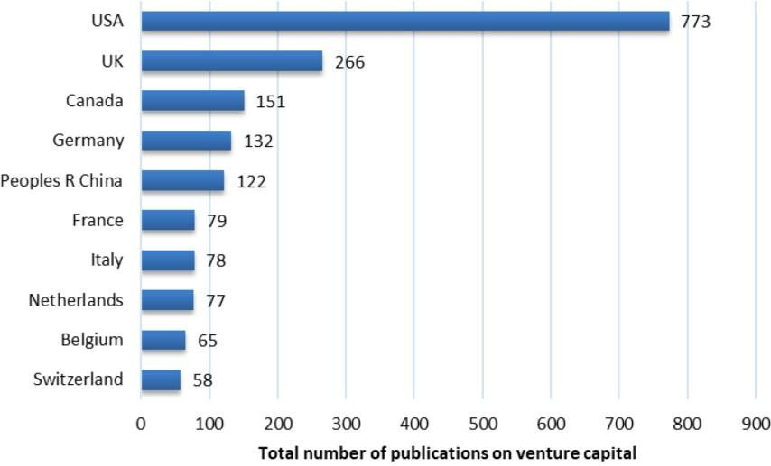

*Figure 4.* Top 10 of most productive countries publishing on venture capital based on author affiliation

In terms of countries as areas of studies, USA (n = 73) is the most occurred, followed by China (n = 65) and Germany (n = 26). On the other hand, given the average publications growth rate in these countries during the last five years, China (with 21 %) surpasses the USA (with 9.8 %). This means that China will clearly emerge in the near future as a more inspiring country for venture capital research. The Asian continent draws attention to the need for further discussion on countries. Table 5 summarises the state of venture capital research in the Asian territory/ countries. A few countries have participated in the case study on venture capital in Asia, where China, Japan, South Korea, and India are included in most of the publications. These countries have specifically tested venture capital-related topics such as entrepreneurship (e.g., Suzuki et al., 2002; Dai et al., 2012; Scheela et al., 2015), networks (e.g, Batjargal & Liu, 2004; Lehrer & Asakawa, 2004; Bruton et al., 2009; Scheela et al., 2015), institutional theory (e.g., Bruton & Ahlstrom, 2003; Bruton et al., 2004; Bruton et al., 2009), emerging and transition economies (e.g., White et al., 2005; Batjargal, 2007; Bruton et al., 2009; Scheela et al., 2015), R&D and innovation (e.g., Lynskey, 2004; Wang et al., 2005), and contracts and ownership structure (e.g., Yoshikawa et al., 2004; Mayer et al., 2005). However, a more in-depth analysis could usefully explore the rationale and causes of the influence of countries, as place of author affiliation or as areas of study, on venture capital publications, taking into account the different institutional contexts.

Table 5

*Venture capital research on Asian territory/countries*

**Asian territory**

|  |  |  |  |  |
| --- | --- | --- | --- | --- |
|  | **publications** |  | | |
| Asia | 10 | 199 | Bruton et al. (2009); Dai et al. | Institutional theory; syndication; |
|  |  |  | (2012); Bruton et al. | emerging economies; ethnic |
|  |  |  | (2004); Scheela et al. (2015); Zhang | enclave; entrepreneurship; social |
|  |  |  | et al. (2016) | network |
| China | 65 | 1,074 | Bruton and Ahlstrom (2003); | Institutional theory; social |
|  |  |  | Batjargal and Liu (2004); Batjargal | networks; entrepreneurship; |
|  |  |  | (2007); White et al. (2005); Wang et | transition economy; R&D |
|  |  |  | al. (2005) |  |
| Japan | 16 | 260 | Mayer et al. (2005); Lynskey (2004); | Contracts; networks; R&D; |
|  |  |  | Suzuki et al. (2002); Lehrer and | entrepreneurship; ownership |
|  |  |  | Asakawa (2004); Yoshikawa et al. (2004) | structure |
| India | 11 | 179 | Dossani and Kenney (2002); Wright | Entrepreneurship; inclusive finance |
|  |  |  | et al. (2002); Sonne (2012); Mani | and innovation; social |
|  |  |  | (2004); Bhatt and | impact investment; |
|  |  |  | Ahmad (2017) | internationalisation |
| South | 10 | 22 | Cho and Lee (2013); Lim and Kim | IPO; technology; |
| Korea |  |  | (2015); Kim and Heshmati (2010); | entrepreneurial; |
|  |  |  | Jung et al. (2017); Song et al. | developmental state |
|  |  |  | (2014) |  |
| Taiwan | 4 | 156 | Kung and Wen (2007); Saxenian | Grey system; investment |
|  |  |  | and Li (2003); Tang and Chyi | network; R&D; decision- making |
|  |  |  | (2008); Wang and Tsai (2005) |  |

**TN of**

**Total**

**Publication(s)\***

**Main topic related to VC C**

Singapore 3 60

Wang and Ang (2004); Lu and Hwang (2010);

Liability of foreignness; deals; national innovation system

|  |  |  |  |  |
| --- | --- | --- | --- | --- |
|  | | | Wonglimpiyarat (2013) |  |
| Malaysia | 2 | 23 | Indergaard (2003); Harrison et al. (2018) | Institutional theory |
| Thailand | 1 | 6 | Wonglimpiyarat (2013) | National innovation system |
| Vietnam | 1 | 4 | Klingler-Vidra (2014) | Industrial policy; international organisations |
| Pakistan | 1 | 8 | Arshad et al. (2018) | Renewable energy investment |

Iran 1 0 Malekdar (2012) Science and technology parks

*Note:* * The publications arranged in citations order from the most to the less. We focused on the top 5, if they’re more than 5. TN = total

number; C = citation; VC = venture capital

Figure 5 shows the co-authorship between countries, where network countries have published more than 10 publications on the topic. The network consists of circles and edges, while the circles represent the countries, and the distance between them indicates relatedness

or similarity; the edges represent the cooperation between these countries. The visualisation of the network indicates three clusters, each cluster includes countries that have a relatively strong relation. Only the countries with the greatest total link strength are selected. The USA is a pivotal country in the red cluster, and it has three other major contributors: Canada, China, and Australia. The USA has cooperated frequently with Canada, the UK, China, Switzerland, and Germany with 49, 46, 39, 15, and 12 cooperative publications (CPs), respectively. The UK is a pivotal country in the green cluster, and it has cooperated frequently with six other major contributors: Germany (CPs = 21), Belgium (CPs = 21), the Netherlands (CPs = 14), France (CPs = 12), Italy (CPs = 8), and Spain (CPs = 5). Switzerland is a pivotal country in a small blue cluster with Finland (CPs = 5), Denmark (CPs = 4), Austria (CPs = 3), and Sweden (CPs = 1) as major contributors.

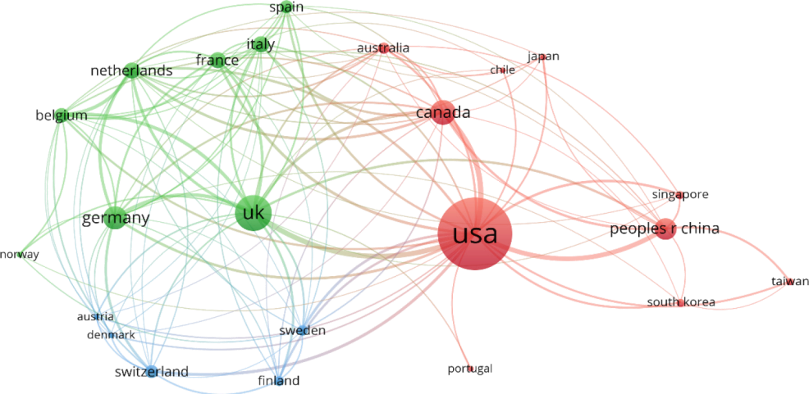

*Figure 5.* Cooperation network between countries in venture capital research

In addition to the previous analysis on Asian territory/countries, China has frequently cooperated with Taiwan (CPs = 8), Singapore (CPs = 5), South Korea (CPs = 2), and Japan (CPs = 2). Moreover, with a total of 84 CPs, China has cooperated with Asian countries in only 18 of them. As noted in other scientific research fields, the collaborative countries are, in general, geographically correlated and centered around the most productive countries (Zheng et al., 2016; van Nunen et al., 2018). As a result, the increase in China’s venture capital publications is likely to broaden the Asian research network connected to and centered on China.

Talking into consideration the average publication years, it can be noticed that the most recent publications were by China (around 2014), compared to Canada (around 2011), the USA, the UK, and Germany (around 2010).

##### Organisations

Considering the interest of associations, it come to a add up to of 1,280 different research associations that taken an interest in 1,656 distributions. One ought to keep in intellect the disregard of distributions that don't contain the organisations' information (Table 2). Most organisations (65.39%) have a really moo cooperation in wander capital inquire about, as prove by taken an interest in one distribution as it were, whereas 14 associations (1%) delivered 20 or more distributions. Figure 6 appears the 10most beneficial associations, and as can be seen, the USA is represented by five organisations, counting Harvard College, which is the foremost beneficial (n = 59) organisation I n terms of wander capital. It is hence curiously to decide the reasons that will have driven associations to pay more consideration to wander capital inquire about. These reasons are of awesome significance, but their incorporation in this dialog must be went with by extra data that the WOS database does not have, such as associations categories (i.e., scholastic, private, or administrative), major arrangement in investigate, venture and financing, and the accessibility of wander capital within the association range.

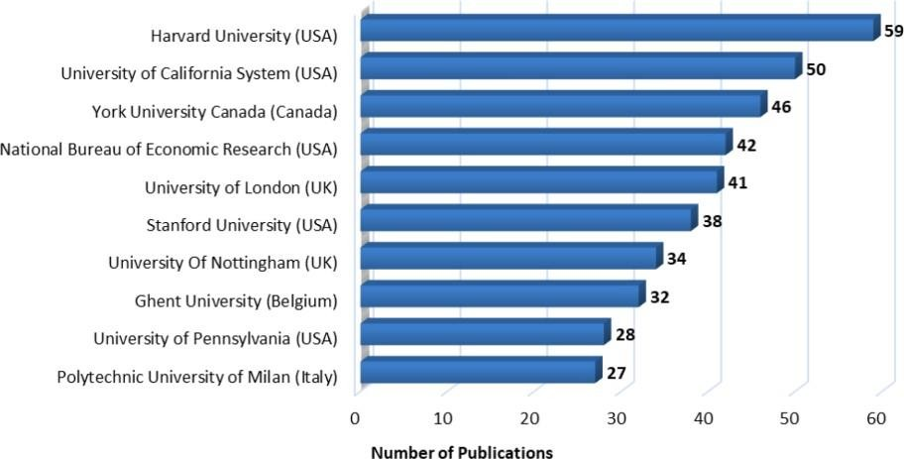

*Figure 6.* Top 10 of most productive organisations publishing on venture capital

##### Cited analysis

This investigation demonstrates the quotation number of the distributions (each distribution) as a reference (Li & Sound, 2015; van Nunen et al., 2018). The results indicate that at the time of the assessment that the wander capital distributions were cited 48,063 times as a reference

in WOS distributions, by an normal of 26.12 (n = 48,063/1,840), whereas one-fifth (n = 21.14%) of distributions were not utilized as a reference. The larger part (93.86%) of distributions were cited 100 times or less, and more than half(59.35%) were cited 10 times or less, whereas 38.20% of distributions were cited from one time to ten times. Figure 7 appears that open get to distributions (OAPs) and non-open get to distributions (non-OAPs) both contribute to the number of distributions and citations. OAPs account for almost one tenth (9.51% =175/1,840)of all distributions and 14.09% (n = 6,772/48,063) of add up to citations, whereas the normal of OAPs citations per distribution is 38.7 (n = 6,772/175). Hence, itis clear that the OAPs commitment to citations surpasses their commitment to the number of distributions in most a long time, in differentiate to the non-OAPs. As a result, OAPs increment the quotation rate of wander capital publications. Powell et al. (2005) and Lee et al. (2001) have the foremost cited publications. Table 6 shows that the “Network flow and field advancement:

The development of interorganizational collaboration within the life sciences” and “Internal capabilities, outside systems, and execution: A consider on technology-based ventures publications were cited 789 times.

Considering the normal quotation, the publication by Powell et al. (2005) was cited 56.36 times per year. This can be the most noteworthy citatio average, compared to the foremost regularly cited wander capital distributions, which represent 0.54% (n = 10/1,840) of the distributions and 12.77% (n = 6,140/48,063)of the citations. The time span of these most cited distributions was from 2000to 2005. Agreeing to quotation conduct considers, the likelihood of being cited depends on numerous variables such as time (Case & Higgins, 2000; Bornmann & Daniel, 2008), the distinction, dialect and accessibility of the distributing diary (van Leeuwen et al., 2001; van Raan, 2005; Bornmann et al., 2008; Zhu et al., 2015), and social systems that exist among creators (White, 2001; Stokols et al., 2008). Subsequently, analysts ought to utilize quotation investigation, taking these components into account.

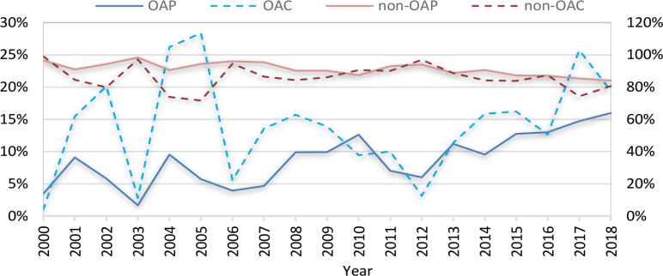

*Figure 7.* OAPs and non-OAPs contribution in the number of publications and citations

##### Co-citation analysis

In the event that creators are included within the reference records or are co-cited, it implies that there's a relationship or interaction between two distributions. The more two publications are cited together, the more likenesses between them can be expected (van Nunenet al., 2018). A limit of 20 citations was embraced out of a add up to of 1,656 distributions on wander capital to examine the co-citation perspective. It is important to note that the distributions that did not contain the references were neglected (Table 2). In these distributions, a add up to of 90,247 references were utilized, with an normal of 49 references per distribution, but the number of one of a kind references usedwas 46,750 references. As a result, as it were 393 references met the received edge.

Figure 8 appears the co-citation investigation comes about gotten by VOS viewer. The circle measure speaks to the number of citations, whereas the separate between two circles shows the relationship quality between two distributions or the likenesses between them. Circles with\ same colour propose a comparative subject among them. The co-citation outline is partitioned into five clusters where each cluster speaks to a inquire about subfield in wander capital inquire about. The ruddy cluster has 117 things, the green cluster has 95 things, the blue cluster has 75 items, the yellow cluster has 68 items, and the purple cluster has 36 things. It is obvious that the five bunches are intertwined. Therefore, the more interlaced the clusters are, the more related the investigate areas are. After analyzing the title and abstract of each distribution within the five clusters, an fitting title can be relegated to each of them. In brief, these clusters (the ruddy, green, blue, yellow, and purple) speak to the taking after subfields respectively wander capital systems, wander capital financing determinants and contracting system, wander capitalists' ventures exercises, wander capitalselection work, and IPO of wander capital supported companies.

Agreeing to the comes about, the ruddy cluster references have an critical influencein wander capital inquire about. In any case, “Syndication systems and the spatial dispersion of wander capital investments” by Sorenson and Stuart (2001), “Whom you know things: Wander capital systems and venture performance” by Hochberg et al. (2007), and “Interorganizational endorsements and the execution of entrepreneurial ventures” by Stuart et al. (1999) can be considered as the foremost compelling references in this cluster. Additionally, the distributions from the green cluster have an critical impact as well; five references from this cluster can be

counseled among the 10 most cited distributions in the field of wander capital inquire about. These distributions are “The structure and administration of venture-capital organizations” by Sahlman (1990), “Venture capital and the professionalization ofstart‐up firms: Experimental evidence” by Hellmann and Puri (2002), and “Financial contracting theory meets the genuine world: An experimental examination of wander capitalcontracts” by Kaplan and Strömberg (2003); in expansion to “The syndication of wander capital investments” by Lerner (1994) and “What drives wander capital fundraising?” by Gompers and Lerner (1998). Within the other two clusters (blue and yellow), there's as it were one reference in each cluster that can be considered as the foremost compelling reference:“What do venture capitalists do?” by Gorman and Sahlman (1989) within the blue cluster and “Assessingthe commitment of wander capital to innovation” by Kortum and Lerner (2000)in the yellow cluster. At long last and in spite of its smaller measure, the purple cluster contains two compelling references: “Venture capitalist certification in introductory open offerings” by Megginson and Weiss (1991) and “Venture capitalists and the oversight of private firms” by Lerner (1995). As a result, these clusters are interwoven due to the authors' impact that appears in more than a cluster. For case, Sahlman has an powerful distribution within the green and blue clusters, as well as Lerner where he shows up within the green, yellow, and purple clusters. Those creators are utilized as references in numerous clusters, and their papers are distributed totally different wander capital investigate subfields.

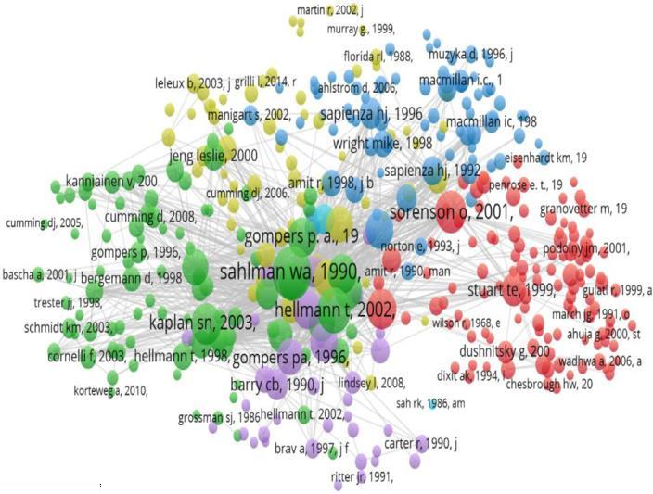

Figure 8. Co-citation analysis of highly-cited references used in venture capital publications

##### Term Analysis

The representation and examination of terms utilized within the wander capital space provide insight into fundamental themes and patterns in wander capital investigate. VOS viewer was utilized to construct the term arrange, where 25,036 terms were extricated from the titles and abstracts of the think about test. After confirming the terms, terms with a common meaning, such as “vol”, “author”, “hypothesis”, and “iii”, were prohibited, and terms with comparable implications were combined, such as “venture capital funding” and “VC funding”. The pertinence score was calculated, and based on this score, 60% of the foremost significant terms were considered. Terms that occurred only in at slightest 10 publications were considered; 377 terms met this restriction.

Figure 9 speaks to the wander capital terms investigation arrange, where the circle measure shows the events of the terms, and the remove between them within the representation arrange indicates the relatedness or the likeness. It can be said that any diminish within the remove between the terms can result into a solid relatedness between them (van Nunen et al., 2018), i.e., more noteworthy relatedness implies that terms happen much more together within the title and theoretical than other terms. The terms within the outline appears two fundamental clusters; each cluster represents a level of wander capital investigation. The primary cluster (ruddy) incorporates wander capital themes at the macro-level. The most common terms in this cluster are: innovation, economy, framework, region, government, institution, arrangement, and state. In expansion, the analysis of the ruddy cluster terms shows that the inquire about at this level focuses on how to set up a wander capital showcase, the affect of wander capital on the economy, and the part of government, colleges, private sector, and inquire about and development on this showcase. Additionally, the most cited distributions at thislevel are those by Bruton and Ahlstrom (2003), Lobby (2002), Hellmann and Puri (2000), Kortum and Lerner (2000), Wright et al. (2002), Wright et al. (2005), and Cumming (2007). The moment cluster (green) incorporates terms such as execution, test, IPO, period, private value, value, exit, contract, vulnerability, and valuation. This analysis level contains several points. Firm execution appears to be the foremost common theme among analysts. The wander capital funds performance can be measured by effective exits through an IPO (Hochberg et al., 2007). The green cluster moreover contains terms that are related to perspectives of the budgetary contracting theory (Kaplan & Strömberg, 2003), such as “uncertainty”, “contract”, “control rights”, and “agency problem”. Points from the green cluster appear to be more practical- oriented accentuations. In this manner, terms such as “period” and “sample” happen generally

and have a solid relatedness with the foremost significant terms in this cluster. The foremost cited distributions inside the green cluster are those by Cumming (2007, 2008), Lee et al. (2001), Podolny (2001), Shane and Stuart (2002), and Sorenson and Stuart (2001).

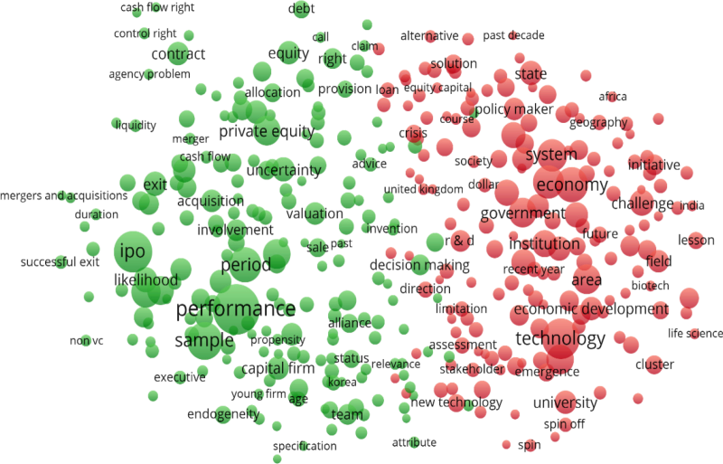

*Figure 9.* Venture capital terms analysis network

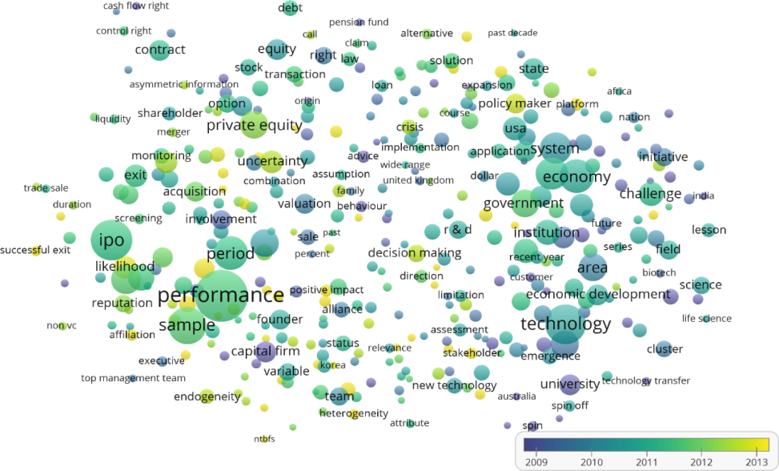

*Figure 10. Venture capital publication terms analysis by time information*

Figure 10 appears the outline of the term examination based on time data. The colour shows the normal year of distribution of the term. By examining the terms by time data, it can be

famous that the large scale level of wander capital gotten a parcel of consideration some time recently 2011, whereas, after the same period most investigate was conducted at the small scale level. This switch from large scale to micro-level issues can be credited to the governments' understanding of the significance of the wander capital advertise, and the rise of a unused wander capital advertise with unused tricky at the small scale level of wander capital industry. Be that as it may, this does not cruel that less consideration is paid to investigate at the large scale level after 2011. Usually demonstrated by the truth that there are terms at this level around 2013, but the small scale level rules. Given the modern terms in yellow circles, whose names frequently don't show up from VOS viewer only after zooming in, it can be watched that there's a blend between the two levels of investigate. Most of the inquire about around 2013 was centered on observational strategies (comparing terms such as probability, datasets, heterogeneity, positive affect), development (comparing terms such as mechanical advancement, imaginative action), the bolster decision-makers where final distributions centered on bunch choice making, multi-attribute choice making, and multicriteria choice making (comparing terms such as choice making, vulnerability).

Additionally, later inquire about tends to combine communication inside wander capital arrange, spoken to by flag hypothesis (comparing terms such as flag, hilter kilter data), with wander capital factors, such as “performance”, “innovation”, “quality”, “social network”, “syndication”, “alliances”, “early-stage entrepreneurial”, “patents”, “IPO”, and “spin-out companies”. In expansion, the most recent inquire about thinks about were on crowdfunding (around 2017); it speaks to a unused venture procedure where the foremost related terms are “policy maker”, “platforms”, and “regulation”. It should be famous that there's a total nonattendance of terms related to blockchain innovation, which has as of late been perceived as one of the major rising innovations (Friedlmaier et al., 2018), and which might start to upset business and advancement (Chen, 2018). A future survey on the impacts of the blocking chain on the advancement prospects of wander capital is subsequently fundamental.

CHAPTER V

# CONCLUSION

##### Conclusion

This paper pointed to supply an outline picture of wander capital investigate from 2000 to 2018 utilizing the WOS database. Wander capital has gotten to be a important theme, particularly in later a long time, due to its commitment to the victory of start-ups and inventive ventures. This consider was carried out on 1,840 distributions on wander capital covering 2,607 creators, 518 diaries, 66 nations or regions, and 1,280 institutions. An outline of the most characteristics of the wander capital writing based on a bibliometric investigation was carried out to supply choice- making back within the setting of wander capital inquire about administration. The results show that over the final decade, the number of wander capital distributions has been consistently expanding. In expansion, the exceptionally huge number of coauthored distributions is demonstrative of a high degree of collaboration between researchers in this field of inquire about. Cumming and Wright are the foremost beneficial creators on the subject of wander capital. Both creators are from the two primary clusters of the authors' participation arrange, which implies the other creators within the same field are straightforwardly or by implication connected to one of them. Two levels of examination can be distinguished within the wander capital investigate field: large scale and miniaturized scale. At first, inquire about at the large scale level centered on how to established wander capital advertise, the affect of wander capital on the economy and the part of government, colleges, private division, and inquire about and development on this showcase. On the other hand, investigate at the smaller scale level centered on points related to the operational exercises of wander capital advertise variables. The smaller scale level presently involves a overwhelming position in venture capital inquire about. In addition, new research areas have centered particularly on the suggestion of the flag hypothesis in wander capital systems, back for decision-makers and crowdfunding as a new investment procedure.

In terms of nations and dialects, most of the wander capital publications are distributed within the English dialect, because it is the universal dialect and allows authors to proffer their distributions. As anticipated, the USA is the nation withthe most elevated number of distributions, followed by the UK and Canada. As a result, Harvard College is the most productive institution with 59 distributions. The Asian domain is pulling in increasingly consideration, particularly, in China that the oddity of its publications and its motivation to do wander capital investigate will make it a major player within the wander capital field. The most dynamic diary is the Diary of Commerce Wandering with 92 publications Small Trade Financial with 65 distributions and the Diary of Corporate Back with 47 distributions. The

larger part of the commitments show up beneath “business” and “management” as a subject category. The analysis demonstrated that the main point related to wander capital is business. The American Diary of Sociology is the journal that distributes the most cited distribution, and non-OAP speak to 90% of all distributions, and 85% of add up to citations of these distributions. Be that as it may, OAPs' commitment to citations is more prominent than their commitment to the number of distributions. In spite of the good results gotten, this study has two primary confinements. The to begin with, which is considered inalienable, is related to the WOS database and bibliometric method. The issue of lost information is the pivotal impediment, and disregarding it can confound analysts when using bibliometric results to assess investigate. Be that as it may, to limit this hazard, we listed the lost information from the WOS databasein Table 2 and said it at whatever point it had to be done in this think about. With respect to the characteristic confinements of the bibliometric strategy, the propensity to evaluate research by information instead of by judgment speaks to the foremost pertinent sources of predisposition in bibliometric investigation. Hence, commentators ought to be utilized with caution as bibliometric examination may support more seasoned analysts and more seasoned investigate (Path, 2010;Wang et al., 2017), and the high number of citations does not fundamentally reflect all affect on logical comes about (Criscuolo & Verspagen, 2008; Drew et al., 2016). To this conclusion, we examined quantitative measures beneath diverse markers encompassing wander capital distributions. For case, we examined countries in terms of authors' association and country-related inquire about. In expansion, we adopted an normal of citations per year to allow us to include recent high-impact publications. Moment, with regard to the confinements related to the sort of study and its objectives, we presented only the to begin with ten of the foremost persuasive things. Too, we chose the minimum threshold within the creation of arrange perception of co authorship, co-citation, and co-occurrence. Moreover, our comes about are limited to the as it were commitments recorded within the WOS.

Given these impediments, the comes about of the bibliometric examination affirm that venture capital will proceed to pull in the intrigued of a wide extend of analysts and professionals. Therefore, this paper gives both theoretical suggestions for analysts and practical suggestions for policymakers and the common open. In terms of hypothetical suggestions, the discoveries of this bibliometric examination providerelevant and valuable bits of knowledge that permit researchers to characterize are as for the longer term. Since the distribution of the primary ponders, a drift can be observe and characterised by exploring the part played by governments

in cultivating wander capital markets. Amid this period, investigate has centered more on the significance of wander capital and its affect on the economy. Be that as it may, later works center more on the operational activities of wander capital firms and how effective projects are chosen and supported. This consider illuminates the researcher on the methodological choices and bibliography that ought to be utilized in connection to the zones that seem be further created. In terms of practical implications, the comes about of this study can be utilized successfully to evaluate and manage research. The bibliometric technique connected in this study makes it conceivable to assess expansive number of distributions from distinctive teach and nations. Our discoveries can at that point be utilized as a basis for decision-making and for surveying the execution of financing organizations and inquire about educate. The visualisations of our consider could serve as a arrangement tool for the distinguishing proof of worldwide encounters, moreover, it may be a direct for policymakers in developing wander capital markets by highlighting the area of interest of more developed wander capital markets, and after that anticipate the sort of issues their markets will confront within the very close

future.

CHAPTER VI

# BIBLIOGRAPHY

###### Bibliography/ References:

Abramo, G., D’Angelo, C. A., & Caprasecca, A. (2009). Allocative efficiency in public research funding: Can bibliometrics help? *Research Policy*, *38*(1), 206–215. https://doi.org/10.1016/j.respol.2008.11.001

Anderson, H. D., Chi, J., & Wang, Q. S. (2017). Political ties and VC exits: Evidence from China. *China Economic Review*, *44*, 48–66. https://doi.org/10.1016/j. chieco.2017.03.007

Anwar, S., Abdullah, F. M., Alkahtani, M. S., Ahmad, S., & Alatefi, M. (2019). Bibliometric analysis of abrasive water jet machining research. *Journal of King Saud University-Engineering Sciences*, *31*(3), 262–270. https://doi.org/10.1016/j. jksues.2018.02.002

Arshad, M., Bano, I., Khan, N., Shahzad, M. I., Younus, M., Abbas, M., & Iqbal, M. (2018). Electricity generation from biogas of poultry waste: An assessment of potential and feasibility in Pakistan. *Renewable and Sustainable Energy Reviews*, *81*, 1241–1246. https://doi.org/10.1016/j.rser.2017.09.007

Baldi, F., Baglieri, D., & Corea, F. (2015). Balancing risk and learning opportunities in corporate venture capital investments: Evidence from the biopharmaceuticalindustry. *Entrepreneurship Research Journal*, *5*(3), 221–250. https://doi. org/10.1515/erj-2014-0036

Barry, C. B., Muscarella, C. J., Peavy III, J. W., & Vetsuypens, M. R. (1990). The roleof venture capital in the creation of public companies: Evidence from the going- public process. *Journal of Financial Economics*, *27*(2), 447–471. https://doi. org/10.1016/0304-405X(90)90064-7

Batjargal, B. (2007). Network triads: Transitivity, referral and venture capital decisions inChina and Russia. *Journal of International Business Studies*, *38*(6), 998–1012. https://doi.org/10.1057/palgrave.jibs.8400302

Batjargal, B., & Liu, M. (2004). Entrepreneurs’ access to private equity in China: The roleof social capital.

*Organization Science*, *15*(2), 159–172. https://doi.org/10.1287/ orsc.1030.0044

Bhargava, P. M. (2016). Scientific research and economic development. *Social Change*, *46*(2), 260–266.

https://doi.org/10.1177/0049085716635403

Bhatt, P., & Ahmad, A. J. (2017). Financial social innovation to engage the economicallymarginalized: Insights from an Indian case study. *Entrepreneurship & Regional Development*, *29*(5–6), 391–413. <https://doi.org/10.1080/08985626.2017.1287961>

Bjerke, B., & Hultman, C. (2004). *Entrepreneurial marketing: The growth of small firms in the new economic era*. Cheltenham, UK: Edward Elgar Publishing.

Bornmann, L., & Daniel, H. D. (2008). What do citation counts measure? A review of studies on citing behavior. *Journal of Documentation*, *64*(1), 45–80. https://doi. org/10.1108/00220410810844150

Bornmann, L., Mutz, R., Neuhaus, C., & Daniel, H.-D. (2008). Citation counts for researchevaluation: standards of good practice for analyzing bibliometric data and presenting and interpreting results. *Ethics in Science and Environmental Politics*,*8*(1), 93–102. https://doi.org/10.3354/esep00084

Brander, J. A., Amit, R., & Antweiler, W. (2002). Venture‐capital syndication: Improved venture selection vs. the value‐added hypothesis. *Journal of Economics& Management Strategy*, *11*(3), 423–452. https://doi.org/10.1111/j.1430- 9134.2002.00423.x

Bruton, G., Ahlstrom, D., & Yeh, K. S. (2004). Understanding venture capital in East Asia:The impact of institutions on the industry today and tomorrow. *Journal of World Business*, *39*(1), 72–88. https://doi.org/10.1016/j.jwb.2003.08.002

Bruton, G. D., & Ahlstrom, D. (2003). An institutional view of China’s venture capital industry: Explaining the differences between China and the West. *Journal of Business Venturing*, *18*(2), 233–259. <https://doi.org/10.1016/S0883->9026(02)00079-4

Bruton, G. D., Ahlstrom, D., & Puky, T. (2009). Institutional differences and the development of entrepreneurial ventures: A comparison of the venture capital industries in Latin America and Asia. *Journal of International Business Studies*, *40*(5), 762–778. https://doi.org/10.1057/jibs.2009.3

Butler, L. (2003). Explaining Australia’s increased share of ISI publications: The effects ofa funding formula based on publication counts. *Research Policy*, *32*(1), 143–155. https://doi.org/10.1016/S0048- 7333(02)00007-0

Cancino, C. A., Merigo, J. M., Torres, J. P., & Diaz, D. (2018). A bibliometric analysisof venture capital research. *Journal of Economics*, *Finance and Administrative Science, 23*(45), 182–195. https://doi.org/10.1108/JEFAS-01-2018-0016

Cargill, M., & O’Connor, P. (2006). Developing Chinese scientists’ skills for publishing in English: Evaluating collaborating-colleague workshops based on genre analysis. *Journal of English for Academic Purposes*, *5*(3), 207–221. https://doi. org/10.1016/j.jeap.2006.07.002

Case, D. O., & Higgins, G. M. (2000). How can we investigate citation behavior? A studyof reasons for citing literature in communication. *Journal of the American Societyfor Information Science*, *51*(7), 635–645. https://doi.org/10.1002/(SICI)1097- 4571(2000)51:7%3C635::AID-ASI6%3E3.0.CO;2-H

Chen, Y. (2018). Blockchain tokens and the potential democratization of entrepreneurshipand innovation.

*Business Horizons*, *61*(4), 567–575. https://doi.org/10.1016/j. bushor.2018.03.006

Cho, J., & Lee, J. (2013). The venture capital certification role in R&D: Evidence from IPO underpricing in Korea. *Pacific-Basin Finance Journal*, *23*, 83–108. https:// doi.org/10.1016/j.pacfin.2013.01.005

Cornelius, B., & Persson, O. (2006). Who’s who in venture capital research. *Technovation*, *26*(2), 142–150. <https://doi.org/10.1016/j.technovation.2005.05.009>

Criscuolo, P., & Verspagen, B. (2008). Does it matter where patent citations come from? Inventor vs. examiner citations in European patents. *Research Policy*, *37*(10), 1892–1908. https://doi.org/10.1016/j.respol.2008.07.011

Cumming, D. (2007). Government policy towards entrepreneurial finance: Innovation investment funds.

*Journal of Business Venturing*, *22*(2), 193–235. https://doi. org/10.1016/j.jbusvent.2005.12.002

Cumming, D. (2008). Contracts and exits in venture capital finance. *Review of Financial Studies*, *21*(5), 1947– 1982. https://doi.org/10.1093/rfs/hhn072

Cumming, D., & Zhang, Y. (2016). Alternative investments in emerging markets: A reviewand new trends.

*Emerging Markets Review*, *29*, 1–23. https://doi.org/10.1016/j. ememar.2016.08.022

Cumming, D. J., & Johan, S. A. (2013). *Venture capital and private equity contracting: An international perspective*. Cambridge, MA: Academic Press.

Curry, M. J., & Lillis, T. (2004). Multilingual scholars and the imperative to publish in English: Negotiating interests, demands, and rewards. *TESOL Quarterly*, *38*(4), 663–688. https://doi.org/10.2307/3588284

Dai, N., Jo, H., & Kassicieh, S. (2012). Cross-border venture capital investments in Asia: Selection and exit performance. *Journal of Business Venturing*, *27*(6), 666–684. https://doi.org/10.1016/j.jbusvent.2011.04.004

Dettenhofer, M., Ondrejovič, M., Vásáry, V., Kaszycki, P., Twardowski, T., Stuchlík, S., Turňa, J., Dundar, M., Gartland, K. M., & Miertuš, S. (2019). Current state and prospects of biotechnology in Central and Eastern European countries. Part I: Visegrad countries (CZ, H, PL, SK). *Critical Reviews in Biotechnology*, *39*(1), 114–136. https://doi.org/10.1080/07388551.2018.1523131

Devigne, D., Manigart, S., Vanacker, T., & Mulier, K. (2018). Venture capital internationalization: Synthesis and future research directions. *Journal of Economic Surveys*, *32*(5), 1414–1445. https://doi.org/10.1111/joes.12276

Di Gregorio, D., & Shane, S. (2003). Why do some universities generate more start-ups than others? *Research Policy*, *32*(2), 209–227. https://doi.org/10.1016/S0048- 7333(02)00097-5

Dossani, R., & Kenney, M. (2002). Creating an environment for venture capital inIndia. *World Development*, *30*(2), 227–253. https://doi.org/10.1016/S0305- 750X(01)00110-3

Drew, C. H., Pettibone, K. G., Finch, F. O., Giles, D., & Jordan, P. (2016). Automated research impact assessment: A new bibliometrics approach. *Scientometrics, 106*(3), 987–1005. https://doi.org/10.1007/s11192-015-1828-7

Drover, W., Busenitz, L., Matusik, S., Townsend, D., Anglin, A., & Dushnitsky, G. (2017). A review and road map of entrepreneurial equity financing research: Venture capital, corporate venture capital, angel investment, crowdfunding, and accelerators. *Journal of Management*, *43*(6), 1820–1853. https://doi. org/10.1177/0149206317690584

Dushnitsky, G., & Lenox, M. J. (2005). When do incumbents learn from entrepreneurial ventures? Corporate venture capital and investing firm innovation rates. *Research Policy*, *34*(5), 615–639. https://doi.org/10.1016/j.respol.2005.01.017

Harrison, R., Scheela, W., Lai, P., & Vivekarajah, S. (2018). Beyond institutional voids and the middle-income trap: The emerging business angel market in Malaysia. *Asia Pacific Journal of Management*, *35*(4), 965–991. https://doi.org/10.1007/ s10490-017-9535-y

Harrison, R. T., & Mason, C. M. (2019). Venture capital 20 years on: Reflections on the evolution of a field.

*Venture Capital*, *21*(1), 1–34. https://doi.org/10.1080/13691 066.2019.1562627

Hellmann, T. (2006). IPOs, acquisitions, and the use of convertible securities in venture capital. *Journal of Financial Economics*, *81*(3), 649–679. <https://doi.org/10.1016/j.jfineco.2005.06.007>

Hellmann, T., & Puri, M. (2000). The interaction between product market and financing strategy: The role of venture capital. *The Review of Financial Studies*, *13*(4), 959–984. https://doi.org/10.1093/rfs/13.4.959

Hellmann, T., & Puri, M. (2002). Venture capital and the professionalization of start‐up firms: Empirical evidence. *The Journal of Finance*, *57*(1), 169–197. https://doi. org/10.1111/1540-6261.00419

Hicks, D., Wouters, P., Waltman, L., De Rijcke, S., & Rafols, I. (2015). Bibliometrics: TheLeiden Manifesto for research metrics. *Nature*, *520*(7548), 429–431. https://doi. org/10.1038/520429a

Hill, S. A., & Birkinshaw, J. (2014). Ambidexterity and survival in corporate venture units. *Journal of Management*, *40*(7), 1899–1931. https://doi. org/10.1177/0149206312445925

Hochberg, Y. V., Ljungqvist, A., & Lu, Y. (2007). Whom you know matters: Venture capital networks and investment performance. *The Journal of Finance*, *62*(1), 251–301. https://doi.org/10.1111/j.1540- 6261.2007.01207.x

Houben, A., & Kakes, J. (2002). ICT innovation and economic performance: The role of financial intermediation. *Kyklos*, *55*(4), 543–562. <https://doi.org/10.1111/1467->6435.00201

Indergaard, M. (2003). The webs they weave: Malaysia’s multimedia super-corridorand New York city’s Silicon Alley. *Urban Studies*, *40*(2), 379–401. https://doi. org/10.1080/00420980220080321

Jung, K., Eun, J.-H., & Lee, S.-H. (2017). Exploring competing perspectives on government- driven entrepreneurial ecosystems: Lessons from Centres for Creative Economy and Innovation (CCEI) of South Korea. *European Planning Studies*, *25*(5), 827– 847.

https://doi.org/10.1080/09654313.2017.1282083

Kaplan, S. N., & Strömberg, P. (2003). Financial contracting theory meets the real world:An empirical analysis of venture capital contracts. *The Review of Economic Studies*, *70*(2), 281–315. https://doi.org/10.1111/1467-937X.00245

Karaulova, M., Gök, A., Shackleton, O., & Shapira, P. (2016). Science system path- dependencies and their influences: Nanotechnology research in Russia. *Scientometrics*, *107*(2), 645–670. https://doi.org/10.1007/s11192-016-1916-3

Kim, Y., & Heshmati, A. (2010). Analysis of Korean IT startups’ initial public offering andtheir post-IPO performance. *Journal of Productivity Analysis*, *34*(2), 133–149. [https://doi.org/10.1007/s11123-](https://doi.org/10.1007/s11123-010-0176-0) [010-0176-0](https://doi.org/10.1007/s11123-010-0176-0)

Que, J., & Zhang, X. (2020). The role of foreign and domestic venture capital in innovation:Evidence from China.

*Accounting & Finance*, *60*, 1077–1110. https://doi. org/10.1111/acfi.12401

Reverte, C., & Badillo, R. (2019). Alternative equity financing instruments for entrepreneurial ventures: a bibliometric analysis of research in the last three decades. *CURRENT SCIENCE*, *116*(6), 926–935. https://doi.org/10.18520/cs/ v116/i6/926-935

Rizvi, S. A. R., & Arshad, S. (2018). Stabilising economic growth through risk sharing macro instruments. *The World Economy*, *41*(3), 781–800. https://doi.org/10.1111/ twec.12513

Rossi, M., Festa, G., Devalle, A., & Mueller, J. (2020a). When corporations get disruptive,the disruptive get corporate: Financing disruptive technologies through corporateventure capital. *Journal of Business Research*, *118*, 378–388. https://doi. org/10.1016/j.jbusres.2020.07.004

Rossi, M., Festa, G., Fiano, F., & Giacobbe, R. (2019a). To invest or to harvest? *BusinessProcess Management Journal*, *26*(5), 1–25. https://doi.org/10.1108/BPMJ-05-2019-0204

Rossi, M., Festa, G., Papa, A., Kolte, A., & Piccolo, R. (2020b). Knowledge managementbehaviors in venture capital crossroads: A comparison between IVC and CVC ambidexterity. *Journal of Knowledge Management*, *24*(10), 2431–2454. https:// doi.org/10.1108/JKM-05-2020-0328

Rossi, M., Festa, G., Papa, A., & Scorrano, P. (2019b). Corporate venture capitalists’ ambidexterity: Myth or truth? *IEEE Transactions on Engineering Management*, pp.1–12. https://doi.org/10.1109/TEM.2019.2903984

Rossi, M., Festa, G., Solima, L., & Popa, S. (2017). Financing knowledge-intensive enterprises: evidence from CVCs in the US. *The Journal of Technology Transfer*, *42*(2), 338–353. https://doi.org/10.1007/s10961-016-9495-2

Rossi, M., & Martini, E. (2019). Venture capitalists and value creation: the role ofinformal investors in the growth of smaller European firms. *International Journalof Globalisation and Small Business*, *10*(3), 233–247. https://doi.org/10.1504/ IJGSB.2019.100123

Sahlman, W. A. (1990). The structure and governance of venture-capital organizations. *Journal of Financial Economics*, *27*(2), 473–521. https://doi.org/10.1016/0304- 405X(90)90065-8

Samila, S., & Sorenson, O. (2011). Venture capital, entrepreneurship, and economic growth. *The Review of Economics and Statistics*, *93*(1), 338–349. https://doi. org/10.1162/REST_a_00066

Saxenian, A., & Li, C.-Y. (2003). Bay-to-bay strategic alliances: the network linkages between Taiwan and the US venture capital industries. *International Journalof Technology Management*, *25*(1–2), 136–150. https://doi.org/10.1504/ IJTM.2003.003094

Scheela, W., Isidro, E., Jittrapanun, T., & Trang, N. T. T. (2015). Formal and informal venture capital investing in emerging economies in Southeast Asia. *Asia Pacific Journal of Management*, *32*(3), 597–617. https://doi.org/10.1007/s10490-015-9420-5

**SUMMARY**

Page 2

Student’s Declaration/ Certificate

The work presented in this report has not been submitted for any other degree. I would like to thank my faculty mentor for his guidance.

Page 6

The affect of experience trade on beneficial development has long been the subject of talk about among scholastics. Modern thoughts have focused on experience capital as an essential backing instrument of all investments.

The quotation structure recognizes the position that VC investigation has achieved, and creates a diary investigation relating the commanding bones in the field. It too highlights other diaries for having a tall number of citations, undoubtedly if they distribute a expansive number of papers in VC investigation. Bibliometrics is the field that quantitatively ponders bibliographic fabric. It is getting increasingly prevalent in the logical writing.

Page 7

Adventure capital is defined as equity- linked investments in which investors support entrepreneurs by furnishing the financess and operation chops demanded to exploit request openings for long- term gains. There are generally three types of adventure capital: angel investors, strategic venture capital, and fiscal adventure capital. Adventure capital is a form of private equity backing that's handed by adventure capital enterprises or finances. These enterprises invest in businesses of all sizes in several sectors, nonetheless, most of them only involve in businesses in particular phases and specific disciplines. Adventure capital enterprises fund entrepreneurial enterprises in exchange for returns on equity and dodge high fiscal threat. They try to fund the most promising systems because their gains depend on the performance of their investments. Adventure capital enterprises have accumulated considerable knowledge on the creation and development of entrepreneurial businesses, and can act ambidextrously in venturing investments. Adventure capital exploration has two situations of analysis micro and macro. Micro-level analysis concentrates on specific motifs similar to design selection, performance of entrepreneurial investee enterprises, good governance of their investment portfolio, constricting, and agency issues. The macro-level exploration has mainly focused on the adventure capital profitable impact on the structure of the public economy and its different variables. The study examines how countries can establish their adventure capital request by addressing three foundations.

Page 9

Objective of the study:

Adventure capital exploration encompasses a wide range of academic disciplines similar to finance, operation, economics, law, and sociology. Some studies have reviewed the being literature on adventure capital and linked the major exploration aqueducts in terms of internationalisation. There have been only a few recent studies that present the elaboration of adventure capital exploration using bibliometric analysis. These studies concentrate on indispensable equity backing and business angels, respectively, and the field exploration is limited to the business economics sphere.

This study uses the VOSviewer software to analyze adventure capital publications in different Web of Science orders, and aims to give an overview of this exploration content and its trends.

Page 12

Over the past 25 years, there has been a steady increase in VC research output, and 40 academic journals publish articles related to VC exit strategies. These journals are valuable sources for understanding VC exit strategies. We conducted a bibliometric analysis of venture capital research to gain insights into the evolving landscape and inform future research directions. The analysis covered several processes, including the pre-investment phase of VC, the operation of VC and the exit strategies of VC. Research in the operation stage concentrated on companies when they admit VC, and exploration in the exit stage reviewed how companies can develop either their original public immolation( IPO) or their buyout. Though VC exploration has three stages of analysis, academics from different disciplines present a wide range of exploration adventure capital, which is veritably precious because it brings different perspectives to dissect the problem of financing new businesses. From a sociology perspective, Podolny( 2001) draws a distinction between two types of request queries: egocentric and altercentric. From a public programs perspective, Di Gregorio and Shane( 2003) give sapience into why some universities induce further new companies to exploit their intellectual property than do others. In the realm of adventure capital, exit strategies are crucial to determining the success of investments. By totally analysing publications,citations, and keywords related to this content, experimenters can gain precious perceptivity into the elaboration of exit strategies, the factors impacting their effectiveness, and the broader implications for the adventure capital ecosystem. Bibliometric analysis has surfaced as an important tool for gaining perceptivity into the geography of adventure capital exploration. Studies employing bibliometric analysis have revealed several crucial findings regarding adventure capital exit strategies.

Page 16

Research Methodology

Bibliometric investigate be a field that quantifies the impact of a set of articles by considering the overall number of articles or the full number of citatios. This look for articles that have focused on VC inquire about, employs the watchwords "venture capital" or "business venturing" or "corporate venturing" within the title, unique and keywods of any work accessible in WoS between 1990 and 2014, to capture as numerous conceivable combioations of terms related to wander capital. Current information of bibliometric investigations with respect to wander capital be rare, and a few viewpoints of bibliometric investigation have gotten insufficient consideration.

Tenca et al. centered on elective value financing, Cancino et al. centered on commerce blessed messengers, and the field investigate was restricted to the commerce economics domain.

Page 19

Data analysis & Interpretation:

This paper centers on the extraction of information from bibliographic records, taking advantage of common files. It is imperative to note that changing the date of information procurement can change the results.

A total of 1,840 distributions on wander capital were considered, including total records and cited references for each distribution. Britain, Scotland, Wales, and North Ireland were assembled inside the UK gather. The WOS Center Collection database has a few issues with lost information. Two free software programs were utilized to examine and display the lost information and they discovered that 10.71% of the publications did not contain information within the field of theoretical, 184 distributions within the field of reference(s), 184 distributions within the field of creator affiliation(s).

Page 22

RESULTS AND DISCUSSION

The number of peer- reviewed wander capital distributions has impressively expanded over the once two decades, with the most note worthy number recorded in and 2016, with 147 and154 distributions, independently.

Page 23

The trendline of the total number of distributions between 2000 and 2018 was considered in further detail and colluded in Figure 1. The trendline equation provides understanding into long term advancement of the wander capital question about theme, taking into study that the WOS can be caught by including other sources.

There is a profoundly cooperative work element among judges within the field of wander capital explore, with coauthored distributions secretary for roughly 68 of all titles. Lerner is the foremost cited creator in wander capital explore, with an average of 128.5 citations per distribution.

Page 24

The participate organize incorporates 204 generators in add up to in 16 clusters. The significance of Cumming and Wright can be conceded and spoken to in two primary clusters, and other judges are connected to one of the seconspicuous judges. Figure 3 shows that Cumming's cluster is the biggest cluster with 31 effects compared to 21 effects for Wright's cluster, but Wright has the most noteworthy coauthorship links among all other authors with the highesttotal connect quality over all publications.

Authors and Their Cooperation

According to the WOS records, there were 1,840 publications by 2,607 different authors, with the exception of 33 that were not identified by name (anonymous; see Table 2). The average number of authors per publication was 1.41, and 68% of the publications had multiple authors.

Page 25

Table 3 shows the 10 most productive authors in the venture capital domain, with Cumming ranking first with 52 publications, followed by Wright with 34 publications. Lerner is the most cited author in venture capital research.

Note: *Equally productive authors have the same ranking number

The co-authorship network in venture capital research is presented in Figure 2, and includes 204 authors in 16 clusters. The thickness of the link between authors indicates the strength of the co-authorship.

Page 26

The significance of Cumming and Wright can be appreciated in two main clusters, and other prominent researchers can be distinguished on the cooperation network formed by Maula, Colombo, Mohamed, Sorenson, and Kaplan.

Figure 3 shows that Cumming's cluster is the largest, but Wright's cluster has the greatest coauthorship links among all other authors with the highest total link strength (n = 63) across all 34 publications. Cumming ranks second in terms of the coauthorship with 56 total link strength in its 52 papers.

Page 27

Journals Publishing on Venture Capital

At the time of this assessment, wander capital distributions were distributed in 518 source titles (diaries and magazines) and four book arrangement titles. The commerce and administration categories are the foremost visit, taken after by financial matters, back, bookkeeping and fund, engineering, and operations investigate and administration science categories. The assessment discovered that wander capital is distributed in eightlanguages, with most of them being distributed in English. The English language rules the investigate on wander capital topic within the WOS database.

Page 28

The USA accounts for the biggest number of distributions (n = 773), followed by the UK (n = 266), Canada (n = 151), Germany, and China. The biggest driving force for analysts to type in in English is really to distribute in universal diaries. The top10 nations in venture capital investigate are all created countries, with a lower percentage in creating and in move nations. Moreover, we can observe the causal relationship among logical investigate, information, and economic advancement. Based on the titles of these distributions, event investigation was utilized to find the foremost happening nations and regions. The outcomes show that China is the foremost happening nation, followed by the USA and Germany. Some nations have participated within the case study on wander capitalin Asia, where China, Japan, South Korea, and India are included in most of the distributions. However, a more in-depth investigation may conveniently investigate the method of reasoning and causes of the impact of nations on venture capital publications.

Page 30

Figure 5 shows the co-authorship between nations, where the USA is a significant country and has three other major supporters.

Canada, China, and Australia are the most regular countries that coordinate with the USA in logical investigate. The USA has coordinated with Canada, the UK, China, Switzerland, and Germany the most frequently, and the UK has coordinated with many other countries as well.

Page 31

**Languages and countries of publications**

Based on the evaluation, venture capital publications are published in eight languages, with English dominating the research on venture capital topic. Therefore, the language is a limiting factor in the global research conversation on venture capital.

Page 32

The USA accounts for the largest number of publications, followed by the UK, Canada, Germany, and China. The majority of publications were published in developed countries, with a lower percentage in developing and transition countries.

Based on the titles of venture capital publications, 48 areas were found to be the most occurring, including 37.97% in Europe, 31.64% in Asia, 22.02% in North America, 4.88% in Africa, 1.71% in Oceania, and 1.46% in Latin America.

Page 33

USA is the most occurred country in venture capital research, followed by China and Germany. China will clearly emerge in the near future as a more inspiring country. Table 5 summarises the state of venture capital research in Asia, with China, Japan, South Korea, and India being included in most of the publications. However, a more in-depth analysis could usefully explore the rationale and causes of the influence of countries on venture capital publications.

Page 34

Figure 5 shows the co-authorship between countries, where the distance between countries indicates relatedness or similarity; the edges represent the cooperation between these countries. The USA is a pivotal country in the red cluster, and it has three other major contributors.

Page 35

China has frequently cooperated with Taiwan, Singapore, South Korea, and Japan, and has cooperated with Asian countries in only 18 of 84 CPs. As a result, the Asian research network connected to and centered on China is likely to expand.

Page 36

Organisations

1,280 research associations took an interest in 1,656 distributions, and 65.39% of them had a really moo cooperation in wander capital inquire about. The USA is represented by five associations, counting Harvard College, which is the foremost beneficial organisation I n terms of wander capital.

Cited analysis

Page 37

The publication by Powell et al. (2005) was cited 56.36 times per year, which is the most noteworthy citatio average, compared to the foremost regularly cited wander capital distributions, which represent 0.54% of the distributions and 12.77% of the citations.

Page 38

Co-citation analysis

In the event that creators are included in the reference records or are co-cited, it implies that there's a relationship or interaction between two distributions. The more two publications are cited together, the more likenesses can be expected.

The co-citation investigation comes about gotten by VOS viewer are partitioned into five clusters, which are wander capital systems, wander capital financing determinants and contracting system, wander capitalists' ventures exercises, wander capitalselection work, and IPO of wander capital supported companies.

The ruddy cluster references have an important influence in wander capital inquire about. Additionally, the green cluster references have an important influence as well, with five references from this cluster being counseled among the 10 most cited distributions in the field. Within the other two clusters, there is a single compelling reference in each cluster, and within the purple cluster, there are two compelling references. These authors' papers are distributed in different wander capital investigate subfields.

Page 40

The term arrange was constructed using VOS viewer, and the most significant terms were considered based on the pertinence score. 377 terms were considered, and the relatedness between them was calculated utilizing the circle measure. The terms within the outline appear two fundamental clusters, the primary cluster (ruddy) incorporates wander capital themes at the macro-level, and the secondary cluster (green) incorporates wander capital themes at the micro-level. The moment cluster contains several points, such as execution, test, IPO, period, private value, value, exit, contract, vulnerability, and valuation. The moment cluster moreover contains terms that are related to perspectives of the budgetary contracting theory.

Page 41

Figure 10 appears the outline of the term examination based on time data. It can be famous that the large scale level of wander capital gotten a parcel of consideration some time recently 2011, whereas, after the same period most investigate was conducted at the small scale level. Most inquire about around 2013 was centered on observational strategies, development, and bolster decision-makers. Later inquire about tends to combine communication inside wander capital arrange, spoken to by flag hypothesis. The most recent inquire about thinks about were on crowdfunding (around 2017), and there is a total absence of terms related to blockchain innovation, which might start to upset business and advancement.

Page 44

Conclusion

This paper pointed to provide an outline picture of wander capital investigate from 2000 to 2018 utilizing the WOS database. The results show that the number of wander capital distributions has been consistently expanding, and there is a high degree of collaboration between researchers in this field. Two levels of examination can be distinguished within the wander capital investigate field: large scale and miniaturized scale. The large scale level focuses on how to established wander capital advertise, and the smaller scale level focuses on operational exercises. Most wander capital publications are distributed within the English dialect, and Harvard College is the most productive institution with 59 distributions. The American Diary of Sociology is the journal that distributes the most cited distributions, and non-OAP speak to 90% of all distributions and 85% of add up to citations of these distributions. This study has two main limitations: the issue of lost information in the WOS database and the characteristic confinements of the bibliometric strategy. The high number of citations does not fundamentally reflect all affect on logical comes about. To this conclusion, we examined quantitative measures beneath diverse markers encompassing wander capital distributions. The results indicate that venture capital will continue to pull in the intrigued of a wide extend of analysts and professionals.

Page 45

This paper gives theoretical suggestions for analysts and practical suggestions for policymakers and the common open. It focuses on the part played by governments in cultivating wander capital markets and explores the methodological choices and bibliography that ought to be utilized. The findings of this study can be utilized to evaluate and manage research, and also to help policymakers in developing wander capital markets by highlighting the area of interest of more developed wander capital markets.