**ANALYZING THE IMPLEMENTATION GAPS OF NIPAS LAW WITH THE OTHER INTERFACING ENVIRONMENTAL LAWS**

***(RA 7586 NIPAS LAW and RA 11038 E-NIPAS LAW)***

**Engr. Concepcion “Connie” V. Torregosa-Macapayag**

University of Southeastern Philippines

College of Development Management

ORCID Number: 0009-0009-3891-2375

**Abstract**

This study aimed to identify the implementation gaps and the possible way forward of the RA 7586 Law also known as the National Integrated Protected Areas System - Implementing Rules and Regulations (NIPAS Law IRR). It also emphasized the importance of this Law to protect the Philippines’ national parks, monuments, and natural resources, as well as understanding how it will be fully understood by the law enforcer in implementing it on the ground. In the Philippines, the identified protected areas under this NIPAS Law are not even fully recognized by the residents, which leads to a higher possibility of not giving importance to the protected natural resources’s value. Nine other existing pertinent laws in the Philippines deal with the Local Government Unit (LGU) and Department of Environment and Natural Resources - Regional Offices (DENR-RO) that play an important role in making this law successfully implemented, through public information dissemination by conducting Focus Group Discussion (FGD) on the directly involved individuals and stakeholders.

**Keywords:** RA 7586, NIPAS LAW IRR, Philippine national monument, environment, safeguard, protected areas, implementation

1. **Introduction**

As defined by the Law, RA 7586 - NIPAS Law is the Act providing for the establishment and management of the National Integrated Protected Areas System, defining its scope and coverage and other purposes. Cognizant of the profound impact of man’s activities on all components of the natural environment particularly the effect of increasing population, resource exploitation, and industrial advancement, and recognizing the critical importance of protecting and maintaining the natural biological and physical diversities of the environment notably on areas with biologically unique features to sustain human life and development, as well as plant and animal life, it is hereby declared the policy of the State to secure for the Filipino people of present and future generations the perpetual existence of all native plants and animals through the establishment of a comprehensive system of integrated protected areas within the classification of national park as provided for in the Constitution (Philippine Official Gazette, RA 7586, June 1992).

There are environmental laws that govern the Philippines with the same objective which is to protect and preserve natural resources. But most often, these Laws are typically complacent and stored on the bookshelves and even forgotten. Worst scenario, when a certain business gets the Environmental Compliance Certificate (ECC) from the DENR- RO, as form part of the building permit requirements by the LGU, these protected areas are often neglected or not given consideration on the safeguards stated in the RA 7586 Law as the parameters of their check and balance when issuing the business licenses. These laws, if properly imposed with a proper IRR mechanism to implement the guidelines without over-promising the rules and regulations but with a workable baseline, are supposed to be part of the bible of every Filipino in taking care of our environment.

1. **Objective of the Study**

This study aimed to give clarity from the context of law enforcement and to understand the legal sanctions for violating RA 7586 Law. To delve into the existing environmental laws and how they will effectively interface with RA 7586 in safeguarding our environment, specifically the identified protected areas from direct human activities, catastrophic weather impacts, and elemental pollutants. To evaluate and redefine clear parameters on the stated guidelines that can be achievable by all stakeholders involved in handling the protected areas.

The data collected from the survey is responding to the following question: What are the interfacing gaps of RA 7586 (NIPAS) Law in terms of its implementing policy from the other existing Laws that pertain to protecting our natural resources?

1. **Methodology**

This research study was conducted using the qualitative research methodology. An online poll was responded to by 25 professionals in different academic backgrounds and fields of expertise through Google Sheets Forms. The interview data were processed, encoded, and analyzed to generate statistical data in the form of graphs or tables. Online polling is a process of distributing the instrument or the questionnaire to the target respondents using online platforms (Torrentira, 2020). According to Goertzen (2017), in the most basic terms, quantitative research methods are concerned with collecting and analyzing data that is structured and can be represented numerically. One of the central goals is to build accurate and reliable measurements that allow for statistical analysis. In short, quantitative research generally focuses on measuring social reality by viewing the world as a reality that can be objectively determined so rigid guides in data collection and analysis are very important (Sukamolson, 2007). The data gathered responded to the primary endpoints of the research question such as the knowledge of the existing environmental laws in the Philippines and how these laws impact the Filipino citizen’s awareness. The data collected are only limited to the responses from the (10) questions answered by the (25) respondents.

1. **Results and Discussion**

In the online poll conducted with 25 respondents, eight respondents were familiar with RA 7586. In comparison, nine respondents have limited knowledge of the law, and the remaining 12 respondents have yet to learn what NIPAS Law is about. From this data, it is worth noting that there an obvious gaps in the law dissemination of information that need to be addressed. The survey shows that 17 out of 25 have no idea of what and where are the protected areas in the country located. Much of the information to the existing Laws, our data shows that 2 out of 25 respondents have little knowledge of the similar environmental laws interfacing with RA 7586, while the remaining 23 out of 25 respondents do not know the other existing laws that govern environmental protection.

There were clear responses from the respondents with 25 out of 25 expressing their agreement on the NIPAS Law implementation and guidelines that shall be adopted in a sustainable way which is dependent on the collaboration of all stakeholders through a functional delineation, transparent rules and by-laws, accountable on its obligation, and most of all a participatory governance mechanism.

**Table 1: NIPAS Law implementation and guidelines - Survey Response**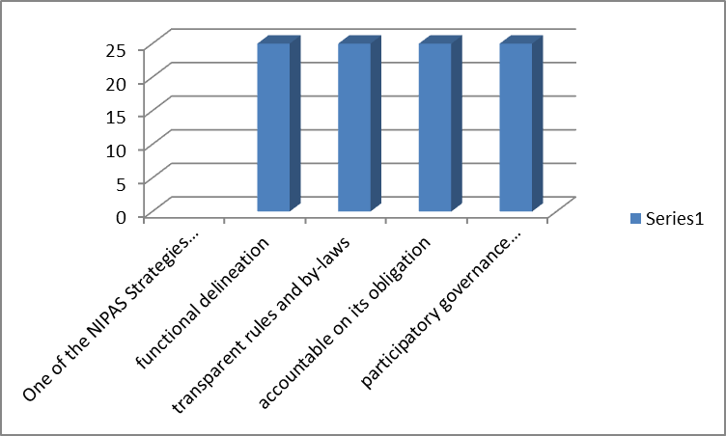

1. **Discussions**

From the (10) survey questions, the response tabulated in Table 1 is a good indicator on what are the gaps in the RA 7586 - NIPAS Law Implementation and what are the possible solutions to make this law effective.

The NIPAS Law implementation and guidelines according to Section 10 - Administration and Management of the System, emphasize that the Secretary of the Department of Environment and Natural Resources (DENR) is empowered to conduct studies on various characteristic features and conditions of the different protected areas using commonalities in their characteristics, classify and define them into categories and prescribe permissible or prohibited human activities in each category in the System. The Secretary has the right to control the occupancy of suitable portions of the protected area and resettle outside of said area forest occupants therein, except for the members of indigenous communities area; and To perform such other functions as may be directed by the President

of the Philippines, and to do such acts as may be necessary or incidental to the accomplishment of the purpose and objectives of the System (Philippine Official Gazette, RA 7586, June 1992).

Having mentioned the salient responsibilities of the Secretary of DENR that have to do with dealing with the other stakeholders, it is significant to emphasize how vague is stated responsibilities are. To address the problem of implementation and become a sustainable way that is dependent on the collaboration of all stakeholders through a functional delineation, transparent rules, and by-laws, accountability on its obligation, and most of all a participatory governance mechanism, it is appropriate to suggest the following mitigation measures:

1. Clear budget allocation, the proper name of the Project Office in every region, and its full functions towards the stakeholders.
2. Clear Outline of the rules and by-laws of all stakeholders involved with their functions and responsibilities aligning with the RA 7586
3. To state the (9) interfacing environmental laws and how they will work together with RA 7586.
4. Clear Rules and Regulation of committing a crime against RA 7586
5. Clear Sanctions of Violations and Tariff for Penalty Amount
6. A yearly event of a (1) month-long nationwide celebration and information dissemination of what RA 7586 is all about through social media, public forums, and focus group discussion.
7. **Reference**

Torrentira, Moises C. , Jr..Online data collection as an adaptation in conducting quantitative and qualitative research during the COVID-19 pandemic. European Journal of Education Studies, [S.l.], v. 7, n. 11, sep. 2020. ISSN 25011111. Available at: <<https://oapub.org/edu/index.php/ejes/article/view/3336>>. Date accessed: 06 May 2024. doi <http://dx.doi.org/10.46827/ejes.v7i11.3336>.

[Republic Act No. 7586 | Official Gazette of the Republic of the Philippines](https://www.officialgazette.gov.ph/1992/06/01/republic-act-no-7586/)

Sukamolson, Suphat. (2007). Fundamentals of quantitative research. The main purpose of this article is to introduce some important fundamental concepts of quantitative research to readers, especially novice researchers.

[Download citation of Fundamentals of quantitative research (researchgate.net)](https://www.researchgate.net/publication/242772176_Fundamentals_of_quantitative_research/citation/download)

[Chapter 3. Introduction to Quantitative Research and Data | Goertzen | Library Technology Reports (ala.org)](https://journals.ala.org/index.php/ltr/article/view/6325/8274)