**ONLINE LEARNING PLATFORM**

**K.sribalaji*1, T. Nirmal Raj*2**

*1Student, Department of Computer Science and Applications, SCSVMV [Deemed to be University], Kanchipuram, Tamil Nadu, India

*2Assistant Professor, Department of Computer Science and Applications, SCSVMV [Deemed to be University], Kanchipuram, Tamil Nadu, India

**ABSTRACT**

The Internet has made online learning possible, and many educators and researchers are interested in online learning courses to enhance and improve the student learning outcomes while battling the shortage in resources, facilities and equipment particularly in higher education institution. Online learning has become popular particularly in higher education institution. Online learning has become popular because of its potential for providing more flexible access to content and instruction at any time, from any place. It is imperative that the researchers consider, and examine the efficacy of online learning in educating students. For this study, the researchers reviewed literature through meta-analysis as the method of research concerning the use of ADDIE (Analysis, Design, Development, Implementation and Evaluation) framework for designing and developing instructional materials that can provide wider access to quality higher education. This framework can be used to list generic processes that instructional designers and training developers use (Morrison et al., 2010). It represents a descriptive guideline for building effective training and performance support tools in five phases, as follows: 1.) Analysis, 2.) Design, 3.) Development, 4.) Implementation, and 5.) Evaluation. The researchers collected papers relating to online learning courses efficacy studies to provide a synthesis of scientifically rigorous knowledge in online learning courses, the researchers searched on ERIC (Education Resources Information Center), ProQuest databases, PubMed, Crossref, Scribd EBSCO, and Scopus. The researchers also conducted a manual search using Google Scholar. Based on the analysis, three main themes developed: 1.) comparison of online learning and traditional face-to-face setting, 2.) identification of important factors of online learning delivery, and 3.) factors of institutional adoption of online learning. Based on the results obtained 50 articles. The researchers examine each paper and found 30 articles that met the efficacy of online learning courses through having well-planned, well-designed courses and programs for higher education institution. Also, it highlights the importance of instructional design and the active role of institutions play in providing support structures for educators and students. Identification of different processes and activities in designing and developing an Online Learning Courses for Higher Education Institution will be the second phase of this study for which the researchers will consider using the theoretical aspect of the ADDIE framework.

1. **INTRODUCTION**

The Integrated System for Ionic Caloric Material Selection, Heat Transfer Analysis, and Stability Control represents a groundbreaking initiative, seamlessly amalgamating the pivotal components of ionic caloric material applications. With a client-centric ethos at its core, the system empowers users to articulate their material requisites effortlessly, interfacing with the Ionic Synthesis module for tailored recommendations within budgetary constraints. Utilizing encrypted data storage via the Diffie-Hellman algorithm ensures robust security, safeguarding sensitive information. Meanwhile, the Heat Transfer Analysis optimizes heat exchanger selections, bolstering efficiency and providing detailed performance insights, while the Stability Control feature assures long-term reliability through comprehensive material evaluations. This streamlined approach not only simplifies material selection for clients but also enhances energy efficiency and environmental sustainability, aligning seamlessly with global goals. The integration of Bayesian Linear Regression algorithms further enhances accuracy and efficiency, promising a greener, more efficient future in refrigeration and heat transfer technologies.

1. **LITERATURE REVIEW**
2. **Allen, E., & Seaman, J. (2010). Class Difference$: Online Education in the United States**.

Alonso, F., Lopez, G., Manrique, D., & Vines, J. M. (2005). An instructional model for web-based e- learning education with a blended learning process approach. British Journal of Educational Technology, 36(2), 217-235.

1. **Arbaugh, J.B., Godfrey, M., Johnson, M., Pollack, BL., Niendorf, B., & Wresch, W., (2009). Research in online and blended learning in the business disciplines: Key findings and possible future direction.**

Bell, B. S., & Fedeman, J. E. (2013). E-learning in postsecondary education. The Future of Children, 23(1), 165–185.

1. **Chen, L., (2016). A Model for Effective Online Instructional Design.**

Dick, W., Carey, L., & Carey, J. O. (2014). The systematic design of instruction (8th ed.). New Jersey: Pearson Education, Inc..

1. **Lorenzetti, J. (2013). Academic Administration - Running a MOOC: Secrets of the World’s Largest Distance Education Classes - Magna Publications.**

McConnell, D. (2000). Implementing computer supported cooperative learning.

1. **Rubric for Online Instruction (2010). QOLT (Quality Online Teaching and Learning).**

Saba, F. (2012). A systems approach to the future of distance education in colleges and universities: Research, development, and implementation. Continuing Higher Education Review, 76, 30–37.

Schmid, R. F., Bernard, R. M., Borokhovski, E., Tamim, R. M., Abrami, P. C., & Surkes, M. A. (2014). The effects of technology use in postsecondary education: A meta-analysis of classroom applications. Computers & Education, 72, 271–291.

1. **OBJECTIVE**

An effective online learning platform must prioritize user engagement and accessibility to deliver a comprehensive educational experience. By incorporating interactive elements such as live webinars, discussion forums, and gamified learning modules, the platform can enhance student participation and motivation. Additionally, offering a wide range of courses across various disciplines ensures that learners of all interests and professional backgrounds can find valuable content. The use of adaptive learning technologies, which tailor educational materials to individual student needs and progress, further personalizes the learning journey, making it more effective and efficient.

1. **PROPOSED SYSTEM**

The proposed online learning platform aims to revolutionize the educational landscape by providing a flexible, accessible, and interactive environment for learners of all ages. Leveraging advanced technologies, the platform will offer a wide array of courses across diverse disciplines, delivered through high-quality video lectures, interactive quizzes, and real-time virtual classrooms. A robust recommendation engine will personalize learning paths based on individual progress and preferences, ensuring a tailored educational experience. The platform will also foster a sense of community through discussion forums, peer reviews, and collaborative projects. To enhance engagement and retention, gamification elements such as badges, leaderboards, and progress tracking will be integrated. Additionally, the system will support various assessment methods, including automated grading and instructor feedback, to provide comprehensive evaluation of learners’ performance. With mobile accessibility and offline capabilities, the platform aims to democratize education, making learning opportunities available anytime and anywhere.

1. **SYSTEM ARCHITECTURE**

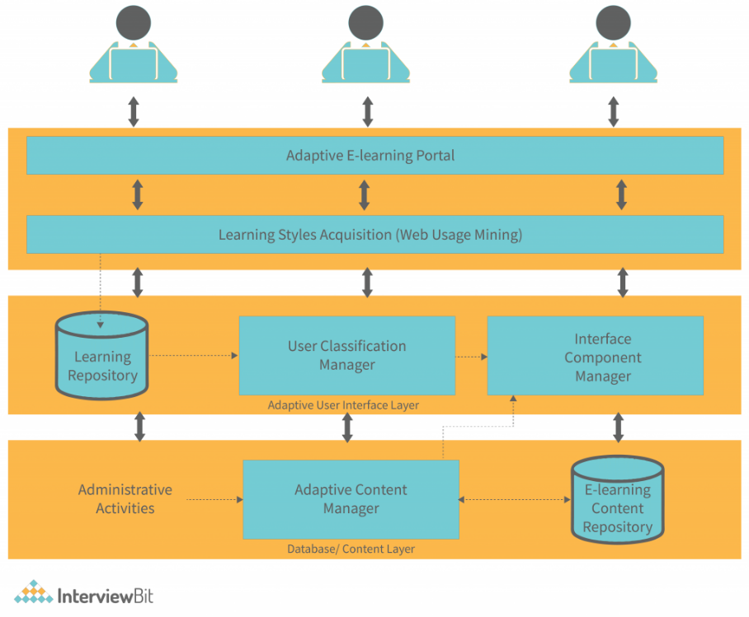

**Figure-1** System Architecture: Illustrates the overall architecture and flow of the system. Depicts the various modules and their interactions.

1. **MODULE DESCRIPTION**

**Course Management System (CMS)** **:**

Overview: Facilitates the creation, organization, and delivery of courses.

Features:

Course creation tools with customizable templates.

Scheduling and syllabus management.

Multimedia content integration (videos, audio, PDFs).

Module and lesson planning.



**Figure-**2 search the course:

**Admin Module:**

The Admin Module is the backbone of the online learning platform, providing essential tools and functionalities for the effective management and administration of the system. This module is designed to ensure smooth operation, facilitate user management, and oversee the educational content. Key features include:

**User Management:** Admins can create, edit, and delete user accounts (students, instructors, and other admins). They can also assign roles and permissions, manage user groups, and monitor user activity and progress.

**Course Management:** Admins have the ability to create, organize, and manage courses. This includes uploading course materials, setting course prerequisites, managing enrollment, and scheduling classes.

**Content Management:** This feature allows admins to upload, update, and organize various types of educational content, including video lectures, reading materials, quizzes, and assignments.

**Reporting and Analytics:** Provides detailed insights and analytics on user performance, course completion rates, and overall platform usage. Admins can generate reports to assess the effectiveness of courses and the platform's performance.

**Communication Tools**: Enables admins to communicate with users through announcements, emails, and notifications. This feature helps in disseminating important information and updates efficiently.

**System Configuration**: Admins can configure system settings, including platform branding, payment gateways, and integration with third-party tools and services

**Support and Maintenance**: Admins can manage support tickets, user feedback, and technical issues to ensure a seamless learning experience for user.



**Figure-3** Admin Approval: This figure shows Admin Approval from client requirements.

**User Module:**

The User Module is designed to provide a user-friendly interface and a rich learning experience for students and instructors. This module focuses on accessibility, engagement, and interactive learning. Key features include:

**User Dashboard:** A personalized dashboard for users to view their courses, track progress, access recent activities, and receive announcements.

**Course Catalog**: Users can browse and search for courses based on categories, skill levels, and interests. They can also view course details, such as descriptions, syllabi, and instructor profiles.

**Enrollment and Registration**: Allows users to enroll in courses, manage their enrollment status, and access course materials upon successful registration.

**Learning Management**: Provides tools for accessing course content, participating in discussions, submitting assignments, and taking quizzes. This feature ensures a cohesive learning experience with easy navigation through different course components.

**Progress Tracking:** Users can monitor their progress through interactive progress bars, grades, and feedback from instructors. This feature helps users stay motivated and on track with their learning goals.

**Communication Tools:** Enables users to interact with instructors and peers through forums, chat, and messaging systems. This promotes collaborative learning and knowledge sharing.

**Certificates and Badges**: Users can earn certificates and digital badges upon course completion. These can be displayed on their profiles and shared on social media or professional networks.

**Profile Management**: Users can manage their personal information, learning preferences, and privacy settings. This ensures a personalized learning experience tailored to individual needs.

**Mobile Access**: The platform is optimized for mobile devices, allowing users to access courses and learning materials anytime, anywhere.

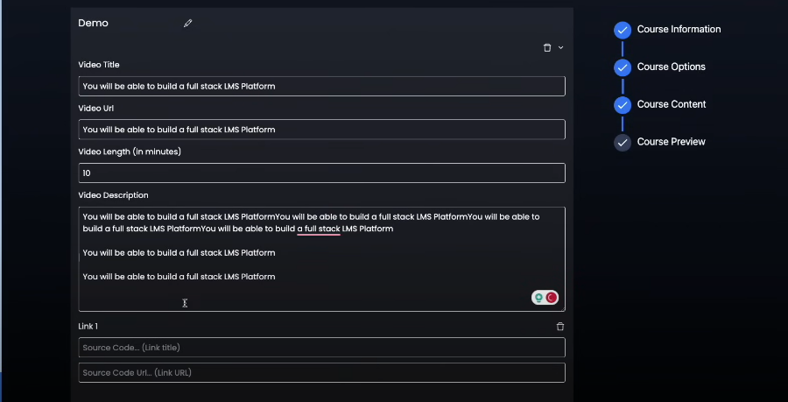

**Figure-4** This figure shows to view the demo

the optimization of heat exchanger choices. This module systematically assessing various heat exchangers based on factors such as efficiency, thermal conductivity, and compatibility with ionic caloric materials. Users derive significant value from detailed performance reports, gaining insights into the effectiveness of selected heat exchangers. These reports, rich in data, empower users to make informed, data-driven decisions, ensuring the chosen components align seamlessly with project goals. The module's commitment to energy efficiency shines through its recommendations, prioritizing heat exchangers that maximize energy efficiency and contribute to the overarching sustainability objectives of the project. A pivotal aspect of the module's functionality is its dedication to system effectiveness. It ensures the selected heat exchangers not only enhance individual performance but also harmonize with the entire system. This commitment translates into improved overall performance and reliability within refrigeration and heat transfer technologies. This module also facilitates secure communication and upholds the confidentiality of all the information using ElGamal algorithm**.** It’s contributions extend beyond efficiency actively promoting sustainability goals, it plays a crucial role in fostering environmentally friendly practices in thermal management.

.

1. **CONCLUSION**

The project offers an integrated system for efficient material selection, enhanced system performance, and long-term stability assurance in the field of ionic caloric refrigerants. It optimizes decision-making for clients, reduces energy consumption, ensures material durability, and aligns with sustainability goals.

1. **FUTURE WORKS**

**In the rapidly evolving landscape of online learning, future works for platforms entail incorporating advanced AI for personalized learning experiences, fostering deeper engagement through virtual reality simulations, enhancing collaboration tools for seamless group projects, integrating real-time feedback mechanisms for immediate assessment, and ensuring inclusivity through accessible design and content adaptation for diverse learners. Additionally, leveraging big data analytics to refine content delivery and optimize learning outcomes, as well as prioritizing cybersecurity measures to safeguard user data and privacy, will be crucial for the continued evolution and success of online learning platforms in the future.**

1. **REFERENCES**

Akyol, Z., & Garrison, D. R. (2011). Understanding cognitive presence in an online and blended community of inquiry: Assessing outcomes and processes for deep approaches to learning. British Journal of Educational Technology, 42(2), 233-250.

Bates, A. W. & Poole, G. (2003). Effective teaching with technology in higher education: Foundations for success. Indianapolis, IN: Jossey-Bass.

Bonk, C. J. & Graham, C. R. (Eds.). (2005). Handbook of blended learning: Global Perspectives, local designs. San Francisco, CA: Pfeiffer Publishing.

Conceição, S. C. O., & Lehman, R. M. (2011). Managing online instructor workload: Strategies for finding balance and success. San Francisco, CA: Jossey-Bass.

Duffy, T. M. & Kirkley, J. (2004). Learner-centered theory and practice in distance education: Cases for higher education. Mahwah, NJ: Lawrence Erblaum Associates.

Dziuban, C., Hartman, J., Cavanagh, T. Moskal, P., (2011). Blended Courses as Drivers of Institutional Transformation. A. Kitchenham, Ed. Blended Learning Across Disciplines: Models for Implementation, (pp. 17-37) Hershey: PA: IGI Global.

Garrison, D. R., & Vaughan, N. D. (2008). Blended Learning in Higher Education, Framework, Principles, and Guidelines. San Francisco: Jossey-Bass.

Means, B., Toyama, Y., Murphy, R., & Baki, M. (2013). The effectiveness of online and blended learning: A meta-analysis of the empirical literature. Teachers College Record, 115,1-47.

Palloff, Rena M., Pratt, Keith. (2007) Building online learning communities: Effective strategies for the virtual classroom San Francisco, CA: Jossey-Bass,

Picciano, A. G., & Dziuban, C. D. (Eds.). (2007). Blended Learning Research Perspectives, United States: The Sloan Consortium.

Picciano, A., Dziuban, C., & Graham, C. (Eds.) (2014). Blended learning: Research perspectives (Vol. 2). New York: Routledge.

Roblyer, M.D. (2006). Integrating educational technology into teaching. (4th ed.). Upper Saddle River, NJ: Pearson Education, Merrill.