# *DESIGN AND FABRICATION OF VORTEX FLOW INDUCED VIBRATION HARVESTER’*

**Ayaan Thakur, & Prof. V. Murali Mohan (**Associate Professor)

*Mechanical Engineering Department,*

**Hope Foundations’ Finolex Academy of Management and Technology, Ratnagiri,Maharashtra, India-415638**

**A B S T R A C T**

***This paper presents the design and fabrication of a Vortex Flow Induced Vibration (VIV) harvester, a novel technology that harnesses fluid dynamics to convert ambient flow-induced vibrations into electrical energy. The study explores VIV principles and structural dynamics, optimizing materials and geometries for efficiency and durability. Testing under controlled conditions validates its effectiveness, leading to enhancements in efficiency and reliability. This research contributes to the advancement of sustainable, renewable energy solutions.***

**KEYWORDS:**Vortex Induced Vibrations (VIV), Energy Harvester, fluid dynmaics

## *INTRODUCTION:*

## The introduction to the research work titled "Design and Fabrication of Vortex Flow Induced Vibration Harvester" begins by emphasizing the significance of sustainable energy solutions and the potential of innovative engineering combined with natural phenomena. It highlights the inspiration behind the study, which is the ubiquitous presence of fluid flows in the environment and the untapped energy potential in Vortex-Induced Vibrations (VIVs).

## The primary objective of the project is to develop a Vortex Flow Induced Vibration Harvester that can convert these vibrations into electrical energy. The research combines fluid dynamics, structural engineering, and energy conversion mechanisms, focusing on the interplay between these elements.

## The study starts with an in-depth exploration of VIV principles, fluid-structure interaction, and the dynamics governing VIV phenomena. This understanding guides the design process, considering materials selection, geometric configurations, and computational simulations using tools like Computational Fluid Dynamics (CFD).

## Following the design phase, the fabrication process translates theoretical insights into a prototype capable of capturing and converting vibrational energy into electrical power. Throughout the project, challenges arise from complex fluid dynamics and material selection for optimal performance and durability.

## The research work aims to contribute to the advancement of sustainable energy innovation by chronicling the journey from conceptualization to realization, showcasing the integration of theoretical foundations, computational modeling, empirical validations, and iterative refinements that lead to the development of a Vortex Flow Induced Vibration Harvester.

### *Literature Review*

*The literature review for the project titled "Design and Fabrication of Vortex Flow Induced Vibration Harvester" begins by highlighting relevant research works that contribute to the understanding of Vortex-Induced Vibrations (VIVs) and their potential for energy harvesting.*

*Korkischko and Meneghini's (2010) study investigates flow-induced vibrations on isolated and tandem circular cylinders fitted with strakes, providing insights into the vibrations produced by bluff bodies due to vortex vibrations. This work sets the foundation for understanding the phenomenon and its effects on structures.*

*Rostami and Renewable Energy (2016) focus on the impact of vortex-induced motions for renewable energy harvesting. They develop an analytical model for energy harvesting through vortex-induced vibrations, which offers a theoretical framework for harnessing this energy source.*

*S. Meninger et al. (2001) explore the conversion of vibrations to electricity, emphasizing the potential of this phenomenon for power generation. Their work provides a basis for understanding the relationship between vibrations and electricity production.*

*Willden and Graham (2005) numerically predict the effects of VIV on long flexible circular cylinders. Their analysis and calculations contribute to the understanding of VIV's behavior on flexible structures, which is crucial for designing efficient energy harvesters.*

*Lastly, Lobo's (2012) paper introduces the concept of a hydro-kinetic energy harvesting system based on vortex-induced vibrations through a bluff body. This work demonstrates the potential application of VIVs in marine energy systems, further highlighting the importance of the research topic.*

*These literature reviews collectively demonstrate the growing interest in understanding and harnessing the energy potential of Vortex Flow Induced Vibrations, setting the stage for the current project's contribution to the field.*

### Proposed Methodology

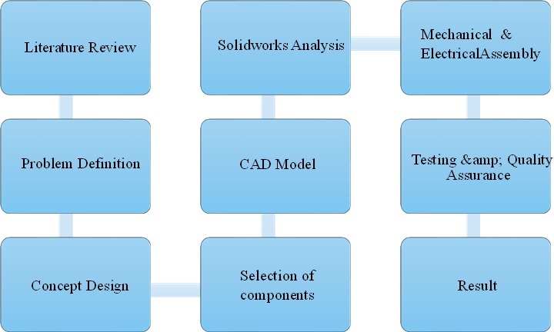

**Figure 1: Methodology**

**Design Objectives:**

### The objectives for the project titled "Design and Fabrication of Vortex Flow Induced Vibration Harvester" are structured around key milestones that aim to achieve the overall goal of developing a functional Vortex Flow Induced Vibration Harvester. These objectives are as follows:

### 1. Understand Vortex-Induced Vibration (VIV) Principles: The primary objective is to gain a comprehensive understanding of the fundamental principles governing Vortex-Induced Vibrations. This includes investigating the fluid dynamics, structural mechanics, and the interactions between these elements. This knowledge will serve as the foundation for designing an efficient VIV harvester.

### 2. Design Optimization for Energy Harvesting: The second objective is to optimize the design of the Vortex Flow Induced Vibration Harvester for maximum energy harvesting efficiency.

### 3. Computational Simulation and Validation: The third objective is to employ computational simulations, such as Computational Fluid Dynamics (CFD), to model and analyze the proposed design. These simulations will help refine the harvester's design and provide valuable insights into its performance. Validation of the simulation results against experimental data will ensure the accuracy and reliability of the computational models.

### 4. Prototype Fabrication and Integration: The fourth objective is to fabricate a functional prototype of the Vortex Flow Induced Vibration Harvester. This will involve precision engineering techniques to construct the harvester according to the optimized design. The integration of various components, such as the energy conversion system, will be crucial in this stage to ensure the prototype's effectiveness in capturing and converting vibrational energy.

### 5. Performance Evaluation and Optimization: The final objective is to evaluate the performance of the fabricated prototype and optimize its functioning. This will involve testing the harvester under various environmental conditions and flow rates to assess its efficiency in converting VIVs into electrical energy. The results will guide further refinements to the design, ultimately leading to an improved and more efficient Vortex Flow Induced Vibration Harvester.

### These objectives collectively outline the project's key steps, aiming to contribute to the development of a sustainable energy solution by harnessing the potential of Vortex Flow Induced Vibrations.

**Methods employed to construct the vibration energy harvester:**

1. 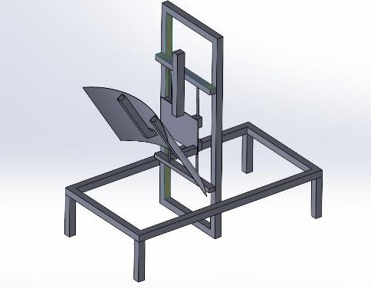**Design Cad Model:** We have designed our wheelchair in software like **AutoCAD** for chassis and **SolidWorks** for whole model design.

Figure 2. CAD Model of vibration energy harvester

1. 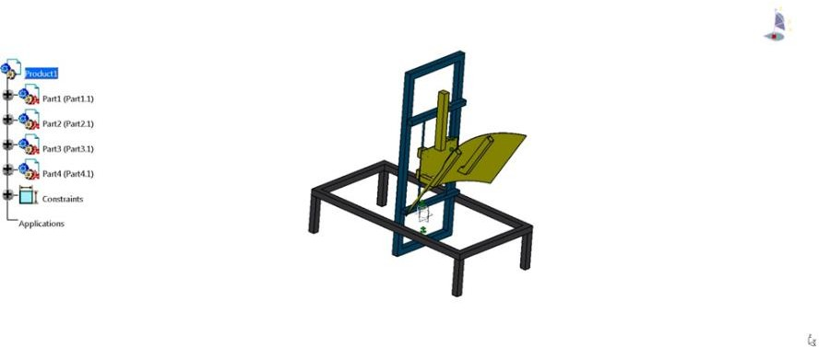**Model Analysis from Software:** The design made on solidworks to show the working of each component,

### Figure 3. Model analysis

1. **Calculations for frame design and spring:** Calculation were done for selection of frame design and spring by considering the bending stress equation for frame.

Finally, we have come with results of calculation of required frame will be of square tube to manufacture the complete structure and a spring of stiffness(K) above 0.1962 N/mm is selected according to calculation.

1. **Material Selection with standards:** We have selected MS (Mild steel) in the design and fabrication of vortex flow induced vibration harvester with their proper standards to be compatible with project that offers following benefits:
   * + - Strength and Durability
       - Cost-Effectiveness
       - Weldability
       - Repairability
       - Weight
       - Customization
       - Corrosion Resistance

**Fabrication of model:** After selection of material was done, we started to fabricate our model by following steps-

1. 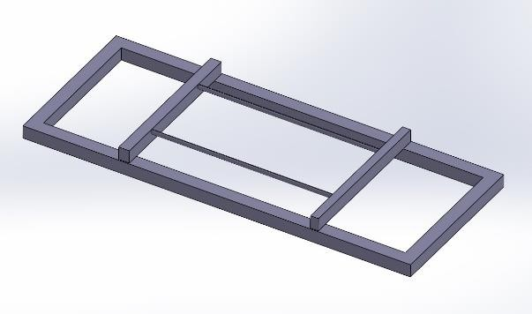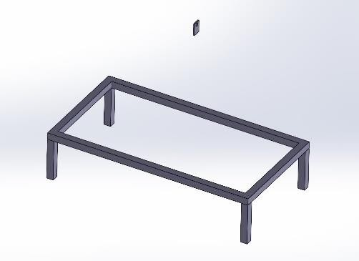**Frame –** Fabrication process was started by building up the frame as shown in fig below

### Figure 4. Frames

1. **Rack and pinion mechanism –** It is a type of linear actuator that comprises a circular gear engaging a linear gear. In our project we using rack and pinion arrangement for conversion of vibrations to linear motions. It then provides the motions to the dynamo motor which helps in producing energy. We decided to use this arrangement made from plastic so as to lessen the total weight of our prototype yet also to get the required results.

### Components –

1. **200 rpm dynamo motor –** We have used a 200-rpm dynamo motor for our prototype to convert the vibrations into energy and supplies it to leds via cables.

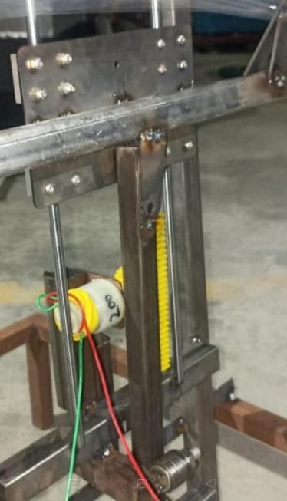

### Figure 5. Rack and pinion arrangement along with dynamo motor

**Final Model –**

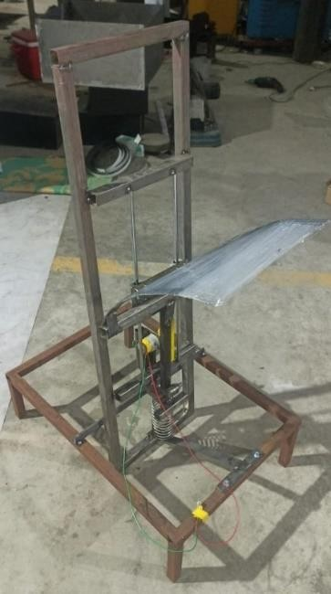 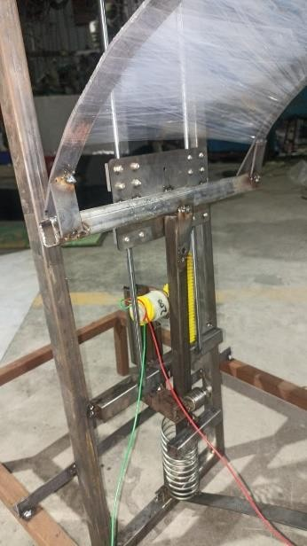

**Figure 6. Final Model Develop**

**RESULTS:**

The results section of the paper publication on "Design and Fabrication of Vortex Flow Induced Vibration Harvester" highlights the key findings and performance outcomes of the developed energy harvester. The main points discussed are as follows:

1. **Testing Procedure**: The authors describe the testing process, which involved using a blower to generate vortex-induced vibrations. This method allowed them to evaluate the energy harvesting capabilities of their device under controlled conditions.
2. **Exceptional Performance**: The paper emphasizes the exceptional performance achieved by the Vibration Energy Harvester during testing. The device successfully converted vibration energy into electrical power, demonstrating the feasibility of this approach for harnessing green energy.
3. **Hassle-Free Energy Production**: The authors note that the energy production through vibrations was hassle-free, indicating the potential for a user-friendly and low-maintenance energy harvesting solution.
4. **Energy Fluctuations**: The testing process revealed fluctuations in energy output as the wind speed changed. This observation highlights the dependence of the harvester's performance on environmental factors, which can be further investigated for optimization and improved stability.
5. **Green Energy and Cost-Effectiveness**: The paper concludes by reiterating the commitment to developing a Vortex Vibration Energy Harvester that can produce green energy at a lower cost compared to traditional wind turbines. Additionally, the harvester's reliability is emphasized as an advantage over conventional wind energy systems.

This paper showcases the successful development and testing of a Vortex Flow Induced Vibration Harvester, highlighting its potential as a cost-effective and reliable green energy solution.

**Table 1. Readings taken on multimeter**

|  |  |
| --- | --- |
| VIBRATION / MIN | VOLTAGE |
|  |  |
| 1 | 0.5 |
| 2 | 1.9 |
| 3 | 3.3 |
| 4 | 4.7 |
| 5 | 6.1 |
| 6 | 7.5 |
| 7 | 8.9 |
| 8 | 10.3 |
| 9 | 11.7 |
| 10 | 13.1 |
| 11 | 14.5 |
| 12 | 15.9 |

The above table shows how much voltage was produced when the vibrations were taking place which is measured through a multimeter

The above graph shows as the vibration increases there is increase in the production of voltage

**CONCLUSIONS:**

The conclusions section of the paper publication on "Design and Fabrication of Vortex Flow Induced Vibration Harvester" summarizes the key findings and implications of the study. The main points discussed are as follows:

1. **Definition of Vibration Energy Harvesting:** The paper begins by defining Vibration Energy Harvesting as a process that combines a transduction mechanism with ambient vibrations to convert mechanical energy into electrical energy. It highlights three main types of ambient vibrations: machine vibrations, human movement, and flow-induced vibrations.

2. **Existing Solutions for Harvesting Energy:** The conclusions provide an overview of existing solutions for harvesting energy from machine vibrations, such as linear generators that utilize mechanisms like rack and pinion, DC motors, and electrostatic transducers. It also mentions that electromagnetic energy harvesters offer the highest power density among these options.

3. **Challenges in Micro-Scale Applications:** The paper points out the limitations of electromagnetic vibration harvesters at the micro scale, which can significantly reduce their performance, making them unsuitable for MEMS applications.

4. **Importance of Flow-Induced Vibration Energy Harvesters:** The authors emphasize the growing interest in flow-induced vibration energy harvesters as alternatives to turbine generators. They highlight that these devices have successfully generated useful power in existing facilities, even at reduced initial flow velocities (5.5 m/s).

5. **Potential for Improvement:** The conclusions section also notes that most reported flow-induced vibration energy harvesters tend to be larger than other vibrational energy harvesting devices. This suggests an opportunity for further research and development to optimize the design and miniaturize these harvesters for enhanced practical applications.

This paper publication highlight the importance of Vortex Flow Induced Vibration Harvesters as a promising alternative to traditional energy harvesting methods. The study underscores the need for continued research to improve their efficiency and reduce their size, making them more suitable for various practical applications.

### REFERENCES

1. [R. H. J. Willden and J. M. R. Graham, "Numerical prediction of VIV on long flexible circular cylinders," Journal of Fluids and Structures, vol. 15, pp. 659-669.](https://www.sciencedirect.com/science/article/abs/pii/S0889974600903591)
2. T. Sarpkaya, "Vortex-Induced Oscillations: A Selective Review,"
3. Journal of Applied Mechanics, vol. 46, pp. 241-258, 1979
4. T. Sarpkaya, "Vortex-Induced Oscillations: A Selective Review,"
5. Journal of Applied Mechanics, vol. 46, pp. 241-258, 1979
6. [T. Sarpkaya, "Vortex-Induced Oscillations: A Selective Review," Journal of Applied Mechanics, vol. 46, pp. 241-258, 1979](https://asmedigitalcollection.asme.org/appliedmechanics/article-abstract/46/2/241/424108/Vortex-Induced-Oscillations-A-Selective-Review?redirectedFrom=fulltext)
7. [S. Meninger, J. O. Mur-Miranda, R. Amirtharajah, A. Chandrakasan, and J. Lang, "Vibration-to-electric energy conversion," IEEE Transactions on Very Large-Scale Integration (VLSI) Systems, vol. 9, pp. 64-76, Feb. 2001.](https://citeseerx.ist.psu.edu/document?repid=rep1&type=pdf&doi=439adc983dcedf41e10359c9d283fc641d025d14)
8. [R. H. J. Willden and J. M. R. Graham, "Numerical prediction of VIV on long flexible circular cylinders," Journal of Fluids and Structures, vol. 15, pp. 659 – 669.](https://www.researchgate.net/publication/257280561_Numerical_prediction_of_VIV_on_long_flexible_circular_cylinders)
9. P. W. Bearman, "Vortex Shedding from Oscillating Bluff Bodies,"
10. Annual Review of Fluid Mechanics, vol. 16, pp. 195-222, 1984
11. P. W. Bearman, "Vortex Shedding from Oscillating Bluff Bodies,"
12. Annual Review of Fluid Mechanics, vol. 16, pp. 195-222, 1984
13. [P. W. Bearman, "Vortex Shedding from Oscillating Bluff Bodies," Annual Review of Fluid Mechanics, vol. 16, pp. 195-222, 1984](https://www.annualreviews.org/content/journals/10.1146/annurev.fl.16.010184.001211)