UNRAVELING THE INTRICACIES OF DYNAMIC PHOTO-DRIVEN FILTRATION FOR ENVIRONMENTAL ENHANCEMENT

M.Naveen^{*1}, Dr. S. Prakasam^{*2}
^{*1}PG Student, Computer Science And Application, SCSVMV University, Kanchipuram, India.
^{*2}Associate Professor, Computer Science And Application, SCSVMV University, Kanchipuram, India

ABSTRACT

The project “Unraveling The Intricacies Of Dynamic Photo-Driven Filtration For Environmental Enhancement” delves into the realms of filtration, aiming to redefine conventional methods with advanced photo-mechanical nano-crystal technology. Through meticulous selection and integration, the project seeks to amplify filtration systems' efficiency and effectiveness across a spectrum of applications. With an emphasis on harnessing the distinct properties of nano-crystals, the research ventures into uncharted territories, where light activation serves as a catalyst for dynamic filtration mechanisms. By intricately aligning membranes with photo-mechanical nano-crystals, the project ensures seamless integration and heightened filtration performance, offering tailored solutions to environmental and industrial challenges. The project's objectives extend beyond mere experimentation, encompassing a comprehensive exploration of nano-crystal behavior and responsiveness to varying energy levels.

I.INTRODUCTION

Water, the essence of life, sustains ecosystems, nourishes crops, and nurtures communities, serving as an indispensable resource for human survival and development. In an era marked by escalating environmental challenges and burgeoning population growth, the imperative of ensuring access to clean, safe water has never been more pressing. The advent of photomechanical filtration represents a paradigm shift in the realm of water treatment and purification, offering a transformative approach to addressing the complexities of modern water managemen

- Sustainable and high-performance electronics
- Revolutionizing electronic devices
- Energy storage for next-generation batteries and supercapacitors
- Fast and energy-efficient data storage solutions
- Highly accurate and responsive sensors for medical and environmental monitoring

II. Flow Chart

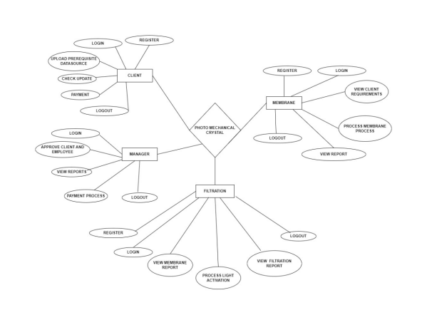Fig. 1: Flow Chart

Key points:

- Python operates proficiently on diverse platforms including Windows, Mac, Linux, and Raspberry Pi.
- Python boasts an intuitive syntax akin to the natural flow of the English language.
- Python's syntax lends itself to succinct programming, enabling developers to craft code with brevity unmatched by certain other programming languages.
- Python operates via an interpreter system, facilitating instantaneous execution of code upon its creation. This feature expedites prototyping, rendering the process exceedingly swift.

III. System Architecture:

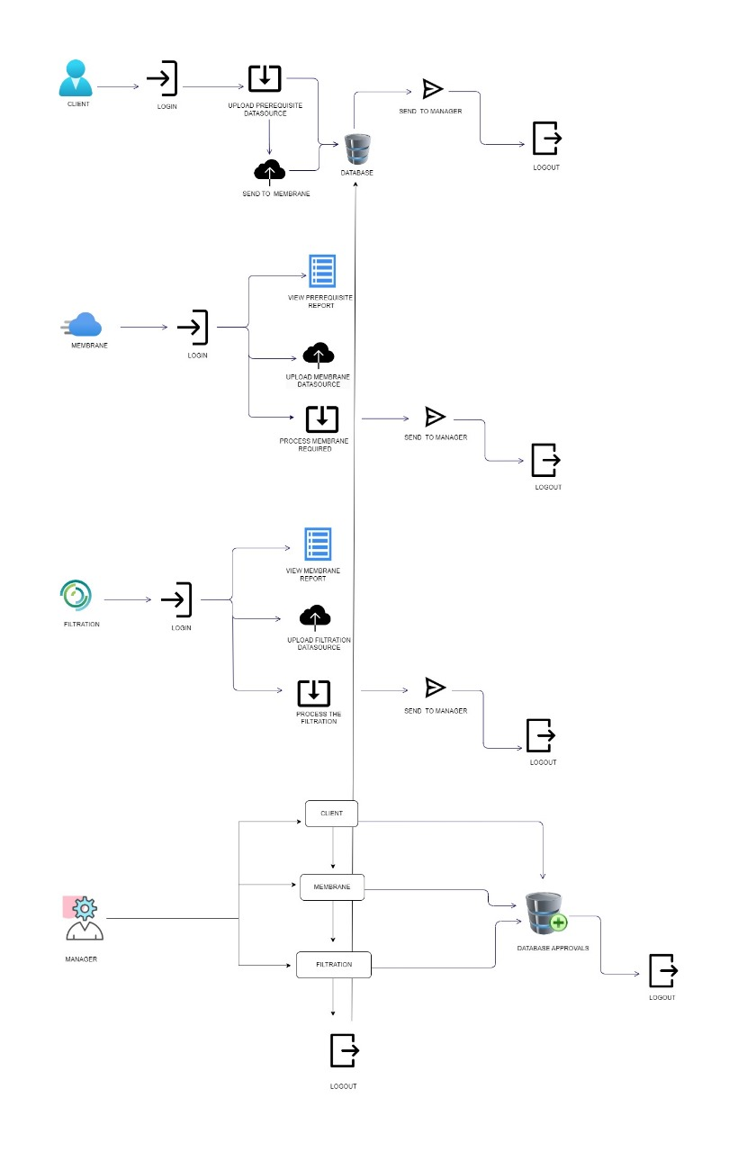

.

Fig. 2: System Architecture

MODULE DESCRIPTION
CLIENTS:
Following the registration process, clients' access remains pending until approval by the manager, who evaluates and verifies the submitted details. Once approved, clients are issued a unique client ID, serving as a secure identifier for authentication purposes. Upon obtaining their client ID, users can securely log in to the system, gaining access to its various functionalities. The system is organized into three primary sections: Order, Track, and Payment, each serving distinct purposes in the client interaction process.

MEMBRANE TEAM:
To embark on their journey within this module, Membrane Team members embark on the registration process by navigating to the designated page. This meticulously designed page diligently gathers their essential details, including names, designations, passwords, contact information, and email addresses. Each team member meticulously enters this vital information, ensuring accuracy and completeness.

FILTRATION TEAM:
The Filtration Team's journey begins at the secure registration portal. Here, they meticulously provide their credentials, including names, roles, passwords, contact information, and email addresses. To ensure the system's integrity, a crucial step of managerial approval follows. Managers diligently review each registration detail, verifying accuracy and completeness before granting access. Upon successful approval, Filtration Team members unlock their designated module, empowering them to commence their critical tasks. Each session begins with secure authentication.

MANAGER:
In the Manager module, the primary focus lies in overseeing the registration and access of both new clients and the Processing team. Access to the system is granted only upon the manager's approval, ensuring a controlled and secure environment. Once approved, clients and the Processing team can log in to the system to commence their work. The journey of a report begins with the Processing team, which initiates the submission process.

V. SCREENSHOTS

Home page:
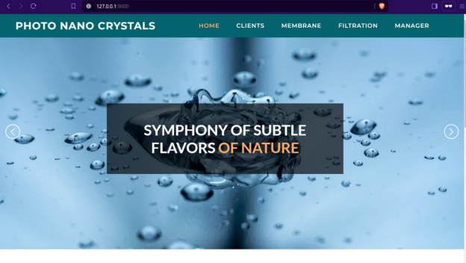
Fig 5.1 Home Page – Step into the symphony of subtle flavors of nature

Register Page:


Fig 5.2 Register Page - Welcome! Join our community by creating an account. It’s quick, easy, and unlocks a world of features tailored just for you.

Client Order Page:


Fig 5.3 Client Order Page - You can order through this Client Order page

Filtration Page:


Fig 5.4 Filtration Page:Unveiling the Secrets of Pure Water
Manager Page:
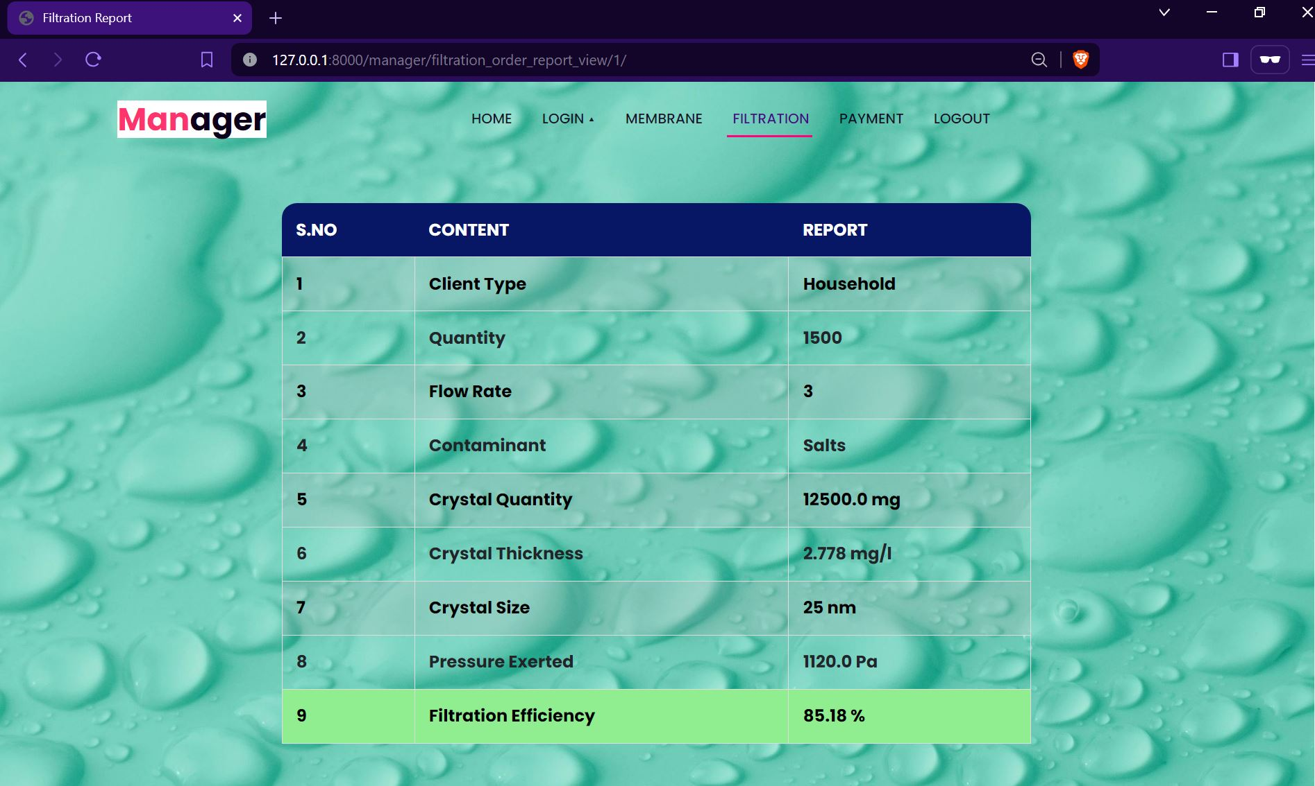

Fig 5.5 Manager Page - Welcome to our Manager Page! Here, you can easily forecast the report using this page

Membrane Page:
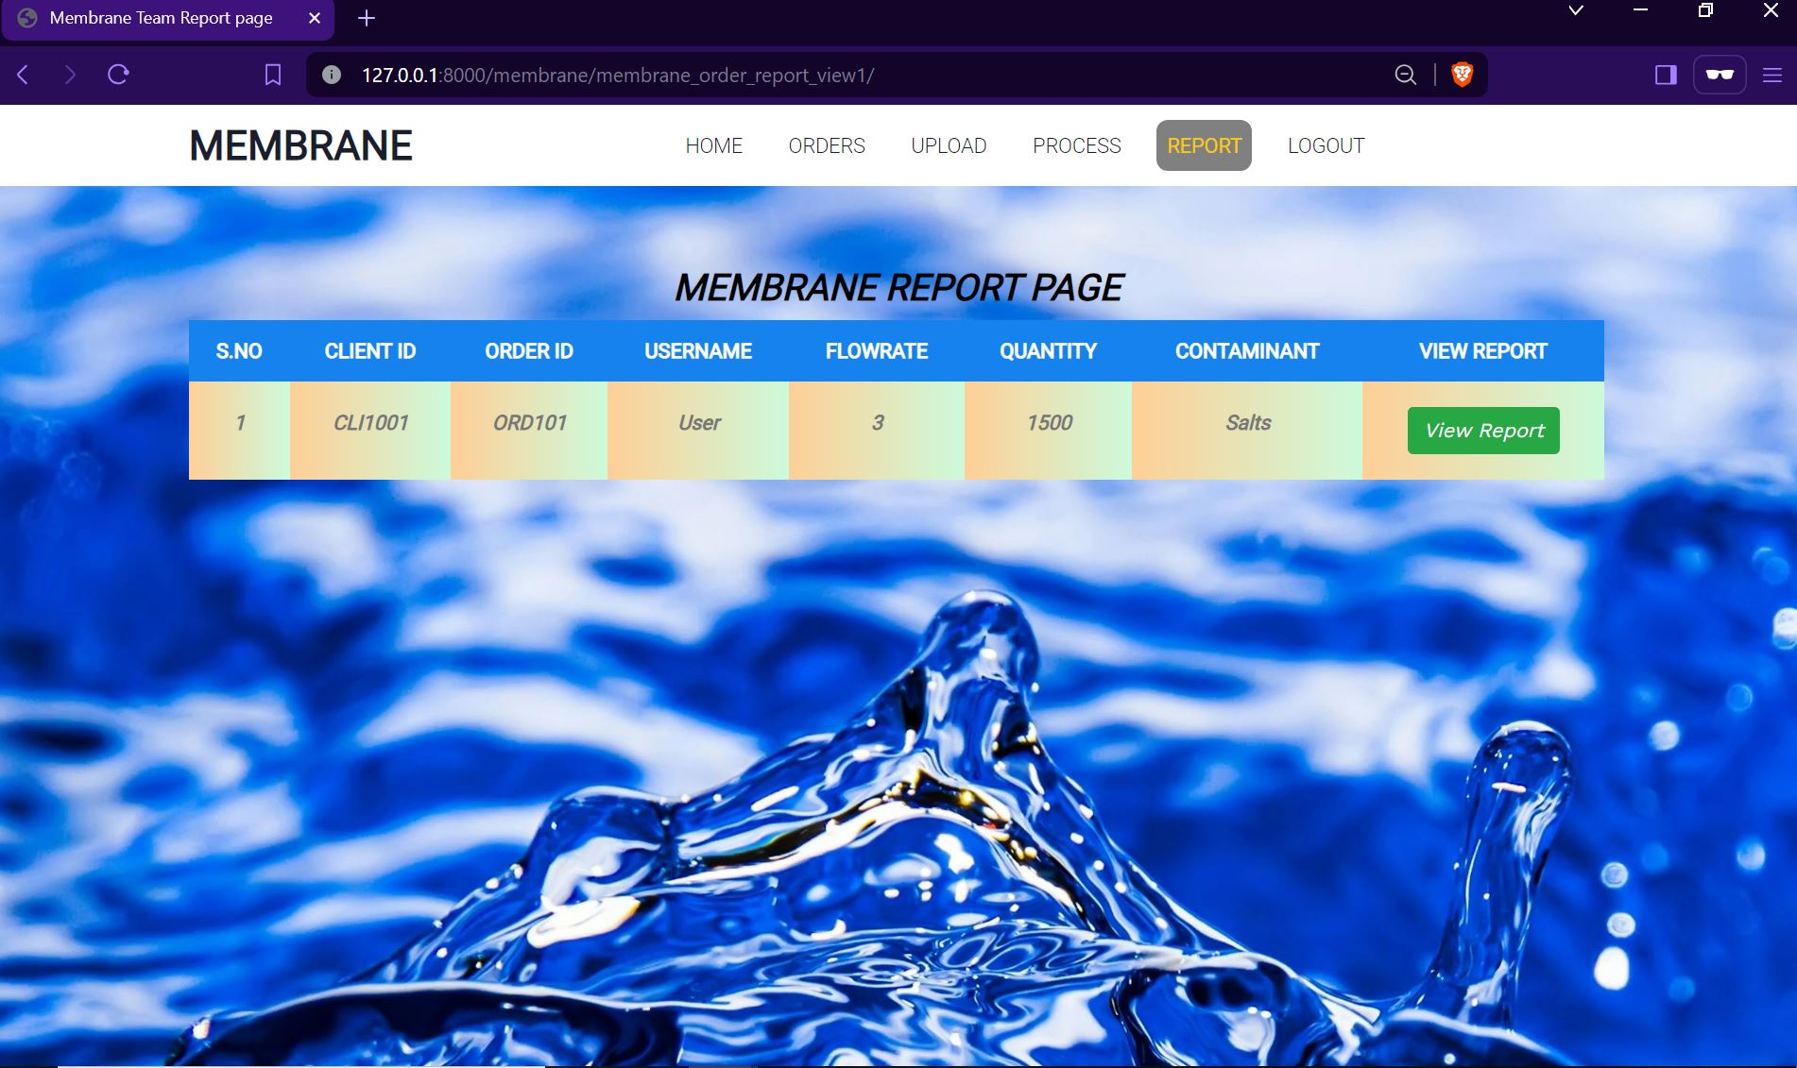

Fig 5.6 Membrane Page - Welcome to our Membrane Page! Here, you'll find all the details you need to understand our Membrane structure

VI. CONCLUSION AND FUTURE ENHANCEMENT

Conclusion:
In conclusion, the utilization of photo-mechanical nano-crystals in filtration systems heralds a remarkable leap forward in the field of environmental engineering and resource management. The inherent adaptability and precision of nano-crystals empower filtration systems to achieve unparalleled levels of efficiency and effectiveness in contaminant removal. As demonstrated through extensive research and experimentation, the versatility of nano-crystal technology transcends traditional filtration methods, offering a transformative solution to the challenges of water purification, industrial processing, and environmental remediation. Moreover, the continuous advancement of nano-crystal technology promises even greater potential for innovation and refinement in filtration systems of the future.

Future Enhancement:
This project encompasses a comprehensive exploration of photo-mechanical nano-crystal-enhanced filtration systems, delving into their potential to revolutionize contemporary filtration methodologies. By leveraging cutting-edge advancements in nano-material science, the scope extends to the meticulous selection and characterization of membranes tailored for seamless integration with photo-mechanical nano-crystals. The project's ambit includes the systematic investigation of energy activation mechanisms, aiming to unlock the full potential of nano-crystals in dynamically responding to environmental uses.

ACKNOWLEDGEMENTS

I express my heartfelt gratitude to Associate Prof. Dr. S. Prakasam, whose unwavering dedication to my growth has been truly inspiring. His encouragement and guidance have been crucial in shaping my academic pursuits, instilling confidence, and fostering determination. I feel profoundly fortunate to have been mentored by someone who consistently prioritized my development and well-being.

REFERENCES

- https://www.skillvertex.com/courses/?c=17&b=240105&lc=1
- https://www.kaggle.com/datasets
- Wang, X., Wen, J., Zhang, Y., Wang, Y. (2014). This study utilizes a support vector machine (SVM) optimized by particle swarm optimization (PSO) for forecasting real estate prices, published in Optik-International Journal for Light and Electron Optics, volume 125, issue 3, pages 1439-1443.
- "Real Estate Price Prediction with Regression and Classification," a final project report for CS 229 from Autumn 2016, explores methods for predicting real estate prices using both regression and classification techniques.
- Park, B., Bae, J.K. (2015). This paper investigates housing price prediction using various
machine learning algorithms, published in a journal volume 42, on pages 2928-2934.

