**INVENTORY MANAGEMENT SYSTEM**

**R.SANTHOSH** 1 **, M.KRISHNAMOORTHY2**

1PG Student, Department of CSA, SCSVMV [Deemed to be University], Enathur, Kanchipuram, Tamilnadu, India.

2 Assistant Professor, Department of CSA,SCSVMV [Deemed to be University], Enathur, Kanchipuram, Tamilnadu,India.

**ABSTRACT**

This paper presents the development of an inventory Management System web application using the Django, which consists of HTML, JavaScript, CSS, and SQLite. The application aims to deliver a The IMS comprises modules for inventory tracking, order management, supplier management, and reporting. It leverages real-time data and advanced analytics to provide accurate insights into inventory status and trends. Key functionalities include barcode scanning, automated reordering, inventory forecasting, and integration with other business systems such as accounting and customer relationship management (CRM).

**Keywords:** Inventory, Django, JavaScript, HTML, CSS, SQLite.

**1.** **INTRODUCTION**

An Inventory Management System (IMS) is a software solution designed to automate and streamline inventory-related processes. It facilitates the tracking of inventory levels, orders, sales, and deliveries, providing a centralized platform for managing all inventory activities. The implementation of an IMS helps businesses achieve accuracy in inventory tracking, enhances visibility into stock movements, and improves overall operational efficiency. Recognizing this need, we made the decision to create an inventory management system web application as our project. This project is implemented using Django. Django is an open-source python-based stack that is used for building dynamic web applications more quickly and easily. It is a combination of modern technologies for building high-end online apps. django is a package of JavaScript, HTML, CSS and SQLite.

**2.PROBLEM STATEMENT**

Generating backup data is a critical process in a project for our shopkeeper. This work can be categorized as time consuming job and need high accuracy when placing the proper materials with its quantity. Moreover the project scalability itself will increase the risk so is the processing time hence can make us loose the control when there is a lot of revision, like drop and insert, that being made. Since this is the first time we create the automation, there are so many requirements that might not defined properly. Thus the purpose of this paper is to review and redefine the automation’s requirements from basic like

**3. E-COMMERCE**

The procedure of stock proportionality is most fitting for inventories that stay inconspicuous by the purchaser, rather than "keep full" frameworks where a retail customer might want to see full retires of the item they are purchasing so as not to think they are purchasing something old, undesirable or stale; and separated from the "trigger point" frameworks where item is reordered when it hits a specific level; stock proportionality is utilized viably by without a moment to spare assembling procedures and retail applications where the item is escaped see.

Types of E-commerce:

1) Periodic Inventory System: Inventory is physically counted at specific intervals (e.g., monthly, quarterly, annually). Simple to implement, low-cost, suitable for small businesses with limited inventory.

2) Perpetual Inventory System: Inventory levels are continuously updated in real-time with each transaction. High accuracy, real-time tracking, better for high-volume businesses, supports automated reordering.

3) Cloud-Based Inventory System: Inventory data is stored and managed on remote servers accessible via the internet. Accessible from anywhere, easy to scale, lower upfront costs, automatic updates and backups.

4) Vendor-Managed Inventory (VMI) System: Suppliers manage the inventory levels based on agreed-upon parameters and sales data. Reduces the burden on the buyer, improves supply chain efficiency, potential for better supplier-buyer relationships.

**4. METHODOLOGY USED**

1. Research strategy can be characterized as efficient and purposive examination of actualities with a goal deciding the powerful relationship among such certainties and research between at least two wonders from the broad writing study it is much clearer to contribute specifically for the effective consummation of the venture, are impacted by stock administration framework. Specifically, looks into were directed to little degree to investigate about stock administration in development ventures. This cause affect on execution of the stock administration. To yield a coveted execution, it is important to guarantee the task work successfully. Poll study was directed among development experts to distinguish their feeling towards stock administration framework in their association. The got information is dissected to discover the recurrence of reaction for different elements.
2. Objective Definition: Clearly define the objectives of the inventory management system (e.g., reducing excess inventory, improving order accuracy, etc.).Stakeholder IdentificationIdentify and consult with all stakeholders (e.g., warehouse staff, purchasing managers, sales team).Needs Assessment Conduct interviews, surveys, and observations to gather detailed requirements.
3. Process Mapping: Map current inventory processes to understand workflows and identify areas for improvement.System Specifications Define the functional and non-functional requirements (e.g., software capabilities, performance criteria).Architecture Design Design the system architecture, including hardware and software components, database schema, and user interfaces.

**B) ARCHITECTURE DIAGRAM**

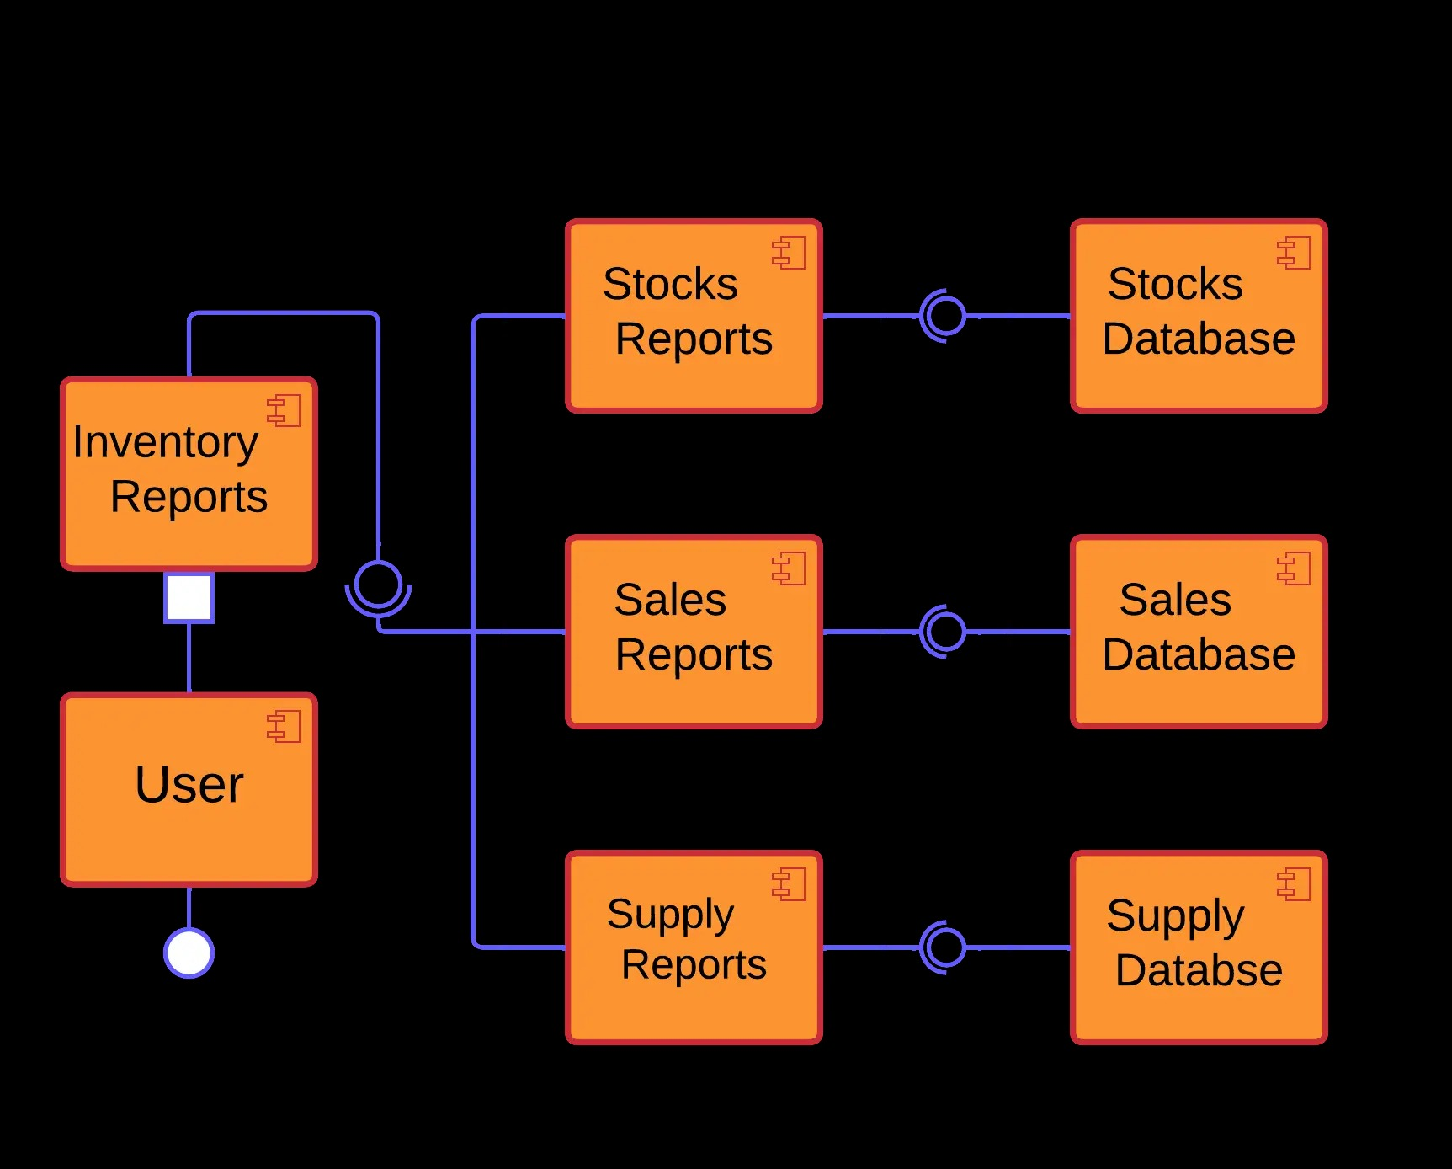

**Figure 2:** Architecture diagram

**5. ADVANTAGES**

1) Improved Accuracy

2) Cost Savings

3) Enhanced Efficiency

4) Better Decision Making

5) mproved Customer Satisfaction.

6) Enhanced Traceability and Accountability

**6. RESULTS**

**1)User**

A) Login page

The project login page consists of the user to easily login to the home page which are newly added to the database by the admin. User can switch to the preferred category by using navbar section.

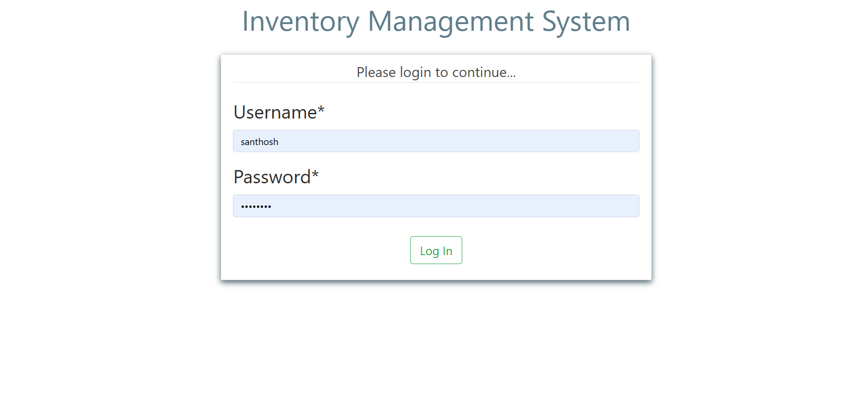

**Figure 3:** Login page

B) product adding page

The project product adding is where users can add and create their product in web application.

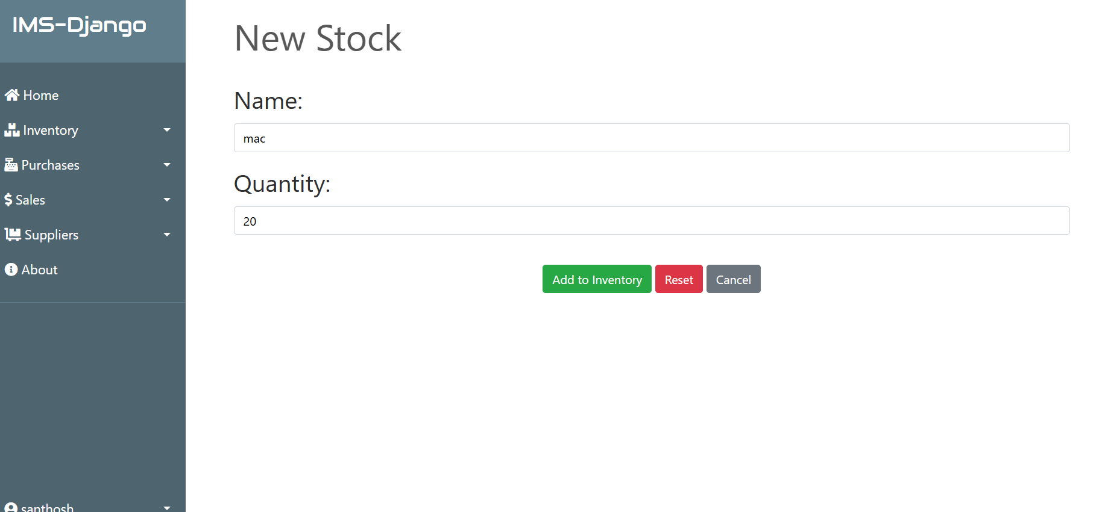

**Figure 5:** Sign up page

C) Supplier adding page

In this page user can view the add supplier and they can proceed to payment and checkout.

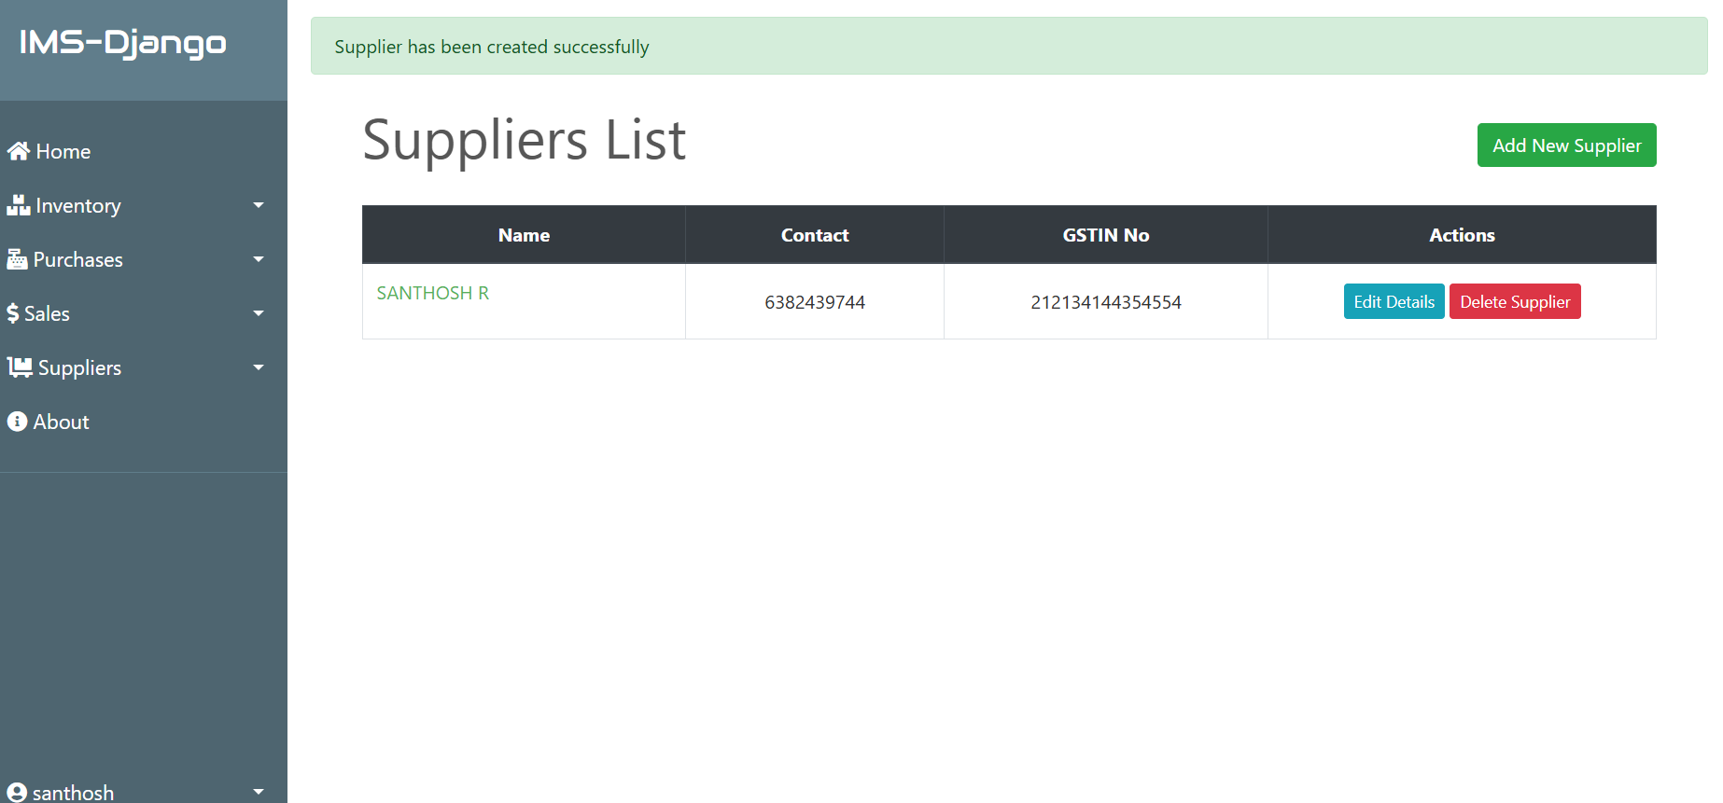

**Figure 6:** Cart page

A) Purchase page

In this page, supplier can purchase a new product in the database.

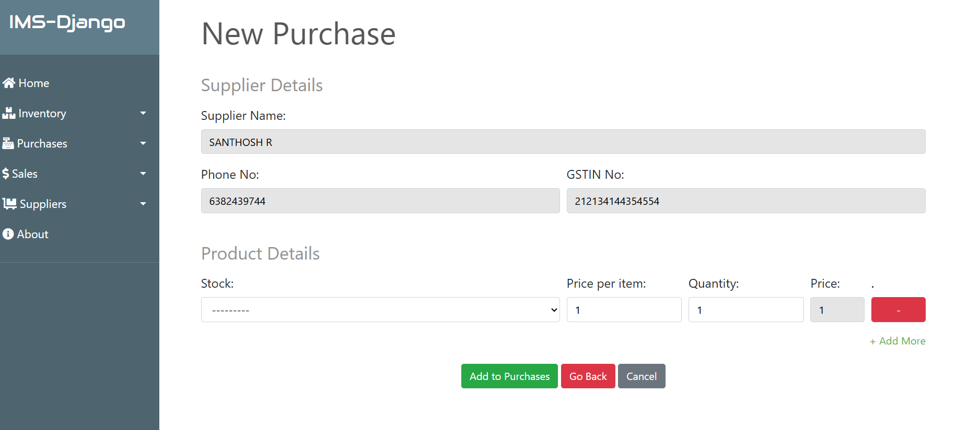

**Figure 7: Add** product page

B) Invoice page

In this page, Admin can able to view invoice available in the database.

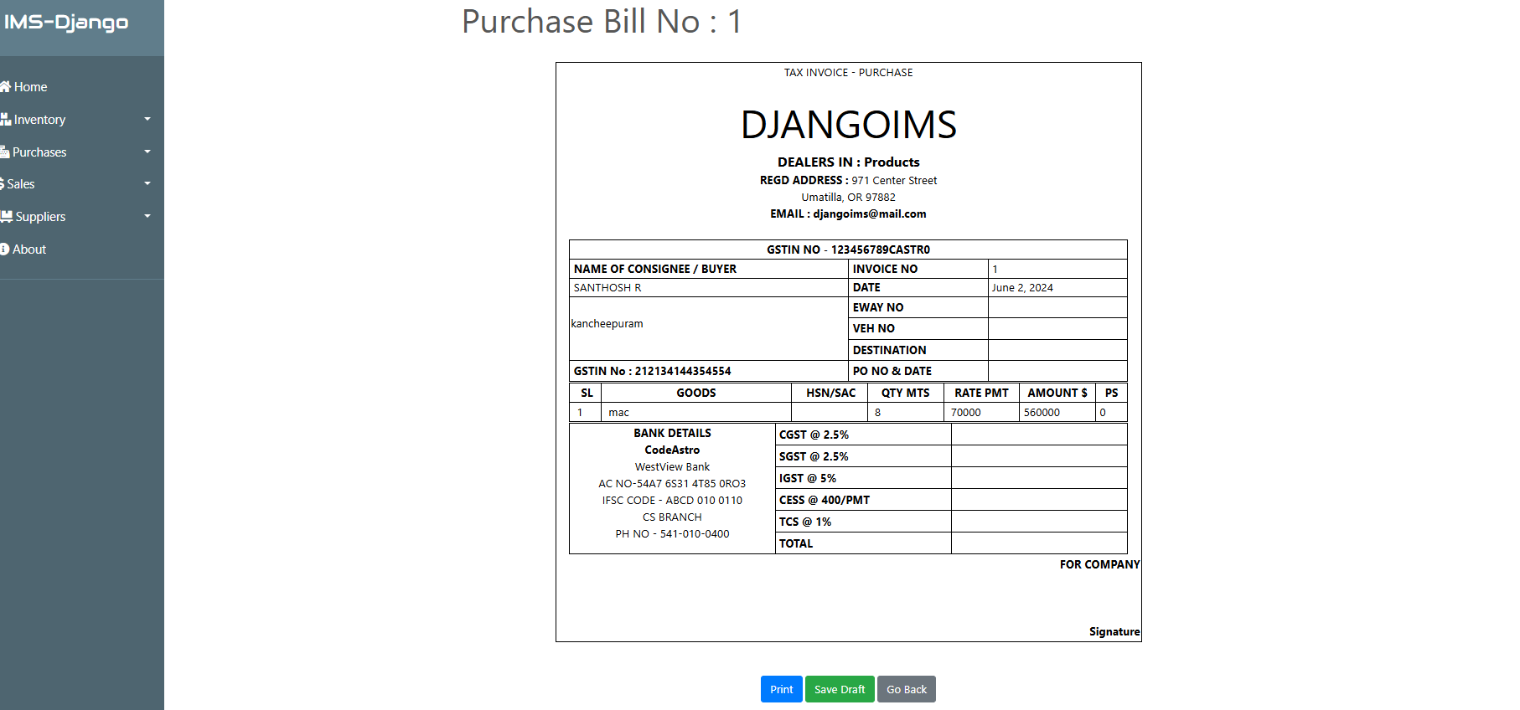

**Figure 8:** All product list

**7. CONCLUSION**

This paper presents an alarm about the information section in the bill which in view of desktop application. It's a straightforward desktop application inwhich the network to the immediate distribution center with the goal that information ought to be refreshed in store for the confirmation. It's a secure application in which the no information spillage from the stockroom. And furthermore gives the one table organization look so that after the finish of month we know about what we sold.

**REFERENCES**

[1] Aditya A. Pande, S.Sabihuddin, “Study of Material Management Techniques on Construction Project”, International Journal of Informative & Futuristic Research, ISSN: 2347-1697, Vol.2 (3), May 2015, pp.3479-3486.

[2] S.Angel Raphella, S.Gomathi Nathan and G.Chitra, “Inventory Management- A Case Study”, International Journal of Emerging Research in Management &Technology, ISSN: 2278-9359, Vol.3 (3) June 2014, pp.94-102.

[3] Ashwini R.Patil, Smita V. Pataskar, “Analyzing Material Management Techniques on Construction Project”, International Journal of Engineering and InnovativeTechnology (IJEIT), Vol.3 (4), Jan 2013, pp.96-100.

[4] Dipak P. Patil, Pankaj P. Bhangale, Swapnil S.Kulkarni, “Study of Cost Control on Construction Project”, International Journal of Advanced Engineering Research and Studies, Vol.02, April 2014, ISSN2249–8974. [5]P.G. Matsebatlela and K. Mpofu, “Inventory Management Framework to Minimize Supply and Demand Mismatch on a Manufacturing Organization”, International Federation of Automatic Control, Vol.3, No.48, Mar 2015, pp-260- 265