**DESIGN OF DEFORMABLE ORIGAMI WHEEL**

**R Gobika 1, Dr.S.Periyasamy2 , Dr.N.Nandakumar3** 1Pg Scholar, Department Engineering Design, Government College Of Technology, Coimbatore, Tamil Nadu, India.

2Associate Professor, Department Engineering Design, Government College of Technology, Coimbatore, Tamil Nadu, India.

3Professor, Department Engineering Design, Government College of Technology, Coimbatore, Tamil Nadu, India.

# ABSTRACT

Designing a deformable origami wheel using the ball-shaped water bomb origami pattern, the so-called magic-ball pattern. The magic-ball origami design is a popular pattern that transitions from a long cylindrical shape to a flat circular form, enabling flexible and controlled movement. While traditional wheel drive mechanisms are simple, stable, and efficient, they face limitations in unstructured terrain. However, this special origami structure allows for a mechanically functional wheel without the need for extensive mechanical components. This unique origami structure allows for shape changing capabilities, enabling the wheel to adapt to different terrains and conditions Furthermore, the prototyping process is cost-effective and swift, as it can be initially done using paper before transitioning to other materials. This approach eliminates the necessity for laser cutting or 3D printing, enabling rapid prototyping using only manual skills and paper. This innovative deformable origami wheel has potential applications in robotics, transportation, space, and mobility devices, offering advantages such as compactness, versatility, and simplified actuation.

**Keywords:** Origami, Deformable wheel, Magic ball, Transformable wheel, Origami-inspired mechanism

# INTRODUCTION

Robots have become integral in numerous domains of modern life, including manufacturing, education, and medicine, due to their ability to accomplish tasks beyond human capabilities. One such task is exploration, which often necessitates the use of robotic assistants, particularly in inaccessible environments. For instance, search and rescue operations in collapsed buildings and surgeries in challenging anatomical locations require robots that can navigate with minimal damage [1-3]. To address the challenges, researchers have explored the concept of using minimally invasive techniques, employing small-sized robots to minimize potential damage. However, designing such robots presents a significant hurdle in terms of size constraints [4]. The robot must be small enough to navigate narrow access points while still accommodating a functional locomotion system. In response, researchers have investigated morphing structures that can reconfigure and change their shape from small to large [5]. One solution is the development of modular robots, consisting of interconnected small units that can form larger robot configurations. Another approach involves constructing three-dimensional structures from two-dimensional sheets using folding techniques. In recent years, origami robots and self-folding sheets have emerged as potential solutions for creating morphing structures in various applications [6, 7]. Researchers aim to design robots with high degrees of freedom, featuring simple manufacturing processes and cost-effectiveness. These robots can self-fold and self-assemble, enabling them to perform minimally invasive tasks by transforming from a two-dimensional sheet into a three-dimensional structure [8]. Origami, an art form originating from Japan, involves folding paper to create intricate structures. Its principles have been observed in natural phenomena and applied as a design tool in engineering. By leveraging origami-inspired folding processes, engineers can fabricate complex 3D objects with distinct mechanical properties [9]. Origami robots represent a novel approach to robotics, where their shape and function are derived from folding patterns. The robots are constructed from a single planar sheet that is folded into a complex 3D structure. Due to the geometry of the folds and creases, origami robots possess built-in compliance and exhibit characteristics of both rigid and soft robots [10]. The origami folding pattern enables the creation of rigid structures and spatial linkage mechanisms through a tiling structure. The origami approach to robot fabrication offers advantages over conventional bottom-up assembly methods, which involve manually assembling independent components. By simplifying and accelerating the design and fabrication processes, origami robots provide opportunities for advancement in the field. However, several technical challenges remain, including determining the behavior of origami structures and identifying suitable materials and actuation systems. Researchers continue to explore various origami structures and investigate alternative materials to replace paper, which is commonly used in current origami robot prototypes [11].

1. **MOTIVATION**

The motivation behind the design of a deformable origami wheel lies in the pursuit of developing innovative wheel structures that can address specific challenges in various fields, including robotics, transportation, and mobility devices.

**Terrain adaptation**

Traditional rigid wheels often face limitations when encountering diverse and uneven terrains. Deformable origami wheels offer the potential for shape-changing capabilities, allowing them to adapt and conform to different terrain conditions. This adaptability improves mobility, stability, and maneuverability in challenging environments.

**Compactness and portability**

Deformable origami wheels possess the advantage of folding and unfolding, enabling them to occupy minimal space when not in use. This compactness is particularly valuable in applications that require efficient storage, transportation, or deployment in constrained environments.

**Mechanical Simplicity**

Conventional wheel designs typically rely on complex mechanical components to achieve desired functionalities. In contrast, deformable origami wheels leverage the inherent properties of folded structures, reducing the reliance on numerous mechanical parts. This simplicity of design contributes to cost-effectiveness, ease of manufacturing, and enhanced reliability.

**Simplified actuation**

Deformable origami wheels can be actuated using a minimal number of actuators due to the constraints imposed by the folding patterns. The unique structure of the wheel allows for controlling its shape using only a few actuation mechanisms. This streamlined actuation system results in improved energy efficiency and simplified control.

**Versatility and application potential**

Deformable origami wheels offer versatility in their ability to be applied across various domains, including robotics, transportation systems, and mobility devices. Their adaptable and controllable nature allows for navigation in challenging environments, performing specialized tasks such as search and rescue operations, exploration in confined spaces, or precise maneuvering in medical

1. **PROBLEM IDENTIFICATION**

One of the primary problems with normal robot wheels is their limited adaptability to different terrains and obstacles. They typically have fixed shapes and sizes, making it challenging to navigate uneven surfaces, pass through narrow gaps, or traverse obstacles of varying heights. This lack of adaptability restricts the robot's mobility and hinders its ability to perform effectively in diverse environments. Another issue is the complex mechanical systems required for achieving variable transmission and adaptability in traditional wheels. These mechanisms often involve intricate assemblies, multiple components, and sophisticated actuators, which increase the overall complexity and cost of the system. The maintenance and control of such mechanisms can be challenging, leading to potential reliability issues. Furthermore, normal robot wheels may suffer from inefficient force distribution across their contact surface. This uneven distribution of forces can result in reduced traction, compromised stability, and increased energy consumption. Inefficient force transmission can limit the robot's ability to generate sufficient propulsion, especially in demanding tasks or challenging terrains. Size and weight are additional concerns for traditional wheels, especially when dealing with smaller robotic platforms. Conventional wheel designs may not be easily scalable or lightweight enough to fit the requirements of compact robots. This limitation restricts the range of applications for these robots and may hinder their mobility and maneuverability in confined spaces.

1. **DESIGN OF ORIGAMI WHEEL**

**Origami**

Origami is the Japanese term for the ancient art of folding paper. It typically involves patterns of creases arranged to create shapes and forms. Paper is uniquely suited for folding because of the ability it has to hold creases and bend at will. However, origami patterns are not exclusively applicable to paper, as many materials can be used if adapted properly. Origami is useful for more than just paper cranes, the techniques used can be applied to a wide array of applications like furniture, clothing, and science. While originally used as an art and craft, it has evolved to be a valuable inspiration for engineered systems

**Robot wheels**

Wheels are one of the greatest inventions in human history for locomotion. They are easy to design, implement, and practical for robots that require speed. They provide stability as the robot's center of gravity remains consistent during motion or when stationary. However, wheels face challenges on uneven or rough terrain and slippery surfaces. Despite these limitations, wheels continue to be widely used in robotics for their practicality and effectiveness in various applications. Ongoing research aims to optimize wheel performance and overcome these limitations for improved robotic mobility.

**Wheel structure**

The water bomb pattern is one of the well-known origami patterns, which is composed of basic patterns. The magic-ball pattern is one of the variations of a pattern that has a circular shape made by attaching each end of the pattern. We design deformable wheels using some characteristics of this structure. Use the pattern composed of 300 x 150mm basic patterns. When the endpoint of the wheel is pushed inside, the radius of the wheel is increased.

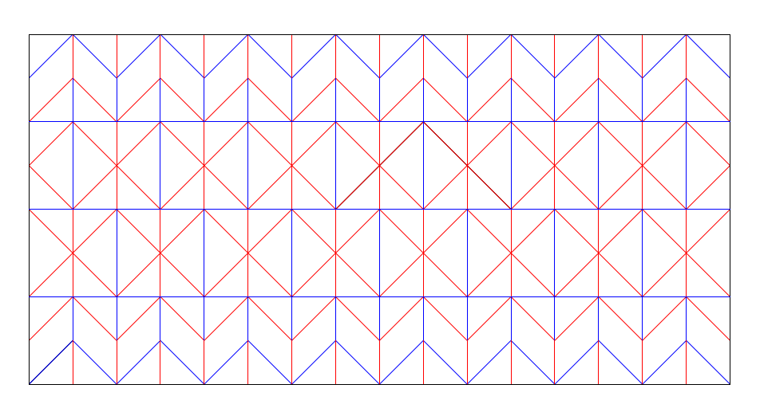

Fig.1 Pattern of origami wheel structure

(Fig 1) present a blue line means valley fold, Boundary edges have black and a red line means mountain fold. ‘AUTOCAD’ software is used for design. AutoCAD file import by ‘origami simulator’. (Fig 2) This origami simulator utilizes a unique approach to simulate the folding of any origami crease pattern. Unlike traditional paper folding techniques that follow a sequential series of steps, the simulator aims to fold all creases simultaneously. It achieves this by iteratively calculating small displacements in the initially flat sheet's geometry, taking into account the forces exerted by the creases. Through this iterative process, the simulator accurately predicts how the geometry of the crease pattern evolves as folding forces are applied. It considers the interactions and constraints between different creases, resulting in a comprehensive simulation of the folding process. It is important to note that this simulation-based approach may produce results that differ from the conventional understanding of origami. Rather than focusing on step-by-step folding instructions, the simulator focuses on the overall behavior of the crease pattern when subjected to folding forces. By simulating the folding process in this manner, the origami simulator offers valuable insights into the behavior, stability, and potential final shapes that can be achieved with a given crease pattern. This approach opens up exciting opportunities for exploring complex origami designs, empowering researchers, artists, and enthusiasts to experiment with a broader range of possibilities and push the boundaries of origami art and engineering.



Fig.2 Folded pattern

**Wheel deformation mechanism**

The integration of a servo motor, slider-crank mechanism, and origami wheel facilitates controlled shape-changing through coordinated actuation and motion control. (Fig 3) present a slider-crank mechanism, driven by the servo motor, converts rotary motion into linear motion, enabling precise manipulation of the origami wheel's shape. A sophisticated control system orchestrates the servo motor's position and speed based on input from sensors or user commands, effectively determining the desired wheel shape. This closed-loop control mechanism ensures accurate and responsive actuation of the slider-crank mechanism, resulting in controlled deformation of the origami wheel. Iterative testing and optimization of the control system refine its performance, allowing for precise shape control and adaptability to different terrains. The servo motor, chosen for its precise angular positioning, speed control, and torque output, provides the necessary power and control for actuating the slider-crank mechanism. This integration of components enables dynamic and controlled motion, allowing the origami wheel to adapt its shape to varying environmental conditions. By incorporating the servo motor, slider-crank mechanism, and origami wheel, robotic systems gain enhanced agility, adaptability, and versatility. The ability to actively control the wheel's shape provides advantages in navigating challenging terrains and performing complex tasks with efficiency and precision. This integration paves the way for advanced robotic applications that require shape-changing capabilities for optimized locomotion and interaction in diverse environments.

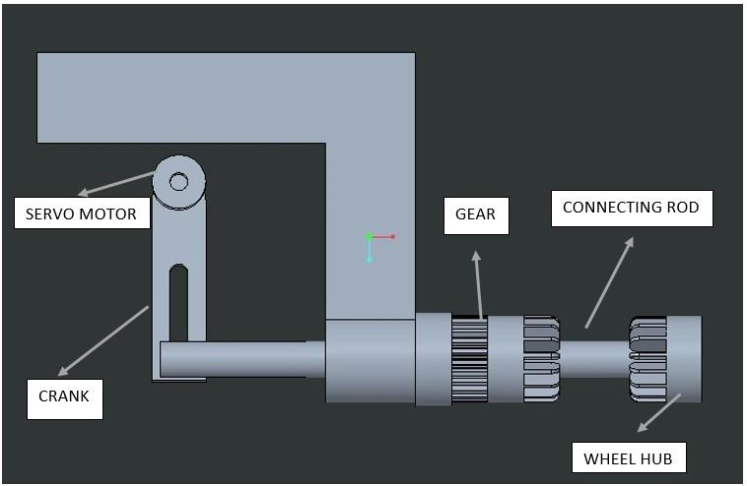

Fig.3 Deformation mechanism design

1. **CONCLUSION**

This paper proposed a deformable wheeled robot based on an origami structure. Inspired by the principles of origami, these innovative wheel structures offer unique advantages in terms of terrain adaptation, compactness, mechanical simplicity, simplified actuation, and versatility. Researchers have explored various origami patterns and fabrication methods to create deformable wheels capable of adapting to different environments and challenges. The integration of a servo motor, slider-crank mechanism, and origami wheel enables dynamic shape-changing capabilities, allowing robots to adapt to varying terrains and obstacles. Future research efforts should focus on further optimizing the design, fabrication, and control mechanisms of origami-inspired wheels to unlock their full potential in advancing the field of robotics and enabling new applications in exploration, transportation, and mobility assistance.

# REFERENCES

[1] H. Banerjee, S. Kakde and H. Ren, "OrumBot: Origami-Based Deformable Robot Inspired by an Umbrella Structure," 2018 IEEE International Conference on Robotics and Biomimetics (ROBIO), Kuala Lumpur, Malaysia, 2018, pp. 910-915, doi: 10.1109/ROBIO.2018.8664762.

[2] D. -Y. Lee, J. -S. Kim, J. -J. Park, S. -R. Kim and K. -J. Cho, "Fabrication of origami wheel using pattern embedded fabric and its application to a deformable mobile robot," 2014 IEEE International Conference on Robotics and Automation (ICRA), Hong Kong, China, 2014, pp. 2565-2565, doi: 10.1109/ICRA.2014.6907222.

[3] S. M. Felton, D. -Y. Lee, K. -J. Cho and R. J. Wood, "A passive, origami-inspired, continuously variable transmission," 2014 IEEE International Conference on Robotics and Automation (ICRA), Hong Kong, China, 2014, pp. 2913-2918, doi: 10.1109/ICRA.2014.6907278.

[4] D. -Y. Lee, G. -P. Jung, M. -K. Sin, S. -H. Ahn and K. -J. Cho, "Deformable wheel robot based on origami structure," 2013 IEEE International Conference on Robotics and Automation, Karlsruhe, Germany, 2013, pp. 5612-5617, doi: 10.1109/ICRA.2013.6631383

[5] Lee, D.-Y., Kim, S.-R., Kim, J.-S., Park, J.-J.: Origamiwheel transformer: a variable-diameter wheel drive robot using an origami structure. Soft Robot. 4(2), 163–180 (2017)

[6] Rhoads, BP, & Su, H. "The Design and Fabrication of a Deformable Origami Wheel." Proceedings of the ASME 2016 International Design Engineering Technical Conferences and Computers and Information in Engineering Conference.

[7] C. D. Onal, R. J. Wood and D. Rus, "Towards printable robotics: Origami-inspired planar fabrication of three-dimensional mechanisms," 2011 IEEE International Conference on Robotics and Automation*,* Shanghai, China, 2011, pp. 4608-4613, doi: 10.1109/ICRA.2011.5980139.

[8] S. Hirose, “Variable constraint mechanism and its application for the design of mobile robots,” The International Journal of Robotics Research, vol. 19, no. 11, pp. 1126–1138, 2000.

[9]Ma J, You Z. Modelling of the water bomb origami pattern and its applications. ASME Int Design Eng Techn Conf 2014:V05BT08A047.

[10] Kuribayashi K, Tsuchiya K, You Z, Tomus D, Umemoto M, Ito T, et al. Self-deployable origami stent grafts as a biomedical application of Ni-rich TiNi shape memory alloy foil. Mat Sci Eng 2006; 419:131–137.

[9] Lee J-Y, Kang BB, Lee D-Y, Baek S-M, Kim W-B, Choi W-Y, et al. Development of a multi-functional soft robot (SNUMAX) and performance in RoboSoft Grand Challenge. Front Robotics AI 2016; 3:63.

[10] Peraza-Hernandez EA, Hartl DJ, Malak RJ, Lagoudas DC. Origami-inspired active structures: a synthesis and review. Smart Mat Struct 2014; 23:094001. 2011.Felton S, Tolley M, Demaine E, Rus D, Wood R. A method for building self-folding machines. Science 2014; 345:644–646.

# [11] D. Dureisseix, “An Overview of Mechanisms and Patterns with Origami”, International Journal of Space Structures, Vol. 27, No. 1, pp 1–14, 2012.