**AI CHATBOT**

**K.S.YOGA ANANDAN *1 , Dr. M.KRISHNAMOORTHY*2**

*1 PG Scholar, Department of Computer Science and Applications, SCSVMV [Deemed to be University], Kanchipuram, Tamil Nadu, India

*2Assistant Professor, Department of Computer Science and Applications, SCSVMV [Deemed to be University], Kanchipuram, Tamil Nadu, India

**ABSTRACT**

A Chat-bot is a software application used to conduct an online chat conversation via text or text-to speech, instead of providing direct contact with a live human agent. Designed to convincingly simulate the way a human would behave as a conversational partner. In the proposed system, we presented a chatbot that generates a dynamic response for online client's queries. The Proposed System is based on Artificial Intelligence-powered Chatbot. The web

based platform provides a vast intelligent base that can help simulate problem- solving for humans. This proposed chatbot identifies the user context which triggers the particular intent for a response. Since it is responding dynamic response the desired answer will be generated for the user. The proposed system used machine learningalgorithms to learn the Chatbot by experiencing various user's responses and requests. After referring to 17 IEEE papers and 13 Standard papers our research finding a state that the strong point of Chat-bot is that it comes to use in numerous fields of our daily life. Nowadays chat-bot is started to becoming so robust because Artificial Intelligence aids the human touch in every conversation, chat-bot

understand the user's query, and trigger an accurate response. The objective of this project is that chatbots can help to reduce the dependency of an organization on humans and also minimize the need for a different system for different processes.

Keywords—Chatbot, Artificial Intelligence, Machinelearning,

Web-based

1. **INTRODUCTION**

Artificial intelligence (A.I.) has grown in popularity for simulating conversations between bots and humans,particularly on mobile platforms. The functionality of these chatbots ranges from utilitarian to entertainment, but the value is often not clearly defined. The purpose and need for these chatbots are often not clearly defined.Curiosity and interest may spark an initial interaction with a chatbot, but to add more value to ongoing interactions we should identify a broadly acceptable role that has a defined purpose. What a chatbot is, and how to use one effectively, are new concepts that many struggle to define. Chatbot experiences can happen through text or voice interactions, and can be more or less valuable depending on the context. Determining the preferred input modality means understanding the entire context of the individual involved, user end goal, and environmental variables. Rather than defining a purpose based on the chatbot creator’s perspective, we take a user-centered approach to understand how chatbots are perceived and experienced by people in their everyday lives.By understanding how chatbot experiences live up to expectations and how chatbot services compare to alternatives, we can begin to evaluate their performance and purpose. Now that chatbots are available on mobile devices, we can expect greater accessibility to this

technology. The number of chatbot apps on mobile has steadily grown, as has the number of chatbot functions that live in communication platforms like Facebook Messenger, Slack, Telegram, and Skype.

**2. LITERATURE SURVEY**

Chat bots, or conversational interfaces as they are also known, present a new way for individuals to interact with computer systems. Traditionally, to get a question answered by a software program involved using a search engine, or filling out a form. A chat bot allows a user to simply ask questions in the same manner that they would address a human. The most well-known chat bots currently are voice chat bots: Alexa and Siri. However, chat bots are currently being adopted at a high rate on computer chat platforms. The technology at the core of the rise of the chat bot is natural language processing (“NLP”). Recent advances in

machine learning have greatly improved the accuracy and effectiveness of natural language processing, making chat bots a viable option for many organizations. This improvement in NLP is firing a great deal of additional research which should lead tocontinued improvement in the effectiveness of chat bots in the years to come. the Chatbot has a very bright future because in recent years we are going to see that it will become very common as a website. And it is not that much costly so anyone who has a website can afford it. As the prevalence of chat bots in society has reached a new high. Most of the studies on chat bots is using different algorithms and how to create an advanced chat bot. This study is mainly dependent on

expert personnel’s results or any software or applications. Chat bots can reach out to a large audience on messaging apps and be more effective than humans. They may develop into a capable information- gathering tool in the near future. The aim of the present studies is to create a chat bot with different features, and information different algorithms based on natural language processing.

1. **PROPOSED SYSTEM**

Our project is based on Artificial Intelligence- powered Chatbot. A python is software that provides a user friendly interface to make the connection easier and convenient with the internet providing valid and reliable web services. We've created a sample chatbot using the

same with a twitch as an online platform that provides a chatbot platform to the online clients. The web-based platform provides a vast intelligent base that can help simulate problem-solving for humans. We can help if the user wants to have any query or he wants to enquire about something. Our methodology includes API of Chatbot that will be developed with Cascading style sheet which covers all the styling part and the Javascript is used for functioning the chatbot Back end part will be done with Python programming language. It also contains various machine learning algorithms to learn the Chatbot by experiencing various user's responses and requests.

1. **SYSTEM ARCHITECTURE**

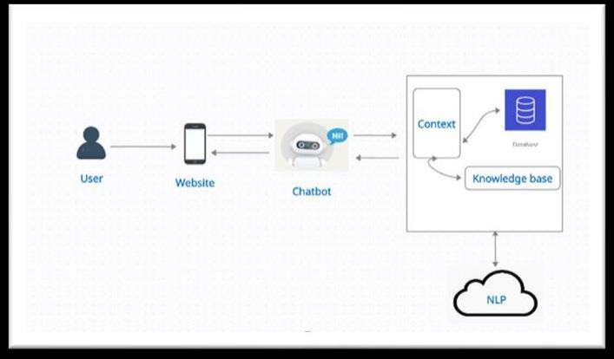

1. **REFERENCES**

[1] A Platform for Human-Chat bot Interaction Using Python

[2] Bhaumik Kohli , Tanupriya Choudhury, Shilpi Sharma, Praveen Kumar.,” A Platform for Human- Chat bot Interaction Using Python”, IEEE , 2018.

[3] Tussanai Parthornratt, Pasd Putthapipat, Dollachart Kitsawat , Prapap Koronjaruwat,” A Smart Home Automation via Facebook Chat bot and Raspberry Pi”, IEEE, 2018.

[4] Parth Thosani ,Manas Sinkar ,Jaydeep Vaghasiya, Radha Shankarmani,” A Self Learning Chat-Bot from User Interactions and Preferences”, IEEE , 2020.

[5] Prakhar Srivastava, Nishant Singh,” Automatized Medical Chat bot (Medibot)”, IEEE, 2020.

[6] Jitendra Purohi,,Aditya Bagwe,Rishbh Mehta, OjaswiniMangaonkar , Elizabeth George, “Natural Language Processing based Jaro-The Interviewing Chatbot” , IEEE, 2019.

[7] Bhavika R. Ranoliya , Nidhi Raghuwansh and Sanjay Singh , “Chatbot for University Related FAQs”,IEEE, 2017.

[8] Ankil Shah, Bhargav Jain, Bhavin Agrawal, Saurabh Jain, Simon Shim, “Problem Solving Chat bot for DataStructures” ,IEEE, 2018.

[9] Falguni Patel, Riya Thakore,Ishita Nandwani , Santosh kumar Bharti, “Combating Depression in Students using an Intelligent Chat Bot: A Cognitive Behavioral Therapy”, IEEE ,2019.

[10] Nitirajsingh Sandu , Ergun Gide, “Adoption of AI- Chat bots to Enhance Student Learning Experience in Higher Education in India”, IEEE ,2019.

[11] Neelkumar P. Patel, Devangi R. Parikh, “AI and Web-Based Human-Like Interactive University Chat bot (UNIBOT)”, IEEE,2019.

[12] Urmil Bharti, Deepali Bajaj, Hunar Batra, Shreya Lalit, Shweta Lalit, Aayushi Gangwan, “Med bot: Conversational Artificial Intelligence Powered Chat bot for Delivering Tele-Health after COVID-19”,IEEE ,2020.

[13] Prof.K.Bala,Mukesh Kumar,Sayali Hulawale, Sahil Pandita, “Chat-Bot For College Management System Using A.I”, International Research Journal of Engineering and Technology(IRJET)