**“A REVIEW ON EXPLORING MOUTH ULCER, ITS TYPES & TREATMENT FOR IT”**

**Mr. Bhandari Vipul Vishal, Miss. Ghorpade P. R, Dr. Garje S. Y, Dr. Gaffar G. A**

**SAJVPM’S College Of Pharmaceutical Science And Research Centre, Kada (Beed), Maharashtra, India.**

**Corresponding Author: Bhandari Vipul**

**ABSTRACT:**

The present study aimed to develop and evaluation of the pharmaceutical herbal mucosal gel containing betel leaves for the treatment of mouth ulcer. A mouth ulcer is an ulcer that develops on the lining of the mouth. "A breach within the mucosal surface of the buccal cavity," based on the definition. A mucous membrane or skin surface ulcer is an open sore where inflammatory dead tissue has been removed Causes of mouth ulcers include the deficiency of some nutrition's such as iron, vitamins especially B12 and vit. C, poor oral hygiene, infections, stress, indigestion, mechanical injury, food allergies, hormonal imbalance, skin disease etc. The mouth ulcers also known as Canker Sores. The more acceptable remedies are natural that they are safer and lesser side effects than the synthetic medicines. Herbal medicinal plants which are widely used in the treatment of skin diseases and also known to possess wound healing, antifungal, antiviral and antimicrobial activities. The present investigational formulations were prepared by using the different concentration of the Carbopol 934, PEG 400, Methyl paraben used as a preservative. The formulation were characterized for pH, viscosity. spreadability, extrudability and mucoadhesion time and in-vitro drug release. It was demonstrated that the developed herbal gel formulations of Glycyrrhiza glabra, Aloe vera and Curcumin possess significant, therapeutically efficacious. The results showed that due to combination dosage form developed new herbal gel formulation having good mucoadhesion activity so it is safe, stable and good for mouth ulcer treatment.

Keywords: Mouth Ulcer, Mucosal Gel, Carbopol 934, Mucoadhesion, Drug Delivery, Formulation, Evaluation, Betel leaves

**INTRODUCTION:**

The world oral health report, 2003, emphasized oral health as an essential and crucial component of general health. Most of the chemical products contains an antiseptic that plays an important role in controlling plaque accumulation (1). Mouth ulcer is also known as canker sore-painful grazes that develop in mouth at base of your gum. They can cause problem during drinking, talking and eating. Treatment of oral ulcer may employ antibiotic or analgesic gel formulation semi-solid formulation in addition to antiseptic mouthwash, such as chlorhexidine mouthwash or povidone iodine mouthwash (2). Gel having a liquid phase which are than other components increases thickness. Oral health/dental health is an inseparable part of general health. Health has an effect on general health as it causes considerable pain and suffering. It has an impact on a person's speech, selection of food, quality of life, and well-being. In view of the prevalence of oral diseases, their impact on individuals and society, and the expense of their treatment (3).

Topical gel is useful for the application on skin or to like mucosal surface for local action or percutaneous penetration of medicament preparation. A large number of Indian herbalmedicinal plants are attributed different pharmacological activity, since they contain herbs fortreatment of mouth ulcers (4).The efficacy of the therapy can be improved by the approach ofpolyherbal oral mucosal gel Plant supplements are made as gels using a variety of gelling agents. The foundation of the gel compositions must have respectable mucoadhesion so that the medication remains on the spot of application for a longer time. These drug systems form an intimate contact with the oral mucosal membrane and facilitate the rapid release of drug molecules at the location of absorption and hence the better bioavailability of drug (5). Common causes of mouth ulcers indicates deficiencies of nutritions such as iron, vitamins, especially B12 and C, poor oral hygiene, infections, stress, indigestion, mechanical injury, foodallergies, hormonal imbalance, skin disease etc. Mouth ulcers also be called as aphthous ulcers,can be painful when eating, drinking or brushing teeth

**OBJECTIVES:**

We want to emphasize the significance of both synthetic drugs and natural herbs for their anti-ulcer properties. This includes understanding their components, how they work, their advantages, drawbacks, and what the future holds for them. Ultimately, our goal ensure all patients receive quality healthcare regardless of their background, promoting equality in healthcare services.

**TYPES OF MOUTH ULCER:**

Based on the duration ulcers can be broadly classified into Acute (short term) or chronic (long term), aphthous ulcers, chancres Traumatic ulcers and herpetic ulcers are examples of acute ulcers that last no longer than three weeks before spontaneously retreating. Major aphthous ulcers from, malignant ulcers, gummas, odontogenic infection, secondary ulcers to enervating systemic diseases, and some examples of chronic ulcers traumatic ulcers that last for weeks or months. (with a lingering traumatic component)

**They are also sub classified into-**

**Minor ulcers:** These are usually small, ranging from 2 to 8 mm in diameter and may

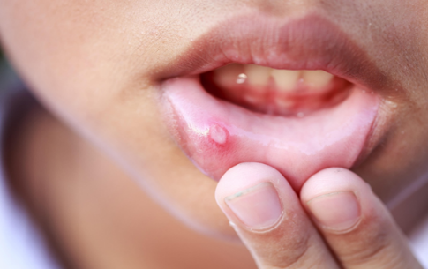take up to 10 to 14 days to clear up.

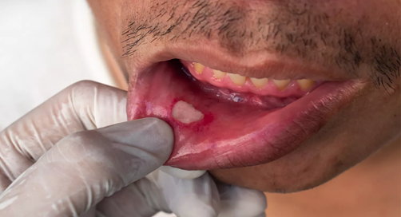**Major ulcers:** These are bigger in size, deeper with raised and irregular borders, often 1 cm or more. Healing time ranges from several weeks to months.

**Herpetiform ulcers:** These are a cluster of smaller ulcers, as small as the size of a sewing Needle

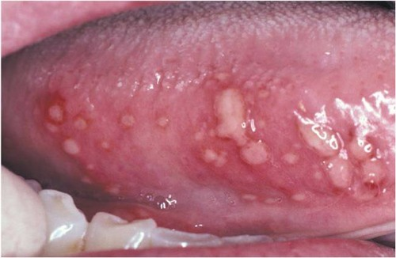

**SIGNS AND SYMPTOMS-**

* A yellow-greyish membrane at the graze's base, raised edges on all sides, and One day prior to the ulcer's actual growth, a severe pain or hurming sensation starts to appear on the buccal mucosa, labial mucosa, upper region inside of the mouth or on the tongue.
* unusual skin redness.
* The pain is increased during speaking, swallowing, and eating. Typically, the pain lasts
* three to four days.
* Idiopathic
* Gastrointestinal diseases-Inflammatory bowel disease, coeliac disease
* Infection- Viral:
* HSV, Coxsackie; Fungal: candidiasis; Bacterial: syphilis, Tuberculosis
* Systemic disease- Reactive Arthritis, SLE
* Trauma-dentures
* Neoplasia- Squamous cell carcinoma

**DOSAGE FORMS USED FOR THE TREATMENT OF MOUTH ULCERS:**

* Pastes
* Drugs-Chemotherapy antimalarials (10).
* Mouthwashes
* Buccal tablet
* Buccal patch
* Medicated chewing gum (11).
* Pharmaceutical gel

**PHARMACEUTICAL GEL:**

Pharmaceutical gel is a solid or semi-solid system consisting of at least two components, Liquid permeated with condensed substances. Gels and jellies are components of a little number of solids dispersed throughout a large volume of liquid, however they have a solid-like rather than a liquid-like consistency. The presence of some type of epi- dermal structure, which gives jelly and gel their solid- like qualities, is a distinguishing feature .

Gels are typically semi-solid formulations having a liquid phase that has been thickened with other components. Demand for medicinal plants is increasing in both developing and developed countries. Research on medicinal plants is one of the leading areas of research globally.

**VARIOUS CAUSES OF MOUTH ULCERS INCLUDE:**

* Chewing hard food
* Poorly fitted dentures
* The inner side of the cheek unintentionally biting or injured.
* Brushing teeth roughly
* Constant contact with a tooth that is sharp or damaged
* Hot food burns

**HOME MEDICATIONS FOR MOUTH SORES:**

* Gargle salt water and baking soda
* Place milk of magnesia on the sores
* Apply ice
* Take over-the-counter medications if the sores are accompanied by pain
* Use mouth rinses containing a steroid for pain management
* Take nutritional supplements including zinc, B-12, vitamin B-6, and folic acid(16).
* Avoid acidic foods and beverages, such as liquorice
* Think about using natural therapies like chamomile tea, and root
* Avoid from Avoid alcohol tobacco use
* Use a bristled-soft toothbrush
* Use without sodium lauryl sulphate toothpaste (SLS)

**COMMONLY USED ALLOPATHY MEDICINES FOR CANKER SORES:**

* Thriphalachoornam
* Gandharvahastadi kashayam
* Amruthotharam kashayam
* Vilwadi lehyam
* Dadimashtakachoornam
* Hinguvachadi choornam

**HERBAL PLANT WHICH CAN BE USED FOR MOUTH ULCER**:

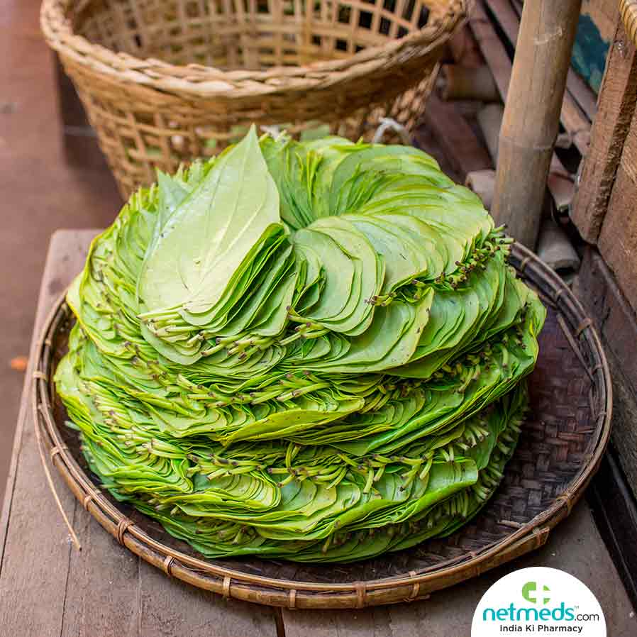**Betel Leaves-**

Scientific Name-(Piper betel L.)

Common Name-Paan

Family-Piperaceae

**Chemical constituents:** Alkaloids, Carbohydrate, Amino acids, Tannins and Steroidal components, chavicol, eugenol, piper betol and the betel oil contains cadinene carvacrol, allyl catechol, chavicol, pcymene, caryophyllene, chavibetol, cincole and estragol as the major components (16)(17)

**Phytochemicals:** Piper betel contains a wide variety of biologically active compounds whose concentration depends on the variety of the plant, season and climate. Chemical compositions of essential oil constitute safrole present in the leaf, stalk, stem, root and B-phellandrene present in the fruit. The presence of hydroxychavicol acetate, allylpyrocatechol piperbetol, isoeugenol, sorthole, stearic acid, methyl eugenol, carvacrol, polyphenol, alkaloids, saponin, tannin, steroids and other compounds are also found in Piper bete(15). The aroma of betel leaf is due to the presence of essential oils, consisting of phenols and terpenes (12). The active ingredient of piper betel oil which is obtained from the leaves is primary a class of allyl benzene compounds, chavibetol, chavicol, estragole, eugenol, methyl eugenol and hydroxycatechol(18) (19)

**Active Components:**

Maior constituents of Piner betel are chavibetol (53.1%) and chavihetol acetate (15.5%). Other stituents were allvpyrocatechol diacetate (0.71%), campene (0.48%), chavibetol methyl ester -48%), eugenol (0.32%), a pinene (0.21%), B-pinene (0.21%), a-limonene (0.14%), role (0.11%) and 1,8-cincole (0.04%). Hexane fraction of leaf stalks yielded four alipathic compounds in pure form pentadecyl 6-hydroxytridecanoate, pentatriacontanol, methyl hecacos-7-ennate and 6. 9- heptacosa diene. The principle chemical constituents of Piner betel procatechol and C. eugenol, chavicol, charvacrol, which were reported to exhibit strong antioxidant activity. Further Best polyphenols exert their protective activities through their superior radical scavenging and mune modulating potentials. Therapeutic Importance: Piper betel possess various pharmacological properties include anticancer, antimutagenic, anti-amoebic, antigiardial, anti- ammatory, mosquito larvicidal, antimicrobial, immunomodulatory, antiulcerogenic. dieprotective, antileishmanial, and antifungal activity(17). In addition the leaf extract has alse been reported to have antioxidant, antimicrobial, antifungal, anti-inflammatory and radio- protective properties. Piper betel leaf is also useful for the treatment of various diseases like bad breath, boils and abscesses, conjunctivitis, constipation, headache, hysteria, itches, mastitis, mastoiditis, leucorrhoea, otorrhoea, ringworm, swelling of gum, rheumatism, abrasion, cuts and injuries as folk medicine while the root is known for its female Geographical Source- Betel leaves native in southeast Asia. Cultivated in various states Assam, Andhra Pradesh, Bihar, Gujrat, Odisha, Karnataka

**Plant description:** Perronial dioecious creeper The stem is semi-woody and climbs upwards. short adventitious roots Leaves 10-20 cm long, broad ovate, slightly heart-shaped Bases often equel short and pointed, glabrous, both bluish The sides are light green or yellowish, and thepetioles are strong and 2.0-2.5 cm long male spines Cylindrical tight. Female spines are 150 5.0 cm long and drooping fruit tate Generated and often buried in lesby spices to form sodular structures (20).

**Leaf:** The leaf juice is given systemically to treat cough and indigestion in children and siso as malarial activity, antibacterial activity, antifungal study, insecticidal activities, antioxidant activity, anti-diabetic activity, gastro protective activity, antinociceptive activity, cytotoxic activity and anti-platelet.

**Stem:** Stems are supposed to be useful in treating indigestion, bronchitis, constipation, coughs lasthma

**Whole Plant:** The plants of genus Piper are also used for many other purposes such as foods and spices, fish bait, fish poison, hallucinogens, insecticides, oils, ornaments, perfumes, wiwormal and anti-infectious agent because of its pungent taste. It helps in normalizing the digestive tract hence is very effective in maintaining the digestive system because of its light properties. Modern medicinal use Betel leaves are beneficial in pulmonary infection in childhood and old age. The leaves, soaked in mustard oil and warmed, may be applied to the chest to relive cough and difficulty in breathing. Local application of the leaves is effective in tresting sore throat. The crushed fruit or berry should be mixed with honey and taken to relieve innating cough. Betel leaves are useful in treatment of nervous pain, nervous exhaustion and debility. The juice of few betel leaves, with a teaspoon of honey, will serve as a good tonic. Applied locally, betle leaves are beneficial in the treatment of inflammation such as arthritis end orchitin i.e. inflammation of the testes. Betle leaves have analgesic and cooling properties. It is also a valuable remedy for boils. A leaf is gently warmed till it gets soft, and is then coated with a layer of castor oil. The oiled leaf is spread over the inflammation. A hot poultice of the javes or their juice mixed with some bland oil can be applied to the loins with beneficial results in lumbago (17). The leaves can be used to heal wounds. The ince of the leaves should be extracted and applied on the wounds. The application of leaves sured with oil is said to promote secretion of milk when applied to the breast during lactation. According to Unani system the leaf has a sharp taste and good aml which helps improve appecie. It also acts as a tonic to brain, heart and liver(21).

**Medicinal Properties:**

* Bad breath
* Boils
* Conjunctivitis
* Constipation
* Headache
* Swelling of gum

**CONCLUSION:**

In current study herbal gel formulation was formulated evaluated for various parameters. The results indicates that the formulation passed the test. The prepared herbal gel formulation which has no toxic effect are shown in formulation for mouth ulcer. It is the most popular form of primary healthcare, owing to its cultural acceptability, compatibility with natural objects, and lack of side effects. Canker sores can be treated or prevented with the use of dietary supplements and lifestyle adjustments. Mouth ulcers can be effectively treated using a homeopathic approach. This problem can be entirely treated in a few months with the help of a well-chosen Homeopathic remedy. The therapy for mouth ulcers with homeopathy varies from person to person. Homeopathic remedies for mouth ulcers are very safe to use and show highly promising outcomes.

**FUTURE SCOPE:**

Many of chemical based herbal mouth ulcer formulations are now been available in the market e the form of different brands consisting the synthetic form. This mouth ulcer can may reduce the health care can related transmission of harmful diseases but they also have some short wonings and adverse effect on humans' tissues and environment. Production cost of herbal formulation is also high. Herbal formulation ingredient do no produce toxic effect on human beings Further more such formulation reduce manufacturing cost and proven to be more economical than synthetic chemicals.

**REFERENCES:**

1. Vesper 1 formulation and evaluation of herbel mouthwash containing formulation and evaluation of herbal mouthwash containing natural ingredients for anti-microbial 2022.(june).

2. Shekar BRC, Nagarajappa R, Suma 5, Thakur R. Herbal extracts in oral health care - A review of the current scenario and its future needs. Pharmacogn Rev. 2015.9(18):87-92

3. Madan V. Herbal mouth ulcer gel: A Review: 2022:(June)

4 Sharma V. Page). "Formulation and Evaluation of Pharmaceutical Polyherbal Mucosal Gel for Treatment of Mouth Ulcers Containing Glycyrrhiza glabra, Aloe vera and Curcumin." Quest Journals J Res Pharm Sci [Internet]. 2021;7(8):2347-995. Available from: www.questjournals.org

5. Thorat YS, Sarvagod AM, Kulkarni S V., Hosmani AH. Treatment of mouth ulcer by curcumin londed thermoreversible mucoadhesive gel: A technical note. Int J Pharm Pharm Sci. 2015;7(10):399-402

6. Siu A, Landon K, Ramos DM. Differential diagnosis and management of oral ulcers. Semin Cutan Med Surg. 2015;34(4):171-7.

7. Agnihotri A, Kaur A, Arora R. Oral Ulceration and Indian Herbs: A Scoping Review. Dent J Adv Stud. 2020:8(03):071-9.

8. Moretto M, Wang Z, Mohammed A. Syzygium cumini inhibits adenosine deaminase activity and reduces glucose levels in hyperglycemic patients.

9. Recurrent mouth ulcers- Ayurvedic Treatment, Diet, Exercises, Research Papers, Yoga & Pranayama - Ayurvedaforall UK Blog

10. Banakar M, Moayedi S, Shamsoddin E, Vahedi Z, Banakar MH, Mousavi SM, et al. Chewing Gums as a Drug Delivery Approach for Oral Health. Int J Dent. 2022;2022:1- 10.

11. Khandelwal KR. Practical pharmacognosy Techniques and experiments. 9Th edition Pune, NiraliPrakashan; 2002: 149-160. [2]. Ayurvedic Pharmacopoeia, 1St edition. Government of India. Ministry of health and Family welfare department of Ayurveda, Yoga and Naturopathy, Unani, Siddha and Homoeopathy, New Delhi, 2007; 3: 25-26. [3]. Bhangare N.K., Pansare T.A., Ghoongane B.B., Nesari T.M. Screening for Anti-inflammatory and anti-allergic activity of Bharangi (Clerodendrumserratumlinn. Moon) in animals. Int J Pharm. Biosci. 2014: 34.245-254.