**Orchestrating Dynamic Wellness Solutions through Integrated Analytical Systems**

**VK. Chandrahasan, S. Prakasam**

Student, Department of Computer Science and Applications, SCSVMV [Deemed to be University], Kanchipuram, Tamil Nadu, India

Head of the Department, Department of Computer Science and Applications, SCSVMV [Deemed to be University], Kanchipuram, Tamil Nadu, India

**ABSTRACT**

The project, "Orchestrating Dynamic Wellness Solutions through Integrated Analytical Systems," stands at the forefront of healthcare innovation by seamlessly integrating sensor technology and incorporating a secure computing concept with Rijndael Encryption Algorithm and Fernet symmetric key encryption algorithm and Machine Learning- Gradient Boosting Regressor Algorithm. This groundbreaking approach ensures real-time monitoring and assessment of patient well-being through strategically placed sensors embedded in smart clothing. Within the project's closed-loop system, a continuous flow of data, from upload to detailed report generation, empowers healthcare professionals with prompt access to invaluable insights, enhancing the overall efficiency of healthcare management. A key advantage of the project is its inherent adaptability to the dynamic landscape of healthcare needs. This adaptability is particularly notable in the integration of secure computing- Rijndael Encryption Algorithm and Fernet symmetric key encryption algorithm and Machine Learning- Gradient Boosting Regressor Algorithm which promotes precision, security, and responsiveness. The distributed ledger technology elevates data integrity, providing an immutable record of patient information and ensuring the utmost security for sensitive healthcare data. The system's intuitive user interface, coupled with advanced procedures, not only enhances the user experience but also simplifies the navigation of complex diagnostic data, promoting accessibility for healthcare professionals. Within the project's modules, the transparent and secure nature of secure computing and machine learning contributes to efficient communication, well-coordinated sensor placement, and streamlined diagnostic processes. This holistic integration fosters a robust and responsive healthcare ecosystem, ultimately advancing the effectiveness of healthcare services. In essence, the project presents a transformative solution that prioritizes patient-centric care, embraces real-time updates, and seamlessly integrates cutting-edge sensor technology with the added layer of secure computing and machine learning, setting new standards in healthcare management and paving the way for the future of patient-centric wellness solutions.

1. **INTRODUCTION**

"Orchestrating Dynamic Wellness Solutions through Integrated Analytical Systems" represents a pioneering initiative in healthcare innovation, aimed at enhancing the efficiency and effectiveness of healthcare management. This project integrates advanced technologies to enable real-time monitoring and assessment of patient well being. By leveraging a closed-loop system, the project facilitates the seamless flow of data, empowering healthcare professionals with timely access to valuable insights. One of the project's key strengths lies in its adaptability to the evolving landscape of healthcare needs, ensuring that it remains responsive and relevant. Through its user friendly interface and advanced procedures, the project simplifies the navigation of complex diagnostic data, making it more accessible and intuitive for healthcare professionals. Overall, this project signifies a transformative step towards patient centric care, setting new standards in healthcare management and paving the way for future advancements in wellness solutions.

1. **LITERATURE REVIEW**
2. Introduction to **Orchestrating Dynamic Wellness Solutions through Integrated Analytical Systems** in healthcare has revolutionized the way wellness solutions are designed and implemented. By leveraging big data, machine learning, and advanced analytics, healthcare providers can deliver more personalized, efficient, and effective care. This literature review examines key contributions to the field, focusing on the impact of integrated analytical systems on dynamic wellness solutions.
3. Health Analytics and Data Integration: Larson and Owen (2016) emphasize the transformative power of health analytics in **orchestrating dynamic wellness solutions through integrated analytical systems**. They advocate for integrating data from diverse sources such as electronic health records (EHRs) and wearable devices to provide a comprehensive view of patient health. This integration facilitates predictive analytics, enabling proactive healthcare management and the creation of responsive wellness solutions tailored to individual patient needs.
4. Improving Safety with Information Technology: Bates and Gawande (2003) examine the role of information technology in improving patient safety by reducing medical errors. They discuss how integrated IT systems, such as electronic health records and clinical decision support systems, provide real-time alerts and better data management. Their findings indicate that comprehensive IT systems are crucial for **orchestrating dynamic wellness solutions** that adapt to the evolving needs of patients and ensure safety.
5. Creating Value through Big Data: discuss the role of big data analytics in creating value in healthcare by enhancing decision-making processes. They present case studies where big data analytics have led to cost reductions, improved patient outcomes, and enhanced operational efficiencies. Their research supports the strategic implementation of **integrated analytical systems to orchestrate dynamic wellness solutions** that leverage the full potential of big data in healthcare.
6. Cognitive Models and Clinical Decision-Making: Patel and Arocha (2000) examine cognitive models of clinical reasoning and their implications for training healthcare professionals. They argue that understanding these models can enhance the design of decision support systems, making them more intuitive and effective. Their work suggests that integrated analytical systems, when designed with cognitive insights, are crucial for **orchestrating dynamic wellness solutions** that support clinical decision-making and improve patient outcomes.
7. **PROPOSED SYSTEM**

The proposed work, encapsulated in "Orchestrating Dynamic Wellness Solutions through Integrated Analytical Systems," envisions a transformative paradigm in healthcare management. By seamlessly integrating cutting-edge sensor technology and secure computing Rijndael Encryption Algorithm concept and Fernet symmetric key encryption algorithm and Machine Learning- Gradient Boosting Regressor Algorithm, our project aims to address the existing challenges prevalent in traditional healthcare systems. This innovative approach ensures assessment of patient well-being, facilitated by strategically placed sensors within smart clothing, thereby fostering a continuous data flow that empowers healthcare professionals with prompt access to valuable insights. The major focus of our proposed work lies in its adaptability to the dynamic landscape of evolving healthcare needs. Through the incorporation of secure computing and machine learning technology, we enhance the precision, security, and responsiveness of our system. The distributed ledger technology ensures the integrity of patient information, providing an immutable record that elevates data security and trust. The project's intuitive user interface, complemented by advanced algorithms, not only enhances user experience but also simplifies the navigation of intricate diagnostic data, making healthcare services more accessible for professionals. Our proposed work further advances the effectiveness of healthcare services through the integration of transparent and secure communication, well-coordinated sensor placement, and streamlined diagnostic processes. By combining real-time updates, patient-centric care, and the powerful integration of sensor technology with secure computing and machine learning, our project sets new standards in healthcare management. In essence, our proposed work is positioned to revolutionize the healthcare landscape by providing a holistic, patient-focused, and technologically advanced solution that responds to the evolving needs of both patients and healthcare providers.

1. **CLASS DIAGRAM**

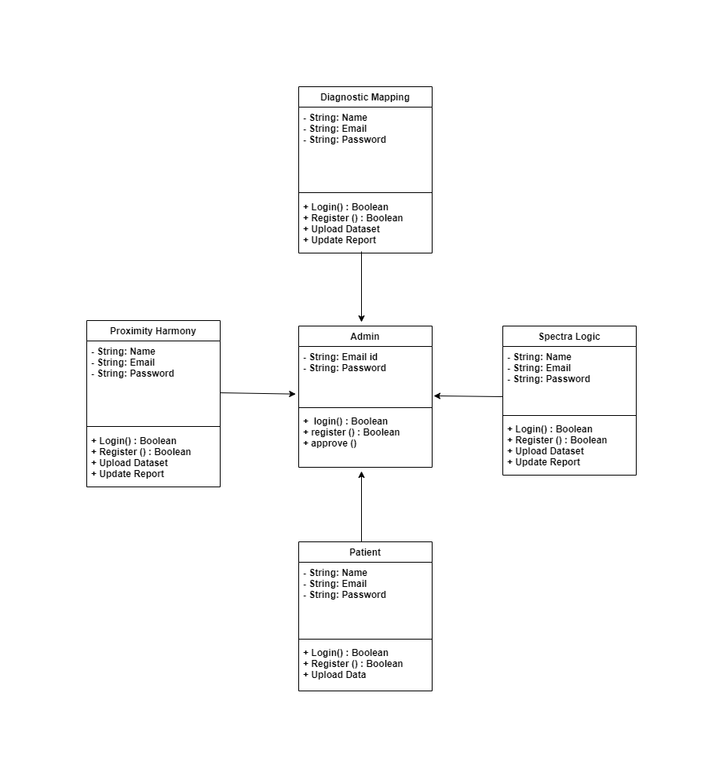

**Figure-1** Class Diagram: Shows the classes and their relationships in the system design.

1. **USE CASE DIAGRAM**

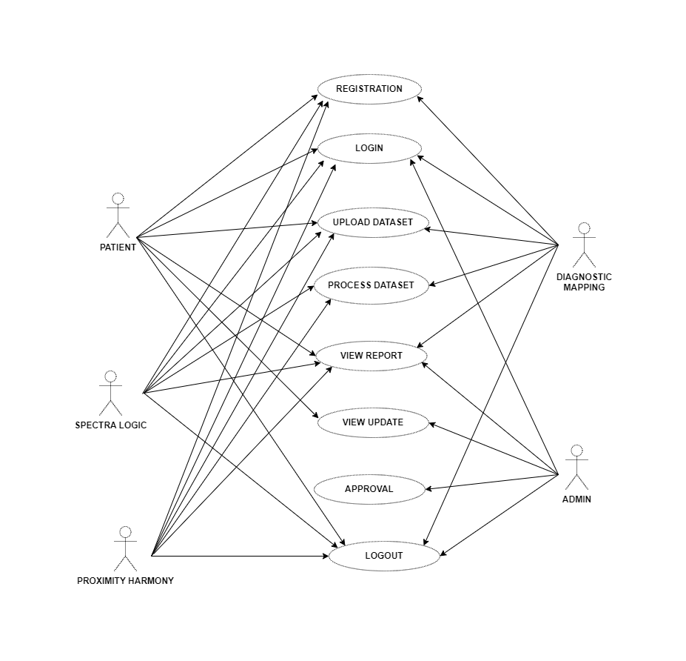

**Figure-2** Use Case Diagram.

1. **SYSTEM ARCHITECTURE**

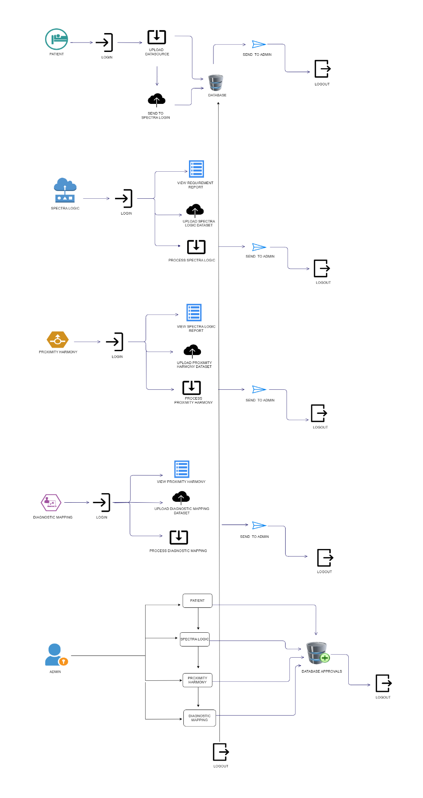

**Figure-3** System Architecture: Illustrates the overall system architecture design.

1. **MODULE DESCRIPTION**

**Admin**: The Admin module begins with a secure login process, utilizing predefined credentials. Once logged in, the administrator manages log statuses, ensuring a secure and organized system. Subsequently, the admin approves Spectra Logic reports, validating the critical insights generated from sensor data. Following this, the administrator approves Proximity Harmony reports, facilitating coordinated sensor placement and patient group processing. Continuing in the role of oversight, the admin approves Diagnostic Mapping reports, aligning the healthcare system with accurate diagnostic procedures. Moreover, the admin has the ability to review patient-uploaded data from smart clothing, checking for reprocessing needs and ensuring the continuous improvement of healthcare services. The Admin module then concludes its tasks with a secure logout, emphasizing its vital role in maintaining system integrity and facilitating effective healthcare administration.



**Figure-4** Home Page of the Admin module

**Patient:** The Patient module is a comprehensive system that facilitates a seamless healthcare experience. Patients begin by accessing the portal through a secure registration and login process. Subsequently, doctors utilize the platform to upload essential information, including the patient's medical history, details of surgeries, and relevant data for the development of smart clothing. This smart clothing is equipped with sensors strategically placed to monitor the patient's health conditions. Users can then access detailed reports generated through sensor processing, providing valuable insights into the patient's well-being. Furthermore, doctors can update the patient's information based on the smart clothing's feedback, allowing for continuous monitoring and assessment. The system ensures a closed loop, where doctors upload data, monitor patient conditions through smart clothing, receive sensor-processed reports, update information as needed, and finally, patients can securely logout, ensuring a holistic and efficient healthcare management process.

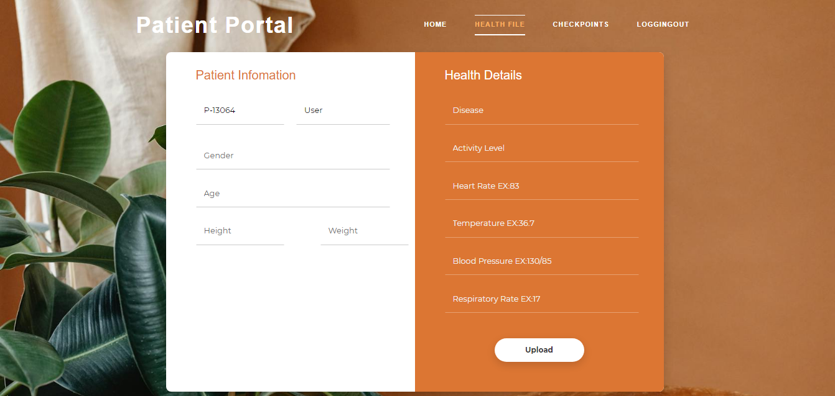

**Figure-5** Page of the patient module.

**Spectra Logic:** The Spectra Logic module is a pivotal component in the healthcare system, streamlining the integration of smart clothing technology. Initiated by secure registration and login, the module allows the sensor analyzer to access patient requirements for the necessary smart clothing. Following this, the analyzer uploads the material sensor dataset, which is then meticulously processed to discern the patient's specific needs for the smart cloth. Once the analysis is complete, a comprehensive report is generated and promptly sent to the administrator for further action.This commitment to accuracy, security, and responsiveness solidifies the module's indispensable role in advancing smart clothing technology in healthcare.



**Figure-6** Home Page of the spectra logic module

**Proximity Harmony:** The Proximity Harmony module begins with a secure login and registration process, granting access to Spectra Logic reports. Following this, the module uploads datasets on sensor placement, meticulously processing patient groups and determining sensor types and quantities required. Upon completion, a detailed report is generated and promptly sent to the administrator. This streamlined process ensures effective communication and coordination within the healthcare system. Finally, the Proximity Harmony module concludes its tasks with a secure logout, contributing to the overall efficiency and integration of sensor technology in healthcare management. the Proximity Harmony module plays a pivotal role in advancing the integration of sensor technology, ultimately contributing to improved patient care and overall system effectiveness.

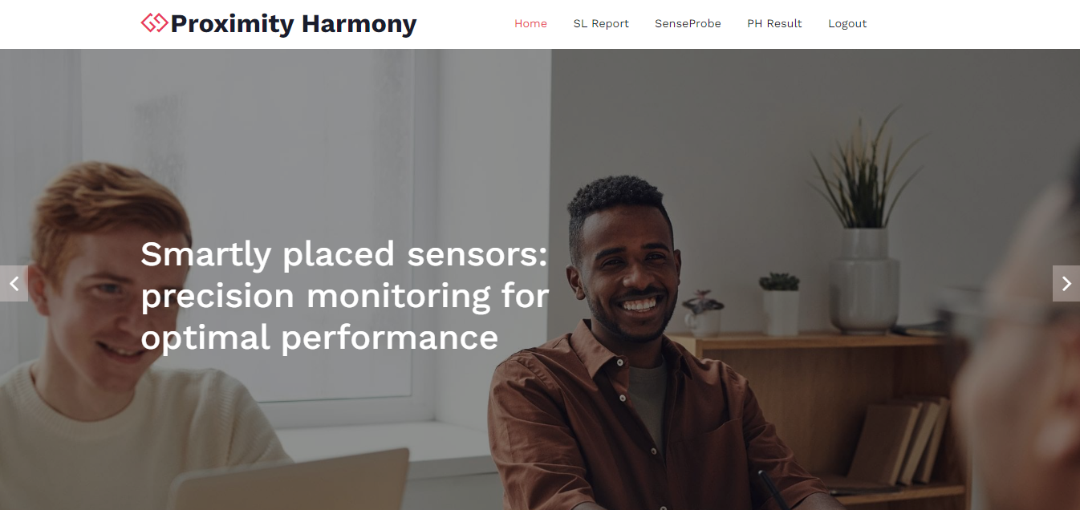

**Figure-7** Home Page of the proximity harmony module

**Diagnostic Mapping:** The Diagnostic Mapping module initiates its operations with a secure login and registration process, enabling access to reports generated from sensor processing and placement. Subsequently, the module uploads the sensor testing dataset, ensuring a thorough examination of the collected data. Further enhancing accuracy, the module uploads a dataset for precision, contributing to a comprehensive diagnostic mapping process. the Diagnostic Mapping module boasts an intuitive interface, simplifying the navigation through complex diagnostic data for healthcare professionals. Its integration with advanced algorithms ensures real-time updates, aiding prompt decision-making.

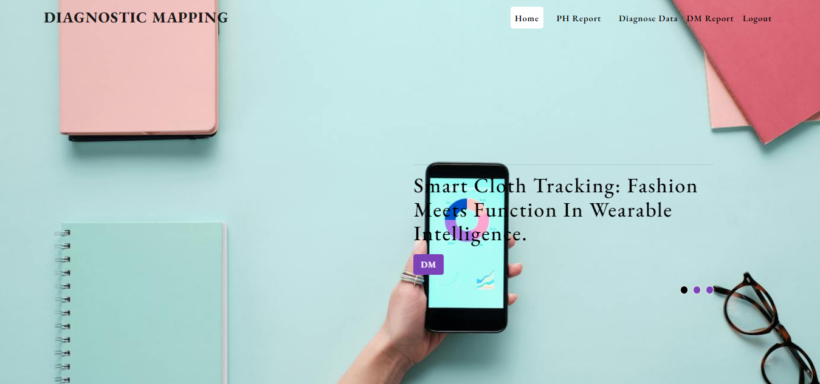

**Figure-8** Home Page of the diagnostic mapping module

1. **SCOPE OF THE PROJECT**

This project aims to enhance patient care and operational efficiency by orchestrating dynamic wellness solutions through integrated analytical systems. Key focus areas include data integration from diverse sources, advanced analytics for predictive modeling, and personalized wellness plans. The project will also implement clinical decision support systems and optimize healthcare workflows. Challenges to address include data privacy, interoperability, and user adoption. The ultimate goal is to improve healthcare outcomes through innovative and efficient analytical systems.

1. **CONCLUSION**

The project, "Orchestrating Dynamic Wellness Solutions through Integrated Analytical Systems," represents a groundbreaking initiative in healthcare management. By seamlessly integrating cutting-edge technology, it addresses existing challenges, ensuring real-time monitoring, adaptability to evolving healthcare needs, enhanced precision, improved security, and a user-friendly interface. This transformative solution stands to revolutionize healthcare by offering swift access to valuable insights, streamlined navigation of diagnostic data, transparent communication, and a holistic, patient-focused approach. The proposed work signifies a leap forward in technological innovation, positioning itself as a cost-effective and efficient solution for modern healthcare management. In the future, the project envisions expanding its impact through diverse initiatives. This includes further sensor integration to enhance insights by monitoring a broader range of health parameters. The incorporation of machine learning aims to predict and adapt to emerging healthcare trends

1. **REFERENCES**
2. Y. Zheng, R. Lu, Y. Guan, J. Shao, and H. Zhu, “Efficient privacy preserving similarity range query with quadsector tree in ehealthcare,” IEEE Trans. Services Comput., early access, May 18, 2021, doi: 10.1109/TSC.2021.3081350.
3. “Big data market:Increasing data generation to drive growth post the crisis,” 2021. [Online].Available:https://www.prnewswire.com/news-releases/big-data-market increasing-data-generation-to drive-growth-post-the-crisis-301315941.html
4. Larson, R., & Owen, M. (2016). Health Analytics: Gaining the Insights to Transform Health Care. Wiley.
5. Y. Elmehdwi, B. K. Samanthula, and W. Jiang, “Secure k nearest neighbor query over encrypted data in outsourced environments,” in Proc. IEEE Int. Conf. Data Eng., 2014, pp. 664–675.

5. Smith, J. A. (2015). Leveraging Big Data Analytics for Improved Healthcare Outcomes (Doctoral dissertation, University of California, Berkeley).